**UNX510 – Act5**

**Sanghyuk Lee(129405171)**

**p.18**

Activity:Create Sample.txt file with following data

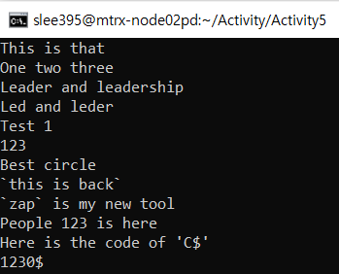

Search for “123”

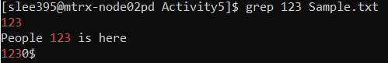

Search for “L”

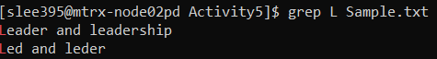

Search for $



**p.19**

**Q.** How to search for those lines which contain ‘`’ (back-tick character)

**A.**



**Q.** How to search for those lines which contain single quote character?

**A.**



**P.36**

In the /etc/passwd, find all lines which have ‘9’ in their third field

• You noticed that in /etc/passwd file the “:” is the separator. So, you can tell AWK what to consider as separator using “-F” option: – Awk –F ”:” ‘{ print $1 } ‘ /etc/passwd

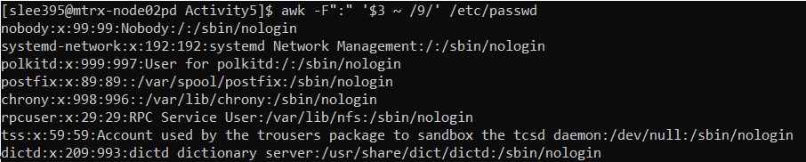

**P.37**

What does the following code do?

• Awk –F”:” ‘ NR==1, NR==10 { print $1 } ‘ /etc/passwd

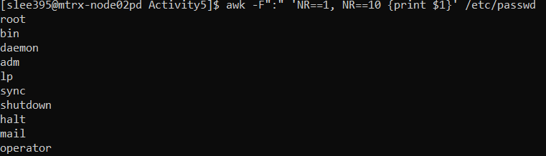

It sets the “:” as delimiter to decide the field and find where NR==1, NR==10 and then print the first column from the file /etc/passwd

**p.38**

Download the file from the BB- >courseDocument->week4->sampleFile and copy it into the matrix: – scp file.txt your account@matrix.senecac.on.ca:file.txt

• Try to practice some of the examples (3 of them) in previous slides

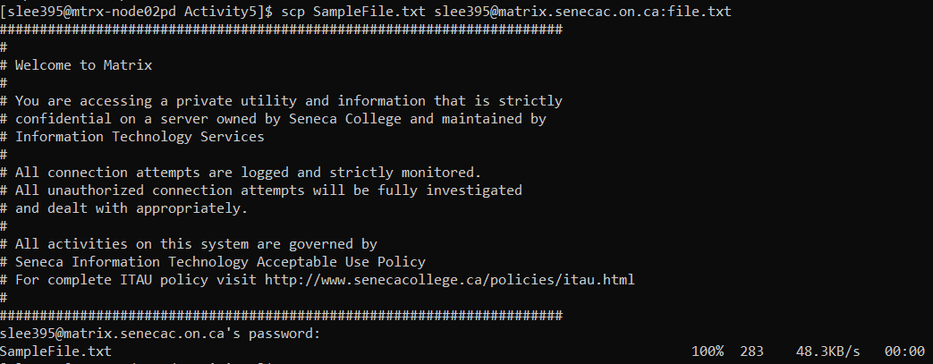

Example1

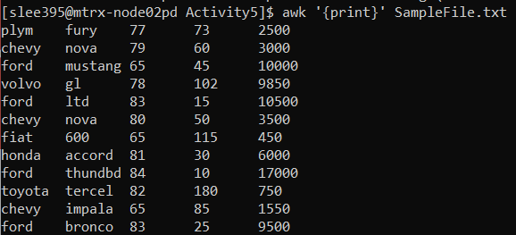

Example2

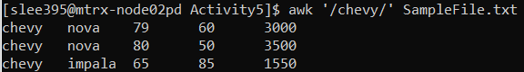

Example4

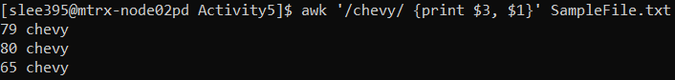

**P.47**

– Display all users in /etc/passwd which

/etc/passwd file is the following:

I considered the 5th field as the user name field as you can see there is such a name; Alex Salagean, Olga Gudnova etc.

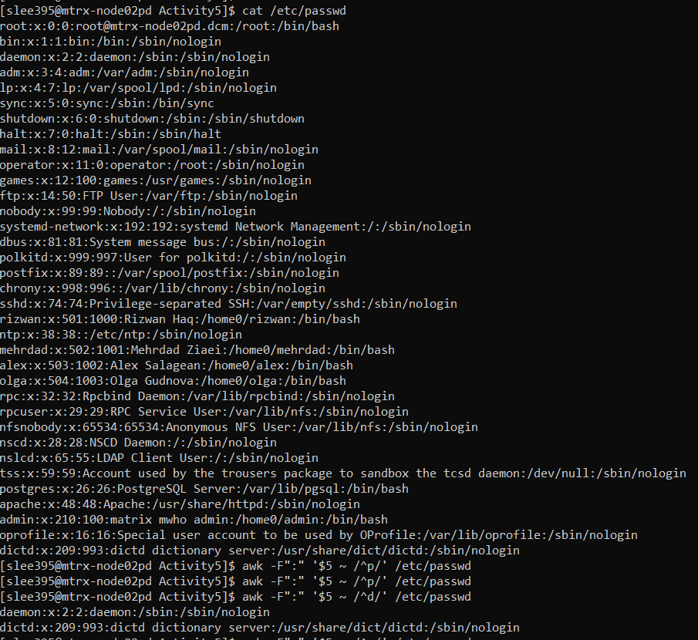

• Their username starts with ‘p’

As the username starting with p does not exist the command shows nothing.



Display all users in /etc/passwd which • Their username ends with ‘p’

