**UNX510 – Act56**

**Sanghyuk Lee(129405171)**

**All the answers are based on the given file, cars.txt**

**p.4**

• Try the sample queries in the BB (cars.txt)

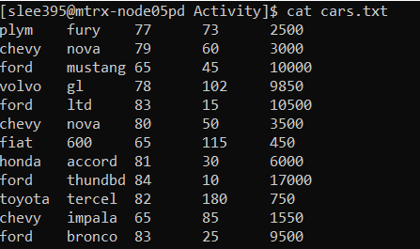

**Awk Arithmetic**

Ex1)



Ex2)



Ex3)



**Comparing sed And awk**

Ex1)

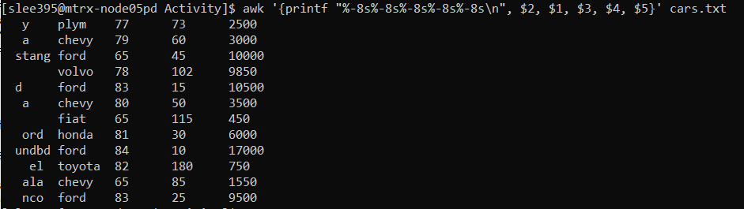

Ex2)

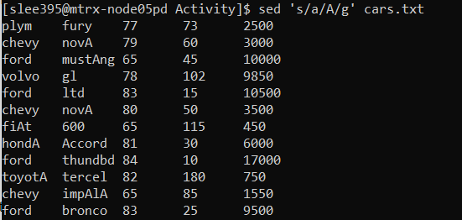

Ex3)

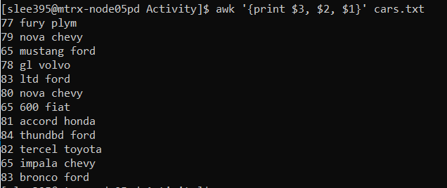

**p.12**Activity: What does the following command do? Explain it.

• awk 'END { print NR }' Sample.txt

I’ve used given file cars.txt



It reads the number of the rows (records) and output is 12.

**p.13**

Using awk/grep/sed , Display the first 3 columns of /etc/passwd with Heading titles (column1, column2,..) as follow:

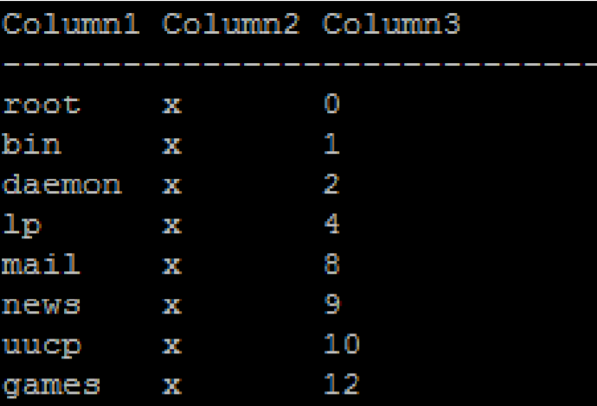

Following is the content of the /etc/passwd:

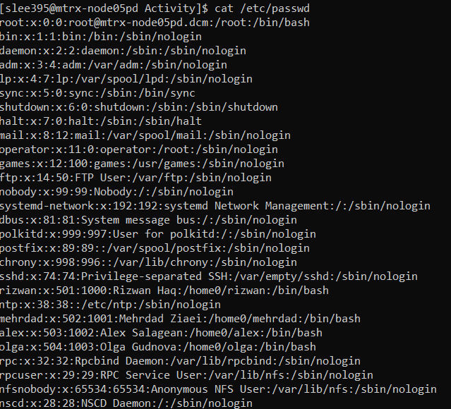

My Answer:

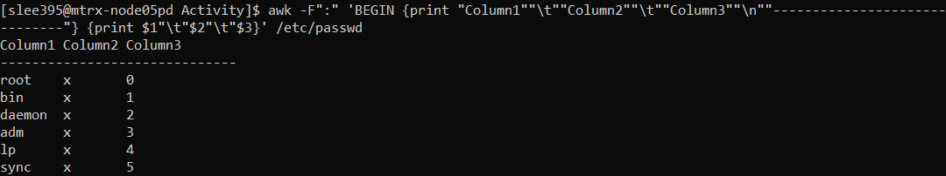

**p.14**

echo "Welcome To The Geek Stuff" | sed 's/\(\b[A-Z]\)/\(\1\)/g‘



It wraps each first letter of word with ‘()’