**UNX510 – Act8**

**Sanghyuk Lee(129405171)**

**p8**

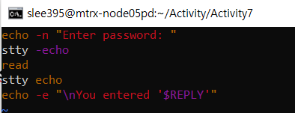

• Explain how it works.

The stty commad makes what you are typing invisible. So that it displays the line to enter the password from user and when user types something on the terminal, user cannot see what is typing and by turn on the stty it shows again. At the end, it shows what you have typed with the sentence.

• What is the role of $REPLY?

In this case, although there is no specific variable to accept what the user typed for password, by using $REPLY, you can check what you have typed previously.

**p.14**

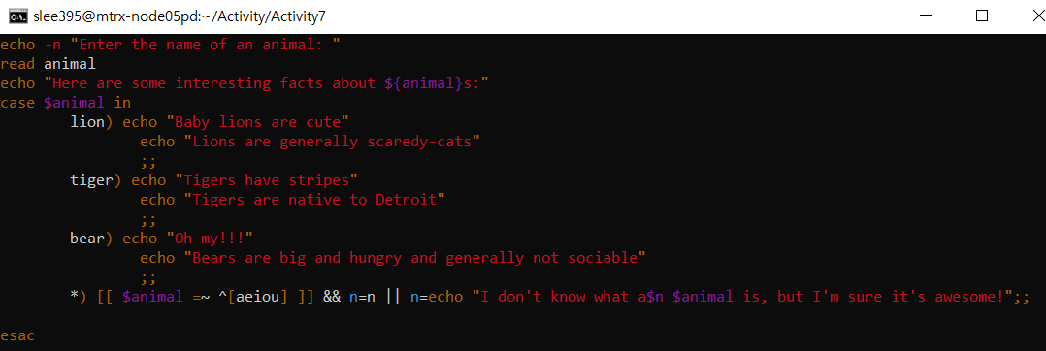

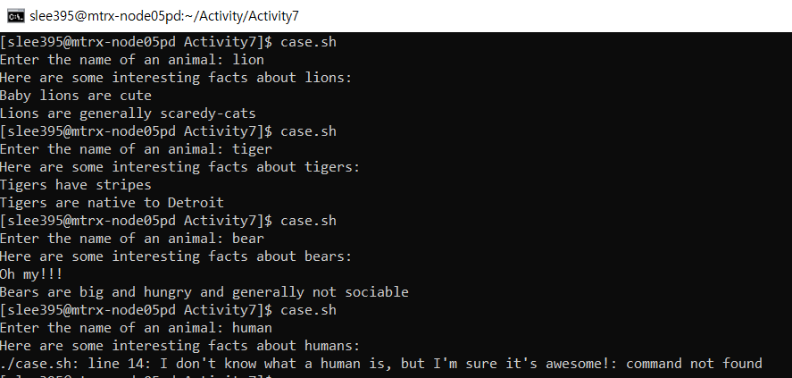

First of all, it accepts user type to a variable animal. If the cases based on what the user typed are matching with given condition such as lion, tiger, and bear, it echo what we have set on case statement. But if user type none of them, then it triggers *) which stands for ‘otherwise’ and implement following statement. The last condition stands for if anything is typed except the word starting with aeiou, then it displays the command following.

**p.16**

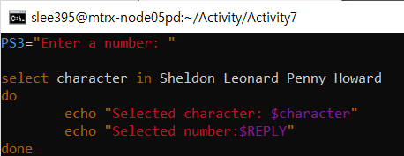

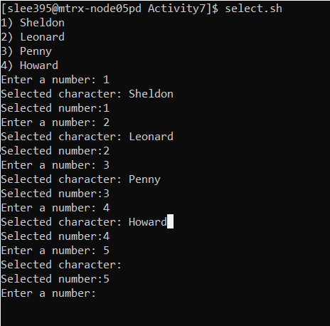

It lets the user select the options among Sheldon, Leonard, Penny and Howard. When the user selects a number, the commands display the matched character and the number you typed. If user selects none of them then it shows nothing.