**Activity9**

**Sanghyuk Lee(129405171)**

**I’ve demonstrated all the questions with the keyword ‘DemonstrationN)’ after the number.**

**I demonstrated the whole code roughly and then I answered the question of usage of CASE,SED,TRAP,STTY command in each script**

1. Files in current directory

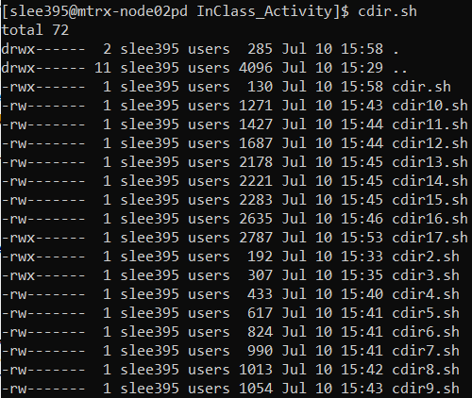

Without an argument

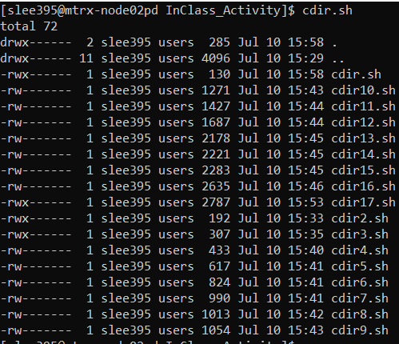

With argument “~”

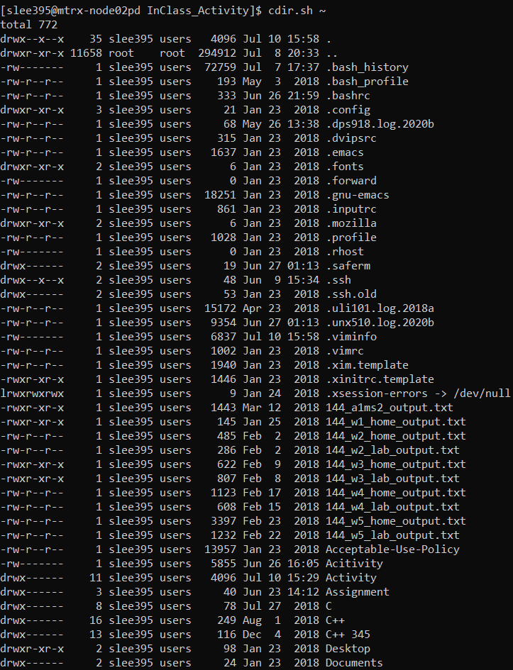

With argument “/”

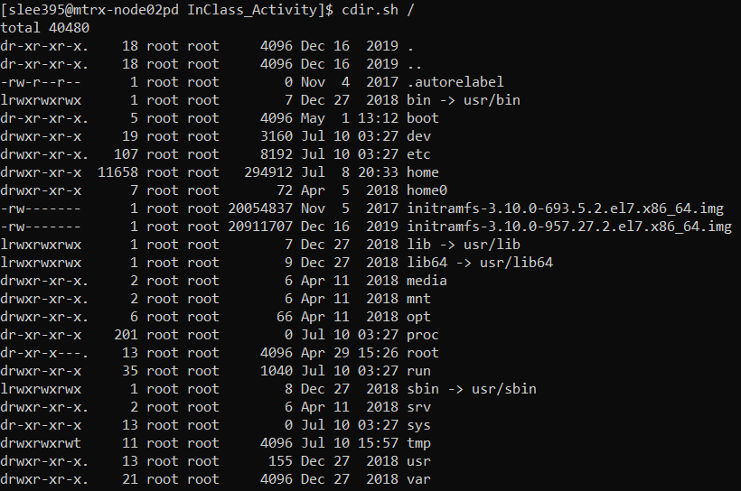

With more than one argument



**Demonstration1)** With the **CASE** statement using the number of argument, when it accepts 0 argument then it shows the hidden file and when there is 1 argument, it shows what it accepted, and when there is more then one argument it shows an error message saying “cdir: only one argument is allowed”. After the case statement is done, it sets the current directory to appropriate directory and issue the ls -al command.

**What does the CASE command do in this script?** – In this script, it divides the options to handle each different action.

1. With an argument of non-existing directory



**Demonstration2)** If you put argument other than directory, it shows an error message saying “cdir: argument must be a directory” and this condition is done by ‘-d’ option in the if statement. After that, it redirects to appropriate directory and do ls -al command.

**What does the CASE command do in this script?** – In this script, it divides the options to handle each different action.

1. With an argument of /root



**Demonstration3)** It checks whether the argument has a sufficient permission or not with a ‘-x’ option in the if statement. If an argument with insufficient permission has passed, then it shows an error message saying “insufficient permission to directory”.

**What does the CASE command do in this script?** – In this script, it divides the options to handle each different action.

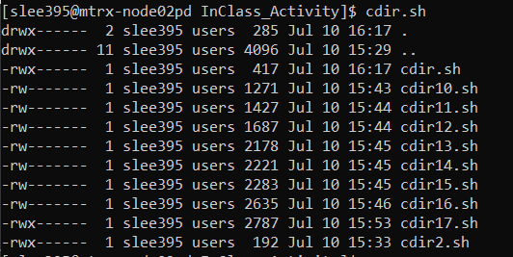

**Demonstration4)** The script makes the output redirect to ls -al command to temp file and with the sed command it display the first 12 line of the temp file and removes the temp file at the end.

**What does the CASE command do in this script?** – In this script, it divides the options to handle each different action.

**What does the SED command do in this script?** – In this script, it prints out from 1st to 12th line of the temp file.

1. It shows next 12 lines when I enter ‘n’

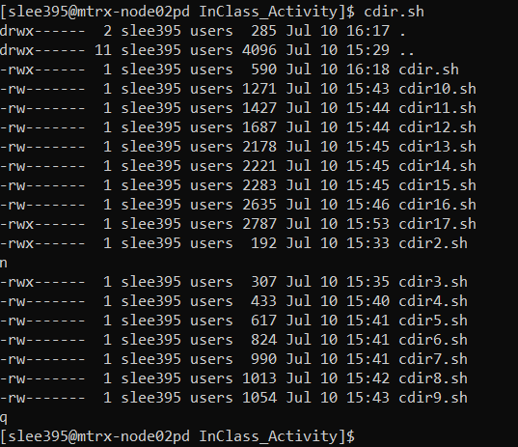

**Demonstration5)** It added a variable called filenum to set as a standard of first line of output. So it shows 12 line at the very first and it accepts user argument with a variable ‘command’ using ‘read’ command and when the variable ‘command’ is ‘n’ then it initialize the variable filenum to 13 so that it reads from 13rd line to 24th line and so on. If the user type ‘q’ then it removes a temp file and exit the loop and terminate.

**What does the CASE command do in this script?** – In this script, it divides the options to handle each different action.

**What does the SED command do in this script?** – In this script, it prints out from filenum to filenum+11 line of the temp file.

1. When I type ‘n’, It shows next 12 lines and when I type ‘p’, it shows the previous 12 lines in the temp file.

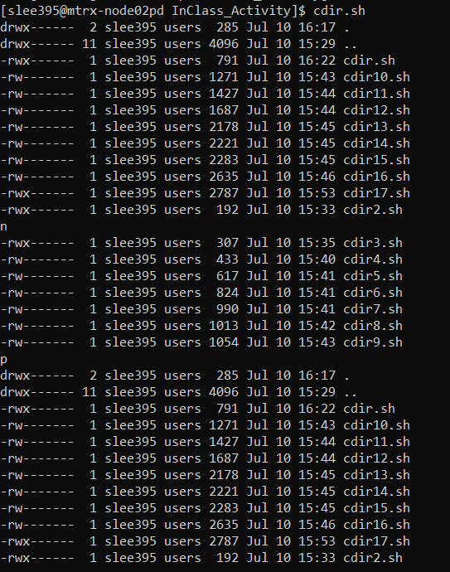

**Demonstration6)** In the case statement, the case ‘p’ is added. What the ‘p’ option does is when the variable ‘filenum’ is greater than 1, which means there was a case that user has typed ‘n’ option before, it subtracts 12 from filenum so that it displays the previous page.

**What does the CASE command do in this script?** – In this script, it divides the options to handle each different action.

**What does the SED command do in this script?** – In this script, it prints out from filenum to filenum+11 line of the temp file.

1. The cursor is on the first line and returns to first line whenever I try to change in the files displayed.

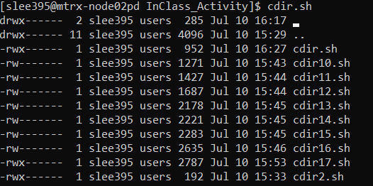

**Demonstration7)** With the ‘tput cup first second’ queries, which stands for move cursor position to row ‘first’ column ‘second’, it sets the cursor position. And whenever the option is selected whether ‘n’ or ‘p’, it initialize the variable cursor to 0 so that it moves the cursor to 0 row.

**What does the CASE command do in this script?** – In this script, it divides the options to handle each different action.

**What does the SED command do in this script?** – In this script, it prints out from filenum to filenum+11 line of the temp file.

1. Created long file name that is longer than screen width.

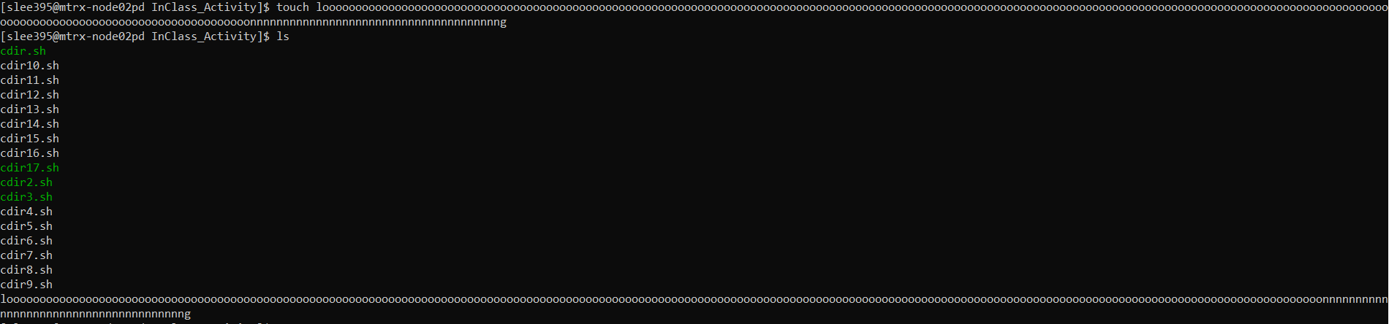

It limited the screen width to display the line of file name

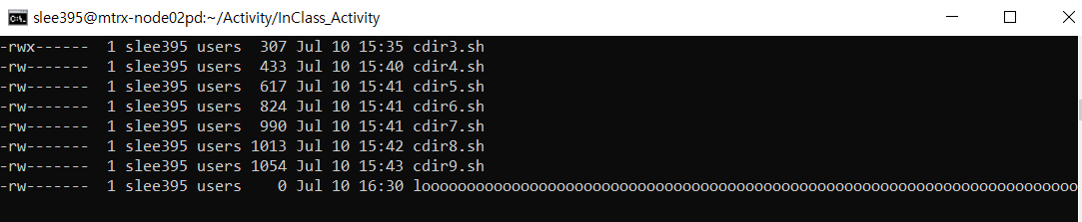

**Demonstration8)** It added the line

ls -al | tail -n +2 | cut -c1-$(tput cols) > /tmp/cdir.temp.$$

and what it means, it implement the command ls -al and with the ‘-n’ option of tail command, it outputs starting with the 2nd and by using the cut command it extracts first character to a number of columns in current display and redirects the output to temp file.

**What does the CASE command do in this script?** – In this script, it divides the options to handle each different action.

**What does the SED command do in this script?** – In this script, it prints out from filenum to filenum+11 line of the temp file.

1. The first line of cdir.sh using trap – INT syntax stands for resetting action for <Ctrl>-c to default



**Demonstration9)** As I mentioned, by using trap-INT syntax, it resets the action(removing temp file) for <Ctrl>-c to default

**What does the CASE command do in this script?** – In this script, it divides the options to handle each different action.

**What does the SED command do in this script?** – In this script, it prints out from filenum to filenum+11 line of the temp file.

**What does the TRAP command do in this script?** – When it exit, it does the action removing temp file.

1. When the console displays the output of cdir.sh which is first 12 lines of file content, we can move through keyboard key following:
2. When we type d<Return>, it moves down the cursor on the filename line one by one until the end of the displaying file content, which is 12nd line
3. When we type u<Return>, it moves up the cursor on the filename line one by one until the very top of the displaying file content, which is 1st line

**Demonstration10)** It added two more options, d and u, into case statement. When user type ‘d’ option and the row number is less than 11 and a variable filenum + cursor is less than total line of file displaying, which is 12 in this case, it moves down. If user type ‘u’ option and the number of row is greater than 0 then it moves the row number of current location of cursor to 1 line up.

**What does the CASE command do in this script?** – In this script, it divides the options to handle each different action.

**What does the SED command do in this script?** – In this script, it prints out from filenum to filenum+11 line of the temp file.

**What does the TRAP command do in this script?** – When it exit, it does the action removing temp file.

1. It returns the output highlighting the directories

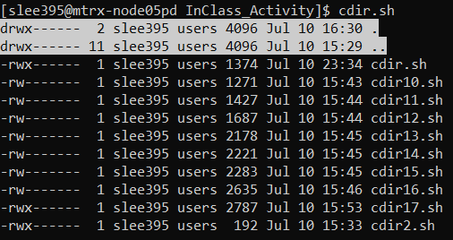

**Demonstration11)** It grep the line starting with character ‘d’ and highlighting that line with ‘tput smso’ command. And then whether it is directory or not, it prints the line and turn of the highlighting with ‘tput rmso’ command which refers to ‘remove mode standout’.

**What does the CASE command do in this script?** – In this script, it divides the options to handle each different action.

**What does the SED command do in this script?** – In this script, it prints out from filenum to filenum+11 line of the temp file.

**What does the TRAP command do in this script?** – When it exit, it does the action removing temp file.

1. It shows the menu/instruction how to move the cursor on the displaying console and when you terminate the script, unlike other codes, it moves the cursor below the bottom line of the menu

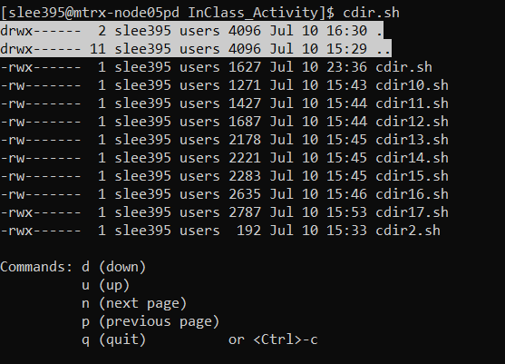

**Demonstrate12)** With the ‘tput cup 19 0’ action in the trap command, it moves cursor position to row 19 to 0 when you exit. And added a menu with the printf command.

**What does the CASE command do in this script?** – In this script, it divides the options to handle each different action.

**What does the SED command do in this script?** – In this script, it prints out from filenum to filenum+11 line of the temp file.

**What does the TRAP command do in this script?** – When it exit, it does the action removing temp file and move the cursor from row 19 to 0.

1. If I do s<Enter> on the line of directory name is written, it shows the files within it. Otherwise, it ignores.

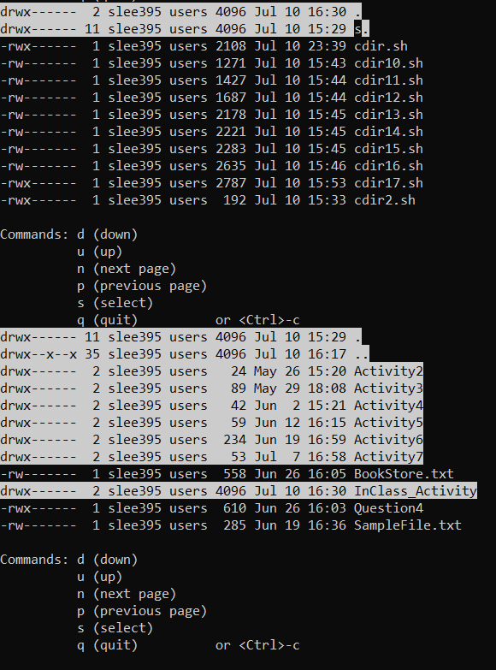

**Demonstration13)** It added the option ‘s’ in the case statement. It checks whether the cursor position is whether on the directory or not. And if it is directory, then it moves to given directory and it implement the command ls -al and with the ‘-n’ option of tail command, it outputs starting with the 2nd and by using the cut command it extracts first character to a number of columns in current display and redirects the output to temp file. After that, it initializes variable filenum. filecolumn, and cursor with appropriate values.

**What does the CASE command do in this script?** – In this script, it divides the options to handle each different action.

**What does the SED command do in this script?** – In this script, it prints out from filenum to filenum+11 line of the temp file.

**What does the TRAP command do in this script?** – When it exit, it does the action removing temp file.

1. While the console is displaying, It hides what the user is typing and you can finish it by q<Enter> or <Ctrl>-c

**Demonstration14)** It hides what the user is typing with the command ‘stty -echo’ and when you exit then it resets to what it was by the command ‘stty echo’

**What does the CASE command do in this script?** – In this script, it divides the options to handle each different action.

**What does the SED command do in this script?** – In this script, it prints out from filenum to filenum+11 line of the temp file.

**What does the TRAP command do in this script?** – When it exit, it does the action removing temp file and make the user type unhidden.

**What does the STTY command do in this script?** – It sets whether user typing hidden or not.

1. You can move your cursor without entering after one of the options registered on the menu, and you can finish it by q<Enter> or <Ctrl>-c

**Demonstration15)** The command ‘stty -icanon min 1 time 0 -echo’ stands for setting 1 character minimum for a completed read and setting read timeout of 0 tenths of a second. And when the user exit, it resets to default.

**What does the CASE command do in this script?** – In this script, it divides the options to handle each different action.

**What does the SED command do in this script?** – In this script, it prints out from filenum to filenum+11 line of the temp file.

**What does the TRAP command do in this script?** – When it exit, it does the action removing temp file and reset the minimum and time.

**What does the STTY command do in this script?** – setting 1 character minimum for a completed read and setting read timeout of 0 tenths of a second

1. You can now move your cursor with the arrow keys on the keyboard and if you want to select one file, you just need to enter on that line.

**Demonstration16)** The command ‘tput smkx’ is used to handle cursor keys. And using the following to accept as a condition to handle a menu:  **tput kcuf1, tput kcub1, tput kcud1, tput kcuu1, tput cr.** And use the command ‘stty -icrnl’ which disables carriage-return to new line conversion.

**What does the CASE command do in this script?** – In this script, it divides the options to handle each different action.

**What does the SED command do in this script?** – In this script, it prints out from filenum to filenum+11 line of the temp file.

**What does the TRAP command do in this script?** – When it exit, it does the action removing temp file and reset the minimum and time.

**What does the STTY command do in this script?** – setting 1 character minimum for a completed read and setting read timeout of 0 tenths of a second and disables carriage-return to new line conversion.

1. **Demonstration17)** By setting a variable ‘redraw’ as a Boolean flag and shows the menu first with proper condition and set the flag to no. And then whenever the ‘n’,’p’,’s’ options are typed, then it sets the flag to yes. By handling flag, it redraw the screen at the top of the loop when required.

**What does the CASE command do in this script?** – In this script, it divides the options to handle each different action.

**What does the SED command do in this script?** – In this script, it prints out from filenum to filenum+11 line of the temp file.

**What does the TRAP command do in this script?** – When it exit, it does the action removing temp file and reset the minimum and time.

**What does the STTY command do in this script?** – setting 1 character minimum for a completed read and setting read timeout of 0 tenths of a second and disables carriage-return to new line conversion.