**UNX510 – Assignment1**

**Sanghyuk Lee(129405171)**

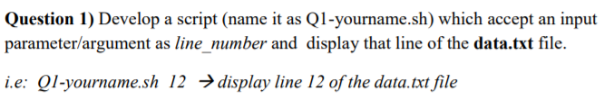

The file content of *data.txt* file

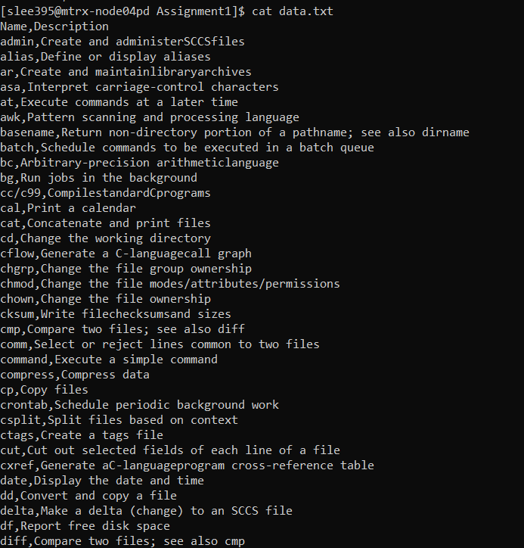

The file content of Q1-SanghyukLee.sh

It accepts an argument and find the matching row



Output:

1. When I try to read line number 3



1. When I try to read line number 7



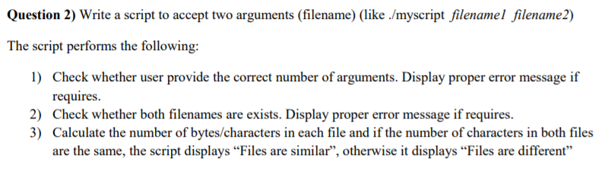

Following picture is a script file accepting two arguments and handle the conditions:

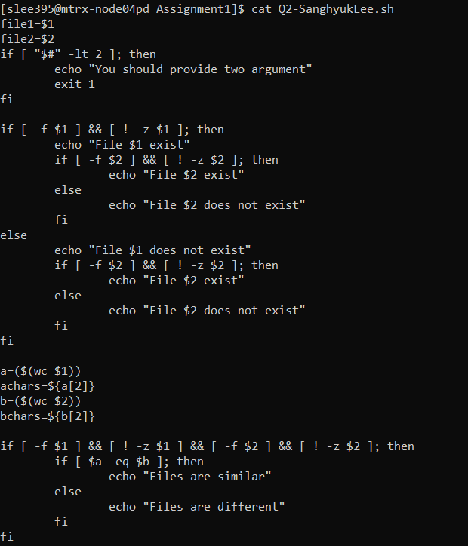

A1) First if statement figure it out a number of arguments and if the number of input arguments are less then ‘2’, then it prints the string “You should provide two arguments”

1. If I don’t put any argument



1. If I put only one argument



A2) Second if statement checks if both file names are existing and even if one of those files does not exist, then it prints an error message

1. If one of files doesn’t exist



1. If both of files don’t exist



A3) Third if statement checks if both files are existing and if it does then compare the number of characters of both files and if both number of characters are the same, then it shows “Files are similar”, otherwise it shows “Files are different”

1. If I put two arguments which have different number of characters

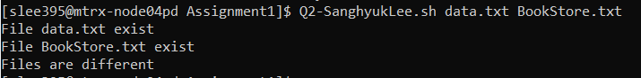

1. If I put two arguments which have the same number of characters

(data2.txt is the copy of data.txt file, which means the content of both files are the same)

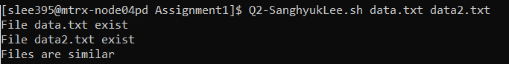

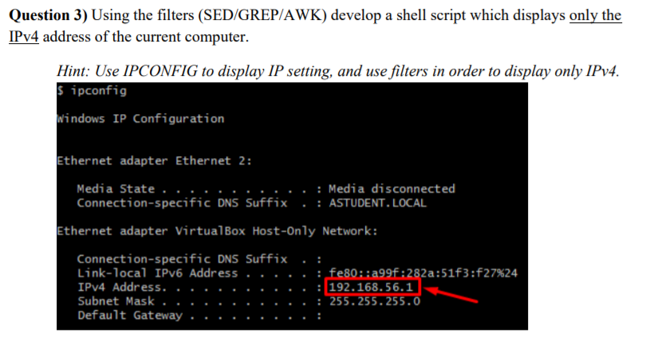

Following picture is my ip address:

(I will get the highlighted one)

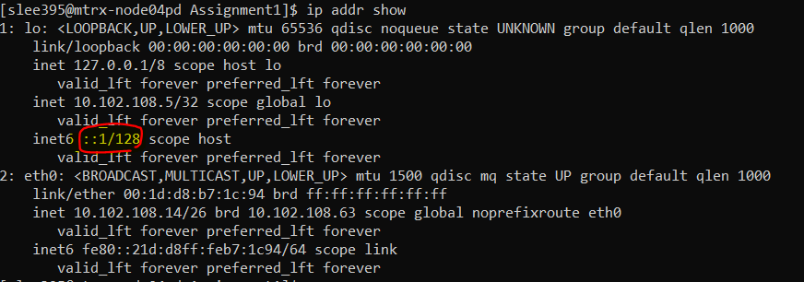

By using ‘awk’ command, I could successfully get what I wanted.



1. Ip addr show – display the information of ip
2. awk ‘NR==7’ - reads line number 7
3. awk -F’ ‘ ‘{print $2}’ – set the delimiter as a space and read the 2nd field

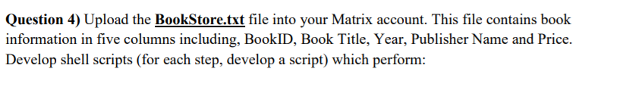

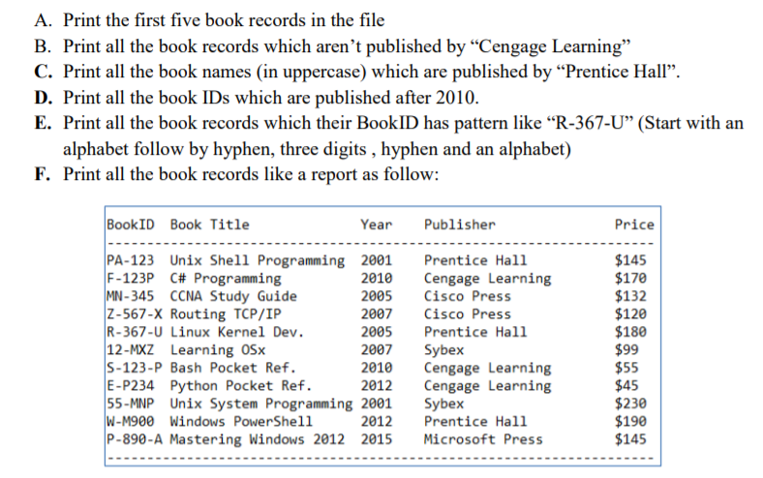

Following is the picture of BookStore.txt

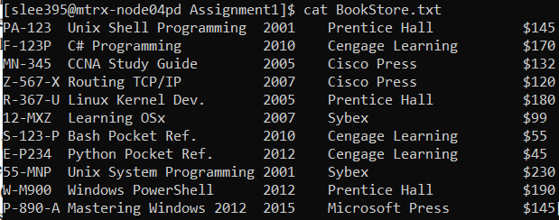

1. Using the ‘head -5’ command which reads the first 5 records of file, it output the first 5 records in the file

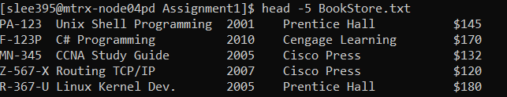

1. Using the grep -v “Cengage Learning” command which does read except the pattern, it output all the records which publisher is not “Cengage Learning”

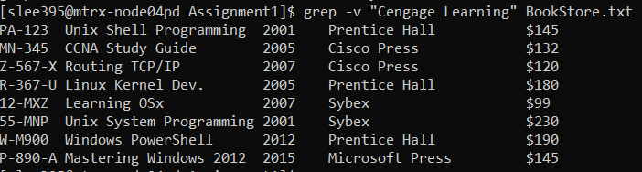

1. Using grep command to find the lines of “Prentice Hall”, tr “[a-z]” “[A-Z]” command to change to uppercase, cut -f2 to cut the fields and display only 2nd field



1. Using the awk command and set the delimiter as ‘\t’ and set the condition where the book is published after 2010 and print only a BookID

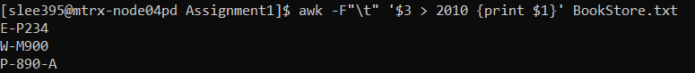

1. Using regular expression to find the records matching the pattern you want to find

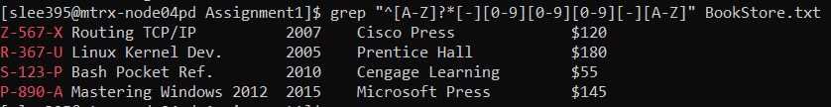

1. Using the functionality of ‘Advanced AWK’ (BEGIN{}, END{}), set the file like the given picture

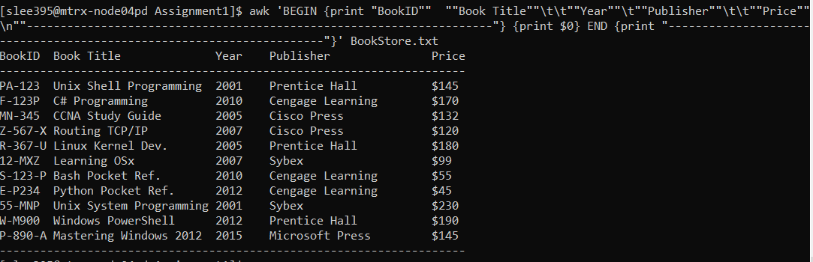

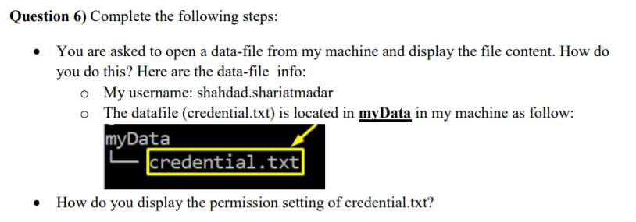

1. To display the file content which is belongs to the user, shadad.shariatmadar, I use the ‘cat ~shadad.shariatmadar/myData/credential.txt’ to access the file content

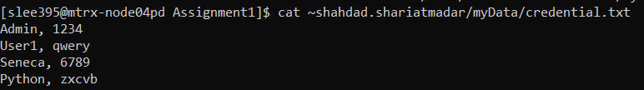

1. To display the permission setting of credential.txt, I used ‘ls -l’ command

