**UNX510 – Assignment2**

**Sanghyuk Lee(129405171)**

1. **When user typed non-valid directory or more than two arguments**

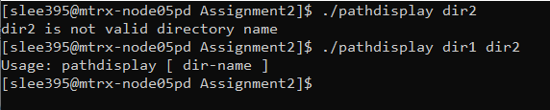

1. **When user typed no argument**

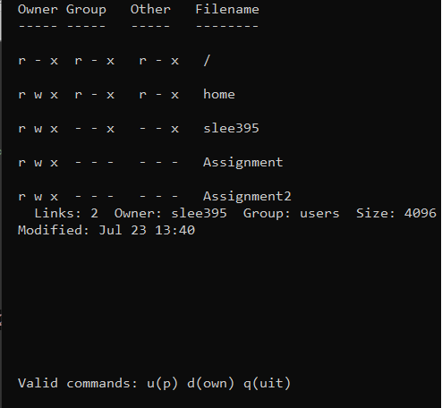

1. **Enter ./pathdisplay ~unx510/sample.dir1/testdir1**

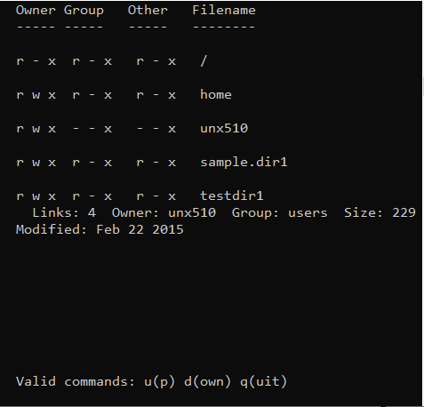

1. **Hitting d and x had no effect. Hitting u (with no Enter) produced the following:**

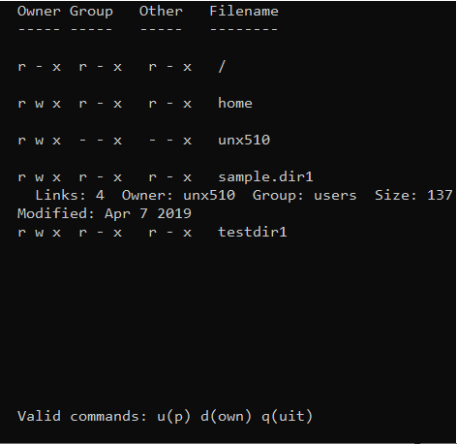

1. **Hitting u again produced the following:**

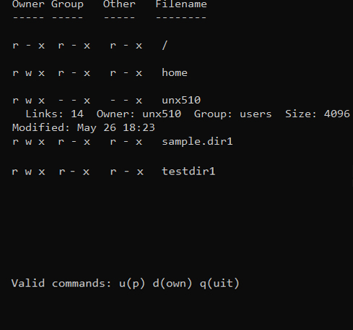

1. **Hitting u again produced the following:**

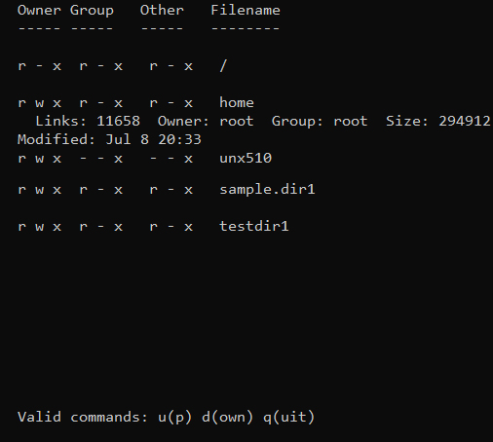

1. **Hitting u again produced the following:**

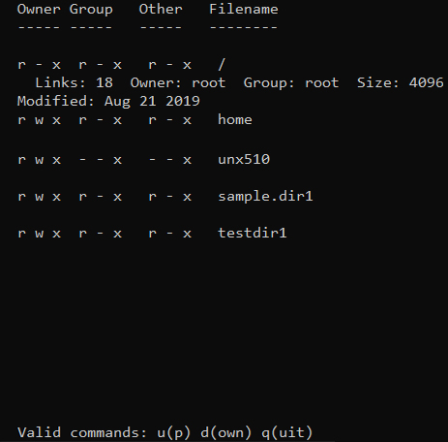

1. **Hitting u again had no effect. Hitting d four (or more) times produced the following:**



1. **Hitting q produced the following. Note that the prompt is displayed after the bottom line of the pathdisplay display:**

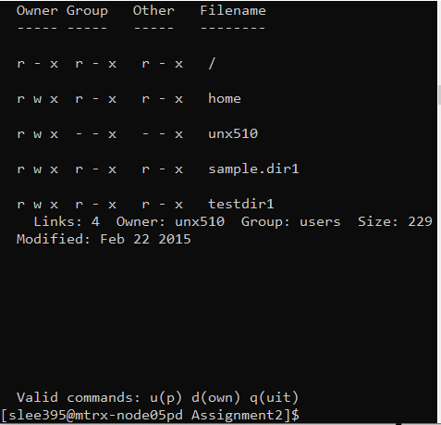

1. **Increasing the screen size 32 rows by 96 columns, then entering cd unx510/sample.dir1/testdir1 followed by ./pathdisplay(I typed ~/Assignment/Assignment2/pathdisplay where the file is located in) produced the following:**

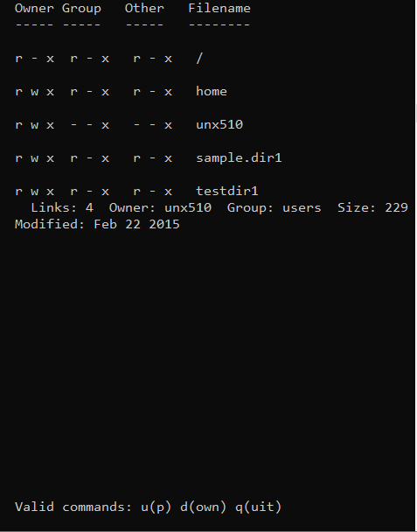

1. **Hitting q produced the following. Note that the prompt is still displayed after the bottom line of the pathdisplay display:**

