**UNX510 – Assignment3**

**Sanghyuk Lee(129405171)**

1. Testing valid arguments

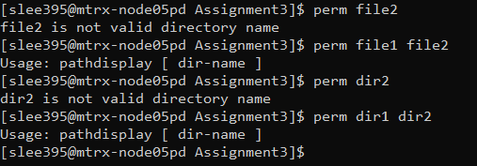

1. Testing script with long directory name

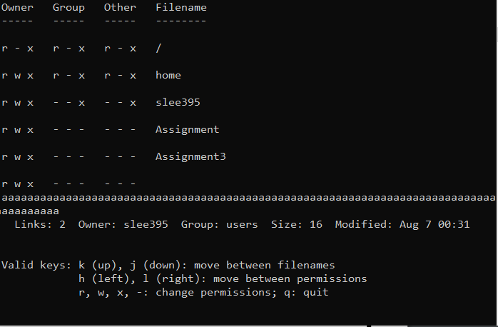

1. Hitting j and x had no effect. Hitting k twice (with no ) produced the following:

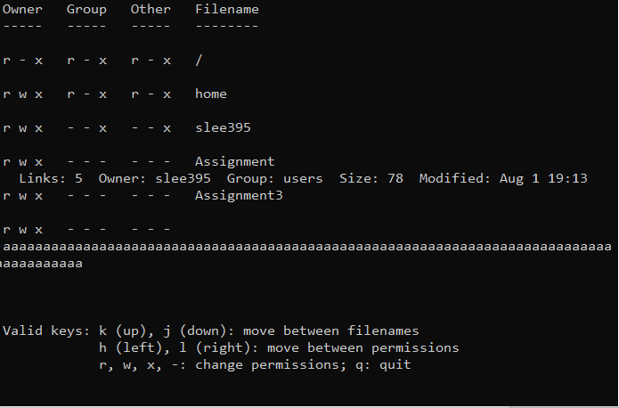

1. Hitting l had no effect. Hitting h five times produced the following:

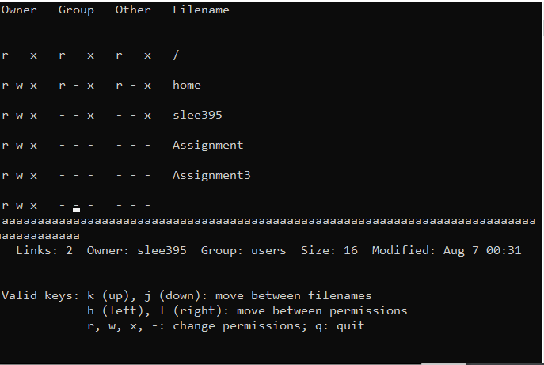

1. Hitting x had no effect. Hitting w produced the following:

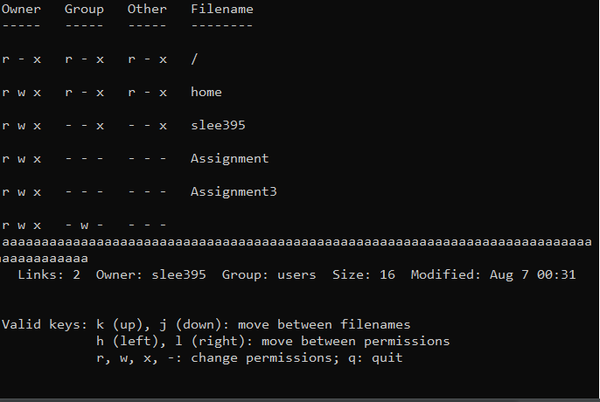

1. Hitting k four times produced the following:

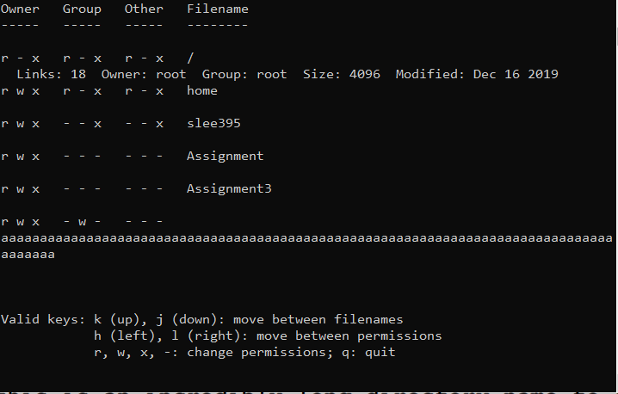

1. Hitting w and k had no effect. After you move to the permission content and you type ‘-‘ then it will remove that permission of that part. So In my case, It removes the ‘w’ permission and following is the output:

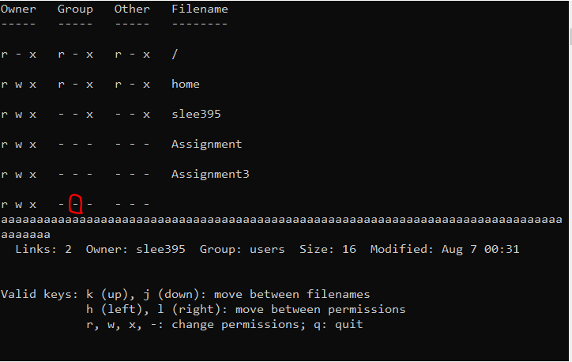

1. Hitting h until the start of the line produced the following:

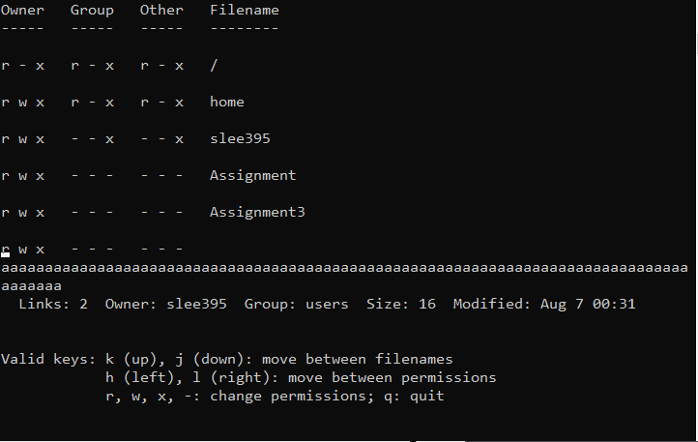

1. Hitting the keys hhhrkhh- will move to permission of r of Other and will move to the very top red circle one:

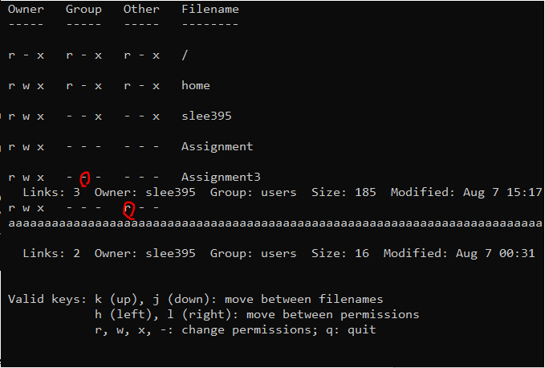

1. Hitting q produced the following. Note that the prompt is still displayed after the bottom line of the perm display:

