Question3

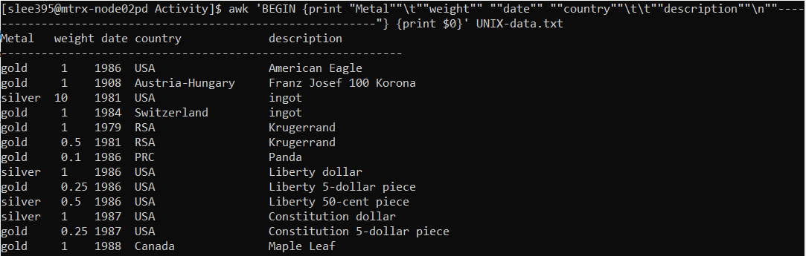

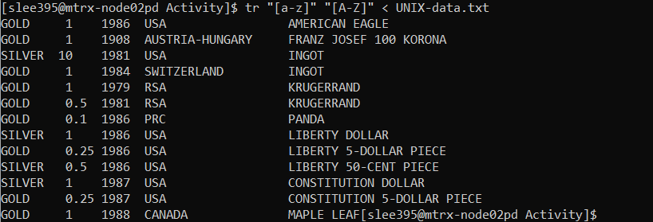



1. I created new file called SanghyukLee.txt and put the output of the sed command into SanghyukLee.txt

