Question4

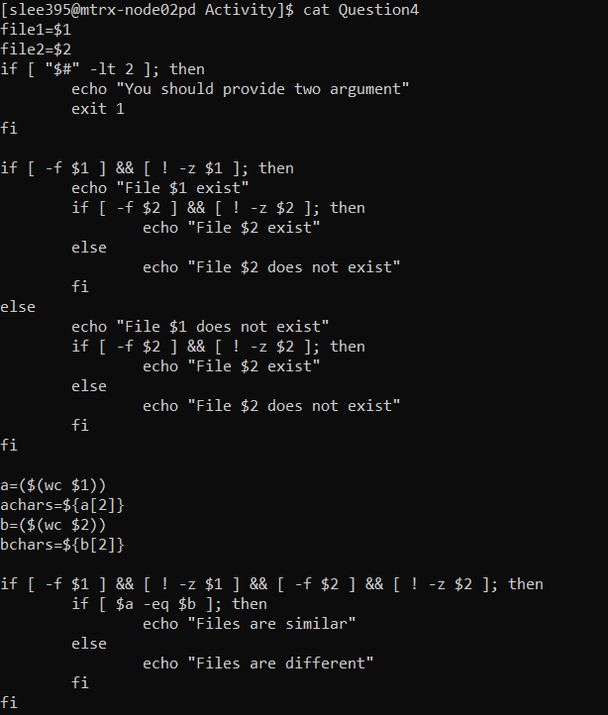

1. Check whether user provides the correct number of arguments. Display proper error message if requires.

The first ‘if statement’ uses a condition to check the number of arguments by using ‘$#’. And if the number of arguments is less than 2 then it would generate the error message saying “You should provide two arguments”

1. Check whether both filenames are exists. Display proper error message if requires.

The second “if statement” checks whether both filenames are exists or not.

Following picture is I put the files which are not existing on purpose to show what does it get:

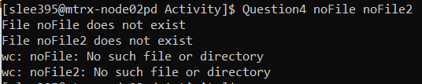

1. Calculate the number of bytes/characters in each file and if the number of characters in both files are the same, the script displays “Files are similar”, otherwise it displays “Files are different”

The third “if statement” defines if all the conditions are correct such as files are existing and two arguments are accepted, then it compares two arguments (files) and generate message. If the characters are the same then it would generate the “Files are similar”, otherwise it will generate “Files are different”

Following picture is cases of running the program to compare the files

1. When I put the files, which have same number of characters

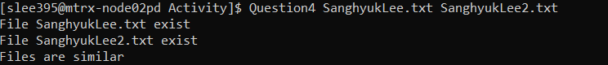

1. When I put the files, which have different number of characters

