Question7

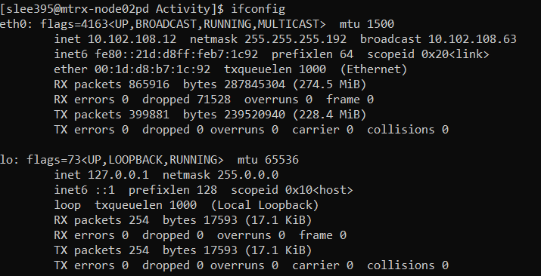

By using pipe and awk, get the inet6 address

