**Test**

**Sanghyuk Lee(129405171)**

**Question 1)**

Explain what does the following commands do:

head -7 file1 – It reads first 7 lines of file1

find / -name "tempfile" – lists the pathname of filename ‘tempfile’, from the root directory and any subdirectories.

chmod 644 file1 – It gives the permission of read and write to User, read only to Group and Other. So, when you do ls -l command to file1, what you can see is rw-r—r--

grep sky$ testfile – It displays the line ends in the string ‘sky’ from the filename ‘testfile’

mkdir  THIS IS A ULi_Example – It makes 4 directory(THIS, IS, A, Uli_Example) as there is a space between each argument.

**Question 2)** You execute the following command and receive the output:

**$ awk '{ print }' cars**  
plym    fury    77     73     2500  
chevy   nova    79     60     3000  
ford    mustang 65     45     17000  
volvo   gl      78     102    9850  
ford    ltd     83     15     10500  
Chevy   nova    80     50     3500  
fiat    600     65     115    450  
honda   accord  81     30     6000  
ford    thundbd 84     10     17000  
toyota  tercel  82     180    750  
chevy   impala  65     85     1550  
ford    bronco  83     25     9525

Answer the followings:

1. Modify the command to display all cars_info which their price (last column) is greater than 8000.
2. awk ‘$5 > 8000 {print}’ cars
3. Modify the command to display car_name and model (1st and 2nd column)  for those cars which their name starts with "f".
4. awk ‘$1 ~ /^f/ {print $1,$2}’ cars

**Question 3)**Based on your experience of working with SED and AWK, explain one main advantages of each command. Explain your answer by a practical use (real world scenario) of using these commands.

1. Based on my personal experience of using the command SED and AWK, SED is much more readable rather than AWK because SED command has the option such as p, d, q, g and all of them are able to guess what does it means as they are derived the first letter of the word (print, delete, quit, global). However, as the AWK is similar to C language and as I have learnt C language for a year in Seneca, I could get used to it much faster than using SED command. Also, I personally have used SED command to find the **rows** but AWK command is used for **columns**.

So I can say SED is better when you find in rows and AWK is better in columns.

**Question 4)**Consider the following scrip is saved in a filename:Q2.sh

value=55  
if test $((value % 2)) –eq 0  
then      
  echo "yap"   
else  
  echo "nop"

fi

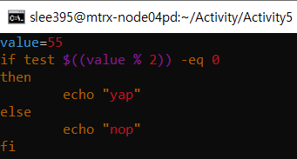

Answer the followings:

1. What does the output of the program?
2. nop



1. How does this program work? Explain each line.
2. Assign the 55 to variable ‘value’
3. Check the condition if the remainder of value is equal to 0 or not in the ‘if’ statement
4. Then If the remainder is 0 then the output is ‘yap’
5. If the remainder is not 0 then the output is ‘nop’
6. And close the if loop statement with ‘fi’
7. To make this script more dynamic, instead of hardcode the value of 55, modify this program to prompt/ask user to enter a "value".

Modified to accept the user input by using echo and read command

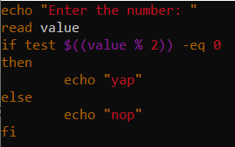

Accept the user value (55, 20) and shows the output based on the function.

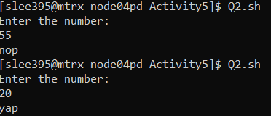

**Question 5)**Create a file contains three phone no and person name as follow

Jack, 4161112222

Sara, 4163334444

Mick, 6471112222

Try to assign this file to a "file descriptor" and display the file content using the declared file descriptor.

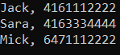

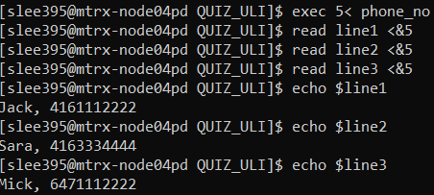

By using the file descriptor I set that the input would be redirected from file descriptor 5 and it reads from filename ‘phone_no’ and use the variable line1,2 and 3 to redirect the output of read command from ‘phone_no’. At the end, I used echo command to see the value assigned of the variables.