9. Image to text
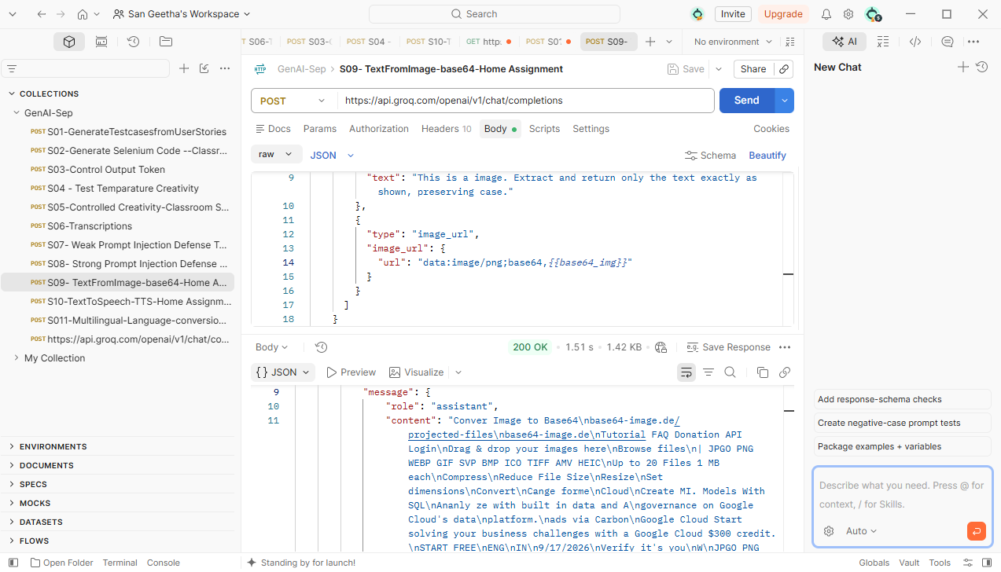
"role": "assistant", "content": "Convert Image to Base64\n\nbase64-image.de/projected-files\nbase64-image.de\n\nTutorial | FAQ | Donation | API | Login\n\nDrag & drop your images here\nBrowse files\n\nSupported Formats:\nJPG | PNG | WEBP | GIF | SVG | BMP | ICO | TIFF | AVIF | HEIC\n\nUp to 20 files, 1 MB each\n\nCompress\nReduce File Size\n\nResize\nSet Dimensions\n\nConvert\nChange Format\n\nCloud\nCreate ML Models with SQL\n\nAnalyze with built-in data and AI governance on Google Cloud's data platform.\n\nAds via Carbon\nGoogle Cloud: Start solving your business challenges with a Google Cloud $300 credit.\nSTART FREE\n\nENG | IN\n\n9/17/2026\n\nVerify it's you\n\nJPG | PNG | WEBP | GIF | SVG | BMP | ICO | TIFF | AVIF | HEIC\n\nUp to 20 files, 1 MB each\n\nCompress\nReduce File Size\n\nResize\nSet Dimensions\n\nConvert\nChange Format\n\nCloud\nCreate ML Models with SQL\n\nAnalyze with built-in data and AI governance on Google Cloud's data platform.\n\nAds via Carbon\nGoogle Cloud: Start solving your business challenges with a Google Cloud $300 credit.\nSTART FREE\n\nENG | IN\n\n9/17/2026\n\nHot..."
10.Text to Speech
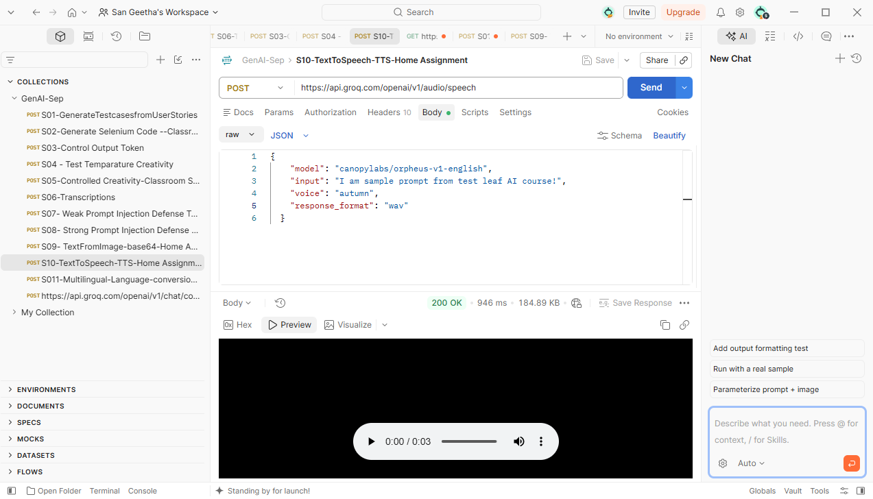
11. Multi lingual language conversion
