- Showing the data as a column chart (simple) Using HTML5 and D3.js

<!DOCTYPE html>
<html lang="en">
<head>
<meta charset="UTF-8" />
<title>D3.js Column Chart</title>
<script src="https://d3js.org/d3.v7.min.js"></script>
<style>
.bar {
fill: steelblue;
}
.axis-label {
font-size: 12px;
font-family: sans-serif;
}
</style>
</head>
<body>
<h3>Sales Data (D3.js)</h3>
<svg width="270" height="175"></svg>
<script>
const data = [
{ month: "Jan", value: 30 },
{ month: "Feb", value: 45 },
{ month: "Mar", value: 28 },
{ month: "Apr", value: 60 }
];
const svg = d3.select("svg");
const margin = {top: 20, right: 30, bottom: 40, left: 40};
const width = +svg.attr("width") - margin.left - margin.right;
const height = +svg.attr("height") - margin.top - margin.bottom;
const chart = svg.append("g")
.attr("transform", `translate(${margin.left},${margin.top})`);

// Scales
const x = d3.scaleBand()
.domain(data.map(d => d.month))
.range([0, width])
.padding(0.2);
const y = d3.scaleLinear()
.domain([0, d3.max(data, d => d.value)])
.nice()
.range([height, 0]);

// X Axis
chart.append("g")
.attr("transform", `translate(0,${height})`)
.call(d3.axisBottom(x));
// Y Axis
chart.append("g")
.call(d3.axisLeft(y));
// Bars
chart.selectAll(".bar")
.data(data)
.join("rect")
.attr("class", "bar")
.attr("x", d => x(d.month))
.attr("y", d => y(d.value))
.attr("height", d => height - y(d.value))
.attr("width", x.bandwidth());
// Title
svg.append("text")
.attr("x", width / 2 + margin.left)
.attr("y", margin.top / 2)
.attr("text-anchor", "middle")
.style("font-weight", "bold")
.text("Sales Data");
</script>
</body>
</html>

OUTPUT
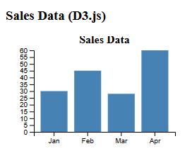

- Showing the data as a column chart (simple) Using HTML5 and Canvas.js

<!DOCTYPE html>
<html>
<head>
<title>Simple Column Chart</title>
<script src="https://canvasjs.com/assets/script/canvasjs.min.js"></script>
</head>
<body>

<div id="chartContainer" style="height: 270px; width: 25%;"></div>

<script>
window.onload = function () {

var chart = new CanvasJS.Chart("chartContainer", {
title:{ text:"Sales Data (canvasjs)" },
data: [{
type: "column",
dataPoints: [
{ label: "Jan", y: 30 },
{ label: "Feb", y: 45 },
{ label: "Mar", y: 28 },
{ label: "Apr", y: 60 }
]
}]
});

chart.render();
}
</script>

</body>
</html>
OUTPUT
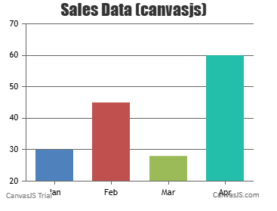

(B) Showing the data as a stacked column chart Using HTML5 and D3.js

<!DOCTYPE html>
<html>
<head>
<title>Stacked Column Chart with Axes</title>
<script src="https://d3js.org/d3.v7.min.js"></script>
</head>
<body>

<h2>Stacked Column Chart(D3)</h2>

<svg width="270" height="170"></svg>

<script>
// Sample data
var data = [
{month:"Jan", A:30, B:20},
{month:"Feb", A:40, B:25},
{month:"Mar", A:35, B:30},
{month:"Apr", A:20, B:15},
{month:"May", A:50, B:30}
];

var svg = d3.select("svg"),
margin = {top: 20, right: 20, bottom: 40, left: 40},
width = +svg.attr("width") - margin.left - margin.right,
height = +svg.attr("height") - margin.top - margin.bottom;

var g = svg.append("g").attr("transform",`translate(${margin.left},${margin.top})`);

// Stack the data
var stack = d3.stack().keys(["A","B"]);
var series = stack(data);
// X scale
var x = d3.scaleBand()
.domain(data.map(d => d.month))
.range([0, width])
.padding(0.2);
// Y scale
var y = d3.scaleLinear()
.domain([0, d3.max(data, d => d.A + d.B)])
.nice()
.range([height, 0]);

// Color scale
var color = d3.scaleOrdinal()
.domain(["A","B"])
.range(["steelblue","orange"]);
// Draw stacked bars
g.selectAll("g.series")
.data(series)
.enter().append("g")
.attr("fill", d => color(d.key))
.selectAll("rect")
.data(d => d)
.enter().append("rect")
.attr("x", d => x(d.data.month))
.attr("y", d => y(d[1]))
.attr("height", d => y(d[0]) - y(d[1]))
.attr("width", x.bandwidth());
// X Axis
g.append("g")
.attr("transform", `translate(0,${height})`)
.call(d3.axisBottom(x));
// Y Axis
g.append("g")
.call(d3.axisLeft(y));
</script>
</body>
</html>
OUTPUT
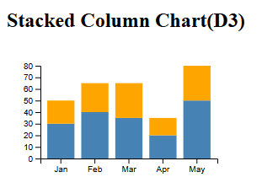
- Showing the data as a stacked column chart Using HTML5 and Canvas.js

<!DOCTYPE html>
<html>
<head>
<title>Stacked Column Chart - CanvasJS Beginner Friendly</title>
<script src="https://canvasjs.com/assets/script/canvasjs.min.js"></script>
</head>
<body>

<h2>Stacked Column Chart using CanvasJS</h2>
<div id="chartContainer" style="height: 300px; width: 400px;"></div>
<script>
window.onload = function() {
var chart = new CanvasJS.Chart("chartContainer", {
animationEnabled: true,
title:{
text: "Monthly Sales of Products"
},
axisY:{
title: "Sales"
},
data: [
{
type: "stackedColumn",
name: "Product A",
showInLegend: true,
dataPoints: [
{ label: "Jan", y: 30 },
{ label: "Feb", y: 40 },
{ label: "Mar", y: 35 },
{ label: "Apr", y: 20 },
{ label: "May", y: 50 }
]
},
{
type: "stackedColumn",
name: "Product B",
showInLegend: true,
dataPoints: [
{ label: "Jan", y: 20 },
{ label: "Feb", y: 25 },
{ label: "Mar", y: 30 },
{ label: "Apr", y: 15 },
{ label: "May", y: 30 }
]
}
]
});

chart.render();
}
</script>
</body>
</html>
OUTPUT
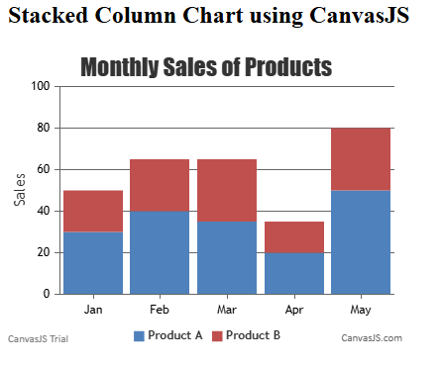
- Showing the Data as a column chart for four age group m Using HTML5 and D3.js

<!DOCTYPE html>
<html>
<head>
<title>Column Chart for Product Categories - D3.js</title>
<script src="https://d3js.org/d3.v7.min.js"></script>
</head>
<body>
<h2>Column Chart for Product Categories Using D3.js</h2>
<svg width="450" height="300"></svg>
<script>
// Sample data for product categories
var data = [
{category: "Electronics", count: 120},
{category: "Clothing", count: 90},
{category: "Groceries", count: 70},
{category: "Books", count: 50}
];
var svg = d3.select("svg"),
margin = {top: 20, right: 20, bottom: 40, left: 40},
width = +svg.attr("width") - margin.left - margin.right,
height = +svg.attr("height") - margin.top - margin.bottom;
var g = svg.append("g").attr("transform", `translate(${margin.left},${margin.top})`);
// X scale - categories
var x = d3.scaleBand()
.domain(data.map(d => d.category))
.range([0, width])
.padding(0.2);
// Y scale - counts
var y = d3.scaleLinear()
.domain([0, d3.max(data, d => d.count)])
.nice()
.range([height, 0]);
// Draw columns
g.selectAll("rect")
.data(data)
.enter()
.append("rect")
.attr("x", d => x(d.category))
.attr("y", d => y(d.count))
.attr("width", x.bandwidth())
.attr("height", d => height - y(d.count))
.attr("fill", "steelblue");
// X Axis
g.append("g")
.attr("transform", `translate(0,${height})`)
.call(d3.axisBottom(x));
// Y Axis
g.append("g")
.call(d3.axisLeft(y));
</script>
</body>
</html>
OUTPUT
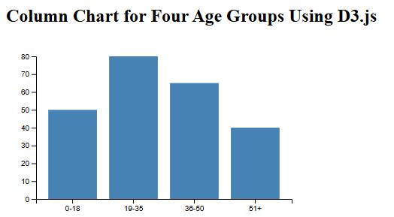
(C) Showing the Data as a column chart for four age group m Using HTML5 and Canvas.js

<!DOCTYPE html>
<html>
<head>
<title>Column Chart for Age Groups - CanvasJS</title>
<script src="https://canvasjs.com/assets/script/canvasjs.min.js"></script>
</head>
<body>
<h2>Column Chart for Four Age Groups using CanvasJS</h2>
<div id="chartContainer" style="height: 250px; width: 400px;"></div>
<script>
window.onload = function () {
var chart = new CanvasJS.Chart("chartContainer", {
animationEnabled: true,
title: {
text: "Population by Age Group"
},
axisY: {
title: "Number of People"
},
axisX: {
title: "Age Groups"
},
data: [{
type: "column",
dataPoints: [
{ label: "0-18", y: 50 },
{ label: "19-35", y: 80 },
{ label: "36-50", y: 65 },
{ label: "51+", y: 40 }
]
}]
});

chart.render();
}
</script>
</body>
</html>
OUTPUT
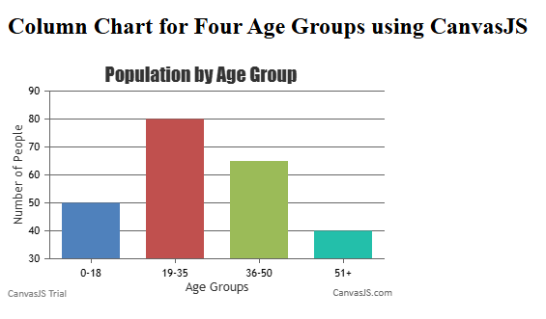
- Showing the data as a Line chart (single, fewer and multiple lines) Using HTML5 and D3.js

<!DOCTYPE html>
<html>
<head>
<title>Line Chart - D3.js Beginner Friendly</title>
<script src="https://d3js.org/d3.v7.min.js"></script>
</head>
<body>

<h3>Line Chart(Single & Multiple Lines Using D3)</h3>
<svg width="400" height="250"></svg>
<script>
// Single line data (Sales per month)
var singleLineData = [
{month: "Jan", sales: 30},
{month: "Feb", sales: 50},
{month: "Mar", sales: 40},
{month: "Apr", sales: 60},
{month: "May", sales: 80}
];

// Multiple line data (Sales for two products)
var multiLineData = [
{month: "Jan", A: 30, B: 20},
{month: "Feb", A: 50, B: 35},
{month: "Mar", A: 40, B: 30},
{month: "Apr", A: 60, B: 45},
{month: "May", A: 80, B: 55}
];

var svg = d3.select("svg"),
margin = {top: 20, right: 80, bottom: 40, left: 50},
width = +svg.attr("width") - margin.left - margin.right,
height = +svg.attr("height") - margin.top - margin.bottom;

var g = svg.append("g").attr("transform", `translate(${margin.left},${margin.top})`);

// X scale (months)
var x = d3.scalePoint()
.domain(singleLineData.map(d => d.month))
.range([0, width]);

// Y scale (values)
var y = d3.scaleLinear()
.domain([0, d3.max(multiLineData, d => Math.max(d.A, d.B))])
.nice()
.range([height, 0]);

// X and Y axes
g.append("g")
.attr("transform", `translate(0,${height})`)
.call(d3.axisBottom(x));

g.append("g")
.call(d3.axisLeft(y));

// Line generator
var line = d3.line()
.x(d => x(d.month))
.y(d => y(d.sales));

// ------------------- Single Line -------------------
g.append("path")
.datum(singleLineData)
.attr("fill", "none")
.attr("stroke", "steelblue")
.attr("stroke-width", 2)
.attr("d", line);

// ------------------- Multiple Lines -------------------
var lineA = d3.line()
.x(d => x(d.month))
.y(d => y(d.A));

var lineB = d3.line()
.x(d => x(d.month))
.y(d => y(d.B));

g.append("path")
.datum(multiLineData)
.attr("fill", "none")
.attr("stroke", "green")
.attr("stroke-width", 2)
.attr("d", lineA);

g.append("path")
.datum(multiLineData)
.attr("fill", "none")
.attr("stroke", "orange")
.attr("stroke-width", 2)
.attr("d", lineB);

</script>
</body>
</html>
OUTPUT
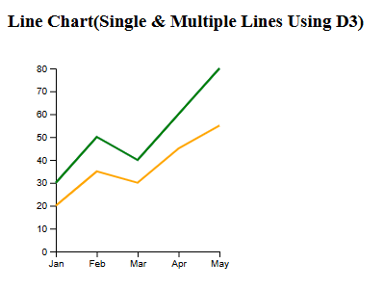
(D)Showing the data as a Line chart (single, fewer and multiple lines) Using HTML5 and Canvas.js
<!DOCTYPE html>
<html>
<head>
<title>Line Chart - CanvasJS Beginner Friendly</title>
<script src="https://canvasjs.com/assets/script/canvasjs.min.js"></script>
</head>
<body>

<h2>Line Chart using CanvasJS</h2>

<div id="chartContainer" style="height: 200px; width: 300px;"></div>

<script>
window.onload = function () {

var chart = new CanvasJS.Chart("chartContainer", {
animationEnabled: true,
title:{
text: "Monthly Sales"
},
axisY:{
title: "Sales"
},
axisX:{
title: "Month"
},
data: [
// ------------------- Single Line -------------------
{
type: "line",
name: "Total Sales",
showInLegend: true,
dataPoints: [
{ label: "Jan", y: 30 },
{ label: "Feb", y: 50 },
{ label: "Mar", y: 40 },
{ label: "Apr", y: 60 },
{ label: "May", y: 80 }
]
},
// ------------------- Multiple Lines -------------------
{
type: "line",
name: "Product A",
showInLegend: true,
dataPoints: [
{ label: "Jan", y: 30 },
{ label: "Feb", y: 50 },
{ label: "Mar", y: 40 },
{ label: "Apr", y: 60 },
{ label: "May", y: 80 }
]
},
{
type: "line",
name: "Product B",
showInLegend: true,
dataPoints: [
{ label: "Jan", y: 20 },
{ label: "Feb", y: 35 },
{ label: "Mar", y: 30 },
{ label: "Apr", y: 45 },
{ label: "May", y: 55 }
]
}
]
});

chart.render();

}
</script>

</body>
</html>

OUTPUT
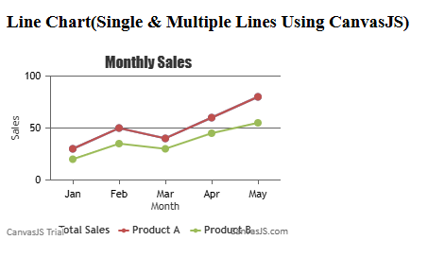

(E) Showing the data as a Pie Chart (single and multiple pie) m Using HTML5 and D3.js
<!DOCTYPE html>
<html>
<head>
<title>Pie Charts - Single & Multiple (D3.js Beginner)</title>
<script src="https://d3js.org/d3.v7.min.js"></script>
</head>
<body>

<h2>Single Pie Chart using D3.js</h2>
<svg id="singlePie" width="300" height="300"></svg>

<h2>Multiple Pie Charts using D3.js</h2>
<svg id="multiplePies" width="600" height="300"></svg>

<script>
// -------- Single Pie Chart Data --------
var singleData = [
{category: "Electronics", value: 40},
{category: "Clothing", value: 30},
{category: "Groceries", value: 20},
{category: "Books", value: 10}
];

// -------- Multiple Pie Charts Data --------
var multipleData = [
[
{category: "Product A", value: 25},
{category: "Product B", value: 35},
{category: "Product C", value: 20},
{category: "Product D", value: 20}
],
[
{category: "Service X", value: 50},
{category: "Service Y", value: 30},
{category: "Service Z", value: 20}
]
];

// -------- Single Pie Chart --------
var width = 300, height = 300, radius = Math.min(width, height)/2;
var color = d3.scaleOrdinal(d3.schemeSet2);

var svgSingle = d3.select("#singlePie")
.append("g")
.attr("transform", `translate(${width/2},${height/2})`);

var pie = d3.pie().value(d => d.value);
var arc = d3.arc().innerRadius(0).outerRadius(radius);

svgSingle.selectAll("path")
.data(pie(singleData))
.enter()
.append("path")
.attr("d", arc)
.attr("fill", d => color(d.data.category))
.attr("stroke", "white")
.style("stroke-width", "2px");

// Labels for single pie
svgSingle.selectAll("text")
.data(pie(singleData))
.enter()
.append("text")
.text(d => d.data.category)
.attr("transform", d => `translate(${arc.centroid(d)})`)
.attr("text-anchor", "middle")
.attr("font-size", "12px");

// -------- Multiple Pie Charts --------
var svgMulti = d3.select("#multiplePies");

multipleData.forEach(function(data, i){
var g = svgMulti.append("g")
.attr("transform", `translate(${150 + i*300}, ${height/2})`);

g.selectAll("path")
.data(pie(data))
.enter()
.append("path")
.attr("d", arc)
.attr("fill", d => color(d.data.category))
.attr("stroke", "white")
.style("stroke-width", "2px");

g.selectAll("text")
.data(pie(data))
.enter()
.append("text")
.text(d => d.data.category)
.attr("transform", d => `translate(${arc.centroid(d)})`)
.attr("text-anchor", "middle")
.attr("font-size", "10px");
});
</script>

</body>
</html>
OUTPUT
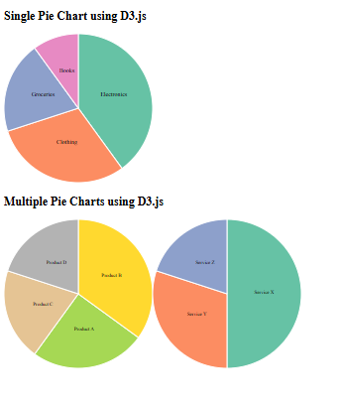

(E) Showing the data as a Pie Chart (single and multiple pie) Using HTML5 and Canvas.js
<!DOCTYPE html>
<html>
<head>
<title>Pie Charts - Single & Multiple (CanvasJS Beginner)</title>
<script src="https://canvasjs.com/assets/script/canvasjs.min.js"></script>
</head>
<body>

<h2>Single Pie Chart</h2>
<div id="singlePieChart" style="height: 300px; width: 450px;"></div>

<h2>Multiple Pie Charts</h2>
<div style="display:flex;">
<div id="multiPieChart1" style="height: 300px; width: 400px;"></div>
<div id="multiPieChart2" style="height: 300px; width: 400px;"></div>
</div>

<script>
window.onload = function () {

// -------- Single Pie Chart --------
var singlePie = new CanvasJS.Chart("singlePieChart", {
animationEnabled: true,
title:{
text: "Sales Distribution by Category"
},
data: [{
type: "pie",
showInLegend: true,
legendText: "{label}",
dataPoints: [
{ y: 40, label: "Electronics" },
{ y: 30, label: "Clothing" },
{ y: 20, label: "Groceries" },
{ y: 10, label: "Books" }
]
}]
});
singlePie.render();

// -------- Multiple Pie Charts --------

// First Pie
var multiPie1 = new CanvasJS.Chart("multiPieChart1", {
animationEnabled: true,
title:{
text: "Product Sales"
},
data: [{
type: "pie",
showInLegend: true,
legendText: "{label}",
dataPoints: [
{ y: 25, label: "Product A" },
{ y: 35, label: "Product B" },
{ y: 20, label: "Product C" },
{ y: 20, label: "Product D" }
]
}]
});
multiPie1.render();

// Second Pie
var multiPie2 = new CanvasJS.Chart("multiPieChart2", {
animationEnabled: true,
title:{
text: "Service Distribution"
},
data: [{
type: "pie",
showInLegend: true,
legendText: "{label}",
dataPoints: [
{ y: 50, label: "Service X" },
{ y: 30, label: "Service Y" },
{ y: 20, label: "Service Z" }
]
}]
});
multiPie2.render();

}
</script>
</body>
</html>
OUTPUT
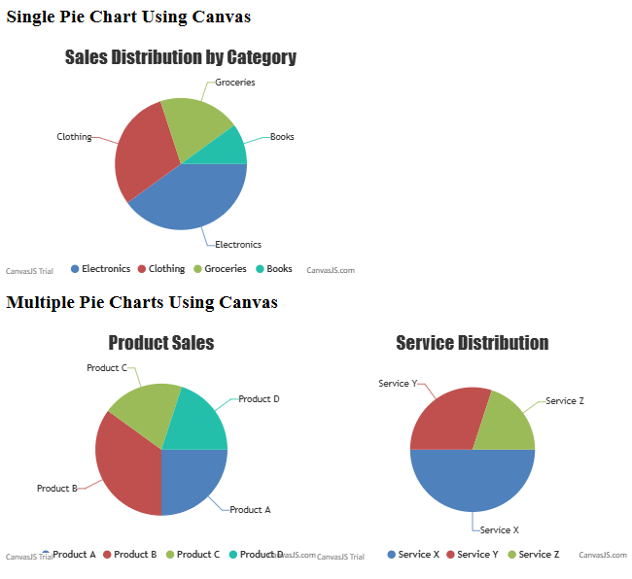

(F)Showing the data as a Bar Chart (Simple and multiple) Using HTML5 and D3.js

<!DOCTYPE html>
<html>
<head>
<title>Bar Charts - D3.js Beginner Friendly</title>
<script src="https://d3js.org/d3.v7.min.js"></script>
</head>
<body>

<h2>Simple Bar Chart Using D3</h2>
<svg id="simpleBar" width="300" height="150"></svg>

<h3>Multiple Bar Chart (Grouped Bars) Using D3</h3>
<svg id="multiBar" width="300" height="200"></svg>

<script>
// -------- Simple Bar Chart Data --------
var simpleData = [
{category: "Electronics", value: 40},
{category: "Clothing", value: 30},
{category: "Groceries", value: 20},
{category: "Books", value: 10}
];

// Simple Bar Chart
var svgSimple = d3.select("#simpleBar"),
margin = {top: 20, right: 20, bottom: 40, left: 40},
width = +svgSimple.attr("width") - margin.left - margin.right,
height = +svgSimple.attr("height") - margin.top - margin.bottom;

var gSimple = svgSimple.append("g").attr("transform", `translate(${margin.left},${margin.top})`);

var xSimple = d3.scaleBand()
.domain(simpleData.map(d => d.category))
.range([0, width])
.padding(0.2);

var ySimple = d3.scaleLinear()
.domain([0, d3.max(simpleData, d => d.value)])
.nice()
.range([height, 0]);

// Draw simple bars
gSimple.selectAll("rect")
.data(simpleData)
.enter()
.append("rect")
.attr("x", d => xSimple(d.category))
.attr("y", d => ySimple(d.value))
.attr("width", xSimple.bandwidth())
.attr("height", d => height - ySimple(d.value))
.attr("fill", "steelblue");

// Axes
gSimple.append("g")
.attr("transform", `translate(0,${height})`)
.call(d3.axisBottom(xSimple));

gSimple.append("g")
.call(d3.axisLeft(ySimple));

// -------- Multiple Bar Chart Data (Grouped Bars) --------
var multiData = [
{category: "Jan", A: 30, B: 20},
{category: "Feb", A: 50, B: 35},
{category: "Mar", A: 40, B: 30},
{category: "Apr", A: 60, B: 45}
];

var svgMulti = d3.select("#multiBar"),
gMulti = svgMulti.append("g").attr("transform", `translate(${margin.left},${margin.top})`),
widthMulti = +svgMulti.attr("width") - margin.left - margin.right,
heightMulti = +svgMulti.attr("height") - margin.top - margin.bottom;

var x0 = d3.scaleBand()
.domain(multiData.map(d => d.category))
.range([0, widthMulti])
.padding(0.2);

var x1 = d3.scaleBand()
.domain(["A","B"])
.range([0, x0.bandwidth()])
.padding(0.05);

var yMulti = d3.scaleLinear()
.domain([0, d3.max(multiData, d => Math.max(d.A, d.B))])
.nice()
.range([heightMulti, 0]);

var color = d3.scaleOrdinal()
.domain(["A","B"])
.range(["steelblue","orange"]);

// Draw grouped bars
gMulti.selectAll("g")
.data(multiData)
.enter()
.append("g")
.attr("transform", d => `translate(${x0(d.category)},0)`)
.selectAll("rect")
.data(d => ["A","B"].map(key => ({key: key, value: d[key]})))
.enter()
.append("rect")
.attr("x", d => x1(d.key))
.attr("y", d => yMulti(d.value))
.attr("width", x1.bandwidth())
.attr("height", d => heightMulti - yMulti(d.value))
.attr("fill", d => color(d.key));

// Axes
gMulti.append("g")
.attr("transform", `translate(0,${heightMulti})`)
.call(d3.axisBottom(x0));

gMulti.append("g")
.call(d3.axisLeft(yMulti));

</script>

</body>
</html>
OUTPUT
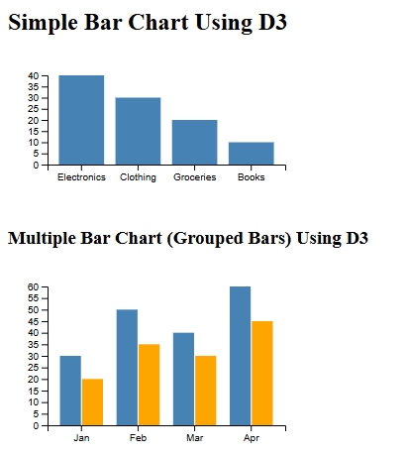
(F)Showing the data as a Bar Chart (Simple and multiple) Using HTML5 and Canvas.js
<!DOCTYPE html>
<html>
<head>
<title>Bar Chart - CanvasJS Beginner Friendly</title>
<script src="https://canvasjs.com/assets/script/canvasjs.min.js"></script>
</head>
<body>

<h3>Simple Bar Chart Using Canvas </h3>
<div id="simpleBarChart" style="height: 200px; width: 350px;"></div>

<h3>Multiple Bar Chart (Grouped Bars) Using Canvas </h3>
<div id="multiBarChart" style="height: 200px; width: 400px;"></div>

<script>
window.onload = function () {

// -------- Simple Bar Chart --------
var simpleBar = new CanvasJS.Chart("simpleBarChart", {
animationEnabled: true,
title:{
text: "Sales by Category"
},
axisY:{
title: "Sales"
},
axisX:{
title: "Category"
},
data: [{
type: "column",
dataPoints: [
{ label: "Electronics", y: 40 },
{ label: "Clothing", y: 30 },
{ label: "Groceries", y: 20 },
{ label: "Books", y: 10 }
]
}]
});
simpleBar.render();

// -------- Multiple Bar Chart (Grouped Bars) --------
var multiBar = new CanvasJS.Chart("multiBarChart", {
animationEnabled: true,
title:{
text: "Monthly Sales of Products"
},
axisY:{
title: "Sales"
},
axisX:{
title: "Month"
},
data: [
{
type: "column",
name: "Product A",
showInLegend: true,
dataPoints: [
{ label: "Jan", y: 30 },
{ label: "Feb", y: 50 },
{ label: "Mar", y: 40 },
{ label: "Apr", y: 60 }
]
},
{
type: "column",
name: "Product B",
showInLegend: true,
dataPoints: [
{ label: "Jan", y: 20 },
{ label: "Feb", y: 35 },
{ label: "Mar", y: 30 },
{ label: "Apr", y: 45 }
]
}
]
});
multiBar.render();

}
</script>

</body>
</html>
OUTPUT
