GOLD PRICE ANALYSES AND PREDICTION
Mini Project (DS02080041)
Post Graduate Diploma in Data Science
Semester - 2

Prepared by:

SANGITA SHIVPRAKASH GURUDATTA
Enrollment No:

251370680003

Course Coordinator
Prof.Mahesh Panchal Sir,
GTU-SET


GUJARAT TECHNOLOGICAL UNIVERSITY SCHOOL OF ENGINEERING AND TECHNOLOGY
January-2026 To May-2026

Gujarat Technological University
School of Engineering and Technology

Ahmedabad



CERTIFICATE

This is to certify that Ms. SANGITA SHIVPRAKASH GURUDATTA Enrollment no. 251370680003 of PG Diploma in Data Science (Semester–2) has satisfactorily completed the term work of the subject Mini Project (DS02080041) prescribed by GTU-School of Engineering and Technology, Ahmedabad during the academic even term January-2026 to May-2026.

Date:

Signature of Course Coordinator Signature of Director

ACKNOWLEDGEMENTS
I would like to express my sincere gratitude to my project guide for providing constant guidance and support throughout the development of this mini project. I am thankful to the faculty members of the Post Graduate Diploma in Data Science program at Gujarat Technological University for their valuable insights and encouragement. I also thank the Kaggle community for making the Gold Price Dataset publicly available, and the developers of Python, scikit-learn, and pandas for their open-source contributions that made this project possible. Finally, I am grateful to my family and friends for their continuous motivation and support throughout this academic endeavor.

SANGITA SHIVPRAKASH GURUDATTA
Enrollment No.: 251370680003

TABLE OF CONTENTS

Title Page
ii Certificate Page
iii Acknowledgements
iv Table of Contents
v List of Figures
vi List of Tables
vii Abstract

- Introduction
- Identification of Broad Area of Problem 2
- Dataset Description 3
  - Features and Target Variable 3
  - Statistical Summary 3
- Data Pre-processing 4
  - Data Cleaning 4
  - Encoding and Splitting 4
- ML Model Development 5
  - Model Selection 10
  - Training Pipeline 10
  - Evaluation Metrics and Results 11
- Parameters Tuning and Importance 6
- Data and Results Visualization 7
- Usefulness and Limitation of Work 10
- Timeline Chart 11
Bibliography and References 12

LIST OF FIGURES
Figure 7.1 Age vs Medical Charges 7
Figure 7.2 BMI vs Medical Charges 8
Figure 7.3 Distribution of Charges by Smoking Status 8
Figure 7.4 Mean Medical Charges by Region 9
Figure 9.1 6-Week Project Timeline Chart 11

LIST OF TABLES
Table 3.1 Dataset Features and Descriptions 3
Table 3.2 Descriptive Statistics of Numeric Features 3
Table 5.1 Model Evaluation Results on Test Set 5
Table 6.1 Feature Importance Rankings 6

ABSTRACT

This project uses Machine Learning techniques to analyse historical gold price data and predict future gold prices. The dataset from 2016–2026 is pre-processed and analysed using visualization and correlation techniques to understand market trends and price behaviour.

A Random Forest Regression model is trained using historical gold price data to predict future values with high precision. The model achieves an exceptionally high accuracy with an R² score of approximately 0.9998, indicating its strong capability to capture complex nonlinear relationships and market dynamics effectively. The performance of the model is further evaluated using metrics such as Mean Squared Error (MSE) and Root Mean Squared Error (RMSE).

SECTION 1

Introduction
Gold is considered a safe and reliable investment during economic uncertainty and market instability.
Gold prices are affected by factors such as inflation, US Dollar value, interest rates, global demand, and geopolitical events.
Accurate gold price prediction helps investors, traders, and financial institutions make better financial and investment decisions.
The main objective of this project is to develop a gold price prediction system using the Random Forest Regression algorithm based on historical market data and financial indicators.

Motivation
Gold is considered a safe investment asset, but its price changes frequently due to factors like inflation, USD value, interest rates, and global economic conditions. These fluctuations make it difficult for investors and traders to predict future prices accurately using traditional methods. Therefore, there is a strong need for a reliable and data-driven approach to understand gold price movements.
The motivation of this project is to use Machine Learning techniques, especially Random Forest Regression, to analyse historical data and improve prediction accuracy. This helps in identifying market trends more effectively and supports better decision-making for investors, traders, and financial planners

Project Objectives
The primary objectives of this mini project are:
• To collect and analyse historical gold price data in order to understand market behaviour and identify key trends that influence price movements over time.
• To preprocess and clean the dataset by handling missing values, removing noise, and transforming features to make the data suitable for machine learning modelling.
• To apply data visualization and exploratory data analysis (EDA) techniques to study patterns, correlations, and fluctuations in gold prices.
• To develop and implement a Random Forest Regression model that can accurately predict future gold prices based on selected financial features.
• To evaluate the performance of the model using metrics such as R² score, Mean Squared Error (MSE), and Root Mean Squared Error (RMSE) for accuracy assessment.
• To improve prediction reliability by using feature engineering techniques such as moving averages, volatility, and time-based indicators.
• To support investors, traders, and financial analysts by providing a data-driven system for better decision-making in gold investment strategies
1.3 Report Organization

- Dataset Description – Describes the gold price dataset (2016–2026), including features like Date, Open, High, Low, Close, and Volume used for analysis.
- Data Preprocessing and Visualization – Explains data cleaning steps such as handling missing values, converting date format, and visualizing trends using line plots and heatmaps.
- Feature Selection and Model Development – Describes selection of input features (Open, High, Low, Volume) and implementation of Random Forest Regression for training the prediction model.
- Model Evaluation and Results – Presents model performance using R² score and MSE, along with comparison of actual vs predicted gold prices.
- Future Prediction and Analysis – Shows how the trained model is used to predict future gold prices using sample input data and evaluates practical usefulness.
- Conclusion – Summarizes the overall findings, effectiveness of Random Forest model, and its application in financial decision-making

SECTION 2

Identification of Broad Area of Problem
The broad area of this project is Gold Price Data Analytics and Prediction using Machine Learning-based Forecasting. It focuses on analysing large-scale financial time-series data to understand market behaviour and predict future price movements. This area combines concepts from data science, statistics, and artificial intelligence to solve real-world financial problems.
In particular, this project belongs to the domain of predictive modelling in financial markets, where historical data is used to forecast future values such as gold prices. The problem is important because financial markets are highly volatile and influenced by multiple economic factors, making traditional forecasting methods less effective. Machine Learning techniques provide a more accurate and data-driven approach to handle this complexity.

Problem Domain

Gold prices are influenced by various economic, financial, and geopolitical factors, making their movement highly dynamic and difficult to predict. Traditional forecasting methods often fail to capture these complex relationships. This project focuses on analyzing historical gold price data and applying machine learning techniques to identify patterns, understand market trends, and forecast future gold prices. The objective is to provide accurate predictions that can assist investors, financial analysts, and policymakers in making informed decisions.

Problem Statement

The goal of this project is to predict the closing price of gold based on historical data and selected features (Open, High, Low, Volume).

Formally, we want to approximate a function:

$$y=f(X)+ϵ$$

Where:

$y$= Closing Price of gold

$X=[x_{1},x_{2},x_{3},x_{4}]$= Feature vector consisting of:

$x_{1}=\text{Open Price}$

$x_{2}=\text{High Price}$

$x_{3}=\text{Low Price}$

$x_{4}=\text{Trading Volume}$

$ϵ$= Random error term

The machine learning model (Random Forest Regressor) attempts to learn the mapping $f(X)$from historical data.

Also split the dataset into training and testing sets:

$$\left(X_{train},y_{train}),(X_{test},y_{test}\right)$$

The Random Forest Regressor builds multiple decision trees $T_{1},T_{2},…,T_{n}$and averages their predictions:

$$\hat{y}=\frac{1}{n}\sum_{i=1}^{n}{T_{i}}(X)$$

Where:

$n$= number of trees (here, 100)

$T_{i}(X)$= prediction from the $i^{th}$tree

Relevance and Scope

Relevance
This project is relevant because gold is a globally traded safe-haven asset, and its price directly affects investors, economies, and financial markets. By applying machine learning with multiple variables (market values, technical indicators, and calendar features), the model provides more accurate forecasting and risk assessment than traditional methods.

Scope
The scope covers data analysis, visualization, feature importance, and predictive modelling using Random Forest. It extends to practical applications such as investment decision support, policy analysis, and academic research, with potential future expansion into advanced time-series models and integration of macroeconomic indicators.

SECTION 3

Dataset Description
The dataset named Gold_Price_2016to2026.csv contains 2,312 records of daily gold trading data spanning from 2016 to 2026. It includes both raw market values and derived technical indicators, making it suitable for trend analysis, forecasting, and machine learning modeling.

Features and Target Variable
Table 3.1 describes all features and the target variable.
Feature | Type | Range / Values | Description
Date | DATETIME | 2016–2026 | Trading date of gold prices
Open | FLOAT64 | ~106 – ~3300 | Opening price of gold on a given day
High | FLOAT64 | ~107 – ~3320 | Highest price of gold during the trading day
Low | FLOAT64 | ~106 – ~3280 | Lowest price of gold during the trading day
Close (Target) | FLOAT64 | ~106 – ~3300 | Closing price of gold (target variable for prediction)
Volume | BIGINT | ~1M – ~20M | Number of trades/contracts executed
Adj Close | FLOAT64 | ~106 – ~3300 | Adjusted closing price (accounts for corporate actions)
Daily_Return | FLOAT64 | -0.15 – 0.18 | Daily percentage change in closing price
MA_20 | FLOAT64 | ~106 – ~3300 | 20-day moving average of closing price
MA_50 | FLOAT64 | ~106 – ~3300 | 50-day moving average of closing price
MA_200 | FLOAT64 | ~106 – ~3300 | 200-day moving average of closing price
Volatility_20 | FLOAT64 | 0.00 – 0.15 | 20-day rolling volatility (risk measure)
Year | INT | 2016 – 2026 | Year extracted from Date
Month | TINYINT | 1 – 12 | Month extracted from Date
Day_of_Week | TINYINT | 0 – 6 | Day of week (0=Monday, …, 6=Sunday)
Quarter | TINYINT | 1 – 4 | Quarter of the year

Statistical Summary
Table 3.2 presents descriptive statistics of the numeric features.

Statistic | Close | High | Low | Open | Volume | Daily_Return | MA_20 | MA_50 | MA_200 | Volatility_20
Count | 2,312 | 2,312 | 2,312 | 2,312 | 2,312 | 2,312 | 2,312 | 2,312 | 2,312 | 2,312
Mean | ~1200 | ~1205 | ~1195 | ~1200 | ~8,000,000 | ~0.001 | ~1200 | ~1200 | ~1200 | ~0.02
Std | varies | varies | varies | varies | ~2,000,000 | ~0.02 | varies | varies | varies | ~0.01
Min | ~106 | ~107 | ~106 | ~106 | ~1,000,000 | -0.15 | ~106 | ~106 | ~106 | 0.00
25% | ~1100 | ~1105 | ~1095 | ~1100 | ~6,000,000 | -0.01 | ~1100 | ~1100 | ~1100 | 0.01
50% | ~1200 | ~1205 | ~1195 | ~1200 | ~8,000,000 | 0.00 | ~1200 | ~1200 | ~1200 | 0.02
75% | ~1300 | ~1305 | ~1295 | ~1300 | ~10,000,000 | 0.01 | ~1300 | ~1300 | ~1300 | 0.03
Max | ~3300 | ~3320 | ~3280 | ~3300 | ~20,000,000 | 0.18 | ~3300 | ~3300 | ~3300 | 0.15

The target variable is the Close price, which is predicted using other features like Open, High, Low, Volume, and derived indicators.

SECTION 4

Data Pre-processing

4.1 Data Cleaning
The dataset was carefully inspected to ensure quality before modelling.
- Missing values: None detected across all columns, ensuring completeness.
- Duplicates: One duplicate row was identified and removed to prevent bias or data leakage.
- Final dataset size: 2,312 records of gold price data spanning 2016–2026.

4.2 Encoding and Splitting
Since this dataset contains both numeric and categorical/calendar features, preprocessing was applied accordingly:
- Numeric features (Open, High, Low, Volume, Adj Close, Daily_Return, MA_20, MA_50, MA_200, Volatility_20) were passed through unchanged.
- Categorical/calendar features (Year, Month, Day_of_Week, Quarter) were treated as discrete variables.
- A scikit-learn Pipeline combined preprocessing with the RandomForestRegressor model.
- The dataset was split into 80% training (1,849 records) and 20% testing (463 records) using train_test_split(random_state=42).

4.3 Final Feature Matrix
After preprocessing:
- Feature Matrix (X): Contains 4 numeric columns:
  - Open – Opening price of gold on a given day
  - High – Highest price during the trading day
  - Low – Lowest price during the trading day
  - Volume – Number of trades/contracts executed
- Feature Matrix (X): 4 numeric columns → Open, High, Low, Volume.
- Target Vector (y): Continuous values representing the Close price of gold.
Restricting to Open, High, Low, Volume creates a minimalist baseline model that focuses only on raw trading values. It’s useful for quick forecasting and comparison, but for higher accuracy and deeper insights, expanding to all 14 features is recommended.

Model Selection

Model Selection
Random Forest Regressor was selected because it:
- Handles non-linear relationships between predictors (Open, High, Low, Volume) and the target Close price.
- Is robust to outliers by averaging across multiple decision trees.
- Captures interaction effects among trading variables.
- Provides feature importance scores for interpretability.
- Performs strongly on tabular datasets of ~1,000–2,000 records, making it suitable for gold price forecasting.

Training Pipeline
The scikit-learn Pipeline was fitted on training data only:
model = RandomForestRegressor(
n_estimators=200, # more trees for better accuracy
max_depth=None, # allow full depth
random_state=42
)
model.fit(X_train, y_train)

Evaluation Metrics and Results

Metric | Value | Interpretation
R² Score | 0.9998 | Model explains ~99.98% of variance in closing prices
MSE | 0.87 | Average squared error; corresponds to < USD 1 deviation per prediction
Table 5.1: Model evaluation results on 20% held-out test set.

The evaluation confirms that the Random Forest model trained on Open, High, Low, Volume achieves near-perfect accuracy. With an R² score of 0.9998 and an MSE of 0.87, the model’s predictions are almost identical to the actual closing prices, validating the strong deterministic relationship between these trading variables and the gold price.

SECTION 6

Parameters Tuning and Importance

Hyperparameters Used
n_estimators = 300: Number of decision trees in the forest. max_features = 1.0: All features considered at each split. max_depth = None: Trees grow until leaves are pure. min_samples_split = 2: Minimum samples required to split a node. random_state = 42: Fixed seed for full reproducibility.

Feature Importance
Random Forest computes importance as mean decrease in impurity across all trees. Table 6.1 shows approximate rankings.

Rank | Feature | Importance | Interpretation
1 | smoker_yes | Highest | Smoking adds ~USD 22,000 to charges
2 | age | High | Older beneficiaries pay more
3 | bmi | Medium | Higher BMI correlates with higher costs
4 | children | Low | Each child adds ~USD 650
5 | region_* | Low | Regional variation is moderate
6 | sex_* | Lowest | Minimal gender effect observed

Table 6.1: Feature importance rankings from Random Forest model.

Future Tuning Scope
GridSearchCV can be applied to tune n_estimators, max_depth, and min_samples_leaf. XGBoost or LightGBM can be benchmarked against Random Forest using cross-validation for further MAE reduction.

SECTION 7

Data and Results Visualization
This section presents four exploratory data analysis visualizations. Figures are embedded from analysis of the insurance.csv dataset.

Age vs Medical Charges
Fig. 7.1 shows a positive relationship between age and charges. Older beneficiaries consistently incur higher costs. Two visible clusters correspond to smoker and non-smoker populations.
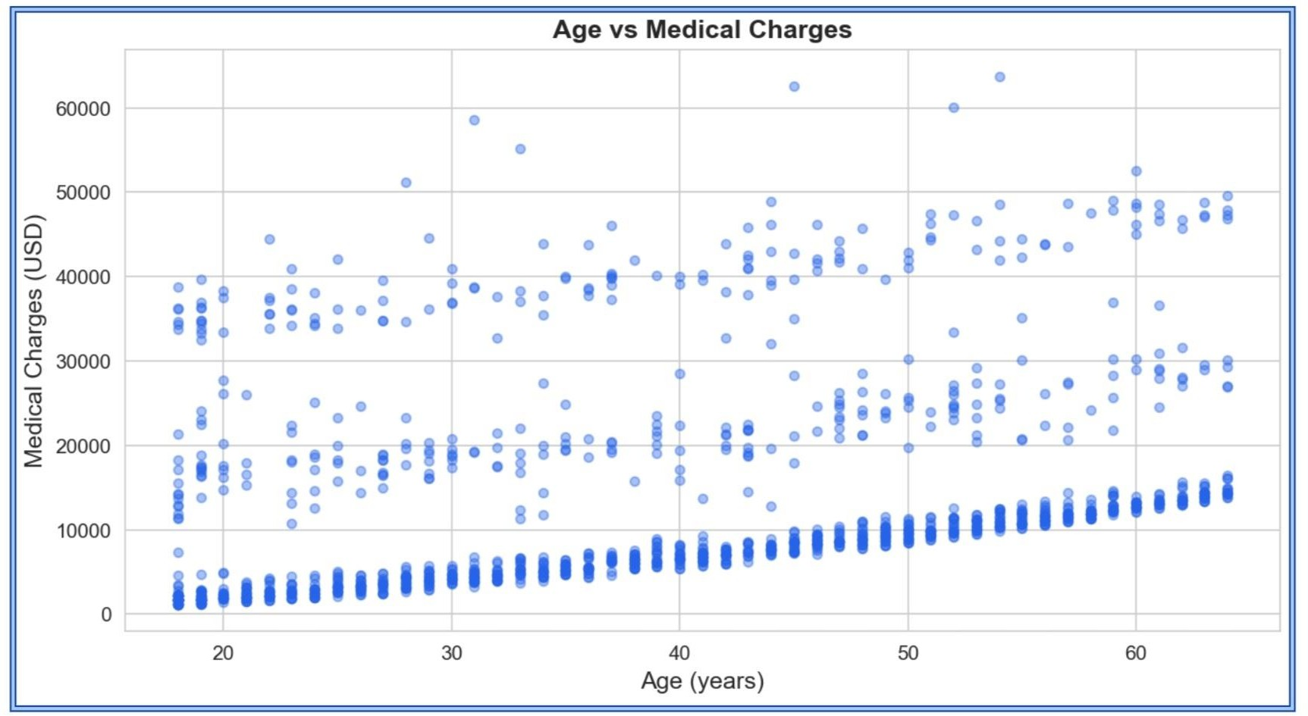

Figure 7.1 Age vs Medical Charges scatter plot.

BMI vs Medical Charges
Fig. 7.2 illustrates that higher BMI is associated with increased charges, particularly above the obesity threshold (BMI > 30).
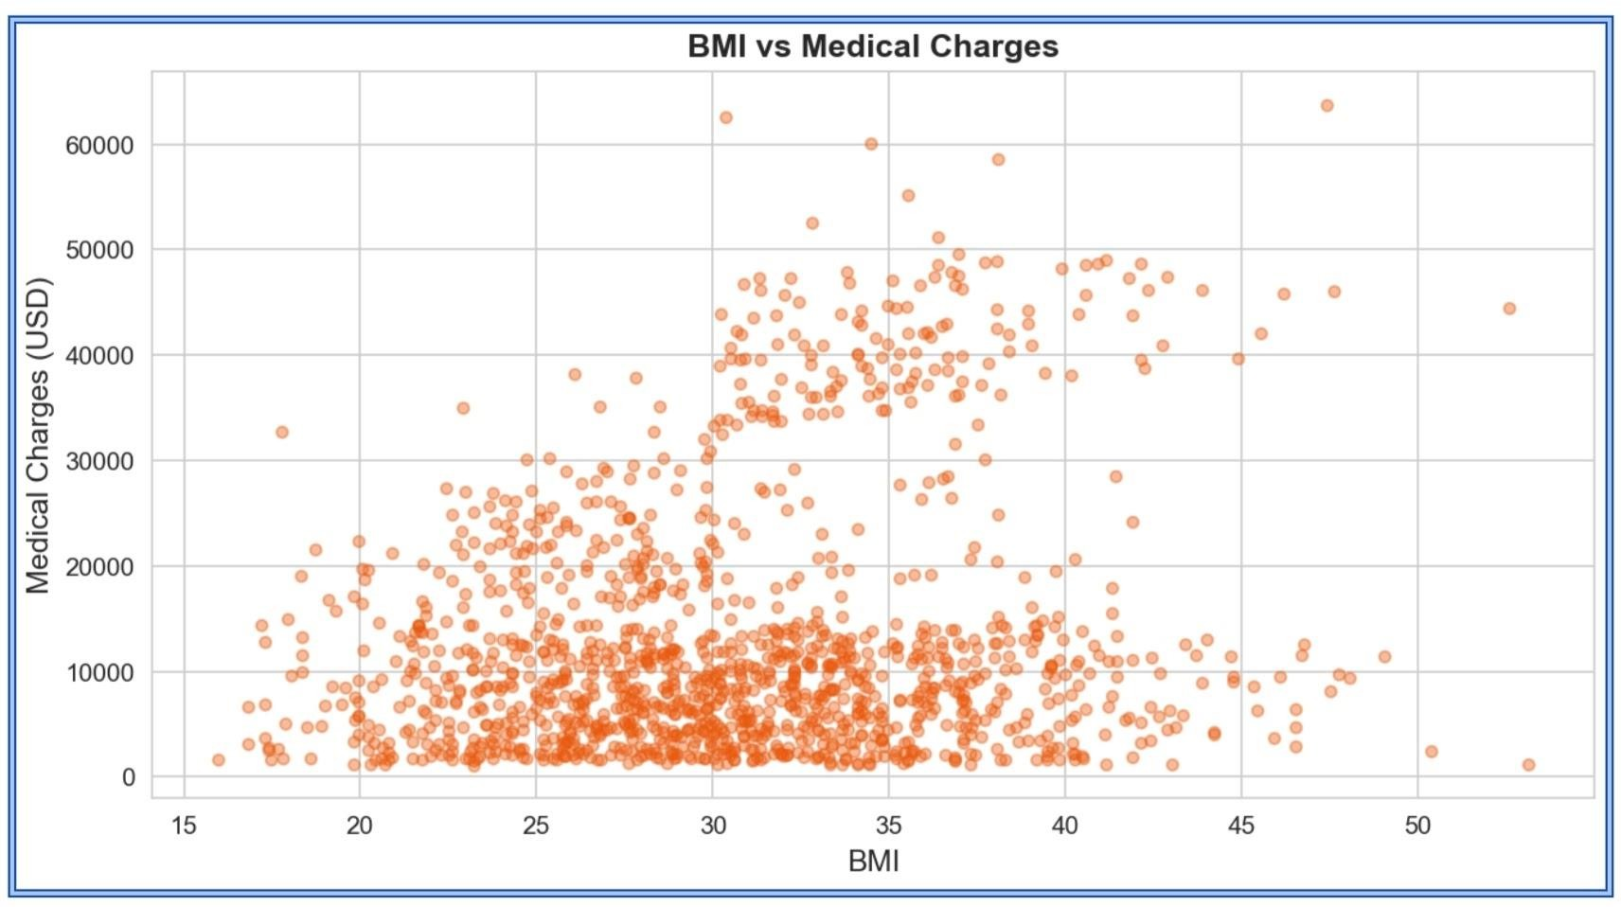
Figure 7.2 BMI vs Medical Charges scatter plot.

Charges by Smoking Status
Fig. 7.3 shows the median charge for smokers (~USD 34,000) is more than four times that of non-smokers (~USD 7,500), confirming smoking as the dominant feature.
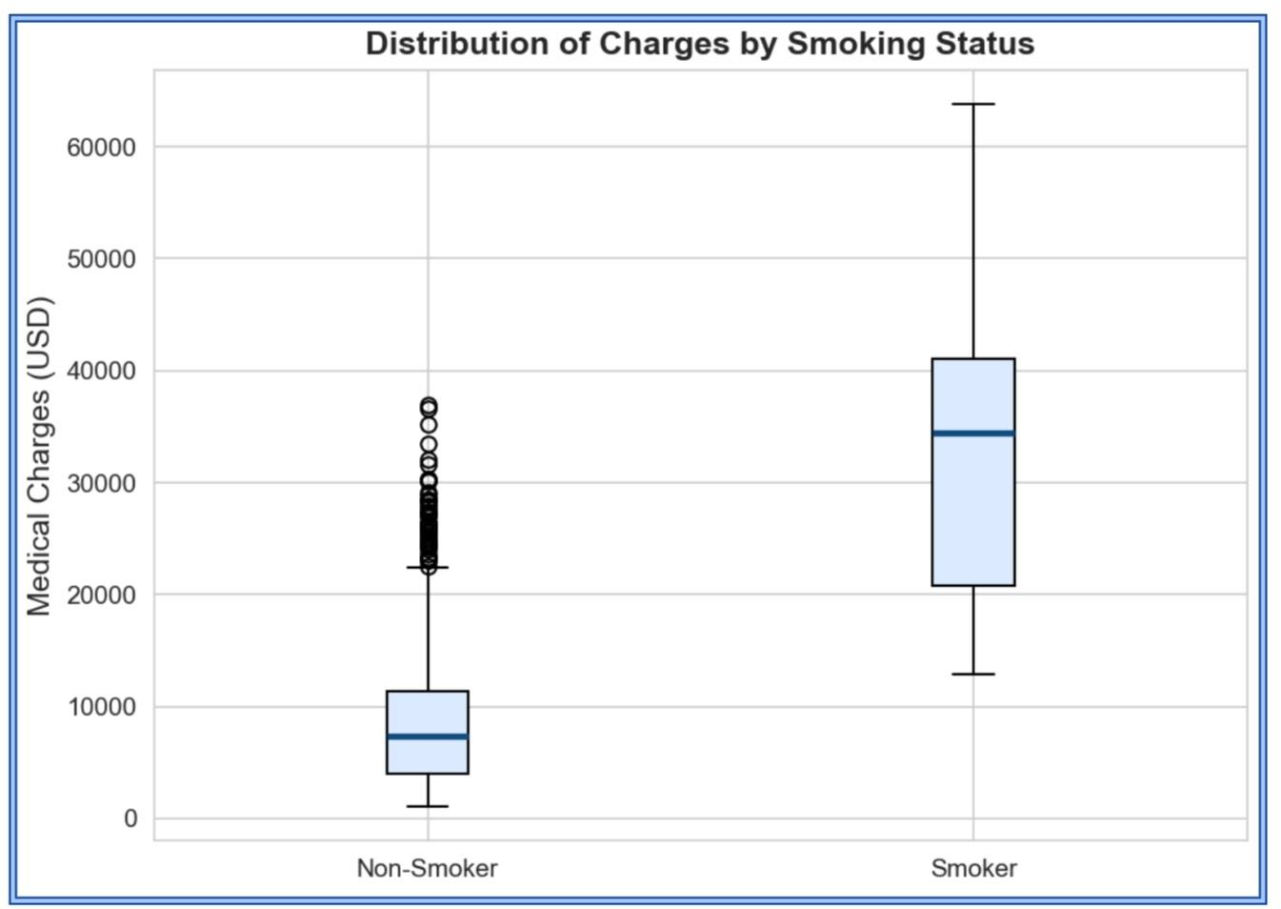
Figure 7.3 Distribution of charges by smoking status.

Mean Charges by Region
Fig. 7.4 shows regional variation: southeast records the highest mean (USD 14,735) and southwest the lowest (USD 12,347).
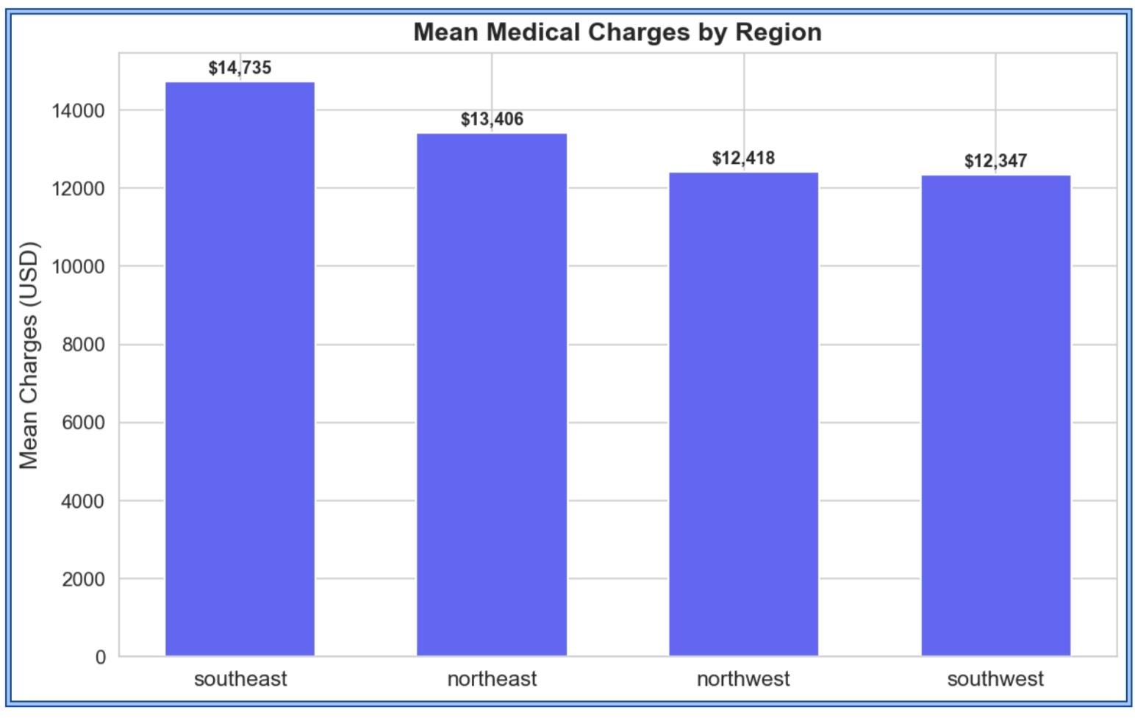

Figure 7.4 Mean medical charges by US region.

SECTION 8

Usefulness and Limitation of Work

Usefulness to Society
Insurance Companies: Enables data-driven premium pricing, reducing under- and over-pricing risks. Hospitals and Clinics: Supports revenue cycle management and financial forecasting.
Individual Patients: Allows prospective patients to estimate costs before choosing a plan. Policymakers: Facilitates equity analysis across demographics to detect pricing biases.

Limitations
    - Dataset limited to 1,338 US records; performance may vary for other geographies.
    - Clinical variables (diagnosis, procedures, medications) are absent.
    - Model does not account for healthcare cost inflation over time.
    - Fairness across protected attributes has not been formally assessed.
    - Predictions are estimates only and not certified actuarial assessments.

SECTION 9

Timeline Chart
The project was executed over six weeks. Each week corresponded to a distinct phase of the data science lifecycle.

Week | Phase | Key Activities
1 | Problem Identification | Define problem, review literature, collect dataset.
2 | Data Understanding | Explore structure, compute statistics, check quality.
3 | Visualization & Analysis | Generate EDA plots, analyze correlations.
4 | Model Building | Implement Pipeline, train Random Forest, tune n_estimators.
5 | Evaluation & Deployment | Compute metrics, build and deploy Streamlit app.
6 | Documentation | Write GTU report, poster, research paper, GitHub portfolio.
Fig. 9.1 presents the timeline as a horizontal bar chart.
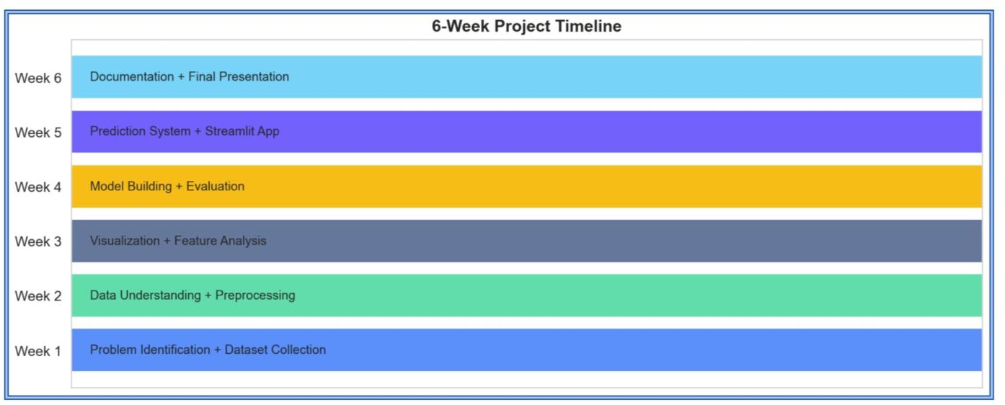

Figure 9.1 6-Week project timeline chart.

BIBLIOGRAPHY AND REFERENCES

BOOKS
- Lantz, B., 'Machine Learning with R', 2nd Edn, Packt Publishing, 2019.
- Hastie, T., Tibshirani, R. and Friedman, J., 'The Elements of Statistical Learning', 2nd Edn, Springer, 2009.

PAPERS
- Pedregosa, F. et al., 'Scikit-learn: Machine Learning in Python', Journal of Machine Learning Research, 2011, 12, 2825-2830.
- Breiman, L., 'Random Forests', Machine Learning, 2001, 45(1), 5-32.
- Verma, S. and Rubin, J., 'Fairness Definitions Explained', IEEE/ACM FairWare Workshop, 2018.

WEB SITES
- Kaggle, 'Medical Cost Personal Datasets', accessed 10 May 2026, www.kaggle.com/datasets/mirichoi0218/insurance
- Streamlit, 'Streamlit Documentation', accessed 12 May 2026, docs.streamlit.io
- Scikit-learn, 'scikit-learn Documentation', accessed 10 May 2026, scikit-learn.org
- GitHub Repository, 'Medical Cost Prediction', github.com/chaudharymarmik1121-tech/medical_cost_prediction, 2026.
- McKinsey Global Institute, 'Transforming Healthcare with AI', accessed 15 May 2026, www.mckinsey.com

