**AI-Powered Diabetes Prediction System**

**Problem Statement, Design Thinking Process and The Phases of Development:**

**Problem Definition:**

The primary objective of this project is to create an AI-powered diabetes prediction system to forecast an individual's risk of developing diabetes, enabling early risk assessment and personalized preventative strategies.

**Design Thinking Process:**

* **Data Collection:** 
  + Gather a comprehensive dataset from reliable sources, including medical features and diabetes diagnosis status.
  + Ensure the dataset is representative and diverse to capture different risk factors.
* **Data Preprocessing:** 
  + Clean the dataset to handle missing or erroneous values.
  + Normalize the data to ensure consistent scales across features.
  + Identify and address outliers in the data**.**
* **Feature Selection:**
  + Employ statistical analysis and domain knowledge to identify relevant features.
  + Select features that are likely to impact diabetes risk prediction.
  + Eliminate less important features to improve model efficiency and interpretability.
* **Model Selection:** 
  + Experiment with various machine learning algorithms, including Logistic Regression, Random Forest, Gradient Boosting, Support Vector Machines, and Neural Networks.
  + Assess the strengths and weaknesses of each algorithm in the context of diabetes prediction.
  + Choose the most suitable algorithm based on performance and suitability for the task.
* **Evaluation:**
  + Evaluate model performance using metrics such as accuracy, precision, recall, F1-score, and ROC-AUC.
  + Gain insights into the model's ability to make accurate predictions and manage false positives and false negatives.
* **Iterative Improvement:** 
  + Engage in iterative cycles of model refinement and fine-tuning.
  + Optimize model parameters to enhance prediction accuracy.
  + Explore feature engineering techniques to improve the system's robustness.
  + Continuously evolve the system to ensure it remains effective and relevant over time.

**Phases of Development:**

**1. Setting Up the Environment:**

* Install necessary libraries and tools.
* Set up a database for storing medical data.

**2. Data Collection and Preprocessing:**

* Collect data from reliable sources.
* Clean, preprocess, and normalize the data.
* Perform feature engineering.

**3. Machine Learning Model:**

* Select appropriate machine learning algorithms (e.g., Logistic Regression, Random Forest, etc.).
* Optimize hyperparameters.
* Integrate the model into the system.

**4. User Interface Development:**

* Design a user-friendly web interface.
* Integrate it with the backend and the prediction model.

**5. Integration and Testing:**

* Integrate the system components and test for accuracy and response time.
* Conduct user acceptance testing, gather feedback, and address issues.

**6. Continuous Improvement:**

* Analyze user feedback and enhance system responses.
* Improve machine learning algorithms for self-learning and integrate new data.

**Dataset Used, Data Preprocessing Steps and Feature Selection Techniques:**

**Dataset Used:**

The dataset used for the AI-powered diabetes prediction system is a critical component. It should be comprehensive and well-suited for the task. Here's a description of the dataset:

* **Data Source:**

The dataset is collected from reliable sources, which could include electronic health records, clinical studies, or publicly available healthcare datasets.

* **Data Composition:**

It comprises medical features and diabetes diagnosis status. The medical features may include variables like age, gender, BMI (Body Mass Index), blood pressure, cholesterol levels, family history, and more.

* **Representativeness:**

The dataset should be representative of the population under consideration and diverse enough to capture various risk factors associated with diabetes. This diversity ensures that the model can provide accurate predictions for a wide range of individuals.

**Data Preprocessing:**

Data preprocessing is a critical phase to ensure that the data is clean and ready for machine learning. Here are some common data preprocessing steps for the diabetes prediction system:

* **Handling Missing Values:**

Identify and handle missing values in the dataset. Depending on the amount of missing data, you can either remove incomplete records, impute missing values using techniques like mean, median, or use more advanced imputation methods if necessary.



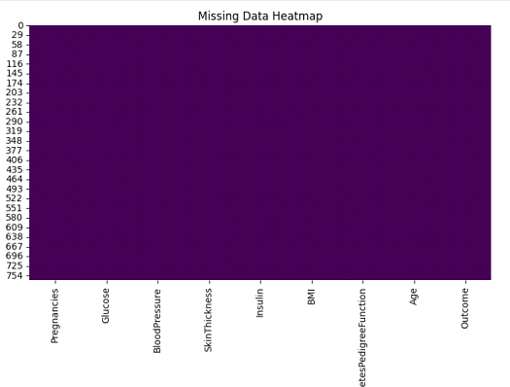

* **Outlier Detection and Handling:**

Identify and address outliers in the data. Outliers can significantly impact model performance. You can choose to remove them or transform them using techniques like winsorization.

* **Data Normalization:**

Normalize the data to ensure consistent scales across features. This step is important, especially when using algorithms that are sensitive to feature scales (e.g., k-Nearest Neighbors or Support Vector Machines).

* **Feature Encoding:**

Categorical variables may need to be encoded into numerical values using techniques such as one-hot encoding or label encoding.

* **Feature Scaling:**

Features may need to be scaled to have similar ranges. Common methods include Min-Max scaling or standardization (z-score normalization).

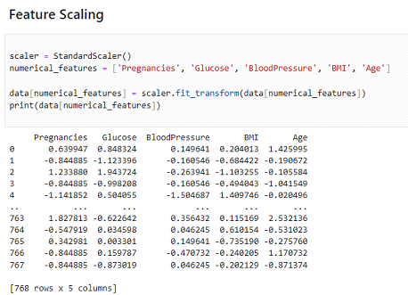

* **Handling Class Imbalance:**

If there's a significant class imbalance in the target variable (e.g., more non-diabetic cases than diabetic cases), techniques like oversampling, undersampling, or using synthetic data (SMOTE) can be applied to balance the dataset.

**Feature Selection:**

Feature selection is crucial to ensure that the model uses only the most relevant features, which can improve model efficiency and interpretability. Here are some common feature selection techniques:

* **Statistical Tests:**

Use statistical tests like chi-squared tests for categorical features and ANOVA for continuous features to determine the statistical significance of each feature in relation to the target variable. Select features with high significance.

* **Correlation Analysis:**

Calculate the correlation between features and the target variable. Features with high correlations are more likely to be relevant.

* **Domain Knowledge:**

Domain experts can help identify and select features based on their understanding of the medical domain and the factors that influence diabetes risk.

* **Recursive Feature Elimination (RFE):**

RFE is an iterative method that starts with all features and recursively removes the least significant features. It continues until the desired number of features is reached.

* **Tree-Based Feature Selection:**

Algorithms like Random Forest can be used to measure the importance of each feature. Features with higher importance are retained.

* **L1 Regularization (LASSO):**

Use L1 regularization to penalize less important features, effectively setting their coefficients to zero.

**Machine Learning Algorithm, Model Training and Evaluation Metrics:**

**Machine Learning Algorithm:**

The Decision Tree algorithm is a suitable choice for several reasons:

* **Interpretability:**

Decision Trees are highly interpretable, and their decision-making process can be visualized in a tree-like structure. This makes it easy to understand how the model is making predictions, which can be crucial in a healthcare context where interpretability is important.

* **Feature Importance:**

Decision Trees can provide information about feature importance. This is valuable in healthcare, where identifying the most critical factors (such as glucose levels, BMI, etc.) for diabetes prediction can help in risk assessment and decision-making.

* **Non-linearity:**

Decision Trees can capture non-linear relationships in the data. This is essential for modeling complex relationships in medical data, as diabetes risk factors may not always follow linear patterns.

* Decision Trees are also known to be prone to overfitting, meaning they can become too specific to the training data. Proper tuning, such as controlling the maximum depth or minimum samples per leaf, can help mitigate this.

**Model Training:**

The following steps for model training:

* **Data Splitting:**

The dataset is split into training and testing sets using the ‘rain_ test _split’ function. This separation allows you to evaluate the model's performance on unseen data, which is a good practice to assess how well it generalizes.

* **Training the Decision Tree Model:**

A Decision Tree classifier is created using the training data. The ‘decision _ tree. Fit (X_ train, y_ train)’ command trains the model. During this process, the model learns from the features in the training data to predict the target variable, which, in this case, is the likelihood of a person having diabetes (the 'Outcome').

**Evaluation Metrics:**

* **Accuracy:**

Accuracy measures the overall correctness of the model's predictions. It calculates the ratio of correct predictions (both true positives and true negatives) to the total number of predictions. In the context of diabetes prediction, accuracy represents how often the model correctly predicts both diabetic and non-diabetic cases.





* **Classification Report:**

The classification report provides a comprehensive breakdown of the model's performance for both classes (diabetic and non-diabetic). It includes metrics such as precision, recall (sensitivity), F1-score, and support for each class. This report helps assess the model's ability to correctly identify diabetic and non-diabetic cases.

* **Confusion Matrix:**

The confusion matrix visually represents the model's performance. It shows the number of true positives, true negatives, false positives, and false negatives. These values are used to calculate metrics like precision, recall, and the F1-score.

**Conclusion:**

The project aims to develop an AI-powered diabetes prediction system through a structured design thinking approach. It involves data collection, preprocessing, feature selection, model training, and evaluation. The implementation plan includes setting up the environment, integrating a user interface, and continuous improvement. The provided code covers data exploration, preprocessing, and training a Decision Tree model. These phases lay the foundation for a reliable diabetes prediction system, aligning with the goal of enhancing healthcare outcomes and empowering individuals to proactively manage their health.