|  |  |  |  |  |  |  |  |
| --- | --- | --- | --- | --- | --- | --- | --- |
| Name | Nguyen Le Thao Vy | No. | 3341 | Div/Dept | DSD/ACD/ACT3 | Job  Date：Dec 8th 2023  Title | Engineer |
| Please tick  the period | First Month | 🗹W1 □W2 □W3 □W4 | | | | | |
| Second Month | □W1 □W2 □W3 □W4 | | | | | |
| Third Month | □W1 □W2 □W3 □W4 | | | | | |

1. The weekly report aims to help accelerate member’s workspace integration and should be reviewed by mentor on the last working day of the week.
2. The new weekly report should be reviewed and signed by mentor and direct supervisor.

|  |
| --- |
| Work Experience Record |
| 1. Please describe the tasks and achievements you learned/executed:   All of the tasks I learned during this first week are based on the training plan of 2023, below are a brief description of topics and tasks I was working on:   * Topics of interest:   + FTC and FTV company profile;   + How to use online meeting tools and VNC;   + LSI design flow, Faraday ASIC workflow and the role of AC / PI. * Tasks that I was working on:   + Study e-courses (done 25/29 courses);   + Read training slides and required quality documents (done 5/11 files);   + Practice using VNC and linux environment. * Outcomes:   + Had an overview of the company profile and some of its policies, i.e. information security policy, TQM applications;   + Got myself familiar with Faraday IP infrastructure and various e-systems;   + Understood the Faraday ASIC workflow and got a rough idea on the steps which an AC engineer may be involved. |
| 1. What are the problems encountered this week? Any actions taken? Any help needed?  * Problem encountered:   + Being rather unfamiliar with working in linux environment;   + Find it difficult to catch up with technical e-courses, due to their poor audio quality. * Actions taken:   + Looked for and comprehend linux and VNC –related training slides / guidelines;   + Used additional materials (VLSI Test Principles and Architectures (book); VLSI Testing (playlist)) to fill in the gap. |
| 1. What are the tasks for next week? Any preparation needed in advance?  * Stick to the given training plan:   + Learn about Linux environment and its common programming language (C-shell, Perl, TCL);   + Learn and practice coding with Verilog. * Complete the remaining e-courses and read the required quality documents   *Intended preparations:* Review related schoolwork and read through the basics before diving in the training materials. |
|  |

|  |  |  |
| --- | --- | --- |
| Name  (Date) | Mentor | Direct Supervisor |
| Nguyen Le Thao Vy  (2023/12/08) | (Signature/Date) | (Signature/Date) |

To further elaborate on the things I have learnt, the follows are mindmaps visualizing the notes that I have been taken along the way:

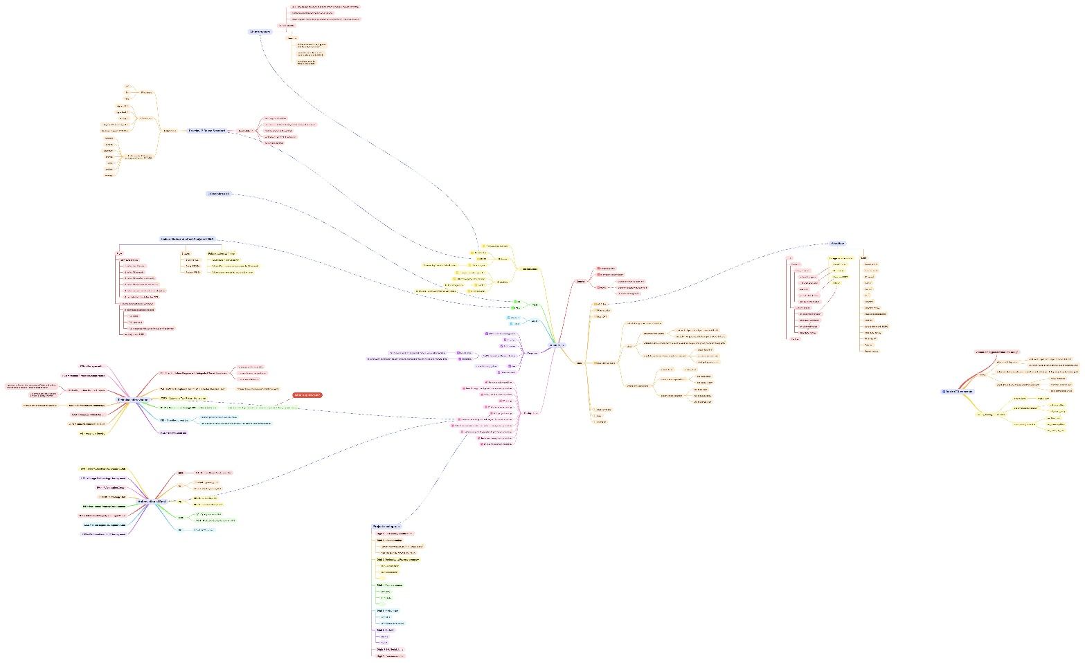

Figure : The full mindmap

For easier tracking, separate segments of the above mindmap are presented.

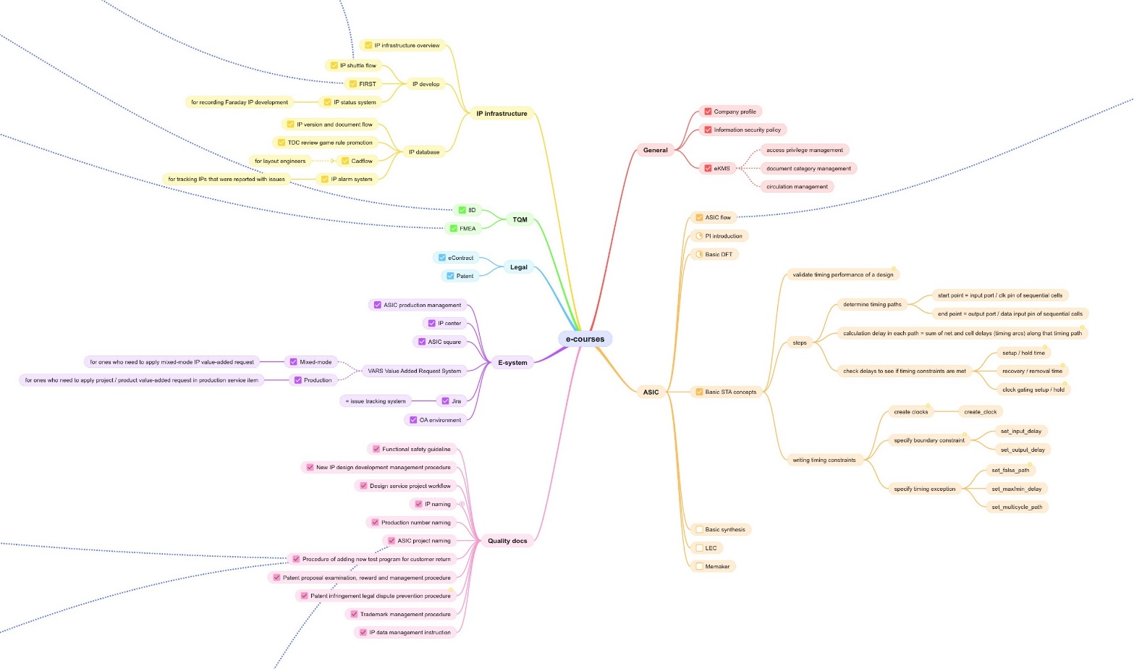

Figure : Overview of topics

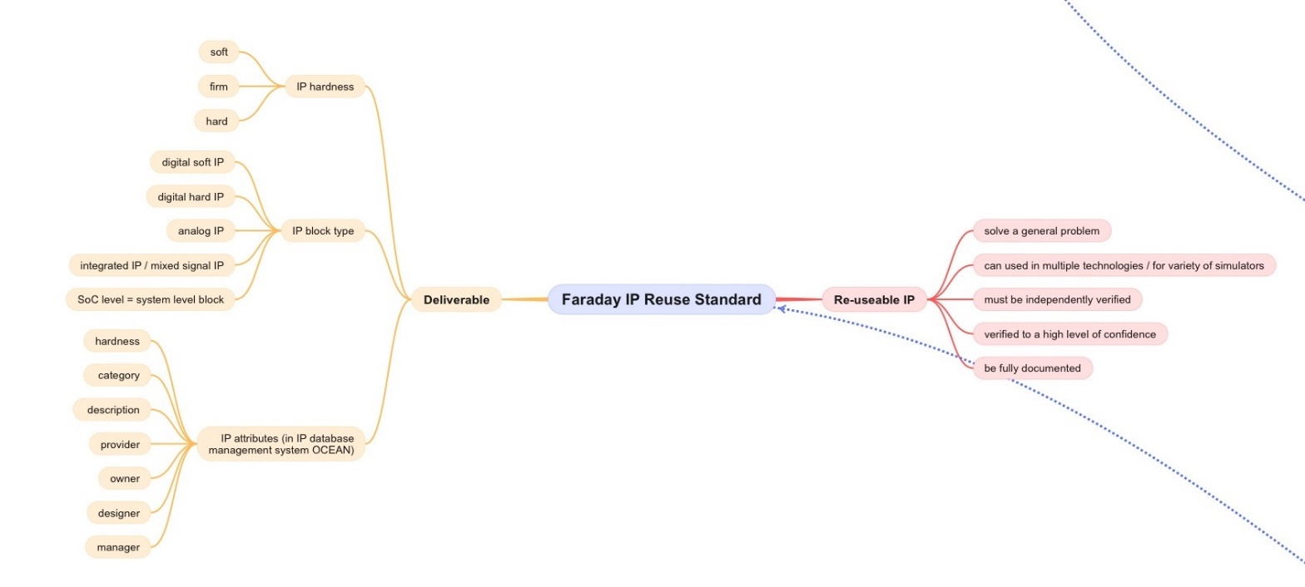

Figure : Faraday IP Reuse Standard FIRST

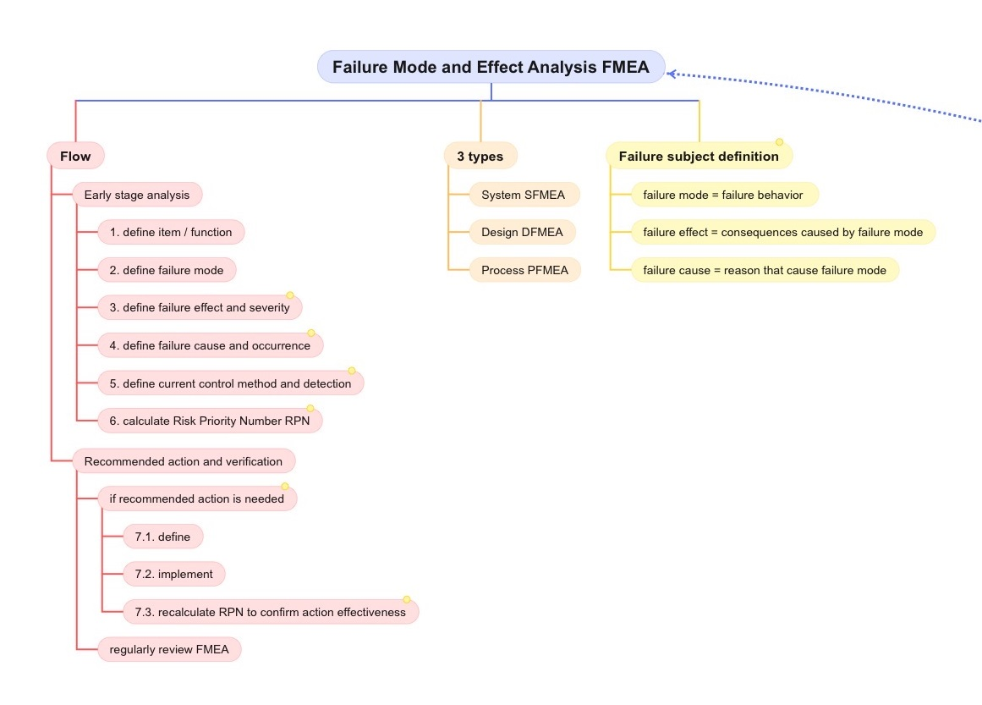

Figure : Failure Mode and Effect Analysis FMEA

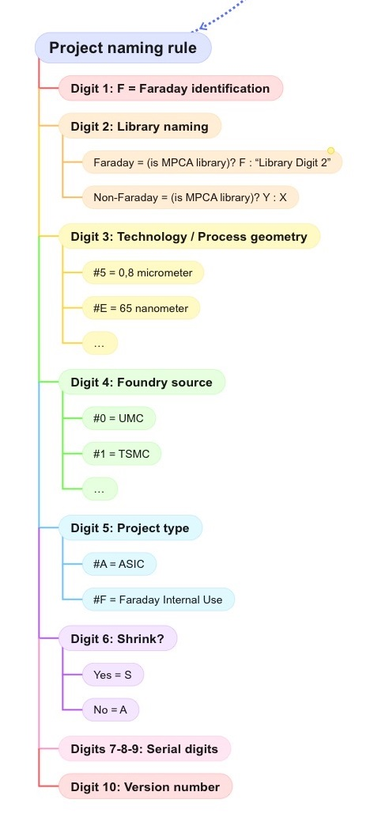

Figure : Project naming rule

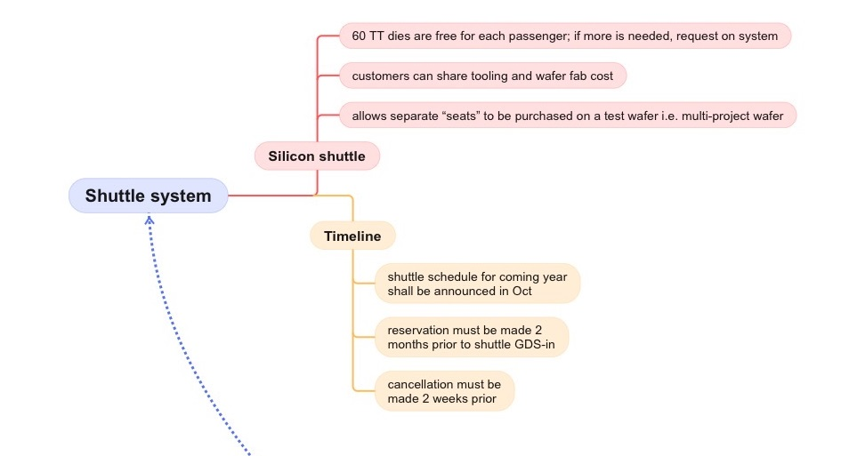

Figure : Shuttle system

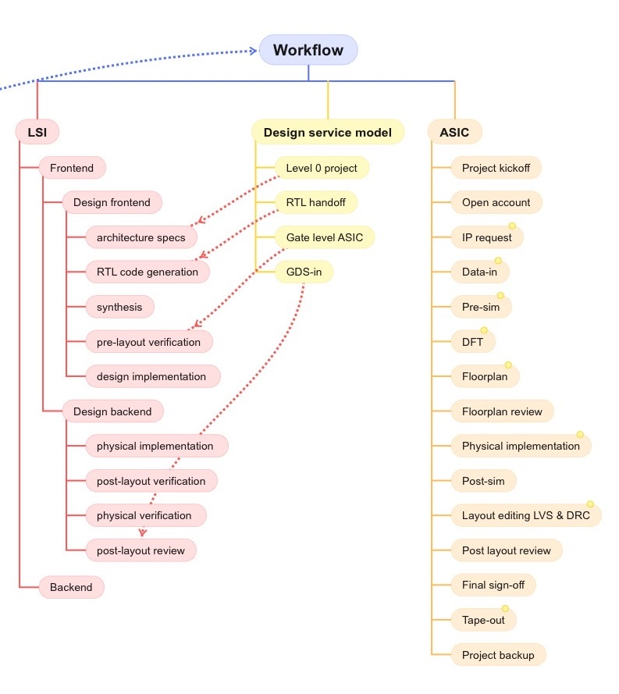

Figure : ASIC workflow

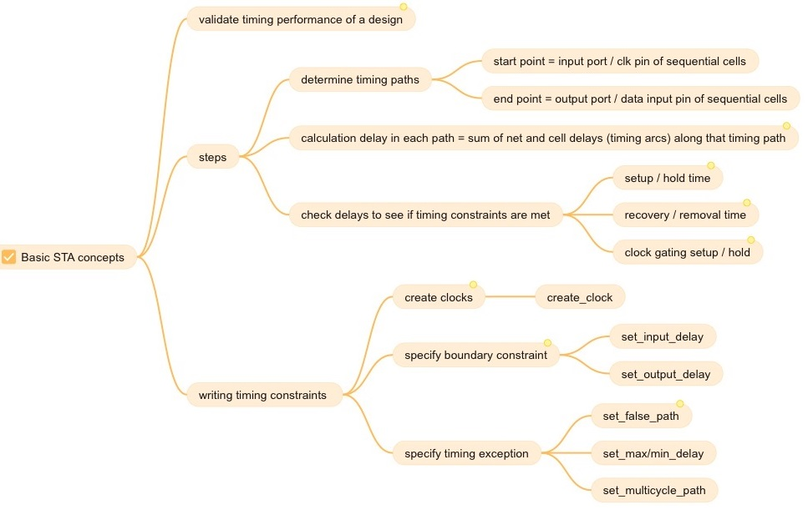

Figure : STA basics