DBMS Project

Student Grade Calculator

* Create a table for students :

CREATE TABLE students ( student_id SERIAL PRIMARY KEY, first_name VARCHAR(50),

last_name VARCHAR(50) );

* Output :



* Insert values into the students table :

INSERT INTO students (student_id, first_name, last_name) VALUES

(1, 'Rajesh', 'Kumar'), (2, 'Sita', 'Sharma'), (3, 'Amit', 'Patel'), (4, 'Poojan', 'Thakker'),

(5, 'Anil', 'Gupta'), (6, 'Priya', 'Singh'), (7, 'Vikram', 'Yadav'), (8, 'Mala', 'Rajput'),

(9, 'Nitin', 'Mishra'),(10, 'Deepa', 'Jha'), (11, 'Arun', 'Bansal'), (12, 'Geeta', 'Reddy'),

(13, 'Rahul', 'Choudhary'), (14, 'Kavita', 'Mehta'), (15, 'Vijay', 'Rao'),

(16, 'Anita', 'Pandey'),(17, 'Sanjay', 'Shukla'),(18, 'Neha', 'Chopra'),

(19, 'Rajendra', 'Malik'),(20, 'Suman', 'Dubey'),(21, 'Ashok', 'Agarwal'),

(22, 'Preeti', 'Srivastava'),(23, 'Ramesh', 'Sharma'),(24, 'Jyoti', 'Verma'),

(25, 'Harish', 'Yadav');

* Display all data from students :

select * from students;

* Output :

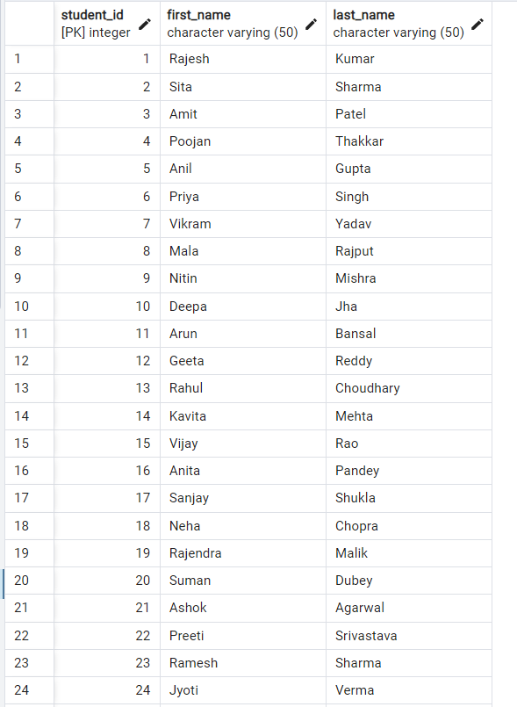

* Create table for student_marks :

create table Student_marks( student_id int ,DBMS_marks float,JAVA_marks float,

DS_marks float, FEE_marks float, Maths_marks float );

* Output :

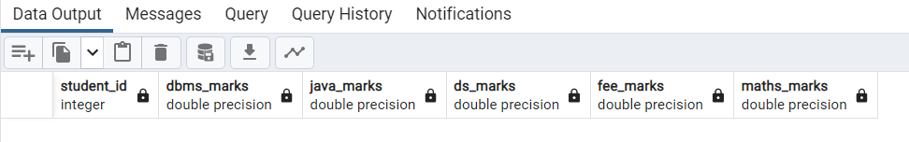

* Insert values into the Student_marks table :

INSERT INTO Student_marks (student_id, DBMS_marks, JAVA_marks, DS_marks, FEE_marks, Maths_marks)

VALUES (1, 85.5, 78.0, 92.5, 90.0, 88.5), (2, 75.0, 89.5, 76.5, 82.0, 94.0),

(3, 92.0, 80.5, 85.0, 78.5, 91.0), (4, 88.5, 94.0, 81.5, 89.0, 85.5),

(5, 78.0, 86.5, 90.0, 75.5, 87.0),(6, 90.5, 92.5, 88.0, 93.0, 82.5),

(7, 86.0, 75.0, 89.5, 80.5, 79.0), (8, 83.5, 91.5, 87.0, 88.5, 92.0),

(9, 79.5, 88.0, 90.5, 81.0, 84.5),(10, 92.5, 84.0, 76.5, 87.5, 79.0),

(11, 85.0, 79.5, 91.0, 88.0, 83.5),(12, 89.0, 87.0, 82.5, 90.5, 85.0),

(13, 77.5, 93.5, 84.5, 76.0, 91.5),(14, 92.0, 85.5, 78.0, 89.5, 87.0),

(15, 80.5, 91.0, 87.5, 82.5, 90.0),(16, 88.5, 78.0, 94.0, 89.0, 76.5),

(17, 92.5, 89.5, 83.0, 90.5, 85.0), (18, 76.0, 87.0, 91.5, 79.5, 88.0),

(19, 85.0, 80.5, 93.0, 86.5, 82.0), (20, 91.0, 92.0, 84.5, 89.5, 78.5),

(21, 77.5, 88.0, 85.5, 76.0, 90.5),(22, 90.0, 81.5, 92.5, 88.5, 79.0),

(23, 83.0, 79.5, 91.0, 84.5, 87.5),(24, 92.5, 86.0, 80.0, 89.0, 76.5),

(25, 78.5, 90.5, 85.0, 77.5, 91.0);

* Display all data from Student_marks :

select * from Student_marks;

* Output :

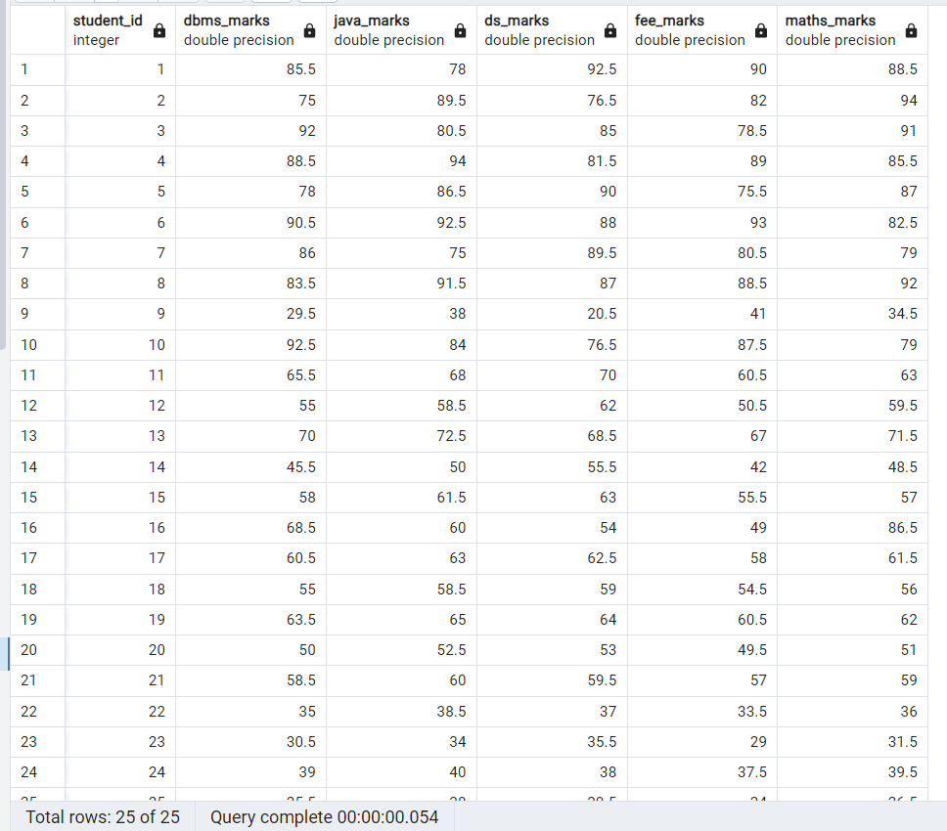

* Create table for result :

create table Result(student_id int,first_name varchar(50),spi float,grad varchar(10));

* Display all data from result :

select * from Result;

* Output :

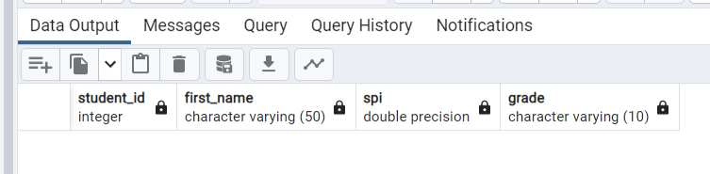

* Create Procedure name as inser_result() :

create or replace procedure insert_result()

as $$

declare

Student_result CURSOR FOR

SELECT student_id, first_name FROM students;

sid students.student_id%type;

sname students.first_name%type;

begin

OPEN Student_result;

LOOP

FETCH Student_result INTO sid,sname;

EXIT WHEN NOT FOUND;

INSERT INTO Result (student_id ,first_name,spi ) values(sid,sname,0.0);

END LOOP;

CLOSE Student_result;

end;

$$

LANGUAGE plpgsql;

* Call the Procedure :

call insert_result();

* Output :

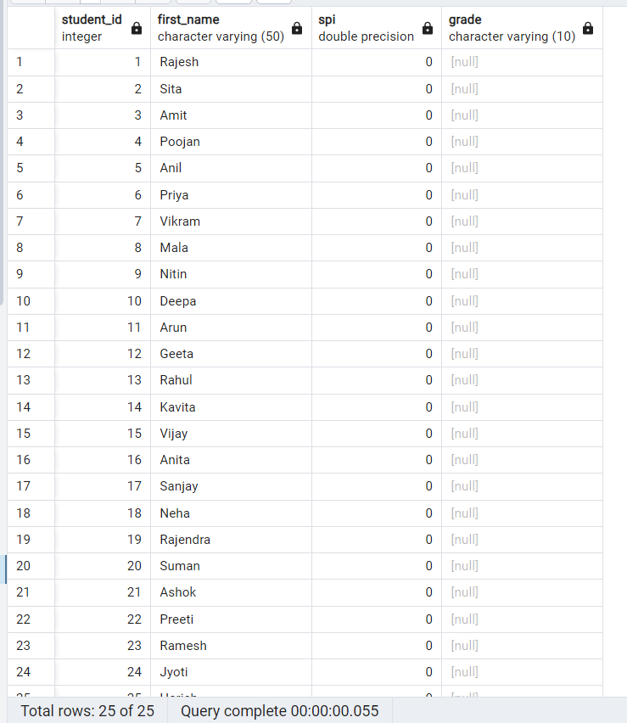

* Create Procedure name as Calculate_spi() :

CREATE OR REPLACE PROCEDURE calculate_spi() AS $$

DECLARE

java_credit int :=6;

dbms_credit int :=6;

ds_credit int :=6;

fee_credit int :=4;

maths_credit int :=4;

total_credits INT := java_credit+dbms_credit+ds_credit+fee_credit+maths_credit;

sid student_marks.student_id%type;

javamarks student_marks.java_marks%type;

dbmsmarks student_marks.dbms_marks%type;

dsmarks student_marks.ds_marks%type;

feemarks student_marks.fee_marks%type;

mathsmarks student_marks.maths_marks%type;

Marks_cursor cursor for

select student_id, dbms_marks,java_marks,ds_marks,fee_marks,maths_marks from student_marks;

total_grade_points FLOAT := 0;

student_spi FLOAT;

subject_rec RECORD;

BEGIN

-- Open the cursor

OPEN Marks_cursor;

-- Loop through subjects

LOOP

FETCH Marks_cursor INTO sid,javamarks,dbmsmarks,dsmarks,feemarks,mathsmarks ;

EXIT WHEN NOT FOUND;

student_spi := (javamarks*java_credit + dbmsmarks*dbms_credit +

dsmarks*ds_credit + feemarks*fee_credit * mathsmarks*maths_credit)/(500*total_credits);

update Result set spi=student_spi where Result.student_id = sid;

END LOOP;

-- Close the cursor

CLOSE Marks_cursor;

END;

$$ LANGUAGE plpgsql;

* Call the Procedure :

CALL calculate_spi();

* Output :

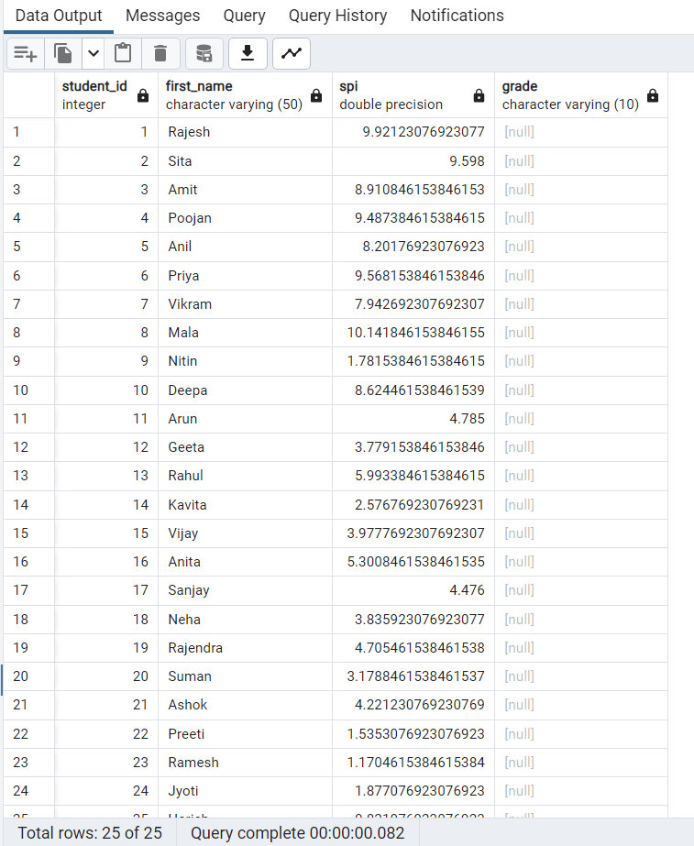

* Create Procedure name as Grade_calculator() :

create or replace procedure grade_calculator()

as $$

declare

Student_grade CURSOR FOR

SELECT student_id, spi FROM Result;

rid Result.student_id%type;

rspi Result.spi%type;

r_grade varchar:='';

begin

OPEN Student_grade;

-- Loop through subjects

LOOP

FETCH Student_grade INTO rid,rspi;

EXIT WHEN NOT FOUND;

if rspi>9 then

r_grade :='O++';

elsif rspi<9 and rspi>=8.5

then r_grade :='O+';

elsif rspi<8.5 and rspi>=8

then r_grade :='O';

elsif rspi<8 and rspi>=7.5

then r_grade :='A++';

elsif rspi<7.5 and rspi>=7

then r_grade :='A+';

elsif rspi<7 and rspi>=6.5

then r_grade :='A';

elsif rspi<6.5 and rspi>=6

then r_grade :='B++';

elsif rspi<6 and rspi>=5.5

then r_grade :='B+';

elsif rspi<5.5 and rspi>=5

then r_grade :='B';

elsif rspi<5 and rspi>=4

then r_grade :='C';

else

r_grade :='F';

insert into Result (grad) values (r_grade) ;--where Result.student_id = rid;

END if;

end loop;

-- Close the cursor

CLOSE Student_grade;

end;

$$

LANGUAGE plpgsql;

* Call the Procedure :

call grade_calculator();

* Output :

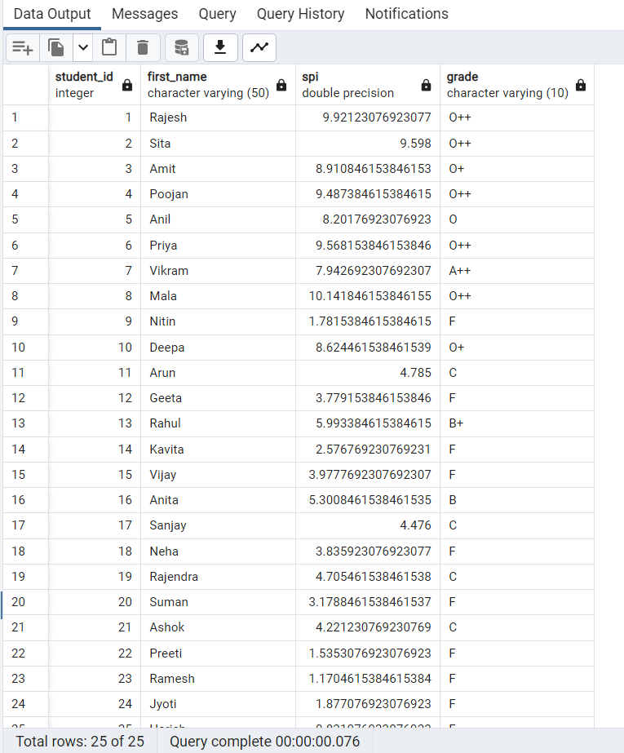

* Pl/pg sql block to display subject & credits :

do

$$

begin

raise notice'Credit of JAVA is 6.';

raise notice'Credit of DBMS is 6.';

raise notice'Credit of DS is 6.';

raise notice'Credit of FEE is 4.';

raise notice'Credit of MATHS is 4.';

END;

$$

* Output :

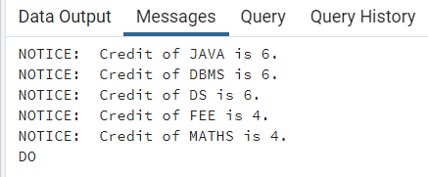

* Procedure to display the result of a spesify student :

create or replace procedure result_student(sid in int)

as $$

declare

Student_spesify_result Result%rowtype;

begin

select * into Student_spesify_result from Result where result.student_id=sid;

if Student_spesify_result.student_id=sid then

raise notice 'Student id = % ',Student_spesify_result.student_id;

raise notice 'Student Name = % ',Student_spesify_result.first_name;

raise notice 'Student SPI = % ',Student_spesify_result.spi;

raise notice 'Student Grade = % ',Student_spesify_result.grade;

else

raise notice 'id not found.';

end if;

end;

$$

LANGUAGE plpgsql;

* Call Procedure :

call result_student(12);

* Output :

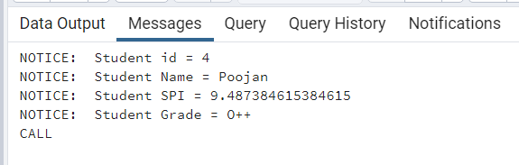

* Some Qurey above table :
* Qurey – 1 :
* Retrieve the students who scored the highest in DBMS:

SELECT students.student_id, students.first_name,students.last_name, student_marks.DBMS_marks

FROM students INNER JOIN Student_marks

ON students.student_id = student_marks.student_id WHERE student_marks.DBMS_marks = (SELECT MAX(DBMS_marks) FROM Student_marks);

* Output :

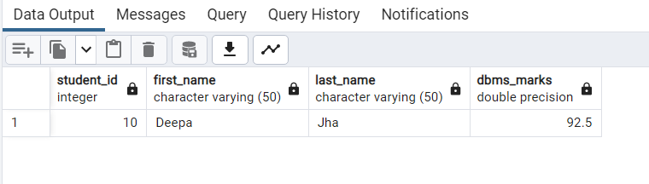

* Qurey – 2 :
* Retrieve the student with the highest total marks (sum of all subjects) :

SELECT students.first_name, result.spi, (

SELECT SUM(DBMS_marks + JAVA_marks + DS_marks + FEE_marks + Maths_marks)

FROM Student_marks

WHERE Student_marks.student_id = result.student_id

) AS total_marks

FROM students

JOIN Result ON students.student_id = result.student_id

ORDER BY total_marks DESC

LIMIT 1;

* Output :

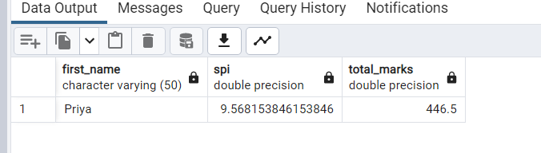

* Qurey – 3 :
* Retrieve the students who scored higher than the average SPI:

SELECT students.* FROM students

WHERE students.student_id IN (

SELECT result.student_id FROM Result WHERE result.spi >

( SELECT AVG(result.spi) FROM Result ) );

Output : 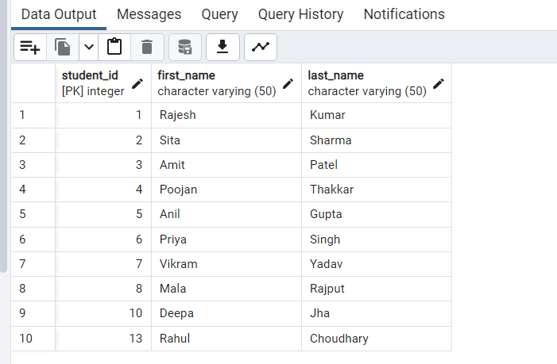

* Qurey – 4 :
* Retrieve the students who scored less than 'Geeta' in Java:

SELECT students.* FROM students

WHERE students.student_id <> 12

AND students.student_id IN ( SELECT Student_marks.student_id

FROM Student_marks WHERE Student_marks.JAVA_marks < (

SELECT JAVA_marks FROM Student_marks

WHERE student_id = 12 ) );

* Output :

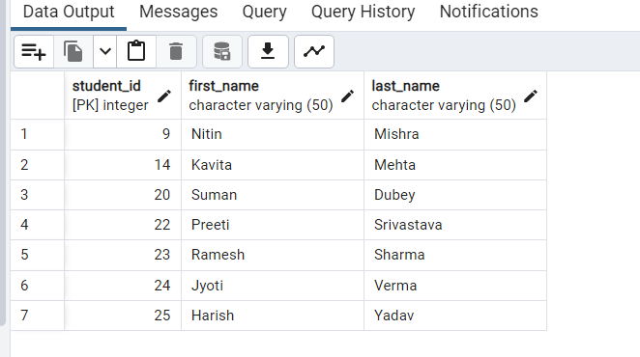

* Qurey – 5 :
* Retrieve the grades of students with SPI between 7 and 8:

Do

$$

DECLARE

student_records cursor for select * from result;

ss_id result.student_id%type;

f_name result.first_name%type;

s_grade result.grade%type;

s_spi result.spi%type;

BEGIN

OPEN Student_records;

LOOP

FETCH Student_records INTO ss_id,f_name,s_spi,s_grade;

EXIT WHEN NOT FOUND;

IF s_spi >= 7 AND s_spi <= 8 THEN

RAISE NOTICE 'Student Name: % Grade: % SPI: %', f_name,s_grade,s_spi;

END IF;

END LOOP;

CLOSE Student_records;

END;

$$

* Output :

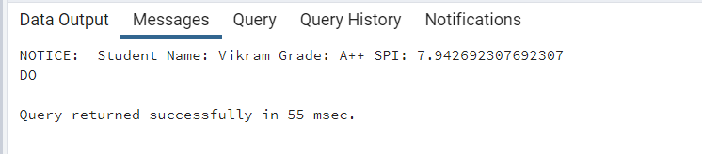

* Qurey – 6 :
* Retrieve the total marks obtained by each student, ordered by total marks in descending order:

SELECT

students .first_name,

SUM(Student_marks.DBMS_marks + Student_marks.JAVA_marks + Student_marks.DS_marks + Student_marks.FEE_marks + Student_marks.Maths_marks) AS total_marks

FROM students

JOIN Student_marks ON Students.student_id = Student_marks.student_id

GROUP BY students.first_name

ORDER BY total_marks DESC;

* Output :

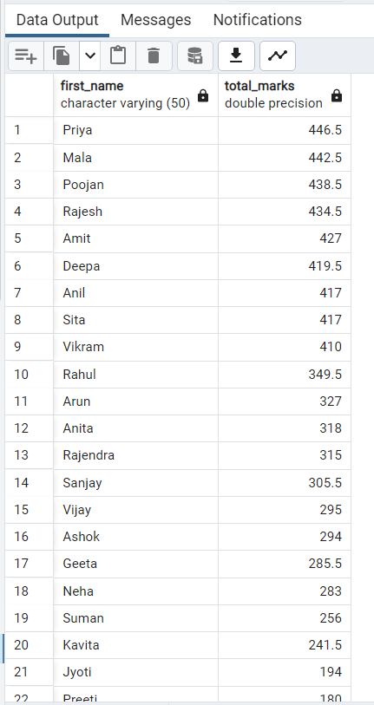

* Qurey – 7 :
* List all students with their all subject marks and spi using a view:

CREATE OR REPLACE VIEW Student_Marks_Spi AS

SELECT result.student_id,result.first_name, Student_marks.java_marks,Student_marks.dbms_marks,

Student_marks.ds_marks,Student_marks.fee_marks,Student_marks.maths_marks,

Result.spi

FROM Student_marks

JOIN Result ON student_marks.student_id = Result.student_id;

SELECT * FROM Student_Marks_Spi;

* Output :

