sЛекция 08
ПСКП
ПОИТ-3

Node.js-WebSockets-сервер

- WebSockets: https://tools.ietf.org/html/rfc6455
- WebSockets: https://learn.javascript.ru/websockets

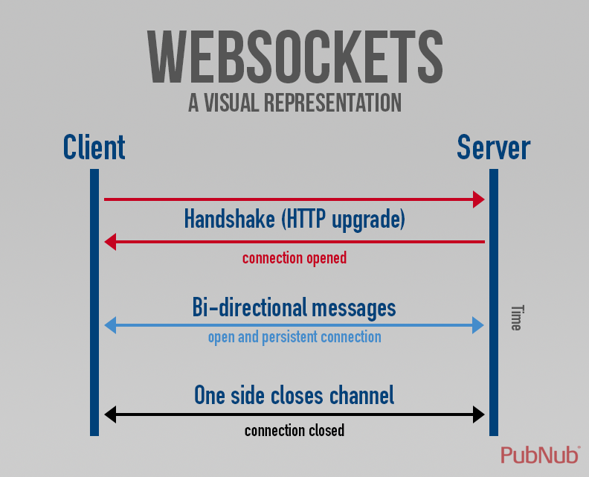

- WebSockets: handshake
- WebSockets: https://github.com/websockets/ws
- WebSockets: npm install ws
- WebSockets: сервер, HTML5-браузер
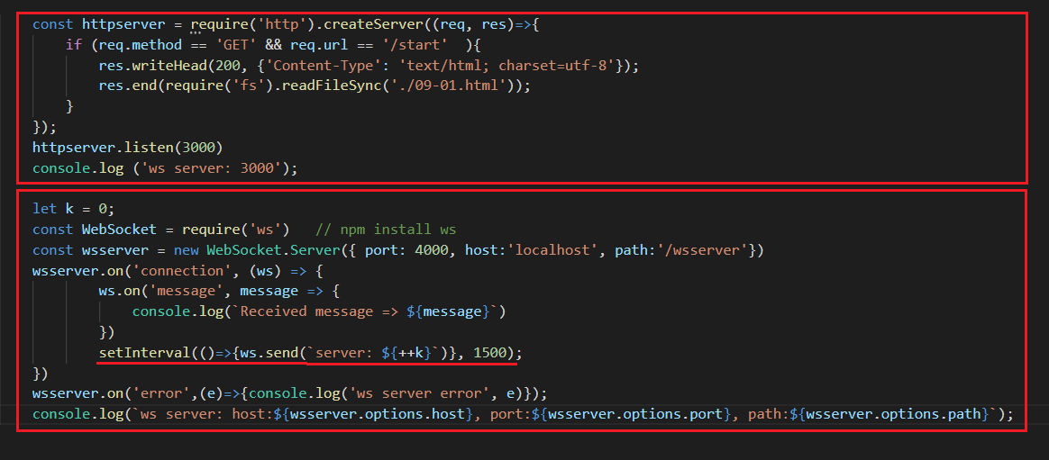

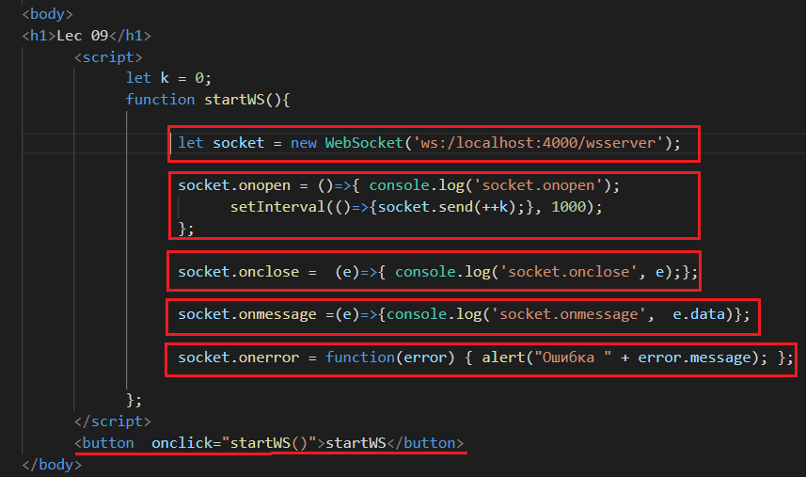

- WebSockets: клиент

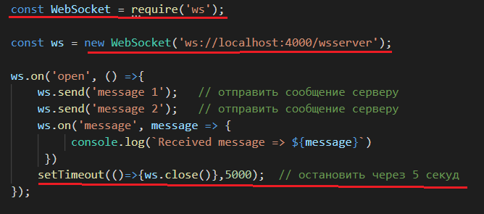

- WebSockets: сервер, broadcast, уведомления

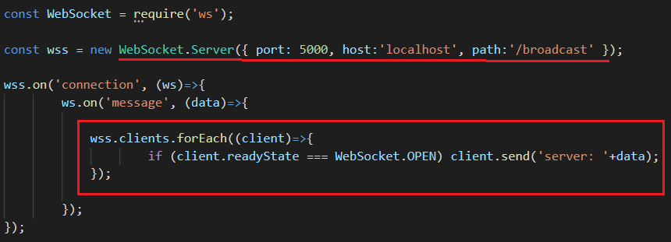

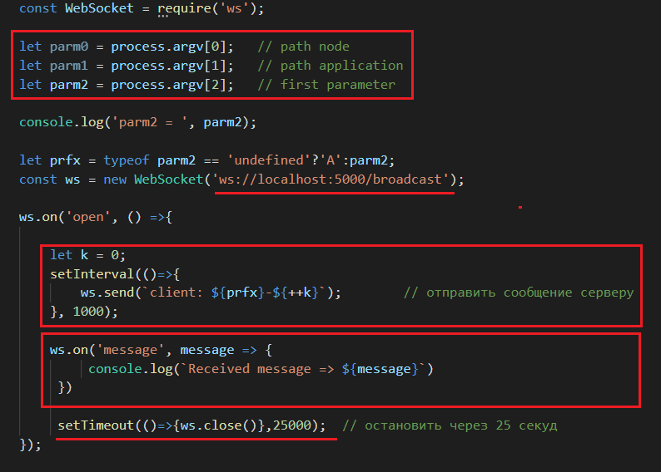

- WebSockets: клиент, взаимодействие с потоком
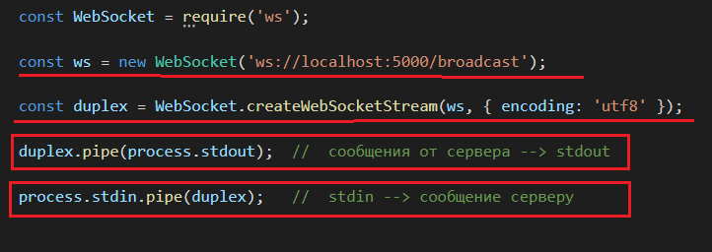

- WebSockets: ping/pong, server-client
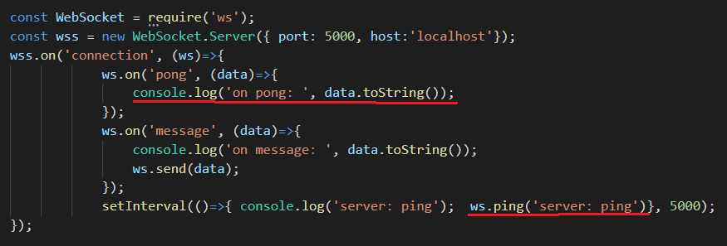

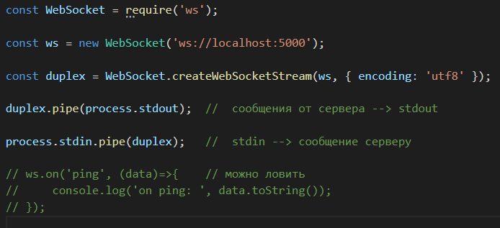

- WebSockets: ping/pong, client-server

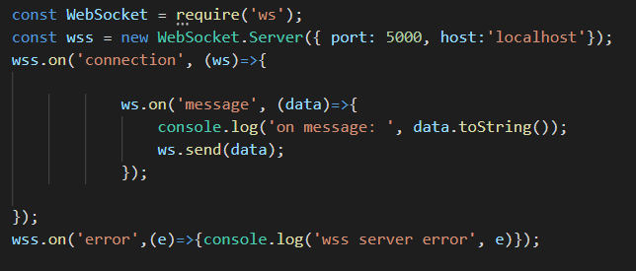
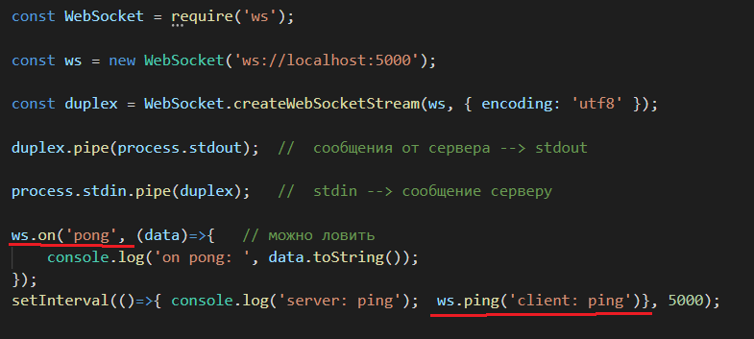

- WebSockets: JSON
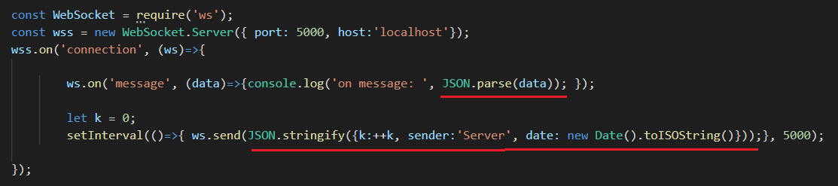

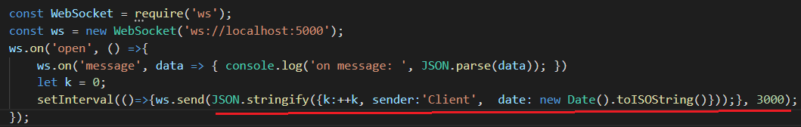

- WebSockets: upload file

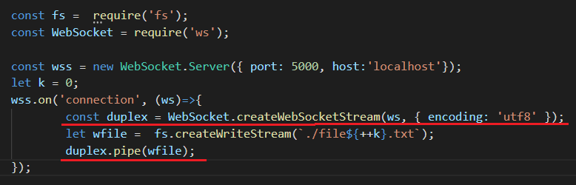

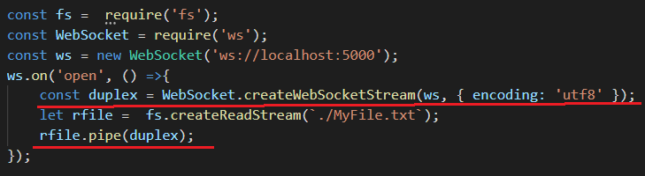

- WebSockets: download file
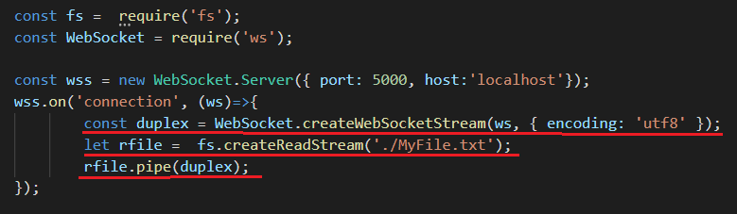
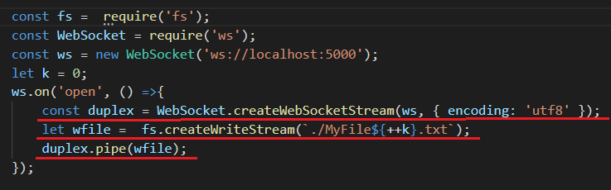

- WebSockets: npm install rpc-WebSocketss
- WebSockets: rpc-websockets, RPC, public, клиент не завершается
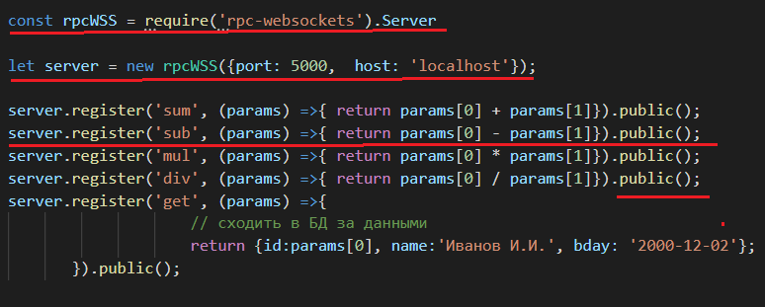
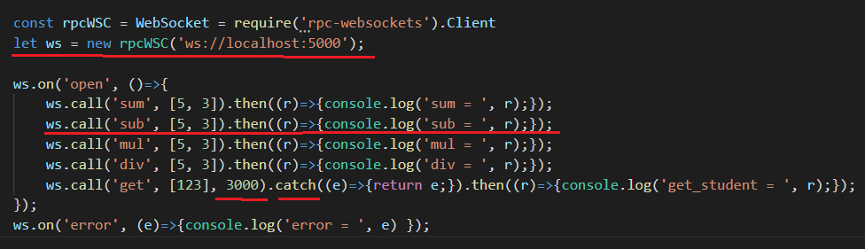
- WebSockets: rpc-websockets, RPC, protected, клиент не завершается 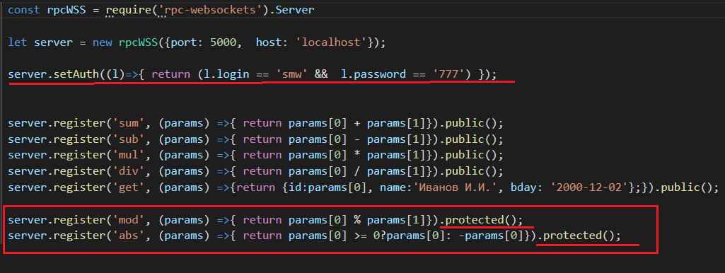
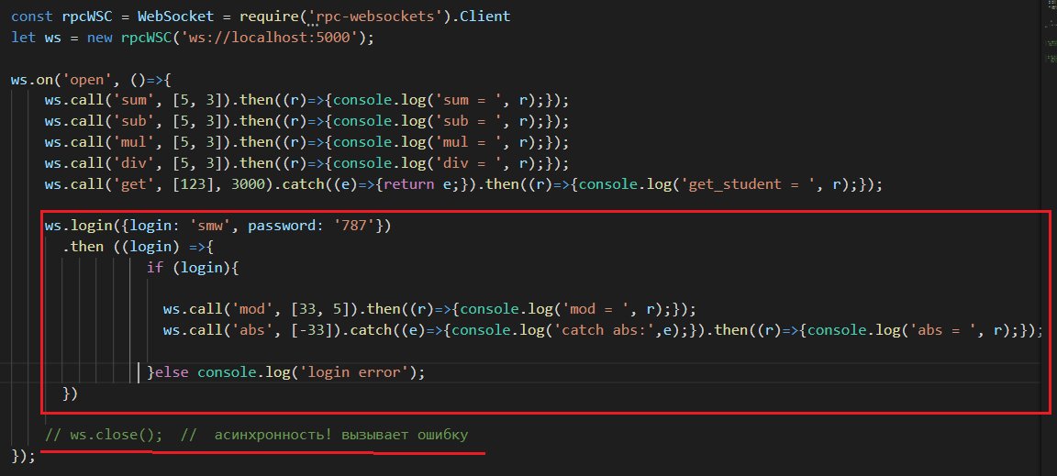

- WebSockets: rpc-websockets, asinc (parallel), RPC, close.
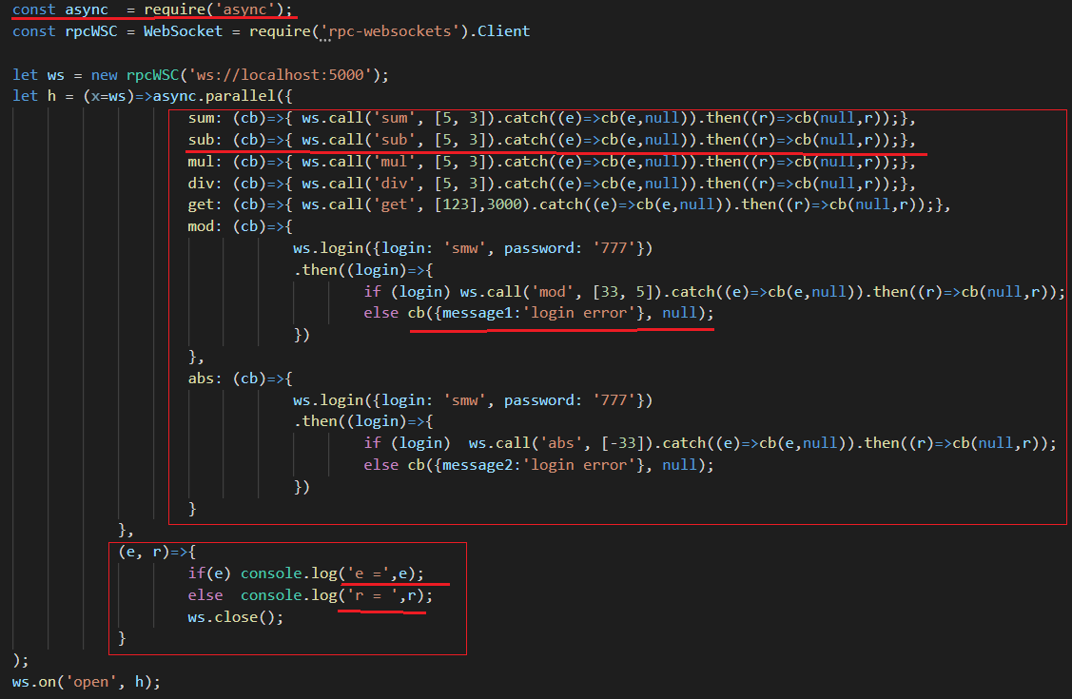

- WebSockets: rpc-websockets, asinc (waterfall), RPC, close.
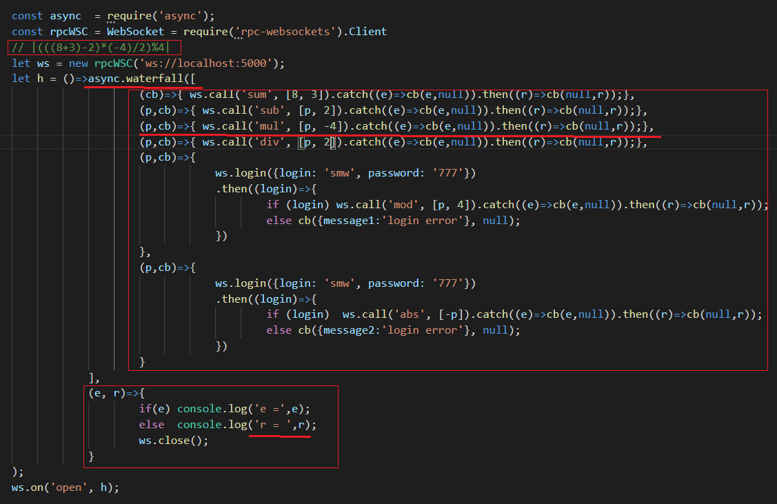
- WebSockets: rpc-websockets, event/subscribe/emit
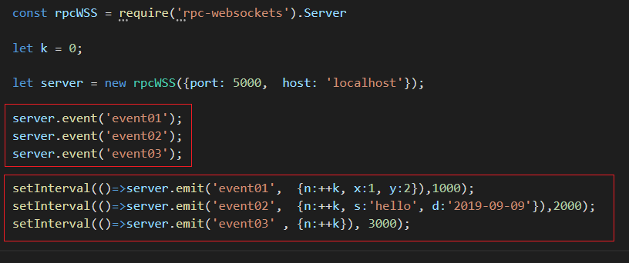
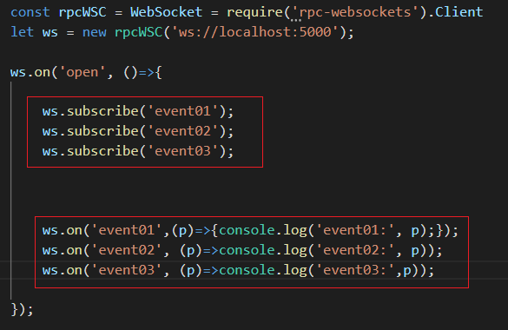

- WebSockets: rpc-websockets, notify

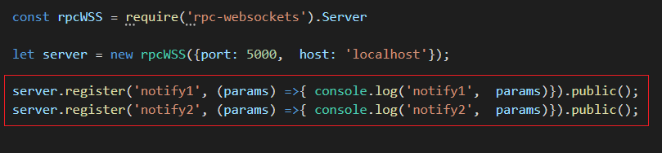
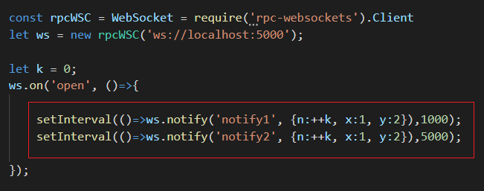

- WebSockets-сервер: https://habr.com/ru/company/ruvds/blog/424557/
- WebSockets-сервер: https://www.npmjs.com/package/WebSocket
- WebSockets-сервер: https://www.npmjs.com/package/websocket-without-native
- WebSockets-сервер: https://www.npmjs.com/package/ws
- WebSockets-сервер: https://learn.javascript.ru/websockets
- WebSockets-сервер: https://www.programmableweb.com/news/what-websockets-push-styled-api-and-how-does-it-work/analysis/2017/04/20
- nodemon: npm install nodemon –g

