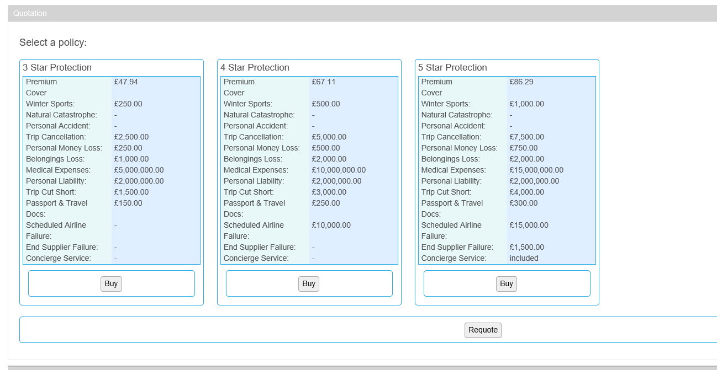

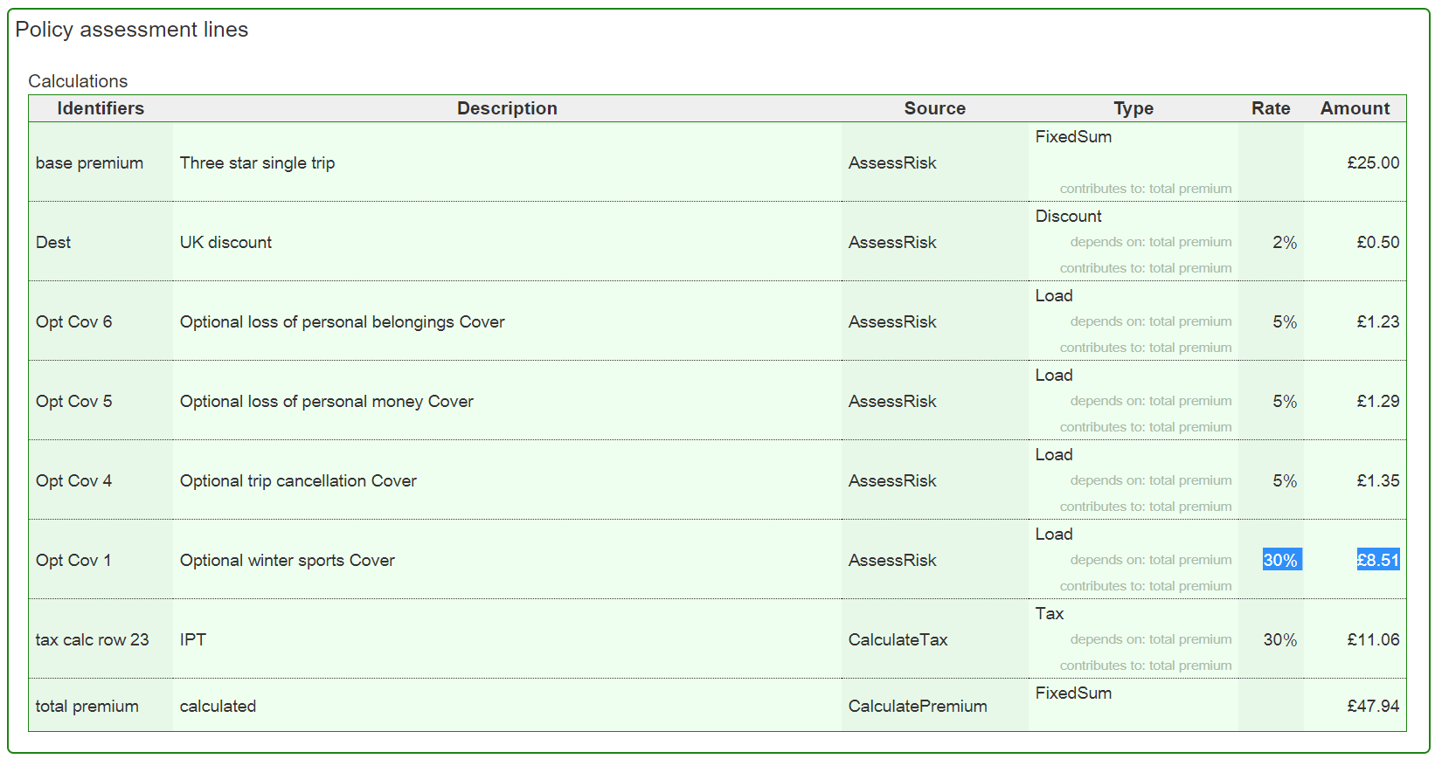

1. Use as a client/user
2. Product Travel Insurance (TravelPlus)

🡺 get a Quote

1. Search Quote
2. Report (Borderaure)
3. Product development (Product configuration/configuration of rules)
4. Website (CMS)

**Mapping**:

+ get a Quote

+ Search Quote

+ Report

+ Product configuration

**Missing**:

+ Rating engine

+ Validatation (eg, backlist customer)

+ Assign product to Broker/Agent

+ Approval

