OctaPoint
Web3 Sequence Diagrams & Move Setup Guide
Blockchain-Backed Credit-as-a-Service Platform with Developer SDKs and AI-Ready MCP Integration
System Architecture & Detail Design Documentation
Task Package 5 — System Documentation

Table of Contents

1. Introduction
This document is part of OctaPoint's system documentation deliverables and covers two things: (1) UML 2.0 sequence diagrams for the platform's core Web3 flows — merchant onboarding, walletless authentication, gasless credit issuance/redemption, AI-agent-triggered operations via the MCP Server, and the anti-fraud rejection paths — and (2) a step-by-step guide for setting up, building, testing, and deploying the Sui Move smart contract that backs the credit ledger.
The diagrams describe both the off-chain fast path (Postgres + Redis, used for the sub-100ms POS checkout requirement) and the on-chain settlement path (Sui Move contract, used for tamper-proof audit and cross-party dispute resolution), and how the two stay consistent.

1.1 Related documents
- User Requirement Document (URD) & Software Requirement Specification (SRS)
- System Architecture & Detail Design Document
- Database Schema & Move Smart Contract Specification
- SDK & MCP Integration Guide
- Test Plan, Installation Guide, and User Manuals

2. Web3 Sequence Diagrams
Each diagram below follows UML 2.0 sequence diagram conventions: solid arrows are synchronous calls, dashed arrows are returns/responses, and shaded frames denote alt (conditional branch) and par (parallel/async) combined fragments.

2.1 Merchant Onboarding & On-Chain Treasury Creation
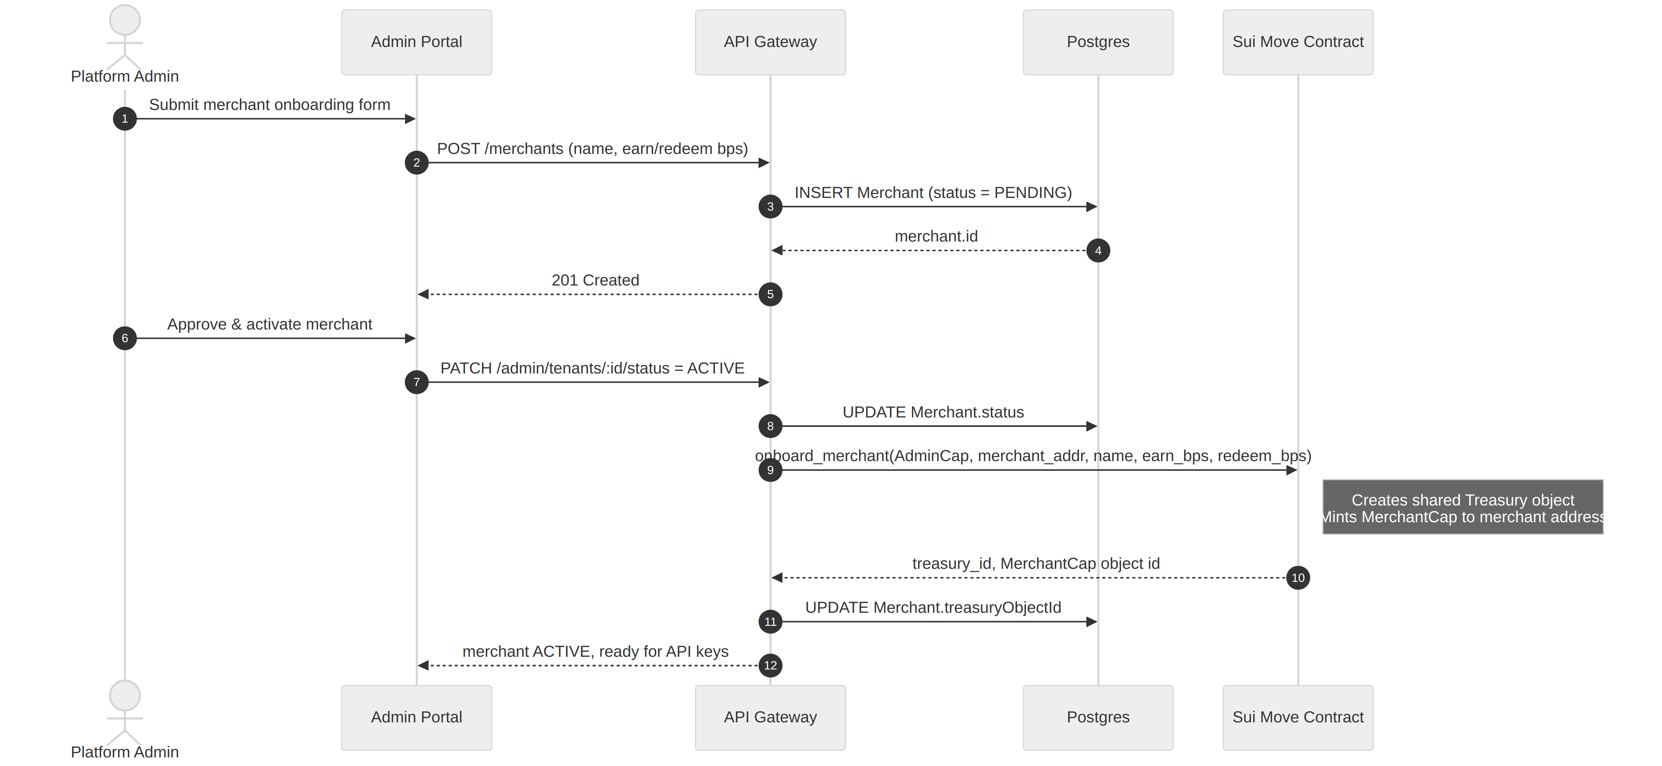
Figure 2.1 — Platform admin onboards a merchant; a shared Treasury object and a MerchantCap are created on-chain.

Actors & components
Actor / Component | Role in the flow
Platform Admin | Operator approving new merchants via the Admin Portal
Admin Portal | Next.js operator console (apps/admin-portal)
API Gateway | Hono service orchestrating the onboarding workflow
Postgres | Off-chain system of record for merchant/tenant metadata
Sui Move Contract | octapoint::credit — onboard_merchant entry function

Narrative
1. The admin submits the merchant onboarding form (name, earn/redeem basis points) from the Admin Portal.
2. The API Gateway creates a Merchant row in Postgres with status PENDING and returns the merchant id.
3. Once reviewed, the admin activates the merchant; the gateway updates the status to ACTIVE.
4. The gateway calls onboard_merchant on the Move contract using the platform's AdminCap, which creates a shared Treasury object scoped to that merchant and mints a MerchantCap transferred to the merchant's address.
5. The resulting treasury object id is written back to Postgres (Merchant.treasuryObjectId) so later issue/redeem calls know which on-chain object to target.

Capability-gated by design
Only the address holding the platform's single AdminCap can create new Treasuries — this is what prevents an unauthorized party from minting a fake merchant treasury.

2.2 Walletless Authentication (zkLogin via Enoki)
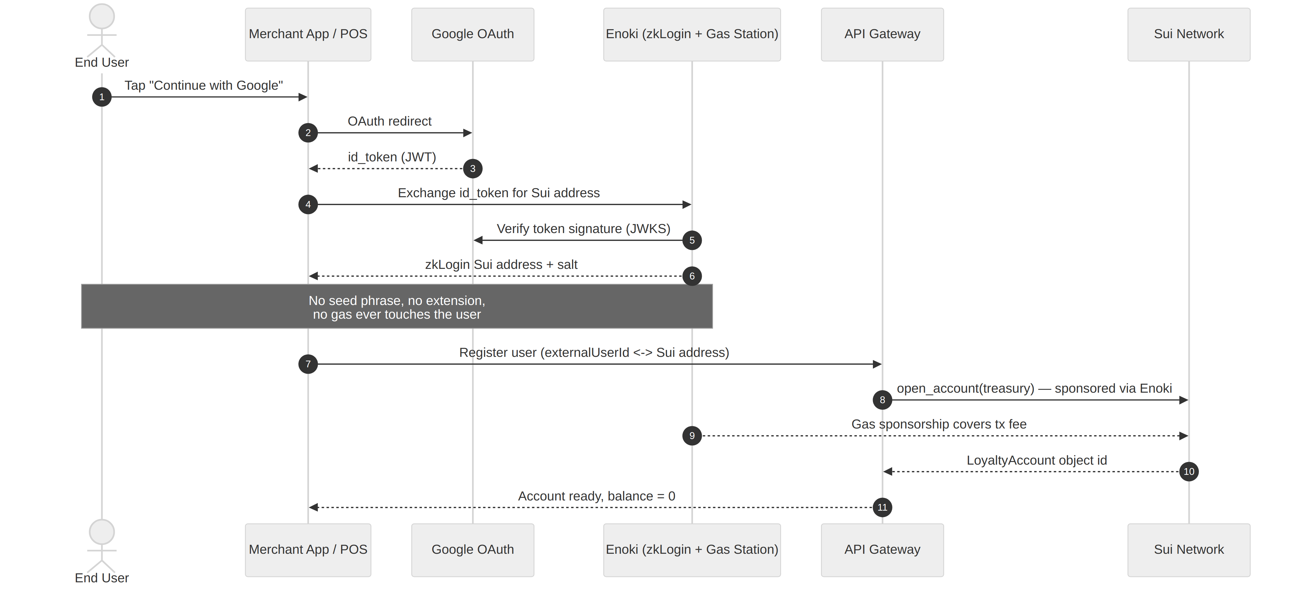
Figure 2.2 — An end user signs in with Google and receives a Sui address without ever managing a seed phrase or paying gas.

Actors & components
Actor / Component | Role in the flow
End User | Shopper / loyalty program member
Merchant App / POS | The merchant's own storefront, app, or point-of-sale terminal
Google OAuth | Standard OAuth2 identity provider
Enoki | Mysten Labs' zkLogin + gas station service
API Gateway | Registers the resulting address against a LoyaltyAccount
Sui Network | Executes open_account, fee sponsored by Enoki

Narrative
1. The user taps "Continue with Google" inside the merchant's app — no wallet extension or seed phrase is ever presented.
2. The merchant app receives a standard OAuth id_token from Google.
3. Enoki exchanges that id_token for a deterministic zkLogin Sui address (verifying the token against Google's JWKS under the hood).
4. The API Gateway registers the mapping between the merchant's own externalUserId and the derived Sui address, then calls open_account on the Treasury.
5. Enoki's gas station sponsors the transaction fee, so the open_account call — and every later issue/redeem/transfer — is fully gasless from the end user's perspective.

Solves the Web3 Friction problem
This is the mechanism that removes the adoption barrier called out in the proposal's context: users authenticate with a familiar Web2 identity, and merchants never have to build wallet UX.

2.3 Gasless Credit Issuance & Redemption
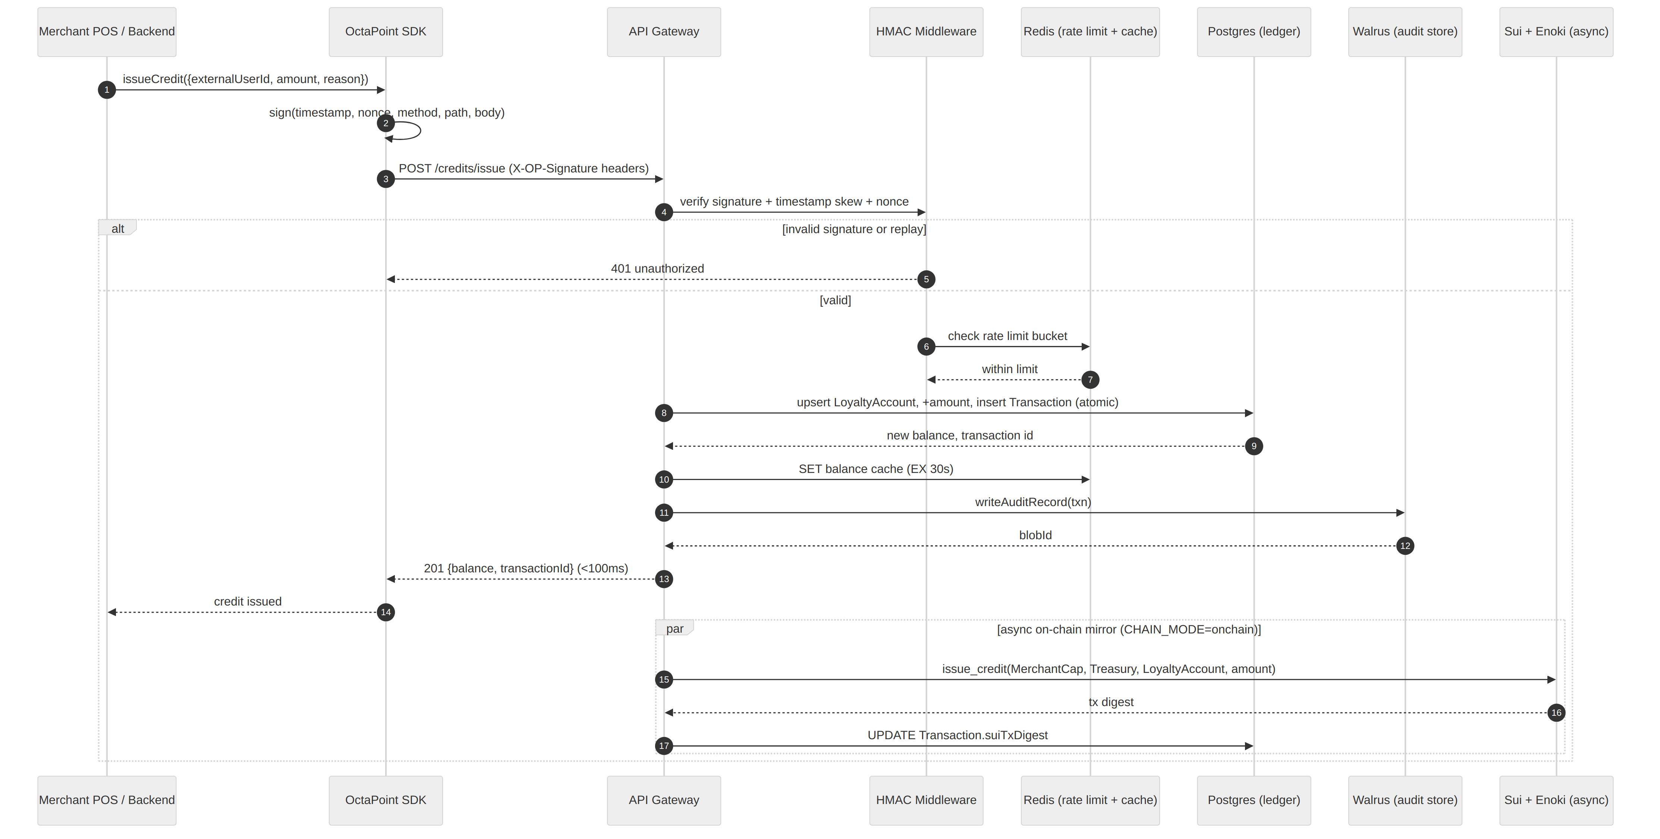
Figure 2.3 — The off-chain fast path answers in under 100ms; on-chain settlement happens asynchronously in parallel.

Actors & components
Actor / Component | Role in the flow
Merchant POS / Backend | Initiates an issue or redeem request, e.g. at checkout
OctaPoint SDK | Signs the request client-side (HMAC-SHA256)
API Gateway | Validates, persists, and (optionally) settles on-chain
HMAC Middleware | Signature, timestamp-skew, and nonce-replay verification
Redis | Per-merchant rate limiting + hot balance cache
Postgres | Atomic ledger write (balance + transaction row)
Walrus | Immutable, content-addressed audit record
Sui + Enoki | Asynchronous on-chain mirror of the same mutation

Narrative
1. The POS calls sdk.issueCredit(...); the SDK computes an HMAC-SHA256 signature over the timestamp, a fresh nonce, the method, path, and body.
2. The API Gateway's HMAC middleware verifies the signature, rejects stale timestamps (>5 min skew), and rejects replayed nonces.
3. The Redis-backed rate limiter checks the merchant's request bucket; anomalous issuance volume is flagged for operator review.
4. Postgres performs an atomic update: increment the LoyaltyAccount balance and insert a Transaction row keyed by an idempotent requestId.
5. The new balance is cached in Redis (30s TTL) so subsequent balance reads stay under the 100ms POS-checkout target.
6. An audit record is written to Walrus (or the local content-addressed fallback in demo mode) and its blob id is attached to the transaction.
7. The gateway responds to the SDK immediately — the on-chain mirror (when CHAIN_MODE=onchain) runs in parallel afterward and back-fills the transaction's suiTxDigest once confirmed.

Why two ledgers
Postgres is the system of record for latency-sensitive reads/writes; the Sui object is the tamper-proof source of truth cross-party disputes ultimately fall back to. The async pattern gets both properties without forcing every checkout to wait on block confirmation.

2.4 AI Agent Credit Operations via the MCP Server
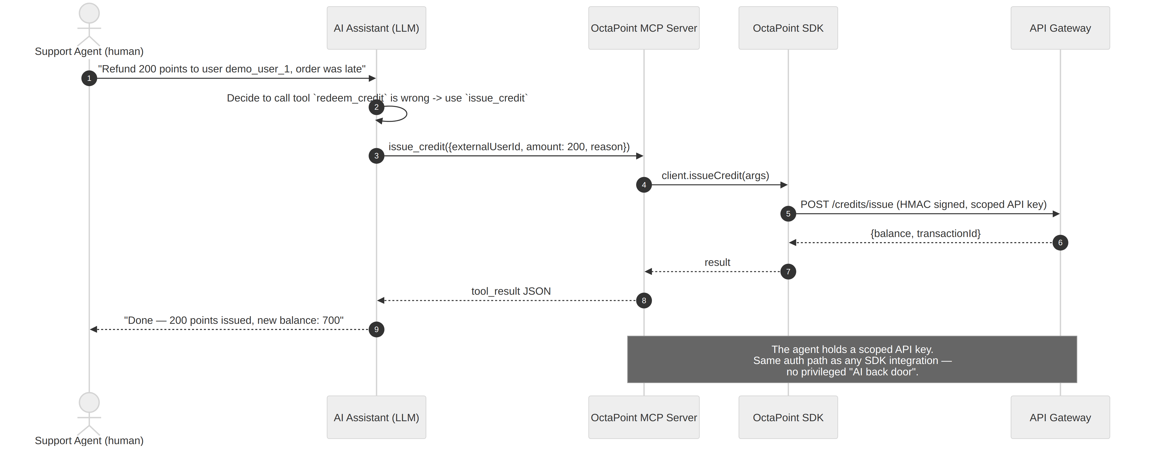
Figure 2.4 — A support agent's AI assistant issues a goodwill credit through the exact same authenticated path as any SDK integration.

Actors & components
Actor / Component | Role in the flow
Support Agent (human) | Requests an action in natural language
AI Assistant (LLM) | Decides which MCP tool to call and with what arguments
OctaPoint MCP Server | Exposes issue_credit, redeem_credit, get_balance, etc. as MCP tools
OctaPoint SDK | Used internally by the MCP Server to call the gateway
API Gateway | Identical HMAC-authenticated path as Section 2.3

Narrative
1. A human support agent asks the AI assistant to issue a goodwill credit in plain language.
2. The AI assistant selects the issue_credit MCP tool and fills in its typed arguments (externalUserId, amount, reason).
3. The MCP Server forwards the call to the API Gateway through the SDK, signed with the same HMAC-SHA256 scheme as Section 2.3 — there is no separate, less-protected path for AI traffic.
4. The gateway processes the request exactly as it would for a POS terminal or a webhook-driven integration.
5. The result is returned to the AI assistant as a tool result, which it turns into a natural-language confirmation for the human agent.

No privileged AI back door
The MCP Server holds a normal, scoped API key/secret pair like any other integration. Access control is enforced the same way regardless of whether the caller is a human-operated POS or an LLM-driven agent.

2.5 Anti-Fraud & Replay Protection
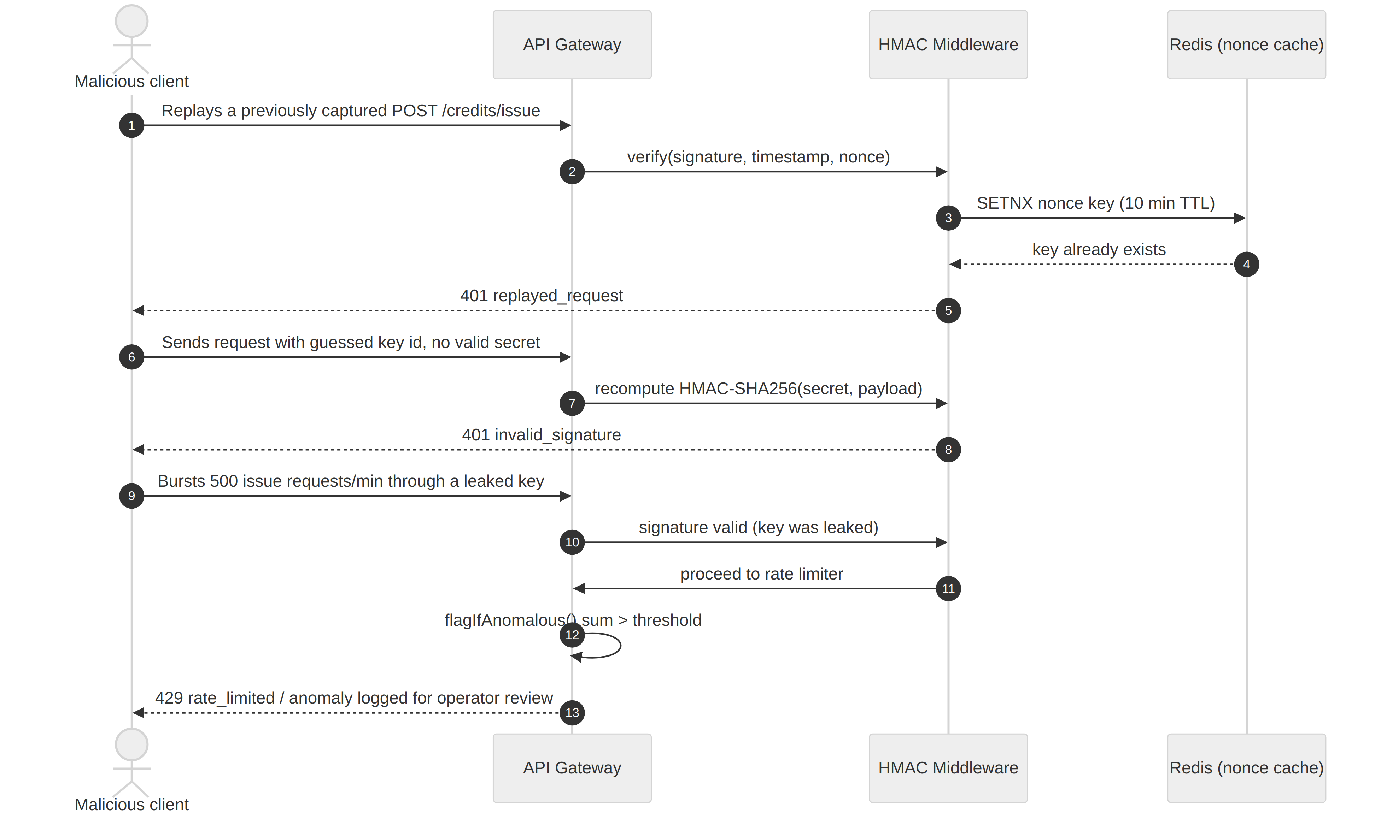
Figure 2.5 — Three classes of abuse rejected by the API Gateway's anti-fraud layer.

Actors & components
Actor / Component | Role in the flow
Malicious client | An attacker attempting spam, replay, or unauthorized minting
API Gateway | Entry point for every credit mutation
HMAC Middleware | Signature + timestamp + nonce verification
Redis (nonce cache) | 10-minute replay window per API key

Narrative
1. Replay attack: a captured, previously-valid request is resent. The nonce was already consumed, so the gateway rejects it with 401 replayed_request.
2. Forged signature: an attacker guesses or brute-forces a key id but does not know the matching secret; the recomputed HMAC does not match, so the gateway rejects it with 401 invalid_signature.
3. Leaked-key abuse: a valid but compromised key is used to burst a high volume of issue calls; the request passes signature checks but trips the anomalous-issuance-volume flag, and the rate limiter throttles further requests with 429.

Defense in depth
HMAC signing stops forgery, the nonce cache stops replay, and the Redis rate limiter plus anomaly flag stop volumetric abuse from a single compromised credential — together they address the "unauthorized point minting" and "API spam" risks named in the project's context.

3. Move Setup Guide
This guide walks through installing the Sui toolchain, building and testing the octapoint::credit Move package (contracts/octapoint), publishing it to Sui Testnet, and wiring the resulting object ids into the API Gateway so CHAIN_MODE=onchain settlement (Section 2.3) can be enabled.
Not required for the demo
The reference build runs end-to-end with CHAIN_MODE=offchain and needs none of this — use this guide when you're ready to exercise the real on-chain path for grading/demo purposes.

3.1 Prerequisites
- Rust toolchain (installed automatically by the Sui installer if missing)
- Git
- ~2 GB free disk space for the Sui binary and its dependencies
- macOS, Linux, or WSL2 on Windows

3.2 Installing the Sui CLI
Install via the prebuilt binaries (fastest) or build from source.

Option A — Homebrew (macOS/Linux)
brew install sui

Option B — Cargo (build from source, all platforms)
cargo install --locked --git https://github.com/MystenLabs/sui.git \
--branch testnet sui
Verify the install:
sui --version

3.3 Configuring a Testnet Environment & Wallet
1. Add and switch to the testnet environment:
sui client new-env --alias testnet --rpc https://fullnode.testnet.sui.io:443
sui client switch --env testnet
2. Generate a new address (or import an existing one):
sui client new-address ed25519
3. Confirm your active address:
sui client active-address

3.4 Funding Your Address (Testnet Faucet)
Request test SUI so you can pay gas for publishing and testing:
sui client faucet
# or via curl if the CLI faucet is rate-limited:
curl --location --request POST 'https://faucet.testnet.sui.io/v2/gas' \
--header 'Content-Type: application/json' \
--data-raw '{"FixedAmountRequest":{"recipient":"<YOUR_ADDRESS>"}}'
Check your balance:
sui client gas

3.5 Project Structure
The contract lives at contracts/octapoint in the OctaPoint monorepo:
contracts/octapoint/
├── Move.toml # package manifest + Sui framework dependency
├── sources/
│ └── credit.move # AdminCap, MerchantCap, Treasury, LoyaltyAccount
└── tests/
└── credit_tests.move # sui::test_scenario unit tests
Move.toml pins the Sui Framework to the testnet branch and declares the package's on-chain address placeholder:
[package]
name = "octapoint"
edition = "2024.beta"

[dependencies]
Sui = { git = "https://github.com/MystenLabs/sui.git",
subdir = "crates/sui-framework/packages/sui-framework",
rev = "framework/testnet" }

[addresses]
octapoint = "0x0" # resolved to the real package id at publish time

3.6 Building & Testing the Contract
1. From the contract directory, build:
cd contracts/octapoint
sui move build
2. Run the unit tests (covers the full issue → redeem flow in credit_tests.move):
sui move test
Expected output ends with a summary similar to:
Running Move unit tests
[ PASS ] octapoint::credit_tests::issue_and_redeem_flow
Test result: OK. Total tests: 1; passed: 1; failed: 0

3.7 Publishing to Testnet
Once tests pass, publish the package:
sui client publish --gas-budget 100000000
The CLI prints a transaction digest and an "Object changes" section. Two entries matter:
- A newly created object of type octapoint::credit::AdminCap — transferred to your address
- The published Package itself — its id is your SUI_PACKAGE_ID

3.8 Post-Deployment: Capturing Object IDs
Save these values — the API Gateway needs them:
Value to capture | Where to find it
SUI_PACKAGE_ID | The "PackageID" field from the publish output's Object changes
Admin address | Your sui client active-address — holds the AdminCap
AdminCap object id | The "ObjectID" of the created AdminCap object
You can re-look these up any time with:
sui client objects --address <YOUR_ADDRESS>

3.9 Onboarding the First Merchant via CLI
This mirrors what the API Gateway's chainService.ts does programmatically, run manually for a first smoke test:
sui client call \
--package <SUI_PACKAGE_ID> \
--module credit \
--function onboard_merchant \
--args <ADMIN_CAP_ID> <MERCHANT_ADDRESS> "Demo Mall" 100 100 0x6 \
--gas-budget 100000000
Argument 0x6 is Sui's well-known shared Clock object, required by every entry function that timestamps its events. The call creates and shares a Treasury object and transfers a MerchantCap to <MERCHANT_ADDRESS>.

3.10 Wiring the Package into the API Gateway
In the repository root .env, set:
CHAIN_MODE=onchain
SUI_NETWORK=testnet
SUI_PACKAGE_ID="0x<your package id>"
SUI_GATEWAY_SIGNER_SECRET="<bech32 or hex secret key the gateway signs with>"
The gateway signer address needs its own MerchantCap (or, for merchant-initiated calls, the merchant's own key) to call issue_credit / redeem_credit — see packages/api-gateway/src/services/chainService.ts.

3.11 Verifying on Sui Explorer
Paste your package id, transaction digest, or object id into the testnet explorer to confirm on-chain state:
https://suiscan.xyz/testnet/home
https://suiexplorer.com/?network=testnet

3.12 Troubleshooting
Symptom | Fix
InsufficientGas | Re-run sui client faucet; testnet gas expires from inactive addresses over time
ENotMerchantOwner / capability mismatch abort | Double-check the MerchantCap object id matches the Treasury you're calling against
Package build fails on framework rev | Your local Sui CLI version may be behind — run sui move build again after sui client upgrade, or pin rev to a specific commit
Object not found calling onboard_merchant | Confirm you're passing the AdminCap's object id (not the package id) as the first argument
Gateway settleOnChain() throws "SUI_GATEWAY_SIGNER_SECRET not configured" | Set CHAIN_MODE=offchain until you've generated and funded a dedicated signer key for the gateway

