|  |
| --- |
|  |
| Capstone Project Document |

**DANDELION**

Report #1 – Project Introduction

|  |  |  |
| --- | --- | --- |
| **Dandelion** | | |
| **Group Members** | Vũ Công Chính | SE02585 |
| Lưu Ngọc Mạnh | SE02619 |
| Nguyễn Minh Huy | SE02723 |
| Dương Đức Anh | SE02700 |
| Vũ Ngọc Trung | SE02967 |
| Cao Thị Phương Mai | SE02908 |
| **Supervisor** | Mr. Nguyễn Văn Sang | |
| **Project code** | DDL | |

**- Hanoi, 09/2015 –**

# SIGNATURE PAGE

AUTHOR: Nguyễn Minh Huy 15/09/2015

Team member

REVIEWERS: Lưu Ngọc Mạnh 16/09/2015

Project manager

APPROVAL: Nguyễn Văn Sang --/--/--15

Supervisor

Record of change

*A - Added M - Modified D – Deleted

|  |  |  |  |  |  |
| --- | --- | --- | --- | --- | --- |
| Effective Date | Changed Item | A,M,D | Change Description | Reason for Change | Rev. Number |
| 15/Sep/2015 | Create Introduction | A | Create Introduction | First version | 1.0 |
|  |  |  |  |  |  |
|  |  |  |  |  |  |
|  |  |  |  |  |  |
|  |  |  |  |  |  |
|  |  |  |  |  |  |
|  |  |  |  |  |  |
|  |  |  |  |  |  |
|  |  |  |  |  |  |
|  |  |  |  |  |  |
|  |  |  |  |  |  |
|  |  |  |  |  |  |
|  |  |  |  |  |  |
|  |  |  |  |  |  |
|  |  |  |  |  |  |
|  |  |  |  |  |  |
|  |  |  |  |  |  |
|  |  |  |  |  |  |
|  |  |  |  |  |  |
|  |  |  |  |  |  |
|  |  |  |  |  |  |
|  |  |  |  |  |  |
|  |  |  |  |  |  |
|  |  |  |  |  |  |

Table of Contents

SIGNATURE PAGE 2

1 INTRODUCTION 4

1.1 Purpose 4

1.2Acronyms and Definitions 4

2 ABSTRACT 4

3 LITERATURE REVIEW 4

4 PROPOSAL 8

4.1The idea 8

4.2Objectives 8

4.3Brief description about system 8

4.4System features 9

4.4.1 Client features 9

4.4.2 Admin features 10

5 BENEFIT FROM PROJECT 11

5.1For our group 11

5.2For Community 11

6 CRITICAL ASSUMPTION AND CONSTRAINTS 11

7 POTENTIAL RISKS 12

8 REFERENCES 12

# INTRODUCTION

## Purpose

This document is created as the introduction for project Dandelion – our Capstone Project at FPT University. In this document, we will descript the overview of some existing systems, the initial idea for our project, a brief description about our expected system and some potential risks, critical assumptions, constrains. Moreover, this document also shows opportunities what it offers for users.

## Acronyms and Definitions

|  |  |
| --- | --- |
| **Acronym & Abbreviation** | **Definition** |
| DDL | Dandelion |
| FU | FPT University |
| Q&A | Question and Answer |

**Table 1-1:** Definitions and Acronyms

# ABSTRACT

We’re a home for everything from films, games, and music to art, design, and technology. Dandelion is full of projects, big and small, that are brought to life through the direct support of people like you. Dandelion is a platform and a resource; we’re not involved in the development of the projects themselves. Anyone can launch a project on Dandelion as long as it follows our rules. Project creators set a funding goal and deadline. If people like a project, they can pledge money to make it happen. Backers are supporting projects to help them come to life, not to profit financially. Instead, project creators offer rewards to thank backers for their support. We believe that creative projects make for a better world, and we’re thrilled to help support new ones. Building a community of backers around an idea is an amazing way to make something new.

# LITERATURE REVIEW

There are quite a few major platform for crowdfunding your project idea. However just have one crowdfunding in Vietnam. And that major platform just aim to comic project. For example: kickstarter.com, comicola.com, indiegogo.com, etc.

**Kickstarter**

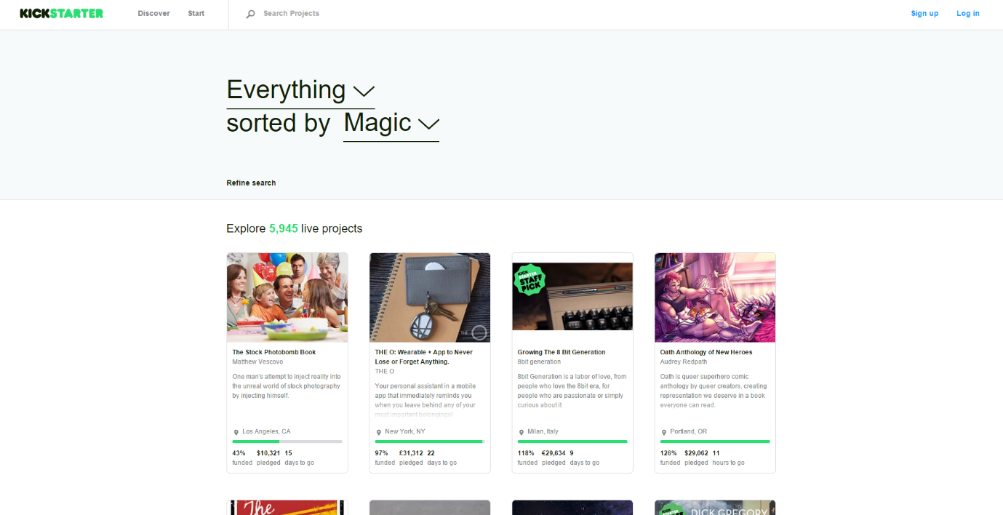

**Figure 1-1:** Website Kickstarter

Kickstarter is the biggest major platform for crowdfunding your project idea, users can create a project, Kickstarter staff look at your proposed project and provide feedback. Then they (hopefully) approve your project and it’s posted on the site. If that project don’t hit the funding goal in the specified time frame, no one’s cards get charged and user don’t receive any of the funds.

* **Advantages:**
* The biggest major platform for crowdfunding
* Kickstarter positions itself mostly as a community for creative projects.
* Kickstarter staff provide feedback to help your project succeed.
* **Disadvantages:**
* You have to be based in the US, Canada, the UK, Australia, New Zealand or the Netherlands.
* Only support PayPal, MasterCard, etc. These are not popular in Vietnam.
* **Comicola**

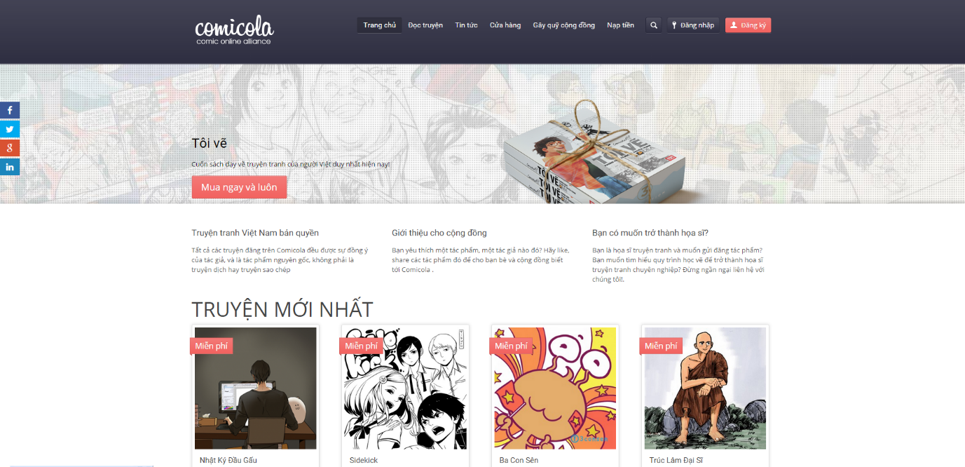

**Figure 1-2:** Website Comicola

Comicola is a major platform for crowdfunding your comic project idea in Vietnam.

* **Advantages:**
  + Has friendly user interface – Vietnamese.
  + Making payments easier for creators and backers.
* **Disadvantages:**
  + Just for comic project.

# PROPOSAL

## The idea

Nowadays people have a lot of idea to make things better. But lots of people are short of funds to raise their idea. Many thanks for internet they can easy to show these ideas to everyone.   
Our project – Dandelion is a major platform for crowdfunding. Anybody could launch a project on Dandelion as long as it follows our rules. We believe that creative projects making a better world, and we’re thrilled to help support new ones. Building a community of backers around an idea is an amazing way to make something new.

## Objectives

This project is the Capstone Project in FPT University studying program.

First, this project is responsibility for all team members. So we must complete all requirements from teacher and FU. During the time doing project, we can learn how to develop a project, how to manage project, how to communicate better between team member, how to control time, how to perform teamwork effectively. Moreover, we also have experience in .NET technology, website designing, software testing Therefore, we think this project is very necessary for us to improve skills, knowledge which we studied in FU. This project also makes our CV more beautiful after graduating from FU. This is also an opportunity for us to prove capacity with recruiters.

Second, because we’d love to support people’s dream, especially Vietnamese users to create something that they want to see exist in the world. Everything from films, games, and music to art, design, and technology. And we want to build a community where people rally around their friends’ projects, fans support people they admire, and others simply come to DDL to be inspired by new ideas. Anyone can create a new project, update, share a project to social network or back a project. Specially, our website can display completely in Vietnamese, so that even users do not know English, they can easily use it.

## Brief description about system

This software is a major platform for crowdfunding with friendly and attractive interface, users can easily find out interesting project to back or create a new project with their idea. User also can send opinion to admin if they need help.

DDL uses familiar technologies as: Bootstraps, .NET MVC5, AngularJS… And we are planning to develop a mobile version for easily connecting.

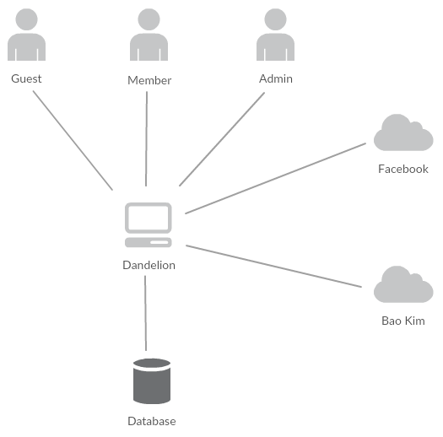

**Figure 1-3:** Brief descriptions diagram of DDL system

## System features

About the features of DDL, we focus to provide for users main features as searching, filter project, create new project, back project, etc. Admin can manage members, manage projects, manage database, manage contribute database and manage Q&A.

In here, we focus on features which can help users can understand the best way what user want to have with features of DDL. There are the detailed features of DDL:

### Client features

* Register: User can register an account and login to use all features of DDL.
* Login/Logout: Users login/logout an account to use or exit system DDL.
* Search: User and guest can search with code of project, name of project, name of creator; and system will display all of project relate to keywords.
* Filter: User can filter with category (Art, Comics, Game, etc.), place (Earth, Vietnam, etc.), Status (Magic, Popularity, Most Funded, etc.). And system will display projects relate to these selected options.
* Project
  + Create New Project: Users can create new projects with basic info, reward, timeline, clip and some pictures.
  + Update Project Information: User can change and update information of projects which created.
  + Comment/Remind: Users can comment/remind a project to follow and discuss with another users.
  + Report: User can report a project which violate regulation to administrator.
* Back Project: User can back another project to donate money to help project success and get rewards.
* Profile:
  + Change password: User can change password to keep security.
  + Update profile: User can change or update information.
  + Manage created projects, backed projects, reminded projects: User can follow process of projects, follow project backed, project reminded. View statistical projects had created, backed, reminded.
  + Sent/Receive message: Users can send to or receive from other users to discuss about projects.

### Admin features

* Manage user:
  + search user: Admin can search with name of user and system will display simple information about that user(name, email, phone number)
  + Inactive/active user: admin can set user’s account to inactive or active.
* Manage project:
  + search project :
    - Search with project name: Admin can search with name of project and system will display simple information about that project.
    - Search with category: Admin can search with category of project and system will display all project with that category
    - Search with Creator name: Admin can search with Creator name of project and system will display all project of that user.
  + Edit project status: Admin can set status of a project: pending to approved, pending to suspend, approved to suspend, etc.
* Manage Backing: Admin can view users who backed a project. Also, Admin can view simple information about that user and which reward they chose.
* Manage Categories:
  + Add new category: Admin can add new category.
  + inactive/active category: Admin can set category’s status to inactive or active
* Manage Slider: Slider list includes images what running at homepage.
  + Add new image: Admin can add new image to slider
  + Inactive/active: Admin can set image’s status to inactive or active on slider.
  + Delete image: Admin can delete image.
* Message: Admin can view received messages/sent messages.
  + Compose new message: Admin can compose new message to send to user.
  + Delete message: Admin can delete received messages/sent messages.

# BENEFIT FROM PROJECT

## For our group

After developing and implementing this project, our group will get some benefits:

* Have more experiences of software project management how to manage plan, time, member and risk.
* Have more knowledge and skill about .NET MVC5 and AngularJS programming
* Know how to communicate with team members and how to teamwork more effective.

## For Community

Just need to have a device that connect to the internet and any web browser, user can:

* Easy join to a community of crowdfunding
* Easy search for interesting project information and back them
* Easy to start a new project idea
* Free for all users.

# CRITICAL ASSUMPTION AND CONSTRAINTS

* Critical assumption:
* Training: All developers can train .NET and AngularJS in 2 weeks. Before starting this project, just 1 member in our team have knowledge about .NET and no one have knowledge about AngularJS, but with programming techniques which we studied at FU, we have to try the best to not missing any deadline in project plan.
* Human resources: Assume that all members in team have a good healthy to do their tasks.
* Constraints:
* Time and deadline: We must complete task on time. We work on 14 weeks, each member works 5 hours/day and 5 days/week. We do not have more time for us to complete developing and deliver application to teachers. Besides, we have to submit report documents before deadline to teacher can review.
* Quality: The products must be run well when users perform main functions in Google Chrome 40 and Firefox 30 or higher.
* Process: We have to follow the software processing of FPT Software
* Human resources: There are 6 member in our team, each member have to study 2 subjects (Japanese and JFE) at school.

# POTENTIAL RISKS

After studying about this project, we find out some problem that we may be encountered:

* Under-estimate scope and time or miss deadline because lack of experience in group working, managing and controlling work.
* Loss data, source code before uploading data to server because of careless.
* Equipment got broken because of careless or accident.
* Human resources: Team member cannot complete their works because of health reasons, key member leave team or un-cooperating on team.
* Change requirements: Requirement changed when some functions cannot be completed or some technologies is not suitable.

# REFERENCES

* **Kickstarter at URL:**  <https://www.kickstarter.com/>
* **Comicola at URL:** <https://www.comicola.com/>
* **Indiegogo at URL:** <https://www.indiegogo.com/>