

**BUS USER SUPPORT SYSTEM**

**DETAIL DESIGN DOCUMENT**

**Data Design**

**Project Code: BUSS**

**Document Code: BUSS_Data_Design_v1.1_EN**

**Ha Noi, 19/06/2015**

**Record of change**

*A - Added M - Modified D – Deleted

|  |  |  |  |  |
| --- | --- | --- | --- | --- |
| **Effective Date** | **Changed Items** | **A* M, D** | **Change Description** | **New Version** |
| 19/06/2015 | Add new | A | Add this document | v1.0 |
| 20/08/2015 | Update | M | Update this document | v1.1 |
|  |  |  |  |  |
|  |  |  |  |  |

**SIGNATURE PAGE**

**AUTHOR:** Nguyen Thanh Nam 19/06/2015

Technical Leader

**REVIEWERS:** Trinh Thi Tuyet Mai 30/06/2015

Developer

**APPROVAL:** Nguyen Van Sang 30/06/2015

Supervisor

**TABLE OF CONTENTS**

1 Introduction 5

1.1 Purpose 5

1.2 Definitions, Acronyms and Abbreviations 5

1.3 References 5

1.4 Overview 6

2 Database 7

2.1 ERDs 7

2.2 Table Database 9

2.2.1 Table diagram 9

2.2.2 User table 10

2.2.3 Place table 11

2.2.4 FavoritePlace table 11

2.2.5 BusRoute table 11

2.2.6 BusStop table 12

2.2.7 Bus table 12

2.2.8 FavoriteBus table 13

2.2.9 Track table 13

2.2.10 Reminder table 13

2.2.11 History table 14

3 Appendix 15

3.1 Data format symbol 15

# Introduction

## Purpose

Bus User Support System data design document describes structure of database and file structure of system including internal file structure as well as interface file structure.

## Definitions, Acronyms and Abbreviations

|  |  |  |
| --- | --- | --- |
| Abbreviations | Description | Comment |
| PK | Primary key | Use to indicate that a field is a primary key in table |
| FK | Foreign key | Use to indicate that a field is a foreign key in table |
| PFK | Primary Foreign key | Use to indicate that a field is a foreign key which referred to a column of another table as well as (a part of) primary of this table |
| V | Check value null | Set value “null” for attribute in table |
| Y | Check value unique | Set value “unique” for attribute in table |
| AI | Auto increment | Attribute of column in table |
| UN | Unsigned | Attribute of numeric column in table |

## References

List the entire reference document such as: other document of the system, or the technical article.

|  |  |
| --- | --- |
| Document Number | Title |
| v1.1 | BUSS_ Class_Design_v1.1_EN |
| v1.1 | BUSS_ Screen_Design_v1.1_EN |

## Overview

General overview of the detail design such as what is the structure of the document:

* Introduction
* Database
* Appendix

# Database

## ERDs

Entity relationship diagrams

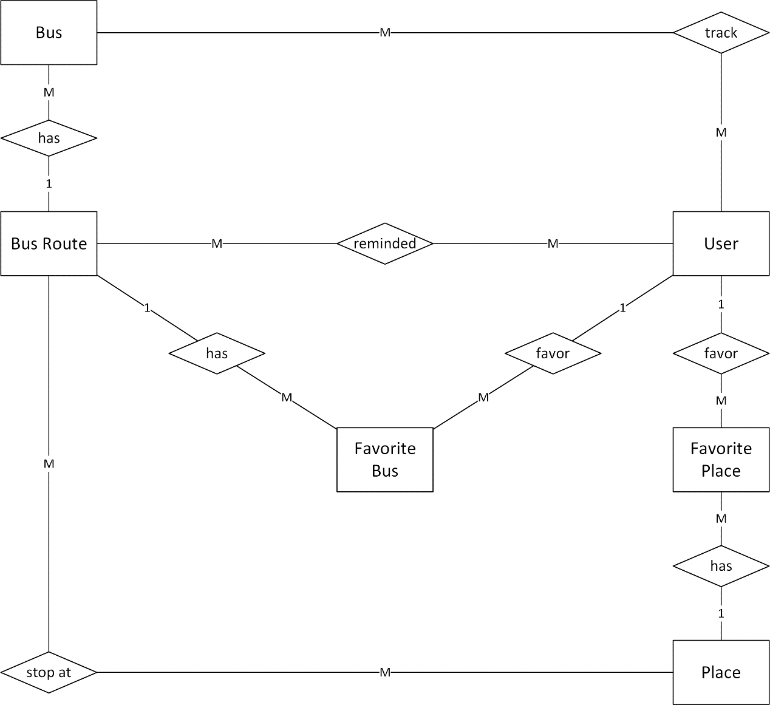

Figure 1.1: Entity relationship diagrams

|  |  |  |
| --- | --- | --- |
| **No** | **Entity** | **Description** |
| 1 | User | User is all of the people using BUSS application. |
| 2 | Bus | The bus with its identify information |
| 3 | Favorite Bus | The favorite bus of user |
| 4 | Place | The place – the location |
| 5 | Favorite Place | The favorite place of user |
| 6 | Bus Route | The bus route |

List of relations of entities and brief description

|  |  |  |  |  |
| --- | --- | --- | --- | --- |
| **No** | **Entity A** | **Entity B** | **Relation** | **Description** |
| 1 | User | Bus Route | Many to many | Each User can set remind for many Bus Routes and each Bus Route can be set remind for many Users |
| 2 | User | Bus | Many to many | Each User can track many Buses and each Bus can be tracked by many Users |
| 3 | User | Favorite Bus | One to many | Each User can has many Favorite Buses and each Favorite Bus is belong to one User |
| 4 | User | Favorite Place | One to many | Each User can has many Favorite Places and each Favorite Place is belong to one User |
| 5 | Bus Route | Bus | One to many | Each Bus Route can has many Bus and each Bus is belong to one Bus Route |
| 6 | Bus Route | Favorite Bus | One to many | Each Bus Route can be set as many Favorite Bus and each Favorite Bus is belong to one Bus Route |
| 7 | Bus Route | Place | Many to many | Each Bus Route have bus stop at many Place and each Place can be the bus stop for many Bus Route |
| 8 | Place | Favorite Place | One to many | Each Place can be set as many Favorite Place and each Favorite Place is one Place |

## Table Database

### Table diagram

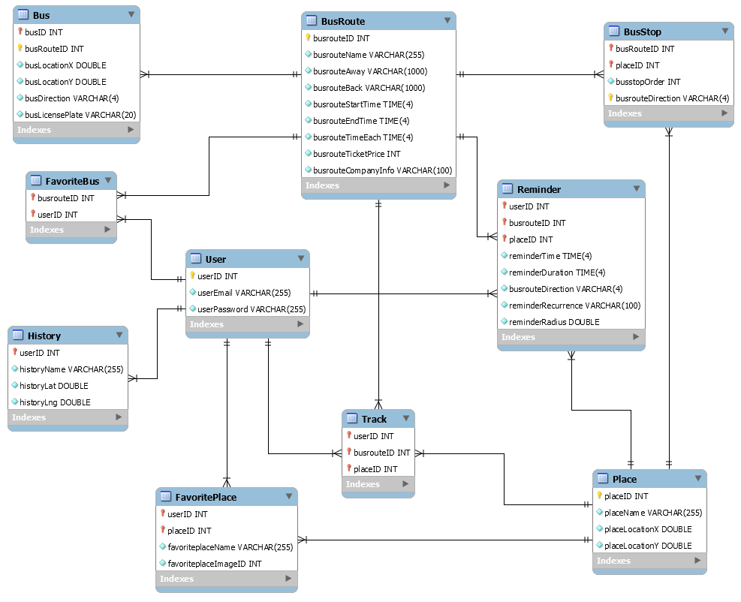Figure 1.2: Table diagram

n

List of tables and brief description

|  |  |  |
| --- | --- | --- |
| **No** | **Table Name** | **Description** |
|  | User | Store all user information |
|  | Place | Store all information of places |
|  | FavoritePlace | Store all information of favorite places |
|  | BusRoute | Store all information of bus routes |
|  | BusStop | Store all information of bus stops |
|  | Bus | Store all information of buses |
|  | FavoriteBus | Store all information of favorite buses |
|  | Track | Store all information of track |
|  | Reminder | Store all information of reminders |
|  | History | Store all information of find path history |

### User table

|  |  |  |  |  |  |  |  |  |
| --- | --- | --- | --- | --- | --- | --- | --- | --- |
| No | Field Name | Type | Length | Null | Unique | P/F Key | Default | Description |
|  | userID | Int |  |  | Y | PK | AI/UN | User’s id |
|  | userEmail | Varchar | 255 |  | Y |  |  | User login email |
|  | userPassword | Varchar | 255 |  |  |  |  | Store password login of user. |

### Place table

|  |  |  |  |  |  |  |  |  |
| --- | --- | --- | --- | --- | --- | --- | --- | --- |
| No | Field Name | Type | Length | Null | Unique | P/F Key | Default | Description |
|  | placeID | Int |  |  | Y | PK | AI/ UN | Place’s id |
|  | placeName | Varchar | 255 |  |  |  |  | Place’s name |
|  | placeLocationX | Double |  |  |  |  | UN | Place’s latitude |
|  | placeLocationY | Double |  |  |  |  | UN | Place’s longitude |

### FavoritePlace table

|  |  |  |  |  |  |  |  |  |
| --- | --- | --- | --- | --- | --- | --- | --- | --- |
| No | Field Name | Type | Length | Null | Unique | P/F Key | Default | Description |
|  | userID | Int |  |  |  | PFK | UN | User’s id |
|  | placeID | Int |  |  |  | PFK | UN | Place’s id |
|  | favoritePlaceName | Varchar | 255 |  |  |  |  | Favorite place name |
|  | favoritePlaceImageID | Int |  |  |  |  | UN | Favorite place image ID |

### BusRoute table

|  |  |  |  |  |  |  |  |  |
| --- | --- | --- | --- | --- | --- | --- | --- | --- |
| No | Field Name | Type | Length | Null | Unique | P/F Key | Default | Description |
|  | busrouteID | Int |  |  | Y | PK | UN | Bus route’s id |
|  | busrouteName | Varchar | 255 |  |  |  |  | Bus route’s name |
|  | busrouteAway | Varchar | 1000 |  |  |  |  | Bus route away |
|  | busrouteBack | Varchar | 1000 |  |  |  |  | Bus route back |
|  | busrouteStartTime | Time | 4 |  |  |  |  | Bus route start time |
|  | busrouteEndTime | Time | 4 |  |  |  |  | Bus route end time |
|  | busrouteTimeEach | Time | 4 |  |  |  |  | Bus route time each |
|  | busrouteTicketPrice | Int |  |  |  |  | UN | Bus route ticket price/ each |
|  | busrouteCompanyInfo | Varchar | 100 |  |  |  |  | Bus route company information |

### BusStop table

|  |  |  |  |  |  |  |  |  |
| --- | --- | --- | --- | --- | --- | --- | --- | --- |
| No | Field Name | Type | Length | Null | Unique | P/F Key | Default | Description |
|  | placeID | Int |  |  |  | PFK | UN | Place’s id |
|  | busrouteID | Int |  |  |  | PFK | UN | Bus route’s id |
|  | busstopOrder | Int |  |  |  |  | UN | Bus stop order |
|  | busrouteDirection | Varchar | 50 |  |  | PK |  | Bus route direction |

### Bus table

|  |  |  |  |  |  |  |  |  |
| --- | --- | --- | --- | --- | --- | --- | --- | --- |
| No | Field Name | Type | Length | Null | Unique | P/F Key | Default | Description |
|  | busID | Int |  |  |  | PK | UN | Bus’s id |
|  | busrouteID | Int |  |  |  | PFK | UN | Bus route’s id |
|  | busLocationX | Double |  |  |  |  | UN | Bus latitude |
|  | busLocationY | Double |  |  |  |  | UN | Bus longitude |
|  | busrouteDirection | Varchar | 4 |  |  |  |  | Bus route direction |

### FavoriteBus table

|  |  |  |  |  |  |  |  |  |
| --- | --- | --- | --- | --- | --- | --- | --- | --- |
| No | Field Name | Type | Length | Null | Unique | P/F Key | Default | Description |
|  | userID | Int |  |  |  | PFK | UN | User’s id |
|  | busRouteID | Int |  |  |  | PFK | UN | Bus route’s id |

### Track table

|  |  |  |  |  |  |  |  |  |
| --- | --- | --- | --- | --- | --- | --- | --- | --- |
| No | Field Name | Type | Length | Null | Unique | P/F Key | Default | Description |
|  | userID | Int |  |  |  | PFK | UN | User’s id |
|  | placeID | Int |  |  |  | PFK | UN | Place’s id |
|  | busID | Int |  |  |  | PFK | UN | Bus id |

### Reminder table

|  |  |  |  |  |  |  |  |  |
| --- | --- | --- | --- | --- | --- | --- | --- | --- |
| No | Field Name | Type | Length | Null | Unique | P/F Key | Default | Description |
|  | userID | Int |  |  |  | PFK | UN | User’s id |
|  | busrouteID | Int |  |  |  | PFK | UN | Bus route’s id |
|  | placeID | Int |  |  |  | PFK | UN | Place’s id |
|  | reminderTime | Time | 4 |  |  | PK |  | Reminder time |
|  | reminderDuration | Time | 4 |  |  |  |  | Reminder duration |
|  | busrouteDirection | Varchar | 4 |  |  |  |  | Bus route direction |
|  | reminderRecurrence | Varchar | 100 |  |  |  |  | Reminder recurrence |
|  | reminderRadius | Double |  |  |  |  |  | Reminder distance |

### History table

|  |  |  |  |  |  |  |  |  |
| --- | --- | --- | --- | --- | --- | --- | --- | --- |
| No | Field Name | Type | Length | Null | Unique | P/F Key | Default | Description |
|  | userID | Int |  |  |  | PFK | UN | User’s id |
|  | historyName | Varchar | 255 |  |  |  |  | History name |
|  | historyLat | Double |  |  |  |  | UN | History latitude |
|  | historyLng | Double |  |  |  |  | UN | History longitude |

# Appendix

## Data format symbol

Following symbols are used to describe format of data field in files as well as in tables.

|  |  |
| --- | --- |
| Symbol | Description |
| # | Digit placeholder. |
| . | Decimal placeholder. |
| , | Thousands separator. |
| : | Time separator. |
| / | Date separator. |
| \ | Treat the next character in the mask string as a literal. This allows you to include the '#', '&', 'A', and '?' characters in the mask. This character is treated as a literal for masking purposes. |
| > | Convert all the characters that follow to uppercase. |
| < | Convert all the characters that follow to lowercase. |
| A | Alphanumeric character placeholder (entry required). |
| A | Alphanumeric character placeholder (entry optional). |
| 9 | Digit placeholder (entry optional). For example: 0 – 9. |
| 0 | Digit placeholder (entry required). For example: 0 – 9. |
| C | Character or space placeholder (entry optional). Valid values for this placeholder are ANSI characters in the following ranges: 32-126 and 128-255. |
| & | Character placeholder (entry required). Valid values for this placeholder are ANSI characters in the following ranges: 32-126 and 128-255. |
| ? | Letter placeholder. For example: a – z or A – Z. |
| Literal | All other symbols are displayed as literals; that is, as themselves. bound in “” like “ABC” |