|  |
| --- |
|  |



BUS USER SUPPORT SYSTEM

**Report #1 – Project Introduction**

**Project Code: BUSS**

**Document Code: BUSS_Introduction_EN**

**- Hanoi, 05/2015 -**

Table of Contents

1 INTRODUCTION 3

1.1 Purpose 3

1.2 Acronyms and Definitions 3

2 ABSTRACT 3

3 LITERATURE REVIEW 3

4 PROPOSAL 5

4.1 The idea 5

4.2 Objectives 5

4.3 Brief description about system 6

4.4 System features 6

5 BENEFIT FROM PROJECT 7

5.1 For our group 7

5.2 For Community 7

6 CRITICAL ASSUMPTION AND CONSTRAINTS 7

7 POTENTIAL RISKS 8

8 REFERENCES 8

# INTRODUCTION

## Purpose

This document is created as the introduction for project Bus User Support System – our Capstone Project at FPT University. In this document, we will describe the overview of some existing systems, the initial idea for our project, a brief description about our expected system and some potential risks, critical assumptions and constraints. In addition, this document also shows opportunities what it offers for users.

## Acronyms and Definitions

|  |  |
| --- | --- |
| **Acronym & Abbreviation** | **Definition** |
| BUSS | Bus User Support System |
| FU | FPT University |
| BU | Bus User |
| IN | Interactive Network |
| Q&A | Question and Answer |
|  |  |
|  |  |

**Table 1-1:** Definitions and Acronyms

# ABSTRACT

In Vietnam, road traffic is the most common and crowded form of transportation. Thus, this is also the worst kind. People used to drive their own personal vehicle everywhere such as cars, bike and especially all kinds of motorbike. The mass use of personal transportation vehicle dramatically decrease the effectiveness of traffic facilities and makes the air pollution situation worse than ever – which directly affects people' lives. This problem is a very familiar in other developing countries as well. Public transportation is the only key to solve this problem. Unfortunately, this kind of transportation is not getting enough attention from both citizens and government in Vietnam. And for the record, buses are the most common used public transportation in our country.

As formally students, we love buses. Bus is a cheap and effective way to get to almost everywhere in the city without too much concern for traffic jams or noise or exhaust gas. Using bus is a great way to contribute to decreasing the level of air pollution in the city and getting rid of the traffic jam status in big cities. To support and encourage the using of bus, BUSS is created base on a single idea of making bus traveling easy and fun for everyone, especially children, students and young people.

# LITERATURE REVIEW

Bus is becoming more and more popular in daily transportation in big cities in Vietnam. However, the engineering limitation of low level public transportation development in our country due to the ignorance of the government does not allow the influence of new and advanced technology to make using bus more convenient. There are quite a few of bus user supporting application published, and most of them are not satisfied users.

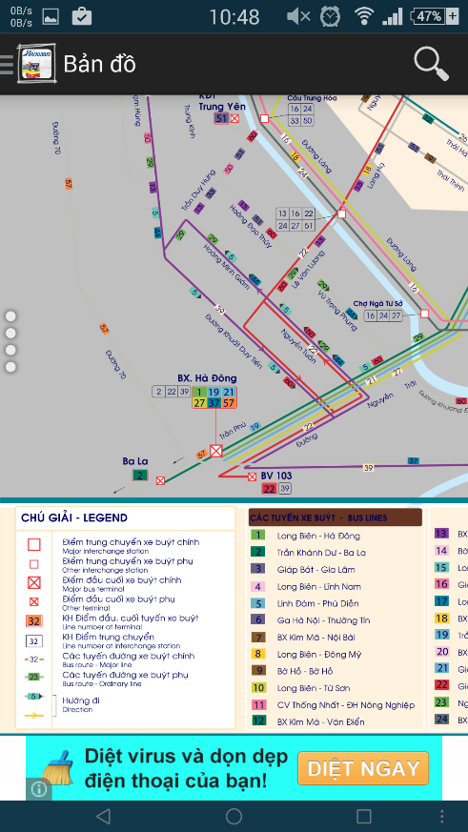**Hanoi Bus**

The app allow users to view bus map, locate current gps, look up bus list, find path and… call for a taxi?!?

*Advantages:*

* Support almost needed features

*Disadvantages:*

* Poorly designed, the bus map is nothing more than a high resolution picture of a real map.
* Including ads
* Out of date and has not been update for quite long

**Figure 1-1:** Hanoi Bus interface

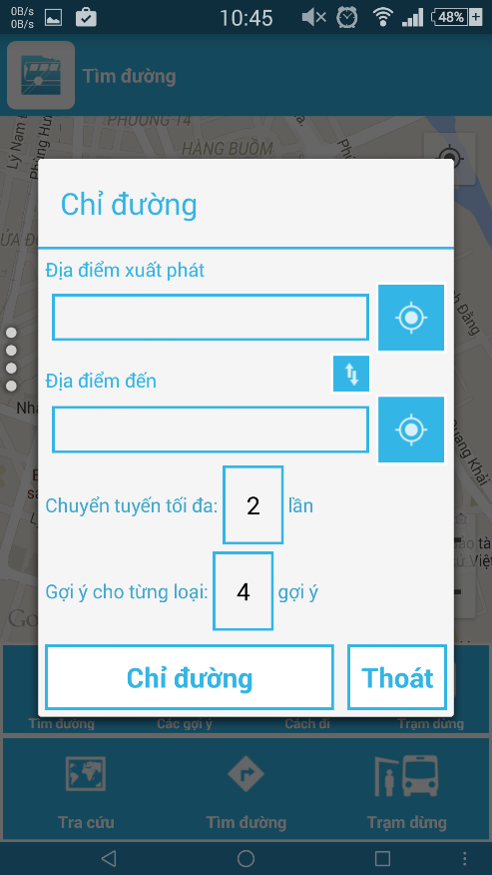**Bus Map**

The app allow users to view bus map, search for bus, look for bus-stop, find path, see bus list.

*Advantages:*

* Support almost needed features
* No ads included

*Disadvantages:*

* Complicate and confusing UI
* Pretty hard to navigate among functions
* Sometimes not function correctly

**Figure 1-2:** Bus Map interface

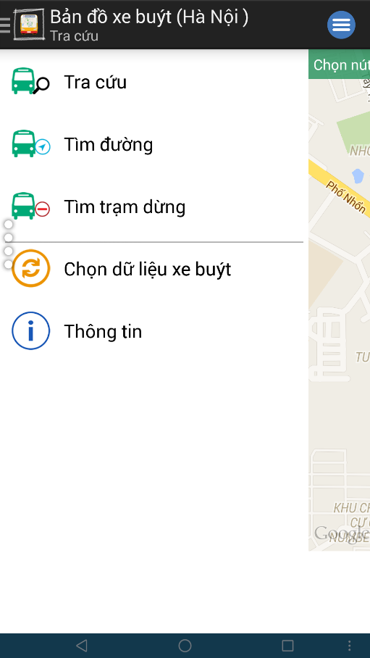**Bản Đồ Xe Buýt**

The app allow users to view bus list, bus detail, find path, find bus-stop.

*Advantages:*

* Support bus data from both Hanoi and Ho Chi Minh city
* Better and simple design

*Disadvantages:*

* Lack of many needed functions

**Figure 1-3:** Bản Đồ Xe Buýt interface

# PROPOSAL

## The idea

Nowadays, there are quite many apps and websites which support finding and making use of buses. All of them have been created for the purpose of making users easier to catch a bus or to travel from places to places using buses. However, we found disadvantages while trying each of them. Some have confusing UI, some are better yet only not functionally focused on bus services and have not much to offer to users. Therefore, our project BUSS offers almost everything a bus user in Vietnam, especially “everyday-bus-users” would need. Not only support users finding buses, setting routes, notifying upcoming trips… All of this would be done through a smartphone application which synchronized to the cloud service. Completely free of charge.

## Objectives

BUSS is our Capstone Project in FPT University study program. Making this project meet all requirements from FU and the guidance teacher is the first objective of all team members. During the project, we should learn how to effectively communicate among members, working in groups, manage personal time, control project progress and develop personal techniques. Approaching to this project, we will have to learn how to develop an Android application using Java framework which is connected to a .NET web service and MSSQL database. The project development process itself must be controlled through a very tight managing model. Therefore, this is a very good chance for us to practice everything we have learned in FU.

Not only means a lot to us, BUSS has its own social goal. By combining a simple and clean user interface with fully loaded user-concentrating functions and a new solution approach, BUSS is hoped to increase the use of buses in the city and further development of public transportations in general. The goal is pretty vague but the chances are good to try.

## Brief description about system

BUSS includes a web service and a smartphone application. The application which runs on Android is well-designed, registration-free and fun to use. Beside traditional bus user support functions such as path finding, bus searching, route navigating, smart stop tracking, etc. The app is tailored for personal use by collecting and summarizing usage data from time to time. The app scores with a pre-designed achievement and ranking system which integrate with collected usage data to reward user with titles and additional fun options. BUSS also support syncing usage data across devices and sharing feedback on bus to social network.

BUSS uses familiar technologies such as: Java, Android SDK, Google Maps SDK, .NET Framework, MSSQL Server, etc.

## System features

BUSS features core functions of path finding, bus searching, route navigating, smart stop tracking and bus reminder.

* **Path finding**: Users input the departure and destination location to find paths available for them to travel by bus. The results will automatically be sorted based on collected personal usage data and can be rearrange or filtered to match users' preferences.
* **Bus searching**: Users can search for specific bus through one of these scenario:
  + Look up from the bus list: Display a full list of all the buses available in the current city. Users can filter this list by number or names of the streets they pass.
  + Look for buses that pass or are near the current locations of users.
  + Look for buses that travel from the current location to a predefined destination.
* **Route navigating**: Step-by-step giving users detailed directions on how to get to the predefined destination mostly by bus. Maps and information will be refresh each time a step completed, continuously guide users until they reach their destination.
* **Smart stop tracking**: Once users get on a bus, they can setup an tracker which will keep an eye on the bus all the time. The user only have to choose a stop they want to get off, and leave the rest to the tracker. Whenever the bus comes near that predefined stop, it will notify them to prepare the leave.
* **Bus reminder**: the app functions similarly to an alarm yet with greater effort by integrating map information and bus information into users' schedule. To use this feature, the user first sets up a time frame at about which they need to hit the road. User then chooses a departure location and a bus that they should get on. About time, the app will notify user if there are buses of the preferred kind which about to get to the nearest bus-stop of the departure location. This feature function well in combination with **Path finding** and **Smart stop tracking** features.

# BENEFIT FROM PROJECT

## For our group

After developing and implementing this project, our group will achieve some benefits:

* Gain more experiences of managing a software project: how to manage plan, time, member and risk.
* Acquire more knowledge and skill about Android programming, database organization and web service behavior.
* Understand how to effectively communicate with team members and how to gather team effort with ease.
* If BUSS is well developed and delivered, the Capstone Project will be successfully completed, which is a good start for our future careers.

## For Community

Require only an android smartphone, which has become popular now, bus user can:

* Easily search for bus, bus information, route or path everywhere.
* Integrate the use of bus to daily schedule to optimize productivity and save time.
* Catch a bus with ease, ride buses without much worrying about where to get off.
* Have fun, get to know the bus system and give feedbacks to improve the services.
* Be part of the changes: save the environment, encourage desirable attention on public transportation, eliminate the mass use of motorbike.

# CRITICAL ASSUMPTION AND CONSTRAINTS

By analyzing requirements of this project and resources of our team, we have come to some assumptions and constraints as listed below:

* Assumed that team’s main developer can learn and complete a short training on Android in at most 3 weeks.
* Assumed that team’s secondary developer can study and design a web service in at most 4 weeks.
* By any means, the project must be delivered on time and all tasks must be completed at most 3 days before the final deadline
* The system must be thoroughly tested in real conditions to assure an acceptable quality and reliable performance.

# POTENTIAL RISKS

After studying the project, we found out some problem that we might encounter:

* It is the first time we participate in such a big project, we have not much experience in exchanging information, managing and controlling work so we might miss the deadline or under estimate scope, time.
* It is the first time our team work together so conflicts and disagreements are unavoidable.
* We do not have much knowledge and experience in developing Android application. Therefore, we almost start from zero. Our team might be faced with technical difficulties that might result in project delay.
* Project scope might be ill defined, too large or too vague that make it hard to implement the development process and to complete it in time.
* Team member might not be able to apply coding conventions, editing conventions and not properly back up data that result in hidden defects, losing data, etc.

# REFERENCES

**[1] Hanoi Bus at**  https://play.google.com/store/apps/details?id=com.apkvn.hanoitravel

**[2] Bus Map at**  https://play.google.com/store/apps/details?id=com.t7.busmap

**[3] Bản Đồ Xe Buýt at** https://play.google.com/store/apps/details?id=com.haui.busmaphaui.activity