

Bus User Support System

Architecture Design

**Project Code: BUSS**

**Document Code: BUSS_ Screen Design_v1.0_EN**

**Ha Noi, 29/06/2015**

Record of change

*A - Added M - Modified D – Deleted

|  |  |  |  |  |
| --- | --- | --- | --- | --- |
| **Effective Date** | **Changed Items** | **A* M, D** | **Change Description** | **New Version** |
| 29/06/2015 | Screen design | A | Create this document | v1.0 |
|  |  |  |  |  |
|  |  |  |  |  |

**Signature page**

**Riginator** Trinh Thi Tuyet Mai 29/06/2015

Developer

**Reviewer**  Nguyen Thanh Nam

Project Manager

**Approval** Nguyen Van Sang

Supervisor

Table of Contents

1 Introduction 6

1.1 Purpose 6

1.2 Definitions, Acronyms and Abbreviations 6

1.3 Overview 6

2 Screen Flow 7

2.1 Log In 9

2.2 Sign Up 11

2.3 Forgot Password 12

2.4 Settings 14

2.5 Menu 16

2.6 Bus List 19

2.7 Bus Detail/ Info 22

2.8 Bus Route 24

2.9 Bus Nearest 26

2.10 Bus Map 28

2.11 Set Tracker 30

2.12 Bus Near Me 33

2.13 Path Finder 35

2.14 Paths Found 37

2.15 Path Details 39

2.16 Directions 42

2.17 Bus Reminder 44

2.18 Add Reminder 47

2.19 Edit Reminder 49

2.20 Reminder Set Done 51

2.21 Favorite Places 54

2.22 Search Place 57

2.23 Add Favorite Place 59

2.24 Edit Favorite Place 61

2.25 Favorite Buses 63

2.26 Change Password 66

2.27 Confirm Delete 67

3 Other considerations 69

# Introduction

## Purpose

## Definitions, Acronyms and Abbreviations

|  |  |  |
| --- | --- | --- |
| Abbreviations | Description | Comment |
| BUSS | Bus User Support System |  |
| BU | Bus user |  |
| Q&A | Question and answer |  |
|  |  |  |

1. **Definition and Acronyms**

## Overview

# Screen Flow

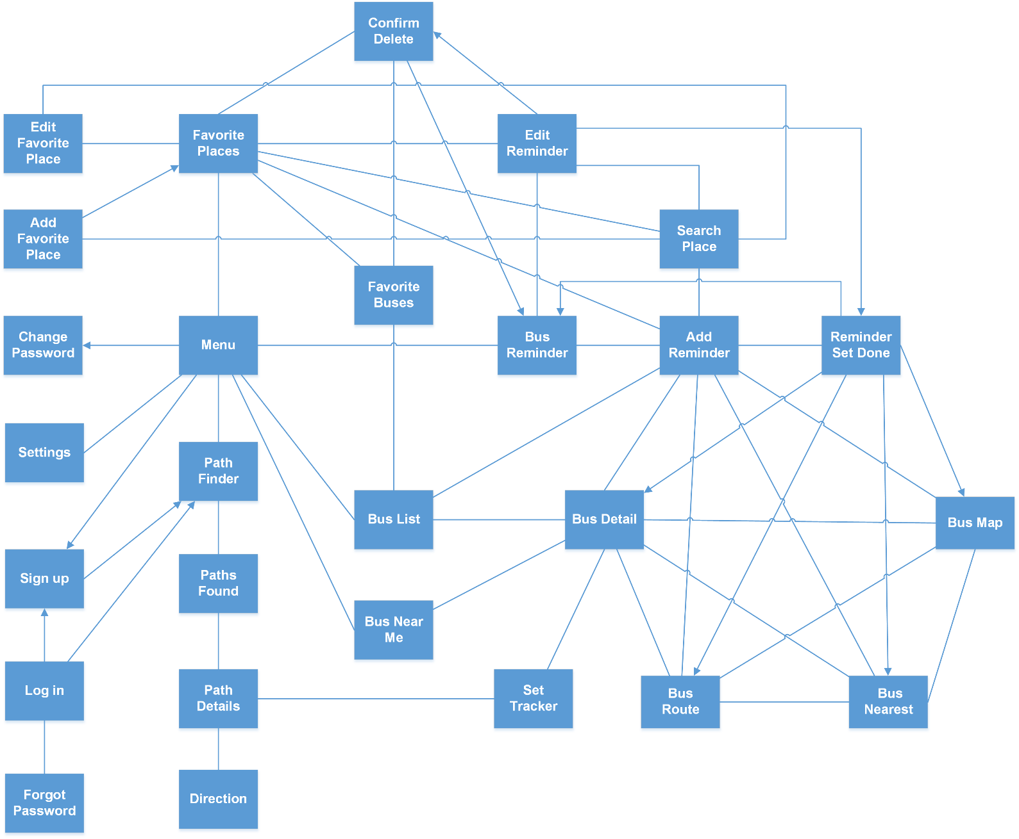

1. **System flow**

|  |  |  |
| --- | --- | --- |
| No | Screen Name | Description |
| 1 | Log in | Log in |
| 2 | Sign up | Sign up account |
| 3 | Forgot Password | (Dialog) Send password to email |
| 4 | Settings | Settings |
| 5 | Menu | Menu |
| 6 | Bus List | Bus route list |
| 7 | Bus Detail/ Info | Bus route details/info |
| 8 | Bus Route | Display all the bus-stops of the chosen bus route |
| 9 | Bus Nearest | Display nearest buses of the chosen bus route |
| 10 | Bus Map | Display the chosen bus route on map |
| 11 | Set Tracker | Set tracker to notify BU to leave when the bus comes near the predefined stop |
| 12 | Bus Near Me | Display all nearest bus |
| 13 | Path Finder | Find path and all buses which belong to that path |
| 14 | Paths Found | Results of finding path |
| 15 | Path Detail | Details of the chosen path |
| 16 | Directions | Step-by-step giving users detailed directions |
| 17 | Bus Reminder | Lists of bus reminders which will reminder BU when the predefined bus is up to comes to the chosen bus-stop |
| 18 | Add Reminder | Add reminder |
| 19 | Edit Reminder | Edit reminder |
| 20 | Reminder Set Done | Reminder Set Done |
| 21 | Favorite Places | Lists of favorite places |
| 22 | Search place | Search place |
| 23 | Add Favorite Place | Add favorite place |
| 24 | Edit Favorite Place | Edit Favorite Place |
| 25 | Favorite Buses | List of favorite buses |
| 26 | Change Password | Change password dialog |
| 27 | Confirm Delete | Confirm Delete dialog |

1. **Screen List**

## Log In

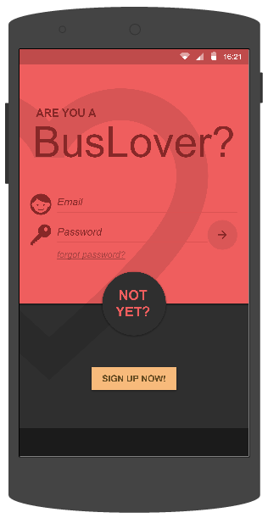

1. **Log in screen**

|  |  |  |  |  |  |  |  |
| --- | --- | --- | --- | --- | --- | --- | --- |
| **No** | **Field name** | **Field name in Vietnamese** | **Type** | **Require** | **Mandatory** | **Length** | **Description** |
| 1 | Email | Email | Edit Text | Text | Y | 100 | User inputs email |
| 2 | Password | Mật khẩu | Edit Text | Text | Y | 50 | User inputs password |
| 3 | Log in | Đăng nhập | Button | Click | Y |  | User taps on Sign in button |
| 4 | Sign up now | Đăng ký | Button | Click | Y |  | User taps on Sign up now button |

1. **Log In screen’s description**

## Sign Up

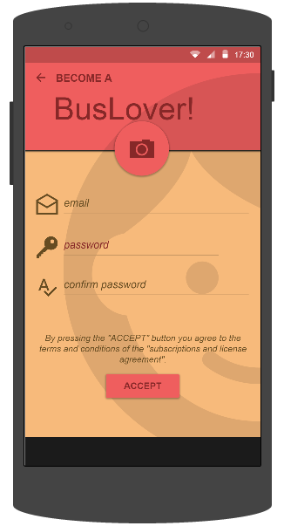

1. **Sign up screen**

|  |  |  |  |  |  |  |  |
| --- | --- | --- | --- | --- | --- | --- | --- |
| **No** | **Field name** | **Field name in Vietnamese** | **Type** | **Require** | **Mandatory** | **Length** | **Description** |
| 1 | Avatar | Ảnh đại diện | Button | Click | Y |  | User taps Avatar button to add use’s avatar. |
| 1 | Email | Email | Edit Text | Text | Y | 255 | User inputs email |
| 2 | Password | Mật khẩu | Edit Text | Password | Y | 50 | User inputs password that only contains number and character |
| 3 | Confirm password | Xác nhận mật khẩu | Edit Text | Text | Y | 50 | User inputs password again |
| 4 | Accept | Chấp nhận | Button | Click | Y |  | User taps on Accept button |

1. **Sign Up screen’s description**

## Forgot Password

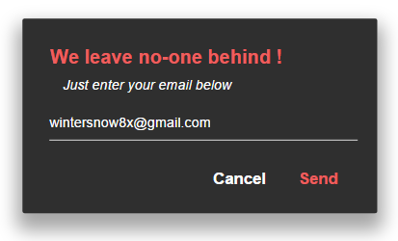

1. **Forgot Password dialog**

|  |  |  |  |  |  |  |  |
| --- | --- | --- | --- | --- | --- | --- | --- |
| **No** | **Field name** | **Field name in Vietnamese** | **Type** | **Require** | **Mandatory** | **Length** | **Description** |
| 1 | Email | email | Edit Text | Text | Y | 100 | User inputs email |
| 2 | Send | Gửi | Button | Click | Y |  | User taps Send button to send password to email |
| 3 | Cancel | Hủy | Button | Click | Y |  | User taps Cancel button |

1. **Forgot Password dialog**’s **description**

## Settings

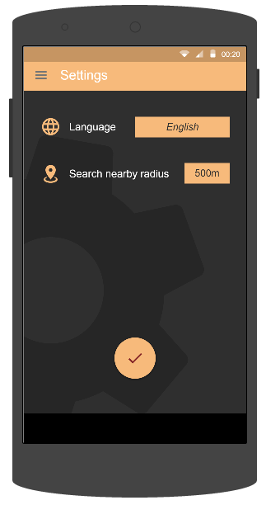

1. **Settings screen**

|  |  |  |  |  |  |  |  |
| --- | --- | --- | --- | --- | --- | --- | --- |
| **No** | **Field name** | **Field name in Vietnamese** | **Type** | **Require** | **Mandatory** | **Length** | **Description** |
| 1 | Language | Ngôn ngữ | Drop down list | Click | Y |  | User taps Language dropdown list to choose a language |
| 2 | Search nearby range | Phạm vi tìm kiếm buýt xung quanh | Drop down list | Click | Y |  | User taps Search nearby range dropdown list to choose range |

1. **Settings screen’s description**

## Menu

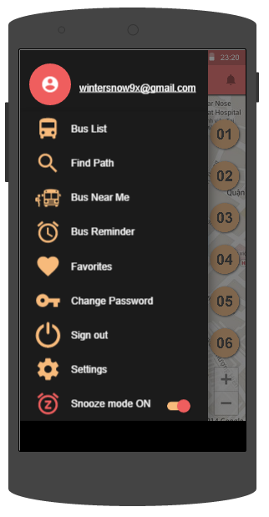

1. **Menu screen (Snooze mode ON)**

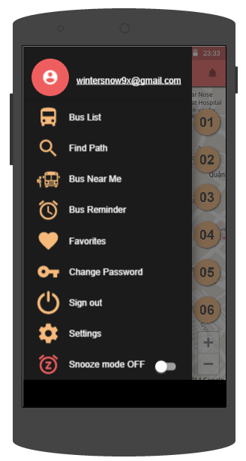

1. **Menu screen (Snooze mode OFF)**

|  |  |  |  |  |  |  |  |
| --- | --- | --- | --- | --- | --- | --- | --- |
| **No** | **Field name** | **Field name in Vietnamese** | **Type** | **Require** | **Mandatory** | **Length** | **Description** |
| 1 | Avatar | Ảnh đại diện | Image | Click | Y |  | User taps Avatar to change avatar |
| 2 | Email | email | Text |  |  |  | User’s email |
| 3 | Bus List | Danh sách buýt | Menu Item | Click | Y |  | User taps Bus List item to enter Bus List screen |
| 4 | Find Path | Tìm đường | Menu Item | Click | Y |  | User taps Bus List item to enter Bus List screen |
| 5 | Bus Near Me | Buýt xung quanh | Menu Item | Click | Y |  | User taps Bus List item to enter Bus List screen |
| 6 | Bus Reminder | Nhắc nhở | Menu Item | Click | Y |  | User taps Bus List item to enter Bus List screen |
| 7 | Favorites | Yêu thích | Menu Item | Click | Y |  | User taps Bus List item to enter Bus List screen |
| 8 | Change Password | Đổi mật khẩu | Menu Item | Click | Y |  | User taps Bus List item to enter Bus List screen |
| 9 | Sign Out | Đăng xuất | Menu Item | Click | Y |  | User taps Bus List item to enter Bus List screen |
| 10 | Settings | Thiết lập | Menu Item | Click | Y |  | User taps Bus List item to enter Bus List screen |
| 11 | Snooze Mode | Chế độ im lặng | Menu Item | Click | Y |  | User taps Bus List item to enter Bus List screen |

1. **Bus List screen’s description**

## Bus List

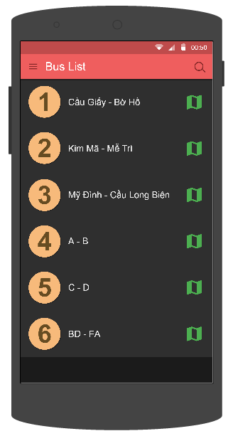

1. **Bus List screen**

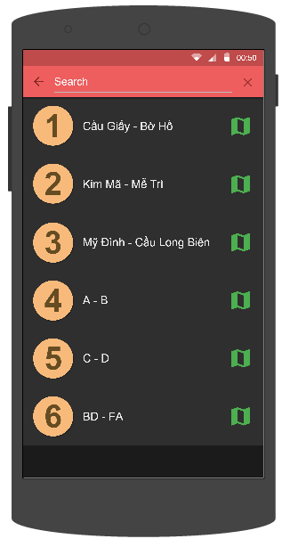

1. **Bus List screen (Search status)**

|  |  |  |  |  |  |  |  |
| --- | --- | --- | --- | --- | --- | --- | --- |
| **No** | **Field name** | **Field name in Vietnamese** | **Type** | **Require** | **Mandatory** | **Length** | **Description** |
| 1 | Bus route | Tuyến xe buýt | List item | Click | Y |  | User taps on Skip button |
| 2 | Search | Tìm kiếm | Button | Click | Y |  | User taps on Search button |
| 3 | Search Text Field | Khung tìm kiếm | Edit Text | Text | Y | 255 | User inputs their key word they want to search with length less than 255 characters |
| 4 | Menu | Danh sách | Button | Click | Y |  | User taps on Menu button |
| 5 | Back | Quay lại | Button | Click | Y |  | User taps on Back button |

1. **Bus List screen’s description**

## Bus Detail/ Info

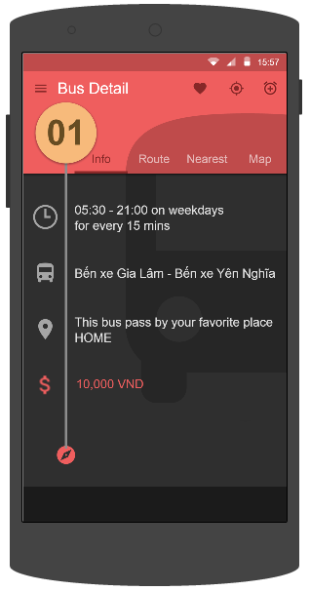

1. **Bus Detail/ Info screen**

|  |  |  |  |  |  |  |  |
| --- | --- | --- | --- | --- | --- | --- | --- |
| **No** | **Field name** | **Field name in Vietnamese** | **Type** | **Require** | **Mandatory** | **Length** | **Description** |
| 1 | Info | Thông tin | Tab | Click | Y |  | User taps on Info tab |
| 2 | Route | Tuyến đường | Tab | Click | Y |  | User taps on Route tab |
| 3 | Nearest | Gần nhất | Tab | Click | Y |  | User taps on Nearest tab |
| 4 | Map | Bản đồ | Tab | Click | Y |  | User taps on Map button |
| 5 | Favorite | Yêu thích | Button | Click | Y |  | User taps on Favorite button |
| 6 | Tracker | Theo dõi | Button | Click | Y |  | User taps on Track button |
| 7 | Menu | Danh sách | Button | Click | Y |  | User taps on Menu button |
| 8 | Add Reminder | Thêm nhắc nhở | Button | Click | Y |  | User taps on Add Reminder button |

1. **Bus Detail/ Info screen’s description**

## Bus Route

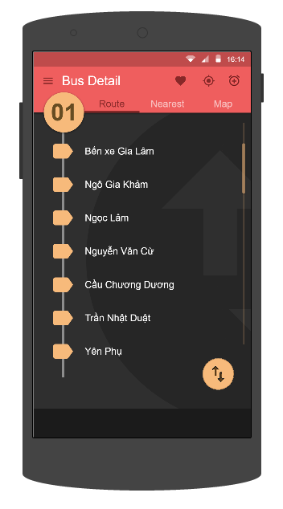

1. **Bus Route screen**

|  |  |  |  |  |  |  |  |
| --- | --- | --- | --- | --- | --- | --- | --- |
| **No** | **Field name** | **Field name in Vietnamese** | **Type** | **Require** | **Mandatory** | **Length** | **Description** |
| 1 | Info | Thông tin | Tab | Click | Y |  | User taps on Info tab |
| 2 | Route | Tuyến đường | Tab | Click | Y |  | User taps on Route tab |
| 3 | Nearest | Gần nhất | Tab | Click | Y |  | User taps on Nearest tab |
| 4 | Map | Bản đồ | Tab | Click | Y |  | User taps on Map button |
| 5 | Favorite | Yêu thích | Button | Click | Y |  | User taps on Favorite button |
| 6 | Tracker | Theo dõi | Button | Click | Y |  | User taps on Track button |
| 7 | Menu | Danh sách | Button | Click | Y |  | User taps on Menu button |

1. **Bus Route screen’s description**

## Bus Nearest

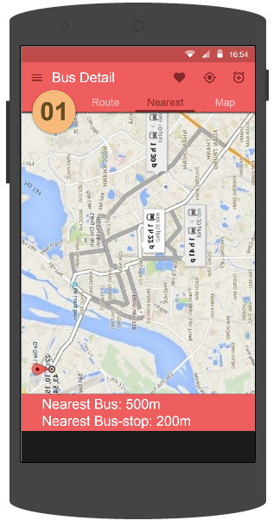

1. **Bus Nearest screen**

|  |  |  |  |  |  |  |  |
| --- | --- | --- | --- | --- | --- | --- | --- |
| **No** | **Field name** | **Field name in Vietnamese** | **Type** | **Require** | **Mandatory** | **Length** | **Description** |
| 1 | Info | Thông tin | Tab | Click | Y |  | User taps on Info tab |
| 2 | Route | Tuyến đường | Tab | Click | Y |  | User taps on Route tab |
| 3 | Nearest | Gần nhất | Tab | Click | Y |  | User taps on Nearest tab |
| 4 | Map | Bản đồ | Tab | Click | Y |  | User taps on Map button |
| 5 | Favorite | Yêu thích | Button | Click | Y |  | User taps on Favorite button |
| 6 | Tracker | Theo dõi | Button | Click | Y |  | User taps on Track button |
| 7 | Menu | Danh sách | Button | Click | Y |  | User taps on Menu button |
| 8 | Add Reminder | Thêm nhắc nhở | Button | Click | Y |  | User taps on Add Reminder button |

1. **Bus Nearest screen’s description**

## Bus Map

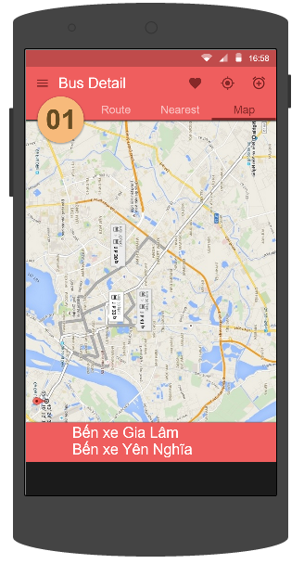

1. **Bus Map screen**

|  |  |  |  |  |  |  |  |
| --- | --- | --- | --- | --- | --- | --- | --- |
| **No** | **Field name** | **Field name in Vietnamese** | **Type** | **Require** | **Mandatory** | **Length** | **Description** |
| 1 | Info | Thông tin | Tab | Click | Y |  | User taps on Info tab |
| 2 | Route | Tuyến đường | Tab | Click | Y |  | User taps on Route tab |
| 3 | Nearest | Gần nhất | Tab | Click | Y |  | User taps on Nearest tab |
| 4 | Map | Bản đồ | Tab | Click | Y |  | User taps on Map button |
| 5 | Favorite | Yêu thích | Button | Click | Y |  | User taps on Favorite button |
| 6 | Tracker | Theo dõi | Button | Click | Y |  | User taps on Track button |
| 7 | Menu | Danh sách | Button | Click | Y |  | User taps on Menu button |
| 8 | Add Reminder | Thêm nhắc nhở | Button | Click | Y |  | User taps on Add Reminder button |

1. **Bus Map screen’s description**

## Set Tracker

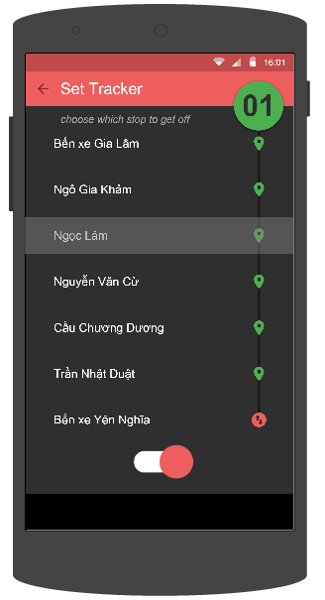

1. **Set Tracker screen**

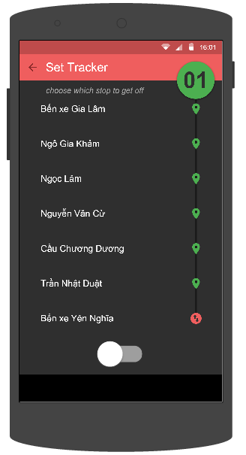

1. **Set Tracker screen (Cancel Tracker status)**

|  |  |  |  |  |  |  |  |
| --- | --- | --- | --- | --- | --- | --- | --- |
| **No** | **Field name** | **Field name in Vietnamese** | **Type** | **Require** | **Mandatory** | **Length** | **Description** |
| 1 | Track | Theo dõi | Switch | Click | Y |  | User taps on Track switch |
| 2 | Reverse | Đảo chiều | Button | Click | Y |  | User taps on Revert button to reverse direction |
| 3 | Bus stop | Trạm dừng | List item | Click | Y |  | User taps on Bus stop item to choose where to stop. |
| 2 | Back | Quay lại | Button | Click | Y |  | User taps on Back button to go back |

1. **Set Tracker screen’s description**

## Bus Near Me

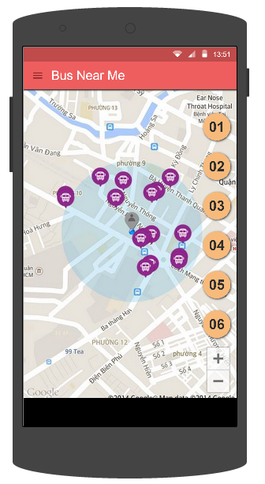

1. **Bus Near Me screen**

|  |  |  |  |  |  |  |  |
| --- | --- | --- | --- | --- | --- | --- | --- |
| **No** | **Field name** | **Field name in Vietnamese** | **Type** | **Require** | **Mandatory** | **Length** | **Description** |
| 1 | Menu | Danh sách | Button | Click | Y |  | User taps Menu button |
| 2 | Bus route | Tuyến buýt | Button | Click | Y |  | User taps Bus route button |
| 3 | Bus | Buýt | Icon | Click | Y |  | User taps Bus icon on map |

1. **Bus Near Me screen’s description**

## Path Finder

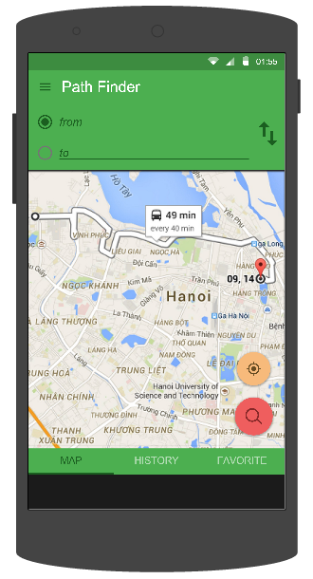

1. **Path Finder screen**

|  |  |  |  |  |  |  |  |
| --- | --- | --- | --- | --- | --- | --- | --- |
| **No** | **Field name** | **Field name in Vietnamese** | **Type** | **Require** | **Mandatory** | **Length** | **Description** |
| 1 | From | Từ | Edit Text | Text | Y | 255 | User inputs their position or the place they start to go with less than 255 characters. |
| 2 | To | Đến | Edit Text | Text | Y | 255 | User inputs the place they want to go with less than 255 characters. |
| 3 | Reverse | Đảo chiều | Button | Click | Y |  | User taps on Reverse button |
| 4 | Search | Tìm kiếm | Button | Click | Y |  | User taps on Search button |
| 5 | Get current location | Lấy vị trí hiện tại | Button | Click | Y |  | User taps on Get current location button |
| 6 | Map | Bản đồ | Tab | Click | Y |  | User taps on Map tab |
| 7 | History | Lịch sử | Tab | Click | Y |  | User taps on History tab |
| 8 | Favorite | Yêu thích | Tab | Click | Y |  | User taps on Favorite tab |
| 9 | Menu | Danh sách | Button | Click | Y |  | User taps on Menu button |

1. **Find Path screen’s description**

## Paths Found

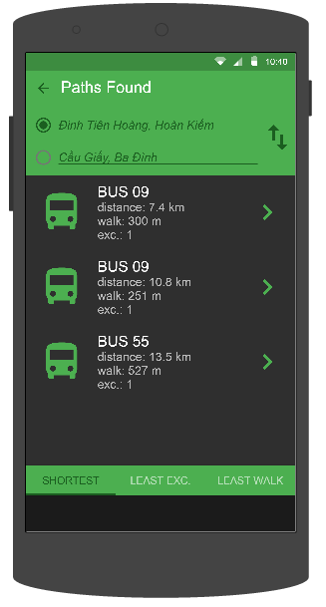

1. **Paths Found screen**

|  |  |  |  |  |  |  |  |
| --- | --- | --- | --- | --- | --- | --- | --- |
| **No** | **Field name** | **Field name in Vietnamese** | **Type** | **Require** | **Mandatory** | **Length** | **Description** |
| 1 | Reverse | Đảo chiều | Button | Click | Y |  | User taps on Reverse button |
| 2 | Shortest | Quãng đường ngắn nhất | Tab | Click | Y |  | User taps on Shortest tab |
| 3 | Least Exc | Chuyển tuyến ít nhất | Tab | Click | Y |  | User taps on Least Exc tab |
| 4 | Least Walk | Đi bộ ít nhất | Tab | Click | Y |  | User taps on Least Walk tab |
| 5 | Menu | Danh sách | Button | Click | Y |  | User taps on Menu button |

1. **Paths Found screen’s description**

## Path Details

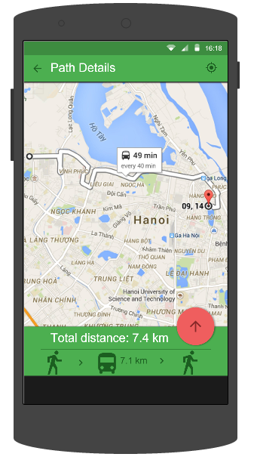

1. **Path Details screen**

|  |  |  |  |  |  |  |  |
| --- | --- | --- | --- | --- | --- | --- | --- |
| **No** | **Field name** | **Field name in Vietnamese** | **Type** | **Require** | **Mandatory** | **Length** | **Description** |
| 1 | Track | Theo dõi | Button | Click | Y |  | User taps on Track button |
| 2 | Bus | Buýt | Icon | Click | Y |  | User taps Bus icon displaying on map |
| 3 | Arrow up | Mũi tên đi lên | Button | Click | Y |  | User taps on Arrow up button |
| 4 | Arrow down | Mũi tên đi xuống | Button | Click | Y |  | User taps on Arrow down button |
| 5 | Path detail | Chi tiết đường đi | List item |  |  |  |  |
| 6 | Navigate | Chỉ đường | Button | Click | Y |  | User taps on Navigate button |
| 7 | Back | Quay lại | Button | Click | Y |  | User taps on Back button |

1. **Path Details screen’s description**

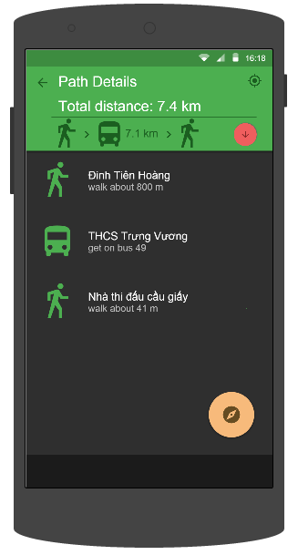

1. **Path Details 2 screen**

## Directions

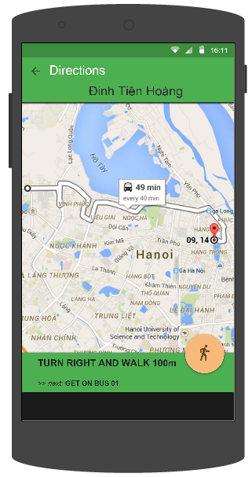

1. **Directions screen**

|  |  |  |  |  |  |  |  |
| --- | --- | --- | --- | --- | --- | --- | --- |
| **No** | **Field name** | **Field name in Vietnamese** | **Type** | **Require** | **Mandatory** | **Length** | **Description** |
| 1 | Back | Quay lại | Button | Click | Y |  | User taps on Back button |

1. **Directions screen’s description**

## Bus Reminder

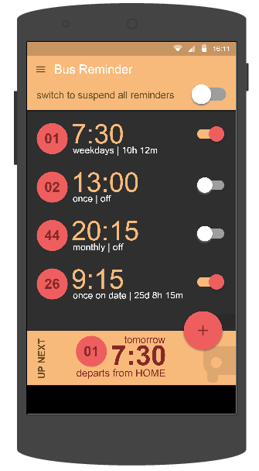

1. **Bus Reminder screen (Unsuspend all status)**

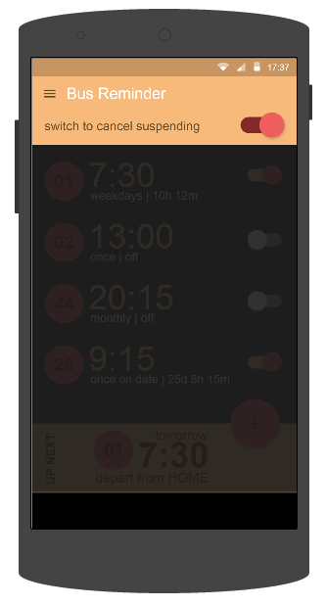

1. **Bus Reminder screen (Suspend all status)**

|  |  |  |  |  |  |  |  |
| --- | --- | --- | --- | --- | --- | --- | --- |
| **No** | **Field name** | **Field name in Vietnamese** | **Type** | **Require** | **Mandatory** | **Length** | **Description** |
| 1 | Add | Thêm | Button | Click | Y |  | User taps on Add button |
| 2 | Menu | Danh sách | Button | Click | Y |  | User taps on Menu button |
| 3 | Suspend all | Ngừng tất cả | Switch | Click | Y |  | User taps on Suspend all switch |
| 4 | Reminder | Nhắc nhở | List item | Click | Y |  | User taps on Reminder item |
| 5 | Suspend | Ngừng | Switch | Click | Y |  | User taps on Suspend switch |

1. **Bus Reminder screen’s description**

## Add Reminder

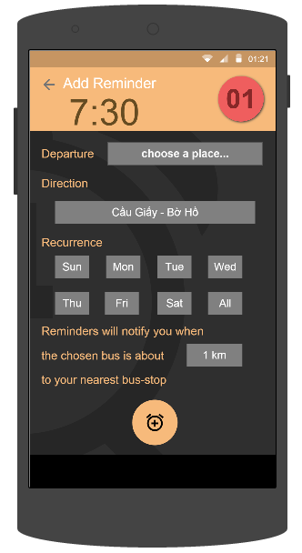

1. **Add Reminder screen**

|  |  |  |  |  |  |  |  |
| --- | --- | --- | --- | --- | --- | --- | --- |
| **No** | **Field name** | **Field name in Vietnamese** | **Type** | **Require** | **Mandatory** | **Length** | **Description** |
| 1 | Bus route | Tuyến buýt | Button | Click | Y |  | User taps on Bus route button |
| 2 | Clock | Báo thức | Button | Click | Y |  | User taps on Clock button |
| 3 | Departure | Điểm đi | Drop down list | Click | Y |  | User taps Departure drop down list |
| 4 | Direction | Hướng | Drop down list | Click | Y |  | User taps Direction drop down list |
| 5 | Recurrence | Lặp lại | Button | Click | Y |  | User taps Recurrece (dates) buttons |
| 6 | Reminder distance | Khoảng cách nhận thông báo | Drop down list | Click | Y |  | User taps Reminder distance drop down list |
| 7 | Add Reminder | Thêm | Button | Click | Y |  | User taps on Add button to add reminder |
| 8 | Back | Quay lại | Button | Click | Y |  | User taps on Back button to go back |

1. **Add Reminder screen’s description**

## Edit Reminder

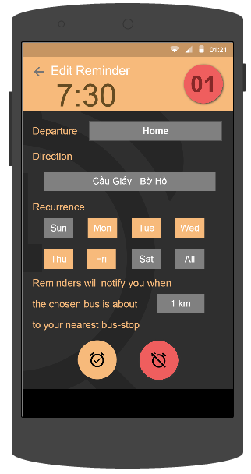

1. **Edit Reminder screen**

|  |  |  |  |  |  |  |  |
| --- | --- | --- | --- | --- | --- | --- | --- |
| **No** | **Field name** | **Field name in Vietnamese** | **Type** | **Require** | **Mandatory** | **Length** | **Description** |
| 1 | Bus route | Tuyến buýt | Button | Click | Y |  | User taps on Bus route button |
| 2 | Clock | Báo thức | Button | Click | Y |  | User taps on Clock button |
| 3 | Departure | Điểm đi | Drop down list | Click | Y |  | User taps Departure drop down list |
| 4 | Direction | Hướng | Drop down list | Click | Y |  | User taps Direction drop down list |
| 5 | Recurrence | Lặp lại | Button | Click | Y |  | User taps Recurrece (dates) buttons |
| 6 | Reminder distance | Khoảng cách nhận thông báo | Drop down list | Click | Y |  | User taps Reminder distance drop down list |
| 7 | Save | Lưu | Button | Click | Y |  | User taps on Save button |
| 8 | Delete | Xóa | Button | Click | Y |  | User taps on Delete button |
| 9 | Back | Quay lại | Button | Click | Y |  | User taps on Back button to go back |

1. **Edit Reminder screen’s description**

## Reminder Set Done

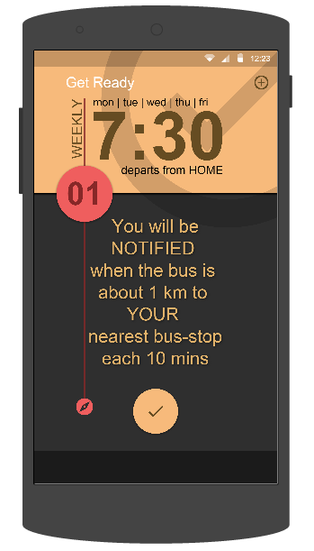

1. **Reminder Set Done screen (Add reminder status)**

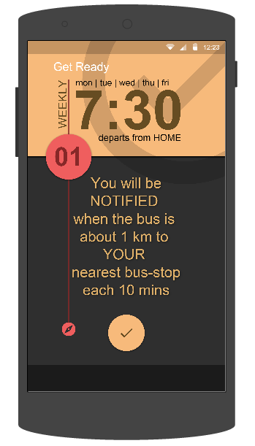

1. **Reminder Set Done screen (Edit Reminder status)**

|  |  |  |  |  |  |  |  |
| --- | --- | --- | --- | --- | --- | --- | --- |
| **No** | **Field name** | **Field name in Vietnamese** | **Type** | **Require** | **Mandatory** | **Length** | **Description** |
| 1 | Done | Xong | Button | Click | Y |  | User taps on Done button |
| 2 | Add other reminder | Thêm nhắc nhở khác | Button | Click | Y |  | User taps on Add other reminder button |

1. **Reminder Set Done screen’s description**

## Favorite Places

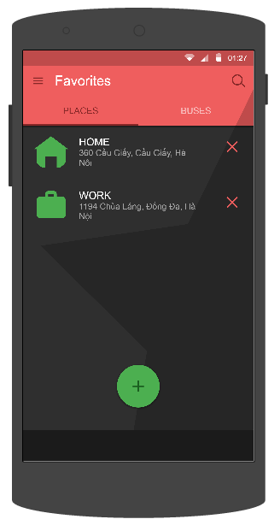

1. **Favorite Places screen**

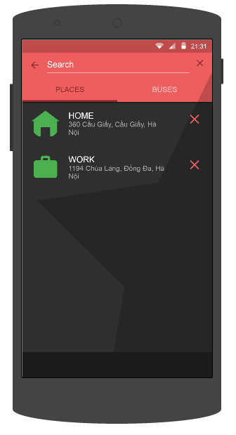

1. **Favorite Places screen (Search status)**

|  |  |  |  |  |  |  |  |
| --- | --- | --- | --- | --- | --- | --- | --- |
| **No** | **Field name** | **Field name in Vietnamese** | **Type** | **Require** | **Mandatory** | **Length** | **Description** |
| 1 | Add | Thêm | Button | Click | Y |  | User taps on Add button |
| 2 | Delete | Xóa | Button | Click | Y |  | User taps on Delete button |
| 3 | Favorite place | Địa điểm yêu thích | List item | Click | Y |  | User taps on Favorite place item to edit |
| 4 | Places | Địa điểm | Tab | Click | Y |  | User taps on Places tab item |
| 5 | Buses | Buýt | Tab | Click | Y |  | User taps on Buses tab item |
| 6 | Search | Tìm kiếm | Button | Click | Y |  | User taps on Search button |
| 7 | Menu | Danh sách | Button | Click | Y |  | User taps on Menu button |
| 8 | Search Text | Khung tìm kiếm | Edit Text | Text | Y | 255 | User inputs their key word they want to search with length less than 255 characters |
| 9 | Remove all text | Xóa hết chữ | Button | Click | Y |  | User taps on Remove all text button |

1. **Favorite Places screen’s description**

## Search Place

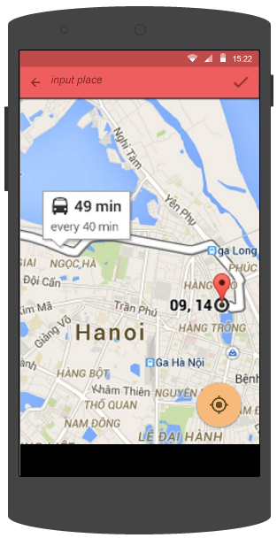

1. **Search Place screen**

|  |  |  |  |  |  |  |  |
| --- | --- | --- | --- | --- | --- | --- | --- |
| **No** | **Field name** | **Field name in Vietnamese** | **Type** | **Require** | **Mandatory** | **Length** | **Description** |
| 1 | Input place | Nhập địa điểm | Edit Text | Text | Y | 255 | User inputs the place they want to search with the length less than 255 characters |
| 2 | Back | Quay lại | Button | Click | Y |  | User taps on Back button to go back |
| 3 | Confirm | Xác nhận | Button | Click | Y |  | User taps on Confirm button |
| 4 | Current location | Vị trí hiện tại | Button | Click | Y |  | User taps on Current location button |

1. **Search Place screen’s description**

## Add Favorite Place

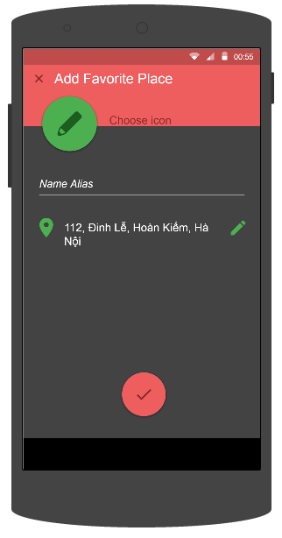

1. **Add Favorite Place screen**

|  |  |  |  |  |  |  |  |
| --- | --- | --- | --- | --- | --- | --- | --- |
| **No** | **Field name** | **Field name in Vietnamese** | **Type** | **Require** | **Mandatory** | **Length** | **Description** |
| 1 | Choose icon | Chọn biểu tượng | Button | Click | Y |  | User taps on Choose icon button |
| 2 | Name alias | Tên bí danh | Edit Text | Text | Y | 50 | User inputs “Name alias” text field. |
| 3 | Location | Địa điểm | Text |  |  |  |  |
| 4 | Edit location | Thay đổi địa điểm | Button | Click | Y |  | User taps “Edit location” button |
| 5 | Done | Hoàn tất | Button | Click | Y |  | User taps “Done” button |

1. **Add Favorite Place screen’s description**

## Edit Favorite Place

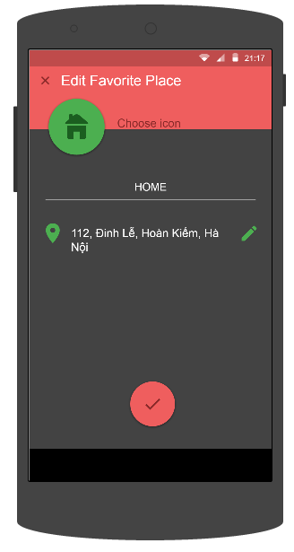

1. **Edit Favorite Place screen**

|  |  |  |  |  |  |  |  |
| --- | --- | --- | --- | --- | --- | --- | --- |
| **No** | **Field name** | **Field name in Vietnamese** | **Type** | **Require** | **Mandatory** | **Length** | **Description** |
| 1 | Choose icon | Chọn biểu tượng | Button | Click | Y |  | User taps on Choose icon button |
| 2 | Name alias | Tên bí danh | Edit Text | Text | Y | 50 | User inputs “Name alias” text field. |
| 3 | Location | Địa điểm | Text |  |  |  |  |
| 4 | Edit location | Thay đổi địa điểm | Button | Click | Y |  | User taps “Edit location” button |
| 5 | Done | Hoàn tất | Button | Click | Y |  | User taps “Done” button |

1. **Edit Favorite Place screen’s description**

## Favorite Buses

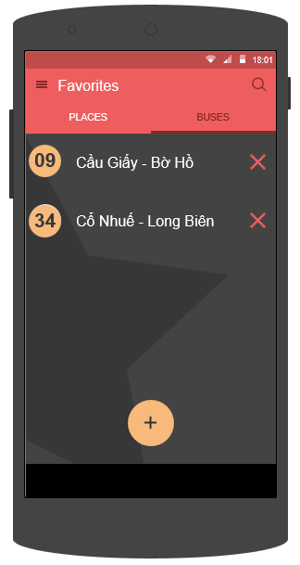

1. **Favorite Buses screen**

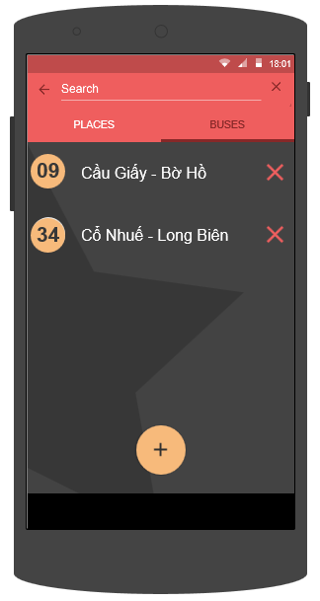

1. **Favorite Buses screen (Search status)**

|  |  |  |  |  |  |  |  |
| --- | --- | --- | --- | --- | --- | --- | --- |
| **No** | **Field name** | **Field name in Vietnamese** | **Type** | **Require** | **Mandatory** | **Length** | **Description** |
| 1 | Add | Thêm | Button | Click | Y |  | User taps on Add button |
| 2 | Delete | Xóa | Button | Click | Y |  | User taps on Delete button |
| 3 | Favorite bus | Địa điểm yêu thích | List item | Click | Y |  | User taps on Favorite bus item to edit |
| 4 | Places | Địa điểm | Tab | Click | Y |  | User taps on Places tab item |
| 5 | Buses | Buýt | Tab | Click | Y |  | User taps on Buses tab item |
| 6 | Search | Tìm kiếm | Button | Click | Y |  | User taps on Search button |
| 7 | Menu | Danh sách | Button | Click | Y |  | User taps on Menu button |
| 6 | Search Text | Khung tìm kiếm | Edit Text | Text | Y | 255 | User inputs their key word they want to search with length less than 255 characters |

1. **Favorite Buses screen’s description**

## Change Password

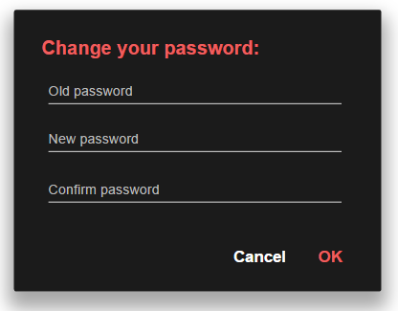

1. **Change Password dialog**

|  |  |  |  |  |  |  |  |
| --- | --- | --- | --- | --- | --- | --- | --- |
| **No** | **Field name** | **Field name in Vietnamese** | **Type** | **Require** | **Mandatory** | **Length** | **Description** |
| 1 | Old Password | Mật khẩu cũ | Edit Text | Text | Y | 50 | User inputs Old password |
| 2 | New Password | Mật khẩu mới | Edit Text | Text | Y | 50 | User inputs New password |
| 3 | Confirm Password | Xác nhận mật khẩu | Edit Text | Text | Y | 50 | User inputs Confirm password |
| 4 | OK | Đồng ý | Button | Click | Y |  | User taps OK button to change password |
| 5 | Cancel | Hủy | Button | Click | Y |  | User taps Cancel button to cancel |

1. **Change Password dialog**’s **description**

## Confirm Delete

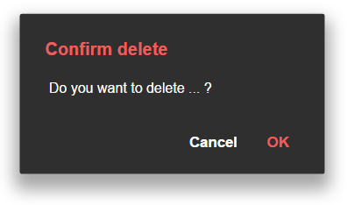

1. **Confirm Delete dialog**

|  |  |  |  |  |  |  |  |
| --- | --- | --- | --- | --- | --- | --- | --- |
| **No** | **Field name** | **Field name in Vietnamese** | **Type** | **Require** | **Mandatory** | **Length** | **Description** |
| 1 | Content of dialog | Nội dung | Text View |  |  |  |  |
| 2 | OK | Đồng ý | Button | Click | Y |  | User taps OK button to confim delete |
| 3 | Cancel | Hủy | Button | Click | Y |  | User taps Cancel button to cancel delete |

1. **Confirm Delete dialog**’s **description**

# Other considerations

**N/A**