

BUS USERS SUPPORT SYSTEM

SOFTWARE REQUIREMENT SPECIFICATION

**Project Code: BUSS**

**Document Code: BUSS_ Software requirement specification_v1.0_EN**

**- Hanoi, 06/2015 -**

**SIGNATURE PAGE**

|  |  |  |
| --- | --- | --- |
| AUTHOR: | Nguyen Thanh Nam  Project Manager (PM) | 03/06/2015 |
| REVIEWERS: | Trinh Thi Tuyet Mai  Test Leader | 03/06/2015 |
|  |  |
| Bui Bich Phuong  Tester | 03/06/2015 |
|  |  |
| APPROVAL: | Nguyen Van Sang  Supervisor | 19/06/2015 |
|  |  |

**Record of change**

*A - Added M - Modified D – Deleted

|  |  |  |  |  |  |  |
| --- | --- | --- | --- | --- | --- | --- |
| **Effective Date** | **Changed Item** | **A* M, D** | **Change Description** | **Reason for Change** | **Revision Number** | |
| 03/06/2015 | Add SRS | A | Create this document | First Version | v1.0 |
|  |  |  |  |  |  |
|  |  |  |  |  |  |

Table of Contents

1.1 Introduction 6

1.1.1 Purposes 6

1.1.2 Definition and Acronyms 6

1.2 System Purpose 6

1.3 Scope 6

1.4 Overall Description 6

1.4.1 System overview 6

1.4.2 Product Features 7

1.4.3 User Characteristics 9

1.4.4 User Documentation 9

1.4.5 Assumption 10

1.5 Entity Relation Model 10

1.5.1 Entity-Relationship Diagram 10

1.5.2 Entity Detail 10

1.6 Functional Specification 13

1.6.1 Account management module 13

1.6.2 Common module 21

1.6.3 Bus module 24

1.6.4 Path finder module 41

1.6.5 Reminder module 55

1.6.6 Track module 74

1.6.7 Favorite module 80

1.7 Non-functional Specification 104

1.7.1 Reliability 104

1.7.2 Performance Requirements 104

1.7.3 User Interface 104

1.7.4 Maintainability 104

1.7.5 Usability 105

1.7.6 Security Requirements 105

1.7.7 Hardware/Software Requirements 105

## Introduction

### Purposes

This document is created for better understanding about our Capstone project – Bus User Interactive Network. In this document, we will provide an overview of all the functions and use cases of our system, and a brief description of our solution for designing the system. This document is based on thorough analysis of user requirements and other requirements.

### Definition and Acronyms

This section describes the definitions, terms, and acronyms that are used in software requirements specification.

|  |  |
| --- | --- |
| Acronym & Abbreviation | Definition |
| BUSS | Bus User Support System |
| FU | FPT University |
| BU | Bus User |
| IN | Interactive Network |
| Q&A | Question and Answer |
|  |  |

1. **Definition and Acronyms**

## System Purpose

The system is developed to make using buses easier and more convenient. It is hoped to create a habit of using public transportation in young people by making it more interesting and fun.

## Scope

This project will consist of creating usable Android application that is connected to .NET web service and runs smoothly on Android 4.4 and above devices. The project will be completed by August 28st, 2015. Main modules of the app will include Bus-Searching, Path-Finding and Schedule-Reminding.

## Overall Description

### System overview

Nowadays, there are quite many apps and websites which support finding and making use of buses. All of them have been created for the purpose of making users easier to catch a bus or to travel from places to places using buses. However, we found disadvantages while trying each of them. Some have confusing UI, some are better yet only not functionally focused on bus services and have not much to offer to users. Therefore, our project BUSS offers almost everything a bus user in Vietnam, especially “everyday-bus-users” would need. Completely free of charge.

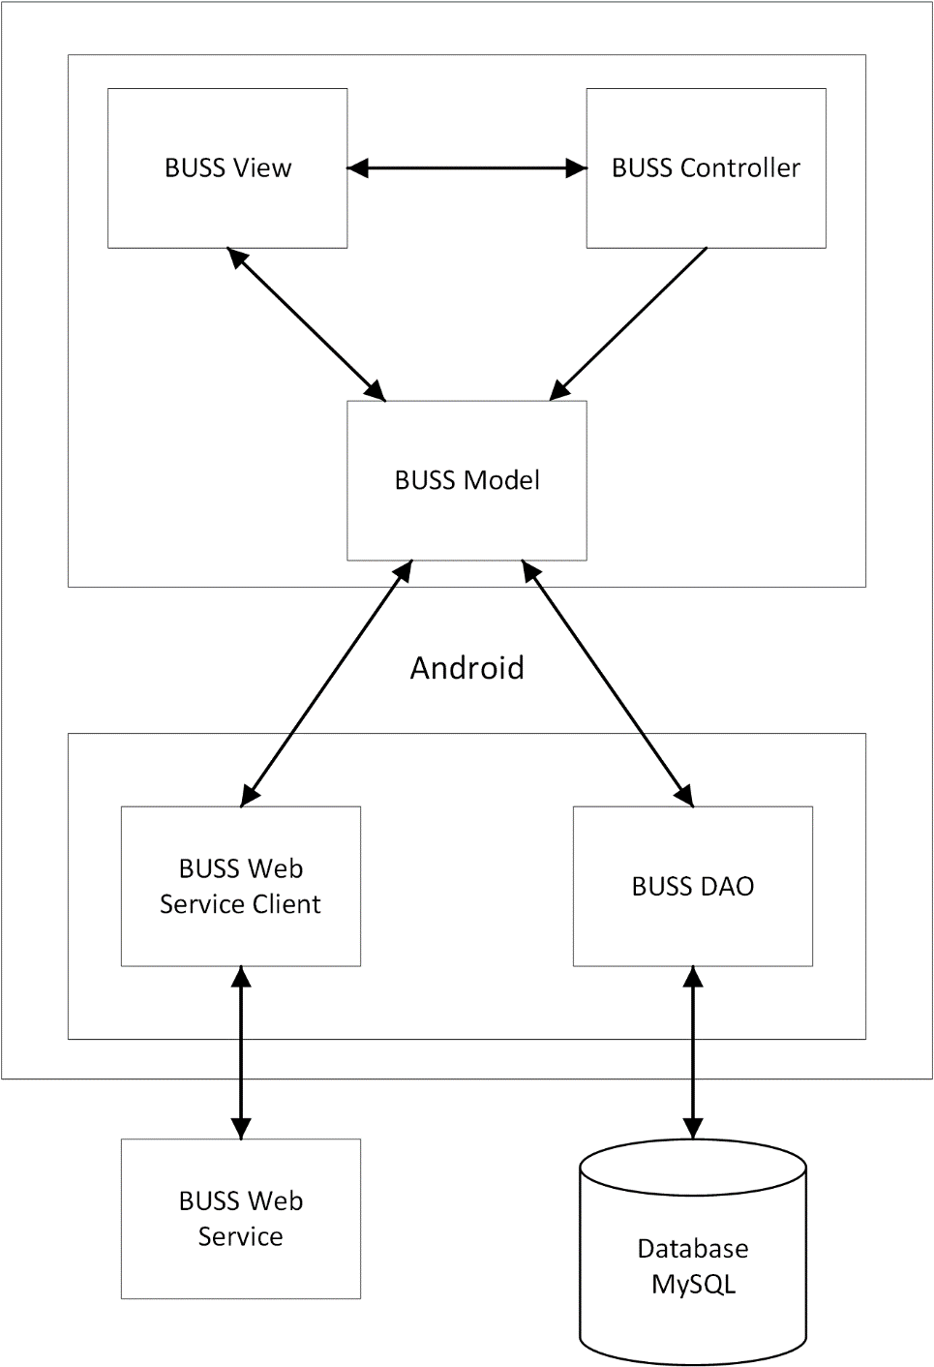

1. **System overview**

### Product Features

|  |  |  |  |
| --- | --- | --- | --- |
| **Use Case No.** | **Group of functions** | **Functions** | **Glossary** |
| **BUSS USER MODULES** | | | |
| **Account Management Module** | | | |
|  |  | Sign in | Đăng nhập |
|  | Sign up | Đăng ký |
|  | Sign out | Đăng xuất |
|  | Forgot Password | Quên mật khẩu |
|  | Change account info | Chỉnh sửa thông tin cá nhân |
| **Common Module** | | | |
|  |  | Change app settings | Thay đổi cài đặt |
| **Bus Module** | | | |
|  |  | View bus list | Xem danh sách buýt |
|  | Search bus in list | Tìm kiếm trong danh sách buýt |
|  | View bus info | Xem thông tin của xe buýt |
|  | View bus route | Xem lộ trình của xe buýt |
|  | View nearest bus | Xem xe buýt gần nhất thuộc tuyến đã chọn |
|  | View bus map | Xem đường đi của xe buýt trên bản đồ |
|  | View bus near me | Xem tất cả các xe buýt ở gần |
| **Path Finder Module** | | | |
|  |  | Find path | Tìm đường |
|  | View paths found | Xem kết quả tìm được |
|  | View path detail | Xem chi tiết đường đi |
|  | View direction | Xem đường đi từng bước |
| **Reminder module** | | | |
|  |  | View bus reminder | Xem tất cả nhắc nhở |
|  | Add reminder | Thêm nhắc nhở |
|  | Edit reminder | Sửa nhắc nhở |
|  | Delete reminder | Xoá nhắc nhở |
|  | Suspend/Cancel suspend all reminder | Hoãn/Ngừng hoãn tất cả nhắc nhở |
|  | Suspend/Cancel suspend a chosen reminder | Hoãn/Ngừng hoãn một nhắc nhở đã chọn |
| **Track module** | | | |
|  |  | Set track | Theo dõi |
|  | Cancel track | Ngừng theo dõi |
| **Favorite Module** | | | |
|  |  | View favorite places | Xem địa điểm yêu thích |
|  | Add favorite place | Thêm địa điểm yêu thích |
|  | Edit favorite place | Sửa địa điểm yêu thích |
|  | Delete favorite place | Xoá địa điểm yêu thích |
|  | Search favorite places | Tìm kiếm địa điểm yêu thích |
|  | View favorite buses | Xem xe buýt yêu thích |
|  | Add favorite bus | Thêm xe buýt yêu thích |
|  | Delete favorite bus | Xoá xe buýt yêu thích |
|  | Search favorite buses | Tìm kiếm xe buýt yêu thích |

1. **Product Features**

### User Characteristics

This application is developed towards young people who are using bus every day or have the need to use bus as their main transportation vehicle. The system requires users to have an Android smartphone with an active internet connection and GPS enabled. Users can freely use all functions without any limitation but to save their usage data, they must log in – which requires only a minimum number of information and steps.

### User Documentation

List of document when delivering this application is in the table below:

|  |  |
| --- | --- |
| **Name** | **Description** |
| User Manual | Provide detailed explanation about the system, screens and guide users how to use all features of BUSS system. |

1. **User Documentation**

### Assumption

* On each bus, there is a GPS device which is able to submit JSON over 3G network.
* Reviewers will have seven days to approve a milestone document. If no comments were received within this time period, the documents would be considered approved.

## Entity Relation Model

### Entity-Relationship Diagram

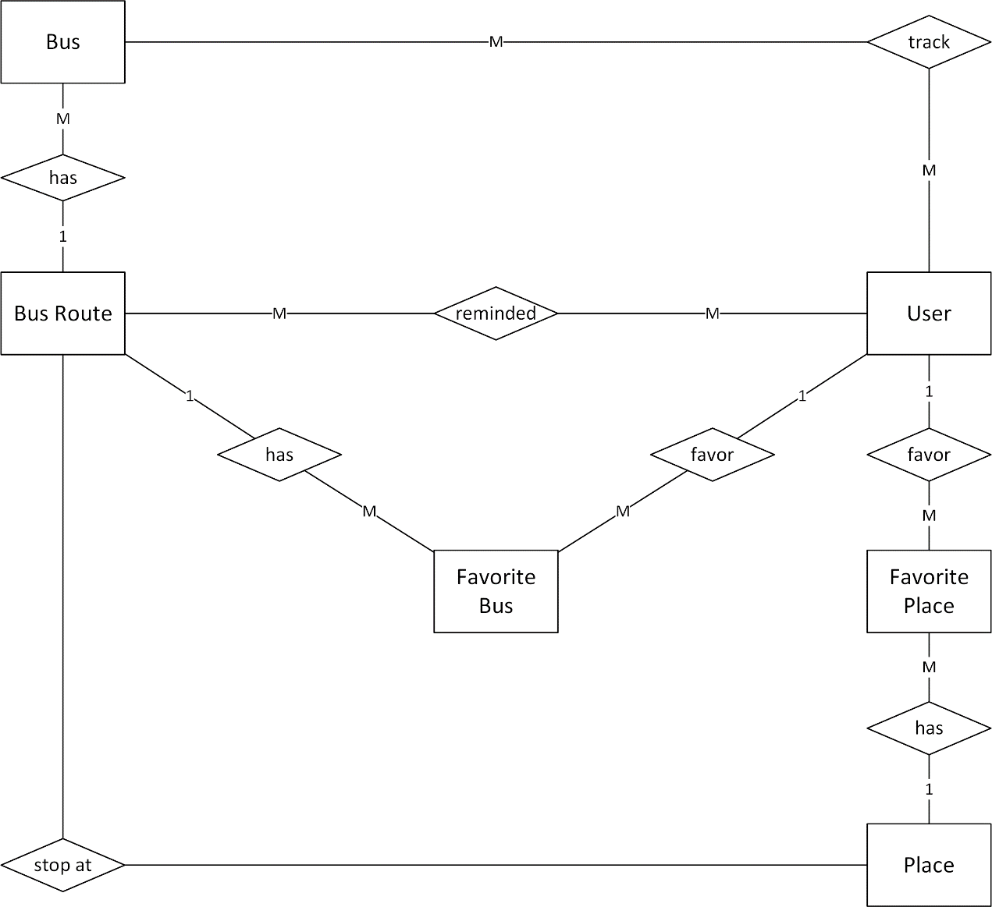

1. **Entity – Relationship Diagram**

### Entity Detail

#### Bus

|  |  |  |  |  |
| --- | --- | --- | --- | --- |
| No | Field Name | Type | Mandatory | Description |
|  | bus_id | String | Y | Bus’s id |
|  | bus_route_id | Number | Y | Bus route’s number |

1. **Bus Entity**

#### Bus Route

|  |  |  |  |  |
| --- | --- | --- | --- | --- |
| No | Field Name | Type | Mandatory | Description |
|  | bus_route_id | Number | Y | Bus route’s id |
|  | bus_route_away | String | Y | Bus away route |
|  | bus_route_back | String | Y | Bus back route |
|  | bus_route_start_time | Time | Y | Bus route start time |
|  | bus_route_end_time | Time | Y | Bus route end time |
|  | bus_route_time_each | Time | Y | Bus route time between two bus |

1. **Bus Route entity**

#### Favorite Bus

|  |  |  |  |  |
| --- | --- | --- | --- | --- |
| No | Field Name | Type | Mandatory | Description |
|  | user_id | Number | Y | User’s id |
|  | bus_route_id | Number | Y | Bus route’s id |

1. **Favorite Bus entity**

#### User

|  |  |  |  |  |
| --- | --- | --- | --- | --- |
| No | Field Name | Type | Mandatory | Description |
| 1. 11 | user_id | Number | Y | User’s id |
|  | user_email | String | Y | User’s email |
|  | user_password | String | Y | User’s password |

1. **User entity**

#### Place

|  |  |  |  |  |
| --- | --- | --- | --- | --- |
| No | Field Name | Type | Mandatory | Description |
|  | place_id | Number | Y | Place’s id |
|  | place_name | String | Y | Place’s name |
|  | place_locationX | Number | Y | Place’s location X |
|  | place_locationY | Number | Y | Place’s location Y |

1. **Place entity**

#### Favorite Place

|  |  |  |  |  |
| --- | --- | --- | --- | --- |
| No | Field Name | Type | Mandatory | Description |
|  | user_id | Number | Y | User’s id |
|  | place_id | String | Y | Place’s id |
|  | favorite_place_name | String | Y | Favorite place’s name |

1. **Favorite Place entity**

## Functional Specification

### Account management module

#### Use case diagram

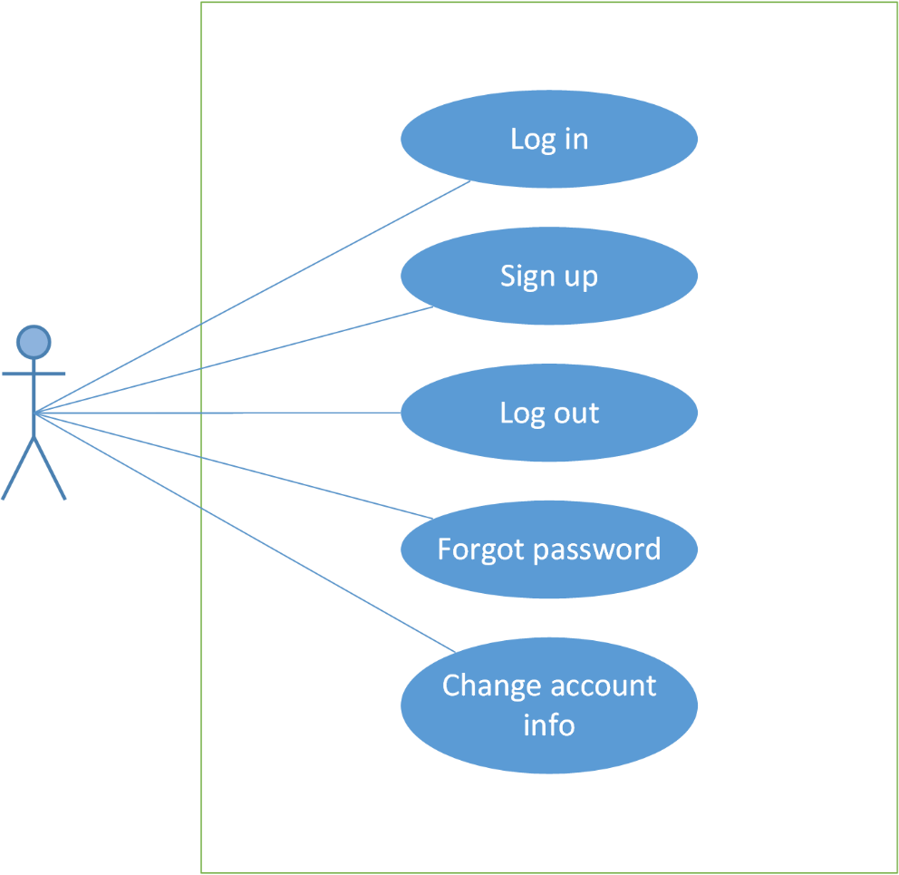

1. **Account Management Module use case diagram**

#### UC0001: Log in

##### Screen definition

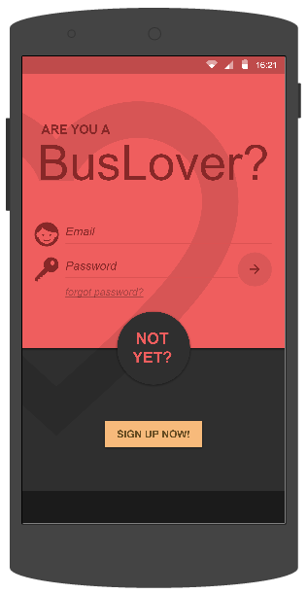

1. **Log In screen**

|  |  |  |  |  |  |  |  |
| --- | --- | --- | --- | --- | --- | --- | --- |
| **No** | **Field name** | **Field name in Vietnamese** | **Type** | **Require** | **Mandatory** | **Length** | **Description** |
| 1 | Email | Email | Text field | Text | Y | 100 | User inputs email |
| 2 | Password | Mật khẩu | Text field | Text | Y | 50 | User inputs password |
| 3 | Log in | Đăng nhập | Button | Click | Y |  | User taps on Sign in button |
| 4 | Sign up now | Đăng ký | Button | Click | Y |  | User taps on Sign up now button |

1. **Log In screen’s description**

##### Use Case Specification

|  |  |  |  |  |
| --- | --- | --- | --- | --- |
| **Use Case ID** | | UC0001 | **Version** | 1.0 |
| **Use Name** | | Log in | | |
| **Actor** | | BUSS User | | |
| **Description** | | The function allows an user to log in. | | |
| **Precondition** | | User has registered account but not logged in yet | | |
| **Trigger** | | User taps “Log in” button | | |
| **Post-Condition** | | “Find Path” screen is shown | | |
| **Main flows** | | | | |
| **Step** | **Actor** | **Action** | | |
| 1 | BUSS User | Opens the Bus lover app | | |
| 2 | BUSS | Displays “Log in” screen | | |
| 3 | BUSS User | Inputs “email” and “password” field, then taps “Log in” button | | |
| 4 | BUSS | Validates information and logs user into app then moves to “Find Path” screen. | | |
|  | | | | |

**Exception**

|  |  |  |
| --- | --- | --- |
| **E1** | At step 3 in the main flows**,** if BUSS User leaves either “email” or “password” field blank then taps “Sign in” button | |
| **Step** | **Actor** | **Action** |
| 4.1 | BUSS | Returns Error message “Email/Password is required” |

|  |  |  |
| --- | --- | --- |
| **E2** | At step 4 in the main flows**,** if BUSS fails to validate email & password | |
| **Step** | **Actor** | **Action** |
| 4.2 | BUSS | Returns Error message “Please enter a correct combination of email and password” |

1. **Log In use case**

#### UC0002: Sign up

##### Screen definition

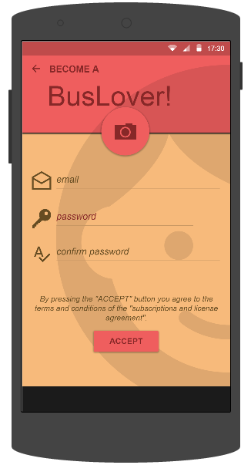

1. **Sign Up screen**

|  |  |  |  |  |  |  |  |
| --- | --- | --- | --- | --- | --- | --- | --- |
| **No** | **Field name** | **Field name in Vietnamese** | **Type** | **Require** | **Mandatory** | **Length** | **Description** |
| 1 | Avatar | Ảnh đại diện | Button | Click | Y |  | User taps Avatar button to add use’s avatar. |
| 1 | Email | Email | Text field | Text | Y | 255 | User inputs email |
| 2 | Password | Mật khẩu | Text field | Password | Y | 50 | User inputs password that only contains number and character |
| 3 | Confirm password | Xác nhận mật khẩu | Text field | Text | Y | 50 | User inputs password again |
| 4 | Accept | Chấp nhận | Button | Click | Y |  | User taps on Accept button |

1. **Sign Up screen’s description**

##### Use Case Specification

|  |  |  |  |  |
| --- | --- | --- | --- | --- |
| **Use Case ID** | | UC0002 | **Version** | 1.0 |
| **Use Name** | | Sign up | | |
| **Actor** | | BUSS User | | |
| **Description** | | The function allows an user to sign up an account in order to sign in. | | |
| **Precondition** | | User doesn’t have account | | |
| **Trigger** | | User taps “Sign up now” button | | |
| **Post-Condition** | | “Find Path” screen is shown | | |
| **Main flows** | | | | |
| **Step** | **Actor** | **Action** | | |
| 1 | BUSS User | Opens the Bus lover app and tap “Sign up now” button | | |
| 2 | BUSS | Displays “Sign up” screen | | |
| 3 | BUSS User | Inputs “email”, “password” and “confirm password” field, then taps “Accept” button | | |
| 4 | BUSS | Validates information and logs user into app then moves to “Find Path” screen and notify user that “Sign up was completed”. | | |
|  | | | | |

**Exception**

|  |  |  |
| --- | --- | --- |
| **E1** | At step 3 in the main flows**,** if BUSS User leaves either “email” or “password” or “confirm password” blank then taps “Sign in” button | |
| **Step** | **Actor** | **Action** |
| 4.1 | BUSS | Returns Error message “Email/ Password/ Confirm password is required” |

|  |  |  |
| --- | --- | --- |
| **E2** | At step 4 in the main flows**,** if BUSS fails to validate email & password | |
| **Step** | **Actor** | **Action** |
| 4.2 | BUSS | Returns Error message “Please enter a correct combination of email and password” |

|  |  |  |
| --- | --- | --- |
| **E3** | At step 3 in the main flows**,** if BUSS User inputs “password” and “confirm password” field that are not matched, then taps “Sign in” button. | |
| **Step** | **Actor** | **Action** |
| 4.2 | BUSS | Returns Error message “Confirm password is not matched with new password” |

1. **Sign Up use case**

#### UC0003: Sign out

##### Use Case Specification

|  |  |  |  |  |
| --- | --- | --- | --- | --- |
| **Use Case ID** | | UC0003 | **Version** | 1.0 |
| **Use Name** | | Sign out | | |
| **Actor** | | BUSS User | | |
| **Description** | | The function allows an user to sign up an account in order to sign in. | | |
| **Precondition** | | User has logged in | | |
| **Trigger** | | User taps “Sign out” button | | |
| **Post-Condition** | | “Sign in” screen is shown | | |
| **Main flows** | | | | |
| **Step** | **Actor** | **Action** | | |
| 1 | BUSS User | Taps “Sign out” button | | |
| 2 | BUSS | Signs user out and displays “Sign in” screen | | |
|  | | | | |

1. **Sign Out use case**

#### UC0004: Forgot password

##### Use Case Specification

|  |  |  |  |  |
| --- | --- | --- | --- | --- |
| **Use Case ID** | | UC0004 | **Version** | 1.0 |
| **Use Name** | | Forgot password | | |
| **Actor** | | BUSS User | | |
| **Description** | | The function allows an user to receive their password if they forgot. | | |
| **Precondition** | | User hasn’t logged in | | |
| **Trigger** | | User taps “forgot password” button | | |
| **Post-Condition** | | Displays “Sign in” screen and password is sent to email | | |
| **Main flows** | | | | |
| **Step** | **Actor** | **Action** | | |
| 1 | BUSS User | Enters Bus lover app | | |
| 2 | BUSS | Displays “Sign in” screen | | |
| 3 | BUSS User | Taps “forgot password” button | | |
| 4 | BUSS | Displays “Forgot password” dialog | | |
| 5 | BUSS | Inputs “Email” text field then taps “Send” button | | |
| 6 | BUSS | Validates email and sends password to the inputted email | | |
|  | | | | |

**Alternative scenario**

|  |  |  |
| --- | --- | --- |
| **AT1** | At step 5 in the main flows**,** if BUSS User taps Cancel button | |
| **Step** | **Actor** | **Action** |
| 6.1 | BUSS | Returns Log In screen |

**Exception**

|  |  |  |
| --- | --- | --- |
| **E1** | At step 5 in the main flows**,** if BUSS User leaves email blank | |
| **Step** | **Actor** | **Action** |
| 6.1 | BUSS | Returns Error message “Email is required” |

|  |  |  |
| --- | --- | --- |
| **E2** | At step 6 in the main flows**,** if BUSS failed to validate email | |
| **Step** | **Actor** | **Action** |
| 6.2 | BUSS | Returns popup with Error message “Please enter a correct email” |

1. **Forgot Password use case**

#### UC0005: Change account info

##### Use Case Specification

|  |  |  |  |  |
| --- | --- | --- | --- | --- |
| **Use Case ID** | | UC0005 | **Version** | 1.0 |
| **Use Name** | | Change account info | | |
| **Actor** | | BUSS User | | |
| **Description** | | The function allows an user to change his/her account profile info | | |
| **Precondition** | | User has logged in | | |
| **Trigger** | | User taps Change account info item | | |
| **Post-Condition** | | Changes account info popup is shown | | |
| **Main flows** | | | | |
| **Step** | **Actor** | **Action** | | |
| 1 | BUSS User | Taps menu button | | |
| 2 | BUSS | Displays Menu | | |
| 3 | BUSS User | Taps Change account info item | | |
| 4 | BUSS | Displays Change account info popup | | |
| 5 | BUSS User | Edits “Old Password”, “New Password” and “Confirm password” field then taps Save button | | |
| 6 | BUSS | System will validate and save the changes | | |
|  | | | | |

**Exception**

|  |  |  |
| --- | --- | --- |
| **E1** | At step 5 in the main flows**,** if BUSS User leaves “old password”, “new password” and “confirm password” field blank, then taps “Save” button | |
| **Step** | **Actor** | **Action** |
| 6.1 | BUSS | Returns Error message “Old Password/ New Password/ Confirm password is required” |

|  |  |  |
| --- | --- | --- |
| **E2** | At step 6 in the main flows, if BUSS fails to validate password, then taps “Save” button | |
| **Step** | **Actor** | Action |
| 6.2 | BUSS | Returns Error message “Old password is incorrect” |

|  |  |  |
| --- | --- | --- |
| **E3** | At step 5 in the main flows**,** if BUSS User inputs “new password” and “confirm password” field that are not matched, then taps “Save” button. | |
| **Step** | **Actor** | **Action** |
| 6.3 | BUSS | Returns Error message “Confirm password is not matched with new password” |

1. **Change account info use case**

### Common module

#### Use case diagram

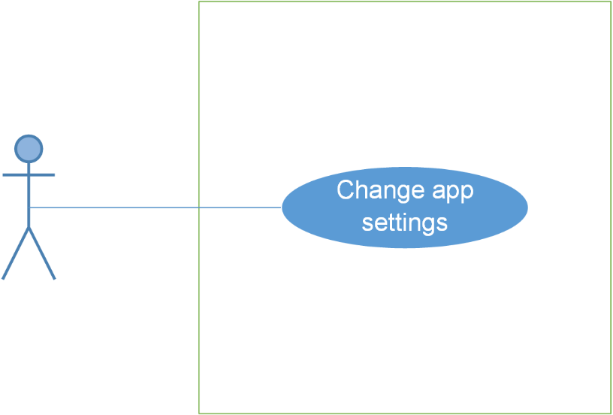

1. **Common Module use case diagram**

#### UC0006: Change app settings

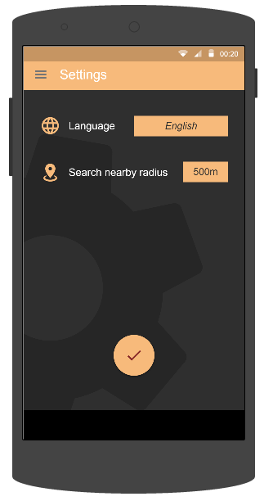

1. **Settings screen**

##### Screen definition

|  |  |  |  |  |  |  |  |
| --- | --- | --- | --- | --- | --- | --- | --- |
| **No** | **Field name** | **Field name in Vietnamese** | **Type** | **Require** | **Mandatory** | **Length** | **Description** |
| 1 | Language | Ngôn ngữ | Drop down list | Click | Y |  | User taps Language dropdown list to choose a language |
| 2 | Search nearby range | Phạm vi tìm kiếm buýt xung quanh | Drop down list | Click | Y |  | User taps Search nearby range dropdown list to choose range |

1. **Settings screen’s description**

##### Use Case Specification

|  |  |  |  |  |
| --- | --- | --- | --- | --- |
| **Use Case ID** | | UC0007 | **Version** | 1.0 |
| **Use Name** | | Change app setting | | |
| **Actor** | | BUSS User | | |
| **Description** | | The function allows an user to change app setting | | |
| **Precondition** | | User has logged in | | |
| **Trigger** | | User taps Menu then taps Setting item | | |
| **Post-Condition** | | Setting screen is shown | | |
| **Main flows** | | | | |
| **Step** | **Actor** | **Action** | | |
| 1 | BUSS User | Taps “Menu” button then tap “Settings” button | | |
| 2 | BUSS | Displays Settings screen | | |
| 3 | BUSS User | Taps “Language” and “Search nearby range” dropdown to choose an item | | |
| 4 | BUSS | The information of “Language” and “Search nearby range” field are changed | | |
| 5 | BUSS User | Taps Done button | | |
| 6 | BUSS | Saves all edited information | | |
|  | | | | |

**Alternative scenario**

|  |  |  |
| --- | --- | --- |
| **AT1** | At step 3 in the main flows**,** if BUSS User doesn’t change anything and taps Done button | |
| **Step** | **Actor** | **Action** |
| 4.1 | BUSS | Nothing is changed |

1. **Change App Settings use case**

### Bus module

#### Use case diagram

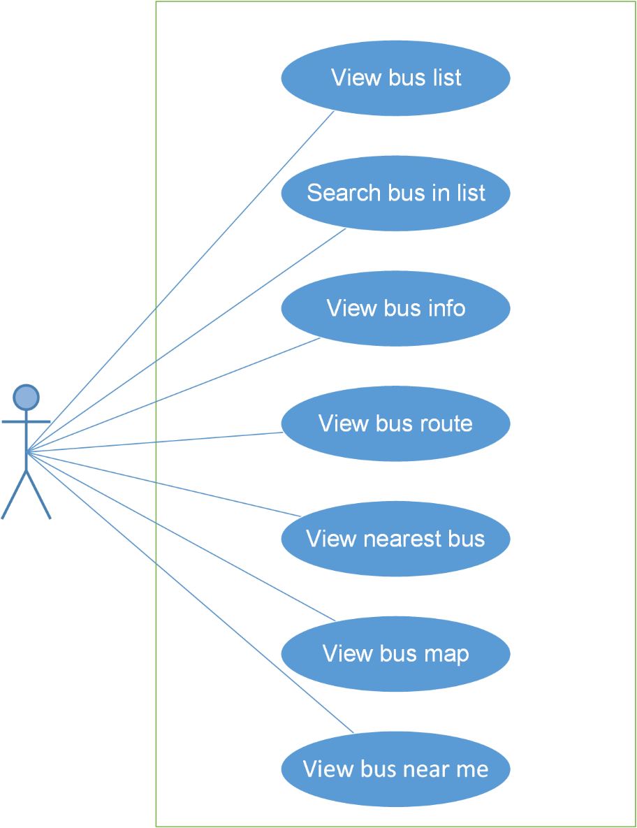

1. **Bus Module use case digram**

#### UC0009: View bus list

##### Screen definition

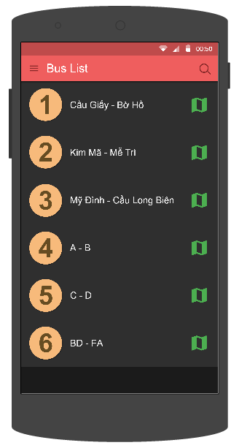

1. **Bus List screen**

|  |  |  |  |  |  |  |  |
| --- | --- | --- | --- | --- | --- | --- | --- |
| **No** | **Field name** | **Field name in Vietnamese** | **Type** | **Require** | **Mandatory** | **Length** | **Description** |
| 1 | Bus route | Tuyến xe buýt | List item | Click | Y |  | User taps on Skip button |
| 2 | Search | Tìm kiếm | Button | Click | Y |  | User taps on Search button |
| 3 | Menu | Danh sách | Button | Click | Y |  | User taps on Menu button |

1. **Bus List screen’s description**

##### Use Case Specification

|  |  |  |  |  |
| --- | --- | --- | --- | --- |
| **Use Case ID** | | UC0009 | **Version** | 1.0 |
| **Use Name** | | View bus list | | |
| **Actor** | | BUSS User | | |
| **Description** | | The function allows a user to view bus list. | | |
| **Precondition** | | User has logged in | | |
| **Trigger** | | User taps Menu then taps Bus List item | | |
| **Post-Condition** | | Bus List screen is displayed | | |
| **Main flows** | | | | |
| **Step** | **Actor** | **Action** | | |
| 1 | BUSS User | Taps on Menu then taps on “Bus list” item | | |
| 2 | BUSS | Displays “Bus list” screen | | |
|  | | | | |

1. **View Bus List use case**

#### UC0010: Search bus in list

##### Screen definition

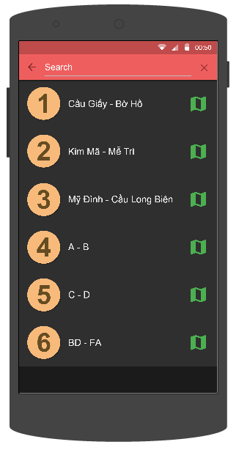

1. **Bus List screen**

|  |  |  |  |  |  |  |  |
| --- | --- | --- | --- | --- | --- | --- | --- |
| **No** | **Field name** | **Field name in Vietnamese** | **Type** | **Require** | **Mandatory** | **Length** | **Description** |
| 1 | Bus route | Tuyến xe buýt | List item | Click | Y |  | User taps on Skip button |
| 2 | Search | Tìm kiếm | Button | Click | Y |  | User taps on Search button |
| 3 | Search Text Field | Khung tìm kiếm | Text field | Text | Y | 255 | User inputs their key word they want to search with length less than 255 characters |
| 4 | Back | Quay lại | Button | Click | Y |  | User taps on Back button |

1. **Bus List screen’s description**

##### Use Case Specification

|  |  |  |  |  |
| --- | --- | --- | --- | --- |
| **Use Case ID** | | UC0010 | **Version** | 1.0 |
| **Use Name** | | Search bus in list | | |
| **Actor** | | BUSS User | | |
| **Description** | | The function allows a user to search bus in the bus list. | | |
| **Precondition** | | Bus List screen displayed | | |
| **Trigger** | | User taps Search button | | |
| **Post-Condition** | | Displays the bus results | | |
| **Main flows** | | | | |
| **Step** | **Actor** | **Action** | | |
| 1 | BUSS User | Taps on Search button on the top of screen | | |
| 2 | BUSS | Displays Search form on Search bar | | |
| 3 | BUSS User | Inputs search keyword | | |
| 4 | BUSS | Searches and displays results | | |
|  | | | | |

**Exception**

|  |  |  |
| --- | --- | --- |
| **E1** | At step 4 in the main flows**,** if BUSS doesn’t find any item that is matched with search keyword | |
| **Step** | **Actor** | **Action** |
| 4.1 | BUSS | Returns message “Sorry, no search result for”...” ” |

1. **Search Bus In List use case**

#### UC0011: View bus info

##### Screen definition

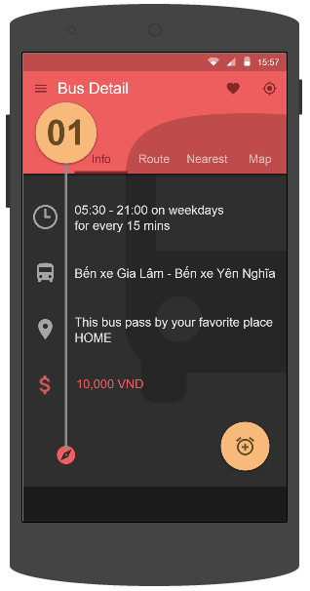

1. **Info tab of Bus Detail screen**

|  |  |  |  |  |  |  |  |
| --- | --- | --- | --- | --- | --- | --- | --- |
| **No** | **Field name** | **Field name in Vietnamese** | **Type** | **Require** | **Mandatory** | **Length** | **Description** |
| 1 | Info | Thông tin | Tab | Click | Y |  | User taps on Info tab |
| 2 | Route | Tuyến đường | Tab | Click | Y |  | User taps on Route tab |
| 3 | Nearest | Gần nhất | Tab | Click | Y |  | User taps on Nearest tab |
| 4 | Map | Bản đồ | Tab | Click | Y |  | User taps on Map button |
| 5 | Favorite | Yêu thích | Button | Click | Y |  | User taps on Favorite button |
| 6 | Tracker | Theo dõi | Button | Click | Y |  | User taps on Track button |
| 7 | Menu | Danh sách | Button | Click | Y |  | User taps on Menu button |
| 8 | Add Reminder | Thêm nhắc nhở | Button | Click | Y |  | User taps on Add Reminder button |

1. **Info tab of Bus Detail screen’s description**

##### Use Case Specification

|  |  |  |  |  |
| --- | --- | --- | --- | --- |
| **Use Case ID** | | UC0011 | **Version** | 1.0 |
| **Use Name** | | View bus info | | |
| **Actor** | | BUSS User | | |
| **Description** | | The function allows a user to view all information of a bus. | | |
| **Precondition** | | Bus List screen displayed | | |
| **Trigger** | | User taps on one bus | | |
| **Post-Condition** | | Bus Detail screen displayed | | |
| **Main flows** | | | | |
| **Step** | **Actor** | **Action** | | |
| 1 | BUSS User | Taps on a bus item. | | |
| 2 | BUSS | Displays Bus Detail screen – Info tab. | | |
|  | | | | |

1. **View Bus Info use case**

#### UC0012: View bus route

##### Screen definition

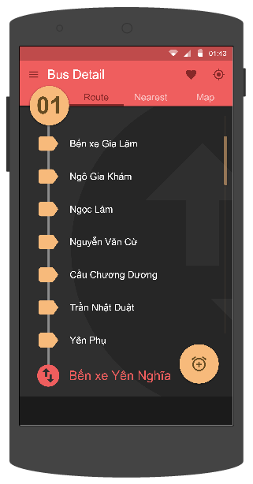

1. **Route tab of Bus Detail screen**

|  |  |  |  |  |  |  |  |
| --- | --- | --- | --- | --- | --- | --- | --- |
| **No** | **Field name** | **Field name in Vietnamese** | **Type** | **Require** | **Mandatory** | **Length** | **Description** |
| 1 | Info | Thông tin | Tab | Click | Y |  | User taps on Info tab |
| 2 | Route | Tuyến đường | Tab | Click | Y |  | User taps on Route tab |
| 3 | Nearest | Gần nhất | Tab | Click | Y |  | User taps on Nearest tab |
| 4 | Map | Bản đồ | Tab | Click | Y |  | User taps on Map button |
| 5 | Favorite | Yêu thích | Button | Click | Y |  | User taps on Favorite button |
| 6 | Tracker | Theo dõi | Button | Click | Y |  | User taps on Track button |
| 7 | Menu | Danh sách | Button | Click | Y |  | User taps on Menu button |

1. **Route tab of Bus Detail screen’s description**

##### Use Case Specification

|  |  |  |  |  |
| --- | --- | --- | --- | --- |
| **Use Case ID** | | UC0012 | **Version** | 1.0 |
| **Use Name** | | View bus route | | |
| **Actor** | | BUSS User | | |
| **Description** | | The function allows a user to view route of a chosen bus. | | |
| **Precondition** | | Bus Detail screen displayed | | |
| **Trigger** | | User taps on Route tab | | |
| **Post-Condition** | | Route tab of Bus Detail displayed | | |
| **Main flows** | | | | |
| **Step** | **Actor** | **Action** | | |
| 1 | BUSS User | Taps on Route tab on the Bus Detail screen. | | |
| 2 | BUSS | Displays Bus Detail screen with the Route tab. | | |
|  | | | | |

1. **View Bus Route use case**

#### UC0013: View nearest bus

##### Screen definition

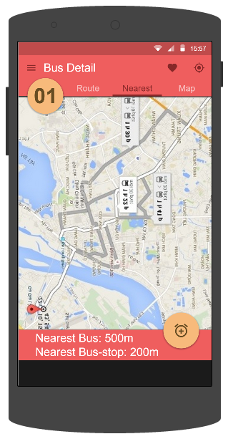

1. **Nearest Bus tab of Bus Detail screen**

|  |  |  |  |  |  |  |  |
| --- | --- | --- | --- | --- | --- | --- | --- |
| **No** | **Field name** | **Field name in Vietnamese** | **Type** | **Require** | **Mandatory** | **Length** | **Description** |
| 1 | Info | Thông tin | Tab | Click | Y |  | User taps on Info tab |
| 2 | Route | Tuyến đường | Tab | Click | Y |  | User taps on Route tab |
| 3 | Nearest | Gần nhất | Tab | Click | Y |  | User taps on Nearest tab |
| 4 | Map | Bản đồ | Tab | Click | Y |  | User taps on Map button |
| 5 | Favorite | Yêu thích | Button | Click | Y |  | User taps on Favorite button |
| 6 | Tracker | Theo dõi | Button | Click | Y |  | User taps on Track button |
| 7 | Menu | Danh sách | Button | Click | Y |  | User taps on Menu button |
| 8 | Add Reminder | Thêm nhắc nhở | Button | Click | Y |  | User taps on Add Reminder button |

1. **Nearest Bus tab of Bus Detail screen’s description**

##### Use Case Specification

|  |  |  |  |  |
| --- | --- | --- | --- | --- |
| **Use Case ID** | | UC0013 | **Version** | 1.0 |
| **Use Name** | | View nearest bus | | |
| **Actor** | | BUSS User | | |
| **Description** | | The function allows a user to view all nearest bus of the chosen bus route. | | |
| **Precondition** | | Bus Detail screen displayed | | |
| **Trigger** | | User taps on Nearest tab | | |
| **Post-Condition** | | Bus Detail tab Nearest displayed | | |
| **Main flows** | | | | |
| **Step** | **Actor** | **Action** | | |
| 1 | BUSS User | Taps on Nearest tab on the Bus Detail screen. | | |
| 2 | BUSS | Displays Bus Detail screen with the Nearest tab. | | |
|  | | | | |

1. **View Nearest Bus use case**

#### UC0014: View bus map

##### Screen definition

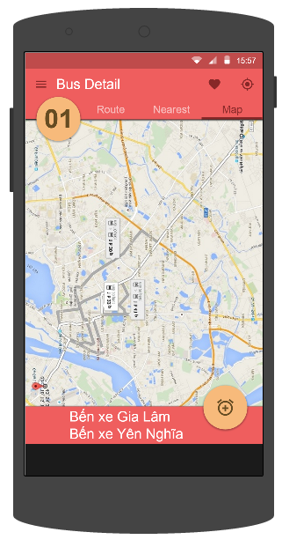

1. **Map tab of Bus Detail screen**

|  |  |  |  |  |  |  |  |
| --- | --- | --- | --- | --- | --- | --- | --- |
| **No** | **Field name** | **Field name in Vietnamese** | **Type** | **Require** | **Mandatory** | **Length** | **Description** |
| 1 | Info | Thông tin | Tab | Click | Y |  | User taps on Info tab |
| 2 | Route | Tuyến đường | Tab | Click | Y |  | User taps on Route tab |
| 3 | Nearest | Gần nhất | Tab | Click | Y |  | User taps on Nearest tab |
| 4 | Map | Bản đồ | Tab | Click | Y |  | User taps on Map button |
| 5 | Favorite | Yêu thích | Button | Click | Y |  | User taps on Favorite button |
| 6 | Tracker | Theo dõi | Button | Click | Y |  | User taps on Track button |
| 7 | Menu | Danh sách | Button | Click | Y |  | User taps on Menu button |
| 8 | Add Reminder | Thêm nhắc nhở | Button | Click | Y |  | User taps on Add Reminder button |

1. **Map tab of Bus Detail screen’s description**

##### Use Case Specification

|  |  |  |  |  |
| --- | --- | --- | --- | --- |
| **Use Case ID** | | UC0014 | **Version** | 1.0 |
| **Use Name** | | View bus map | | |
| **Actor** | | BUSS User | | |
| **Description** | | The function allows a user to view route of a chosen bus on the map. | | |
| **Precondition** | | Bus Detail screen displayed | | |
| **Trigger** | | User taps on Map tab | | |
| **Post-Condition** | | Bus Detail tab Map displayed | | |
| **Main flows** | | | | |
| **Step** | **Actor** | **Action** | | |
| 1 | BUSS User | Taps on Map tab on the Bus Detail screen. | | |
| 2 | BUSS | Displays Bus Detail screen with the Map tab. | | |
|  | | | | |

1. **View Bus Map use case**

#### UC0015: View bus near me

##### Screen definition

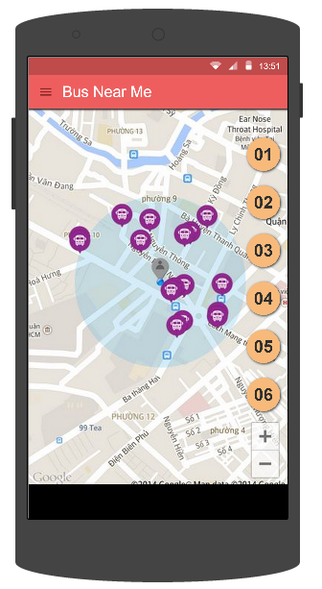

1. **Bus Near Me screen**

|  |  |  |  |  |  |  |  |
| --- | --- | --- | --- | --- | --- | --- | --- |
| **No** | **Field name** | **Field name in Vietnamese** | **Type** | **Require** | **Mandatory** | **Length** | **Description** |
| 1 | Menu | Danh sách | Button | Click | Y |  | User taps Menu button |
| 2 | Bus route | Tuyến buýt | Button | Click | Y |  | User taps Bus route button |
| 3 | Bus | Buýt | Icon | Click | Y |  | User taps Bus icon on map |

1. **Bus Near Me screen’s description**

##### Use Case Specification

|  |  |  |  |  |
| --- | --- | --- | --- | --- |
| **Use Case ID** | | UC0015 | **Version** | 1.0 |
| **Use Name** | | View bus near me | | |
| **Actor** | | BUSS User | | |
| **Description** | | The function allows a user to view all buses near his/her current location. | | |
| **Precondition** | | User has logged in | | |
| **Trigger** | | User taps Bus near me button | | |
| **Post-Condition** | | Bus near me screen displayed | | |
| **Main flows** | | | | |
| **Step** | **Actor** | **Action** | | |
| 1 | BUSS User | Taps on Bus near me button. | | |
| 2 | BUSS | Displays Bus near me screen. | | |
| 3 | BUSS User | Taps on Bus route button | | |
| 4 | BUSS | Displays buses of the chosen bus route | | |
| 5 | BUSS User | Taps on Bus icon on map | | |
| 6 | BUSS | Shows how far from bus to the nearest bus-stop | | |
|  | | | | |

1. **View Bus Near Me use case**

### Path finder module

#### Use case diagram

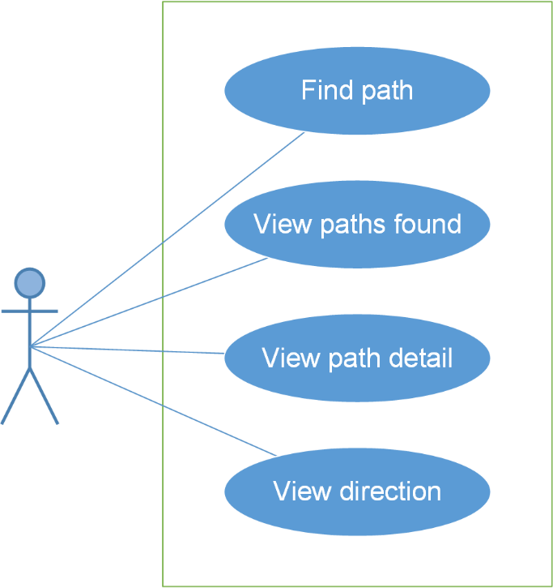

1. **Path finder Module use case diagram**

#### UC0016: Find path

##### Screen definition

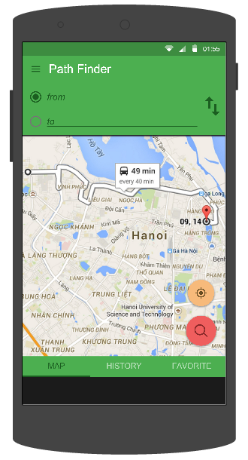

1. **Path Finder screen**

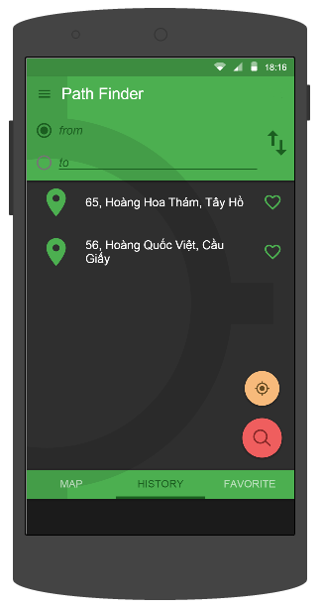

1. **Path Finder screen – tab History**

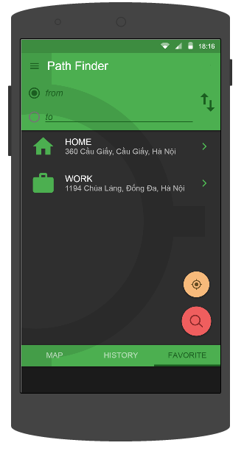

1. **Path Finder screen – tab Favorite**

|  |  |  |  |  |  |  |  |
| --- | --- | --- | --- | --- | --- | --- | --- |
| **No** | **Field name** | **Field name in Vietnamese** | **Type** | **Require** | **Mandatory** | **Length** | **Description** |
| 1 | From | Từ | Text field | Text | Y | 255 | User inputs their position or the place they start to go with less than 255 characters. |
| 2 | To | Đến | Text field | Text | Y | 255 | User inputs the place they want to go with less than 255 characters. |
| 3 | Reverse | Đảo chiều | Button | Click | Y |  | User taps on Reverse button |
| 4 | Search | Tìm kiếm | Button | Click | Y |  | User taps on Search button |
| 5 | Get current location | Lấy vị trí hiện tại | Button | Click | Y |  | User taps on Get current location button |
| 6 | Map | Bản đồ | Tab | Click | Y |  | User taps on Map tab |
| 7 | History | Lịch sử | Tab | Click | Y |  | User taps on History tab |
| 8 | Favorite | Yêu thích | Tab | Click | Y |  | User taps on Favorite tab |
| 9 | Menu | Danh sách | Button | Click | Y |  | User taps on Menu button |
| 10 | History | Lịch sử | List item | Click | Y |  | User taps on History item |
| 11 | Favorite | Yêu thích | List item | Click | Y |  | User taps on Favorite item |

1. **Find Path screen’s description**

##### Use Case Specification

|  |  |  |  |  |
| --- | --- | --- | --- | --- |
| **Use Case ID** | | UC0016 | **Version** | 1.0 |
| **Use Name** | | Find path | | |
| **Actor** | | BUSS User | | |
| **Description** | | The function allows an user to find path | | |
| **Precondition** | | User has logged in | | |
| **Trigger** | | User taps “Path finder” item on Menu | | |
| **Post-Condition** | | “Path finder” screen is shown | | |
| **Main flows** | | | | |
| **Step** | **Actor** | **Action** | | |
| 1 | BUSS User | Taps “Path finder” item on menu | | |
| 2 | BUSS | Display “Path finder” screen | | |
| 3 | BUSS User | In “Map” tab, inputs departure into “from” text field and destination into “to” text field then taps Search button | | |
| 4 | BUSS | Searches and displays found paths | | |
|  | | | | |

**Alternative scenario**

|  |  |  |
| --- | --- | --- |
| **AT1** | At step 3 in the main flows**,** if BUSS User inputs “from” and “to” text field then taps Revert direction button then taps Search button | |
| **Step** | **Actor** | **Action** |
| 4.1 | BUSS | Swaps 2 locations then searches and displays found paths |

|  |  |  |
| --- | --- | --- |
| **AT2** | At step 3 in the main flows**,** in “Map” tab, if BUSS User taps “Get current location” button in order to input “from” or “to” text field and inputs the other text field then taps Search button | |
| **Step** | **Actor** | **Action** |
| 4.2 | BUSS | Returns user’s current location into that text field then searches and displays found paths |

|  |  |  |
| --- | --- | --- |
| **AT3** | At step 3 in the main flows**,** in “Map” tab, if BUSS User chooses locations on map in order to input “from” and “to” text field then taps Search button | |
| **Step** | **Actor** | **Action** |
| 4.3 | BUSS | Returns locations into “from” and “to” text field then searches and displays found paths |

|  |  |  |
| --- | --- | --- |
| **AT4** | At step 3 in the main flows**,** if BUSS User taps “History” tab then chooses places for “from”/ “to” text field then taps Search button | |
| **Step** | **Actor** | **Action** |
| 4.4 | BUSS | Displays places which were found before then searches and displays found paths |

|  |  |  |
| --- | --- | --- |
| **AT5** | At step 3 in the main flows**,** if BUSS User taps “Favorite” tab then chooses places for “from”/ “to” text field then taps Search button | |
| **Step** | **Actor** | **Action** |
| 4.5 | BUSS | Displays favorite places which were set before then searches and displays found paths |

**Exception**

|  |  |  |
| --- | --- | --- |
| **E1** | At step 3 in the main flows**,** if BUSS User inputs a place, which doesn’t exist, into “from”/ “to” text field then taps Search button | |
| **Step** | **Actor** | **Action** |
| 4.1 | BUSS | Returns popup with Error message “from/ to không tồn tại” |

|  |  |  |
| --- | --- | --- |
| **E2** | At step 3 in the main flows**,** if BUSS User leaves “from”/ “to” text field blank then taps Search button | |
| **Step** | **Actor** | **Action** |
| 4.2 | BUSS | Returns popup with Error message “Vui lòng nhập đầy đủ thông tin” |

|  |  |  |
| --- | --- | --- |
| **E3** | At step 3 in the main flows**,** if BUSS User inputs “from” and “to” text field then taps Search button without Internet | |
| **Step** | **Actor** | **Action** |
| 4.3 | BUSS | Returns popup with Error message “Thiết bị không kết nối mạng” |

1. **Find Path use case**

#### UC0017: View paths found

##### Screen definition

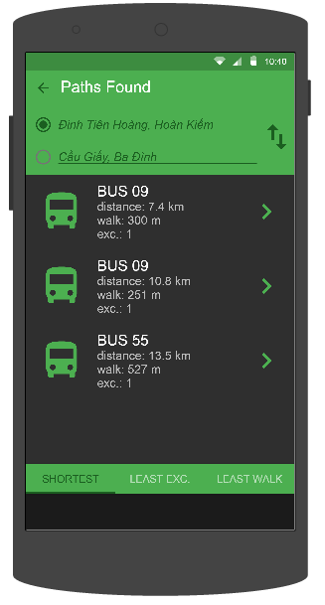

1. **Paths Found screen**

|  |  |  |  |  |  |  |  |
| --- | --- | --- | --- | --- | --- | --- | --- |
| **No** | **Field name** | **Field name in Vietnamese** | **Type** | **Require** | **Mandatory** | **Length** | **Description** |
| 1 | Reverse | Đảo chiều | Button | Click | Y |  | User taps on Reverse button |
| 2 | Shortest | Quãng đường ngắn nhất | Tab | Click | Y |  | User taps on Shortest tab |
| 3 | Least Exc | Chuyển tuyến ít nhất | Tab | Click | Y |  | User taps on Least Exc tab |
| 4 | Least Walk | Đi bộ ít nhất | Tab | Click | Y |  | User taps on Least Walk tab |
| 5 | Menu | Danh sách | Button | Click | Y |  | User taps on Menu button |

1. **Paths Found screen’s description**

##### Use Case Specification

|  |  |  |  |  |
| --- | --- | --- | --- | --- |
| **Use Case ID** | | UC0017 | **Version** | 1.0 |
| **Use Name** | | View path found | | |
| **Actor** | | BUSS User | | |
| **Description** | | The function allows an user to view path found | | |
| **Precondition** | | “Path Finder” screen displayed | | |
| **Trigger** | | User taps Search button | | |
| **Post-Condition** | | “Paths Found” screen is shown | | |
| **Main flows** | | | | |
| **Step** | **Actor** | **Action** | | |
| 1 | BUSS User | Enters “Path Finder” screen, inputs informations and taps Search button | | |
| 2 | BUSS | * Searches and displays list of found paths in “Paths found” screen. * “from”/ “to” text field and Revert direction button will be disable. * A path will show the following information: total distance , walking distance, the number of exchange | | |
| 3 | BUSS User | Taps “Shortest” tab | | |
| 4 | BUSS | Displays list paths found by filter: shortest | | |
|  | | | | |

**Alternative scenario**

|  |  |  |
| --- | --- | --- |
| **AT1** | At step 3 in the main flows**,** if BUSS User taps “Least Exc ” tab | |
| **Step** | **Actor** | **Action** |
| 4.1 | BUSS | Displays list paths found by filter: least exchange |

|  |  |  |
| --- | --- | --- |
| **AT2** | At step 3 in the main flows**,** in “Map” tab, if BUSS User taps “Least walk” tab | |
| **Step** | **Actor** | **Action** |
| 4.2 | BUSS | Displays list paths found by filter: least walk |

1. **View Paths Found use case**

#### UC0018: View path detail

##### Screen definition

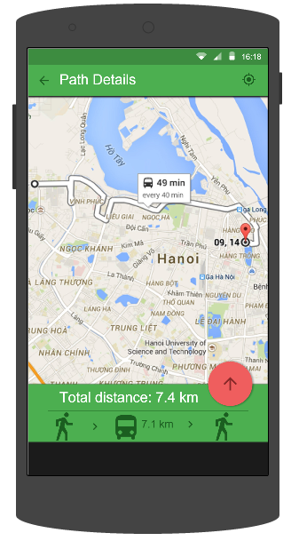

1. **Path Details screen**

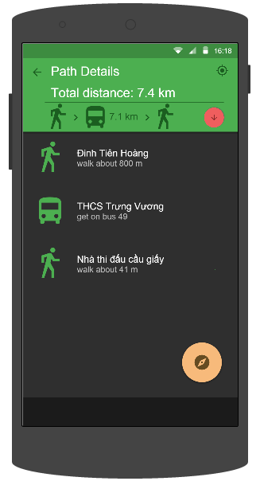

1. **Path Details 2 screen**

|  |  |  |  |  |  |  |  |
| --- | --- | --- | --- | --- | --- | --- | --- |
| **No** | **Field name** | **Field name in Vietnamese** | **Type** | **Require** | **Mandatory** | **Length** | **Description** |
| 1 | Track | Theo dõi | Button | Click | Y |  | User taps on Track button |
| 2 | Bus | Buýt | Icon | Click | Y |  | User taps Bus icon displaying on map |
| 3 | Arrow up | Mũi tên đi lên | Button | Click | Y |  | User taps on Arrow up button |
| 4 | Arrow down | Mũi tên đi xuống | Button | Click | Y |  | User taps on Arrow down button |
| 5 | Path detail | Chi tiết đường đi | List item |  |  |  |  |
| 6 | Navigate | Chỉ đường | Button | Click | Y |  | User taps on Navigate button |
| 7 | Back | Quay lại | Button | Click | Y |  | User taps on Back button |

1. **Path Details screen’s description**

##### Use Case Specification

|  |  |  |  |  |
| --- | --- | --- | --- | --- |
| **Use Case ID** | | UC0018 | **Version** | 1.0 |
| **Use Name** | | View path details | | |
| **Actor** | | BUSS User | | |
| **Description** | | The function allows an user to view path detail | | |
| **Precondition** | | “Path Found” screen displayed | | |
| **Trigger** | | User taps one path | | |
| **Post-Condition** | | “Path Details” screen is shown | | |
| **Main flows** | | | | |
| **Step** | **Actor** | **Action** | | |
| 1 | BUSS User | In “Path Found” screen, chooses a path | | |
| 2 | BUSS | Displays “Path Details” screen and shows:   * The chosen path on the map * The bus which is nearest from the departure location will also be shown on the path draw.This bus will show how far from bus to the nearest bus-stop that is from departure location. * The nearest bus-stop from departure and the nearest bus-stop from destination | | |
|  | | | | |

**Alternative scenario**

|  |  |  |
| --- | --- | --- |
| **AT1** | After step 2 in the main flows**,** if BUSS User taps “Arrow up” button | |
| **Step** | **Actor** | **Action** |
| 3.1 | BUSS | Displays Path Details 2 screen with the list: how far walk, which bus to get on... |

1. **View Path Detail use case**

#### UC0019: View direction

##### Screen definition

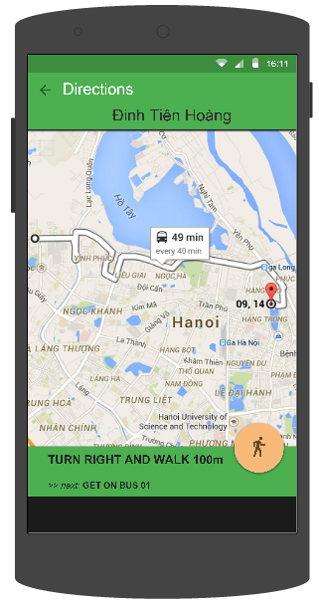

1. **Directions screen**

|  |  |  |  |  |  |  |  |
| --- | --- | --- | --- | --- | --- | --- | --- |
| **No** | **Field name** | **Field name in Vietnamese** | **Type** | **Require** | **Mandatory** | **Length** | **Description** |
| 1 | Back | Quay lại | Button | Click | Y |  | User taps on Back button |

1. **Directions screen’s description**

##### Use Case Specification

|  |  |  |  |  |
| --- | --- | --- | --- | --- |
| **Use Case ID** | | UC0019 | **Version** | 1.0 |
| **Use Name** | | View direction | | |
| **Actor** | | BUSS User | | |
| **Description** | | The function allows an user to view path direction | | |
| **Precondition** | | “Path Detail” screen displayed | | |
| **Trigger** | | User taps “Navigate” button | | |
| **Post-Condition** | | “Direction” screen is shown | | |
| **Main flows** | | | | |
| **Step** | **Actor** | **Action** | | |
| 1 | BUSS User | In “Path Detail” screen, taps “Arrow up” button | | |
| 2 | BUSS | Displays “Path Detail” screen | | |
| 3 | BUSS User | Taps “Navigate” button | | |
| 4 | BUSS | Shows step-by-step detailed direction according to the user’s current location. | | |
|  | | | | |

1. **View Direction use case**

### Reminder module

#### Use case diagram

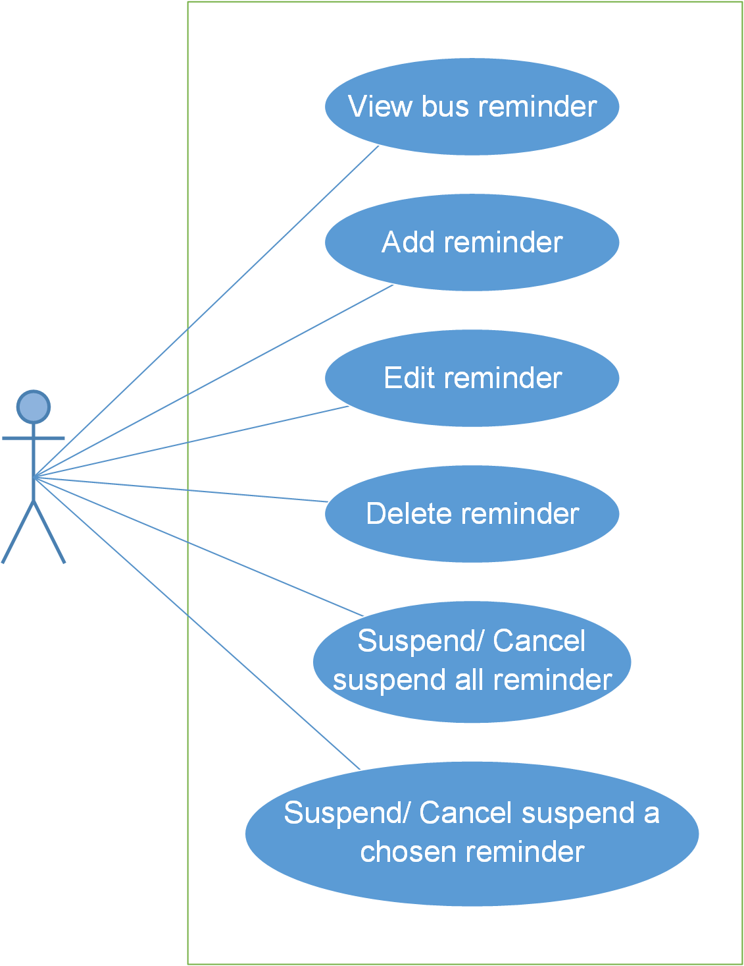

1. **Reminder Module use case diagram**

#### UC0020: View bus reminder

##### Screen definition

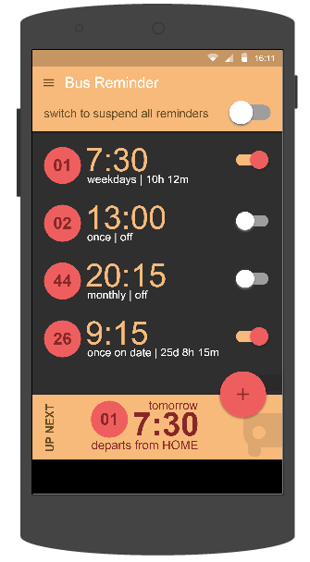

1. **Bus Reminder screen**

|  |  |  |  |  |  |  |  |
| --- | --- | --- | --- | --- | --- | --- | --- |
| **No** | **Field name** | **Field name in Vietnamese** | **Type** | **Require** | **Mandatory** | **Length** | **Description** |
| 1 | Add | Thêm | Button | Click | Y |  | User taps on Add button |
| 2 | Menu | Danh sách | Button | Click | Y |  | User taps on Menu button |
| 3 | Suspend all | Ngừng tất cả | Switch | Click | Y |  | User taps on Suspend all switch |
| 4 | Reminder | Nhắc nhở | List item | Click | Y |  | User taps on Reminder item |
| 5 | Suspend | Ngừng | Switch | Click | Y |  | User taps on Suspend switch |

1. **Bus Reminder screen’s description**

##### Use Case Specification

|  |  |  |  |  |
| --- | --- | --- | --- | --- |
| **Use Case ID** | | UC0020 | **Version** | 1.0 |
| **Use Name** | | View bus reminder | | |
| **Actor** | | BUSS User | | |
| **Description** | | The function allows an user to view bus reminders | | |
| **Precondition** | | User has logged in | | |
| **Trigger** | | User taps “Reminders” button | | |
| **Post-Condition** | | “Bus Reminder” screen is shown | | |
| **Main flows** | | | | |
| **Step** | **Actor** | **Action** | | |
| 1 | BUSS User | Taps “Reminders” button | | |
| 2 | BUSS | Displays “Bus Reminder” screen and shows list of reminders and the next reminder. If there isn’t any reminder, system will show message “There aren’t any reminders” | | |
|  | | | | |

**Alternative scenario**

|  |  |  |
| --- | --- | --- |
| **AT1** | At step 1 in the main flows**,** if BUSS User taps Menu and chooses “Bus reminder” item | |
| **Step** | **Actor** | **Action** |
| 2.1 | BUSS | Displays “Bus Reminder” screen and shows list of reminder and the next reminder. If there isn’t any reminder, system will show message “There aren’t any reminders” |

1. **View Bus Reminder use case**

#### UC0021: Add reminder

##### Screen definition

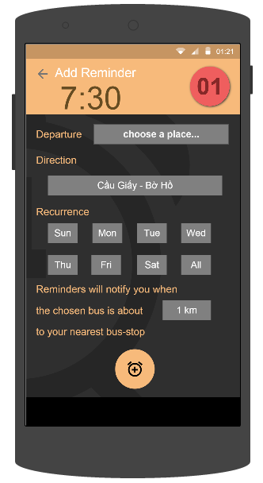

1. **Add Reminder screen**

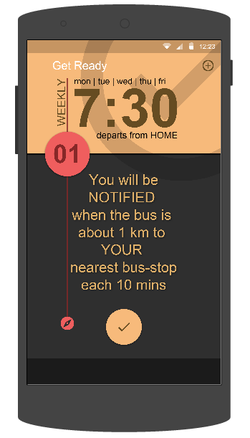

1. **Set Reminder Done screen**

|  |  |  |  |  |  |  |  |
| --- | --- | --- | --- | --- | --- | --- | --- |
| **No** | **Field name** | **Field name in Vietnamese** | **Type** | **Require** | **Mandatory** | **Length** | **Description** |
| 1 | Bus route | Tuyến buýt | Button | Click | Y |  | User taps on Bus route button |
| 2 | Clock | Báo thức | Button | Click | Y |  | User taps on Clock button |
| 3 | Departure | Điểm đi | Drop down list | Click | Y |  | User taps Departure drop down list |
| 4 | Direction | Hướng | Drop down list | Click | Y |  | User taps Direction drop down list |
| 5 | Recurrence | Lặp lại | Button | Click | Y |  | User taps Recurrece (dates) buttons |
| 6 | Reminder distance | Khoảng cách nhận thông báo | Drop down list | Click | Y |  | User taps Reminder distance drop down list |
| 7 | Add Reminder | Thêm | Button | Click | Y |  | User taps on Add button to add reminder |
| 8 | Back | Quay lại | Button | Click | Y |  | User taps on Back button to go back |
| 9 | Done | Xong | Button | Click | Y |  | User taps on Done button |
| 10 | Add other reminder | Thêm nhắc nhở khác | Button | Click | Y |  | User taps on Add other reminder button |

1. **Add Reminder screen’s description**

##### Use Case Specification

|  |  |  |  |  |
| --- | --- | --- | --- | --- |
| **Use Case ID** | | UC0021 | **Version** | 1.0 |
| **Use Name** | | Add reminder | | |
| **Actor** | | BUSS User | | |
| **Description** | | The function allows an user to add reminder | | |
| **Precondition** | | User has logged in | | |
| **Trigger** | | User taps “Add” button | | |
| **Post-Condition** | | “Bus reminder” screen is shown | | |
| **Main flows** | | | | |
| **Step** | **Actor** | **Action** | | |
| 1 | BUSS User | Taps Menu and choose “Bus reminder” item then taps “Add” button. | | |
| 2 | BUSS | Displays “Add reminder” screen | | |
| 3 | BUSS User | Inputs “Time” field | | |
| 4 | BUSS | Shows inputted time in “Time” field | | |
| 5 | BUSS User | Taps “Bus route” button | | |
| 6 | BUSS | Displays Bus List | | |
| 7 | BUSS User | Chooses a bus item in Bus list | | |
| 8 | BUSS | Return Add Reminder screen and shows the chosen bus in “Bus route” button | | |
| 9 | BUSS User | Taps “Departure” field | | |
| 10 | BUSS | Shows Departure dropdown list with 2 options: Favorite Place and Other Place. | | |
| 11 | BUSS User | Chooses Favorite Place item in list | | |
| 12 | BUSS | Displays Favorite Place screen | | |
| 13 | BUSS User | Chooses a place | | |
| 14 | BUSS | Return Add Reminder screen and shows the chosen place in “Departure” field. | | |
| 15 | BUSS User | Taps “Direction” field then chooses an item in Direction dropdown list | | |
| 16 | BUSS | Shows the chosen item in “Direction” field. | | |
| 17 | BUSS User | In “Recurrence” field, choose some dates | | |
| 18 | BUSS | Shows the chosen dates. | | |
| 19 | BUSS User | Taps “Reminder distance” field then chooses an item in Distance dropdown list | | |
| 20 | BUSS | Shows the chosen item in “Reminder distance” field. | | |
| 21 | BUSS User | Taps “Add Reminder” button | | |
| 22 | BUSS | Saves reminder and displays “Reminder set done” screen | | |
| 23 | BUSS User | Taps “Done” button | | |
| 24 | BUSS | Returns “Bus reminder” screen. This reminder will be shown in Bus Reminders list and its Suspend switch will turn into ON status | | |
|  | | | | |

**Alternative scenario**

|  |  |  |
| --- | --- | --- |
| **AT1** | At step 1 in the main flows**,** if BUSS User enters “Bus List” screen and chooses a bus from list, then taps “Add Reminder” button | |
| **Step** | **Actor** | **Action** |
| 2.1 | BUSS | Displays Add Reminders screen. |

|  |  |  |
| --- | --- | --- |
| **AT2** | At step 11 in the main flows**,** if BUSS User chooses Other Place item in list | |
| **Step** | **Actor** | **Action** |
| 12.2 | BUSS | Displays “Search Place” screen |

|  |  |  |
| --- | --- | --- |
| **AT3** | At step 23 in the main flows**,** if BUSS User taps “Add other reminder” button | |
| **Step** | **Actor** | **Action** |
| 24.3 | BUSS | Displays “Add Reminder” screen |

|  |  |  |
| --- | --- | --- |
| **AT4** | From step 3 to step 21, if BUSS User inputs only “Departure” field then taps “Add Reminder” button | |
| **Step** | **Actor** | **Action** |
| 22.4 | BUSS | Saves reminder with inputted “Departure” field and others default info |

**Exception**

|  |  |  |
| --- | --- | --- |
| **E1** | At step 9 in the main flows**,** if BUSS User leaves “departure” text field blank, then taps Add button | |
| **Step** | **Actor** | **Action** |
| 14.1 | BUSS | Skips from step 10 to step 13 and returns Error message “Departure is required” |

1. **Add Reminder use case**

#### UC0022: Edit reminder

##### Screen definition

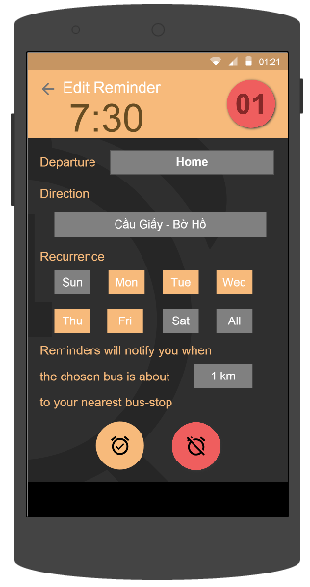

1. **Edit Reminder screen**

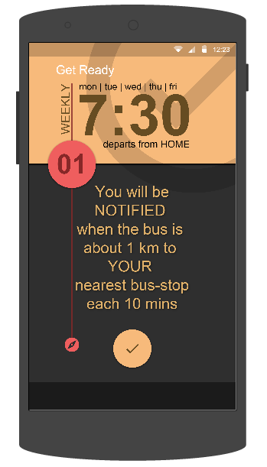

1. **Set Reminder Done screen**

|  |  |  |  |  |  |  |  |
| --- | --- | --- | --- | --- | --- | --- | --- |
| **No** | **Field name** | **Field name in Vietnamese** | **Type** | **Require** | **Mandatory** | **Length** | **Description** |
| 1 | Bus route | Tuyến buýt | Button | Click | Y |  | User taps on Bus route button |
| 2 | Clock | Báo thức | Button | Click | Y |  | User taps on Clock button |
| 3 | Departure | Điểm đi | Drop down list | Click | Y |  | User taps Departure drop down list |
| 4 | Direction | Hướng | Drop down list | Click | Y |  | User taps Direction drop down list |
| 5 | Recurrence | Lặp lại | Button | Click | Y |  | User taps Recurrece (dates) buttons |
| 6 | Reminder distance | Khoảng cách nhận thông báo | Drop down list | Click | Y |  | User taps Reminder distance drop down list |
| 7 | Save | Lưu | Button | Click | Y |  | User taps on Save button |
| 8 | Delete | Xóa | Button | Click | Y |  | User taps on Delete button |
| 9 | Back | Quay lại | Button | Click | Y |  | User taps on Back button to go back |
| 10 | Done | Xong | Button | Click | Y |  | User taps on Done button |

1. **Edit Reminder screen’s description**

##### Use Case Specification

|  |  |  |  |  |
| --- | --- | --- | --- | --- |
| **Use Case ID** | | UC0022 | **Version** | 1.0 |
| **Use Name** | | Edit reminder | | |
| **Actor** | | BUSS User | | |
| **Description** | | The function allows an user to edit reminder | | |
| **Precondition** | | “Bus Reminder” screen displayed | | |
| **Trigger** | | User taps on one Reminder | | |
| **Post-Condition** | | “Edit Reminder” screen is shown | | |
| **Main flows** | | | | |
| **Step** | **Actor** | **Action** | | |
| 1 | BUSS User | Taps on one Reminder | | |
| 2 | BUSS | Displays “Edit Reminder” screen | | |
| 3 | BUSS User | Edits “Time”, “Destination” , “Direction”, “Recurrence” and “Reminder distance” field then taps “Save” button | | |
| 4 | BUSS | Saves reminder and displays “Reminder set done” screen | | |
| 5 | BUSS User | Taps “Done” button | | |
| 6 | BUSS | Returns “Bus reminder” screen. This reminder will be shown in Bus Reminders list and its Suspend switch will turn into ON status | | |
|  | | | | |

**Alternative scenario**

|  |  |  |
| --- | --- | --- |
| **AT1** | At step 3 in the main flows**,** if BUSS User taps “Save” button without editing any fields | |
| **Step** | **Actor** | **Action** |
| 4.1 | BUSS | Saves reminder and displays “Reminder set done” screen |

**Exception**

|  |  |  |
| --- | --- | --- |
| **E1** | At step 3 in the main flows**,** if BUSS User leaves “Destination” text field blank, then taps “Save” button | |
| **Step** | **Actor** | **Action** |
| 4.1 | BUSS | Returns Error message “Destination is required” |

1. **Edit Reminder use case**

#### UC0023: Delete reminder



1. **Edit Reminder screen**

|  |  |  |  |  |  |  |  |
| --- | --- | --- | --- | --- | --- | --- | --- |
| **No** | **Field name** | **Field name in Vietnamese** | **Type** | **Require** | **Mandatory** | **Length** | **Description** |
| 1 | Bus route | Tuyến buýt | Button | Click | Y |  | User taps on Bus route button |
| 2 | Clock | Báo thức | Button | Click | Y |  | User taps on Clock button |
| 3 | Departure | Điểm đi | Drop down list | Click | Y |  | User taps Departure drop down list |
| 4 | Direction | Hướng | Drop down list | Click | Y |  | User taps Direction drop down list |
| 5 | Recurrence | Lặp lại | Button | Click | Y |  | User taps Recurrece (dates) buttons |
| 6 | Reminder distance | Khoảng cách nhận thông báo | Drop down list | Click | Y |  | User taps Reminder distance drop down list |
| 7 | Save | Lưu | Button | Click | Y |  | User taps on Save button |
| 8 | Delete | Xóa | Button | Click | Y |  | User taps on Delete button |
| 9 | Back | Quay lại | Button | Click | Y |  | User taps on Back button to go back |

1. **Edit Reminder screen’s description**

##### Use Case Specification

|  |  |  |  |  |
| --- | --- | --- | --- | --- |
| **Use Case ID** | | UC0023 | **Version** | 1.0 |
| **Use Name** | | Delete reminder | | |
| **Actor** | | BUSS User | | |
| **Description** | | The function allows an user to delete reminder | | |
| **Precondition** | | “Bus Reminder” screen displayed | | |
| **Trigger** | | User taps on one Reminder then taps “Delete” button | | |
| **Post-Condition** | | “Bus Reminder” screen is shown without deleted Reminder | | |
| **Main flows** | | | | |
| **Step** | **Actor** | **Action** | | |
| 1 | BUSS User | Taps on one Reminder | | |
| 2 | BUSS | Displays “Edit Reminder” screen | | |
| 3 | BUSS User | Taps “Delete” button | | |
| 4 | BUSS | Displays “Confirm delete” dialog. | | |
| 5 | BUSS User | Taps “OK” button | | |
| 6 | BUSS | Deletes this reminder and comes back to Bus Reminder screen. | | |
|  | | | | |

**Alternative scenario**

|  |  |  |
| --- | --- | --- |
| **AT1** | At step 5 in the main flows**,** if BUSS User taps “Cancel” button. | |
| **Step** | **Actor** | **Action** |
| 6.1 | BUSS | Do not delete anything and returns to Reminder Detail screen |

1. **Delete Reminder use case**

#### UC0024: Suspend/Cancel suspend all reminder

##### Screen definition



1. **Bus Reminder screen**

|  |  |  |  |  |  |  |  |
| --- | --- | --- | --- | --- | --- | --- | --- |
| **No** | **Field name** | **Field name in Vietnamese** | **Type** | **Require** | **Mandatory** | **Length** | **Description** |
| 1 | Add | Thêm | Button | Click | Y |  | User taps on Add button |
| 2 | Menu | Danh sách | Button | Click | Y |  | User taps on Menu button |
| 3 | Suspend all | Ngừng tất cả | Switch | Click | Y |  | User taps on Suspend all switch |
| 4 | Reminder | Nhắc nhở | List item | Click | Y |  | User taps on Reminder item |
| 5 | Suspend | Ngừng | Switch | Click | Y |  | User taps on Suspend switch |

1. **Bus Reminder screen’s description**

##### Use Case Specification

|  |  |  |  |  |
| --- | --- | --- | --- | --- |
| **Use Case ID** | | UC0024 | **Version** | 1.0 |
| **Use Name** | | Suspend/Cancel suspend all reminder | | |
| **Actor** | | BUSS User | | |
| **Description** | | The function allows an user to suspend/Cancel suspend all reminder | | |
| **Precondition** | | “Bus Reminder” screen displayed, “switch to suspend all reminders” switch button is OFF | | |
| **Trigger** | | User taps “switch to suspend all reminders” button | | |
| **Post-Condition** | | “switch to suspend all reminders” switch button turn from OFF to ON | | |
| **Main flows** | | | | |
| **Step** | **Actor** | **Action** | | |
| 1 | BUSS User | Taps “switch to suspend all reminders” switch button | | |
| 2 | BUSS | Suspends all reminders and hides them. | | |
| 3 | BUSS User | Taps “switch to suspend all reminders” switch button again | | |
| 4 | BUSS | Cancel suspends all reminders and shows them. | | |
|  | | | | |

1. **Suspend/Cancel suspend All Reminder use case**

#### UC0025: Suspend/Cancel suspend a chosen reminder

##### Screen definition



1. **Bus Reminder screen**

|  |  |  |  |  |  |  |  |
| --- | --- | --- | --- | --- | --- | --- | --- |
| **No** | **Field name** | **Field name in Vietnamese** | **Type** | **Require** | **Mandatory** | **Length** | **Description** |
| 1 | Add | Thêm | Button | Click | Y |  | User taps on Add button |
| 2 | Menu | Danh sách | Button | Click | Y |  | User taps on Menu button |
| 3 | Suspend all | Ngừng tất cả | Switch | Click | Y |  | User taps on Suspend all switch |
| 4 | Reminder | Nhắc nhở | List item | Click | Y |  | User taps on Reminder item |
| 5 | Suspend | Ngừng | Switch | Click | Y |  | User taps on Suspend switch |

1. **Bus Reminder screen’s description**

##### Use Case Specification

|  |  |  |  |  |
| --- | --- | --- | --- | --- |
| **Use Case ID** | | UC0025 | **Version** | 1.0 |
| **Use Name** | | Suspend/Cancel suspend a chosen reminder | | |
| **Actor** | | BUSS User | | |
| **Description** | | The function allows an user to suspend/Cancel suspend a chosen reminder | | |
| **Precondition** | | “Bus Reminder” screen displayed, “Suspend” switch button is OFF | | |
| **Trigger** | | User taps “Suspend” button | | |
| **Post-Condition** | | “Suspend” switch button turn from OFF to ON/ON to OFF | | |
| **Main flows** | | | | |
| **Step** | **Actor** | **Action** | | |
| 1 | BUSS User | Taps “Suspend” switch button | | |
| 2 | BUSS | Suspends that reminder | | |
| 3 | BUSS User | Taps “Suspend” switch button again | | |
| 4 | BUSS | Cancel suspends that reminder | | |
|  | | | | |

1. **Suspend/Cancel suspend A Chosen Reminder use case**

### Track module

#### Use case diagram

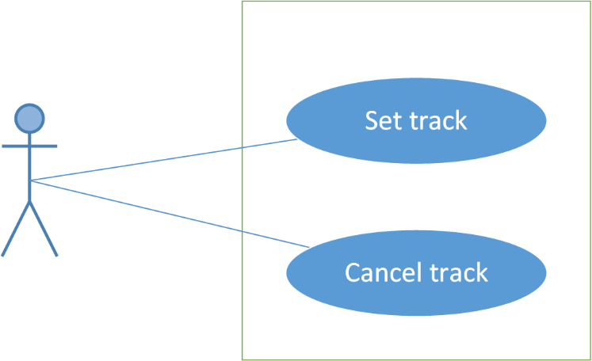

1. **Track Module use case diagram**

#### UC0026: Set tracker

##### Screen definition

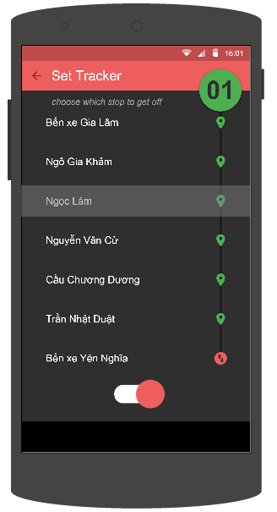

1. **Set Tracker screen**

|  |  |  |  |  |  |  |  |
| --- | --- | --- | --- | --- | --- | --- | --- |
| **No** | **Field name** | **Field name in Vietnamese** | **Type** | **Require** | **Mandatory** | **Length** | **Description** |
| 1 | Track | Theo dõi | Switch | Click | Y |  | User taps on Track switch |
| 2 | Reverse | Đảo chiều | Button | Click | Y |  | User taps on Revert button to reverse direction |
| 3 | Bus stop | Trạm dừng | List item | Click | Y |  | User taps on Bus stop item to choose where to stop. |
| 2 | Back | Quay lại | Button | Click | Y |  | User taps on Back button to go back |

1. **Set Tracker screen’s description**

##### Use Case Specification

|  |  |  |  |  |
| --- | --- | --- | --- | --- |
| **Use Case ID** | | UC0026 | **Version** | 1.0 |
| **Use Name** | | Set track | | |
| **Actor** | | BUSS User | | |
| **Description** | | The function allows an user to set track | | |
| **Precondition** | | User has logged in | | |
| **Trigger** | | User taps on “Set tracker” button | | |
| **Post-Condition** | | “Track” switch button turn from OFF to ON | | |
| **Main flows** | | | | |
| **Step** | **Actor** | **Action** | | |
| 1 | BUSS User | In Bus Detail screen, taps “Set tracker” button | | |
| 2 | BUSS | Displays “Set Tracker” screen | | |
| 3 | BUSS User | Taps on one bus stop | | |
| 4 | BUSS | “Track” switch button turn from OFF to ON. When the bus comes near the predefined stop, system will notify the user to leave | | |
|  | | | | |

**Alternative scenario**

|  |  |  |
| --- | --- | --- |
| **AT1** | At step 1 in the main flows**,** if BUSS User taps “Set tracker” button in Path Detail screen | |
| **Step** | **Actor** | **Action** |
| 2.1 | BUSS | Displays “Set Tracker” screen |

**Exception**

|  |  |  |
| --- | --- | --- |
| **E1** | At step 3 in the main flows**,** if BUSS User doesn’t choose any bus stop then taps “Track” switch | |
| **Step** | **Actor** | **Action** |
| 4.1 | BUSS | Returns Error message “Choose a bus stop to get off” |

1. **Set Tracker use case**

#### UC0027: Cancel track

##### Screen definition

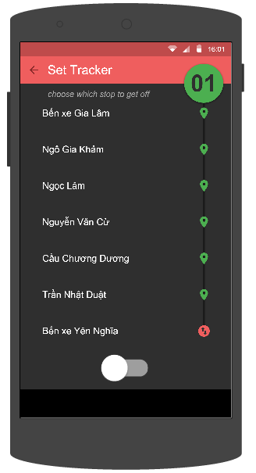

1. **Set Track screen’s description**

|  |  |  |  |  |  |  |  |
| --- | --- | --- | --- | --- | --- | --- | --- |
| **No** | **Field name** | **Field name in Vietnamese** | **Type** | **Require** | **Mandatory** | **Length** | **Description** |
| 1 | Track | Theo dõi | Switch | Click | Y |  | User taps on Track switch |
| 2 | Reverse | Đảo chiều | Button | Click | Y |  | User taps on Revert button to reverse direction |
| 3 | Bus stop | Trạm dừng | List item | Click | Y |  | User taps on Bus stop item to choose where to stop. |
| 2 | Back | Quay lại | Button | Click | Y |  | User taps on Back button to go back |

1. **Set Track screen’s description**

##### Use Case Specification

|  |  |  |  |  |
| --- | --- | --- | --- | --- |
| **Use Case ID** | | UC0027 | **Version** | 1.0 |
| **Use Name** | | Set track | | |
| **Actor** | | BUSS User | | |
| **Description** | | The function allows an user to cancel track | | |
| **Precondition** | | “Set Tracker” screen displayed and “Track” switch is ON | | |
| **Trigger** | | User taps on “Track” switch | | |
| **Post-Condition** | | “Track” switch turn from ON to OFF | | |
| **Main flows** | | | | |
| **Step** | **Actor** | **Action** | | |
| 1 | BUSS User | Taps “Track” switch | | |
| 2 | BUSS | Cancels tracker and “Track” switch turn from ON to OFF | | |
|  | | | | |

1. **Cancel Track use case**

### Favorite module

#### Use case diagram

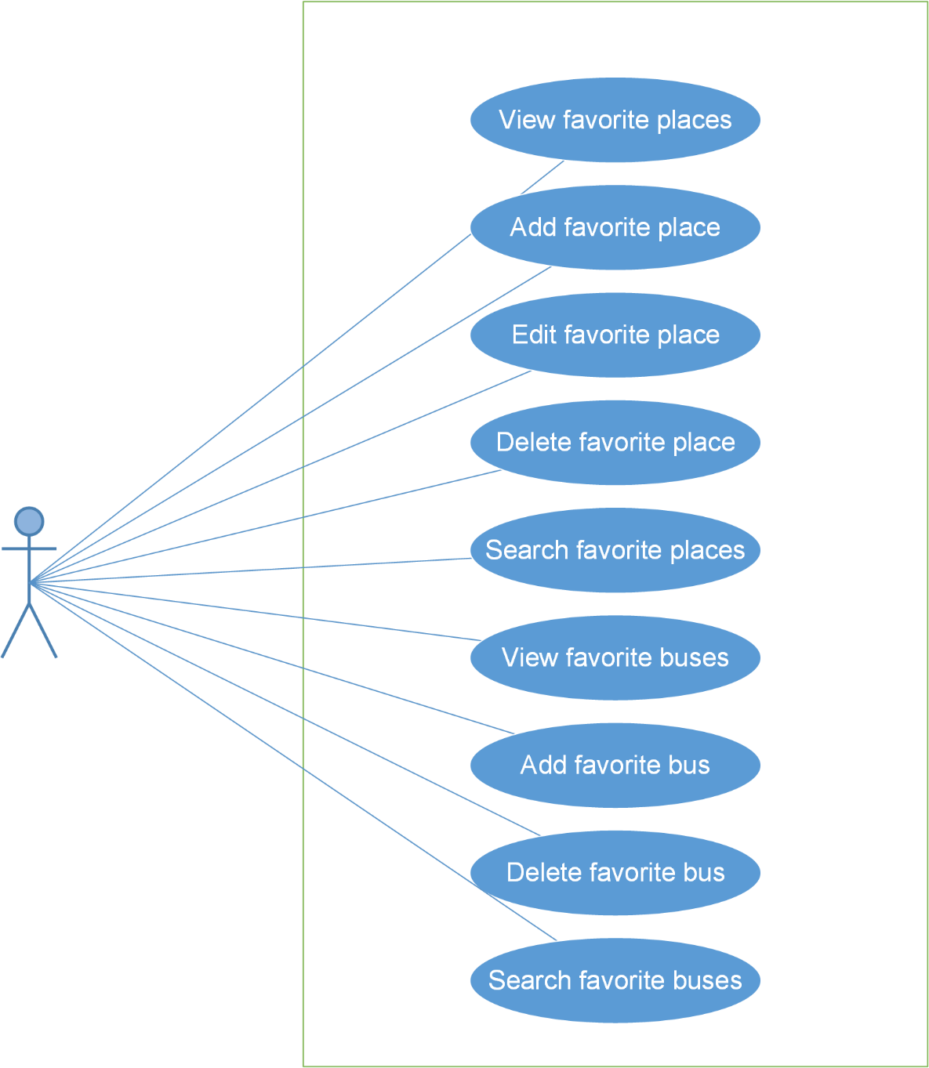

1. **Favorite Module use case diagram**

#### UC0028: View favorite places

##### Screen definition

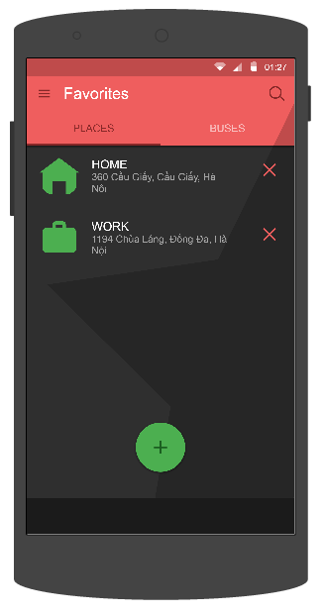

1. **Favorite Places screen**

|  |  |  |  |  |  |  |  |
| --- | --- | --- | --- | --- | --- | --- | --- |
| **No** | **Field name** | **Field name in Vietnamese** | **Type** | **Require** | **Mandatory** | **Length** | **Description** |
| 1 | Add | Thêm | Button | Click | Y |  | User taps on Add button |
| 2 | Delete | Xóa | Button | Click | Y |  | User taps on Delete button |
| 3 | Favorite place | Địa điểm yêu thích | List item | Click | Y |  | User taps on Favorite place item to edit |
| 4 | Places | Địa điểm | Tab | Click | Y |  | User taps on Places tab item |
| 5 | Buses | Buýt | Tab | Click | Y |  | User taps on Buses tab item |
| 6 | Search | Tìm kiếm | Button | Click | Y |  | User taps on Search button |
| 7 | Menu | Danh sách | Button | Click | Y |  | User taps on Menu button |

1. **Favorite Places screen’s description**

##### Use Case Specification

|  |  |  |  |  |
| --- | --- | --- | --- | --- |
| **Use Case ID** | | UC0028 | **Version** | 1.0 |
| **Use Name** | | View favorite place | | |
| **Actor** | | BUSS User | | |
| **Description** | | The function allows a user to view the favorite place list he/she added before. | | |
| **Precondition** | | User has logged in | | |
| **Trigger** | | User taps Favorite item on Menu | | |
| **Post-Condition** | | “Favorite Places” screen displayed | | |
| **Main flows** | | | | |
| **Step** | **Actor** | **Action** | | |
| 1 | BUSS User | Taps Menu then taps Favorite item | | |
|  | | | | |

1. **View Favorite Places use case**

#### UC0029: Add favorite place

##### Screen definition

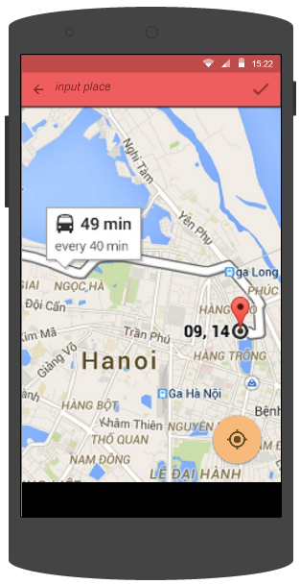

1. **Search Places screen**

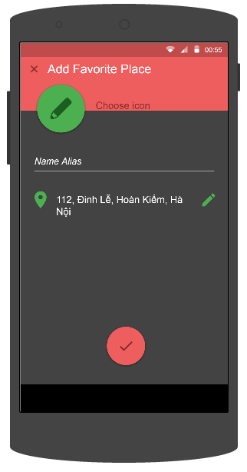

1. **Add Favorite Places screen**

|  |  |  |  |  |  |  |  |
| --- | --- | --- | --- | --- | --- | --- | --- |
| **No** | **Field name** | **Field name in Vietnamese** | **Type** | **Require** | **Mandatory** | **Length** | **Description** |
| 1 | Input place | Nhập địa điểm | Text | Text | Y | 255 | User inputs the place they want to search with the length less than 255 characters |
| 2 | Back | Quay lại | Button | Click | Y |  | User taps on Back button to go back |
| 3 | Confirm | Xác nhận | Button | Click | Y |  | User taps on Confirm button |
| 4 | Current location | Vị trí hiện tại | Button | Click | Y |  | User taps on Current location button |
| 5 | Choose icon | Chọn biểu tượng | Button | Click | Y |  | User taps on Choose icon button |
| 6 | Name alias | Tên bí danh | Text field | Text | Y | 50 | User inputs “Name alias” text field. |
| 7 | Location | Địa điểm | Text |  |  |  |  |
| 8 | Edit location | Thay đổi địa điểm | Button | Click | Y |  | User taps “Edit location” button |
| 9 | Done | Hoàn tất | Button | Click | Y |  | User taps “Done” button |

1. **Add Favorite Place screen’s description**

##### Use Case Specification

|  |  |  |  |  |
| --- | --- | --- | --- | --- |
| **Use Case ID** | | UC0029 | **Version** | 1.0 |
| **Use Name** | | Add favorite place | | |
| **Actor** | | BUSS User | | |
| **Description** | | The function allows a user to add the favorite place he/she cares. | | |
| **Precondition** | | Favorite Place screen displayed | | |
| **Trigger** | | User taps on Add button | | |
| **Post-Condition** | | Favorite Place screen displayed (new place added) | | |
| **Main flows** | | | | |
| **Step** | **Actor** | **Action** | | |
| 1 | BUSS User | Taps on Add button. | | |
| 2 | BUSS | Displays “Place Search” screen with blank info | | |
| 3 | BUSS User | Enters the place User want to search into the input form. | | |
| 4 | BUSS | Searches and display a list of place which has name like the key word. | | |
| 5 | BUSS User | Taps on Place item on search result | | |
| 6 | BUSS | Displays “Add Favorite Place” screen, and shows the chosen place | | |
| 7 | BUSS User | Enters “Name alias” text field and chooses icon then taps “Done” | | |
| 8 | BUSS | Returns “Favorite Place” screen. The chosen place will be added in the favorite place list. | | |
|  | | | | |

**Alternative scenario**

|  |  |  |
| --- | --- | --- |
| **AT1** | At step 3 in the main flows**,** if BUSS User chooses a place on map | |
| **Step** | **Actor** | **Action** |
| 4.1 | BUSS | Shows this place on Input place text field |
| 5.1 | BUSS User | Taps on Confirm button |

|  |  |  |
| --- | --- | --- |
| **AT2** | At step 3 in the main flows**,** if User taps Current location button | |
| **Step** | **Actor** | **Action** |
| 4.2 | BUSS | Gets current location and displays its coordinates |
| 5.2 | BUSS User | Taps on Confirm button |

**Exception**

|  |  |  |
| --- | --- | --- |
| **E1** | At step 4 in the main flows**,** if BUSS enters the place which doesn’t exit | |
| **Step** | **Actor** | **Action** |
| 4.1 | BUSS | Returns message “No search result for”...” ” |

1. **Add Favorite Place use case**

#### UC0030: Edit favorite place

##### Screen definition

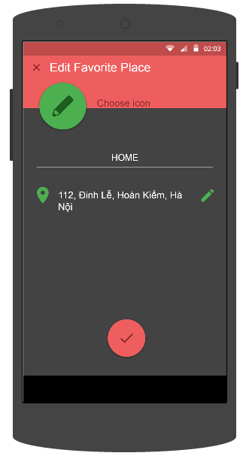

1. **Edit Favorite Places screen**

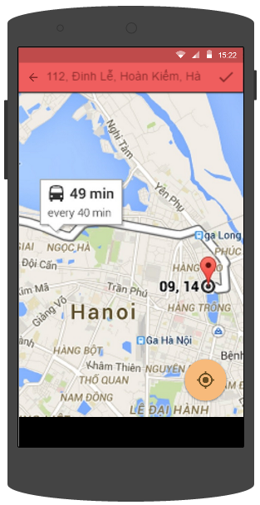

1. **Search Places screen**

|  |  |  |  |  |  |  |  |
| --- | --- | --- | --- | --- | --- | --- | --- |
| **No** | **Field name** | **Field name in Vietnamese** | **Type** | **Require** | **Mandatory** | **Length** | **Description** |
| 1 | Input place | Nhập địa điểm | Text | Text | Y | 255 | User inputs the place they want to search with the length less than 255 characters |
| 2 | Back | Quay lại | Button | Click | Y |  | User taps on Back button to go back |
| 3 | Confirm | Xác nhận | Button | Click | Y |  | User taps on Confirm button |
| 4 | Current location | Vị trí hiện tại | Button | Click | Y |  | User taps on Current location button |
| 5 | Choose icon | Chọn biểu tượng | Button | Click | Y |  | User taps on Choose icon button |
| 6 | Name alias | Tên bí danh | Text field | Text | Y | 50 | User inputs “Name alias” text field. |
| 7 | Location | Địa điểm | Text |  |  |  |  |
| 8 | Edit location | Thay đổi địa điểm | Button | Click | Y |  | User taps “Edit location” button |
| 9 | Done | Hoàn tất | Button | Click | Y |  | User taps “Done” button |

1. **Edit Favorite Place screen’s description**

##### Use Case Specification

|  |  |  |  |  |
| --- | --- | --- | --- | --- |
| **Use Case ID** | | UC0030 | **Version** | 1.0 |
| **Use Name** | | Edit favorite place | | |
| **Actor** | | BUSS User | | |
| **Description** | | The function allows a user to edit the favorite place in the list. | | |
| **Precondition** | | Favorite Place screen displayed | | |
| **Trigger** | | User taps on one place | | |
| **Post-Condition** | | Favorite Place screen displayed (place edited) | | |
| **Main flows** | | | | |
| **Step** | **Actor** | **Action** | | |
| 1 | BUSS User | Taps on a favorite place. | | |
| 2 | BUSS | Displays Edit Favorite Place screen with information about it. | | |
| 3 | BUSS User | Edit favorite place’s name | | |
| 4 | BUSS | Displays edited name | | |
| 5 | BUSS User | Taps on favorite place’s location | | |
| 6 | BUSS | Displays Search Place screen | | |
| 7 | BUSS User | Edits location | | |
| 8 | BUSS | Gets that location and displays its coordinates | | |
| 9 | BUSS User | Taps Done button | | |
| 10 | BUSS | Displays Favorite Place screen with edited info | | |
|  | | | | |

**Alternative flows**

|  |  |  |
| --- | --- | --- |
| **AT1** | At step 7 on main scenario, if User taps Current location button | |
| **Step** | **Actor** | **Action** |
| 8.2 | BUSS | Gets current location and displays its coordinates |

|  |  |  |
| --- | --- | --- |
| **AT2** | At step 3 in the main flows**,** if BUSS User chooses a place on map | |
| **Step** | **Actor** | **Action** |
| 4.2 | BUSS | Shows this place on Input place text field |
| 5.2 | BUSS User | Taps on Confirm button |

**Exception**

|  |  |  |
| --- | --- | --- |
| **E1** | At step 4 in the main flows**,** if BUSS enters the place which doesn’t exit | |
| **Step** | **Actor** | **Action** |
| 4.1 | BUSS | Returns message “No search result for”...” ” |

1. **Edit Favorite Place use case**

#### UC0031: Delete favorite place

##### Screen definition



1. **Favorite Places screen**

|  |  |  |  |  |  |  |  |
| --- | --- | --- | --- | --- | --- | --- | --- |
| **No** | **Field name** | **Field name in Vietnamese** | **Type** | **Require** | **Mandatory** | **Length** | **Description** |
| 1 | Add | Thêm | Button | Click | Y |  | User taps on Add button |
| 2 | Delete | Xóa | Button | Click | Y |  | User taps on Delete button |
| 3 | Favorite place | Địa điểm yêu thích | List item | Click | Y |  | User taps on Favorite place item to edit |
| 4 | Places | Địa điểm | Tab | Click | Y |  | User taps on Places tab item |
| 5 | Buses | Buýt | Tab | Click | Y |  | User taps on Buses tab item |
| 6 | Search | Tìm kiếm | Button | Click | Y |  | User taps on Search button |
| 7 | Menu | Danh sách | Button | Click | Y |  | User taps on Menu button |

1. **Favorite Places screen’s description**

##### Use Case Specification

|  |  |  |  |  |
| --- | --- | --- | --- | --- |
| **Use Case ID** | | UC0031 | **Version** | 1.0 |
| **Use Name** | | Delete favorite place | | |
| **Actor** | | BUSS User | | |
| **Description** | | The function allows a user to delete the favorite place if he/she does not need anymore. | | |
| **Precondition** | | Favorite Place screen displayed | | |
| **Trigger** | | User taps on Delete button then taps Yes button | | |
| **Post-Condition** | | Displays Favorite Place screen (chosen place deleted) | | |
| **Main flows** | | | | |
| **Step** | **Actor** | **Action** | | |
| 1 | BUSS User | Taps on Delete button | | |
| 2 | BUSS | Displays Delete confirm notice | | |
| 3 | BUSS User | Taps on “OK” button | | |
| 4 | BUSS | Deletes this place from database and displays Favorite Place screen | | |
|  | | | | |

1. **Delete Favorite Places use case**

**Alternative scenario**

|  |  |  |
| --- | --- | --- |
| **AT1** | At step 3 in the main flows**,** if BUSS User taps “Cancel” button. | |
| **Step** | **Actor** | **Action** |
| 4.1 | BUSS | Do not delete anything and returns to Favorite Place screen |

1. **Delete Favorite Places use case**

#### UC0032: Search favorite place

##### Screen definition

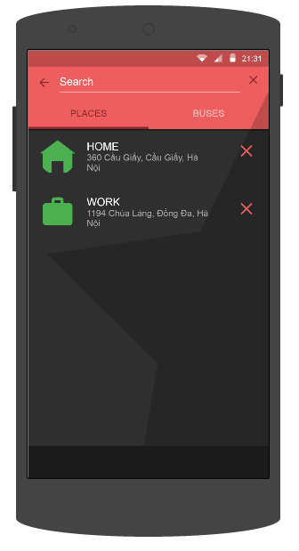

1. **Favorite Places screen**

|  |  |  |  |  |  |  |  |
| --- | --- | --- | --- | --- | --- | --- | --- |
| **No** | **Field name** | **Field name in Vietnamese** | **Type** | **Require** | **Mandatory** | **Length** | **Description** |
| 1 | Add | Thêm | Button | Click | Y |  | User taps on Add button |
| 2 | Delete | Xóa | Button | Click | Y |  | User taps on Delete button |
| 3 | Favorite place | Địa điểm yêu thích | List item | Click | Y |  | User taps on Favorite place item to edit |
| 4 | Places | Địa điểm | Tab | Click | Y |  | User taps on Places tab item |
| 5 | Buses | Buýt | Tab | Click | Y |  | User taps on Buses tab item |
| 6 | Search Text | Khung tìm kiếm | Text | Text | Y | 255 | User inputs their key word they want to search with length less than 255 characters |
| 7 | Menu | Danh sách | Button | Click | Y |  | User taps on Menu button |

1. **Favorite Places screen’s description**

##### Use Case Specification

|  |  |  |  |  |
| --- | --- | --- | --- | --- |
| **Use Case ID** | | UC0032 | **Version** | 1.0 |
| **Use Name** | | Search favorite place | | |
| **Actor** | | BUSS User | | |
| **Description** | | The function allows a user to search in the favorite place list. | | |
| **Precondition** | | Favorite Place displayed | | |
| **Trigger** | | User taps on Search item then input keyword | | |
| **Post-Condition** | | Favorite Place displayed (place searched) | | |
| **Main flows** | | | | |
| **Step** | **Actor** | **Action** | | |
| 1 | BUSS User | Taps on Search item. | | |
| 2 | BUSS | Displays Search form. | | |
| 3 | BUSS User | Inputs the place where user wants to search into the Search form. | | |
| 4 | BUSS | Displays a list of place which has name like the keyword. | | |
|  | | | | |

1. **Search Favorite Places use case**

#### UC0033: View favorite buses

##### Screen definition

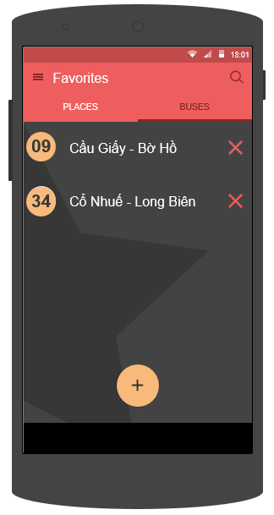

1. **Favorite Buses screen**

|  |  |  |  |  |  |  |  |
| --- | --- | --- | --- | --- | --- | --- | --- |
| **No** | **Field name** | **Field name in Vietnamese** | **Type** | **Require** | **Mandatory** | **Length** | **Description** |
| 1 | Add | Thêm | Button | Click | Y |  | User taps on Add button |
| 2 | Delete | Xóa | Button | Click | Y |  | User taps on Delete button |
| 3 | Favorite bus | Địa điểm yêu thích | List item | Click | Y |  | User taps on Favorite bus item to edit |
| 4 | Places | Địa điểm | Tab | Click | Y |  | User taps on Places tab item |
| 5 | Buses | Buýt | Tab | Click | Y |  | User taps on Buses tab item |
| 6 | Search | Tìm kiếm | Button | Click | Y |  | User taps on Search button |
| 7 | Menu | Danh sách | Button | Click | Y |  | User taps on Menu button |

1. **Favorite Buses screen’s description**

##### Use Case Specification

|  |  |  |  |  |
| --- | --- | --- | --- | --- |
| **Use Case ID** | | UC0033 | **Version** | 1.0 |
| **Use Name** | | View favorite bus | | |
| **Actor** | | BUSS User | | |
| **Description** | | The function allows a user to view the favorite bus list he/she added before. | | |
| **Precondition** | | Favorite Place screen displayed | | |
| **Trigger** | | User taps on Buses tab | | |
| **Post-Condition** | | Favorite Bus screen displayed | | |
| **Main flows** | | | | |
| **Step** | **Actor** | **Action** | | |
| 1 | BUSS User | Taps on Buses tab on the Favorite screen. | | |
| 2 | BUSS | Displays Favorite screen with Buses tab. | | |
|  | | | | |

1. **View Favorite Buses use case**

#### UC0034: Add favorite bus

##### Use Case Specification

|  |  |  |  |  |
| --- | --- | --- | --- | --- |
| **Use Case ID** | | UC0034 | **Version** | 1.0 |
| **Use Name** | | Add favorite bus | | |
| **Actor** | | BUSS User | | |
| **Description** | | The function allows a user to add the favorite bus he/she cares. | | |
| **Precondition** | | Favorite Bus screen displayed | | |
| **Trigger** | | User taps Add button then chooses a bus and taps Heart item | | |
| **Post-Condition** | | Favorite Bus screen displayed (new bus added) | | |
| **Main flows** | | | | |
| **Step** | **Actor** | **Action** | | |
| 1 | BUSS User | Taps on Add button | | |
| 2 | BUSS | Displays Bus List screen | | |
| 3 | BUSS User | Chooses a bus he/she want to add | | |
| 4 | BUSS | Displays Favorite Bus screen with new bus added | | |
|  | | | | |

1. **Add Favorite Buses use case**

#### UC0035: Delete favorite bus

##### Screen definition



1. **Favorite Buses screen**

|  |  |  |  |  |  |  |  |
| --- | --- | --- | --- | --- | --- | --- | --- |
| **No** | **Field name** | **Field name in Vietnamese** | **Type** | **Require** | **Mandatory** | **Length** | **Description** |
| 1 | Add | Thêm | Button | Click | Y |  | User taps on Add button |
| 2 | Delete | Xóa | Button | Click | Y |  | User taps on Delete button |
| 3 | Favorite bus | Địa điểm yêu thích | List item | Click | Y |  | User taps on Favorite bus item to edit |
| 4 | Places | Địa điểm | Tab | Click | Y |  | User taps on Places tab item |
| 5 | Buses | Buýt | Tab | Click | Y |  | User taps on Buses tab item |
| 6 | Search | Tìm kiếm | Button | Click | Y |  | User taps on Search button |
| 7 | Search Text | Khung tìm kiếm | Text | Text | Y | 255 | User inputs their key word they want to search with length less than 255 characters |
| 8 | Menu | Danh sách | Button | Click | Y |  | User taps on Menu button |

1. **Favorite Buses screen’s description**

##### Use Case Specification

|  |  |  |  |  |
| --- | --- | --- | --- | --- |
| **Use Case ID** | | UC0035 | **Version** | 1.0 |
| **Use Name** | | Delete favorite bus | | |
| **Actor** | | BUSS User | | |
| **Description** | | The function allows a user to delete the favorite place if he/she does not need anymore. | | |
| **Precondition** | | Favorite Bus screen displayed | | |
| **Trigger** | | User taps on Delete button and taps on Yes button | | |
| **Post-Condition** | | Favorite Bus screen displayed (chosen bus deleted) | | |
| **Main flows** | | | | |
| **Step** | **Actor** | **Action** | | |
| 1 | BUSS User | Taps on Delete button. | | |
| 2 | BUSS | Displays Delete confirm notice. | | |
| 3 | BUSS User | Taps on Yes button. | | |
| 4 | BUSS | Deletes this place from database and displays Favorite screen with Buses tab | | |
|  | | | | |

1. **Delete Favorite Buses use case**

**Alternative scenario**

|  |  |  |
| --- | --- | --- |
| **AT1** | At step 3 in the main flows**,** if BUSS User taps “Cancel” button. | |
| **Step** | **Actor** | **Action** |
| 4.1 | BUSS | Do not delete anything and returns to Favorite Buses screen |

1. **Delete Favorite Bus use case**

#### UC0036: Search favorite bus

##### Screen definition

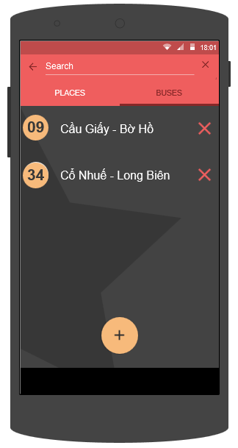

1. **Favorite Buses screen**

|  |  |  |  |  |  |  |  |
| --- | --- | --- | --- | --- | --- | --- | --- |
| **No** | **Field name** | **Field name in Vietnamese** | **Type** | **Require** | **Mandatory** | **Length** | **Description** |
| 1 | Add | Thêm | Button | Click | Y |  | User taps on Add button |
| 2 | Delete | Xóa | Button | Click | Y |  | User taps on Delete button |
| 3 | Favorite bus | Địa điểm yêu thích | List item | Click | Y |  | User taps on Favorite bus item to edit |
| 4 | Places | Địa điểm | Tab | Click | Y |  | User taps on Places tab item |
| 5 | Buses | Buýt | Tab | Click | Y |  | User taps on Buses tab item |
| 6 | Search Text | Khung tìm kiếm | Text | Text | Y | 255 | User inputs their key word they want to search with length less than 255 characters |
| 7 | Menu | Danh sách | Button | Click | Y |  | User taps on Menu button |

1. **Favorite Buses screen’s description**

##### Use Case Specification

|  |  |  |  |  |
| --- | --- | --- | --- | --- |
| **Use Case ID** | | UC0036 | **Version** | 1.0 |
| **Use Name** | | Search favorite bus | | |
| **Actor** | | BUSS User | | |
| **Description** | | The function allows a user to search in the favorite bus list. | | |
| **Precondition** | | Favorite Bus displayed | | |
| **Trigger** | | User taps on Search item then input keyword | | |
| **Post-Condition** | | Favorite Bus displayed (bus searched) | | |
| **Main flows** | | | | |
| **Step** | **Actor** | **Action** | | |
| 1 | BUSS User | Taps on Search item. | | |
| 2 | BUSS | Displays Search form. | | |
| 3 | BUSS User | Inputs the place he/she want to search into the Search form. | | |
| 4 | BUSS | Displays a list of bus which has name like the keyword. | | |
|  | | | | |

1. **Search Favorite Buses use case**

## Non-functional Specification

### Reliability

* Mean time between failures: The mean time between each failure is expected to be about 480 hours of using.
* The maximum bugs per function are 2 bugs/a function when user uses software within 2 months. The average number of bugs in the software during system testing is about to be around 1 bug/1000 LOC.
* The database must be backed up daily and can be recovered if necessary.

### Performance Requirements

#### Availability

The application must be available 95% of time. Users can access to it everywhere from their

Android smartphones with an active internet connection and GPS enabled.

#### Response time

In term of response time, time for the app to fully load will not exceed 5 seconds. Accessing any function will not takes more than 1 second. Depending on the internet connections and GPS services, waiting time of requesting data will takes no more than 20 seconds in worst case.

### User Interface

* **Color:** The background color will mostly be dark grey. The color of text will be white. Accent colors is pink/green/yellow.
* **Language:** Vietnamese by default. English option can be found in Settings menu.
* **Text:** All texts bases on the default Roboto font and title or label will use upper case in the first letter.
* **Graphics:** Big, bold, clear and colorful to attract user’s attention.

### Maintainability

* **Coding standards and naming conventions**
  + Output of the project must include coding standards and naming conventions documentations. Implementation code must be easy to maintain.
  + All code must be clearly commented, including class, method documentations.
  + If some components are reused, the documentations of those components must also be included.
* **Design**
  + The design of the system must be loosely coupled that chances on some module will not affect others.
* **Mean time to repair**: Immediately when problem found. Average 1 day.
* **Logging**
  + All the errors should be logged, supporting for bug fixing and maintenance.
  + All strange or sensitive situations should also be logged.

### Usability

Usability Requirements support the following from the perspective of its primary users:

* **Efficiency of use:** user can complete each function in less than 8 actions
* **Intuitiveness:** all help/error messages are simple and easy to understand (80% of surveyor agreed); user can figure out exactly how to use each feature after using it once.

### Security Requirements

In order to avoid unwanted access by strangers, the security implemented in various ways:

* **User layer**: User data will be stored at user’s devices and can be protected by basic security options provided by Android system itself. User data can be synchronized to server after user active this function with distinct email and password. There will also be an option to delete all user data on the current device – which will not affect synchronized data on server.
* **Manage Data Layer**: Only Administrator can modify database system. User can access data if he/she logged in.
* **Stored Data**: All synchronized user data will be saved in MySQL and optimized for daily backup.

### Hardware/Software Requirements

● **Hardware requirement:** Android smartphones of all kinds (with active internet connection and GPS enabled)

● **Software requirements:** Android 4.4 or higher.