Logo & Company Name
System/Software Requirements Specification
for
<Vietnamese Medicinal Network>
Version 1.0 approved
Prepared by <QuynhHT>
<VMN Team>
<Jan-18-2016>
Table of Contents
Table of Contents ii
Revision History iii
1. Introduction 1
1.1 Purpose 1
1.2 System Purpose 1
1.3 Definitions, Acronyms and Abbreviations 1
1.4 Document Conventions 2
1.5 Intended Audience and Reading Suggestions 2
1.6 Project Scope 2
1.7 References 3
2. Overall Description 3
2.1 Product/System Perspective 3
2.2 Use Case Diagram 4
2.3 System/Product Features 5
2.4 Entity Relation Model 7
2.4.1 Entity-Relationship Diagram 7
2.4.2 Entity Detail 7
2.5 User Classes and Characteristics 7
3. Specific Requirements 8
3.1 Functional Requirements Specification 8
3.1.1 UC01-Login 8
3.1.2 Function2 /Use-case 2 10
3.2 Non-Functional Requirements Specification 16
3.2.1 External Interface Requirements 16
3.2.2 Other Nonfunctional Requirements 17

Revision History
Name | Date | Reason For Changes | Version
Introduction | Jan-18-2016 | 1st creation | 1.0

Introduction

Purpose
The document is aiming at describing detailed specification of functionalities and non-functional requirement of VMN software. It provides detailed information for developers, testers, project manager, managers, supporters and VMN users to have full understanding about VMN software what functionalities, development, and operational constraints the software must have.

By using this document, project team, business support team and the other people can have an overview about the software requirement specification of the VMN application and business/power users can review this document to know how the requirements have been documented. This document also describes the requirement scope of each phase in the project, users can verify the software to make sure the being provided software meet their expectation.

System Purpose
VMN will provides the information about medicinal plants and remedies. Members can search these information that they need. They also can share their experiences and comment or rate useful articles. Eastern drug store can create their remedies article, share address to other members. When problems happen, mod will send message to members. VMN also provides functionalities for mod to manage articles about medicinal plants and remedies such as approve, view, create, update, delete articles; admin to manage member’s account.

Definitions, Acronyms and Abbreviations
The document use the following terms, concepts, and acronyms defined in the table 1-1:

Table 1-1: Definitions, Acronyms and abbreviations
# | Concept, term, abbreviations | Description
1 | Guest | Anyone who have not register in VMN system.
2 | Member | Person who register success in VMN system.
3 | Herb medicine store | Person who register success in VMN system and is approved as Vietnamese herb medicinal store by admin.
4 | Mod | Person who register success in VMN system and their account is approved by admin that they can manage articles.
5 | Admin | System administrator who can manage members and authorize other accounts.
6 | Medicinal plants | System object that member can search, comment and rate. Medicinal plants are plants that have utility for treat disease.
7 | Remedy | System object that member can create, search, comment and rate; mod can manage.  Remedy is set of medicine plants that use for treat disease.
8 | Article | Means that medicinal plants articles or remedy articles
9 | VMN | Vietnamese Medicinal Network

Document Conventions
In this documents, there are the following conventions applied in requirements statements.
- Bold with green background color statement: It means that these requirements are very important, high priority which the readers should read carefully.
- The statement with Italic ad beginning: it means the requirements should have further clarification.

Intended Audience and Reading Suggestions
The document are aiming at the following intended audiences. The readers should consider the suggestion below:
  - Developers should study all sections of this documents to have understanding about the VMN. However, the section 3: Specific Requirements should be more focused to have deep understand functional and non-functional requirements.
  - Testers: should study all sections of this documents to have understanding about the VMN. However, the section 2.3: System Features should be more focused to have deep understand functional requirements.
  - Project manages: should study all sections of this documents to have understanding about the VMN. The section 1.6 Project Scope should be more focused on corporate goals or business strategies
  - Supervisor should study all sections of this documents to have understanding about the VMN in case users need to support.

Project Scope
VMN is built to provide useful information about medicinal plants and remedies to members. MMS project will implements all the states of the software development lifecycle, from requirements analysis, to operation maintenance phase. This version of software being developed from the project will have all functionalities and all operational in this document.

References
The requirements have gathered, analysis, and specified basing on the following sources defined in table 1-2:

Table 1-2: References
# | Source | Description
1 | http://cms.fpt.edu.vn/ | Template_System_Requirement_  Spec (IEEE830 v1.3.doc)
2 | Textbook “Requirements Engineering - From System Goals to UML models to Software Specifications” - Author: Axel van Lamsweerde.

Overall Description

Product/System Perspective

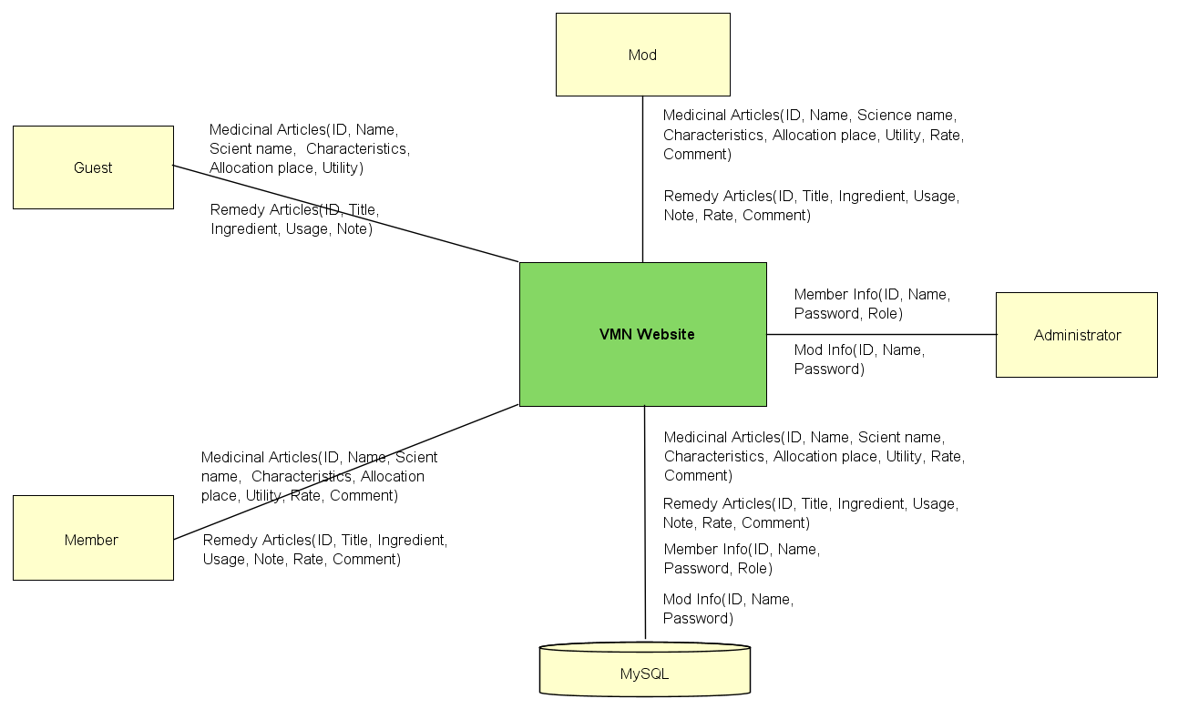
Figure 2-1: System Overview
As described in Figure 2-1, VMN system will has main components: VMN website, Administrator, Mod, Guest, Member and MySQL.
- VMN website: this is software component to be developed in the project. It will provide functions for mod to manage medicinal plants, remedy articles; member to view, search, create, update their articles, comment and rate other articles; guest to view articles; admin to manage accounts.
- Administrator: they can manage and authorize accounts, also run system.
- Mod: they can manage articles, approve member’s article, create and update their articles, manage member’s comments, send
- Guest: is people who can view and basic search medicinal plants and remedy articles.
- Member: person who register success in VMN. They have ability to view and search, rate and comment other articles, create, update their articles, send messages to mod.

Use Case Diagram

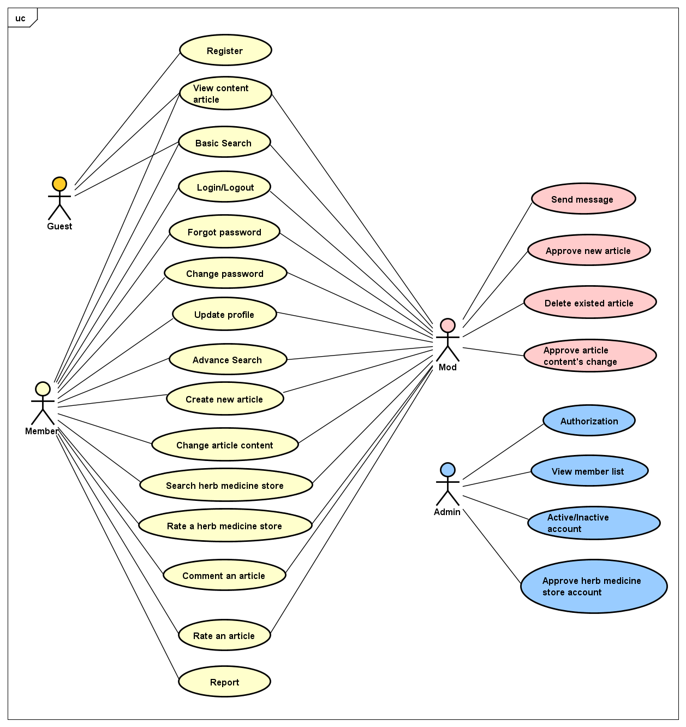
Figure 2-2: Use case diagram of VMN system

System Features

# | Functional group | Use case ID | Function Name | Description
1 | Authentication | UC101 | Login
1 | Authentication | UC102 | Logout
1 | Authentication | UC103 | Authorize members | Admin has ability to grant access right for members. For example: a member want to be a mod, he/she need to wait admin’s approving.
2 | Article  functions | UC201 | View article content | Guest, Member and Mod can view content an article.
2 | Article  functions | UC202 | Create | Member, mod has ability to create new article by basic information such as: name, science name, characteristic, allocation place, utility with medicinal plant article or title, ingredients, usage, utility, note with remedy article.
2 | Article  functions | UC203 | Basic Search | Guest, member, mod has ability to search medicinal plant articles or remedy article by name.
2 | Article  functions | UC204 | Advance Search | Member and mod have ability to search a articles by multiple conditions include: characteristic, utility, allocation place.
2 | Article  functions | UC205 | Change content | Member and mod have ability to update their articles to edit, fix information if need. But if members want to update their articles, they need to wait mod’s approving.
2 | Article  functions | UC206 | Delete existed article | Mod has ability to delete duplicate medicinal plant articles. Then mod has to send notice message to author.
2 | Article  functions | UC207 | Rate | Member and mod have ability to rate articles by hover on rate box.
2 | Article  functions | UC208 | Comment | Member and mod have ability to create new remedy article by basic information such as: title, ingredients, usage, utility, note.
2 | Article  functions | UC209 | Approve new article | Mod has ability to approve a new ar ticle which is wrote by members.
2 | Article  functions | UC210 | Approve article content’s change | After members change their article contents, they have to wait mod’s approving.
 |  | UC211 | Report | Member has ability to report to mod that existing duplicate or wrong information article.
3 | Member functions | UC301 | View members list | Admin has ability to view list of members include member’s information such as: account, name, email, date of birth, phone, register date, job, avatar, member’s role.
3 | Member functions | UC302 | Inactive/active account | Admin has ability to inactive or active an account.
3 | Member functions | UC303 | Send message | Mod has ability to send messages to member if need. For example: when duplicate of articles happens, mod will delete one article and he/she will send a notice message to the article’s author.
3 | Member functions | UC304 | Update profile | Member, mod and herb medicine store have ability to update their profile such as name, email, date of birth, phone, register date, job, avatar, address.
3 | Member functions | UC305 | Change password | Member and mod have ability to change their password if they think that it’s not safe anymore.
4 | Guest functions | UC401 | Register | Guest has ability to create an account to become system’s member.
4 | Guest functions | UC402 | Approve herb medicine store account | When a guest register as a herb medicine store account, the guest has to wait admin’s approving.
5 | Herb medicine store | UC501 | Search herb medicine store | Member and mod have ability to search information of herb medicine store such as: address, description, email, phone.
 |  | UC502 | Rate herb medicine store | Member and mod have ability to rate a herb medicine store by hover on rate box.

Entity Relation Model

Entity-Relationship Diagram

Entity Detail
<List of all requirements comes from end users>

User Classes and Characteristics
VMN website towards to anyone who want to learn and share experiences about medicinal plants and useful remedies. VMN has four objective user:
- Guest: the person who has ability to view medicinal plants and remedy articles, register to become VMN website’s member, then they can use more and more VMN website’s features. This user group no need to have good computer and software skill.
- Member: the person who register to VMN website successful. They can use more VMN website’s features than guest such as: advance search, create and change content their articles, search herb medicine store, comment and rate an article, update profile. This user group no need to have good computer and software skill but they also understand VMN website more than guest.
- Herb medicine store: as a member, herb medicine store has ability to create and change content, share their experiences about high value medicinal plants or useful remedies. They also has ability to share information about their herb medicine store such as phone, email, address to members as advertising information. This user group no need to have good computer and software skill but they also understand VMN website.
- Mod: the person who register to VMN website successful and be granted by admin as who has ability to approve member’s article, send notice message to members, comment and rate an article. This user group should not only have good computer and software skill and deep understand about VMN website, but also have knowledge about medicinal plants and remedy.
- Admin: the person has ability to manage member’s account, approve a herb medicine store account, and authorization. Other case, they also can active and inactive an account when they detect infraction. This user group have good computer and software skill and deep understand about VMN website.

User Documentation
Table 2-2: User Documentation
Name | Description
User Guide | Provide detailed explanation about our system, screens and guide users how to use all feature of VMN system.

Specific Requirements

Functional Requirements Specification

UC101-Login

Screen Design
Login
User name
Password

Figure 3-1: Screen Design of Login

Table 3-1: Screen Definition
# | Field Name | Type | Mandatory | Max Length | Description
1 | Email | Text | Yes | 20
2 | Password | Text | Yes | 20 | Display "*" instead of clear character
3 | Remember Me | Check box | No
4 | Forgot password | Link | No
5 | Login | Button

Use Case Specification

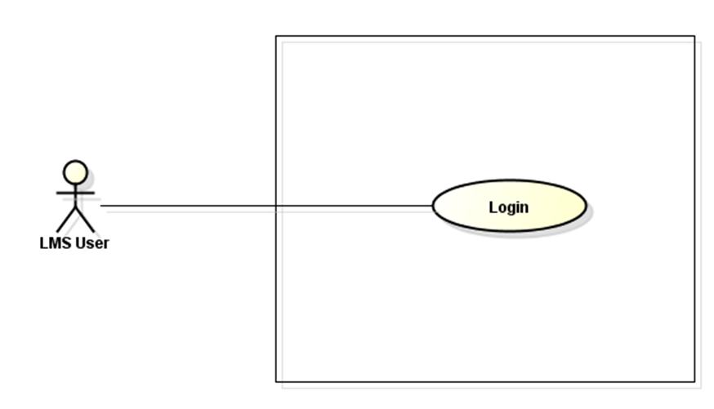
LMS

Figure 3-2: Login Use-Case Diagram

Use Case ID |  |  | UC101
Use Name |  |  | Login
Actor |  |  | VMN Member
Description |  |  | The function allows a user to be able to login in the software when he/she have registered an account and his/her account is still active.
Precondition
Trigger
Post-Condition
Main flows
Step | Actor |  | Action
1 | User |  | Type URL into location field of internet browser and then press enter
2 | VMN |  | Display Login screen with the following fields:  - Email  - Password  - Remember Me  - Forgot password  - Login button
3 | User |  | Enter Email & password into Email & Password fields on the Login screen, then click on Login button.
4 | VMN |  | Validate the entered Email & password and then display Home screen
Alternative flows
AT1 |  | At step 2 in the main flows, if there is an internal error in the system,
Sub step |  | Actor |  | Action
2.1 |  | VMN |  | Display "Error" page with message "Internal System Error, please contact with administrator"
AT2 |  | At step 4 in the main flows, if VMN failed to validate user name & password
Sub step |  | Actor |  | Action
4.1 |  | VMN |  | Display "Login" page with message “The email and password that you entered don’t match.”

Business Rules
# | Rule Description
BR01
BR02

UC102-Logout

Screen Design
Login
User name
Password
Figure 3-1: Screen Design of Login

Table 3-2: Screen Definition
# | Field Name | Type | Mandatory | Max Length | Description
1 | User Profile | Button | No
2 | Logout | Button | No

Use Case Specification

LMS

Figure 3-2: Login Use-Case Diagram

Use Case ID |  |  | UC102
Use Name |  |  | Logout
Actor |  |  | VMN Member, Mod, HMS
Description |  |  | The function allows a user to be able to logout the website when he/she have registered an account and his/her account is still active.
Precondition |  |  | - VMN must be connected to the Internet  - User browsed VMN website  - User logged in to system
Trigger
Post-Condition |  |  | - Log user out from system.  - Redirect user to login page
Main flows
Step | Actor |  | Action
1 | Member, Mod, HMS |  | Click on “Member icon”
2 | VMN |  | Display Logout screen with the following fields:  - User Profile  - Log out button
3 | Member, Mod, HMS |  | Click on “Logout” button
4 | VMN |  | Log out user account then display Login screen
Alternative flows
AT1 |  | At step 2 in the main flows, if there is an internal error in the system,
Sub step |  | Actor |  | Action
2.1 |  | VMN |  | Display "Error" page with message "Internal System Error, please contact with administrator"

Business Rules
# | Rule Description
BR01
BR02

UC103-Authorize Member

Screen Design
Login
User name
Password
Figure 3-1: Screen Design of Login

Table 3-1: Screen Definition
# | Field Name | Type | Mandatory | Max Length | Description
1 | Account | Text | Yes | 20 | Admin cannot edit this information.
2 | Email | Text | Yes | 20 | Admin cannot edit this information.
3 | Member’s name | Text | Yes | 20 | Admin cannot edit this information.
4 | Member’s role | Drop down list | Yes |  | Admin has ability to change member’s role: member becomes mod, mod becomes member. If member’s role is HMS, admin cannot change.
5 | Date of register | Date | Yes |  | Admin cannot edit this information.
6 | Save | Button | Yes |  | After change, admin has to click on this button to update database.
7 | Ban | Button | Yes |  | Admin want to ban an account, he/she will click on this button
8 | Send message | Button | Yes |  | Admin will send a message to member who have been changed about member’s role

Use Case Specification

LMS

Figure 3-2: Authorization Use-Case Diagram

Use Case ID |  |  | UC103
Use Name |  |  | Authorize member
Actor |  |  | Admin
Description |  |  | The function allows admin to change member’s role: member becomes mod, and mod becomes member.
Precondition |  |  | - VMN is connected to Internet  - Admin login to VMN website successful
Trigger
Post-Condition |  |  | - Admin save and send message to member or mod successful  - Database is updated
Main flows
Step | Actor |  | Action
1 | Admin |  | On admin’s screen, click on “Manage User” tab.
2 | VMN |  | Display “Manage User” screen:  - “Search user account and email” text field  - “Detail information of member” table:  - Account  - Email  - Member’s name  - Member’s role  - Action  - Paging
3 | Admin |  | Click on “Detail” button of “Detail information of member” table
4 | VMN |  | Display “Detail user” modal screen:  - Account  - Email  - Member’s name  - “Member’s role” dropdown list  - Date register  - Save button  - Ban button  - Send message button
5 | Admin |  | - Click on dropdown list to change member’s role:  - Member to mod  - Mod to member.  - Click on save button
6 | VMN |  | Update to database then “Do you want to send a notice message to the member” modal appears.
7 | Admin |  | Click on “Ok” or “No”
8 | VMN |  | Send a notice message to the member who has been changed member’s role or not.
Alternative flows
AT1 |  | At step 2 in the main flows, if there is an internal error in the system,
Sub step |  | Actor |  | Action
2.1 |  | VMN |  | Display "Error" page with message "Internal System Error, please contact with administrator"
AT2 |  | At step 6 in the main flows, if VMN failed to update to database
Sub step |  | Actor |  | Action
6.1 |  | VMN |  | Display "Error" page with message "Failed to save to database, please try again "

Business Rules
# | Rule Description
BR01
BR02

UC201-View article content

Screen Design
Login
User name
Password
Figure 3-1: Screen Design of Login

Table 3-2: Medicinal Plant Article Screen Definition
# | Field Name | Type | Mandatory | Max Length | Description
1 | Medicinal plant picture | Image | Yes
2 | Name | Text | Yes | 20
3 | Other name | Text | Yes | 200
4 | Science name | Text | Yes | 40
5 | Description | Text | Yes | 500
6 | Characteristic | Text | Yes | 500
7 | Allocation place | Text | Yes | 100
8 | Utility | Text | Yes | 300
9 | Rate |  | Yes |  | Rate from 1 to 5 stars
10 | Remedy recommendation | Image | Yes |  | Image with Hypertext reference to remedy which include the medicinal plant
11 | Comment | Text | Yes | 100

Use Case Specification

LMS

Figure 3-2: Login Use-Case Diagram

Use Case ID |  |  | UC201
Use Name |  |  | View article content
Actor |  |  | VMN Member, Mod, HMS, Guest
Description |  |  | The function allows a user to be able to view article content
Preconditions |  |  | - VMN must be connected to the Internet  - User browsed VMN website
Trigger
Post-Condition |  |  | User can view article content
Main flows
Step | Actor |  | Action
1 | Member, Mod, HMS |  | - Type URL into location field of internet browser and then press enter  - On home screen, or click on “medicinal plant” tap.  - Click on “Detail” hypertext of each article’s image
2 | VMN |  | Display medicinal plant detail screen:  - Medicinal Plant picture  - Name  - Other name  - Science name  - Description  - Characteristic  - Allocation Place  - Utility  - Rate  - Remedy Recommendation  - Comment
Alternative flows
AT1 |  | At step 2 in the main flows, if there is an internal error in the system,
Sub step |  | Actor |  | Action
2.1 |  | VMN |  | Display "Error" page with message "Internal System Error, please contact with administrator"

Business Rules
# | Rule Description
BR01
BR02

UC301- View members list

Screen Design
Login
User name
Password
Figure 3-1: Screen Design of Login

Table 3-1: Screen Definition
# | Field Name | Type | Mandatory | Max Length | Description
1 | Search user account and email | Text | Yes | 100
2 | Search | Button | Yes
3 | Account | Text | Yes | 20
4 | Email | Text | Yes | 20
5 | User name | Text | Yes | 20
6 | Member’s role | Text | Yes | 20 | There are 2 roles: member and mode
7 | Detail | Button | Yes
8 | Pagging |  | Yes

Use Case Specification

LMS

Figure 3-2: Login Use-Case Diagram

Use Case ID |  |  | UC301
Use Name |  |  | View Member List
Actor |  |  | Administrator
Description |  |  | The function allows a administrator to be able to view member list in the software.
Precondition
Trigger
Post-Condition
Main flows
Step | Actor |  | Action
1 | Admin |  | - Type URL into location field of internet browser and then press enter  - Click on login button  - Enter right email and password to login admin website.  - On admin website, click on “manage user” tap to show user detail table
2 | VMN |  | Display “View Member List” screen with the following fields:  - Search user account and email  - Search  - Account  - Email  - User name  - Member’s role  - Detail  - Pagging
Alternative flows
AT1 |  | At step 2 in the main flows, if there is an internal error in the system,
Sub step |  | Actor |  | Action
2.1 |  | VMN |  | Display "Error" page with message "Internal System Error "

Business Rules
# | Rule Description
BR01
BR02

UC302- Inactive/active account

Screen Design
Login
User name
Password
Figure 3-1: Screen Design of Login

Table 3-1: Screen Definition
# | Field Name | Type | Mandatory | Max Length | Description
1 | Account | Text | Yes | 20 | Admin cannot edit this information.
2 | Email | Text | Yes | 20 | Admin cannot edit this information.
3 | Member’s name | Text | Yes | 20 | Admin cannot edit this information.
4 | Member’s role | Drop down list | Yes |  | Admin has ability to change member’s role: member becomes mod, mod becomes member. If member’s role is HMS, admin cannot change.
5 | Date of register | Date | Yes |  | Admin cannot edit this information.
6 | Save | Button | Yes |  | After change, admin has to click on this button to update database.
7 | Ban | Button | Yes |  | Admin want to ban an account, he/she will click on this button
8 | Send message | Button | Yes |  | Admin will send a message to member who have been changed about member’s role

Use Case Specification

LMS

Figure 3-2: Login Use-Case Diagram

Use Case ID |  |  | UC302
Use Name |  |  | Inactive/ Active account
Actor |  |  | Administrator
Description |  |  | The function allows a administrator to be able to view member list in the software.
Precondition |  |  | VMN is connected to Internet  Admin login to VMN website successful
Trigger
Post-Condition |  |  | Admin save and send message to member or mod about this account has been banned or active.  Database is updated
Main flows
Step | Actor |  | Action
1 | Admin |  | On admin’s screen, click on “Manage User” tab.
2 | VMN |  | Display “Manage User” screen:  - “Search user account and email” text field  - “Detail information of member” table:  - Account  - Email  - Member’s name  - Member’s role  - Action  - “Detail” button  - Paging
3 | Admin |  | Click on “Detail” button of “Detail information of member” table
4 | VMN |  | Display “Detail user” modal screen:  - Account  - Email  - Member’s name  - “Member’s role” dropdown list  - Date register  - Save button  - Ban button  - Send message button
5 | Admin |  | Click on “ban” button
6 | VMN |  | Update to database then “Do you want to send a notice message to the member” modal appears.
7 | Admin |  | Click on “Ok” or “No”
8 | VMN |  | Send a notice message to the member who has been banned or active account.
Alternative flows
AT1 |  | At step 2 in the main flows, if there is an internal error in the system,
Sub step |  | Actor |  | Action
2.1 |  | VMN |  | Display "Error" page with message "Internal System Error "

Business Rules
# | Rule Description
BR01
BR02

UC304- Update Profile

Screen Design
Login
User name
Password
Figure 3-1: Screen Design of Login

Table 3-1: Screen Definition
# | Field Name | Type | Mandatory | Max Length | Description
1 | Email | Text | Yes | 20
2 | Display name | Text | Yes | 20 | Display "*" instead of clear character
3 | Date of birth | Date | Yes | 20 | Display “day-month-year” form
4 | Gender | Check box | Yes |  | Display 2 choice: Male, Female
5 | Avatar | Image | No
6 | Last name | Text | Yes | 20
7 | First name | Text | Yes | 20
8 | Phone | Text | Yes | 20 | Only number
9 | Address | Text | Yes | 50
10 | Save | Button | Yes

Use Case Specification

LMS

Figure 3-2: Login Use-Case Diagram

Use Case ID |  |  | UC304
Use Name |  |  | Update Profile
Actor |  |  | Member, mod and herb medicine store
Description |  |  | The function allows a user to be able to login in the software when he/she have registered an account and his/her account is still active.
Precondition |  |  | VMN is connected to Internet  Member/ mod or herb medicine store login to VMN website successful
Trigger
Post-Condition
Main flows
Step | Actor |  | Action
1 | User |  | Type URL into location field of internet browser and then press enter  Login successful to VMN website  Click on “User profile” button  On “User profile” screen, click edit button to show “update profile screen”
2 | VMN |  | Display update profile screen with the following fields:  - Display name  - Date of birth  - Gender check box  - Avatar image  - Last name  - First name  - Phone  - Address  - Save button
3 | User |  | User can change user information. After that, click save.
4 | VMN |  | Save user information and go back to user profile screen.
Alternative flows
AT1 |  | At step 2 in the main flows, if there is an internal error in the system,
Sub step |  | Actor |  | Action
2.1 |  | VMN |  | Display "Error" page with message "Internal System Error, please contact with administrator"

Business Rules
# | Rule Description
BR01
BR02

UC305-Change Password

Screen Design
Login
User name
Password
Figure 3-1: Screen Design of Login

Table 3-1: Screen Definition
# | Field Name | Type | Mandatory | Max Length | Description
1 | Email | Text | Yes | 20
2 | Old password | Text | Yes | 20
3 | New password | Text | Yes | 20
4 | Re-Enter password | Text | Yes | 20 | Re-Enter password must match old password
5 | Save | Button | Yes

Use Case Specification

LMS

Figure 3-2: Login Use-Case Diagram

Use Case ID |  |  | UC101
Use Name |  |  | Change password
Actor |  |  | Member, mod, herb medicine store
Description |  |  | The function allows a user to be able to change password.
Precondition
Trigger
Post-Condition
Main flows
Step | Actor |  | Action
1 | User |  | Type URL into location field of internet browser and then press enter  Click on change password link
2 | VMN |  | Display Change Password screen with the following fields:  - Email  - Old Password  - New password  - Re-Enter password  - Save button
3 | User |  | Enter Email, old, new, re-enter password.  Click on Save button
4 | VMN |  | Save user new password to database
Alternative flows
AT1 |  | At step 2 in the main flows, if there is an internal error in the system,
Sub step |  | Actor |  | Action
2.1 |  | VMN |  | Display "Error" page with message "Internal System Error, please contact with administrator"
AT2 |  | At step 4 in the main flows, if VMN failed to validate user name & password
Sub step |  | Actor |  | Action
4.1 |  | VMN |  | Display "Login" page with message “The email, password & re-password that you entered don’t match.”

Business Rules
# | Rule Description
BR01
BR02

UC401- Register

Screen Design
Login
User name
Password
Figure 3-1: Screen Design of Login

Table 3-1: Screen Definition
# | Field Name | Type | Mandatory | Max Length | Description
1 | Full name | Text | Yes | 20
2 | Account name | Text | Yes | 20
3 | Email | Text | Yes | 20
4 | Password | Text | Yes | 20
5 | Verify password | Text | Yes
6 | Register herb medicine store | Link | Yes | 20
7 | Register | Text | Yes | 20

Use Case Specification

LMS

Figure 3-2: Login Use-Case Diagram

Use Case ID |  |  | UC401
Use Name |  |  | Register
Actor |  |  | Member, mod
Description |  |  | The function allows a user to be able to register.
Precondition |  |  | VMN is connected to Internet  Member/ mod register account of VMN website successful.
Trigger
Post-Condition
Main flows
Step | Actor |  | Action
1 | User |  | Type URL into location field of internet browser and then press enter  Login successful to VMN website  Click on “Login” button  Click on “Create your user account” link
2 | VMN |  | Display Register screen with the following fields:  - Name  - Account name  - Email  - Password  - Verify password  - “Register herb medicine store” link  - “Register” button
3 | User |  | Click save to register an account.
4 | VMN |  | Show login page
Alternative flows
AT1 |  | At step 2 in the main flows, if there is an internal error in the system,
Sub step |  | Actor |  | Action
2.1 |  | VMN |  | Display "Error" page with message "Internal System Error, please contact with administrator"

Business Rules
# | Rule Description
BR01
BR02

Non-Functional Requirements Specification

External Interface Requirements

User Interfaces
<Describe the logical characteristics of each interface between the software product and the users. This may include sample screen images, any GUI standards or product family style guides that are to be followed, screen layout constraints, standard buttons and functions (e.g., help) that will appear on every screen, keyboard shortcuts, error message display standards, and so on. Define the software components for which a user interface is needed. Details of the user interface design should be documented in a separate user interface specification.>

Hardware Interfaces
<Describe the logical and physical characteristics of each interface between the software product and the hardware components of the system. This may include the supported device types, the nature of the data and control interactions between the software and the hardware, and communication protocols to be used.>

Software Interfaces
<Describe the connections between this product and other specific software components (name and version), including databases, operating systems, tools, libraries, and integrated commercial components. Identify the data items or messages coming into the system and going out and describe the purpose of each. Describe the services needed and the nature of communications. Refer to documents that describe detailed application programming interface protocols. Identify data that will be shared across software components. If the data sharing mechanism must be implemented in a specific way (for example, use of a global data area in a multitasking operating system), specify this as an implementation constraint.>

Communications Interfaces
<Describe the requirements associated with any communications functions required by this product, including e-mail, web browser, network server communications protocols, electronic forms, and so on. Define any pertinent message formatting. Identify any communication standards that will be used, such as FTP or HTTP. Specify any communication security or encryption issues, data transfer rates, and synchronization mechanisms.>

Other Nonfunctional Requirements

Performance Requirements
<If there are performance requirements for the product under various circumstances, state them here and explain their rationale, to help the developers understand the intent and make suitable design choices. Specify the timing relationships for real time systems. Make such requirements as specific as possible. You may need to state performance requirements for individual functional requirements or features.

This section lists all requirements whose Category has been stated in the goal model to be ‘performance’>

Design constraints
<This section lists all requirements whose Category has been stated in the goal model to be ‘development’ or ‘architecture’ (see Figure 7.5)

Safety Requirements
<Specify those requirements that are concerned with possible loss, damage, or harm that could result from the use of the product. Define any safeguards or actions that must be taken, as well as actions that must be prevented. Refer to any external policies or regulations that state safety issues that affect the product’s design or use. Define any safety certifications that must be satisfied.

This section lists all requirements whose Category has another value e.g. ‘safety’

>

Security Requirements
<Specify any requirements regarding security or privacy issues surrounding use of the product or protection of the data used or created by the product. Define any user identity authentication requirements. Refer to any external policies or regulations containing security issues that affect the product. Define any security or privacy certifications that must be satisfied.>

Software Quality Attributes
<Specify any additional quality characteristics for the product that will be important to either the customers or the developers. Some to consider are: adaptability, availability, correctness, flexibility, interoperability, maintainability, portability, reliability, reusability, robustness, testability, and usability. Write these to be specific, quantitative, and verifiable when possible. At the least, clarify the relative preferences for various attributes, such as ease of use over ease of learning.

This section lists all requirements whose Category has another value e.g. ‘accuracy’ >

