

**Vietnamese Study System for Japanese**

**Software Requirement Specification**

**Project Code: Veazy**

**Document Code: Veazy_SRS_en_v1.4**

**Hoa Lac, 2016/06/20**

**RECORD OF CHANGE**

*A - Added M - Modified D - Deleted

|  |  |  |  |  |
| --- | --- | --- | --- | --- |
| **Effective Date** | **Changed Items** | **A* M, D** | **Change Description** | **New Version** |
| 2016/06/20 | SRS | A* | Create SRS | 1.0 |
| 2016/06/26 | SRS | M | Modify SRS | 1.1 |
| 2016/07/12 | SRS | M | Modify SRS | 1.2 |
| 2016/07/25 | SRS | M | Modify SRS | 1.3 |
| 2016/07/29 | SRS | M | Modify SRS | 1.4 |
|  |  |  |  |  |
|  |  |  |  |  |
|  |  |  |  |  |
|  |  |  |  |  |
|  |  |  |  |  |
|  |  |  |  |  |
|  |  |  |  |  |
|  |  |  |  |  |
|  |  |  |  |  |
|  |  |  |  |  |
|  |  |  |  |  |
|  |  |  |  |  |
|  |  |  |  |  |
|  |  |  |  |  |
|  |  |  |  |  |
|  |  |  |  |  |

**SIGNATURE PAGE**

**ORIGINATOR:** Pham Duc Thang 2016/06/20

Developer

**REVIEWERS:** Nguyen Trong Duy 2016/07/12

Developer

**APPROVAL:** Nguyen Van Sang <Date>

Supervisor

**TABLE OF CONTENTS**

**1** **INTRODUCTION 4**

1.1 Purpose 5

1.2 Scope 5

1.3 Definitions, Acronyms, and Abbreviations 5

1.4 References 6

1.5 Overview 6

**2** **OVERALL DESCRIPTION 7**

2.1 Product perspective 7

2.2 Product functions 8

2.3 User characteristics 11

2.4 Constraints 11

2.5 Assumptions & Dependencies: 12

2.6 Requirements subset 13

**3** **SPECIFIC REQUIREMENTS 13**

3.1 Functionality 13

3.2 Usability 68

3.3 Reliability 69

3.4 Performance 70

3.5 Supportability 71

3.6 Design Constraints 71

3.7 On-line User Documentation and Help System Requirements 71

3.8 Purchased Components 71

3.9 Interfaces 71

3.10 Licensing Requirements 72

3.11 Legal, Copyright, and Other Notices 72

3.12 Applicable Standards 72

**4** **SUPPORTING INFORMATION 72**

# INTRODUCTION

## Purpose

The purpose of this document is to present a detailed description of the Veazy. It explains the interface and the features of the system, what the system does the constraints under which it must operate and how the system reacts to external stimuli.

## Scope

The Veazy is a website which supports Japanese people study Vietnamese.

There are four basic users Guest, Member, Content Editor and Admin.

* Guest can use dictionary, study via lesson and do test.
* Member can access basic functions of guests and manage profile, redo recently taken tests and view statistics of abilities based on those taken tests.
* Editor can manage website content which includes lessons, test question. Editor can only update contents of lesson/question
* Administrator can manage user’s i.e checking user detailed information, assign authority and ban/unban.

## Definitions, Acronyms, and Abbreviations

|  |  |
| --- | --- |
| **Term** | **Definition** |
| VEAZY | Vietnamese Study System For Japanese |
| UC | Use case |
| A | Administrator |
| CE | Content Editor |
| M | Member |
| G | Guest |
| MTBF | Mean Time Between Failures |
|  |  |

## References

1. IEEE Software Engineering Standards Committee, “IEEE Std 830-1998, IEEE Recommended Practice for Software Requirements Specifications”, October 20, 1998. (*see Appendix 1*)
2. FPT Software, “Template Software Requirements Specifications”.

## Overview

The remaining of this document includes 3 chapters.

The first chapter represents the overview of the product i.e. the perspective of the product, which the main features of the product are, what the user characteristics, also the constraints, assumptions and dependencies of the product.

The second chapter produces the specific functional and nonfunctional requirements of system which must be satisfied when designers design and testers test the system.

The last chapter shows the additional information to support to make this document easier to understand.

# OVERALL DESCRIPTION

## 2.1 Product perspective:

The product is a web-based system implementing client-server model. The Veazy system is supposed to serve as an e-learning system for all Japanese people who have demand for studying Vietnamese themselves.

In order to build a Vietnamese learning system with various features, increased efficiency in learning, assessment ability through the tests.

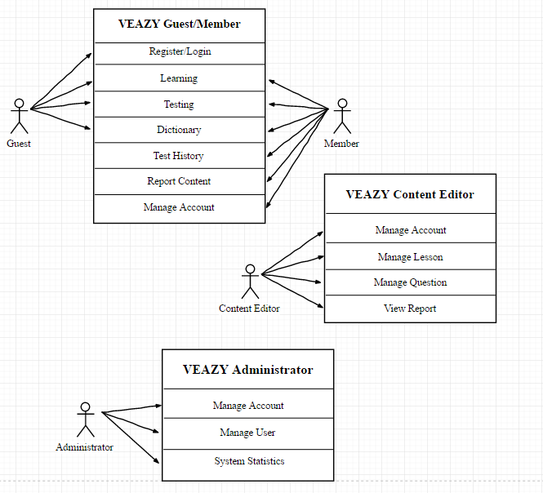

## 2.2 Product functions:

The following are the main features that are included in the system:

* User account: Allows users register new accounts in order to log into the system and provide features of updating and viewing profiles.
* E-learning system: Provides a well-organized lessons system divided based on level of difficulty.
* Taking test: Allow users to take after setting up as well as viewing the test result.
* Dictionary: Provides Vietnamese-Japanese dictionary which is convenient for user to look up while studying.

**Main functions of Guest:**

* **Register new Account**

User registers new account to log into the system.

* **Login**

User login to the system.

* **View Lesson List**

User views list lessons of courses.

* **View Lesson Detail**

User views the content of the selected lesson.

* **Search Lesson**

User searches lesson.

* **Take Test**

User takes a multiple-choice test.

* **View Test Result**

User views result of their test.

* **Search Dictionary**

User searches word in dictionary.

**Main functions of Member:**

* **View Profile**

User views their own profile.

* **Edit Profile**

User edits their own profile.

* **Change Password**

User changes their password.

* **View Test Statistic**

User views summary about their test and their score.

* **Logout System**

User logs out of system.

* **Report Lesson**

User sends their report to Content Manager about wrong content of lesson.

* **Report Question**

User sends their report to Content Manager about wrong content of question.

* **View List Test History**

User views list test history.

* **View Test History**

User views test history detail.

* **ReTake Test**

User retake test.

**Main functions of Content Editor:**

* **View Profile**

User views their own profile.

* **Edit Profile**

User edits their own profile

* **Change Password**

User changes their password

* **Logout System**

User logs out of the system.

* **View Lesson List**

User views list lesson.

* **View Lesson Detail**

User views lesson detail.

* **Search Lesson**

User searches lesson.

* **Create Lesson**

User creates new lesson.

* **Edit Lesson**

User edits lesson.

* **Delete Lesson**

User deletes lesson.

* **View Question List**

User views list question.

* **View Question Detail**

User views question detail.

* **Search Question**

User searches question.

* **Create Question**

User creates new question.

* **Edit Question**

User edits question.

* **Delete Question**

User deletes question.

* **View Report**

User views report about wrong content.

**Main functions of Administrator:**

* **View Profile**

User views their own profile.

* **Change Password**

User changes their password.

* **Logout System**

User logs out of the system.

* **View User List**

User views list member of system.

* **View User Profile**

User views member’s profile.

* **Set Role User**

User sets role for member’s system.

* **Ban User**

User bans member out of system.

* **Unban User**

User unbans member.

* **View System Statistic**

User views statistic of system.

## 2.3 User characteristics:

There are 3 types of users involving in the system:

* Normal users (Guest, Member): Requires basic knowledge of internet & computer.
* Content Editor: Required basic knowledge of internet & computer as normal user. In addition to that, they need to have upper-level of Vietnamese language and ability write academic articles as well as managing them.
* Administrators: Required to have high-level technical, management skills and the ability to promote the website.

## 2.4 Constraints:

The development team must design, develop and test this software within the space of fifteen weeks.

Due to these constraints, as well as the limited number of people working on the project, it may be necessary to prioritize certain aspects of the project over others.

Functionality will be the first priorities.

The system is constrained by the internet connection. Since the browser fetches data from server, it is crucial to have an internet connection to function.

Especially, when user plays media, the speed and bandwidth of the internet connection is a constraint of the system.

The capacity of the database is also a constraint of the system. Since the database is forced to serve many requests at the same time, the time to fetch data will increase depending on the capacity of the database.

## 2.5 Assumptions & Dependencies:

The system depends on which type and version of browser being installed on the client machine i.e. the browser should support both HTML5 and CSS3. The internet connection speed and bandwidth is also a dependency of the system.

One assumption that user has a strong enough internet connect which can adapt to system load. If the speed and bandwidth is slow, there is one scenario that browser cannot fully load the webpage, which may affect web layout displaying. Another scenario is that when user plays media such as listening or watching conversation, the media quality may be affected badly by a weak internet connection, which results a bad user experience.

Another assumption is that user is using a fully technical supported browser. If the browser does not support full technique, website cannot adapt full functionalities

## 2.6 Requirements subset:

# SPECIFIC REQUIREMENTS

## Functionality

### Guest

#### Login

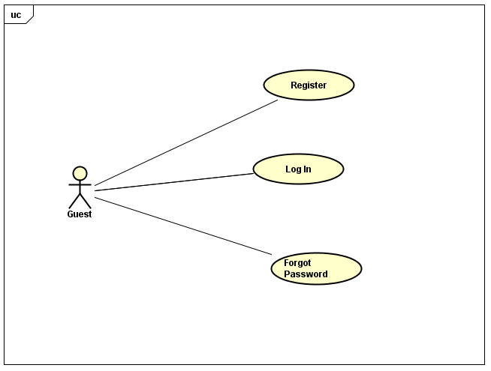

##### **UC-G-001: Login**

|  |  |  |  |  |
| --- | --- | --- | --- | --- |
| Use Case Name | Log In | | | |
| Use Case ID | UC-G-001 | | | |
| Created By | QuanNH | Last Updated By | | ThangPD |
| Date Created | 27/06/2016 | Date Last Updated | | 19/07/2016 |
| Actor | Guest | | | |
| Description | User to login to the front-end system | | | |
| Pre-condition | * Website is available * User has registered account * “Login” link active at the right top of menu | | | |
| Trigger | * User inputs text to the username text field and password text field in “Login” page * User clicks on “Login” link at the right top of menu | | | |
| Post Condition | * Login successfully and redirect user profile page * If exceptions are thrown, the result must match with output of each described exception. | | | |
| Main Success Scenario | | | | |
| Step | **User** | | **System’s Response** | |
| 1 | Click on “Login” hyperlink at the right top of menu | | Show “Login” page | |
| 2 | Enter username and password | |  | |
| 3 | Click on “Login” button | | Redirect to “Home” page | |
| Alternative Scenario | | | | |
| At Step | **User** | | **System’s Response** | |
|  |  | |  | |
| Exception | | | | |
| At Step | **User** | | **System’s Response** | |
| 2 | If Username textbox is null | | Show the notice “Username required!” | |
| 2 | If Password Textbox is null | | Show the notice “Password required!” | |
| 2 | If user enter the wrong Password and Username | | Show the notice "Incorrect username or password!" in the bottom of "Password" textbox. | |

##### **UC-G-002: Register**

|  |  |  |  |  |
| --- | --- | --- | --- | --- |
| Use Case Name | Register | | | |
| Use Case ID | UC-G-002 | | | |
| Created By | QuanNH | Last Updated By | | ThangPD |
| Date Created | 27/06/2016 | Date Last Updated | | 19/07/2016 |
| Actor | Guest | | | |
| Description | User registers new account to log into the system | | | |
| Pre-condition | * Website is available * “Register” link active at the bottom “Welcome to Veazy Course” in “Home” page | | | |
| Trigger | * User clicks on “Register” hyperlink at the bottom “Welcome to Veazy Course” in “Home” page | | | |
| Post Condition | * Register successfully and redirect user profile page or home page * If exceptions are thrown, the result must match with output of each described exception. | | | |
| Main Success Scenario | | | | |
| Step | **User** | | **System’s Response** | |
| 1 | Click on “Register” hyperlink at the bottom “Welcome to Veazy Course” in “Home” page | | Show “Register” page | |
| 2 | Enter necessary and mandatory information | |  | |
| 3 | Click on “Register” button | | Redirect to “Success” page | |
| 4 | Click on “Go to User Profile” button | | Redirect to “Home” page | |
| Alternative Scenario | | | | |
| At Step | **User** | | **System’s Response** | |
| 4 | Click on “Back to HomePage” hyperlink | | Redirect to user profile page | |
| Exception | | | | |
| At Step | **User** | | **System’s Response** | |
| 2 | If Username textbox is null | | Show the notice “Username required!” | |
| 2 | If Email textbox is null | | Show the notice “Email required!” | |
| 2 | If Password textbox is null | | Show the notice “Password required!” | |
| 2 | If Confirm Password textbox is null | | Show the notice “Password does not matched!” | |
| 2 | If user enter Username that less than 6 characters | | Show the notice “Username must be at least 6 characters long!！” | |
| 2 | If user enter Username that more than 30 characters | | Show the notice “Username must be no more than 30 characters long!” | |
| 2 | If user enter the wrong Email | | Show the notice “Invalid email!” | |
| 2 | If user enter Password that less than 6 characters | | Show the notice “Password must be at least 6 characters long!” | |
| 2 | If user enter Password that more than 30 characters | | Show the notice “Password must be no more than 30 characters long!” | |
| 2 | If Confirm Password is not the same Password | | Show the notice “Password does not matched!” | |

##### **UC-G-003: Forgot Password**

|  |  |  |  |  |
| --- | --- | --- | --- | --- |
| Use Case Name | Forgot Password | | | |
| Use Case ID | UC-G-003 | | | |
| Created By | QuanNH | Last Updated By | | ThangPD |
| Date Created | 27/06/2016 | Date Last Updated | | 27/07/2016 |
| Actor | Guest | | | |
| Description | User resets their password | | | |
| Pre-condition | * Website is available * “Forgot your password?” link active in “Login“ page | | | |
| Trigger | * User clicks on “Forgot your password?” in “Login” page | | | |
| Post Condition | * System shows “Reset Password” popup * If exceptions are thrown, the result must match with output of each described exception. | | | |
| Main Success Scenario | | | | |
| Step | **User** | | **System’s Response** | |
| 1 | Clicks on “Forgot your password?” in “Login” page | | Show “Reset Password” popup | |
| 2 | Input Email in “Reset Password” popup | |  | |
| 3 | Click “...” Button in “Reset Password” popup | |  | |
| Alternative Scenario | | | | |
| At Step | **User** | | **System’s Response** | |
|  |  | |  | |
| Exception | | | | |
| At Step | **User** | | **System’s Response** | |
| 2 | If Email textbox is null | |  | |
| 2 | If user enter the wrong Email | |  | |

#### Learning

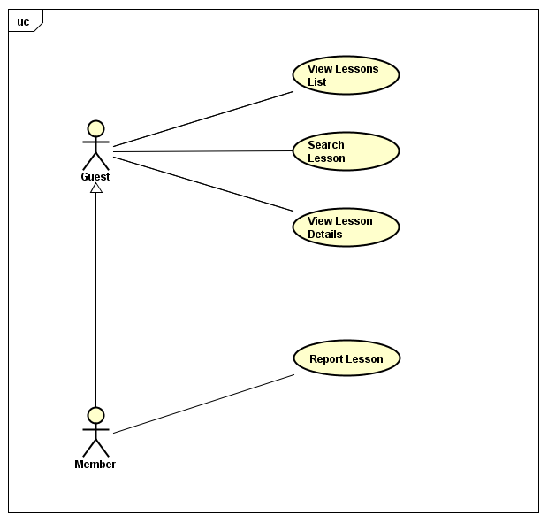

##### **UC-G-004: View Lessons List**

|  |  |  |  |  |
| --- | --- | --- | --- | --- |
| Use Case Name | View Lessons List | | | |
| Use Case ID | UC-G-004 | | | |
| Created By | QuanNH | Last Updated B**y** | | ThangPD |
| Date Created | 27/06/2016 | Date Last Updated | | 19/07/2016 |
| Actor | Guest, Member | | | |
| Description | User views list lessons of courses | | | |
| Pre-condition | * Website is available * “Course” link active in top menu * Level hyperlink in dropdown list active | | | |
| Trigger | User clicks on “Course” link in top menu then click on level hyperlink in dropdown list | | | |
| Post Condition | View Lesson List successfully and system redirects to “Course” page | | | |
| Main Success Scenario | | | | |
| Step | **User** | | **System’s Response** | |
| 1 | Click on “Course” button in top menu then click on level hyperlink in dropdown list | | Redirect to Course page | |
| Alternative Scenario | | | | |
| At Step | **User** | | **System’s Response** | |
| Exception | | | | |
| At Step | **User** | | **System’s Response** | |
|  |  | | | |

##### **UC-G-005: Search Lesson**

|  |  |  |  |  |
| --- | --- | --- | --- | --- |
| Use Case Name | Search Lesson | | | |
| Use Case ID | UC-G-005 | | | |
| Created By | QuanNH | Last Updated By | | ThangPD |
| Date Created | 27/06/2016 | Date Last Updated | | 19/07/2016 |
| Actor | Guest, Member | | | |
| Description | User searches lesson | | | |
| Pre-condition | Website is available | | | |
| Trigger | User inputs text to the search box in “Course” page | | | |
| Post Condition | Search Lesson successfully and system will filter and display result | | | |
| Main Success Scenario | | | | |
| Step | **User** | | **System’s Response** | |
| 1 | Input text to the search box | |  | |
| 2 | Click icon search button | | System filters and display result | |
| Alternative Scenario | | | | |
| At Step | **User** | | **System’s Response** | |
| Exception | | | | |
| At Step | **User** | | **System’s Response** | |

##### **UC-G-006: View Lesson Details**

|  |  |  |  |  |
| --- | --- | --- | --- | --- |
| Use Case Name | View Lesson Details | | | |
| Use Case ID | UC-G-006 | | | |
| Created By | QuanNH | Last Updated By | | ThangPD |
| Date Created | 27/06/2016 | Date Last Updated | | 19/07/2016 |
| Actor | Guest, Member | | | |
| Description | User views the content of the selected lesson | | | |
| Pre-condition | Website is available | | | |
| Trigger | User clicks on “Study” link in each lesson box of “Course” page | | | |
| Post Condition | View Lesson Details successfully and system redirects to “Lesson” page | | | |
| Main Success Scenario | | | | |
| Step | **User** | | **System’s Response** | |
| 1 | Click on “Study” link in each lesson box | | Redirect to “Lesson Details” page | |
| Alternative Scenario | | | | |
| At Step | **User** | | **System’s Response** | |
| Exception | | | | |
| At Step | **User** | | **System’s Response** | |

#### Testing

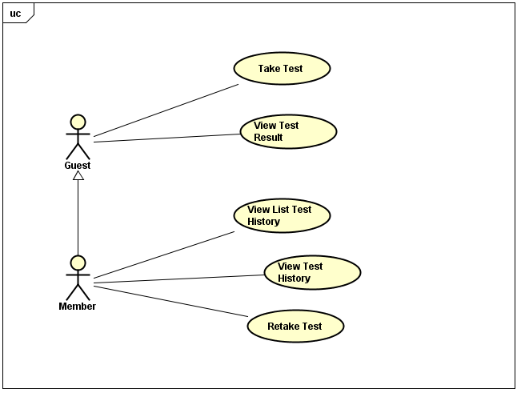

##### **UC-G-007: Take Test**

|  |  |  |  |  |
| --- | --- | --- | --- | --- |
| Use Case Name | Take Test | | | |
| Use Case ID | UC-G-007 | | | |
| Created By | QuanNH | Last Updated By | | ThangPD |
| Date Created | 04/07/2016 | Date Last Updated | | 19/07/2016 |
| Actor | Guest, Member | | | |
| Description | User takes a multiple-choice test | | | |
| Pre-condition | Website is available | | | |
| Trigger | User clicks on “Test” link in top menu | | | |
| Post Condition | Take test successfully and system redirects to “Test” page | | | |
| Main Success Scenario | | | | |
| Step | **User** | | **System’s Response** | |
| 1 | Click on “Test” link in top menu | | Redirect to “Test” page | |
| 2 | Click on “Level” drop down list to select difficulty level | |  | |
| 3 | Click on “Test skill” dropdown list to select the skill that user wants to test | |  | |
| 4 | Input the number of questions | |  | |
| 5 | Click on “Create” button | | System displays the test in accordance with user’s test input | |
| Alternative Scenario | | | | |
| At Step | **User** | | **System’s Response** | |
| Exception | | | | |
| At Step | **User** | | **System’s Response** | |
| 5 | If “Question limit” is null | | Show the notice “Please input number of question” | |

##### **UC-G-008: View Test Result**

|  |  |  |  |  |
| --- | --- | --- | --- | --- |
| Use Case Name | View Exam Result | | | |
| Use Case ID | UC-G-008 | | | |
| Created By | QuanNH | Last Updated By | | ThangPD |
| Date Created | 04/07/2016 | Date Last Updated | | 19/07/2016 |
| Actor | Guest, Member | | | |
| Description | User views result of their test | | | |
| Pre-condition | * Website is available * Done UC-G-006 successfully | | | |
| Trigger | User clicks on “Submit” button at bottom of “Test” page | | | |
| Post Condition | System redirects to “Test Result” page | | | |
| Main Success Scenario | | | | |
| Step | **User** | | **System’s Response** | |
| 1 | Click on “Submit” button at bottom of “Test “page | | Redirect to “Test Result” page | |
| Alternative Scenario | | | | |
| At Step | **User** | | **System’s Response** | |
|  |  | |  | |
| Exception | | | | |
| At Step | **User** | | **System’s Response** | |

#### Search Dictionary

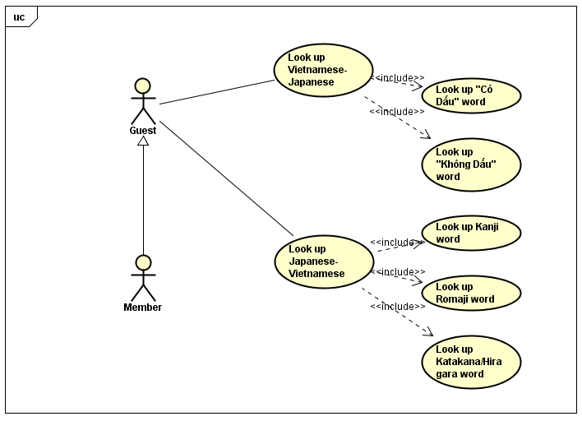

### Member

#### Manage Account

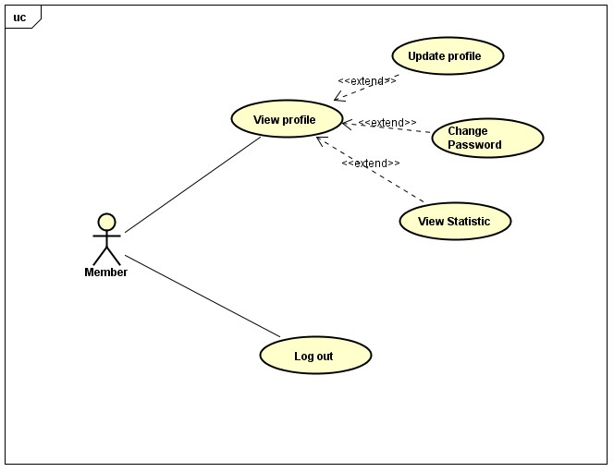

##### **UC-M-001: View Profile**

|  |  |  |  |  |
| --- | --- | --- | --- | --- |
| Use Case Name | View Profile | | | |
| Use Case ID | UC-M-001 | | | |
| Created By | QuanNH | Last Updated By | | ThangPD |
| Date Created | 27/06/2016 | Date Last Updated | | 13/07/2016 |
| Actor | Member | | | |
| Description | User views their profile | | | |
| Pre-condition | * Website is available * Member logged in the website | | | |
| Trigger | User clicks on username hyperlink at the left top of menu | | | |
| Post Condition | System redirects to user profile page | | | |
| Main Success Scenario | | | | |
| Step | **User** | | **System’s Response** | |
| 1 | Click on username hyperlink at the left top of menu | | Redirect to “Profile” Page | |
| Alternative Scenario | | | | |
| At Step | **User** | | **System’s Response** | |
| Exception | | | | |
| At Step | **User** | | **System’s Response** | |

##### **UC-M-002: Update Profile**

|  |  |  |  |  |
| --- | --- | --- | --- | --- |
| Use Case Name | Update Profile | | | |
| Use Case ID | UC-M-002 | | | |
| Created By | QuanNH | Last Updated By | | ThangPD |
| Date Created | 04/07/2016 | Date Last Updated | | 27/07/2016 |
| Actor | Member | | | |
| Description | User edits their own profile | | | |
| Pre-condition | * Website is available * Member logged in the website * Done UC-M-001 successfully | | | |
| Trigger | * User clicks on “Update Profile” in “Actions” dropdown list * User inputs changed information * User clicks on “Save” button in the end of “Update Profile” popup | | | |
| Post Condition | * System stays on initial screen and show update successfully * If exceptions are thrown, the result must match with output of each described exception. | | | |
| Main Success Scenario | | | | |
| Step | **User** | | **System’s Response** | |
| 1 | Click on “Update Profile” in “Actions” dropdown list | | Show “Update Profile Information” popup | |
| 2 | Update information | |  | |
| 3 | Click on “Save” button. | | Update information of user and redirect to “Profile” page | |
| Alternative Scenario | | | | |
| At step | **User** | | **System’s Response** | |
| 1 | Click on “Cancel” button | | Cancel editing profile action and close “Update Profile Information” popup | |
| Exception | | | | |
| At Step | **User** | | **System’s Response** | |

##### **UC-M-003: Change Password**

|  |  |  |  |  |
| --- | --- | --- | --- | --- |
| Use Case Name | Change Password | | | |
| Use Case ID | UC-M-003 | | | |
| Created By | QuanNH | Last Updated By | | QuanNH |
| Date Created | 27/06/2016 | Date Last Updated | | 12/07/2016 |
| Actor | Member | | | |
| Description | User changes their password | | | |
| Pre-condition | * Website is available * Member logged in the website * Done UC-M-001 successfully | | | |
| Trigger | * User clicks on “Change Password” in “Actions” dropdown list * User inputs current password, new password and re-type new password * User clicks “Change” button in the end of “Change Password” popup | | | |
| Post Condition | * System stays on initial screen and password is changed successfully. * If exceptions are thrown, the result must match with output of each described exception. | | | |
| Main Success Scenario | | | | |
| Step | **User** | | **System’s Response** | |
| 1 | Click on “Change Password” in “Actions” dropdown list. | | Show “Change password” popup | |
| 2 | Input information | |  | |
| 3 | Click on “Save” button. | |  | |
| Alternative Scenario | | | | |
| At Step | **User** | | **System’s Response** | |
| 3 | Click on “Cancel” button | | Cancel changing password action and close “Change Password” popup | |
| Exception | | | | |
| At Step | **User** | | **System’s Response** | |
| 2 | If Current password textbox is null | |  | |
| 2 | If New password textbox is null | |  | |
| 2 | If Re-type New password textbox is null and confirmed password is not match | |  | |
| 2 | Current password is not valid | |  | |
| 2 | If user enter New password that less than 6 characters | |  | |
| 2 | If user enter New password that more than 30 characters | |  | |

##### **UC-M-004: View Statistics**

|  |  |  |  |  |
| --- | --- | --- | --- | --- |
| Use Case Name | View Statistic | | | |
| Use Case ID | UC-M-011 | | | |
| Created By | QuanNH | Last Updated By | | QuanNH |
| Date Created | 27/06/2016 | Date Last Updated | | 12/07/2016 |
| Actor | Member | | | |
| Description | User views their statistics | | | |
| Pre-condition | * Website is available * Member logged in the website * Done UC-M-001 successfully | | | |
| Trigger | User clicks on “Statistics” hyperlink in “Profile” page | | | |
| Post Condition | System redirects to “Statistics” page | | | |
| Main Success Scenario | | | | |
| Step | **User** | | **System’s Response** | |
| Alternative Scenario | | | | |
| At Step | **User** | | **System’s Response** | |
| Exception | | | | |
| At Step | **User** | | **System’s Response** | |

##### **UC-M-005: Logout**

|  |  |  |  |  |
| --- | --- | --- | --- | --- |
| Use Case Name | Logout | | | |
| Use Case ID | UC-M-005 | | | |
| Created By | QuanNH | Last Updated By | | ThangPD |
| Date Created | 27/06/2016 | Date Last Updated | | 12/07/2016 |
| Actor | Member | | | |
| Description | User logs out of the front-end system | | | |
| Pre-condition | * Website is available * Member logged in the website | | | |
| Trigger | User clicks on “Logout” hyperlink at dashboard in “Member Dashboard” page | | | |
| Post Condition | Redirect to “Home Screen” and user signed out successfully | | | |
| Main Success Scenario | | | | |
| Step | **User** | | **System’s Response** | |
| 1 | Click on “Logout” hyperlink at dashboard | |  | |
| Alternative Scenario | | | | |
| At Step | **User** | | **System’s Response** | |
| Exception | | | | |
| At Step | **User** | | **System’s Response** | |

#### Report Content

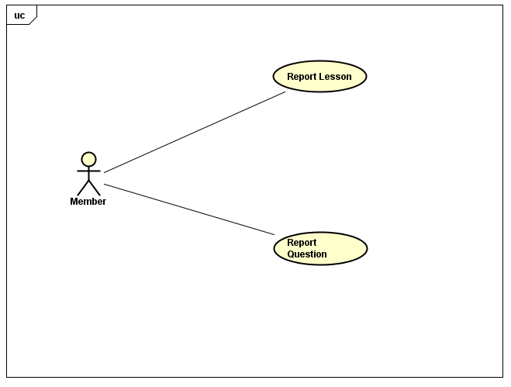

##### **UC-M-007: Report Lesson**

|  |  |  |  |  |
| --- | --- | --- | --- | --- |
| Use Case Name | Report Lesson | | | |
| Use Case ID | UC-M-006 | | | |
| Created By | QuanNH | Last Updated By | | QuanNH |
| Date Created | 04/07/2016 | Date Last Updated | | 12/07/2016 |
| Actor | Member | | | |
| Description | User sends their reports to Content Manager about wrong content of lesson | | | |
| Pre-condition | * Website is available * Member logged in the website * Done UC-G-005 successfully | | | |
| Trigger | User clicks on “Option” dropdown list then click on “Report” link in “Lesson Detail” page | | | |
| Post Condition | System sends a message to Content Manager | | | |
| Main Success Scenario | | | | |
| Step | **User** | | **System’s Response** | |
| 1 | Click on “Option” dropdown list | | Show “Option” dropdown list | |
| 2 | Click on “Report” Link | | Send a message to Content Manager about wrong content | |
|  |  | |  | |
| Alternative Scenario | | | | |
| At Step | **User** | | **System’s Response** | |
| Exception Paths | | | | |
| At Step | **User** | | **System’s Response** | |

##### **UC-M-008: Report Question**

|  |  |  |  |  |
| --- | --- | --- | --- | --- |
| Use Case Name | Report Question | | | |
| Use Case ID | UC-M-007 | | | |
| Created By | QuanNH | Last Updated By | | ThangPD |
| Date Created | 04/07/2016 | Date Last Updated | | 19/07/2016 |
| Actor | Member | | | |
| Description | User sends their reports to Content Manager about wrong question | | | |
| Pre-condition | * Website is available * Member logged in the website * Done UC-G-007 successfully | | | |
| Trigger | User clicks on “Report” button at the right of each question in “Test Result” page | | | |
| Post Condition | System sends a message to Content Manager | | | |
| Main Success Scenario | | | | |
| Step | **User** | | **System’s Response** | |
| 1 | Click on “Report” button in the right of each question | | Send a message to Content Manager about wrong question | |
| Alternative Scenario | | | | |
| At Step | **User** | | **System’s Response** | |
| Exception | | | | |
| At Step | **User** | | **System’s Response** | |

#### Testing



##### **UC-M-009: View Test History**

|  |  |  |  |  |
| --- | --- | --- | --- | --- |
| Use Case Name | View Test History | | | |
| Use Case ID | UC-M-009 | | | |
| Created By | QuanNH | Last Updated By | | ThangPD |
| Date Created | 04/07/2016 | Date Last Updated | | 19/07/2016 |
| Actor | Member | | | |
| Description | User views their test history details | | | |
| Pre-condition | * Website is available * Member logged in the website | | | |
| Trigger | User clicks on “Test Name” link in “Test” page | | | |
| Post Condition | System redirects to “Test Details” page | | | |
| Main Success Scenario | | | | |
| Step | **User** | | **System’s Response** | |
| 1 | Click on “the timing of the tests were done ” link in “Test” page | | Show “Test Details” page | |
| Alternative Scenario | | | | |
| At Step | **User** | | **System’s Response** | |
| Exception | | | | |
| At Step | **User** | | **System’s Response** | |

##### **UC-M-010: Retake Test**

|  |  |  |  |  |
| --- | --- | --- | --- | --- |
| Use Case Name | Retake Test | | | |
| Use Case ID | UC-M-010 | | | |
| Created By | QuanNH | Last Updated By | | ThangPD |
| Date Created | 04/07/2016 | Date Last Updated | | 14/07/2016 |
| Actor | Member | | | |
| Description | User retake test | | | |
| Pre-condition | * Website is available * Member logged in the website * Done UC-M-009 successfully | | | |
| Trigger | User clicks on “Test Name” hyperlink then click “Retake Test” button | | | |
| Post Condition | System redirects to “Test” page | | | |
| Main Success Scenario | | | | |
| Step | **User** | | **System’s Response** | |
| 1 | Click on “the timing of the tests were done” hyperlink that user want to re take test | | Show “Test Details” page | |
| 2 | Click on “Retake Test” button | | Redirect to “Test” page | |
| Alternative Scenario | | | | |
| At Step | **User** | | **System’s Response** | |
|  |  | |  | |
| Exception | | | | |
| At Step | **User** | | **System’s Response** | |

##### **UC-M-011: View List Test History**

|  |  |  |  |  |
| --- | --- | --- | --- | --- |
| Use Case Name | View Exam Statistic | | | |
| Use Case ID | UC-M-011 | | | |
| Created By | QuanNH | Last Updated By | | ThangPD |
| Date Created | 27/06/2016 | Date Last Updated | | 20/07/2016 |
| Actor | Member | | | |
| Description | User views their list test history | | | |
| Pre-condition | * Website is available * Member logged in the website | | | |
| Trigger | User clicks on “Test” button in top menu | | | |
| Post Condition | Show list test history at the bottom fieldset create test | | | |
| Main Success Scenario | | | | |
| Step | **User** | | **System’s Response** | |
| 1 | Click on “Test” button in top menu | | Show list test history at the bottom fieldset create test | |
| Alternative Scenario | | | | |
| At Step | **User** | | **System’s Response** | |
| Exception | | | | |
| At Step | **User** | | **System’s Response** | |

### Content Editor

#### Manage Account

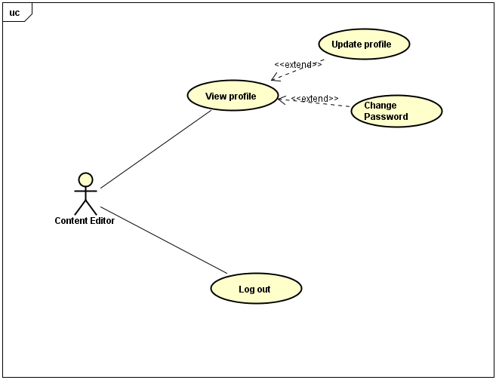

##### **UC-E-001: View Profile**

|  |  |  |  |  |
| --- | --- | --- | --- | --- |
| Use Case Name | View Profile | | | |
| Use Case ID | UC-E-001 | | | |
| Created By | QuanNH | Last Updated By | | ThangPD |
| Date Created | 27/06/2016 | Date Last Updated | | 19/07/2016 |
| Actor | Content Editor | | | |
| Description | User views their profile | | | |
| Pre-condition | * Website is available * Logged in "Content Editor" dashboard | | | |
| Trigger | * Login "Content Editor" dashboard * Users clicks on username hyperlink at the left top of menu | | | |
| Post Condition | * View Profile successful and system redirect to content editor profile page | | | |
| Main Success Scenario | | | | |
| Step | **User** | | **System’s Response** | |
| 1 | Click on username hyperlink at the left top of menu | | Redirect to “View Profile” Page | |
| Alternative Scenario | | | | |
| At Step | **User** | | **System’s Response** | |
| Exception | | | | |
| At Step | **User** | | **System’s Response** | |

##### **UC-E-002: Update Profile**

|  |  |  |  |  |
| --- | --- | --- | --- | --- |
| Use Case Name | Update Profile | | | |
| Use Case ID | UC-E-002 | | | |
| Created By | QuanNH | Last Updated By | | QuanNH |
| Date Created | 04/07/2016 | Date Last Updated | | 12/07/2016 |
| Actor | Content Editor | | | |
| Description | User edits their own profile | | | |
| Pre-condition | * Website is available * Logged in "Content Editor" dashboard | | | |
| Trigger | User clicks “Edit Profile” button | | | |
| Post Condition | * System stays on initial screen and show “Edit Profile” popup * If exceptions are thrown, the result must match with output of each described exception. | | | |
| Main Success Scenario | | | | |
| Step | **User** | | **System’s Response** | |
| 1 | Click on “Edit Profile” button in action dropdown list. | | Show “Edit Profile” popup | |
| 2 | Edit information | |  | |
| 3 | Click on “Save” button. | | Update information of user and redirect to “View Profile” page | |
| Alternative Scenario | | | | |
| At Step | **User** | | **System’s Response** | |
|  |  | |  | |
| Exception | | | | |
| At Step | **User** | | **System’s Response** | |

##### **UC-E-003: Change Password**

|  |  |  |  |  |
| --- | --- | --- | --- | --- |
| Use Case Name | Change Password | | | |
| Use Case ID | UC-E-003 | | | |
| Created By | QuanNH | Last Updated By | | QuanNH |
| Date Created | 27/06/2016 | Date Last Updated | | 12/07/2016 |
| Actor | Content Editor | | | |
| Description | User changes their password | | | |
| Pre-condition | * Website is available * Logged in "Content Editor" dashboard * Done UC-E-002 successfully | | | |
| Trigger | User clicks “Change password” button in “Edit Profile” page | | | |
| Post Condition | * Change password successful and system stay on initial screen and password is changed successfully. * If exceptions are thrown, the result must match with output of each described exception | | | |
| Main Success Scenario | | | | |
| Step | **User** | | **System’s Response** | |
| 1 | Click on “Change password” button in action dropdown list. | | Show a popup with requiring input information | |
| 2 | Input information | |  | |
| 3 | Click on “Save” button. | |  | |
| Alternative Scenario | | | | |
| At Step | **User** | | **System’s Response** | |
| Exception | | | | |
| At Step | **User** | | **System’s Response** | |
|  |  | |  | |

##### **UC-E-004: Logout**

|  |  |  |  |  |
| --- | --- | --- | --- | --- |
| Use Case Name | Logout | | | |
| Use Case ID | UC-E-004 | | | |
| Created By | QuanNH | Last Updated By | | ThangPD |
| Date Created | 27/06/2016 | Date Last Updated | | 19/07/2016 |
| Actor | Content Editor | | | |
| Description | User logout of the front-end system | | | |
| Pre-condition | * Website is available * Logged in "Content Editor" dashboard | | | |
| Trigger | User clicks on “Logout” hyperlink at dashboard in content editor profile page | | | |
| Post Condition | Redirect to “Home” page and user signed out successfully | | | |
| Main Success Scenario | | | | |
| Step | **User** | | **System’s Response** | |
| 1 | Click on “Logout” hyperlink at dashboard | |  | |
| Alternative Scenario | | | | |
| At Step | **User** | | **System’s Response** | |
| Exception | | | | |
| At Step | **User** | | **System’s Response** | |

#### Manage Lessons

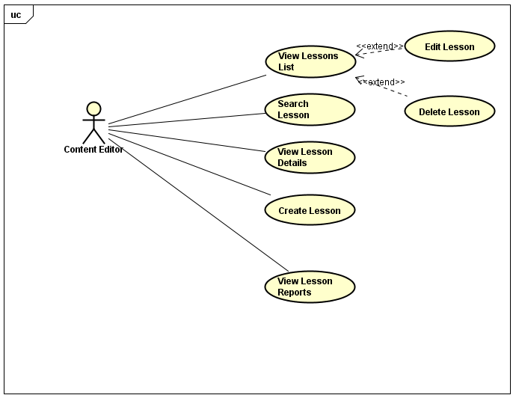

##### **UC-E-005: View Lessons List**

|  |  |  |  |  |
| --- | --- | --- | --- | --- |
| Use Case Name | View Lessons List | | | |
| Use Case ID | UC-E-005 | | | |
| Created By | QuanNH | Last Updated By | | ThangPD |
| Date Created | 27/06/2016 | Date Last Updated | | 19/07/2016 |
| Actor | Content Editor | | | |
| Description | User views list lessons of courses | | | |
| Pre-condition | * Website is available * Logged in "Content Editor" dashboard | | | |
| Trigger | User clicks on “Lessons” sidebar then click “Lesson List” hyperlink at dashboard in “Editor Dashboard” page | | | |
| Post Condition | System redirects to “Lesson List” page | | | |
| Main Success Scenario | | | | |
| Step | **User** | | **System’s Response** | |
| 1 | Click on “Lessons” sidebar | | Show “Lesson List” and “Add Lesson ” link | |
| 2 | Click on “Lesson List” hyperlink at dashboard in “Editor Dashboard” page | | Redirect to “Lesson List” page | |
| Alternative Scenario | | | | |
| At Step | **User** | | **System’s Response** | |
| Exception | | | | |
| At Step | **User** | | **System’s Response** | |

##### **UC-E-006: Search Lesson**

|  |  |  |  |  |
| --- | --- | --- | --- | --- |
| Use Case Name | Search Lesson | | | |
| Use Case ID | UC-E-006 | | | |
| Created By | QuanNH | Last Updated By | | ThangPD |
| Date Created | 27/06/2016 | Date Last Updated | | 19/07/2016 |
| Actor | Content Editor | | | |
| Description | User searches lessons in “Lesson List” page | | | |
| Pre-condition | * Website is available * Logged in "Content Editor" dashboard | | | |
| Trigger | User inputs text to the search box in “Lesson List” page | | | |
| Post Condition | Search Lesson successful and system filters and display result | | | |
| Main Success Scenario | | | | |
| Step | **User** | | **System’s Response** | |
| 1 | Input text to the search box | |  | |
| 2 | Click on “Search” button | | System will filter and display result | |
| Alternative Scenario | | | | |
| At Step | **User** | | **System’s Response** | |
| Exception | | | | |
| At Step | **User** | | **System’s Response** | |

##### **UC-E-007: View Lesson Details**

|  |  |  |  |  |
| --- | --- | --- | --- | --- |
| Use Case Name | View Lesson Details | | | |
| Use Case ID | UC-E-007 | | | |
| Created By | QuanNH | Last Updated By | | ThangPD |
| Date Created | 27/06/2016 | Date Last Updated | | 19/07/2016 |
| Actor | Content Editor | | | |
| Description | User views lesson details | | | |
| Pre-condition | * Website is available * Logged in "Content Editor" dashboard | | | |
| Trigger |  | | | |
| Post Condition | System redirects to lesson details page | | | |
| Main Success Scenario | | | | |
| Step | **User** | | **System’s Response** | |
| 1 | Click on “Lesson Name” link in each lesson box | | Redirect to “Lesson Details” page | |
| Alternative Scenario | | | | |
| At Step | **User** | | **System’s Response** | |
| Exception | | | | |
| At Step | **User** | | **System’s Response** | |

##### **UC-E-008: Create Lesson**

|  |  |  |  |  |
| --- | --- | --- | --- | --- |
| Use Case Name | Create Lesson | | | |
| Use Case ID | UC-E-008 | | | |
| Created By | QuanNH | Last Updated B**y** | | ThangPD |
| Date Created | 27/06/2016 | Date Last Updated | | 14/07/2016 |
| Actor | Content Editor | | | |
| Description | User creates lesson | | | |
| Pre-condition | * Website is available * Logged in "Content Editor" dashboard | | | |
| Trigger | User clicks on “Lessons” sidebar then click “Add Lesson” hyperlink at dashboard in “Editor Dashboard” page | | | |
| Post Condition | * System redirects to “Lesson Details” page   If exceptions are thrown, the result must match with output of each described exception. | | | |
| Main Success Scenario | | | | |
| Step | **User** | | **System’s Response** | |
| 1 | Click on “Lessons” sidebar | | Show “Lesson List” and “Add Lesson ” link | |
| 2 | Click on “Add Lesson” hyperlink at dashboard in “Editor Dashboard” page | | Redirect to “Add Lesson “ page | |
| 3 | Input information | |  | |
| 4 | Click on “Finish” button | | Redirect to UC-E-008 | |
| Alternative Scenario | | | | |
| At Step | **User** | | **System’s Response** | |
| Exception | | | | |
| At Step | **User** | | **System’s Response** | |
| 3 | If Lesson Title textbox is null | | Show the notice “Please Input Lesson Name” | |
| 3 | If Description textbox is null | | Show the notice “Please Input Level” | |

##### **UC-E-009: Edit Lesson**

|  |  |  |  |  |
| --- | --- | --- | --- | --- |
| Use Case Name | Edit Lesson | | | |
| Use Case ID | UC-E-009 | | | |
| Created By | QuanNH | Last Updated By | | QuanNH |
| Date Created | 27/06/2016 | Date Last Updated | | 12/07/2016 |
| Actor | Content Editor | | | |
| Description | User edits lesson | | | |
| Pre-condition | * Website is available * Logged in "Content Editor" dashboard | | | |
| Trigger |  | | | |
| Post Condition | * System redirects to “Lesson Details” page   If exceptions are thrown, the result must match with output of each described exception. | | | |
| Main Success Scenario | | | | |
| Step | **User** | | **System’s Response** | |
| 1 | Click on “Update lesson” button | |  | |
| 2 | Update information | |  | |
| 3 | Click on “Update” button | |  | |
| Alternative Scenario | | | | |
| At Step | **User** | | **System’s Response** | |
| Exception | | | | |
| At Step | **User** | | **System’s Response** | |

##### **UC-E-010: Delete Lesson**

|  |  |  |  |  |
| --- | --- | --- | --- | --- |
| Use Case Name | Delete Lesson | | | |
| Use Case ID | UC-E-010 | | | |
| Created By | QuanNH | Last Updated By | | QuanNH |
| Date Created | 27/06/2016 | Date Last Updated | | 12/07/2016 |
| Actor | Content Editor | | | |
| Description | User deletes lesson | | | |
| Pre-condition | * Website is available * Logged in "Content Editor" dashboard | | | |
| Trigger |  | | | |
| Post Condition | Delete Lesson successful system redirect to “Lesson list” page | | | |
| Main Success Scenario | | | | |
| Step | **User** | | **System’s Response** | |
| 1 | Click “Delete” button | |  | |
| 2 | Click “Yes” button | | Show the notice “Delete successful” | |
|  |  | |  | |
| Alternative Scenario | | | | |
| At Step | **User** | | **System’s Response** | |
| Exception | | | | |
| At Step | **User** | | **System’s Response** | |

##### **UC-E-011: View Lesson Report**

|  |  |  |  |  |
| --- | --- | --- | --- | --- |
| Use Case Name | View Lesson Reports | | | |
| Use Case ID | UC-E-011 | | | |
| Created By | QuanNH | Last Updated By | | QuanNH |
| Date Created | 27/06/2016 | Date Last Updated | | 25/07/2016 |
| Actor | Content Editor | | | |
| Description |  | | | |
| Pre-condition | * Website is available * Logged in "Content Editor" dashboard | | | |
| Trigger |  | | | |
| Post Condition |  | | | |
| Main Success Scenario | | | | |
| Step | **User** | | **System’s Response** | |
| Alternative Scenario | | | | |
| At Step | **User** | | **System’s Response** | |
| Exception | | | | |
| At Step | **User** | | **System’s Response** | |

#### Manage Questions

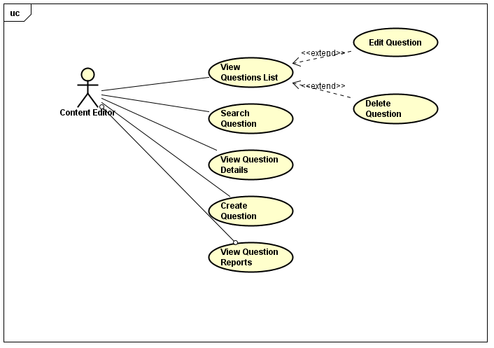

##### **UC-E-012: View Questions List**

|  |  |  |  |  |
| --- | --- | --- | --- | --- |
| Use Case Name | View Question List | | | |
| Use Case ID | UC-E-012 | | | |
| Created By | QuanNH | Last Updated By | | ThangPD |
| Date Created | 04/07/2016 | Date Last Updated | | 19/07/2016 |
| Actor | Content Editor, Content Manager | | | |
| Description | User views list questions | | | |
| Pre-condition | * Website is available * Logged in "Content Editor" dashboard | | | |
| Trigger | User clicks on “Questions” sidebar then click “Questions List” hyperlink at dashboard in “Editor Dashboard” page | | | |
| Post Condition | View Questions List successful and system redirects to “Questions List” page | | | |
| Main Success Scenario | | | | |
| Step | **User** | | **System’s Response** | |
| 1 | Click on “Questions” sidebar | | Show “Question List” and “Add Question ” link | |
| 2 | Click on “Question List” hyperlink at dashboard in “Editor Dashboard” page | | Redirect to “Questions List” page | |
|  |  | |  | |
| Alternative Scenario | | | | |
| At Step | **User** | | **System’s Response** | |
| Exception | | | | |
| At Step | **User** | | **System’s Response** | |

##### **UC-E-013: Search Question**

|  |  |  |  |  |
| --- | --- | --- | --- | --- |
| Use Case Name | Search Question | | | |
| Use Case ID | UC-E-013 | | | |
| Created By | QuanNH | Last Updated By | | ThangPD |
| Date Created | 04/07/2016 | Date Last Updated | | 19/07/2016 |
| Actor | Content Editor, Content Manager | | | |
| Description | User searches question | | | |
| Pre-condition | * Website is available * Logged in "Content Editor" dashboard | | | |
| Trigger | User inputs text to the search box in “Question List” page | | | |
| Post Condition | Search Question successful and system will filter and display result | | | |
| Main Success Scenario | | | | |
| Step | **User** | | **System’s Response** | |
| 1 | Input text to the search box | | System will filter and display result | |
| Alternative Scenario | | | | |
| At Step | **User** | | **System’s Response** | |
| Exception | | | | |
| At Step | **User** | | **System’s Response** | |

##### **UC-E-014: View Question Details**

|  |  |  |  |  |
| --- | --- | --- | --- | --- |
| Use Case Name | View Question Details | | | |
| Use Case ID | UC-E-014 | | | |
| Created By | QuanNH | Last Updated By | | ThangPD |
| Date Created | 04/07/2016 | Date Last Updated | | 19/07/2016 |
| Actor | Content Editor, Content Manager | | | |
| Description | User views question details | | | |
| Pre-condition | * Website is available * Logged in "Content Editor" dashboard * Done UC-E-012 successfully | | | |
| Trigger | User clicks on ”Click here to see content” link of each question in “Question List” page | | | |
| Post Condition | System redirects to question details page | | | |
| Main Success Scenario | | | | |
| Step | **User** | | **System’s Response** | |
| 1 | Click on “Click here to see content” link of each question | | Show “Question Details” popup | |
| Alternative Scenario | | | | |
| At Step | **User** | | **System’s Response** | |
| Exception | | | | |
| At Step | **User** | | **System’s Response** | |

##### **UC-E-015: Create Question**

|  |  |  |  |  |
| --- | --- | --- | --- | --- |
| Use Case Name | Create Question | | | |
| Use Case ID | UC-E-015 | | | |
| Created By | QuanNH | Last Updated By | | ThangPD |
| Date Created | 27/06/2016 | Date Last Updated | | 19/07/2016 |
| Actor | Content Editor | | | |
| Description | User creates question | | | |
| Pre-condition | * Website is available * Logged in "Content Editor" dashboard | | | |
| Trigger | User clicks on “Questions” sidebar then click “Add Lesson” hyperlink at dashboard in “Editor Dashboard” page | | | |
| Post Condition | Create Question successful and system redirects to “Questions List” page  If exceptions are thrown, the result must match with output of each described exception. | | | |
| Main Success Scenario | | | | |
| Step | **User** | | **System’s Response** | |
| 1 | Click on “Add Question” hyperlink in “Editor Dashboard” page | | Redirect to “Add Question” Page | |
| 2 | Choose question type in “Question Type” dropdown list | |  | |
| 3 | Choose question level in “Level” dropdown list | |  | |
| 4 | Choose question skill in “Test Skill” dropdown list | |  | |
| 5 | 5. Input question and answer | |  | |
| 6 | 6. Click on “+” button under answer field to add more answer (for single question) or click on “+” button under question to add more question (for group question) | |  | |
| 7 | 7. Click on “File attachment” and choose file to upload | | Add media to question | |
| 8 | Click on “Finish” button | | Redirect to UC-E-012 | |
| Alternative Scenario | | | | |
| At Step | **User** | | **System’s Response** | |
| Exception | | | | |
| At Step | **User** | | **System’s Response** | |
| 5 | If Question textbox is null | | Show the notice “Please Input Question” | |
| 6 | If Answer textbox is null | | Show the notice “Please Input Answer” | |

##### **UC-E-016: Edit Question**

|  |  |  |  |  |
| --- | --- | --- | --- | --- |
| Use Case Name | Edit Question | | | |
| Use Case ID | UC-E-016 | | | |
| Created By | QuanNH | Last Updated By | | ThangPD |
| Date Created | 27/06/2016 | Date Last Updated | | 19/07/2016 |
| Actor | Content Editor | | | |
| Description | User edits question | | | |
| Pre-condition | * Website is available * Logged in "Content Editor" dashboard * Done UC-E-012 successfully | | | |
| Trigger | User clicks on “Edit” button of each question in “Question List” page | | | |
| Post Condition | * Edit Question successful and system redirects to “Questions List” page * If exceptions are thrown, the result must match with output of each described exception. | | | |
| Main Success Scenario | | | | |
| Step | **User** | | **System’s Response** | |
| 1 | Click on “Edit” button | | Show “Edit Question” popup | |
| 2 | Update question type in “Question Type” dropdown list | |  | |
| 3 | Update question level in “Level” dropdown list | |  | |
| 4 | Update question skill in “Skill” dropdown list | |  | |
| 5 | Update information | |  | |
| 6 | Click on “+” button under answer field to add more answer (for single question) or click on “+” button under question to add more question (for group question) | |  | |
| 7 | Click on “File attachment” and choose file to upload | | Update media in question | |
| 8 | Click on “Update” button | | Redirect to UC-E-012 | |
|  |  | |  | |
| Alternative Scenario | | | | |
| At Step | **User** | | **System’s Response** | |
| Exception | | | | |
| At Step | **User** | | **System’s Response** | |
| 5 | If Question textbox is null | | Show the notice “Please Input Question” | |
| 6 | If Answer textbox is null | | Show the notice “Please Input Answer” | |

##### **UC-E-017: Delete Question**

|  |  |  |  |  |
| --- | --- | --- | --- | --- |
| Use Case Name | Delete Lesson | | | |
| Use Case ID | UC-E-017 | | | |
| Created By | QuanNH | Last Updated By | | ThangPD |
| Date Created | 05/07/2016 | Date Last Updated | | 19/07/2016 |
| Actor | Content Editor | | | |
| Description | User deletes question | | | |
| Pre-condition | * Website is available * Logged in "Content Editor" dashboard * Done UC-E-012 successfully | | | |
| Trigger | User clicks on “Delete” button of each question in “Question List” page | | | |
| Post Condition | Delete Question successful and system redirects to “Lesson List” page | | | |
| Main Success Scenario | | | | |
| Step | **User** | | **System’s Response** | |
| 1 | Click “Delete” button | | Show “Are you sure to delete this question” popup | |
| 2 | Click “Yes” button | | Show the notice “Delete successful” | |
|  |  | |  | |
| Alternative Scenario | | | | |
| At Step | **User** | | **System’s Response** | |
| Exception | | | | |
| At Step | **User** | | **System’s Response** | |

##### **UC-E-018: View Question Report**

|  |  |  |  |  |
| --- | --- | --- | --- | --- |
| Use Case Name | View Question Reports | | | |
| Use Case ID | UC-CM-018 | | | |
| Created By | QuanNH | Last Updated By | | QuanNH |
| Date Created | 27/06/2016 | Date Last Updated | | 12/07/2016 |
| Actor | Content Manager | | | |
| Description |  | | | |
| Pre-condition | * Website is available * Logged in "Content Manager" dashboard | | | |
| Trigger |  | | | |
| Post Condition |  | | | |
| Main Success Scenario | | | | |
| Step | **User** | | **System’s Response** | |
| Alternative Scenario | | | | |
| At Step | **User** | | **System’s Response** | |
| Exception | | | | |
| At Step | **User** | | **System’s Response** | |

### Administrator

#### Manage Account

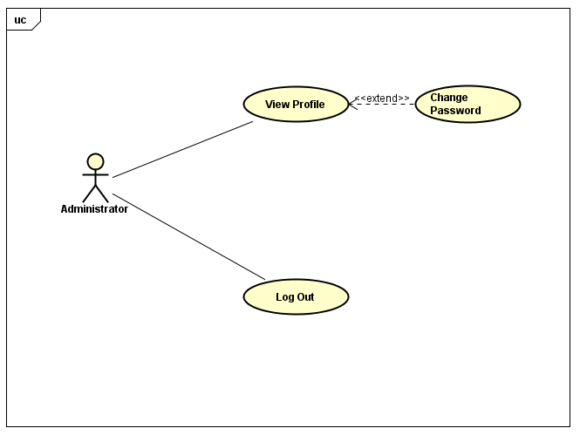

##### **3.1.4.1.1 UC-A-001: View Profile**

|  |  |  |  |  |
| --- | --- | --- | --- | --- |
| Use Case Name | View Profile | | | |
| Use Case ID | UC-A-001 | | | |
| Created By | QuanNH | Last Updated By | | ThangPD |
| Date Created | 27/06/2016 | Date Last Updated | | 19/07/2016 |
| Actor | Administrator | | | |
| Description | User views their profile | | | |
| Pre-condition | * Website is available * Logged in "Administrator" dashboard | | | |
| Trigger | * Login the website * Users clicks on username hyperlink at the left top of menu | | | |
| Post Condition | System redirects to Admin profile page | | | |
| Main Success Scenario | | | | |
| Step | **User** | | **System’s Response** | |
| 1 | Click on username hyperlink at the left top of menu | | Redirect View User Profile Page | |
| Alternative Scenario | | | | |
| At Step | **User** | | **System’s Response** | |
| Exception | | | | |
| At Step | **User** | | **System’s Response** | |

##### **3.1.4.1.2 UC-A-002: Change Password**

|  |  |  |  |  |
| --- | --- | --- | --- | --- |
| Use Case Name | Change Password | | | |
| Use Case ID | UC-A-002 | | | |
| Created By | QuanNH | Last Updated By | | ThangPD |
| Date Created | 27/06/2016 | Date Last Updated | | 19/07/2016 |
| Actor | Administrator | | | |
| Description | User change their password | | | |
| Pre-condition | * Website is available * Logged in "Administrator" dashboard * Sone UC-A-001 successfully | | | |
| Trigger | User clicks “Change password” button in “Edit Profile” page | | | |
| Post Condition | * Password is changed successfully. * If exceptions are thrown, the result must match with output of each described exception. | | | |
| Main Success Scenario | | | | |
| Step | **User** | | **System’s Response** | |
| 1 | Click on “Change password” button. | | Show a popup with requiring input information | |
| 2 | Input information | |  | |
| 3 | Click on “Save” button. | |  | |
| Alternative Scenario | | | | |
| At Step | **User** | | **System’s Response** | |
| Exception | | | | |
| At Step | **User** | | **System’s Response** | |

##### **UC-A-003: Logout**

|  |  |  |  |  |
| --- | --- | --- | --- | --- |
| Use Case Name | Logout | | | |
| Use Case ID | UC-A-003 | | | |
| Created By | QuanNH | Last Updated By | | ThangPD |
| Date Created | 27/06/2016 | Date Last Updated | | 19/07/2016 |
| Actor | Administrator | | | |
| Description | User logs out of the front-end system | | | |
| Pre-condition | * Website is available * Administrator login the website | | | |
| Trigger | User clicks on “Logout” hyperlink at dashboard in content manager profile page | | | |
| Post Condition | Redirect to “Home” page and user signed out successfully | | | |
| Main Success Scenario | | | | |
| Step | **User** | | **System’s Response** | |
| 1 | Click on “Logout” hyperlink at dashboard | |  | |
| Alternative Scenario | | | | |
| At Step | **User** | | **System’s Response** | |
| Exception | | | | |
| At Step | **User** | | **System’s Response** | |

#### Manage User

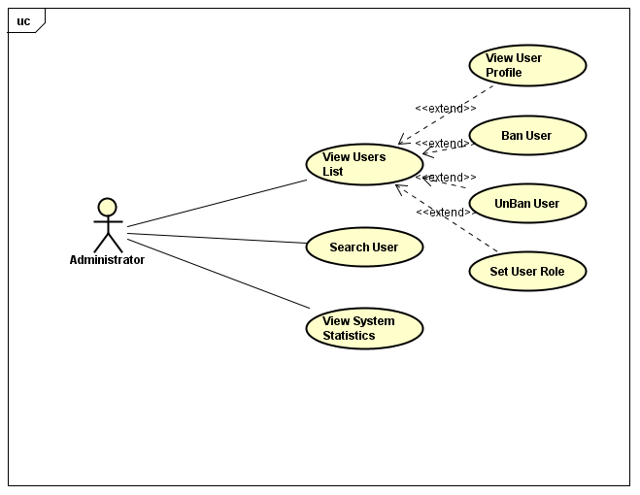

##### **3.1.4.2.1 UC-A-004: View User's List**

|  |  |  |  |  |
| --- | --- | --- | --- | --- |
| Use Case Name | View user list | | | |
| Use Case ID | UC-A-004 | | | |
| Created By | QuanNH | Last Updated By | | QuanNH |
| Date Created | 27/06/2016 | Date Last Updated | | 12/07/2016 |
| Actor | Administrator | | | |
| Description | User views list members | | | |
| Pre-condition | * Website is available * Logged in "Administrator" dashboard | | | |
| Trigger |  | | | |
| Post Condition |  | | | |
| Main Success Scenario | | | | |
| Step | **User** | | **System’s Response** | |
| 1 | In “Admin dashboard page”, click on “Member” button in right menu | | Show “List Member” page | |
| Alternative Scenario | | | | |
| At Step | **User** | | **System’s Response** | |
| Exception | | | | |
| At Step | **User** | | **System’s Response** | |

##### **3.1.4.2.2 UC-A-005: View User Profile**

|  |  |  |  |  |
| --- | --- | --- | --- | --- |
| Use Case Name | View User Profile | | | |
| Use Case ID | UC-A-005 | | | |
| Created By | QuanNH | Last Updated By | | QuanNH |
| Date Created | 27/06/2016 | Date Last Updated | | 12/07/2016 |
| Actor | Administrator | | | |
| Description | User views member's profile | | | |
| Pre-condition | * Website is available * Logged in "Administrator" dashboard * Done UC-A-004 successfully | | | |
| Trigger |  | | | |
| Post Condition | System redirects to user profile page | | | |
| Main Success Scenario | | | | |
| Step | **User** | | **System’s Response** | |
| 1 | 1. Click on “user “hyperlink in list users | | Show a ”User Details Profile” | |
| Alternative Scenario | | | | |
| At Step | **User** | | **System’s Response** | |
| Exception | | | | |
| At Step | **User** | | **System’s Response** | |

##### **UC-A-006: Set Role User**

|  |  |  |  |  |
| --- | --- | --- | --- | --- |
| Use Case Name | Set Role User | | | |
| Use Case ID | UC-A-006 | | | |
| Created By | QuanNH | Last Updated By | | QuanNH |
| Date Created | 27/06/2016 | Date Last Updated | | 12/07/2016 |
| Actor | Administrator | | | |
| Description | User sets role for member of system | | | |
| Pre-condition | * Website is available * Logged in "Administrator" dashboard * Done UC-A-005 successfully | | | |
| Trigger |  | | | |
| Post Condition |  | | | |
| Main Success Scenario | | | | |
| Step | **User** | | **System’s Response** | |
| Alternative Scenario | | | | |
| At Step | **User** | | **System’s Response** | |
| Exception | | | | |
| At Step | **User** | | **System’s Response** | |

##### **UC-A-007: Ban User**

|  |  |  |  |  |
| --- | --- | --- | --- | --- |
| Use Case Name | Ban user | | | |
| Use Case ID | UC-A-007 | | | |
| Created By | QuanNH | Last Updated By | | QuanNH |
| Date Created | 27/06/2016 | Date Last Updated | | 12/07/2016 |
| Actor | Administrator | | | |
| Description | User ban member | | | |
| Pre-condition | * Website is available * Logged in "Administrator" dashboard * Done UC-A-005 successfully | | | |
| Trigger |  | | | |
| Post Condition |  | | | |
| Main Success Scenario | | | | |
| Step | **User** | | **System’s Response** | |
| 1 | In “List users page”, click on member who want to ban | | Show a user profile | |
| 2 | Click on “Ban” button | | Show “Ban user successful” popup | |
| Alternative Scenario | | | | |
| At Step | **User** | | **System’s Response** | |
| Exception | | | | |
| At Step | **User** | | **System’s Response** | |

##### **UC-A-008: Unban User**

|  |  |  |  |  |
| --- | --- | --- | --- | --- |
| Use Case Name | Unban user | | | |
| Use Case ID | UC-A-008 | | | |
| Created By | QuanNH | Last Updated By | | QuanNH |
| Date Created | 27/06/2016 | Date Last Updated | | 12/07/2016 |
| Actor | Administrator | | | |
| Description | User unban members | | | |
| Pre-condition | * Website is available * Logged in "Administrator" dashboard * Done UC-A-005 successfully | | | |
| Trigger |  | | | |
| Post Condition |  | | | |
| Main Success Scenario | | | | |
| Step | **User** | | **System’s Response** | |
| 1 | In “List users page”, click on member who want to unban | | Show a user profile | |
| 2 | Click on “Unban” button | | Show “Unban user successful” popup | |
| Alternative Scenario | | | | |
| At Step | **User** | | **System’s Response** | |
| Exception | | | | |
| At Step | **User** | | **System’s Response** | |

##### **UC-A-009: View System Statistics**

|  |  |  |  |  |
| --- | --- | --- | --- | --- |
| Use Case Name | View System Statistics | | | |
| Use Case ID | UC-A-009 | | | |
| Created By | QuanNH | Last Updated By | | QuanNH |
| Date Created | 27/06/2016 | Date Last Updated | | 12/07/2016 |
| Actor | Administrator | | | |
| Description | User views statistics of system | | | |
| Pre-condition | * Website is available * Logged in "Administrator" dashboard | | | |
| Trigger |  | | | |
| Post Condition |  | | | |
| Main Success Scenario | | | | |
| Step | **User** | | **System’s Response** | |
| Alternative Scenario | | | | |
| At Step | **User** | | **System’s Response** | |
| Exception | | | | |
| At Step | **User** | | **System’s Response** | |

## Usability

* Interface should be simple, clear, user friendly, easy to learn how to use and easy to remember how to use.
* Interface design should support the following from the perspectives of its primary users:
  + Efficiency of use: goals are easy to accomplish quickly and with few or no user errors.
  + Intuitiveness: the interface is easy to learn and navigate: buttons, headings, and help/error messages are simple to understand.
  + Low perceived workload: the interface appears easy to use, rather than intimidating, demanding and frustrating.
* Users need to understand the function of each section to be able to use reasonable discretion and its effectiveness.
* Users should be supported and guided how to use the functionality of the system to use system easily after short time.
  + In the role “Administrator” – after 2 hours of training
  + In the role “Content Manager” – after 1 hour of training
  + In the role “Content Editor” – after 1 hour of training
  + In the role “Member” – after 30 minutes of training
  + In the role “Guest” – after 15 minutes of training
* The system should have the flexibility to be can satisfied future changed as:
  + Can add more lessons, tests and new words.
  + Changes in processing of information.
* The system must meet the requirements for data memory, need to calculate the amount of memory to be able to meet the requirements of the development of the system.

## Reliability

### Availability

* The System shall be available for use at 24 hours a day and 7 days a week.
* The Data Storage shall be available for use 24 hours a day and 7 days a week.
* The Maintenance Time must be announced before 3 days.
* The Mean Time Between Failures (MTBF) must be at least 500 hours.

### The Time Required To Troubleshoot

* The time returned to service must not exceed 1 hours.

### Error Rate Allowed

The system shall have sufficient quality.

For the first release of VEAZY:

* There are no more than 2 bugs per function.
* There are no more than 5 high severity errors per week.

For subsequent releases:

* There is no more than 1 bugs per function.
* There are no more than 5 high severity errors per month.

### Data Backup

* The system must have automatic backup and recovery features containing all the changed data at the time the backup is taken.

## Performance

### Response Time

* Response time when accessing an action on the system depending on system condition such as number of visitors, access tasks.
* When the number of visitors crowded, response time will be longer.
* Time for searching will be at most 10 seconds, time for loading image, media will be at most 5 seconds and time to progress any function will not exceed 7 seconds.

### Throughput

* The throughput of the system will depend on the number of users logged into the system at the same time and complexity of the tasks which required users.

### Capacity

* At the same time there may be many user with access to the system.

### Resource Utilization

* Can change to avoid wasting system resources.

## Supportability

Web system is written in Java and Bootstrap, easily manage and upgrade and easily connect to database system.

## Design Constraints

* Because the system is built on the Web Platform, therefore development language easily manage and upgrade.
* The system must execute independently, less influenced by other systems and capable of performing well on many different operating systems.

## On-line User Documentation and Help System Requirements

* The system shall provide the on-line user documentation with intuitive interface notes and explains.
* The on-line user documentation provides context-dependent help for all user interface functionality.
* The user must be able to perform search on-line user documentation.
* Providing online support tools.

## Purchased Components

## Interfaces

### User Interfaces

* Language’s System is Japanese.
* Manipulation of functions is simple.

### Hardware Interfaces

Any hardware interface is also supported by the software. Compatible software for hardware will be running the system.

### Software Interfaces

### Communications Interfaces

* Compatible and good communication with other systems and devices, not conflict when running.
* Using internet connection to connect to the main database server.

## Licensing Requirements

Out of scope

## Legal, Copyright, and Other Notices

Out of scope

## Applicable Standards

# SUPPORTING INFORMATION

* 1. Appendices:
     1. Appendix 1: 830-1998 - IEEE Recommended Practice for Software Requirements Specifications

“The content and qualities of a good software requirements specification (SRS) are described, and several sample SRS outlines are presented. This recommended practice is aimed at specifying the requirements of software to be developed, but can also be applied to assist in the selection of in-house and commercial software products. Guidelines for compliance with IEEE/EIA Std 12207.1-1997 are also provided.”

https://standards.ieee.org/findstds/standard/830-1998.html