

**Vietnamese Study System for Japanese**

**Software Requirement Specification**

**Project Code: Veazy**

**Document Code: Veazy_SRS_en_v2.0**

**Hoa Lac, 2016/06/20**

**RECORD OF CHANGE**

*A - Added M - Modified D - Deleted

|  |  |  |  |  |
| --- | --- | --- | --- | --- |
| **Effective Date** | **Changed Items** | **A* M, D** | **Change Description** | **New Version** |
| 2016/06/20 | SRS | A* | Create SRS | 1.0 |
| 2016/06/26 | SRS | M | Modify SRS | 1.1 |
| 2016/07/12 | SRS | M | Modify SRS | 1.2 |
| 2016/07/25 | SRS | M | Modify SRS | 1.3 |
| 2016/07/29 | SRS | M | Modify SRS | 1.4 |
| 2016/08/02 | SRS | M | Modify SRS | 1.5 |
| 2016/08/05 | SRS | M | Modify SRS | 1.6 |
| 2016/08/12 | SRS | M | Modify SRS | 1.7 |
| 2016/08/14 | SRS | M | Modify SRS | 1.8 |
| 2016/08/15 | SRS | M | Modify SRS | 1.9 |
| 2016/08/18 | SRS | M | Modify SRS | 2.0 |
|  |  |  |  |  |
|  |  |  |  |  |
|  |  |  |  |  |
|  |  |  |  |  |
|  |  |  |  |  |
|  |  |  |  |  |
|  |  |  |  |  |
|  |  |  |  |  |
|  |  |  |  |  |
|  |  |  |  |  |

**SIGNATURE PAGE**

**ORIGINATOR:** Pham Duc Thang 2016/06/20

Developer

**REVIEWERS:** Nguyen Trong Duy 2016/07/12

Developer

**APPROVAL:** Nguyen Van Sang <Date>

Supervisor

Table of Contents

1 INTRODUCTION 5

1.1 Purpose 5

1.2 Scope 5

1.3 Definitions, Acronyms, and Abbreviations 6

1.4 References 6

1.5 Overview 7

2 OVERALL DESCRIPTION 7

2.1 Product perspective: 7

2.2 Product functions: 8

2.3 User characteristics: 11

2.4 Constraints: 11

2.5 Assumptions & Dependencies: 12

2.6 Requirements subset: 13

3 SPECIFIC REQUIREMENTS 13

3.1 Functionality 13

3.1.1. Guest 13

3.1.2. Member 25

3.1.3. Content Editor 38

3.1.4 Administrator 67

3.2 Usability 75

3.3 Reliability 76

3.3.1 Availability 76

3.3.2 The Time Required To Troubleshoot 76

3.3.3 Error Rate Allowed 76

3.3.4 Data Backup 77

3.4 Performance 77

3.4.1 Response Time 77

3.4.2 Throughput 77

3.4.3 Capacity 77

3.4.4 Resource Utilization 77

3.5 Supportability 77

3.6 Design Constraints 77

3.7 On-line User Documentation and Help System Requirements 78

3.8 Purchased Components 78

3.9 Interfaces 78

3.9.1 User Interfaces 78

3.9.2 Hardware Interfaces 78

3.9.3 Software Interfaces 78

3.9.4 Communications Interfaces 78

3.10 Licensing Requirements 78

3.11 Legal, Copyright, and Other Notices 78

3.12 Applicable Standards 79

4 SUPPORTING INFORMATION 79

4.1 Appendices: 79

4..1.1 Appendix 1: 79

# INTRODUCTION

## Purpose

The purpose of this document is to present a detailed description of the Veazy. It explains the interface and the features of the system, what the system does the constraints under which it must operate and how the system reacts to external stimuli.

## Scope

The Veazy is a website which supports Japanese people study Vietnamese.

There are four basic users Guest, Member, Content Editor and Admin.

* Guest can use dictionary, study via lesson and do test.
* Member can access basic functions of guests and manage profile, redo recently taken tests and view statistics of abilities based on those taken tests.
* Editor can manage website content which includes lessons, test question. Editor can only update contents of lesson/question
* Administrator can manage user’s i.e checking user detailed information, assign authority and ban/unban.

## Definitions, Acronyms, and Abbreviations

|  |  |
| --- | --- |
| **Term** | **Definition** |
| VEAZY | Vietnamese Study System For Japanese |
| UC | Use case |
| A | Administrator |
| CE | Content Editor |
| M | Member |
| G | Guest |
| MTBF | Mean Time Between Failures |
|  |  |

## References

1. IEEE Software Engineering Standards Committee, “IEEE Std 830-1998, IEEE Recommended Practice for Software Requirements Specifications”, October 20, 1998. (*see Appendix 1*)
2. FPT Software, “Template Software Requirements Specifications”.

## Overview

The remaining of this document includes 3 chapters.

The first chapter represents the overview of the product i.e. the perspective of the product, which the main features of the product are, what the user characteristics, also the constraints, assumptions and dependencies of the product.

The second chapter produces the specific functional and nonfunctional requirements of system which must be satisfied when designers design and testers test the system.

The last chapter shows the additional information to support to make this document easier to understand.

# OVERALL DESCRIPTION

## 2.1 Product perspective:

The product is a web-based system implementing client-server model. The Veazy system is supposed to serve as an e-learning system for all Japanese people who have demand for studying Vietnamese themselves.

In order to build a Vietnamese learning system with various features, increased efficiency in learning, assessment ability through the tests.

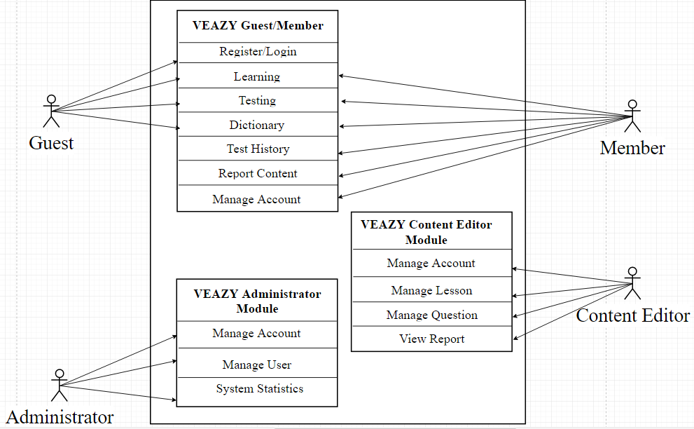

## 2.2 Product functions:

The following are the main features that are included in the system:

* User account: Allows users register new accounts in order to log into the system and provide features of updating and viewing profiles.
* E-learning system: Provides a well-organized lessons system divided based on level of difficulty.
* Taking test: Allow users to take after setting up as well as viewing the test result.
* Dictionary: Provides Vietnamese-Japanese dictionary which is convenient for user to look up while studying.

**Main functions of Guest:**

* **Register new Account**

User registers new account to log into the system.

* **Login**

User login to the system.

* **View Lesson List**

User views list lessons of courses.

* **View Lesson Detail**

User views the content of the selected lesson.

* **Search Lesson**

User searches lesson.

* **Take Test**

User takes a multiple-choice test.

* **View Test Result**

User views result of their test.

* **Search Dictionary**

User searches word in dictionary.

**Main functions of Member:**

* **View Profile**

User views their own profile.

* **Edit Profile**

User edits their own profile.

* **Change Password**

User changes their password.

* **View Test Statistic**

User views summary about their test and their score.

* **Logout System**

User logs out of system.

* **Report Lesson**

User sends their report to Content Editor about wrong content of lesson.

* **Report Question**

User sends their report to Content Editor about wrong content of question.

* **View List Test History**

User views list test history.

* **View Test History**

User views test history detail.

* **ReTake Test**

User retake test.

**Main functions of Content Editor:**

* **View Profile**

User views their own profile.

* **Edit Profile**

User edits their own profile

* **Change Password**

User changes their password

* **Logout System**

User logs out of the system.

* **View Lesson List**

User views list lesson.

* **View Lesson Detail**

User views lesson detail.

* **Search Lesson**

User searches lesson.

* **Create Lesson**

User creates new lesson.

* **Edit Lesson**

User edits lesson.

* **Delete Lesson**

User deletes lesson.

* **View Question List**

User views list question.

* **View Question Detail**

User views question detail.

* **Search Question**

User searches question.

* **Create Question**

User creates new question.

* **Edit Question**

User edits question.

* **Delete Question**

User deletes question.

* **View Report**

User views report about wrong content.

**Main functions of Administrator:**

* **View Profile**

User views their own profile.

* **Change Password**

User changes their password.

* **Logout System**

User logs out of the system.

* **View User List**

User views list member of system.

* **View User Profile**

User views member’s profile.

* **Set Role User**

User sets role for member’s system.

* **Ban User**

User bans member out of system.

* **Unban User**

User unbans member.

* **View System Statistic**

User views statistic of system.

## 2.3 User characteristics:

There are 3 types of users involving in the system:

* Normal users (Guest, Member): Requires basic knowledge of internet & computer.
* Content Editor: Required basic knowledge of internet & computer as normal user. In addition to that, they need to have upper-level of Vietnamese language and ability write academic articles as well as managing them.
* Administrators: Required to have high-level technical, management skills and the ability to promote the website.

## 2.4 Constraints:

A constraint, in project management, is any restriction that defines a project’s limitation. These following are project constraints defined by team members and classified into categories:

* **Time**: The length of project is 4 months (from May to August, 2016). Project must be delivered and ready for demo before the due date of August 25th.
* **Resources**:
* Team scales is limited to 6 people who are all junior software developer.
* Team members spend at least 6 hours per day for the project.
* **Quality**:
* The website should operate well on popular web browsers such as Internet Explorer (version 9.0 above), Firefox (version 40.0 above) andGoogle Chrome (version 45.0 above).
* The website should provide full features listed at part 4.4.

## 2.5 Assumptions & Dependencies:

The system depends on which type and version of browser being installed on the client machine i.e. the browser should support both HTML5 and CSS3. The internet connection speed and bandwidth is also a dependency of the system.

One assumption that user has a strong enough internet connect which can adapt to system load. If the speed and bandwidth is slow, there is one scenario that browser cannot fully load the webpage, which may affect web layout displaying. Another scenario is that when user plays media such as listening or watching conversation, the media quality may be affected badly by a weak internet connection, which results a bad user experience.

Another assumption is that user is using a fully technical supported browser. If the browser does not support full technique, website cannot adapt full functionalities

## 2.6 Requirements subset:

# SPECIFIC REQUIREMENTS

## Functionality

### Guest

#### Manage Account

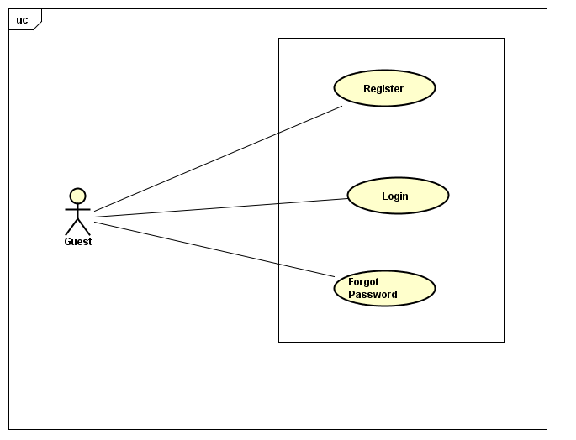

##### **UC-G-001: Login**

|  |  |  |  |  |
| --- | --- | --- | --- | --- |
| Use Case Name | Log In | | | |
| Use Case ID | UC-G-001 | | | |
| Created By | QuanNH | Last Updated By | | ThangPD |
| Date Created | 27/06/2016 | Date Last Updated | | 19/07/2016 |
| Actor | Guest | | | |
| Description | User to login to the front-end system | | | |
| Pre-condition | * Website is available * User has registered account * “Login” link active at the right top of menu | | | |
| Trigger | * User inputs text to the username text field and password text field in “Login” page * User clicks on “Login” button in “Login” page | | | |
| Post Condition | * Login successfully and redirect to home page * If exceptions are thrown, the result must match with output of each described exception. | | | |
| Main Success Scenario | | | | |
| Step | **User** | | **System’s Response** | |
| 1 | Click on “Login” hyperlink at the right top of menu | | Show “Login” page | |
| 2 | Enter username and password | |  | |
| 3 | Click on “Login” button | | Redirect to “Home” page | |
| Alternative Scenario | | | | |
| At Step | **User** | | **System’s Response** | |
| Exception | | | | |
| At Step | **User** | | **System’s Response** | |
| 2 | If Username textbox is null | | Show the notice “Username required!” | |
| 2 | If Password Textbox is null | | Show the notice “Password required!” | |
| 2 | If user enter the wrong Password or Username | | Show the notice "Incorrect username or password!" in the bottom of "Password" textbox. | |

##### **UC-G-002: Register**

|  |  |  |  |  |
| --- | --- | --- | --- | --- |
| Use Case Name | Register | | | |
| Use Case ID | UC-G-002 | | | |
| Created By | QuanNH | Last Updated By | | ThangPD |
| Date Created | 27/06/2016 | Date Last Updated | | 29/07/2016 |
| Actor | Guest | | | |
| Description | User registers new account to log into the system | | | |
| Pre-condition | * Website is available | | | |
| Trigger | * User clicks on “Sign up” button at the bottom “Welcome to Veazy!” in “Home” page | | | |
| Post Condition | * Register successfully and redirect to “Home” page * If exceptions are thrown, the result must match with output of each described exception. | | | |
| Main Success Scenario | | | | |
| Step | **User** | | **System’s Response** | |
| 1 | Click on “Sign up” button at the bottom “Welcome to Veazy !” in “Home” page | | Show “Register” page | |
| 2 | Enter necessary and mandatory information | |  | |
| 3 | Click on “Register” button | | Redirect to “Home” page | |
| Alternative Scenario | | | | |
| At Step | **User** | | **System’s Response** | |
|  |  | |  | |
| Exception | | | | |
| At Step | **User** | | **System’s Response** | |
| 2 | If Username textbox is null | | Show the notice “Username required!” | |
| 2 | If Email textbox is null | | Show the notice “Email required!” | |
| 2 | If Password textbox is null | | Show the notice “Password required!” | |
| 2 | If Confirm Password textbox is null | | Show the notice “Password does not matched!” | |
| 2 | If user enter Username that less than 6 characters | | Show the notice “Username must be at least 6 characters long!” | |
| 2 | If user enter Username that more than 30 characters | | Show the notice “Username must be no more than 30 characters long!” | |
| 2 | If user enter the wrong Email | | Show the notice “Invalid email!” | |
| 2 | If user enter Password that less than 6 characters | | Show the notice “Password must be at least 6 characters long!” | |
| 2 | If user enter Password that more than 32 characters | | Show the notice “Password must be no more than 32 characters long!” | |
| 2 | If Confirm Password is not the same Password | | Show the notice “Password does not matched!” | |

##### **UC-G-003: Forgot Password**

|  |  |  |  |  |
| --- | --- | --- | --- | --- |
| Use Case Name | Forgot Password | | | |
| Use Case ID | UC-G-003 | | | |
| Created By | QuanNH | Last Updated By | | ThangPD |
| Date Created | 27/06/2016 | Date Last Updated | | 27/07/2016 |
| Actor | Guest | | | |
| Description | User resets their password | | | |
| Pre-condition | * Website is available * “Forgot your password?” link active in “Login“ page | | | |
| Trigger | * User clicks on “Forgot your password?” in “Login” page | | | |
| Post Condition | * System shows “Reset Password” popup * If exceptions are thrown, the result must match with output of each described exception. | | | |
| Main Success Scenario | | | | |
| Step | **User** | | **System’s Response** | |
| 1 | Clicks on “Forgot your password?” in “Login” page | | Show “Reset Password” popup | |
| 2 | Input Email in “Reset Password” popup | |  | |
| 3 | Click “...” Button in “Reset Password” popup | |  | |
| Alternative Scenario | | | | |
| At Step | **User** | | **System’s Response** | |
|  |  | |  | |
| Exception | | | | |
| At Step | **User** | | **System’s Response** | |
| 2 | If Email textbox is null | |  | |
| 2 | If user enter the wrong Email | |  | |

#### Learning

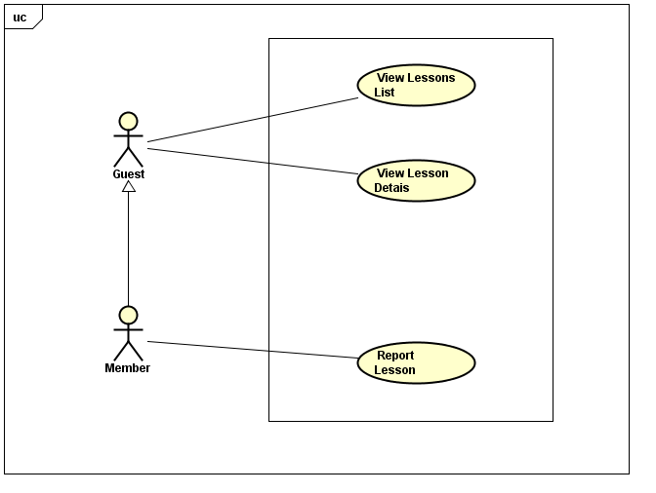

##### **UC-G-004: View Lessons List**

|  |  |  |  |  |
| --- | --- | --- | --- | --- |
| Use Case Name | View Lessons List | | | |
| Use Case ID | UC-G-004 | | | |
| Created By | QuanNH | Last Updated B**y** | | ThangPD |
| Date Created | 27/06/2016 | Date Last Updated | | 12/08/2016 |
| Actor | Guest, Member | | | |
| Description | User views list lessons of courses | | | |
| Pre-condition | * Website is available * “Courses” link active in top menu * Level hyperlink in dropdown list active | | | |
| Trigger | User clicks on “Course” link in top menu then click on level hyperlink in dropdown list | | | |
| Post Condition | View Lesson List successfully and system redirects to “Course” page | | | |
| Main Success Scenario | | | | |
| Step | **User** | | **System’s Response** | |
| 1 | Click on “Course” link in top menu | | Show level dropdown list | |
| 2 | Click on level hyperlink in dropdown list | | Redirect to “Courses” page | |
| Alternative Scenario | | | | |
| At Step | **User** | | **System’s Response** | |
| Exception | | | | |
| At Step | **User** | | **System’s Response** | |

##### **UC-G-005: View Lesson Details**

|  |  |  |  |  |
| --- | --- | --- | --- | --- |
| Use Case Name | View Lesson Details | | | |
| Use Case ID | UC-G-005 | | | |
| Created By | QuanNH | Last Updated By | | ThangPD |
| Date Created | 27/06/2016 | Date Last Updated | | 19/07/2016 |
| Actor | Guest, Member | | | |
| Description | User views the content of the selected lesson | | | |
| Pre-condition | Website is available | | | |
| Trigger | User clicks on “Study” button in courses page | | | |
| Post Condition | View Lesson Details successfully and system redirects to “Lessons” page | | | |
| Main Success Scenario | | | | |
| Step | **User** | | **System’s Response** | |
| 1 | Click on “Study” button in courses page | | Redirect to “Lessons” page | |
| Alternative Scenario | | | | |
| At Step | **User** | | **System’s Response** | |
| Exception | | | | |
| At Step | **User** | | **System’s Response** | |

#### Testing

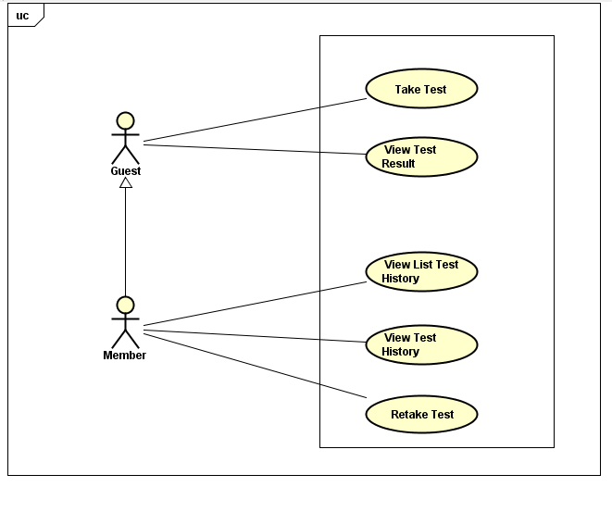

##### **UC-G-006: Take Test**

|  |  |  |  |  |
| --- | --- | --- | --- | --- |
| Use Case Name | Take Test | | | |
| Use Case ID | UC-G-006 | | | |
| Created By | QuanNH | Last Updated By | | ThangPD |
| Date Created | 04/07/2016 | Date Last Updated | | 14/08/2016 |
| Actor | Guest, Member | | | |
| Description | User takes a multiple-choice test | | | |
| Pre-condition | Website is available | | | |
| Trigger | User clicks on “Test” link in top menu | | | |
| Post Condition | Take test successfully and system redirects to “Test” page | | | |
| Main Success Scenario | | | | |
| Step | **User** | | **System’s Response** | |
| 1 | Click on “Test” link in top menu | | Redirect to “Test” page | |
| 2 | Click on “Level” dropdown list to select difficulty level | |  | |
| 3 | Click on “Test skill” dropdown list to select the skill that user wants to test | |  | |
| 4 | Input the number of questions | |  | |
| 5 | Click on “Create” button | | System displays the test in accordance with user’s test input | |
| Alternative Scenario | | | | |
| At Step | **User** | | **System’s Response** | |
| Exception | | | | |
| At Step | **User** | | **System’s Response** | |
| 4 | If “Number of Questions” is null | | Show the notice “…” | |
| 4 | If user enter “Number of Questions” that less than 10 | | Show the notice “Required at least 10!” | |

##### **UC-G-007: View Test Result**

|  |  |  |  |  |
| --- | --- | --- | --- | --- |
| Use Case Name | View Exam Result | | | |
| Use Case ID | UC-G-007 | | | |
| Created By | QuanNH | Last Updated By | | ThangPD |
| Date Created | 04/07/2016 | Date Last Updated | | 19/07/2016 |
| Actor | Guest, Member | | | |
| Description | User views result of their test | | | |
| Pre-condition | * Website is available * Done UC-G-006 successfully | | | |
| Trigger | User clicks on “Submit” button at bottom of “Test” page | | | |
| Post Condition | System redirects to “Test Result” page | | | |
| Main Success Scenario | | | | |
| Step | **User** | | **System’s Response** | |
| 1 | Click on “Submit” button at bottom of “Test “page | | Redirect to “Test Result” page | |
| Alternative Scenario | | | | |
| At Step | **User** | | **System’s Response** | |
| Exception | | | | |
| At Step | **User** | | **System’s Response** | |

#### Search Dictionary

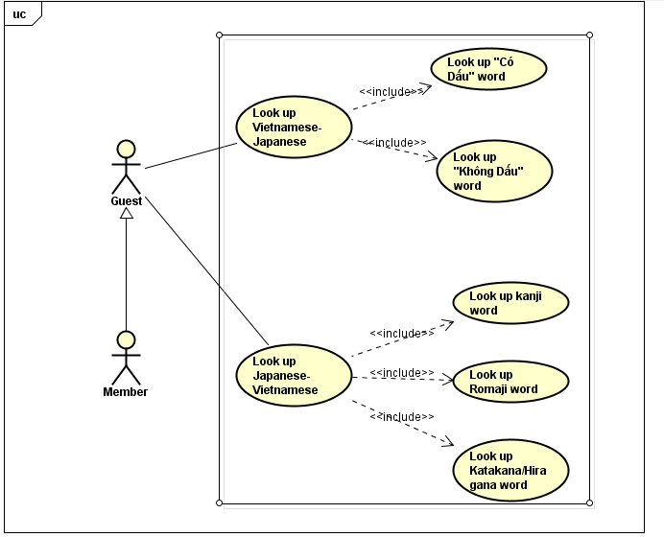

#### 3.1.1.5. Manage Language

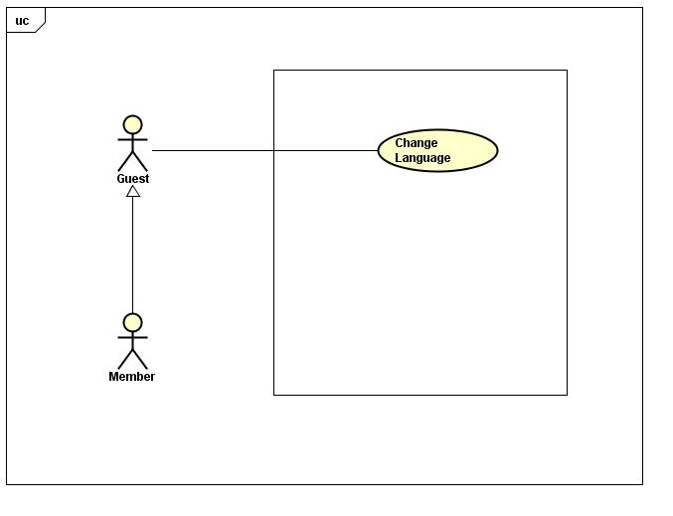

##### **3.1.1.5.1 UC-G-008: Change Language**

|  |  |  |  |  |
| --- | --- | --- | --- | --- |
| Use Case Name | Change Language | | | |
| Use Case ID | UC-G-008 | | | |
| Created By | ThangPD | Last Updated By | | ThangPD |
| Date Created | 27/07/2016 | Date Last Updated | | 05/08/2016 |
| Actor | Member | | | |
| Description | User changes language of website | | | |
| Pre-condition | Website is available | | | |
| Trigger | User clicks on “Veazy” logo at the top of menu in homepage | | | |
| Post Condition | System changed language of website | | | |
| Main Success Scenario | | | | |
| Step | **User** | | **System’s Response** | |
| 1 | Click on “Veazy” logo at the top of menu in homepage | | System changed language of website | |
| Alternative Scenario | | | | |
| At Step | **User** | | **System’s Response** | |
| Exception | | | | |
| At Step | **User** | | **System’s Response** | |

### Member

#### Manage Account

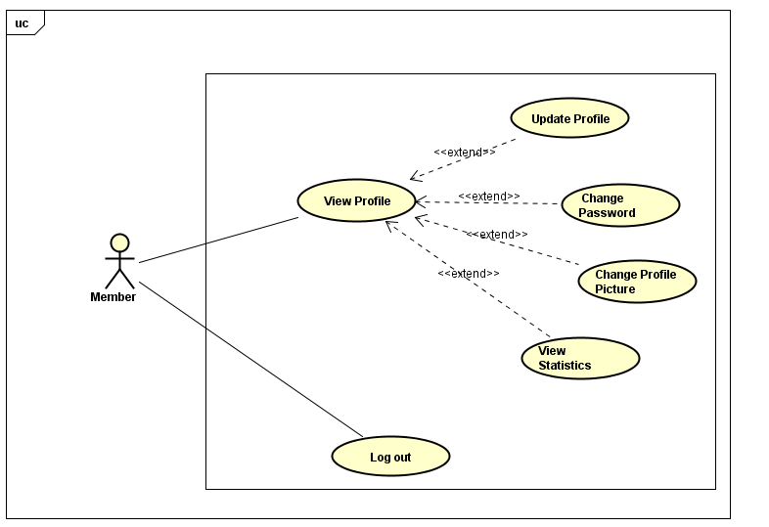

##### **UC-M-001: View Profile**

|  |  |  |  |  |
| --- | --- | --- | --- | --- |
| Use Case Name | View Profile | | | |
| Use Case ID | UC-M-001 | | | |
| Created By | QuanNH | Last Updated By | | ThangPD |
| Date Created | 27/06/2016 | Date Last Updated | | 29/07/2016 |
| Actor | Member | | | |
| Description | User views their profile | | | |
| Pre-condition | * Website is available * Member logged in the website | | | |
| Trigger | User clicks on username hyperlink at the right top of menu then click on “Show Profile” hyperlink in dropdown list | | | |
| Post Condition | System redirects to user profile page | | | |
| Main Success Scenario | | | | |
| Step | **User** | | **System’s Response** | |
| 1 | Click on username hyperlink at the right top of menu | | Show “Show Profile” link and “Logout” link in dropdown list | |
| 2 | Click on “Show Profile” hyperlink in dropdown list | | Redirect to “Profile” Page | |
| Alternative Scenario | | | | |
| At Step | **User** | | **System’s Response** | |
| Exception | | | | |
| At Step | **User** | | **System’s Response** | |

##### **UC-M-002: Update Profile**

|  |  |  |  |  |
| --- | --- | --- | --- | --- |
| Use Case Name | Update Profile | | | |
| Use Case ID | UC-M-002 | | | |
| Created By | QuanNH | Last Updated By | | ThangPD |
| Date Created | 04/07/2016 | Date Last Updated | | 29/07/2016 |
| Actor | Member | | | |
| Description | User edits their own profile | | | |
| Pre-condition | * Website is available * Member logged in the website * Done UC-M-001 successfully | | | |
| Trigger | * User clicks on “Update Profile” in “Actions” dropdown list * User inputs changed information * User clicks on “Save” button in the end of “Update Profile Information” popup | | | |
| Post Condition | * System stays on initial screen and show update successfully * If exceptions are thrown, the result must match with output of each described exception. | | | |
| Main Success Scenario | | | | |
| Step | **User** | | **System’s Response** | |
| 1 | Click on “Update Profile” in “Actions” dropdown list | | Show “Update Profile Information” popup | |
| 2 | Update information | |  | |
| 3 | Click on “Save” button. | | Updated information of user and stay on initial screen and closed popup | |
| Alternative Scenario | | | | |
| At step | **User** | | **System’s Response** | |
| 3 | Click on “Cancel” button | | Cancel editing profile action and close “Update Profile Information” popup | |
| Exception | | | | |
| At Step | **User** | | **System’s Response** | |

##### **UC-M-003: Change Password**

|  |  |  |  |  |
| --- | --- | --- | --- | --- |
| Use Case Name | Change Password | | | |
| Use Case ID | UC-M-003 | | | |
| Created By | QuanNH | Last Updated By | | ThangPD |
| Date Created | 27/06/2016 | Date Last Updated | | 29/07/2016 |
| Actor | Member | | | |
| Description | User changes their password | | | |
| Pre-condition | * Website is available * Member logged in the website * Done UC-M-001 successfully | | | |
| Trigger | * User clicks on “Change Password” in “Actions” dropdown list * User inputs current password, new password and re-type new password * User clicks “Change” button in the end of “Change Password” popup | | | |
| Post Condition | * System stays on initial screen and password is changed successfully. * If exceptions are thrown, the result must match with output of each described exception. | | | |
| Main Success Scenario | | | | |
| Step | **User** | | **System’s Response** | |
| 1 | Click on “Change Password” in “Actions” dropdown list. | | Show “Change password” popup | |
| 2 | Input information | |  | |
| 3 | Click on “Change” button. | | Changed Password and stay on initial screen and closed popup | |
| Alternative Scenario | | | | |
| At Step | **User** | | **System’s Response** | |
| 3 | Click on “Cancel” button | | Cancel changing password action and close “Change Password” popup | |
| Exception | | | | |
| At Step | **User** | | **System’s Response** | |
| 2 | If Current password textbox is null | |  | |
| 2 | If New password textbox is null | |  | |
| 2 | If Re-type New password textbox is null and confirmed password is not match | |  | |
| 2 | Current password is not valid | |  | |
| 2 | If user enter New password that less than 6 characters | |  | |
| 2 | If user enter New password that more than 32 characters | |  | |

##### **UC-M-004: Change Profile Picture**

|  |  |  |  |  |
| --- | --- | --- | --- | --- |
| Use Case Name | Change Profile Picture | | | |
| Use Case ID | UC-M-004 | | | |
| Created By | QuanNH | Last Updated By | | QuanNH |
| Date Created | 27/06/2016 | Date Last Updated | | 29/07/2016 |
| Actor | Member | | | |
| Description | User views their statistics | | | |
| Pre-condition | * Website is available * Member logged in the website * Done UC-M-001 successfully | | | |
| Trigger | User clicks on “Change Profile Picture” button in “Profile” page | | | |
| Post Condition | * System stays on initial screen and profile picture is changed successfully. | | | |
| Main Success Scenario | | | | |
| Step | **User** | | **System’s Response** | |
| 1 | Click on “Change Profile Picture” button in “Profile” page | |  | |
| 2 |  | |  | |
| Alternative Scenario | | | | |
| At Step | **User** | | **System’s Response** | |
|  |  | |  | |
| Exception | | | | |
| At Step | **User** | | **System’s Response** | |

##### **UC-M-005: View Statistics**

|  |  |  |  |  |
| --- | --- | --- | --- | --- |
| Use Case Name | View Statistic | | | |
| Use Case ID | UC-M-005 | | | |
| Created By | QuanNH | Last Updated By | | ThangPD |
| Date Created | 27/06/2016 | Date Last Updated | | 29/07/2016 |
| Actor | Member | | | |
| Description | User views their statistics | | | |
| Pre-condition | * Website is available * Member logged in the website * Done UC-M-001 successfully | | | |
| Trigger | User clicks on “Statistics” button in “Profile” page | | | |
| Post Condition | System shows statistics tab | | | |
| Main Success Scenario | | | | |
| Step | **User** | | **System’s Response** | |
| 1 | Click on “Statistics” button in “Profile” page | | System shows statistics tab | |
| Alternative Scenario | | | | |
| At Step | **User** | | **System’s Response** | |
| Exception | | | | |
| At Step | **User** | | **System’s Response** | |

##### **UC-M-006: Logout**

|  |  |  |  |  |
| --- | --- | --- | --- | --- |
| Use Case Name | Logout | | | |
| Use Case ID | UC-M-006 | | | |
| Created By | QuanNH | Last Updated By | | ThangPD |
| Date Created | 27/06/2016 | Date Last Updated | | 12/07/2016 |
| Actor | Member | | | |
| Description | User logs out of the front-end system | | | |
| Pre-condition | * Website is available * Member logged in the website | | | |
| Trigger | User clicks on username hyperlink at the right top of menu then click on “Logout” hyperlink in dropdown list | | | |
| Post Condition | Redirect to “Login” page and user signed out successfully | | | |
| Main Success Scenario | | | | |
| Step | **User** | | **System’s Response** | |
| 1 | Click on username hyperlink at the right top of menu | |  | |
| 2 | Click on “Logout” hyperlink in dropdown list | | System redirects to “Login” page | |
| Alternative Scenario | | | | |
| At Step | **User** | | **System’s Response** | |
| Exception | | | | |
| At Step | **User** | | **System’s Response** | |

#### Report Content

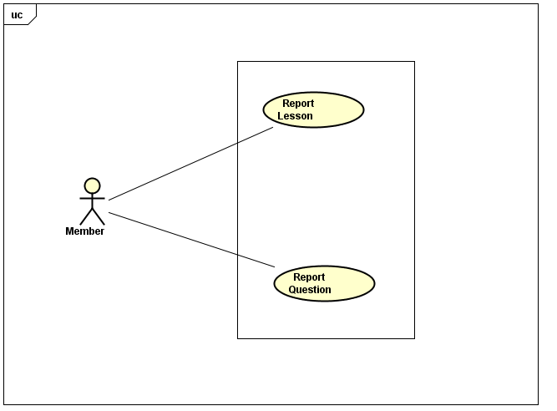

##### **UC-M-007: Report Lesson**

|  |  |  |  |  |
| --- | --- | --- | --- | --- |
| Use Case Name | Report Lesson | | | |
| Use Case ID | UC-M-007 | | | |
| Created By | QuanNH | Last Updated By | | ThangPD |
| Date Created | 04/07/2016 | Date Last Updated | | 14/08/2016 |
| Actor | Member | | | |
| Description | User sends their reports to Content Editor about wrong content of lesson | | | |
| Pre-condition | * Website is available * Member logged in the website * Done UC-G-005 successfully | | | |
| Trigger | User clicks on “Option” dropdown list then click on “Report” link in “Lessons” page | | | |
| Post Condition | System sends a message to Content Editor | | | |
| Main Success Scenario | | | | |
| Step | **User** | | **System’s Response** | |
| 1 | Click on “Report” dropdown list | | Show “Report Lesson” popup | |
| 2 | Input content message | |  | |
| 2 | Click on ”Report” button in “Report Lesson” popup | | Send a message to Content Editor about wrong content and show message “Your report has been submitted for review. We truly apologize for this experience.” | |
| Alternative Scenario | | | | |
| At Step | **User** | | **System’s Response** | |
| 1 | Click on “Cancel” button | | Cancel send a message to Content Editor successfully and close popup | |
| Exception Paths | | | | |
| At Step | **User** | | **System’s Response** | |

##### **UC-M-008: Report Question**

|  |  |  |  |  |
| --- | --- | --- | --- | --- |
| Use Case Name | Report Question | | | |
| Use Case ID | UC-M-008 | | | |
| Created By | QuanNH | Last Updated By | | ThangPD |
| Date Created | 04/07/2016 | Date Last Updated | | 29/07/2016 |
| Actor | Member | | | |
| Description | User sends their reports to Content Editor about wrong question | | | |
| Pre-condition | * Website is available * Member logged in the website * Done UC-G-007 successfully | | | |
| Trigger | User clicks on “Report” button at the right of each question in “Test Result” page | | | |
| Post Condition | System sends a message to Content Editor | | | |
| Main Success Scenario | | | | |
| Step | **User** | | **System’s Response** | |
| 1 | Click on “Report” button in the right of each question | | System shows “Report question” popup | |
| 2 | Input content message | |  | |
| 3 | Click on ”Report” button in “Report question” popup | | Send a message to Content Editor about wrong question | |
| Alternative Scenario | | | | |
| At Step | **User** | | **System’s Response** | |
| 3 | Click on ”Cancel” button in “Report question” popup | | Cancel send a message to Content Editor successfully and close popup | |
| Exception | | | | |
| At Step | **User** | | **System’s Response** | |

#### Testing



##### **UC-M-009: View List Test History**

|  |  |  |  |  |
| --- | --- | --- | --- | --- |
| Use Case Name | View List Test History | | | |
| Use Case ID | UC-M-009 | | | |
| Created By | QuanNH | Last Updated By | | ThangPD |
| Date Created | 27/06/2016 | Date Last Updated | | 20/07/2016 |
| Actor | Member | | | |
| Description | User views their list test history | | | |
| Pre-condition | * Website is available * Member logged in the website | | | |
| Trigger | User clicks on “Test” hyperlink in top menu | | | |
| Post Condition | Show list test history in “Test” page | | | |
| Main Success Scenario | | | | |
| Step | **User** | | **System’s Response** | |
| 1 | Click on “Test” hyperlink in top menu | | Show list test history in “Test” page | |
| Alternative Scenario | | | | |
| At Step | **User** | | **System’s Response** | |
| Exception | | | | |
| At Step | **User** | | **System’s Response** | |

##### **UC-M-010: Retake Test**

|  |  |  |  |  |
| --- | --- | --- | --- | --- |
| Use Case Name | Retake Test | | | |
| Use Case ID | UC-M-010 | | | |
| Created By | QuanNH | Last Updated By | | ThangPD |
| Date Created | 04/07/2016 | Date Last Updated | | 28/07/2016 |
| Actor | Member | | | |
| Description | User retake test | | | |
| Pre-condition | * Website is available * Member logged in the website * Done UC-M-009 successfully | | | |
| Trigger | User clicks on “Test history” hyperlink then click “Retake Test” button | | | |
| Post Condition | System redirects to “Test” page | | | |
| Main Success Scenario | | | | |
| Step | **User** | | **System’s Response** | |
| 1 | Click on “Test history” hyperlink | | Show “Test Result” page | |
| 2 | Click on “Retake Test” button | | Redirect to “Test” page | |
| Alternative Scenario | | | | |
| At Step | **User** | | **System’s Response** | |
| 2 | Click on “Cancel” button | |  | |
| Exception | | | | |
| At Step | **User** | | **System’s Response** | |

##### **UC-M-011: View Test History**

|  |  |  |  |  |
| --- | --- | --- | --- | --- |
| Use Case Name | View Test History | | | |
| Use Case ID | UC-M-011 | | | |
| Created By | QuanNH | Last Updated By | | ThangPD |
| Date Created | 04/07/2016 | Date Last Updated | | 29/07/2016 |
| Actor | Member | | | |
| Description | User views their test history details | | | |
| Pre-condition | * Website is available * Member logged in the website * Done UC-M-009 successfully | | | |
| Trigger | User clicks on test history link in “Test” page | | | |
| Post Condition | System redirects to “Test Result” page | | | |
| Main Success Scenario | | | | |
| Step | **User** | | **System’s Response** | |
| 1 | Click on test history link in “Test” page | | Show “Test Details” page | |
| Alternative Scenario | | | | |
| At Step | **User** | | **System’s Response** | |
| Exception | | | | |
| At Step | **User** | | **System’s Response** | |

### Content Editor

#### Manage Account

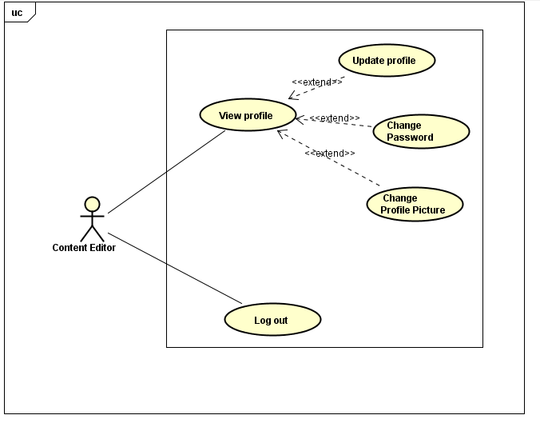

##### **UC-E-001: View Profile**

|  |  |  |  |  |
| --- | --- | --- | --- | --- |
| Use Case Name | View Profile | | | |
| Use Case ID | UC-E-001 | | | |
| Created By | QuanNH | Last Updated By | | ThangPD |
| Date Created | 27/06/2016 | Date Last Updated | | 29/07/2016 |
| Actor | Content Editor | | | |
| Description | User views their profile | | | |
| Pre-condition | * Website is available * Content editor logged in the website | | | |
| Trigger | User clicks on username hyperlink at the right top of menu then click on “Show Profile” hyperlink in dropdown list | | | |
| Post Condition | System redirects to user profile page | | | |
| Main Success Scenario | | | | |
| Step | **User** | | **System’s Response** | |
| 1 | Click on username hyperlink at the right top of menu | | Show “Show Profile” and “Logout” link in dropdown list | |
| 2 | Click on “Show Profile” hyperlink in dropdown list | | Redirect to “Profile” Page | |
| Alternative Scenario | | | | |
| At Step | **User** | | **System’s Response** | |
| Exception | | | | |
| At Step | **User** | | **System’s Response** | |

##### **UC-E-002: Update Profile**

|  |  |  |  |  |
| --- | --- | --- | --- | --- |
| Use Case Name | Update Profile | | | |
| Use Case ID | UC-E-002 | | | |
| Created By | QuanNH | Last Updated By | | ThangPD |
| Date Created | 04/07/2016 | Date Last Updated | | 29/07/2016 |
| Actor | Content Editor | | | |
| Description | User edits their own profile | | | |
| Pre-condition | * Website is available * Content editor logged in the website | | | |
| Trigger | * User clicks on “Update Profile” in “Actions” dropdown list * User inputs changed information * User clicks on “Save” button in the end of “Update Profile Information” popup | | | |
| Post Condition | * System stays on initial screen and show update successfully * If exceptions are thrown, the result must match with output of each described exception. | | | |
| Main Success Scenario | | | | |
| Step | **User** | | **System’s Response** | |
| 1 | Click on “Update Profile” in “Actions” dropdown list | | Show “Update Profile Information” popup | |
| 2 | Update information | |  | |
| 3 | Click on “Save” button. | | Updated information of user and stay on initial screen and closed popup | |
| Alternative Scenario | | | | |
| At Step | **User** | | **System’s Response** | |
| Exception | | | | |
| At Step | **User** | | **System’s Response** | |

##### **UC-E-003: Change Password**

|  |  |  |  |  |
| --- | --- | --- | --- | --- |
| Use Case Name | Change Password | | | |
| Use Case ID | UC-E-003 | | | |
| Created By | QuanNH | Last Updated By | | ThangPD |
| Date Created | 27/06/2016 | Date Last Updated | | 12/07/2016 |
| Actor | Content Editor | | | |
| Description | User changes their password | | | |
| Pre-condition | * Website is available * Content Editor logged in the website * Done UC-E-001 successfully | | | |
| Trigger | User clicks “Change password” button in “Edit Profile” page | | | |
| Post Condition | * User clicks on “Change Password” in “Actions” dropdown list * User inputs current password, new password and re-type new password * User clicks “Change” button in the end of “Change Password” popup | | | |
| Main Success Scenario | | | | |
| Step | **User** | | **System’s Response** | |
| 1 | Click on “Change Password” in “Actions” dropdown list.. | | Show a popup with requiring input information | |
| 2 | Input information | |  | |
| 3 | Click on “Save” button. | | Changed Password and stay on initial screen and closed popup | |
| Alternative Scenario | | | | |
| At Step | **User** | | **System’s Response** | |
| Exception | | | | |
| At Step | **User** | | **System’s Response** | |
|  |  | |  | |

##### **UC-E-004: Change Profile Picture**

|  |  |  |  |  |
| --- | --- | --- | --- | --- |
| Use Case Name | Change Profile Picture | | | |
| Use Case ID | UC-M-004 | | | |
| Created By | QuanNH | Last Updated By | | ThangPD |
| Date Created | 27/06/2016 | Date Last Updated | | 12/07/2016 |
| Actor | Content Editor | | | |
| Description | User views their statistics | | | |
| Pre-condition | * Website is available * Content editor logged in the website * Done UC-E-001 successfully | | | |
| Trigger | User clicks on “Change Profile Picture” button in “Profile” page | | | |
| Post Condition | * System stays on initial screen and profile picture is changed successfully. | | | |
| Main Success Scenario | | | | |
| Step | **User** | | **System’s Response** | |
| 1 |  | |  | |
| 2 |  | |  | |
| Alternative Scenario | | | | |
| At Step | **User** | | **System’s Response** | |
|  |  | |  | |
| Exception | | | | |
| At Step | **User** | | **System’s Response** | |

##### **UC-E-005: Logout**

|  |  |  |  |  |
| --- | --- | --- | --- | --- |
| Use Case Name | Logout | | | |
| Use Case ID | UC-E-005 | | | |
| Created By | QuanNH | Last Updated By | | ThangPD |
| Date Created | 27/06/2016 | Date Last Updated | | 19/07/2016 |
| Actor | Content Editor | | | |
| Description | User logout of the front-end system | | | |
| Pre-condition | * Website is available * Content editor logged in the website | | | |
| Trigger | User clicks on “Logout” link in sidebar | | | |
| Post Condition | Redirect to “Login” page and user signed out successfully | | | |
| Main Success Scenario | | | | |
| Step | **User** | | **System’s Response** | |
| 1 | Click on “Logout” link in sidebar | | System redirects to “Login” page | |
| Alternative Scenario | | | | |
| At Step | **User** | | **System’s Response** | |
| Exception | | | | |
| At Step | **User** | | **System’s Response** | |

#### Manage Language

##### **UC-E-006: Change Language**

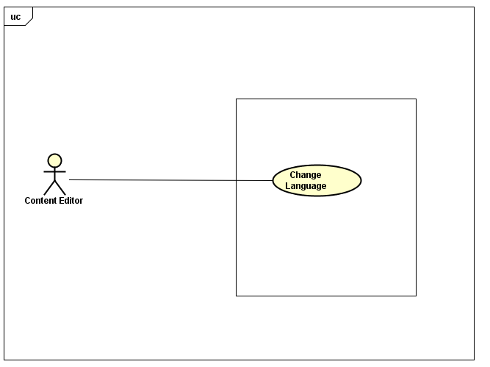

|  |  |  |  |  |
| --- | --- | --- | --- | --- |
| Use Case Name | Change Language | | | |
| Use Case ID | UC-E-006 | | | |
| Created By | ThangPD | Last Updated By | | ThangPD |
| Date Created | 27/07/2016 | Date Last Updated | | 05/08/2016 |
| Actor | Content Editor | | | |
| Description | User changes language of website | | | |
| Pre-condition | Website is available | | | |
| Trigger | User clicks on “Change Language” link at dashboard | | | |
| Post Condition | System changed language of website | | | |
| Main Success Scenario | | | | |
| Step | **User** | | **System’s Response** | |
| 1 | Click on “Change Language” link at dashboard | | System changed language of website | |
| Alternative Scenario | | | | |
| At Step | **User** | | **System’s Response** | |
| Exception | | | | |
| At Step | **User** | | **System’s Response** | |

#### Manage Lessons

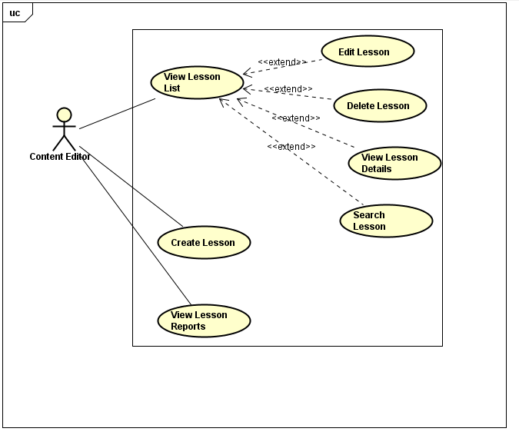

##### **UC-E-007: View Lessons List**

|  |  |  |  |  |
| --- | --- | --- | --- | --- |
| Use Case Name | View Lessons List | | | |
| Use Case ID | UC-E-007 | | | |
| Created By | QuanNH | Last Updated By | | ThangPD |
| Date Created | 27/06/2016 | Date Last Updated | | 05/08/2016 |
| Actor | Content Editor | | | |
| Description | User views list lessons of courses | | | |
| Pre-condition | * Website is available * Content editor logged in the website | | | |
| Trigger | User clicks on “Lessons” link at dashboard then click “Lesson List” hyperlink at dashboard in editor dashboard page | | | |
| Post Condition | System redirects to lesson list page | | | |
| Main Success Scenario | | | | |
| Step | **User** | | **System’s Response** | |
| 1 | Click on “Lessons” link at dashboard | | Show “Lesson List” link and “Add Lesson ” link | |
| 2 | Click on “Lesson List” hyperlink at dashboard in editor dashboard page | | Redirect to lesson list page | |
| Alternative Scenario | | | | |
| At Step | **User** | | **System’s Response** | |
| Exception | | | | |
| At Step | **User** | | **System’s Response** | |

##### **UC-E-008: Search Lesson**

|  |  |  |  |  |
| --- | --- | --- | --- | --- |
| Use Case Name | Search Lesson | | | |
| Use Case ID | UC-E-008 | | | |
| Created By | QuanNH | Last Updated By | | ThangPD |
| Date Created | 27/06/2016 | Date Last Updated | | 03/08/2016 |
| Actor | Content Editor | | | |
| Description | User searches lessons in lesson list page | | | |
| Pre-condition | * Website is available * Content editor logged in the website | | | |
| Trigger | User inputs text to the search box in lesson list page | | | |
| Post Condition | Search Lessons successfully and system filters and display result | | | |
| Main Success Scenario | | | | |
| Step | **User** | | **System’s Response** | |
| 1 | Input text to the search box | |  | |
| 2 | Click on icon search button | | System will filter and display result | |
| Alternative Scenario | | | | |
| At Step | **User** | | **System’s Response** | |
| Exception | | | | |
| At Step | **User** | | **System’s Response** | |

##### **UC-E-009: View Lesson Details**

|  |  |  |  |  |
| --- | --- | --- | --- | --- |
| Use Case Name | View Lesson Details | | | |
| Use Case ID | UC-E-009 | | | |
| Created By | QuanNH | Last Updated By | | ThangPD |
| Date Created | 27/06/2016 | Date Last Updated | | 05/08/2016 |
| Actor | Content Editor | | | |
| Description | User views lesson details | | | |
| Pre-condition | * Website is available * Content editor logged in the website | | | |
| Trigger | User clicks on title name link of table in lesson list page | | | |
| Post Condition | System redirects to lesson details page | | | |
| Main Success Scenario | | | | |
| Step | **User** | | **System’s Response** | |
| 1 | Click on title name link of table in lesson list page | | Redirect to lesson details page | |
| Alternative Scenario | | | | |
| At Step | **User** | | **System’s Response** | |
| Exception | | | | |
| At Step | **User** | | **System’s Response** | |

##### **UC-E-010: Create Lesson**

|  |  |  |  |  |
| --- | --- | --- | --- | --- |
| Use Case Name | Create Lesson | | | |
| Use Case ID | UC-E-010 | | | |
| Created By | QuanNH | Last Updated B**y** | | ThangPD |
| Date Created | 27/06/2016 | Date Last Updated | | 12/08/2016 |
| Actor | Content Editor | | | |
| Description | User creates lesson | | | |
| Pre-condition | * Website is available * Content editor logged in the website | | | |
| Trigger | User clicks on “Lessons” link at dashboard then click “Add Lesson” hyperlink at dashboard in editor dashboard page | | | |
| Post Condition | * System redirects to add lesson page * If exceptions are thrown, the result must match with output of each described exception. | | | |
| Main Success Scenario | | | | |
| Step | **User** | | **System’s Response** | |
| 1 | Click on “Lessons” link at dashboard | | Show “Lesson List” link and “Add Lesson ” link | |
| 2 | Click on “Add Lesson” hyperlink at dashboard in editor dashboard page | | Redirect to add new lesson page | |
| 3 | Input information | |  | |
| 4 | Click on “Create” button | | Redirect to lesson detail page | |
| Alternative Scenario | | | | |
| At Step | **User** | | **System’s Response** | |
| Exception | | | | |
| At Step | **User** | | **System’s Response** | |
| 3 | If “Lesson Title” textbox is null | | Show the notice “Failed to create new lesson! Please make sure you do not leave any section content & lesson information blank.” | |
| 3 | If “Description” textbox is null | | Show the notice “Failed to create new lesson! Please make sure you do not leave any section content & lesson information blank.” | |
| 3 | If “Vocab” or “Grammar” or “Convo” or “Listening” or “Practice” or “Reading” in section “Content” is blank | | Show the notice “Failed to create new lesson! Please make sure you do not leave any section content & lesson information blank.” | |

##### **UC-E-011: Edit Lesson**

|  |  |  |  |  |
| --- | --- | --- | --- | --- |
| Use Case Name | Edit Lesson | | | |
| Use Case ID | UC-E-011 | | | |
| Created By | QuanNH | Last Updated By | | ThangPD |
| Date Created | 27/06/2016 | Date Last Updated | | 12/08/2016 |
| Actor | Content Editor | | | |
| Description | User edits lesson | | | |
| Pre-condition | * Website is available * Content editor logged in the website | | | |
| Trigger | User clicks on “Edit” button in lesson list page | | | |
| Post Condition | * System redirects to lesson details page * If exceptions are thrown, the result must match with output of each described exception. | | | |
| Main Success Scenario | | | | |
| Step | **User** | | **System’s Response** | |
| 1 | Click on “Edit” button | | System redirects to lesson details page | |
| 2 | Update information | |  | |
| 3 | Click on “Update” button | | System updates successfully and redirect to lesson list page and up current version | |
| Alternative Scenario | | | | |
| At Step | **User** | | **System’s Response** | |
| 3 | Click on “Back to List” button | | System redirects to lesson list page | |
| 3 | Click on “Save draft” button | | System saves draft editing lesson and redirect to lesson detail page | |
| 3 | Click on “Back to Detail” button | | System redirects to lesson detail page | |
| Exception | | | | |
| At Step | **User** | | **System’s Response** | |

##### **UC-E-012: Delete Lesson**

|  |  |  |  |  |
| --- | --- | --- | --- | --- |
| Use Case Name | Delete Lesson | | | |
| Use Case ID | UC-E-012 | | | |
| Created By | QuanNH | Last Updated By | | ThangPD |
| Date Created | 27/06/2016 | Date Last Updated | | 12/07/2016 |
| Actor | Content Editor | | | |
| Description | User deletes lesson | | | |
| Pre-condition | * Website is available * Content editor logged in the website | | | |
| Trigger | * User clicks on “Delete” button in lesson list page then click “Delete” button in “Delete Lesson” popup | | | |
| Post Condition | Delete Lessons successfully and system redirect to “Lesson list” page | | | |
| Main Success Scenario | | | | |
| Step | **User** | | **System’s Response** | |
| 1 | Click on “Delete” button in lesson list page | | Show “Delete Lesson” popup | |
| 2 | Click on “Delete” button in “Delete Lesson” popup | | Deleted lesson and closed popup | |
| Alternative Scenario | | | | |
| At Step | **User** | | **System’s Response** | |
| 1 | Click on “Cancel” button in “Delete Lesson” popup | | System closes popup without delete lesson | |
| Exception | | | | |
| At Step | **User** | | **System’s Response** | |

##### **UC-E-013: View Lesson Reports**

|  |  |  |  |  |
| --- | --- | --- | --- | --- |
| Use Case Name | View Lesson Reports | | | |
| Use Case ID | UC-E-013 | | | |
| Created By | QuanNH | Last Updated By | | ThangPD |
| Date Created | 27/06/2016 | Date Last Updated | | 25/07/2016 |
| Actor | Content Editor | | | |
| Description | User views lesson reports | | | |
| Pre-condition | * Website is available * Content editor logged in the website | | | |
| Trigger | User clicks on “Tasks” link at dashboard in content editor dashboard page | | | |
| Post Condition | View lesson report successfully and redirect to task list page | | | |
| Main Success Scenario | | | | |
| Step | **User** | | **System’s Response** | |
| 1 | Click on “Tasks” link at dashboard in content editor dashboard page | | Redirect to task list page | |
| Alternative Scenario | | | | |
| At Step | **User** | | **System’s Response** | |
| Exception | | | | |
| At Step | **User** | | **System’s Response** | |

#### Manage Questions

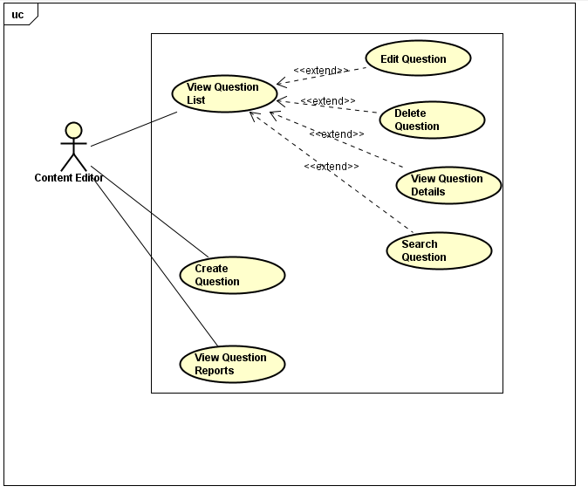

##### **UC-E-014: View Questions List**

|  |  |  |  |  |
| --- | --- | --- | --- | --- |
| Use Case Name | View Questions List | | | |
| Use Case ID | UC-E-014 | | | |
| Created By | QuanNH | Last Updated By | | ThangPD |
| Date Created | 04/07/2016 | Date Last Updated | | 05/08/2016 |
| Actor | Content Editor | | | |
| Description | User views list questions | | | |
| Pre-condition | * Website is available * Content editor logged in the website | | | |
| Trigger | User clicks on “Questions” link at dashboard then click “Questions List” hyperlink at dashboard in “Editor Dashboard” page | | | |
| Post Condition | View questions list successfully and system redirects to “Questions List” page | | | |
| Main Success Scenario | | | | |
| Step | **User** | | **System’s Response** | |
| 1 | Click on “Questions” link at dashboard | | Show “Question List” link and “Add Question ” link | |
| 2 | Click on “Question List” hyperlink at dashboard in editor dashboard page | | Redirect to questions list page | |
| Alternative Scenario | | | | |
| At Step | **User** | | **System’s Response** | |
| Exception | | | | |
| At Step | **User** | | **System’s Response** | |

##### **UC-E-015: Search Question**

|  |  |  |  |  |
| --- | --- | --- | --- | --- |
| Use Case Name | Search Question | | | |
| Use Case ID | UC-E-015 | | | |
| Created By | QuanNH | Last Updated By | | ThangPD |
| Date Created | 04/07/2016 | Date Last Updated | | 04/08/2016 |
| Actor | Content Editor | | | |
| Description | User searches question | | | |
| Pre-condition | * Website is available * Content editor logged in the website | | | |
| Trigger | User inputs text to the search box in question list page | | | |
| Post Condition | Search question successfully and system will filter and display result | | | |
| Main Success Scenario | | | | |
| Step | **User** | | **System’s Response** | |
| 1 | Input text to the search box | |  | |
| 2 | Click on icon search button | | System will filter and display result | |
| Alternative Scenario | | | | |
| At Step | **User** | | **System’s Response** | |
| Exception | | | | |
| At Step | **User** | | **System’s Response** | |

##### **UC-E-016: View Question Details**

|  |  |  |  |  |
| --- | --- | --- | --- | --- |
| Use Case Name | View Question Details | | | |
| Use Case ID | UC-E-016 | | | |
| Created By | QuanNH | Last Updated By | | ThangPD |
| Date Created | 04/07/2016 | Date Last Updated | | 19/07/2016 |
| Actor | Content Editor | | | |
| Description | User views question details | | | |
| Pre-condition | * Website is available * Content editor logged in the website * Done UC-E-014 successfully | | | |
| Trigger | User clicks on ”Click here to see content” link of each question in “Question List” page | | | |
| Post Condition | System redirects to question detail page | | | |
| Main Success Scenario | | | | |
| Step | **User** | | **System’s Response** | |
| 1 | Click on “Click here to see content” link of each question | | Show question detail page | |
| Alternative Scenario | | | | |
| At Step | **User** | | **System’s Response** | |
| Exception | | | | |
| At Step | **User** | | **System’s Response** | |

##### **Create Lesson**

###### **3.1.3.4.4.1. UC-E-017: Create Question Single**

|  |  |  |  |  |
| --- | --- | --- | --- | --- |
| Use Case Name | Create Question Single | | | |
| Use Case ID | UC-E-017 | | | |
| Created By | QuanNH | Last Updated By | | ThangPD |
| Date Created | 27/06/2016 | Date Last Updated | | 12/08/2016 |
| Actor | Content Editor | | | |
| Description | User creates question | | | |
| Pre-condition | Website is availableContent editor logged in the website | | | |
| Trigger | User clicks on “Questions” sidebar then click “Add Lesson” hyperlink at dashboard in editor dashboard page | | | |
| Post Condition | Create question successfully and system redirects to “Questions List” pageIf exceptions are thrown, the result must match with output of each described exception. | | | |
| Main Success Scenario | | | | |
| Step | **User** | | **System’s Response** | |
| 1 | Click on “Add Question” hyperlink in “Editor Dashboard” page | | Redirect to “Add Question” Page | |
| 2 | Choose “Single” in “Question Type” dropdown list | |  | |
| 3 | Choose question level in “Level” dropdown list | | Show level dropdown list | |
| 4 | Choose question skill in “Test Skill” dropdown list | | Show test skill dropdown list | |
| 5 | Input question and answer and choose right answer | |  | |
| 6 | Click on “+” button under answer field to add more answer | | System adds one more answer | |
| 7 | Click on time icon to select time allowed in section “Time allowed” | |  | |
| 8 | Click on “x” button under answer field to delete answer | | System deletes answer | |
| 9 | Click on “Submit” button | | Redirect to UC-E-014 | |
| Alternative Scenario | | | | |
| At Step | **User** | | **System’s Response** | |
| Exception | | | | |
| At Step | **User** | | **System’s Response** | |
| 5 | If Question textbox is null | | System shows notice “Failed to create new question! Please make sure you do not leave any question & answer's contents blank.” in “Error” popup | |
| 5 | If Answer textbox is null | | System shows notice “Failed to create new question! Please make sure you do not leave any question & answer's contents blank.” in “Error” popup | |
| 5 | If don’t choose right answer | | System shows notice “There must be at least one right answer in each question!” in “Error” popup | |

###### **3.1.3.4.4.2. UC-E-018: Create Question Group**

|  |  |  |  |  |
| --- | --- | --- | --- | --- |
| Use Case Name | Create Question Group | | | |
| Use Case ID | UC-E-018 | | | |
| Created By | QuanNH | Last Updated By | | ThangPD |
| Date Created | 27/06/2016 | Date Last Updated | | 12/08/2016 |
| Actor | Content Editor | | | |
| Description | User creates question | | | |
| Pre-condition | Website is availableContent editor logged in the website | | | |
| Trigger | User clicks on “Questions” sidebar then click “Add Lesson” hyperlink at dashboard in editor dashboard page | | | |
| Post Condition | Create question successfully and system redirects to “Questions List” pageIf exceptions are thrown, the result must match with output of each described exception. | | | |
| Main Success Scenario | | | | |
| Step | **User** | | **System’s Response** | |
| 1 | Click on “Add Question” hyperlink in “Editor Dashboard” page | | Redirect to “Add Question” Page | |
| 2 | Choose “Group” in “Question Type” dropdown list | |  | |
| 3 | Choose question level in “Level” dropdown list | | Show level dropdown list | |
| 4 | Input question and answer and choose right answer | |  | |
| 5 | Input information in section “Content” | |  | |
| 6 | Click on “+” button under answer field to add more answer | | System adds one more answer | |
| 7 | Click on “+” button under question to add more question | | System adds one more question | |
| 8 | Click on “x” button under answer field or question field to delete answer or question | | System deletes question or answer | |
| 9 | Click on time icon to select time allowed in section “Time allowed” | |  | |
| 10 | Click on “Submit” button | | Redirect to UC-E-014 | |
| Alternative Scenario | | | | |
| At Step | **User** | | **System’s Response** | |
| Exception | | | | |
| At Step | **User** | | **System’s Response** | |
| 4 | If Question textbox is null | | System shows notice “Failed to create new question! Please make sure you do not leave any question & answer's contents blank.” in “Error” popup | |
| 4 | If Answer textbox is null | | System shows notice “Failed to create new question! Please make sure you do not leave any question & answer's contents blank.” in “Error” popup | |
| 4 | If don’t choose right answer | | System shows notice “There must be at least one right answer in each question!” in “Error” popup | |
| 5 | If section “Content” is blank | | System shows notice “Failed to create new question! Please make sure you do not leave any question & answer's contents blank.” in “Error” popup | |

##### **Edit Question**

###### **3.1.3.4.5.1. UC-E-019: Edit Question Single**

|  |  |  |  |  |
| --- | --- | --- | --- | --- |
| Use Case Name | Edit Question Single | | | |
| Use Case ID | UC-E-019 | | | |
| Created By | QuanNH | Last Updated By | | ThangPD |
| Date Created | 27/06/2016 | Date Last Updated | | 03/08/2016 |
| Actor | Content Editor | | | |
| Description | User edits question | | | |
| Pre-condition | * Website is available * Content editor logged in the website * Done UC-E-014 successfully | | | |
| Trigger | User clicks on “Edit” button of each question in question list page | | | |
| Post Condition | * Edit question successfully and redirect to question detail page * If exceptions are thrown, the result must match with output of each described exception. | | | |
| Main Success Scenario | | | | |
| Step | **User** | | **System’s Response** | |
| 1 | Click on “Edit” button | | Show edit question page | |
| 2 | Update question level in “Level” dropdown list | | Show level dropdown list | |
| 3 | Update question skill in “Test Skill” dropdown list | | Show test skill dropdown list | |
| 4 | Update information in section “Question” and “Answers” | |  | |
| 5 | Click on “+” button under answer field to add more answer | | System adds one more answer | |
| 6 | Click on “x” button under answer field to delete answer | | System deletes answer | |
| 7 | Click on time icon to update time allowed in section “Time allowed” | |  | |
| 8 | Click on “Update” button | | Redirect to question detail page | |
| Alternative Scenario | | | | |
| At Step | **User** | | **System’s Response** | |
| 8 | Click “Back to List” button | | Cancel edit question and redirect to question list page | |
| 8 | Click “Back to Detail” button | | Cancel edit question and redirect to question detail page | |
| Exception | | | | |
| At Step | **User** | | **System’s Response** | |
| 4 | If Question textbox is null | | System shows notice “Failed to create new question! Please make sure you do not leave any question & answer's contents blank.” in “Error” popup | |
| 4 | If Answer textbox is null | | System shows notice “Failed to create new question! Please make sure you do not leave any question & answer's contents blank.” in “Error” popup | |
| 4 | If don’t choose right answer | | System shows notice “There must be at least one right answer in each question!” in “Error” popup | |

###### **3.1.3.4.5.2. UC-E-020: Edit Question Group**

|  |  |  |  |  |
| --- | --- | --- | --- | --- |
| Use Case Name | Edit Question Group | | | |
| Use Case ID | UC-E-020 | | | |
| Created By | QuanNH | Last Updated By | | ThangPD |
| Date Created | 27/06/2016 | Date Last Updated | | 12/08/2016 |
| Actor | Content Editor | | | |
| Description | User edits question | | | |
| Pre-condition | * Website is available * Content editor logged in the website * Done UC-E-014 successfully | | | |
| Trigger | User clicks on “Edit” button of each question in question list page | | | |
| Post Condition | * Edit question successfully and redirect to question detail page * If exceptions are thrown, the result must match with output of each described exception. | | | |
| Main Success Scenario | | | | |
| Step | **User** | | **System’s Response** | |
| 1 | Click on “Edit” button | | Show edit question page | |
| 2 | Update question level in “Level” dropdown list | | Show level dropdown list | |
| 3 | Update information in section “Question” and “Answers” | |  | |
| 4 | Input information in section “Content” | |  | |
| 5 | Click on “+” button under answer field to add more answer | | System adds one more answer | |
| 6 | Click on “+” button under question to add more question | | System adds one more question | |
| 7 | Click on “x” button under answer field or question field to delete answer or question | | System deletes one question or answer | |
| 8 | Click on time icon to update time allowed in section “Time allowed” | |  | |
| 9 | Click on “Update” button | | Redirect to question detail page | |
| Alternative Scenario | | | | |
| At Step | **User** | | **System’s Response** | |
| 9 | Click “Back to List” button | | Cancel edit question and redirect to question list page | |
| 9 | Click “Back to Detail” button | | Cancel edit question and redirect to question detail page | |
| Exception | | | | |
| At Step | **User** | | **System’s Response** | |
| 3 | If Question textbox is null | | System shows notice “Failed to create new question! Please make sure you do not leave any question & answer's contents blank.” in “Error” popup | |
| 3 | If Answer textbox is null | | System shows notice “Failed to create new question! Please make sure you do not leave any question & answer's contents blank.” in “Error” popup | |
| 3 | If don’t choose right answer | | System shows notice “There must be at least one right answer in each question!” in “Error” popup | |
| 4 | If section “Content” is blank | | System shows notice “Failed to create new question! Please make sure you do not leave any question & answer's contents blank.” in “Error” popup | |

##### **UC-E-021: Delete Question**

|  |  |  |  |  |
| --- | --- | --- | --- | --- |
| Use Case Name | Delete Lesson | | | |
| Use Case ID | UC-E-021 | | | |
| Created By | QuanNH | Last Updated By | | ThangPD |
| Date Created | 05/07/2016 | Date Last Updated | | 05/08/2016 |
| Actor | Content Editor | | | |
| Description | User deletes question | | | |
| Pre-condition | * Website is available * Content editor logged in the website * Done UC-E-014 successfully | | | |
| Trigger | User clicks on “Delete” button of each question in “Question List” page | | | |
| Post Condition | Delete question successfully and system redirects to “Lesson List” page | | | |
| Main Success Scenario | | | | |
| Step | **User** | | **System’s Response** | |
| 1 | Click “Delete” button | | Show “Delete Question” popup | |
| 2 | Click “Delete” button | | System deleted question and close popup | |
| Alternative Scenario | | | | |
| At Step | **User** | | **System’s Response** | |
| 1 | Click on “Cancel” button in “Delete Question” popup | | System closes popup without delete question | |
| Exception | | | | |
| At Step | **User** | | **System’s Response** | |

##### **UC-E-022: View Question Report**

|  |  |  |  |  |
| --- | --- | --- | --- | --- |
| Use Case Name | View Question Report | | | |
| Use Case ID | UC-CM-022 | | | |
| Created By | QuanNH | Last Updated By | | ThangPD |
| Date Created | 27/06/2016 | Date Last Updated | | 29/07/2016 |
| Actor | Content Editor | | | |
| Description | User views question reports | | | |
| Pre-condition | * Website is available * Content editor logged in the website | | | |
| Trigger | User clicks on “Tasks” sidebar in content editor dashboard page | | | |
| Post Condition | View question report successfully and redirect to task list page | | | |
| Main Success Scenario | | | | |
| Step | **User** | | **System’s Response** | |
| 1 | Click on “Tasks” sidebar in content editor dashboard page | | Redirect to task list page | |
| Alternative Scenario | | | | |
| At Step | **User** | | **System’s Response** | |
| Exception | | | | |
| At Step | **User** | | **System’s Response** | |

### Administrator

#### Manage Account

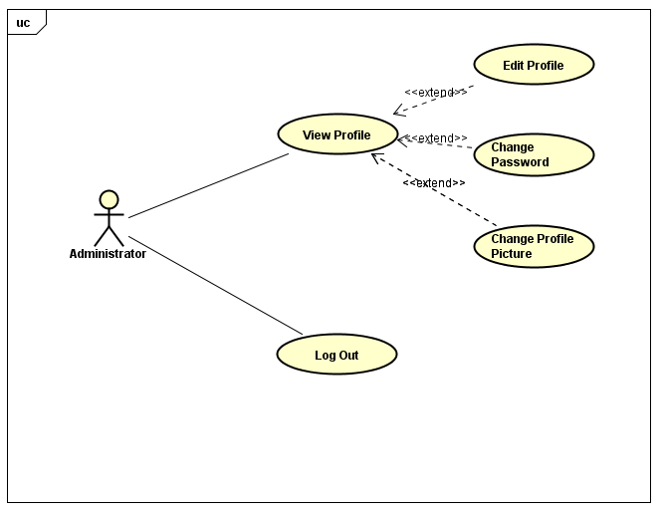

##### **3.1.4.1.1 UC-A-001: View Profile**

|  |  |  |  |  |
| --- | --- | --- | --- | --- |
| Use Case Name | View Profile | | | |
| Use Case ID | UC-A-001 | | | |
| Created By | QuanNH | Last Updated By | | ThangPD |
| Date Created | 27/06/2016 | Date Last Updated | | 19/07/2016 |
| Actor | Administrator | | | |
| Description | User views their profile | | | |
| Pre-condition | * Website is available * Logged in "Administrator" dashboard | | | |
| Trigger | * Login the website * Users clicks on username hyperlink at the left top of menu | | | |
| Post Condition | System redirects to Admin profile page | | | |
| Main Success Scenario | | | | |
| Step | **User** | | **System’s Response** | |
| 1 | Click on username hyperlink at the left top of menu | | Redirect View User Profile Page | |
| Alternative Scenario | | | | |
| At Step | **User** | | **System’s Response** | |
| Exception | | | | |
| At Step | **User** | | **System’s Response** | |

##### **3.1.4.1.2 UC-A-002: Change Password**

|  |  |  |  |  |
| --- | --- | --- | --- | --- |
| Use Case Name | Change Password | | | |
| Use Case ID | UC-A-002 | | | |
| Created By | QuanNH | Last Updated By | | ThangPD |
| Date Created | 27/06/2016 | Date Last Updated | | 19/07/2016 |
| Actor | Administrator | | | |
| Description | User change their password | | | |
| Pre-condition | * Website is available * Logged in "Administrator" dashboard * Sone UC-A-001 successfully | | | |
| Trigger | User clicks “Change password” button in “Edit Profile” page | | | |
| Post Condition | * Password is changed successfully. * If exceptions are thrown, the result must match with output of each described exception. | | | |
| Main Success Scenario | | | | |
| Step | **User** | | **System’s Response** | |
| 1 | Click on “Change password” button. | | Show a popup with requiring input information | |
| 2 | Input information | |  | |
| 3 | Click on “Save” button. | |  | |
| Alternative Scenario | | | | |
| At Step | **User** | | **System’s Response** | |
| Exception | | | | |
| At Step | **User** | | **System’s Response** | |

##### **UC-A-003: Logout**

|  |  |  |  |  |
| --- | --- | --- | --- | --- |
| Use Case Name | Logout | | | |
| Use Case ID | UC-A-003 | | | |
| Created By | QuanNH | Last Updated By | | ThangPD |
| Date Created | 27/06/2016 | Date Last Updated | | 19/07/2016 |
| Actor | Administrator | | | |
| Description | User logs out of the front-end system | | | |
| Pre-condition | * Website is available * Administrator login the website | | | |
| Trigger | User clicks on “Logout” hyperlink at dashboard in admin profile page | | | |
| Post Condition | Redirect to “Home” page and user signed out successfully | | | |
| Main Success Scenario | | | | |
| Step | **User** | | **System’s Response** | |
| 1 | Click on “Logout” hyperlink at dashboard | |  | |
| Alternative Scenario | | | | |
| At Step | **User** | | **System’s Response** | |
| Exception | | | | |
| At Step | **User** | | **System’s Response** | |

#### Manage User

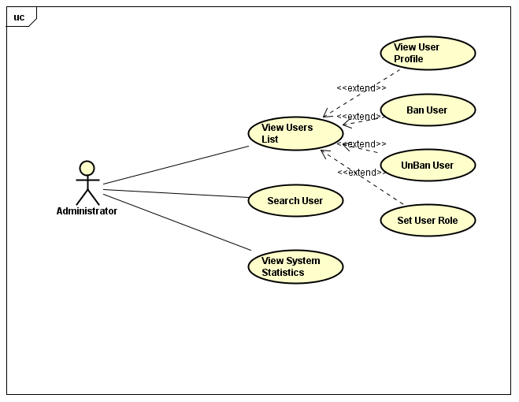

##### **3.1.4.2.1 UC-A-004: View User's List**

|  |  |  |  |  |
| --- | --- | --- | --- | --- |
| Use Case Name | View user list | | | |
| Use Case ID | UC-A-004 | | | |
| Created By | QuanNH | Last Updated By | | QuanNH |
| Date Created | 27/06/2016 | Date Last Updated | | 12/07/2016 |
| Actor | Administrator | | | |
| Description | User views list members | | | |
| Pre-condition | * Website is available * Logged in "Administrator" dashboard | | | |
| Trigger |  | | | |
| Post Condition |  | | | |
| Main Success Scenario | | | | |
| Step | **User** | | **System’s Response** | |
| 1 | In “Admin dashboard page”, click on “Member” button in right menu | | Show “List Member” page | |
| Alternative Scenario | | | | |
| At Step | **User** | | **System’s Response** | |
| Exception | | | | |
| At Step | **User** | | **System’s Response** | |

##### **3.1.4.2.2 UC-A-005: View User Profile**

|  |  |  |  |  |
| --- | --- | --- | --- | --- |
| Use Case Name | View User Profile | | | |
| Use Case ID | UC-A-005 | | | |
| Created By | QuanNH | Last Updated By | | QuanNH |
| Date Created | 27/06/2016 | Date Last Updated | | 12/07/2016 |
| Actor | Administrator | | | |
| Description | User views member's profile | | | |
| Pre-condition | * Website is available * Logged in "Administrator" dashboard * Done UC-A-004 successfully | | | |
| Trigger |  | | | |
| Post Condition | System redirects to user profile page | | | |
| Main Success Scenario | | | | |
| Step | **User** | | **System’s Response** | |
| 1 | Click on “user “hyperlink in list users | | Show a ”User Details Profile” | |
| Alternative Scenario | | | | |
| At Step | **User** | | **System’s Response** | |
| Exception | | | | |
| At Step | **User** | | **System’s Response** | |

##### **UC-A-006: Set Role User**

|  |  |  |  |  |
| --- | --- | --- | --- | --- |
| Use Case Name | Set Role User | | | |
| Use Case ID | UC-A-006 | | | |
| Created By | QuanNH | Last Updated By | | QuanNH |
| Date Created | 27/06/2016 | Date Last Updated | | 12/07/2016 |
| Actor | Administrator | | | |
| Description | User sets role for member of system | | | |
| Pre-condition | * Website is available * Logged in "Administrator" dashboard * Done UC-A-005 successfully | | | |
| Trigger |  | | | |
| Post Condition |  | | | |
| Main Success Scenario | | | | |
| Step | **User** | | **System’s Response** | |
| Alternative Scenario | | | | |
| At Step | **User** | | **System’s Response** | |
| Exception | | | | |
| At Step | **User** | | **System’s Response** | |

##### **UC-A-007: Ban User**

|  |  |  |  |  |
| --- | --- | --- | --- | --- |
| Use Case Name | Ban user | | | |
| Use Case ID | UC-A-007 | | | |
| Created By | QuanNH | Last Updated By | | QuanNH |
| Date Created | 27/06/2016 | Date Last Updated | | 12/07/2016 |
| Actor | Administrator | | | |
| Description | User ban member | | | |
| Pre-condition | * Website is available * Logged in "Administrator" dashboard * Done UC-A-005 successfully | | | |
| Trigger |  | | | |
| Post Condition |  | | | |
| Main Success Scenario | | | | |
| Step | **User** | | **System’s Response** | |
| 1 | In “List users page”, click on member who want to ban | | Show a user profile | |
| 2 | Click on “Ban” button | | Show “Ban user successful” popup | |
| Alternative Scenario | | | | |
| At Step | **User** | | **System’s Response** | |
| Exception | | | | |
| At Step | **User** | | **System’s Response** | |

##### **UC-A-008: Unban User**

|  |  |  |  |  |
| --- | --- | --- | --- | --- |
| Use Case Name | Unban user | | | |
| Use Case ID | UC-A-008 | | | |
| Created By | QuanNH | Last Updated By | | QuanNH |
| Date Created | 27/06/2016 | Date Last Updated | | 12/07/2016 |
| Actor | Administrator | | | |
| Description | User unban members | | | |
| Pre-condition | * Website is available * Logged in "Administrator" dashboard * Done UC-A-005 successfully | | | |
| Trigger |  | | | |
| Post Condition |  | | | |
| Main Success Scenario | | | | |
| Step | **User** | | **System’s Response** | |
| 1 | In “List users page”, click on member who want to unban | | Show a user profile | |
| 2 | Click on “Unban” button | | Show “Unban user successful” popup | |
| Alternative Scenario | | | | |
| At Step | **User** | | **System’s Response** | |
| Exception | | | | |
| At Step | **User** | | **System’s Response** | |

##### **UC-A-009: View System Statistics**

|  |  |  |  |
| --- | --- | --- | --- |
| Use Case Name | View System Statistics | | |
| Use Case ID | UC-A-009 | | |
| Created By | QuanNH | Last Updated By | QuanNH |
| Date Created | 27/06/2016 | Date Last Updated | 12/07/2016 |
| Actor | Administrator | | |
| Description | User views statistics of system | | |
| Pre-condition | * Website is available * Logged in "Administrator" dashboard | | |
| Trigger |  | | |
| Post Condition |  | | |

## Usability

* Interface should be simple, clear, user friendly, easy to learn how to use and easy to remember how to use.
* Interface design should support the following from the perspectives of its primary users:
  + Efficiency of use: goals are easy to accomplish quickly and with few or no user errors.
  + Intuitiveness: the interface is easy to learn and navigate: buttons, headings, and help/error messages are simple to understand.
  + Low perceived workload: the interface appears easy to use, rather than intimidating, demanding and frustrating.
* Users need to understand the function of each section to be able to use reasonable discretion and its effectiveness.
* Users should be supported and guided how to use the functionality of the system to use system easily after short time.
  + In the role “Administrator” – after 2 hours of training
  + In the role “Content Editor” – after 1 hour of training
  + In the role “Member” – after 30 minutes of training
  + In the role “Guest” – after 15 minutes of training
* The system should have the flexibility to be can satisfied future changed as:
  + Can add more lessons, tests and new words.
  + Changes in processing of information.
* The system must meet the requirements for data memory, need to calculate the amount of memory to be able to meet the requirements of the development of the system.

## Reliability

### 3.3.1 Availability

The System shall be available for use at 24 hours a day and 7 days a week.

The Data Storage shall be available for use 24 hours a day and 7 days a week.

The Maintenance Time must be announced before 3 days.

The Mean Time Between Failures (MTBF) must be at least 500 hours.

### 3.3.2 The Time Required To Troubleshoot

The time returned to service must not exceed 1 hour.

### 3.3.3 Error Rate Allowed

The system shall have sufficient quality.

For the first release of VEAZY:

There are no more than 2 bugs per function.

There are no more than 5 high severity errors per week.

For subsequent releases:

There is no more than 1 bug per function.

There are no more than 5 high severity errors per month.

### 3.3.4 Data Backup

* The system must have automatic backup and recovery features containing all the changed data at the time the backup is taken.

## Performance

### 3.4.1 Response Time

* Response time when accessing an action on the system depending on system condition such as number of visitors, access tasks.
* When the number of visitors crowded, response time will be longer.
* Time for searching will be at most 10 seconds, time for loading image, media will be at most 5 seconds and time to progress any function will not exceed 7 seconds.

### 3.4.2 Throughput

* The throughput of the system will depend on the number of users logged into the system at the same time and complexity of the tasks which required users.

### 3.4.3 Capacity

* At the same time there may be many users with access to the system.

### 3.4.4 Resource Utilization

* Can change to avoid wasting system resources.

## Supportability

Web system is written in Java and Bootstrap, easily manage and upgrade and easily connect to database system.

## Design Constraints

* Because the system is built on the Web Platform, therefore development language easily manages and upgrade.
* The system must execute independently, less influenced by other systems and capable of performing well on many different operating systems.

## On-line User Documentation and Help System Requirements

* The system shall provide the on-line user documentation with intuitive interface notes and explains.
* The on-line user documentation provides context-dependent help for all user interface functionality.
* The user must be able to perform search on-line user documentation.
* Providing online support tools.

## Purchased Components

## Interfaces

### 3.9.1 User Interfaces

* Language’s System is Japanese.
* Manipulation of functions is simple.

### 3.9.2 Hardware Interfaces

Any hardware interface is also supported by the software. Compatible software for hardware will be running the system.

### 3.9.3 Software Interfaces

### 3.9.4 Communications Interfaces

* Compatible and good communication with other systems and devices, not conflict when running.
* Using internet connection to connect to the main database server.

## Licensing Requirements

Out of scope

## Legal, Copyright, and Other Notices

Out of scope

## Applicable Standards

# SUPPORTING INFORMATION

## 4.1 Appendices:

### 4..1.1 Appendix 1:

830-1998 - IEEE Recommended Practice for Software Requirements Specifications

“The content and qualities of a good software requirements specification (SRS) are described, and several sample SRS outlines are presented. This recommended practice is aimed at specifying the requirements of software to be developed, but can also be applied to assist in the selection of in-house and commercial software products. Guidelines for compliance with IEEE/EIA Std 12207.1-1997 are also provided.”

https://standards.ieee.org/findstds/standard/830-1998.html