

**VIETNAMESE STUDY SYSTEM FOR JAPANESE**

**SOFTWARE REQUIREMENT**

**SPECIFICATION**

**Project Code: Veazy**

**Document Code: Veazy_SRS_en_v2.4**

**- Ha Noi, 20/062016 -**

**RECORD OF CHANGE**

*A - Added M - Modified D - Deleted

|  |  |  |  |  |
| --- | --- | --- | --- | --- |
| **Effective Date** | **Changed Items** | **A* M, D** | **Change Description** | **New Version** |
| 2016/06/20 | SRS | A* | Create SRS | 1.0 |
| 2016/06/26 | SRS | M | Modify SRS | 1.1 |
| 2016/07/12 | SRS | M | Modify SRS | 1.2 |
| 2016/07/25 | SRS | M | Modify SRS | 1.3 |
| 2016/07/29 | SRS | M | Modify SRS | 1.4 |
| 2016/08/02 | SRS | M | Modify SRS | 1.5 |
| 2016/08/05 | SRS | M | Modify SRS | 1.6 |
| 2016/08/12 | SRS | M | Modify SRS | 1.7 |
| 2016/08/14 | SRS | M | Modify SRS | 1.8 |
| 2016/08/15 | SRS | M | Modify SRS | 1.9 |
| 2016/08/18 | SRS | M | Modify SRS | 2.0 |
| 2016/08/21 | SRS | M | Modify SRS | 2.1 |
| 2016/08/23 | SRS | M | Modify SRS | 2.2 |
| 2016/08/23 | SRS | M | Modify SRS | 2.3 |
| 2016/08/24 | SRS | M | Modify SRS | 2.4 |
|  |  |  |  |  |
|  |  |  |  |  |
|  |  |  |  |  |
|  |  |  |  |  |
|  |  |  |  |  |

**ORIGINATOR:** Pham DucThang 2016/06/20

Developer

**REVIEWERS:** Nguyen Trong Duy2016/08/23

Developer

**APPROVAL:** Nguyen Van Sang 2016/06/01

Supervisor

Table of Contents

1 INTRODUCTION 5

1.1 Purpose 5

1.2 Scope 5

1.3 Definitions, Acronyms, and Abbreviations 5

1.4 References 6

1.5 Overview 6

2 OVERALL DESCRIPTION 6

2.1 Product perspective 6

2.2 Product functions 7

2.3 User characteristics 9

2.4 Constraints 9

2.5 Assumptions & Dependencies 9

3 SPECIFIC REQUIREMENTS 10

3.1 Functionality 10

3.1.1. Guest 10

3.1.2. Member 22

3.1.3. Content Editor 33

3.1.4 Administrator 59

3.2 Usability 70

3.3 Security 70

3.4 Maintainability & Extensibility 70

3.5 Performance 70

3.5 Supportability 71

3.6 Design Constraints 71

3.7 User Manual Documentation 71

4 SUPPORTING INFORMATION 71

4.1 Appendices: 71

4.1.1 Appendix 1: 71

# INTRODUCTION

## Purpose

The purpose of this document is to present a detailed description of the Veazy. It explains the interface and the features of the system, what the system does, the constraints under which it must operate and how the system reacts to external stimuli.

## Scope

Veazy is a website which supports Japanese people study Vietnamese.

There are four basic users Guest, Member, Content Editor and Admin.

* Guest can study via lessons and do test.
* Member can access basic functions of guests and manage profile, redo recently taken tests and view statistics assessed based on those taken tests.
* Editor can manage website content which contains of contents of lesson and test question.
* Administrator can manage users, including checking user detailed information, assign authority and ban/unban.

## Definitions, Acronyms, and Abbreviations

|  |  |
| --- | --- |
| **Term** | **Definition** |
| VEAZY | Vietnamese Study System For Japanese |
| UC | Use case |
| A | Administrator |
| CE | Content Editor |
| M | Member |
| G | Guest |
| Aka | Also known as |
| ID | Identity |

## References

1. IEEE Software Engineering Standards Committee, “IEEE Std 830-1998, IEEE Recommended Practice for Software Requirements Specifications”, October 20, 1998. (*see Appendix 1*)
2. FPT Software, “Template Software Requirements Specifications”.

## Overview

The remaining of this document includes 3 chapters.

The first chapter represents the overview of the product i.e. the perspective of the product, which the main features of the product are, what the user characteristics, also the constraints, assumptions and dependencies of the product.

The second chapter produces the specific functional and nonfunctional requirements of system which must be satisfied when designers design and testers test the system.

The last chapter shows the additional information to support to make this document easier to understand.

# OVERALL DESCRIPTION

## 2.1 Product perspective

The product is a web-based system implementing client-server model. Veazy system serves as an e-learning system which targets mainly Japanese people who working in Vietnam and have demand for studying Vietnamese.

The purpose of Veazy is to create a friendly, easy-to-use and free-of-charge Vietnamese learning system with various features that improves efficiency in study significantlyas well asprovideacoherent system of ability assessment to help users keep track of their level in Vietnamese language.

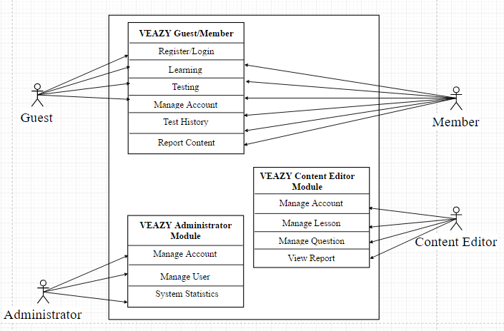

## 2.2 Product functions

The following are the main features that are included in the system:

* User Account Management: Allows users register new accounts in order to log into the system and provide features of updating and viewing profiles.
* E-learning System: Provides a well-organized lessons system divided in courses based on level of difficulty.
* Taking Test: Allows users to take small test and display test result.

**Main functions of Guest:**

|  |  |  |
| --- | --- | --- |
| User | Function Name | Description |
| Guest | **Register new Account** | User registers new account to log into the system |
| **Login** | User login to the system. |
| **View Lesson List** | User views list lessons of courses. |
| **View Lesson Detail** | User views the content of the selected lesson. |
| **Take Test** | User takes a multiple-choice test. |
| **View Test Result** | User views result of their test. |
| Member | **View Profile** | User views their own profile. |
| **Edit Profile** | User edits their own profile. |
| **Change Password** | User changes their password |
| **View Test Statistic** | User views summary about their test and their score |
| **Logout** | User logs out of system. |
| **Report Lesson** | User sends their report to Content Editor about wrong content of lesson |
| **Report Question** | User sends their report to Content Editor about wrong content of question |
| **View List Test History** | User views list test history |
| **View Test History** | User views test history detail |
| **Retake Test** | User retake test |
| Content Editor | **View Profile** | User views their own profile |
| **Edit Profile** | User edits their own profile |
| **Change Password** | User changes their password |
| **Logout** | User logs out of system. |
| **View Lesson List** | User views list lessons of courses. |
| **View Lesson Detail** | User views the content of the selected lesson. |
| **Filter Lesson** | User filters lesson list |
| **Create Lesson** | User creates new lesson |
| **Edit Lesson** | User edits lesson |
| **Delete Lesson** | User deletes lesson |
| **View Question List** | User views list question |
| **View Question Detail** | User views question detail |
| **Filter Question** | User filters question list |
| **Create Question** | User creates new question |
| **Edit Question** | User edits question |
| **Delete Question** | User deletes question |
| **View Report** | User views report about wrong content |
| Admin | **View Profile** | User views their own profile |
| **Change Password** | User changes their password |
| **Logout** | User logs out of system. |
| **View User List** | User views list member of system |
| **View User Profile** | User views member’s profile. |
| **Set Role User** | User sets role for member’s system. |
| **Ban User** | User bans member out of system. |
| **Unban User** | User unbans member. |
| **View System Statistic** | User views statistic of system. |
| **Search User** | User searching for user. |

## 2.3 User characteristics

There are 3 types of users involving in the system:

* Normal users (Guest, Member): Requires basic knowledge of internet & computer.
* Content Editor: Required basic knowledge of internet & computer as normal user. In addition to that, they need to have upper-level of Vietnamese language and ability write academic articles as well as managing them.
* Administrators: Required to have high-level technical, management skills and the ability to promote the website.

## 2.4 Constraints

A constraint, in project management, is any restriction that defines a project’s limitation. These following are project constraints defined by team members and classified into categories:

* **Time**: The length of project is 4 months (from May to August, 2016). Project must be delivered and ready for demo before the due date of August 25th.
* **Resources**:
* Team scales is limited to 6 people who are all junior software developer.
* Team members spend at least 6 hours per day for the project.
* **Quality**:
* The website should operate well on popular web browsers such as Internet Explorer (version 9.0 above), Firefox (version 40.0 above) andGoogle Chrome (version 45.0 above).
* The website should provide full features listed at section 4.4.

## 2.5 Assumptions & Dependencies

The system depends on which type and version of browser being installed on the client machine i.e. the browser should support both HTML5 and CSS3. The internet connection speed and bandwidth is also a dependency of the system.

One assumption that user has a strong enough internet connect which can adapt to system load. If the speed and bandwidth is slow, there is one scenario that browser cannot fully load the webpage, which may affect web layout displaying. Another scenario is that when user plays media such as listening or watching conversation, the media quality may be affected badly by a weak internet connection, which results a bad user experience.

Another assumption is that user is using a fully technical supported browser. If the browser does not support full technique, website cannot adapt full functionalities.

# SPECIFIC REQUIREMENTS

## Functionality

### Guest

#### Manage Account

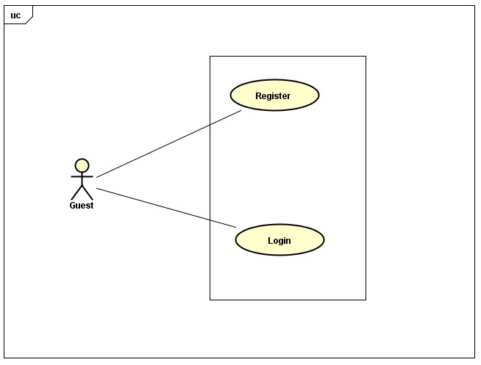

Figure 3‑1 : UC: Manage account

##### **UC-G-001: Login**

|  |  |  |  |  |
| --- | --- | --- | --- | --- |
| Use Case Name | Log In | | | |
| Use Case ID | UC-G-001 | | | |
| Created By | QuanNH | | Last Updated By | ThangPD |
| Date Created | 27/06/2016 | | Date Last Updated | 19/07/2016 |
| Actor | Guest | | | |
| Description | User to login to Veazy system | | | |
| Pre-condition | * Website is available * User has a registered account * “Login” hyperlinkis active at the right top of menu | | | |
| Trigger | * User inputs username and password into textboxes respectively in “Login” page * User clicks “Login” button on “Login” page | | | |
| Post Condition | * Login successfully and redirect to “Home” page * If exceptions are thrown, the result must match with output of each described exception. | | | |
| Main Success Scenario | | | | |
| Step | **User** | **System’s Response** | | |
| 1 | Click “Login” hyperlink at the right top of menu | Shows “Login” page | | |
| 2 | Enters username and password | Username and “Password” textbox border changes to green color | | |
| 3 | Clicks “Login” button | Redirects to “Home” page | | |
| Exception | | | | |
| At Step | **User** | **System’s Response** | | |
| 2 | If “Username” textbox is null | Border of “Username” textbox changes into red  Displays the message:“Username required!” | | |
| 2 | If“Password” textbox is null | Border of “Password” textbox changes into red  Displays the message “Password required!” | | |
| 3 | If user enters the wrong password or username | Displays the message "Incorrect username or password! | | |

##### **UC-G-002: Register**

|  |  |  |  |  |
| --- | --- | --- | --- | --- |
| Use Case Name | Register | | | |
| Use Case ID | UC-G-002 | | | |
| Created By | QuanNH | Last Updated By | | ThangPD |
| Date Created | 27/06/2016 | Date Last Updated | | 29/07/2016 |
| Actor | Guest | | | |
| Description | User registers new account to log into the system | | | |
| Pre-condition | * Website is available | | | |
| Trigger | * User clicks “Sign up” button on “Home” page * User inputs username, email, password and confirms password * User clicks “Register” button on “Register” page | | | |
| Post Condition | * Register successfully and redirect to “Register Success” page * If exceptions are thrown, the result must match with output of each described exception. | | | |
| Main Success Scenario | | | | |
| Step | **User** | | **System’s Response** | |
| 1 | Clicks “Sign up” button on “Home” page | | Shows “Register” page | |
| 2 | Inputs username, email, password and password confirmation | |  | |
| 3 | Clicks “Register” button | | Redirects to “Register Success” page | |
| Alternative Scenario | | | | |
| At Step | **User** | | **System’s Response** | |
| Exception | | | | |
| At Step | **User** | | **System’s Response** | |
| 2 | If “Username” textbox is null | | Border of “Username” textbox changes to red color.  Displays the message: “Username required!” | |
| 2 | If “Email” textbox is null | | Border of “Email” textbox changes to red color.  Displays the message: “Email required!” | |
| 2 | If “Password” textbox is null | | Border of “Password” textbox changes to red color  Displays the message: “Password required!” | |
| 2 | If user inputs username that is less than 6 characters | | Border of “Username” textbox changes to red color  Displays the message: “Username must be at least 6 characters long!” | |
| 2 | If user inputs username that is more than 30 characters | | Border of “Username” textbox changes to red color  Displays the message: “Username must be no more than 30 characters long!” | |
| 2 | If user inputs invalid email | | Border of “Email” textbox changes to red color  Displays the message: “Invalid email!” | |
| 2 | If user inputs password that is less than 6 characters | | Border of “Password” textbox changes to red color  Displays the message: “Password must be at least 6 characters long!” | |
| 2 | If user inputs password that is more than 32 characters | | Border of “Password” textbox changes to red color  Displays the message: “Password must be no more than 32 characters long!” | |
| 2 | If the confirmed password is not the same with password | | Border of “Confirm Password” textbox changes to red color  Displays the message: “Password does not matched!” | |

#### Learning

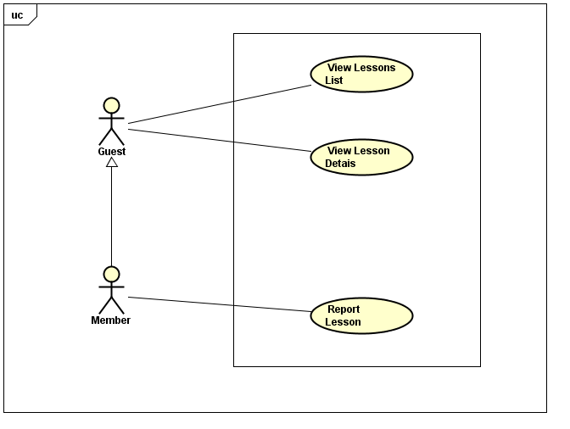

Figure 3‑2 : UC: Learning

##### **UC-G-003: View Lessons List**

|  |  |  |  |  |
| --- | --- | --- | --- | --- |
| Use Case Name | View Lessons List | | | |
| Use Case ID | UC-G-003 | | | |
| Created By | QuanNH | Last Updated B**y** | | ThangPD |
| Date Created | 27/06/2016 | Date Last Updated | | 12/08/2016 |
| Actor | Guest, Member | | | |
| Description | User views list lessons of courses | | | |
| Pre-condition | * Website is available * “Courses” hyperlink is active in top menu * Course level hyperlink in dropdown list is active | | | |
| Trigger | User clicks “Course” link on top menu then clicks the hyperlink of the course level that user wants to choose in dropdown list | | | |
| Post Condition | System redirects to “Course” pagewhich displays lesson list in selected course level | | | |
| Main Success Scenario | | | | |
| Step | **User** | | **System’s Response** | |
| 1 | Clicks “Course” link on top menu | | Shows level dropdown list | |
| 2 | Clicks a course level hyperlink in dropdown list | | Redirect to “Courses” page and displays lesson list in the selected course | |

##### **UC-G-004: View Lesson Details**

|  |  |  |  |  |
| --- | --- | --- | --- | --- |
| Use Case Name | View Lesson Details | | | |
| Use Case ID | UC-G-004 | | | |
| Created By | QuanNH | Last Updated By | | ThangPD |
| Date Created | 27/06/2016 | Date Last Updated | | 19/07/2016 |
| Actor | Guest, Member | | | |
| Description | User views the content of the selected lesson | | | |
| Pre-condition | Website is available | | | |
| Trigger | User clicks “Study” button that belongs to the lesson user wants to study on “Course” page | | | |
| Post Condition | System redirects to “Lesson” pagewhich displays the content of the selected lesson | | | |
| Main Success Scenario | | | | |
| Step | **User** | | **System’s Response** | |
| 1 | Clicks “Study” button of a lesson on “Course” page | | Redirects to “Lesson” page and displays lesson content | |

#### Testing

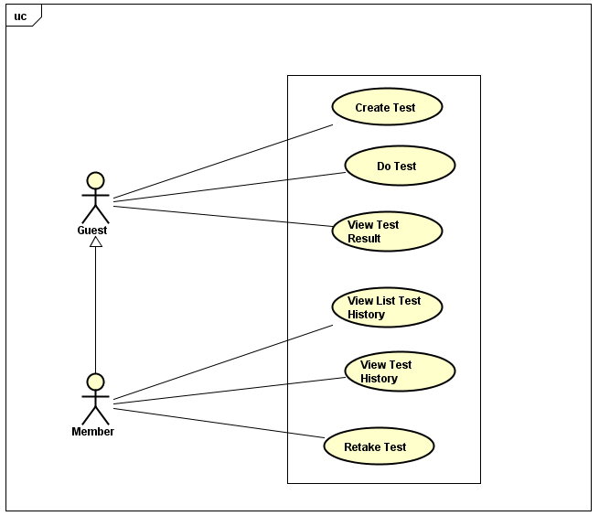

Figure ‑ UC: Testing

##### **UC-G-005: Create Test**

|  |  |  |  |  |
| --- | --- | --- | --- | --- |
| Use Case Name | Create Test | | | |
| Use Case ID | UC-G-005 | | | |
| Created By | QuanNH | Last Updated By | | ThangPD |
| Date Created | 04/07/2016 | Date Last Updated | | 14/08/2016 |
| Actor | Guest, Member | | | |
| Description | User setups to create a new test | | | |
| Pre-condition | Website is available | | | |
| Trigger | * User clicks “Test” link at top menu * User clicks “Level” dropdown list to select difficulty level * User clicks “Test skill” dropdown list to select the skill that user wants to test * User clicks the upward/downward arrow of “Number of question” spin box to increase/decrease the number of questions in test * User clicks “Create” button on “Test” page | | | |
| Post Condition | * + - * System redirects to “Test” page and displays test content which contains the questions in accordance with user’s setup       * If exceptions are thrown, the result must match with output of each described exception. | | | |
| Main Success Scenario | | | | |
| Step | **User** | | **System’s Response** | |
| 1 | Clicks “Test” link at top menu | | Redirects to “Test” page | |
| 2 | Clicks “Level” dropdown list to select difficulty level | |  | |
| 3 | Clicks “Test skill” dropdown list to select test skill | |  | |
| 4 | Clicks the upward/downward arrow of “Number of question” | | The number of questions goes up/down | |
| 5 | Clicks “Create” button on “Test” page | | System shows test content | |
| Exception | | | | |
| At step | **User** | | **System’s response** | |
| 5 | If there is no questions that can be generated in accordance with user’s selected level, skill | | Displays the message: “No question of this level & skill are added yet!” | |

##### **UC-G-006: Do Test**

|  |  |  |  |  |
| --- | --- | --- | --- | --- |
| Use Case Name | Do Test | | | |
| Use Case ID | UC-G-006 | | | |
| Created By | QuanNH | Last Updated By | | ThangPD |
| Date Created | 04/07/2016 | Date Last Updated | | 19/07/2016 |
| Actor | Guest, Member | | | |
| Description | User do test | | | |
| Pre-condition | * Website is available * Done UC-G-005 successfully | | | |
| Trigger | * User clicks the checkbox of the answer that user think is the right answer of a question. | | | |
| Main Success Scenario | | | | |
| Step | **User** | | **System’s Response** | |
| 1 | User clicks the checkbox of answers of questions | | The checkbox value changes to “true/false” value, indicating the answer(s) selected by user | |

##### **UC-G-007: View Test Result**

|  |  |  |  |  |
| --- | --- | --- | --- | --- |
| Use Case Name | View Exam Result | | | |
| Use Case ID | UC-G-007 | | | |
| Created By | QuanNH | Last Updated By | | ThangPD |
| Date Created | 04/07/2016 | Date Last Updated | | 19/07/2016 |
| Actor | Guest, Member | | | |
| Description | User submit test and views result | | | |
| Pre-condition | * Website is available | | | |
| Trigger | * + - * User clicks “Check Answer” button at bottom test content on “Taking Test” page to submit the test.       * User can also wait for time duration to run out so that the test is automatically submitted. | | | |
| Post Condition | System redirects to “Test Result” page which displays test result | | | |
| Main Success Scenario | | | | |
| Step | **User** | | **System’s Response** | |
| 1 | Clicks “Check Answer” button | | Redirects to “Test Result” page and displays test result | |

#### 3.1.1.4. Change Interface Language

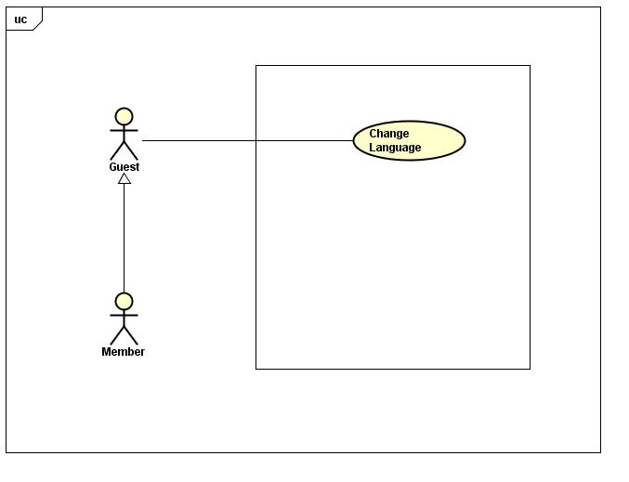

Figure 3‑4: UC: Change Interface Language

##### **3.1.1.4.1 UC-G-008: Change Language**

|  |  |  |  |  |
| --- | --- | --- | --- | --- |
| Use Case Name | Change Language | | | |
| Use Case ID | UC-G-008 | | | |
| Created By | ThangPD | Last Updated By | | ThangPD |
| Date Created | 27/07/2016 | Date Last Updated | | 05/08/2016 |
| Actor | Member | | | |
| Description | User changes language of website | | | |
| Pre-condition | Website is available | | | |
| Trigger | User clicks “Veazy” logo at the top of menu of the webpage | | | |
| Post Condition | System changes language of website to Japanese (if current language is English) or English (if current language is Japanese) | | | |
| Main Success Scenario | | | | |
| Step | **User** | | **System’s Response** | |
| 1 | Clicks “Veazy” logo | | System changes language of website to Japanese/English | |

### Member

#### Manage Account

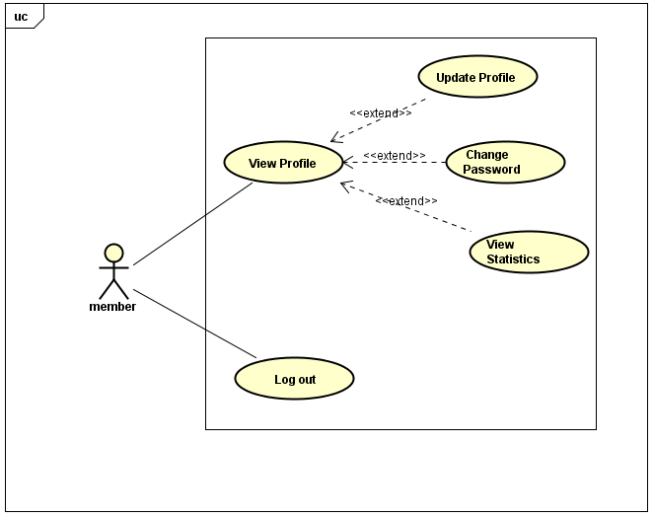

Figure ‑5. UC Manage Account

##### **UC-M-001: View Profile**

|  |  |  |  |  |
| --- | --- | --- | --- | --- |
| Use Case Name | View Profile | | | |
| Use Case ID | UC-M-001 | | | |
| Created By | QuanNH | Last Updated By | | ThangPD |
| Date Created | 27/06/2016 | Date Last Updated | | 29/07/2016 |
| Actor | Member | | | |
| Description | User views profile information | | | |
| Pre-condition | * Website is available * Member logged in the system | | | |
| Trigger | User clicks username hyperlink at the right corner of top menu of website | | | |
| Post Condition | System redirects to “User Profile” page | | | |
| Main Success Scenario | | | | |
| Step | **User** | | **System’s Response** | |
| 1 | User clicks username hyperlink at the right corner of top menu | | Redirects to “User Profile” page | |

##### **UC-M-002: Update Profile**

|  |  |  |  |  |
| --- | --- | --- | --- | --- |
| Use Case Name | Update Profile | | | |
| Use Case ID | UC-M-002 | | | |
| Created By | QuanNH | Last Updated By | | ThangPD |
| Date Created | 04/07/2016 | Date Last Updated | | 29/07/2016 |
| Actor | Member | | | |
| Description | User edits information of their own profile | | | |
| Pre-condition | * Website is available * Member logged in the system * Done UC-M-001 successfully | | | |
| Trigger | * User clicks “Update Profile” in “Actions” dropdown list * User inputs information (including first name, last name, birthday, address, hobbies, about me, favorite quote, website) * User clicks “Save” button at the bottom of “Update Profile Information” popup | | | |
| Post Condition | * System closes dialog, reloads “User Profile” page and show update successfully * If exceptions are thrown, the result must match with output of each described exception. | | | |
| Main Success Scenario | | | | |
| Step | **User** | | **System’s Response** | |
| 1 | Clicks “Update Profile” in “Actions” dropdown list | | Shows “Update Profile Information” popup | |
| 2 | Inputs first name, last name, birthday, address, hobbies, about me, favorite quote, website in respective textbox | |  | |
| 3 | Click “Save” button. | | Updated information of user, then closes popup and reloads “User Profile” page | |
| Alternative Scenario | | | | |
| At step | **User** | | **System’s Response** | |
| 3 | Clicks “Cancel” button | | Cancels editing profile action and closes “Update Profile Information” popup | |
| Exception | | | | |
| At Step | **User** | | **System’s Response** | |
| 2 | If any of those textbox is null | | System skips and does not update the information of the textbox | |

##### **UC-M-003: Change Password**

|  |  |  |  |  |
| --- | --- | --- | --- | --- |
| Use Case Name | Change Password | | | |
| Use Case ID | UC-M-003 | | | |
| Created By | QuanNH | Last Updated By | | ThangPD |
| Date Created | 27/06/2016 | Date Last Updated | | 29/07/2016 |
| Actor | Member | | | |
| Description | User changes their password | | | |
| Pre-condition | * Website is available * Member logged in the system * Done UC-M-001 successfully | | | |
| Trigger | * User click “Change Password” in “Actions” dropdown list * User inputs current password, new password and re-type new password * User clicks “Change” button at the bottom of “Change Password” popup | | | |
| Post Condition | * System stays on initial screen and password is changed successfully. * If exceptions are thrown, the result must match with output of each described exception. | | | |
| Main Success Scenario | | | | |
| Step | **User** | | **System’s Response** | |
| 1 | Clicks “Change Password” in“Actions” dropdown list. | | Shows “Change password” popup | |
| 2 | Inputs current password, new password and password confirmation | |  | |
| 3 | Clicks “Change” button. | | Changes password successfully and closes popup | |
| Alternative Scenario | | | | |
| At Step | **User** | | **System’s Response** | |
| 3 | Clicks “Cancel” button | | Cancels changing password action and closes “Change Password” popup | |
| Exception | | | | |
| At Step | **User** | | **System’s Response** | |
| 2 | If “Current Password” textbox is null | | Displays the message: “Password required!” | |
| 2 | If “New Password” textbox is null | | Displays the message: “Password required!” | |
| 2 | If new password and re-typed password is not the same | | Displays the message: “Password does not match” | |
| 2 | If user inputs new password that is less than 6 characters | | Displays the message: “Password must be at least 6 characters long!” | |
| 2 | If user inputs new password that is more than 32 characters | | Displays the message: “Password must be no more than 32 characters long!” | |
| 2 | If current password is incorrect | | Displays the message: “Incorrect password!” | |

##### **UC-M-005: View Statistics**

|  |  |  |  |  |
| --- | --- | --- | --- | --- |
| Use Case Name | View Statistics | | | |
| Use Case ID | UC-M-005 | | | |
| Created By | QuanNH | Last Updated By | | ThangPD |
| Date Created | 27/06/2016 | Date Last Updated | | 29/07/2016 |
| Actor | Member | | | |
| Description | User views statistics assessed based on their test marks | | | |
| Pre-condition | * Website is available * Member logged in the system * Done UC-M-001 successfully | | | |
| Trigger | User clicks “Statistics” hyperlink on “User Profile” page | | | |
| Post Condition | System shows statistics successfully | | | |
| Main Success Scenario | | | | |
| Step | **User** | | **System’s Response** | |
| 1 | Click “Statistics” button in “User Profile” page | | System displays 3 types of statistics: radar chart of level, line chart of 10 recently taken tests and bar chart of skills. | |

##### **UC-M-006: Logout**

|  |  |  |  |  |
| --- | --- | --- | --- | --- |
| Use Case Name | Logout | | | |
| Use Case ID | UC-M-006 | | | |
| Created By | QuanNH | Last Updated By | | ThangPD |
| Date Created | 27/06/2016 | Date Last Updated | | 12/07/2016 |
| Actor | Member | | | |
| Description | User logs out of Veazy system | | | |
| Pre-condition | * Website is available * Member logged in the system | | | |
| Trigger | User clicks username hyperlink at the right top of menu then clicks “Logout” hyperlink in dropdown list | | | |
| Post Condition | Redirect to “Login” page and signs user out successfully | | | |
| Main Success Scenario | | | | |
| Step | **User** | | **System’s Response** | |
| 1 | Clicks username hyperlink at the right top of menu | | Shows dropdown list | |
| 2 | Clicks “Logout” hyperlink in dropdown list | | Signs user out, then redirects to “Login” page | |

#### C:\Users\Shiba Tatsuya\Desktop\report.PNG Report Content

Figure ‑6. UC Report Content

##### **UC-M-007: Report Lesson**

|  |  |  |  |  |
| --- | --- | --- | --- | --- |
| Use Case Name | Report Lesson | | | |
| Use Case ID | UC-M-007 | | | |
| Created By | QuanNH | Last Updated By | | ThangPD |
| Date Created | 04/07/2016 | Date Last Updated | | 14/08/2016 |
| Actor | Member | | | |
| Description | User sends reports about wrong content of lesson to Content Editor | | | |
| Pre-condition | * Website is available * Member logged in the system * Done UC-G-004 successfully | | | |
| Trigger | User clicks “Report” hyperlink on “Lesson” page | | | |
| Post Condition | System sends the report to Content Editor for review purpose | | | |
| Main Success Scenario | | | | |
| Step | **User** | | **System’s Response** | |
| 1 | Clicks “Report” hyperlink on “Lesson” page | | Shows “Report Lesson” popup | |
| 2 | Inputs content of report (i.e, the reason why user reports the lesson) | |  | |
| 2 | Clicks ”Report” button on “Report Lesson” popup | | Sends report to Content Editorfor review, then and displays the message “Your report has been submitted for review. Thank you for your contribution.” | |
| Alternative Scenario | | | | |
| At Step | **User** | | **System’s Response** | |
| 1 | Clicks “Cancel” button on “Report lesson” popup | | Cancels reporting lesson and closes the popup | |

##### **UC-M-008: Report Question**

|  |  |  |  |  |
| --- | --- | --- | --- | --- |
| Use Case Name | Report Question | | | |
| Use Case ID | UC-M-008 | | | |
| Created By | QuanNH | Last Updated By | | ThangPD |
| Date Created | 04/07/2016 | Date Last Updated | | 29/07/2016 |
| Actor | Member | | | |
| Description | User sends reports about wrong content of question to Content Editor | | | |
| Pre-condition | * Website is available * Member logged in the system * Done UC-G-006 successfully | | | |
| Trigger | User clicks “Report” button at the right side of the question that user wants to report on “Test Result” page | | | |
| Post Condition | System sends the report to Content Editor for review purpose | | | |
| Main Success Scenario | | | | |
| Step | **User** | | **System’s Response** | |
| 1 | Clicks “Report” button at the right of question | | Shows “Report question” popup | |
| 2 | Inputs content of report (i.e, the reason why user reports the question) | |  | |
| 3 | Clicks ”Report” button in “Report question” popup | | Sends the report to Content Editor for review, then and displays the message “Your report has been submitted for review. Thank you for your contribution.” | |
| Alternative Scenario | | | | |
| At Step | **User** | | **System’s Response** | |
| 3 | Clicks “Cancel” button on “Report question” popup | | Cancels reporting question and closes the popup | |

#### Test History



Figure ‑7. UC Test History

##### **UC-M-009: View List Test History**

|  |  |  |  |  |
| --- | --- | --- | --- | --- |
| Use Case Name | View List Test History | | | |
| Use Case ID | UC-M-009 | | | |
| Created By | QuanNH | Last Updated By | | ThangPD |
| Date Created | 27/06/2016 | Date Last Updated | | 20/07/2016 |
| Actor | Member | | | |
| Description | User views list of their taken test (aka test history) | | | |
| Pre-condition | * Website is available * Member logged in the system | | | |
| Trigger | User clicks “Test History” tabon “User Profile” page | | | |
| Post Condition | Shows list test history in “Test History” tab | | | |
| Main Success Scenario | | | | |
| Step | **User** | | **System’s Response** | |
| 1 | Clicks “Test History” tabon“User profile” page | | Shows a lists of taken test records and their details including skill of test, course level, time allowed & time taken, result. | |

##### **UC-M-010: View Test History**

|  |  |  |  |  |
| --- | --- | --- | --- | --- |
| Use Case Name | View Test History | | | |
| Use Case ID | UC-M-010 | | | |
| Created By | QuanNH | Last Updated By | | ThangPD |
| Date Created | 04/07/2016 | Date Last Updated | | 29/07/2016 |
| Actor | Member | | | |
| Description | User views the details of taken tests including all questions, answers (both true answers and their selected answers) as well as the test result | | | |
| Pre-condition | * Website is available * Member logged in the system * Done UC-M-009 successfully | | | |
| Trigger | User clicks “See result” in “Actions” dropdown list in user profile page | | | |
| Post Condition | System redirects to “Test Result” page | | | |
| Main Success Scenario | | | | |
| Step | **User** | | **System’s Response** | |
| 1 | Clicks “See result” in “Actions” dropdown list in user profile page | | Shows “Test Details” page | |

##### **UC-M-011: Retake Test**

|  |  |  |  |  |  |
| --- | --- | --- | --- | --- | --- |
| Use Case Name | Retake Test | | | | |
| Use Case ID | UC-M-011 | | | | |
| Created By | QuanNH | Last Updated By | | ThangPD | |
| Date Created | 04/07/2016 | Date Last Updated | | | 28/07/2016 |
| Actor | Member | | | | |
| Description | User takes the tests (in their test history list) one more time | | | | |
| Pre-condition | * Website is available * Member logged in the system * Done UC-M-009 successfully | | | | |
| Trigger | User clicks “Retake this test” in “Actions” dropdown list on “User Profile” page | | | | |
| Post Condition | System redirects to “Taking Test” page | | | | |
| Main Success Scenario | | | | | |
| Step | **User** | | **System’s Response** | | |
| 1 | Clicks “Actions” hyperlink on the top right corner of the test record | | Displays dropdown list | | |
| 2 | Clicks “Retake this test” hyperlink | | Replicates the tests and redirects to “Taking Test” page | | |
| Alternative Scenario | | | | | |
| At Step | **User** | | **System’s Response** | | |
| 2 | Click “Cancel” button | |  | | |
| Exception | | | | | |
| At Step | **User** | | **System’s Response** | | |

### Content Editor

#### Manage Account

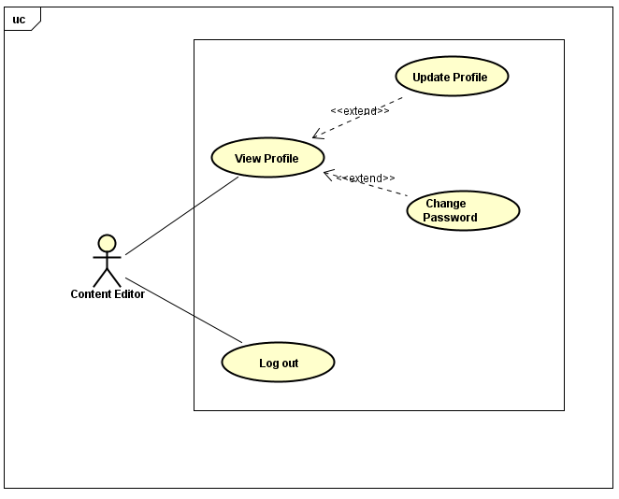

Figure ‑8. UC Manage Account

##### **UC-E-001: View Profile**

|  |  |  |  |  |
| --- | --- | --- | --- | --- |
| Use Case Name | View Profile | | | |
| Use Case ID | UC-E-001 | | | |
| Created By | QuanNH | Last Updated By | | ThangPD |
| Date Created | 27/06/2016 | Date Last Updated | | 29/07/2016 |
| Actor | Content Editor | | | |
| Description | User views their profile | | | |
| Pre-condition | * Website is available * Content editor logged in the system | | | |
| Trigger | User clicks username hyperlink at right-sided editor menu | | | |
| Post Condition | System redirects to “Editor Profile” page | | | |
| Main Success Scenario | | | | |
| Step | **User** | | **System’s Response** | |
| 1 | Clicks username hyperlink at the right of avatar | | Redirects to “Editor Profile” page | |

##### **UC-E-002: Update Profile**

|  |  |  |  |  |
| --- | --- | --- | --- | --- |
| Use Case Name | Update Profile | | | |
| Use Case ID | UC-E-002 | | | |
| Created By | QuanNH | Last Updated By | | ThangPD |
| Date Created | 04/07/2016 | Date Last Updated | | 29/07/2016 |
| Actor | Content Editor | | | |
| Description | User edits information of their own profile | | | |
| Pre-condition | * Website is available * Content editor logged in the system | | | |
| Trigger | * User clicks “Update Profile” in “Actions” dropdown list * User inputs information (including first name, last name, birthday, address, hobbies, about me, favorite quote, website) * User clicks “Save” button at the bottom of “Update Profile Information” popup | | | |
| Post Condition | * System closes the dialog, reloads “Editor Profile” page and shows update successfully * If exceptions are thrown, the result must match with output of each described exception. | | | |
| Main Success Scenario | | | | |
| Step | **User** | | **System’s Response** | |
| 1 | Clicks “Update Profile” in “Actions” dropdown list | | Shows “Update Profile Information” popup | |
| 2 | Inputs first name, last name, birthday, address, hobbies, about me, favorite quote, website in respective textbox | |  | |
| 3 | Clicks “Save” button | | Updates profile successfully, closes dialog and reload “Editor Profile” page | |
| Alternative Scenario | | | | |
| At Step | **User** | | **System’s Response** | |
| 3 | Clicks “Cancel” button. | | Cancels editing profile action and closes “Update Profile Information” popup | |
| Exception | | | | |
| At Step | **User** | | **System’s Response** | |
| 2 | If any of those textbox is null | | System skips and does not update the information of the textbox | |

##### **UC-E-003: Change Password**

|  |  |  |  |  |
| --- | --- | --- | --- | --- |
| Use Case Name | Change Password | | | |
| Use Case ID | UC-E-003 | | | |
| Created By | QuanNH | Last Updated By | | ThangPD |
| Date Created | 27/06/2016 | Date Last Updated | | 12/07/2016 |
| Actor | Content Editor | | | |
| Description | User changes their password | | | |
| Pre-condition | * Website is available * Content Editor logged in the system * Done UC-E-001 successfully | | | |
| Trigger | User clicks “Change password” hyperlink in “Actions” dropdown list on “Editor Profile” page | | | |
| Post Condition | * User click “Change Password” in “Actions” dropdown list * User inputs current password, new password and re-type new password * User clicks “Change” button at the bottom of “Change Password” popup | | | |
| Main Success Scenario | | | | |
| Step | **User** | | **System’s Response** | |
| 1 | Clicks “Change Password” in “Actions” dropdown list. | | Show “Change Password” popup | |
| 2 | Inputs current password, new password and password confirmation | |  | |
| 3 | Click “Save” button. | | Changes password successfully and closes popup | |
| Alternative Scenario | | | | |
| At Step | **User** | | **System’s Response** | |
| 1 | Clicks “Cancel” button. | | Cancels changing password action and closes “Change Password” popup | |
| Exception | | | | |
| At Step | **User** | | **System’s Response** | |
| 2 | If “Current Password” textbox is null | | Displays the message: “Password required!” | |
| 2 | If “New Password” textbox is null | | Displays the message: “Password required!” | |
| 2 | If new password and re-typed password is not the same | | Displays the message: “Password does not match” | |
| 2 | If user inputs new password that is less than 6 characters | | Displays the message: “Password must be at least 6 characters long!” | |
| 2 | If user inputs new password that is more than 32 characters | | Displays the message: “Password must be no more than 32 characters long!” | |
| 2 | If current password is incorrect | | Displays the message: “Incorrect password!” | |

##### **UC-E-004: Logout**

|  |  |  |  |  |
| --- | --- | --- | --- | --- |
| Use Case Name | Logout | | | |
| Use Case ID | UC-E-004 | | | |
| Created By | QuanNH | Last Updated By | | ThangPD |
| Date Created | 27/06/2016 | Date Last Updated | | 19/07/2016 |
| Actor | Content Editor | | | |
| Description | User logouts of the Veazy system | | | |
| Pre-condition | * Website is available * Content editorlogged in the system | | | |
| Trigger | User clicks “Logout” hyperlink at right-sided editor menu | | | |
| Post Condition | Signs user out successfully and redirects to “Login” page | | | |
| Main Success Scenario | | | | |
| Step | **User** | | **System’s Response** | |
| 1 | Click “Logout” hyperlink | | System redirects to “Login” page | |

#### Change Interface Language

##### **UC-E-005: Change Language**

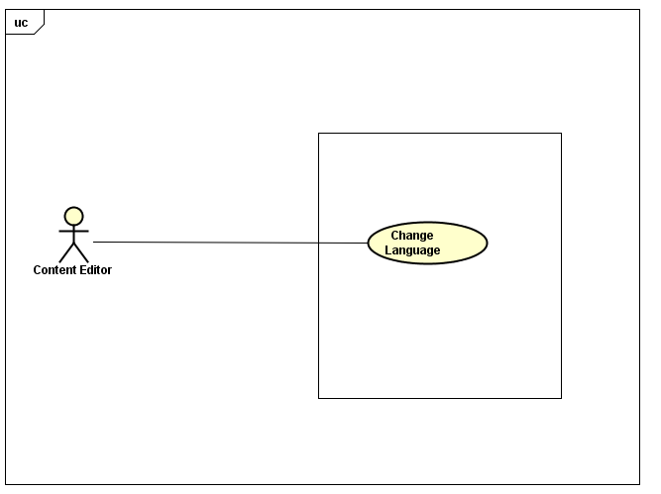

Figure 3‑9. UC Change language

|  |  |  |  |  |
| --- | --- | --- | --- | --- |
| Use Case Name | Change Language | | | |
| Use Case ID | UC-E-005 | | | |
| Created By | ThangPD | Last Updated By | | ThangPD |
| Date Created | 27/07/2016 | Date Last Updated | | 05/08/2016 |
| Actor | Content Editor | | | |
| Description | User changes language of website | | | |
| Pre-condition | Website is available | | | |
| Trigger | User clicks “Change Language To Japanese/English” hyperlink atright-sided editor menu | | | |
| Post Condition | System changes language of website to English/Japanese | | | |
| Main Success Scenario | | | | |
| Step | **User** | | **System’s Response** | |
| 1 | Click “Change Language to English/Japanese” hyperlink | | System changes language of website to English/Japanese | |

#### Manage Lessons

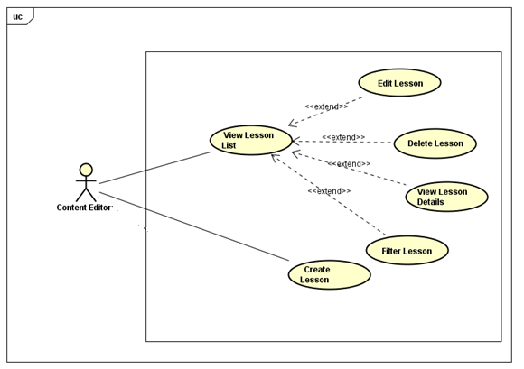

Figure 3‑10. UC Manage Lessons

##### **UC-E-006: View Lesson List**

|  |  |  |  |  |
| --- | --- | --- | --- | --- |
| Use Case Name | View Lesson List | | | |
| Use Case ID | UC-E-006 | | | |
| Created By | QuanNH | Last Updated By | | ThangPD |
| Date Created | 27/06/2016 | Date Last Updated | | 05/08/2016 |
| Actor | Content Editor | | | |
| Description | User views list lessons of courses | | | |
| Pre-condition | * Website is available * Content editor logged in the system | | | |
| Trigger | User clicks “Lessons” hyperlink at right-sided editor menu, then clicks “Lesson List” hyperlink | | | |
| Post Condition | System redirects to “Lesson List” page | | | |
| Main Success Scenario | | | | |
| Step | **User** | | **System’s Response** | |
| 1 | Clicks “Lessons” hyperlink | | Shows “Lesson List”hyperlink and “Add Lesson ” hyperlink | |
| 2 | Clicks “Lesson List” hyperlink | | Redirect to “Lesson List” page | |

##### **UC-E-007:Filter lesson**

|  |  |  |  |  |
| --- | --- | --- | --- | --- |
| Use Case Name | Search Lesson | | | |
| Use Case ID | UC-E-007 | | | |
| Created By | QuanNH | Last Updated By | | ThangPD |
| Date Created | 27/06/2016 | Date Last Updated | | 03/08/2016 |
| Actor | Content Editor | | | |
| Description | User searches lessons in lesson list page | | | |
| Pre-condition | * Website is available * Content editor logged in the system | | | |
| Trigger | * User chooses lesson level in “Level” dropdown list * User type a keyword in “Keyword” textbox * User clicks “Filter” button in lesson list page | | | |
| Post Condition | Searches lessons successfully. System filters all lessons of the selected level and contains the keyword, then displays results | | | |
| Main Success Scenario | | | | |
| Step | **User** | | **System’s Response** | |
| 1 | Choose lesson level in “Level” dropdown list | |  | |
| 2 | Inputs keyword in “Keyword” textbox | |  | |
| 3 | Clicks “Filter” button | | System filters and displays result | |

##### **UC-E-008: View Lesson Details**

|  |  |  |  |  |
| --- | --- | --- | --- | --- |
| Use Case Name | View Lesson Details | | | |
| Use Case ID | UC-E-008 | | | |
| Created By | QuanNH | Last Updated By | | ThangPD |
| Date Created | 27/06/2016 | Date Last Updated | | 05/08/2016 |
| Actor | Content Editor | | | |
| Description | User views lesson details | | | |
| Pre-condition | * Website is available * Content editor logged in the system | | | |
| Trigger | User clicks title name of the lessons in table that users want to view its detail | | | |
| Post Condition | System redirects to “Lesson Detail” page | | | |
| Main Success Scenario | | | | |
| Step | **User** | | **System’s Response** | |
| 1 | Click title name link | | Redirect to “Lesson Detail”page | |

##### **UC-E-009: Create Lesson**

|  |  |  |  |  |
| --- | --- | --- | --- | --- |
| Use Case Name | Create Lesson | | | |
| Use Case ID | UC-E-009 | | | |
| Created By | QuanNH | Last Updated B**y** | | ThangPD |
| Date Created | 27/06/2016 | Date Last Updated | | 12/08/2016 |
| Actor | Content Editor | | | |
| Description | User creates new lesson | | | |
| Pre-condition | * Website is available * Content editor logged in the system | | | |
| Trigger | User clicks “Lessons”hyperlinkat right-sided editor menu, then clicks “Add Lesson” hyperlink | | | |
| Post Condition | * System redirects to “Add Lesson” page * If exceptions are thrown, the result must match with output of each described exception. | | | |
| Main Success Scenario | | | | |
| Step | **User** | | **System’s Response** | |
| 1 | Clicks “Lessons” link | | Shows “Lesson List”hyperlink and “Add Lesson ” hyperlink | |
| 2 | Clicks “Add Lesson” hyperlink | | Redirects to “Add Lesson” page | |
| 3 | Inputs content of lesson for each section including vocabulary, grammar, conversation, listening, practice and reading | |  | |
| 4 | Clicks “Create” button | | Creates new lesson successfully and redirects to “Lesson Detail” page | |
| Exception | | | | |
| At Step | **User** | | **System’s Response** | |
| 3 | If “Title” textbox is null | | Displays the message: “Failed to create new lesson! Please make sure you do not leave any section content & lesson information blank.” | |
| 3 | If “Description” textbox is null | | Displays the message: “Failed to create new lesson! Please make sure you do not leave any section content & lesson information blank.” | |
| 3 | If any section of lesson is null or left blank | | Displays the message: “Failed to create new lesson! Please make sure you do not leave any section content & lesson information blank.” | |

##### **UC-E-010: Edit Lesson**

|  |  |  |  |  |
| --- | --- | --- | --- | --- |
| Use Case Name | Edit Lesson | | | |
| Use Case ID | UC-E-010 | | | |
| Created By | QuanNH | Last Updated By | | ThangPD |
| Date Created | 27/06/2016 | Date Last Updated | | 12/08/2016 |
| Actor | Content Editor | | | |
| Description | User edits content of a lesson | | | |
| Pre-condition | * Website is available * Content editor logged in the system | | | |
| Trigger | User clicks “Edit” button of the lesson in table that user wants to edit | | | |
| Post Condition | * System edits successfully and redirects to “Lesson Detail” page * If exceptions are thrown, the result must match with output of each described exception. | | | |
| Main Success Scenario | | | | |
| Step | **User** | | **System’s Response** | |
| 1 | Clicks “Edit” button | | Redirects to “Edit lesson” page | |
| 2 | Inputs content of lesson for each section including vocabulary, grammar, conversation, listening, practice and reading | |  | |
| 3 | Click “Update” button | | Updates successfully and redirect to “Lesson Detail” page. The version of lesson automatically goes up | |
| Alternative Scenario | | | | |
| At Step | **User** | | **System’s Response** | |
| 3 | Clicks “Save draft” button | | System saves the draft version of lesson so that the next time user edits the lesson, the draft version can be re-created. The lesson does not make any changes in content. | |
| 3 | Clicks “Back to Detail” button | | System redirects to “Lesson Detail” page | |
| Exception | | | | |
| At Step | **User** | | **System’s Response** | |

|  |  |  |
| --- | --- | --- |
| 3 | If “Title” textbox is null | Displays the message: “Failed to create new lesson! Please make sure you do not leave any section content & lesson information blank.” |
| 3 | If “Description” textbox is null | Displays the message: “Failed to create new lesson! Please make sure you do not leave any section content & lesson information blank.” |
| 3 | If any section of lesson is null or left blank | Displays the message: “Failed to create new lesson! Please make sure you do not leave any section content & lesson information blank.” |

##### **UC-E-011: Delete Lesson**

|  |  |  |  |  |
| --- | --- | --- | --- | --- |
| Use Case Name | Delete Lesson | | | |
| Use Case ID | UC-E-011 | | | |
| Created By | QuanNH | Last Updated By | | ThangPD |
| Date Created | 27/06/2016 | Date Last Updated | | 12/07/2016 |
| Actor | Content Editor | | | |
| Description | User deletes lesson | | | |
| Pre-condition | * Website is available * Content editor logged in the system | | | |
| Trigger | * User clicks “Delete” of the lesson in table that user wants to delete, then clicks “Delete” button in “Delete Lesson” popup | | | |
| Post Condition | Delete lesson successfully and system redirects to “Lesson list” page | | | |
| Main Success Scenario | | | | |
| Step | **User** | | **System’s Response** | |
| 1 | Clicks “Delete” button | | Shows “Delete Lesson” popup | |
| 2 | Clicks “Delete” button | | Deletes lesson and closes popup, then reload “Lesson List” page | |
| Alternative Scenario | | | | |
| At Step | **User** | | **System’s Response** | |
| 1 | Clicks “Cancel” button in “Delete Lesson” popup | | Cancels action of deleting system and closes popup | |
| Exception | | | | |
| At Step | **User** | | **System’s Response** | |

#### Manage Questions

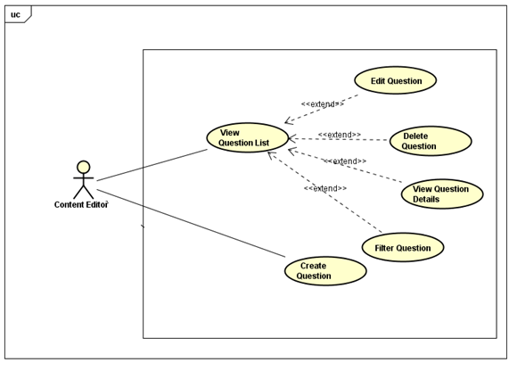

##### **UC-E-012: View Question List**

|  |  |  |  |  |
| --- | --- | --- | --- | --- |
| Use Case Name | View Question List | | | |
| Use Case ID | UC-E-012 | | | |
| Created By | QuanNH | Last Updated By | | ThangPD |
| Date Created | 04/07/2016 | Date Last Updated | | 05/08/2016 |
| Actor | Content Editor | | | |
| Description | User views list questions | | | |
| Pre-condition | * Website is available * Content editor logged in the system | | | |
| Trigger | User clicks “Questions” hyperlink at right-sided bar on dashboard, then clicks “Questions List” hyperlink | | | |
| Post Condition | View questions list successfully and system redirects to “Questions List” page | | | |
| Main Success Scenario | | | | |
| Step | **User** | | **System’s Response** | |
| 1 | Clicks “Questions” hyperlink at right-sided editor menu | | Shows “Question List” hyperlink and “Add Question” Hyperlink | |
| 2 | Clicks “Question List” hyperlink | | Redirects to “Question List” page | |

##### **UC-E-013: Filter question**

|  |  |  |  |  |
| --- | --- | --- | --- | --- |
| Use Case Name | Search Question | | | |
| Use Case ID | UC-E-013 | | | |
| Created By | QuanNH | Last Updated By | | ThangPD |
| Date Created | 04/07/2016 | Date Last Updated | | 04/08/2016 |
| Actor | Content Editor | | | |
| Description | User searches question | | | |
| Pre-condition | * Website is available * Content editor logged in the system | | | |
| Trigger | * User chooses question type in “Type” dropdown list on “Question List” page * User chooses question level in “Level” dropdown liston “Question List” page * User chooses question skill in “Skill” dropdown liston“Question List” page * User inputs a keyword in “Keyword” textbox * User clicks “Filter” button in question list page | | | |
| Post Condition | Search questions successfully and system filtersall questions of the selected combination of type, level, skill and contains the keyword, then displays results | | | |
| Main Success Scenario | | | | |
| Step | **User** | | **System’s Response** | |
| 1 | User chooses question type in “Type” dropdown list | |  | |
| 2 | User chooses question level in “Level” dropdown list | |  | |
| 3 | User chooses question skill in “Skill” dropdown list | |  | |
| 4 | User clicks “Filter” button in question list page | | System filters and displays result | |

##### **UC-E-014: View Question Details**

|  |  |  |  |  |
| --- | --- | --- | --- | --- |
| Use Case Name | View Question Details | | | |
| Use Case ID | UC-E-014 | | | |
| Created By | QuanNH | Last Updated By | | ThangPD |
| Date Created | 04/07/2016 | Date Last Updated | | 19/07/2016 |
| Actor | Content Editor | | | |
| Description | User views question details | | | |
| Pre-condition | * Website is available * Content editor logged in the system * Done UC-E-014 successfully | | | |
| Trigger | User clicks “Click here to see content” hyperlink of the question in table on “Question List” page | | | |
| Post Condition | System redirects to “Question Detail” page | | | |
| Main Success Scenario | | | | |
| Step | **User** | | **System’s Response** | |
| 1 | Clicks “Click here to see content” hyperlink of a question | | Redirect to “Question Detail” page | |

##### **Create Question**

###### **3.1.3.4.4.1.UC-E-015: Create Single-typed Question**

|  |  |  |  |  |
| --- | --- | --- | --- | --- |
| Use Case Name | Create Single-typed Question | | | |
| Use Case ID | UC-E-015 | | | |
| Created By | QuanNH | Last Updated By | | ThangPD |
| Date Created | 27/06/2016 | Date Last Updated | | 12/08/2016 |
| Actor | Content Editor | | | |
| Description | User creates a new single-typed question (which includes question content and multiple answers) | | | |
| Pre-condition | Website is availableContent editor logged in the system | | | |
| Trigger | User click “Questions”hyperlink atright-sided editor menu, then click “Add Question” hyperlink | | | |
| Post Condition | Creates question successfully and system redirects to “Questions Detail” pageIf exceptions are thrown, the result must match with output of each described exception. | | | |
| Main Success Scenario | | | | |
| Step | **User** | | **System’s Response** | |
| 1 | Clicks “Add Question” hyperlink | | Redirects to “Add Question” Page | |
| 2 | Chooses “Single” in “Question Type” dropdown list | |  | |
| 3 | Chooses question level in “Level” dropdown list | |  | |
| 4 | Chooses question skill in “Test Skill” dropdown list | |  | |
| 5 | Inputs question and answer and chooses right answer | |  | |
| 6 | Clicks “+” button under answer list | | Adds one more answers into answer list of question | |
| 7 | Adds one more answers into answer list of question | |  | |
| 8 | Clicks “X” button at an answer | | Removes theanswer | |
| 9 | Clicks “Create” button | | Creates question successfully and redirects to “Question Detail” page | |
| Alternative Scenario | | | | |
| At Step | **User** | | **System’s Response** | |
| 4 | If user chooses “Listening” in “Test Skill” dropdown list | | Displays input that allows user select audio file | |
| Exception | | | | |
| At Step | **User** | | **System’s Response** | |
| 4 | If file chosen to upload is not “.mp3” type | | Displays the message: “This is not valid audio file. Only .mp3 type is allowed!” | |
| 5 | If “Question” textbox is null | | Displays the message: “Failed to create new question! Please make sure you do not leave any question & answer's contents blank.” | |
| 5 | If “Answer” textbox is null | | Displays the message: “Failed to create new question! Please make sure you do not leave any question & answer's contents blank.” | |
| 5 | If user does not choose at least 1 right answer | | Displays the message: “There must be at least one right answer in each question!” | |

###### **3.1.3.4.4.2.UC-E-016: Create Group-typed Question**

|  |  |  |  |  |
| --- | --- | --- | --- | --- |
| Use Case Name | Create Group-typed Question | | | |
| Use Case ID | UC-E-016 | | | |
| Created By | QuanNH | Last Updated By | | ThangPD |
| Date Created | 27/06/2016 | Date Last Updated | | 12/08/2016 |
| Actor | Content Editor | | | |
| Description | User creates new group-typed question (which include a section of reading paragraph and multiple questions) | | | |
| Pre-condition | Website is availableContent editor logged in the system | | | |
| Trigger | User click “Questions” hyperlink at right-sided editor menu, then click “Add Question” hyperlink | | | |
| Post Condition | Creates question successfully and system redirects to “Questions Detail” pageIf exceptions are thrown, the result must match with output of each described exception. | | | |
| Main Success Scenario | | | | |
| Step | **User** | | **System’s Response** | |
| 1 | Clicks “Add Question” hyperlink | | Redirects to “Add Question” Page | |
| 2 | Chooses “Group” in “Question Type” dropdown list | |  | |
| 3 | Chooses question level in “Level” dropdown list | | Show level dropdown list | |
| 4 | Input reading paragraph in “Content” editor | |  | |
| 5 | Inputs question and answer and choose right answer | |  | |
| 6 | Clicks “+” button under answer list | | Adds one more answers intothe question’s answer list of question | |
| 7 | Clicks “+” button under question label | | Adds one more single question into question list | |
| 8 | Clicks “X” button under answer list | | Removes the answer from the answer list of the question | |
| 9 | Clicks “X” button under question label | | Remove the question from question list | |
| 10 | Clicks time icon to select time allowed | |  | |
| 11 | Clicks “Create” button | | Creates question successfully and redirects to “Question Detail” page | |
| Exception | | | | |
| At Step | **User** | | **System’s Response** | |
| 4 | If “Content” section is null or left blank | | Displays the message: “Failed to create new question! Please make sure you do not leave any question & answer's contents blank.” | |
| 5 | If “Question” textbox is null | | Displays the message: “Failed to create new question! Please make sure you do not leave any question & answer's contents blank.” | |
| 5 | If “Answer” textbox is null | | Displays the message: “Failed to create new question! Please make sure you do not leave any question & answer's contents blank.” | |
| 5 | If user does not choose at least 1 right answer in each question | | Displays the message: “There must be at least one right answer in each question!” | |

##### **Edit Question**

###### **3.1.3.4.5.1.UC-E-017: Edit Question Single**

|  |  |  |  |  |
| --- | --- | --- | --- | --- |
| Use Case Name | Edit Question Single | | | |
| Use Case ID | UC-E-017 | | | |
| Created By | QuanNH | Last Updated By | | ThangPD |
| Date Created | 27/06/2016 | Date Last Updated | | 03/08/2016 |
| Actor | Content Editor | | | |
| Description | User edits the content of a single-typed question | | | |
| Pre-condition | * Website is available * Content editor logged in the system * Done UC-E-014 successfully | | | |
| Trigger | User clicks “Edit” button of a question in table on “Question List” page | | | |
| Post Condition | * Edit question successfully and redirect to“Question Detail”page * If exceptions are thrown, the result must match with output ofeach described exception. | | | |
| Main Success Scenario | | | | |
| Step | **User** | | **System’s Response** | |
| 1 | Clicks “Edit” button | | Redirects to “Edit Question” page | |
| 2 | Chooses question level in “Level” dropdown list | |  | |
| 3 | Chooses question skill in “Test Skill” dropdown list | |  | |
| 4 | Inputs question and answer and chooses right answer | |  | |
| 5 | Clicks “+” button under answer list | | Adds one more answers into answer list of question | |
| 6 | Adds one more answers into answer list of question | |  | |
| 7 | Clicks “X” button at an answer | | Removes the answer | |
| 8 | Clicks “Update” button | | Updates question successfully and redirects to “Question Detail” page | |
| Alternative Scenario | | | | |
| At Step | **User** | | **System’s Response** | |
| 4 | If user chooses “Listening” in “Test Skill” dropdown list | | Displays input that allows user select audio file | |
| 8 | Clicks “Back to Detail” button | | Cancels action of editing question and redirects to “Question Detail” page | |
| Exception | | | | |
| At Step | **User** | | **System’s Response** | |
| 3 | If file chosen to upload is not “.mp3” type | | Displays the message: “This is not valid audio file. Only .mp3 type is allowed!” | |
| 4 | If “Question” textbox is null | | Displays the message: “Failed to create new question! Please make sure you do not leave any question & answer's contents blank.” | |
| 4 | If “Answer” textbox is null | | Displays the message: “Failed to create new question! Please make sure you do not leave any question & answer's contents blank.” | |
| 4 | If user does not choose at least 1 right answer | | Displays the message: “There must be at least one right answer in each question!” | |

###### **3.1.3.4.5.2. UC-E-018: Edit Group-typed Question**

|  |  |  |  |  |
| --- | --- | --- | --- | --- |
| Use Case Name | Edit Group-typed Question | | | |
| Use Case ID | UC-E-018 | | | |
| Created By | QuanNH | Last Updated By | | ThangPD |
| Date Created | 27/06/2016 | Date Last Updated | | 12/08/2016 |
| Actor | Content Editor | | | |
| Description | User edits content of a group-typed question | | | |
| Pre-condition | * Website is available * Content editor logged in the system * Done UC-E-014 successfully | | | |
| Trigger | User clicks “Edit” button of a question in table on “Question List” page | | | |
| Post Condition | * Edit question successfully and redirect to “Question Detail” page * If exceptions are thrown, the result must match with output of each described exception. | | | |
| Main Success Scenario | | | | |
| Step | **User** | | **System’s Response** | |
| 1 | Clicks “Edit” button | | Redirects to “Edit Question” page | |
| 2 | Chooses question level in “Level” dropdown list | | Show level dropdown list | |
| 3 | Input reading paragraph in “Content” editor | |  | |
| 4 | Inputs question and answer and choose right answer | |  | |
| 5 | Clicks “+” button under answer list | | Adds one more answers into the question’s answer list of question | |
| 6 | Clicks “+” button under question label | | Adds one more single question into question list | |
| 7 | Clicks “X” button under answer list | | Removes the answer from the answer list of the question | |
| 8 | Clicks “X” button under question label | | Remove the question from question list | |
| 9 | Clicks time icon to select time allowed | |  | |
| 10 | Clicks “Update” button | | Edits question successfully and redirects to “Question Detail” page | |
| Alternative Scenario | | | | |
| At Step | **User** | | **System’s Response** | |
| 9 | Click “Back to Detail” button | | Cancel edit question and redirect to question detail page | |
| Exception | | | | |
| At Step | **User** | | **System’s Response** | |
| 3 | If “Content” section is null or left blank | | Displays the message: “Failed to create new question! Please make sure you do not leave any question & answer's contents blank.” | |
| 4 | If “Question” textbox is null | | Displays the message: “Failed to create new question! Please make sure you do not leave any question & answer's contents blank.” | |
| 4 | If “Answer” textbox is null | | Displays the message: “Failed to create new question! Please make sure you do not leave any question & answer's contents blank.” | |
| 4 | If user does not choose at least 1 right answer in each question | | Displays the message: “There must be at least one right answer in each question!” | |

##### **UC-E-019: Delete Question**

|  |  |  |  |  |
| --- | --- | --- | --- | --- |
| Use Case Name | Delete Lesson | | | |
| Use Case ID | UC-E-019 | | | |
| Created By | QuanNH | Last Updated By | | ThangPD |
| Date Created | 05/07/2016 | Date Last Updated | | 05/08/2016 |
| Actor | Content Editor | | | |
| Description | User deletes question | | | |
| Pre-condition | * Website is available * Content editor logged in the system * Done UC-E-014 successfully | | | |
| Trigger | User clicks “Delete” button of a question in table on “Question List” page | | | |
| Post Condition | Delete question successfully and system reloads “Question List” page | | | |
| Main Success Scenario | | | | |
| Step | **User** | | **System’s Response** | |
| 1 | Clicks “Delete” button on “Question List” page | | Shows “Delete Question” popup | |
| 2 | Clicks “Delete” button in popup | | Deletes question and closes popup, reload “Question List” page | |
| Alternative Scenario | | | | |
| At Step | **User** | | **System’s Response** | |
| 1 | Clicks “Cancel” button in “Delete Question” popup | | Cancels action of deleting system and closes popup | |
| Exception | | | | |
| At Step | **User** | | **System’s Response** | |

#### 3.1.3.5. Manage Reports

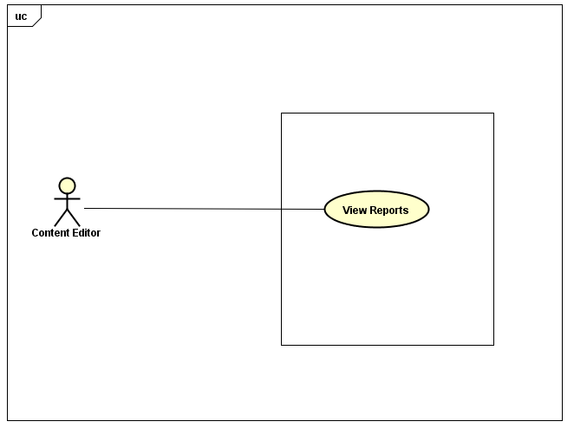

##### **3.1.3.5.1 UC-E-020: View Reports**

|  |  |  |  |  |
| --- | --- | --- | --- | --- |
| Use Case Name | View Reports | | | |
| Use Case ID | UC-E-020 | | | |
| Created By | QuanNH | Last Updated By | | ThangPD |
| Date Created | 27/06/2016 | Date Last Updated | | 25/07/2016 |
| Actor | Content Editor | | | |
| Description | User views reports about lesson & question sent from user | | | |
| Pre-condition | * + - * Website is available       * Content editor logged in the system | | | |
| Trigger | User clicks “Reports” hyperlink at the right-sided editor menu | | | |
| Post Condition | Redirects to “Report List” page which displays report list | | | |
| Main Success Scenario | | | | |
| Step | **User** | | **System’s Response** | |
| 1 | Click “Reports” hyperlink | | Redirects to “Report List” page and display reports list | |

##### **3.1.3.5.2 UC-E-021: View Reported Lesson**

|  |  |  |  |  |
| --- | --- | --- | --- | --- |
| Use Case Name | View Reported Lesson | | | |
| Use Case ID | UC-E-021 | | | |
| Created By | QuanNH | Last Updated By | | ThangPD |
| Date Created | 27/06/2016 | Date Last Updated | | 25/07/2016 |
| Actor | Content Editor | | | |
| Description | User views the content of the lesson reported by user for review purpose | | | |
| Pre-condition | * + - * Website is available       * Content editor logged in the system       * Done UC-E-020 successfully | | | |
| Trigger | User clickslesson title hyperlink in a report in table to display the detail of the lesson | | | |
| Post Condition | Redirects to “Lesson Detail” page which displays lesson detail | | | |
| Main Success Scenario | | | | |
| Step | **User** | | **System’s Response** | |
| 1 | Clicks lesson titlehyperlink | | Redirects to “Lesson Detail” page and displays the content of the lesson | |

##### **3.1.3.5.2 UC-E-022: View Reported Question**

|  |  |  |  |  |
| --- | --- | --- | --- | --- |
| Use Case Name | View Reported Question | | | |
| Use Case ID | UC-E-022 | | | |
| Created By | QuanNH | Last Updated By | | ThangPD |
| Date Created | 27/06/2016 | Date Last Updated | | 25/07/2016 |
| Actor | Content Editor | | | |
| Description | User views the content of the question reported by user for review purpose | | | |
| Pre-condition | * + - * Website is available       * Content editor logged in the system       * Done UC-E-020 successfully | | | |
| Trigger | User clicksquestion ID hyperlink in a report in table to display the detail of the lesson | | | |
| Post Condition | Redirects to “Question Detail” page which displays question detail | | | |
| Main Success Scenario | | | | |
| Step | **User** | | **System’s Response** | |
| 1 | Clicks question IDhyperlink | | Redirects to “Question Detail” page and displays the content of the question | |

### Administrator

#### Manage Account



##### **3.1.4.1.1 UC-A-001: View Profile**

|  |  |  |  |  |
| --- | --- | --- | --- | --- |
| Use Case Name | View Profile | | | |
| Use Case ID | UC-A-001 | | | |
| Created By | QuanNH | Last Updated By | | ThangPD |
| Date Created | 27/06/2016 | Date Last Updated | | 19/07/2016 |
| Actor | Administrator | | | |
| Description | User views user’s profile detail | | | |
| Pre-condition | * Website is available * Admin logged in the system | | | |
| Trigger | User clicks username hyperlink at right-sided bar of admin dashboard | | | |
| Post Condition | System redirects to “Admin Profile” page | | | |
| Main Success Scenario | | | | |
| Step | **User** | | **System’s Response** | |
| 1 | Clicks username hyperlink at the right of avatar | | Redirects to “Admin Profile” page | |

##### **3.1.4.1.2 UC-A-002: Update Profile**

|  |  |  |  |  |
| --- | --- | --- | --- | --- |
| Use Case Name | Update Profile | | | |
| Use Case ID | UC-A-002 | | | |
| Created By | QuanNH | Last Updated By | | ThangPD |
| Date Created | 04/07/2016 | Date Last Updated | | 29/07/2016 |
| Actor | Administrator | | | |
| Description | User edits information of their own profile | | | |
| Pre-condition | * Website is available * Admin logged in the system * Done UC-A-001 successfully | | | |
| Trigger | * User inputs information (including first name, last name, birthday, address, hobbies, about me, favorite quote, website) * User clicks “Save” button at the bottom of “Update Profile Information” popup Information” popup | | | |
| Post Condition | * System closes the dialog, reloads “Admin Profile” page and shows update successfully * If exceptions are thrown, the result must match with output of each described exception. | | | |
| Main Success Scenario | | | | |
| Step | **User** | | **System’s Response** | |
| 1 | Clicks “Update Profile” in “Actions” dropdown list | | Shows “Update Profile Information” popup | |
| 2 | Inputsfirst name, last name, birthday, address, hobbies, about me, favorite quote, website in respective textbox | |  | |
| 3 | Clicks “Save” button | | Updates profile successfully, closes dialog and reload “Admin Profile” page | |
| Alternative Scenario | | | | |
| At step | **User** | | **System’s Response** | |
| 3 | Clicks “Cancel” button | | Cancels editing profile action and closes “Update Profile Information” popup | |
| Exception | | | | |
| At Step | **User** | | **System’s Response** | |
| 2 | If any of those textbox is null | | System skips and does not update the information of the textbox | |

##### **3.1.4.1.2 UC-A-003: Change Password**

|  |  |  |  |  |
| --- | --- | --- | --- | --- |
| Use Case Name | Change Password | | | |
| Use Case ID | UC-A-003 | | | |
| Created By | QuanNH | Last Updated By | | ThangPD |
| Date Created | 27/06/2016 | Date Last Updated | | 19/07/2016 |
| Actor | Administrator | | | |
| Description | User change their password | | | |
| Pre-condition | * Website is available * Done UC-A-001 successfully * Admin logged in the system | | | |
| Trigger | User clicks “Change password” hyperlink in “Actions” dropdown list on “Editor Profile” page | | | |
| Post Condition | * + - * User click “Change Password” in “Actions” dropdown list       * User inputs current password, new password and re-type new password       * User clicks “Change” button at the bottom of “Change Password” popup | | | |
| Main Success Scenario | | | | |
| Step | **User** | | **System’s Response** | |
| 1 | Clicks “Change Password” in “Actions” dropdown list. | | Shows “Change Password” popup | |
| 2 | Inputs current password, new password and password confirmation | |  | |
| 3 | Click “Save” button. | | Changes password successfully and closes popup | |
| Alternative Scenario | | | | |
| At Step | **User** | | **System’s Response** | |
| 1 | Clicks “Cancel” button. | | Cancels changing password action and closes “Change Password” popup | |
| Exception | | | | |
| At Step | **User** | | **System’s Response** | |
| 2 | If “Current Password” textbox is null | | Displays the message: “Password required!” | |
| 2 | If “New Password” textbox is null | | Displays the message: “Password required!” | |
| 2 | If new password and re-typed password is not the same | | Displays the message: “Password does not match” | |
| 2 | If user inputs new password that is less than 6 characters | | Displays the message: “Password must be at least 6 characters long!” | |
| 2 | If user inputs new password that is more than 32 characters | | Displays the message: “Password must be no more than 32 characters long!” | |
| 2 | If current password is incorrect | | Displays the message: “Incorrect password!” | |

##### **UC-A-004: Logout**

|  |  |  |  |  |
| --- | --- | --- | --- | --- |
| Use Case Name | Logout | | | |
| Use Case ID | UC-A-004 | | | |
| Created By | QuanNH | Last Updated By | | ThangPD |
| Date Created | 27/06/2016 | Date Last Updated | | 19/07/2016 |
| Actor | Administrator | | | |
| Description | User logs out of the Veazy system | | | |
| Pre-condition | * Website is available * Admin login the website | | | |
| Trigger | User clicks “Logout” hyperlink at right-sided bar of admin dashboard | | | |
| Post Condition | Signs user out successfully and redirects to “Login” page | | | |
| Main Success Scenario | | | | |
| Step | **User** | | **System’s Response** | |
| 1 | Click “Logout” hyperlink at admin dashboard | | System redirects to “Login” page | |

#### Manage User

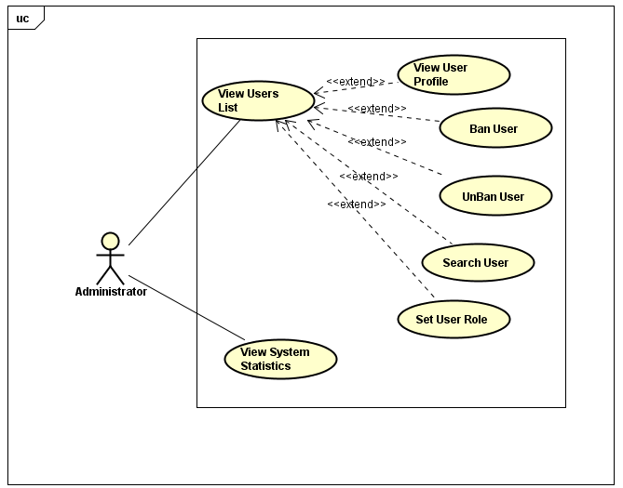

##### **3.1.4.2.1 UC-A-005: View User List**

|  |  |  |  |  |
| --- | --- | --- | --- | --- |
| Use Case Name | View User List | | | |
| Use Case ID | UC-A-005 | | | |
| Created By | QuanNH | Last Updated By | | QuanNH |
| Date Created | 27/06/2016 | Date Last Updated | | 12/07/2016 |
| Actor | Administrator | | | |
| Description | User views list of Veazy members | | | |
| Pre-condition | * Website is available * Admin logged in the system | | | |
| Trigger | Admin click “User Management” hyperlink at the right-sided administration menu | | | |
| Post Condition | System redirects to “User List” page which displays list of Veazy members, including both User and Editor | | | |
| Main Success Scenario | | | | |
| Step | **User** | | **System’s Response** | |
| 1 | Clicks “User Management” hyperlink | | Redirects to “User List” page and display member list | |

##### **3.1.4.2.2 UC-A-006: View User Profile**

|  |  |  |  |  |
| --- | --- | --- | --- | --- |
| Use Case Name | View User Profile | | | |
| Use Case ID | UC-A-006 | | | |
| Created By | QuanNH | Last Updated By | | QuanNH |
| Date Created | 27/06/2016 | Date Last Updated | | 12/07/2016 |
| Actor | Administrator | | | |
| Description | User views member's profile | | | |
| Pre-condition | * Website is available * Done UC-A-005 successfully * Admin logged in the system | | | |
| Trigger | Users username hyperlink of member in table on “User List” page | | | |
| Post Condition | System shows “User Profil1e” popup which displays user information including occupation, first name, last name, birthday, address, hobbies, favorite quote and website. | | | |
| Main Success Scenario | | | | |
| Step | **User** | | **System’s Response** | |
| 1 | Clicks username hyperlink | | Shows “User Profile” dialog and display user information | |

##### **UC-A-007: Assign User as Admin**

|  |  |  |  |  |
| --- | --- | --- | --- | --- |
| Use Case Name | Assign User as Admin | | | |
| Use Case ID | UC-A-007 | | | |
| Created By | QuanNH | Last Updated By | | QuanNH |
| Date Created | 27/06/2016 | Date Last Updated | | 12/07/2016 |
| Actor | Administrator | | | |
| Description | User assigns a user as admin of Veazy | | | |
| Pre-condition | * Website is available * Done UC-A-005 successfully * Admin logged in the system | | | |
| Trigger | User clicks “Manage” hyperlink of a user in table, then clicks “Assign as admin” in dropdown list | | | |
| Post Condition | The user is assigned as new admin of Veazysytem and can access exclusive features of admin after login. | | | |
| Main Success Scenario | | | | |
| Step | **User** | | **System’s Response** | |
| 1 | Click “Manage” hyperlink | | Show dropdown list that contains “Assign as editor”, “Assign as admin”, “Ban” hyperlink | |
| 2 | Clicks “Assign as admin” | | Changes user type of the user to “Admin” and reloads “User List” page, shows update successfully | |
| Alternative Scenario | | | | |
| At Step | **User** | | **System’s Response** | |
| Exception | | | | |
| At Step | **User** | | **System’s Response** | |

##### **UC-A-008: Assign User as Editor**

|  |  |  |  |  |
| --- | --- | --- | --- | --- |
| Use Case Name | Assign User as Editor | | | |
| Use Case ID | UC-A-008 | | | |
| Created By | QuanNH | Last Updated By | | QuanNH |
| Date Created | 27/06/2016 | Date Last Updated | | 12/07/2016 |
| Actor | Administrator | | | |
| Description | User sets role for member of system | | | |
| Pre-condition | * Website is available * Done UC-A-00 successfully * Admin logged in the system | | | |
| Trigger | User clicks “Manage” hyperlink of a user in table, then clicks “Assign as editor” in dropdown list | | | |
| Post Condition | The user is assigned as new editor of Veazy system and can access exclusive features of editor after login. | | | |
| Main Success Scenario | | | | |
| Step | **User** | | **System’s Response** | |
| 1 | Click “Manage” hyperlink | | Show dropdown list that contains “Assign as editor”, “Assign as admin”, “Ban” hyperlink | |
| Alternative Scenario | | | | |
| At Step | **User** | | **System’s Response** | |
| Exception | | | | |
| At Step | **User** | | **System’s Response** | |

##### **UC-A-009: Ban User**

|  |  |  |  |  |
| --- | --- | --- | --- | --- |
| Use Case Name | Ban user | | | |
| Use Case ID | UC-A-009 | | | |
| Created By | QuanNH | Last Updated By | | QuanNH |
| Date Created | 27/06/2016 | Date Last Updated | | 12/07/2016 |
| Actor | Administrator | | | |
| Description | User bans member | | | |
| Pre-condition | * Website is available * Done UC-A-006 successfully * Admin logged in the system * The status of the user is “Active” | | | |
| Trigger | User clicks “Manage” hyperlink of a user in table, then clicks “Ban” in dropdown list | | | |
| Post Condition | Systems reload “User List” page and shows update successfully. The user can no longer log in Veazy system under their username | | | |
| Main Success Scenario | | | | |
| Step | **User** | | **System’s Response** | |
| 1 | Clicks “Manage” hyperlink | | Shows dropdown list that contains “Assign as editor”, “Assign as admin”, “Ban” hyperlink | |
| 2 | Clicks “Ban” | | Changes user’s status to “Banned” and prevents that user from logging into system. | |

##### **UC-A-010: Unban User**

|  |  |  |  |  |
| --- | --- | --- | --- | --- |
| Use Case Name | Unban user | | | |
| Use Case ID | UC-A-010 | | | |
| Created By | QuanNH | Last Updated By | | QuanNH |
| Date Created | 27/06/2016 | Date Last Updated | | 12/07/2016 |
| Actor | Administrator | | | |
| Description | User unban member | | | |
| Pre-condition | * Website is available * Done UC-A-006 successfully * Admin logged in the system * The status of the user is “Banned” | | | |
| Trigger | User clicks “Manage” hyperlink of a user in table, then clicks “Unban” in dropdown list | | | |
| Post Condition | Systems reload “User List” page and shows update successfully. The user is enabled to log in Veazy system under their username | | | |
| Main Success Scenario | | | | |
| Step | **User** | | **System’s Response** | |
| 1 | Clicks “Manage” hyperlink | | Shows dropdown list that contains “Assign as editor”, “Assign as admin”, “Unban” hyperlink | |
| 2 | Clicks “Unban” | | Changes user’s status to “Active” and allow that user to log into system. | |

##### **UC-A-011: View System Statistics**

|  |  |  |  |  |
| --- | --- | --- | --- | --- |
| Use Case Name | View System Statistics | | | |
| Use Case ID | UC-A-011 | | | |
| Created By | QuanNH | Last Updated By | | QuanNH |
| Date Created | 27/06/2016 | Date Last Updated | | 12/07/2016 |
| Actor | Administrator | | | |
| Description | User views statistics of system | | | |
| Pre-condition | * Website is available * Admin logged in the system | | | |
| Trigger | Clicks “Statistics” hyperlink at right-sided admin menu | | | |
| Post Condition | Systems redirect to “System Statistics” page which displays the statistics of users, lessons, questions and reports | | | |
| Main Success Scenario | | | | |
| Step | **User** | | **System’s Response** | |
| 1 | Clicks “Statistics” hyperlink | | Redirects to “System Statistics” page and displays statistics of users, lessons, questions and reports | |

## Usability

* Interface should be simple, clear, user-friendly, easy to learn how to use and easy to remember how to use.
* Interface design should support the following from the perspectives of its primary users:
  + Efficiency of use: each action is taken by no more than 8 steps.
  + Intuitiveness: the interface is easy to learn and navigate: buttons, headings, and help/error messages are simple to read and understand.
  + Low perceived workload: the interface appears easy to use, rather than intimidating, demanding and frustrating.
* Users need to understand the function of each section to be able to use reasonable discretion and its effectiveness.
* Users should be supported and guided how to use the functionality of the system to use system easily after short time.
  + In the role “Administrator” – after 2 hours of training
  + In the role “Content Editor” – after 1 hour of training
  + In the role “Member” – after 30 minutes of training
  + In the role “Guest” – after 15 minutes of training
* The system should have the flexibility to be can satisfied future changed as:
  + Can add more lessons, tests and new words.
  + Changes in processing of information.
* The system must meet the requirements for data memory, need to calculate the amount of memory to be able to meet the requirements of the development of the system.

## Security

* + - * Password of user is md5-hashed before being sent in request to server and saved into database
      * Request sent from client is authorize using cookies.

## Maintainability & Extensibility

* + - * Strictly follow Java & JavaScript best practices and English-like syntax naming convention in order to help improve readability of source code and keep the Veazy website maintainable in the future.

## Performance

* Response time when accessing an action on the system depending on system condition such as number of visitors, access tasks.
* Time for loading image, media will be at most 15 seconds and time to progress any function will not exceed 17 seconds.

## Supportability

* + - * Web system is written in Java and Bootstrap, easily manage and upgrade and easily connect to database system.

## Design Constraints

* Because the system is built on the Web Platform, therefore development language easily manages and upgrade.
* The system must execute independently, less influenced by other systems and capable of performing well on many different operating systems.

## User Manual Documentation

* Integration guild with both English and Japanese language, image and clear explanation

# SUPPORTING INFORMATION

## 4.1 Appendices:

### 4.1.1 Appendix 1:

830-1998 - IEEE Recommended Practice for Software Requirements Specifications

“The content and qualities of a good software requirements specification (SRS) are described, and several sample SRS outlines are presented. This recommended practice is aimed at specifying the requirements of software to be developed, but can also be applied to assist in the selection of in-house and commercial software products. Guidelines for compliance with IEEE/EIA Std 12207.1-1997 are also provided.”

https://standards.ieee.org/findstds/standard/830-1998.html