|  |  |
| --- | --- |
|  | **MINISTRY OF EDUCATION AND TRAINING** |

**FPT UNIVERSITY**

**CAPSTONE PROJECT DOCUMENT**

**AGC101**

**Report #2 – Software Project Management Plan**

|  |  |
| --- | --- |
| **Tra Da** | |
| **Group Member** | SE03451 – Soulivong Phimmathong |
| SE03271 – Hoang Van Canh |
| SE03030 – Vu Hoang Hieu |
| SE03193 – Nguyen Hoang |
| SE03334 – Nguyen Huu Thao |
| **Supervisor** | Nguyen Van Sang |
| **Project Code** | AGC101 |

Hanoi, May 2016 – August 2016

Table of Contents

1 INTRODUCTION 4

1.1 Purpose 4

1.2 Definition and Acronyms 4

1.3 References 4

2 PROJECT OVERVIEW 5

2.1 Project Description 5

2.2 Scope 5

2.3 Standard Objectives 6

2.4 Milestone and Deliverables 6

3 PROJECT ORGANIZATION 8

3.1 Software Process Model 8

3.1.1 Inception phase 9

3.1.2 Elaboration phase 9

3.1.3 Construction phase 9

3.1.4 Transition phase 9

3.2 Project lifecycle 10

3.3 Organizational Chart 11

3.4 Roles and Responsibilities 11

4 TOOLS AND INFRASTRUCTURES 13

4.1 Hardware tool 13

4.2 Software tool 14

5 SCHEDULE 16

5.1 Detailed Schedule 16

5.2 Meeting Schedule 17

5.3 Effort Estimation 17

6 RISK MANAGEMENT 18

6.1 Risk Register 18

6.2 Risk probability and impact matrix 18

7 QUALITY MANAGEMENT 18

7.1 Quality Checklist 18

7.2 Quality Assurance 19

7.3 Quality Control 20

8 CODING CONVENTION 21

8.1 Php naming convention 21

8.2 File naming convention 21

# 1 INTRODUCTION

## Purpose

The purpose of this document is to be used as a guide for AGC software development process, it briefly describes steps of what to be doing first and later. The document will be used by project manager to ensure AGC web application will be completed successfully.

## Definition and Acronyms

|  |  |  |
| --- | --- | --- |
| Acronym & Abbreviation | Full form | Definition |
| AGC | AGC | Project name |
| AGC101 | AGC101 | Project code |
| Tra Da | Tra Da | Group name |
| SRS | Software Requirements Specification | A document |
| SPMP | Software Project Management plan | A document |
| SDD | Software Design Description | A document |
| STD | Software Test Documentation | A document |
| SUM | Software User’s Manual | A document |
| IDE | Integrated Environment Development | Software development tool |
| QA | Quality Assurance |  |
| QC | Quality Control |  |

Table 1 Definitions and Acronyms

## References

1. *Information Technology Project Management | 7e Kathy Schwalbe textbook.*
2. [*http://www.projectmanagementdocs.com/project-documents/quality-checklist.html#axzz49LxmQ8h0*](http://www.projectmanagementdocs.com/project-documents/quality-checklist.html#axzz49LxmQ8h0)
3. [*https://en.wikipedia.org/wiki/Rational_Unified_Process*](https://en.wikipedia.org/wiki/Rational_Unified_Process)
4. *AGC_WorkSchedule.mpp*
5. *AGC_Risk_Register.xlsx*
6. *AGC_Risk_Probablity_and_Impact_Matric.xlsx*

# PROJECT OVERVIEW

## Project Description

We plan to create a responsive website that assembles restaurants in Hanoi, Vietnam.

All information gathered will be organized neatly and accurately publish to users. On the other hand, restaurant owners will be able to post their menus, services and detailed description of their restaurants on AGC website.

## Scope

**In Scope**

* Gather all types of restaurants in Hanoi, Vietnam in Vietnam
* Customer will be able to perform table booking, interact with social network and view general information in the system
* Restaurant owner will have functionalities to add/update/delete his/her restaurant information as well as updating table booking status
* Admin will be able to control users’ accounts and view numbers of users and restaurants’ account

**Out scope:**

* Choosing menu in a restaurant online
* Developing mobile web based application
* Online payment functionalities

## Standard Objectives

1. Deploy the project before August 27, 2016.
2. Fulfil all requirements specified in SRS.
3. Submit all reports to FPT university capstone stone project committees and academic department.
4. Successfully defense thesis at FPT University.

## Milestone and Deliverables

* **Milestones**

|  |  |  |
| --- | --- | --- |
| **No** | **Milestones** | **Date** |
| **1** | Hold kick – off meeting | 13 Apr 2016 |
| **2** | Completed Report No. 1 Introduction | 25 April 2016 |
| **3** | Created project schedule | 30 Apr 2016 |
| **4** | Completed Report No. 2 SPMP | 5 May 2016 |
| **5** | Competed writing use case | 12 May 2016 |
| **6** | Completed Report No. 3 SRS | 15 May 2016 |
| **7** | Complete Report No. 4 SDD | 5 Jun 2016 |
| **8** | Complete coding and unit test | 3 Aug 2016 |
| **9** | Deliver tested codes (Code demo 1) | 12 Aug 2016 |
| **10** | Completed Report No. 5 STD | 12 Aug 2016 |
| **11** | Completed Report No. 6 SUM | 17 Aug 2016 |
| **12** | Represent capstone project and close the project | 31 Aug 2016 |

Table 2 Milestones

* **Deliverables**

|  |  |  |  |  |
| --- | --- | --- | --- | --- |
| **No** | **Deliverables** | **Format** | **Delivery Date** | **Delivery Method** |
| **Internal deliverables** | | | | |
| **1** | AGC_WorkSchedule | .mpp | 12 May 2016 | GitHub repository |
| **2** | AGC_Risk_Register | .xlsx | 13 May 2016 | GitHub repository |
| **3** | AGC_Test_Case | .xlsx | 6 Aug 2016 |  |
| **External deliverables** | | | | |
| **1** | Report No.1 Introduction | .docx | 25 Apr 2016 | GitHub repository |
| **2** | Report No. 2 SPMP | .docx | 5 May 2016 | GitHub repository |
| **3** | Report No. 3 SRS | .docx | 15 May 2016 | GitHub repository |
| **4** | Report No. 4 SDD | .docx | 5 Jun 2016 | GitHub repository |
| **5** | Report No.5 STD | .docx | 12 Aug 2016 | GitHub repository |
| **6** | Report No.6 SUM | .docx | 17 Aug 2016 | GitHub repository |
| **7** | The CD - Source Code Executable Program Package | .rar | 24 Aug 2016 | Hand directly by hand |
| **8** | Final documentation | .docx | 24 Aug 2016 | Hand directly by hand |

Table 3 Deliverables

# PROJECT ORGANIZATION

## Software Process Model

We use Rational Unified Process model to develop AGC website. The Rational Unified Process (RUP) is an [iterative](https://en.wikipedia.org/wiki/Iterative_and_incremental_development) [software development process](https://en.wikipedia.org/wiki/Software_development_process) framework created by the [Rational Software](https://en.wikipedia.org/wiki/Rational_Software) Corporation, a division of [IBM](https://en.wikipedia.org/wiki/IBM) since 2003. RUP is not a single concrete prescriptive process, but rather an adaptable process [framework](https://en.wikipedia.org/wiki/Software_framework), intended to be tailored by the development organizations and software project teams that will select the elements of the process that are appropriate for their needs. RUP is a specific implementation of the [Unified Process](https://en.wikipedia.org/wiki/Unified_Process).

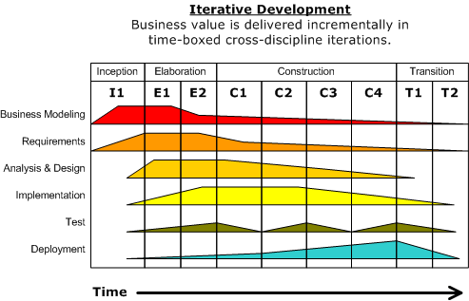

Figure 1: Rational Unified Process Model

### Inception phase

The primary objective is to scope the system adequately as a basis for validating initial costing and budgets. In this phase the business case which includes business context, success factors (expected revenue, market recognition, etc.), and financial forecast is established. To complement the business case, a basic use case model, project plan, initial risk assessment and project description (the core project requirements, constraints and key features) are generated.

### Elaboration phase

The primary objective is to mitigate the key risk items identified by analysis up to the end of this phase. The elaboration phase is where the project starts to take shape. In this phase the problem domain analysis is made and the architecture of the project gets its basic form. The key domain analysis for the elaboration is the system architecture.

### Construction phase

The primary objective is to build the software system. In this phase, the main focus is on the development of components and other features of the system. This is the phase when the bulk of the coding takes place. In larger projects, several construction iterations may be developed in an effort to divide the use cases into manageable segments that produce demonstrable prototypes.

This phase produces the first external release of the software. Its conclusion is marked by the initial operational capability milestone.

### Transition phase

The primary objective is to 'transit' the system from development into production, making it available to and understood by the end user. The activities of this phase include training the end users and maintainers and beta testing the system to validate it against the end users' expectations. The system also goes through an evaluation phase, any developer which is not producing the required work is replaced or removed. The product is also checked against the quality level set in the Inception phase.

If all objectives are met, the product release milestone is reached and the development cycle is finished.

## Project lifecycle

There are 4 phases in this development:

1. **Inception phase**

This is a first phase of project development. We plan to develop business case, software project management plan and prototype. Define scope, cost and schedule.

1. **Elaboration phase**

During this phase, we further analyze and complete the work in the Inception phase. Identifies users, develop use cases, prototype, and software architecture. After this stage we should have been able to decide whether the project is worth develop or not.

1. **Construction phase**

During this phase, all remaining components and application features are developed and integrated into the product. The main activities will be coding and testing.

1. **Transition phase**

Is the last phase in this software development life cycle, we will have a final check of overall project within Tra Da team and with the advisor to approve. Finally, presentation slide will be created. Then, all documentations and source codes will be submitted to FPT University thesis defense committees.

## Organizational Chart

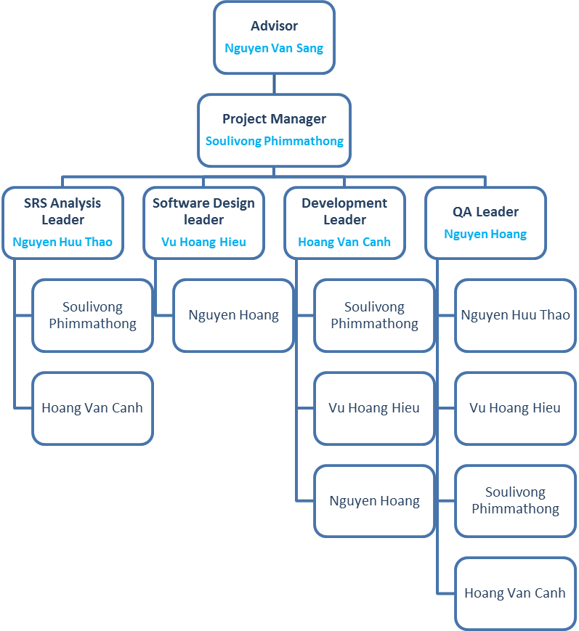

Figure 2: AGC101 Organizational Chart

## Roles and Responsibilities

|  |  |  |
| --- | --- | --- |
| **Full Name** | **Roles** | **Responsibilities** |
| **Nguyen Van Sang** | Team Advisor | * Give team direction. * Give team consultation. * Approve all deliverables. * Approve project success or fail. |
| **Soulivong Phimmathong** | Project Manager | * Oversee overall project. * Encourage and motivate members. * Initialize meeting. * Ensure all tasks will be all schedule * Divide and assign tasks. * Create SPMP. * Control work quality. |
| **SRS Analysis** | | |
| **Nguyen Huu Thao** | SRS Analysis Leader | * Lead collecting and analyzing software requirements. * Complete SRS documentation. |
| **Soulivong Phimmathong** | SRS Analysis member | * Work closely with the SRS analysis leader. |
| **Software Design** | | |
| **Vu Hoang Hieu** | Software design Leader | * Lead and design the look and feel of AGC web application. * Complete SDD documentation. |
| **Nguyen Hoang** | Software design member | * Work closely with the Software design leader. |
| **Development** | | |
| **Hoang Van Canh** | Development Leader | * Lead coding team. * Demonstrate the completed sytem. |
| **Soulivong Phimmathong** | Development member | * Work closely with the Development leader. |
| **Vu Hoang Hieu** | Development member | * Work closely with the Development leader. |
| **Nguyen Hoang** | Development member | * Work closely with the Development leader. |
| **Testing** | | |
| **Nguyen Hoang** | QA Leader | * Lead Testing team. * Complete STD. |
| **Nguyen Huu Thao** | QA member | * Work closely with the testing leader. |
| **Vu Hoang Hieu** | QA member | * Work closely with the testing leader. |
| **Soulivong Phimmathong** | QA member | * Work closely with the testing leader. |
| **Hoang Van Canh** | QA member | * Work closely with the testing leader. |

Table 4: Roles and Responsibilities

# TOOLS AND INFRASTRUCTURES

## Hardware tool

|  |  |  |
| --- | --- | --- |
| **Hardware** | **Purpose** | **Detail** |
| 5 Laptop computers | development tool | With minimum: 4GB RAM, 500GB Hard disk and Intel core i5, 1.80 GHz |
| 2 Android phones | testing tool | Android 5.0 |
| 2 IOS phones | testing tool | IOS 9 |
| 2 iPad | testing toll | Ipad 2 mini and iPad 4 |

Table 5 Hardware tool

## Software tool

|  |  |  |
| --- | --- | --- |
| **Category** | **Software** | **Version** |
| IDE | Netbeans IDE | 8.1 |
| MySQL Workbench | 6.3 CE |
| Operating system | Windows 7, 8.1, 10 | Home, Professional, Education |
| Communication | Facebook |  |
| Email |  |
| Skype |  |
| Documentation | Microsoft Word | 2013 |
| Microsoft Excel | 2013 |
| Microsoft PowerPoint | 2013 |
| Microsoft Project | 2007 |
| Database | MySQL |  |
| Data Repository | Google Drive |  |
| Git Hub and Tortoise Git |  |
| Facebook |  |
| Design | https://www.draw.io/ |  |
| https://pidoco.com/ |  |
| Enterprise Architect | 12.1 |
| Microsoft Visio | 2010 |
| Language | Php | 5.6 |
| Framework | CodeIgniter | 3.0.6 |
| Bootstrap | 3.3.7 |
| Server | XAMPP | 5.6 |
| Apache | 2.4 |

Table 6 Software tools

# SCHEDULE

## Detailed Schedule

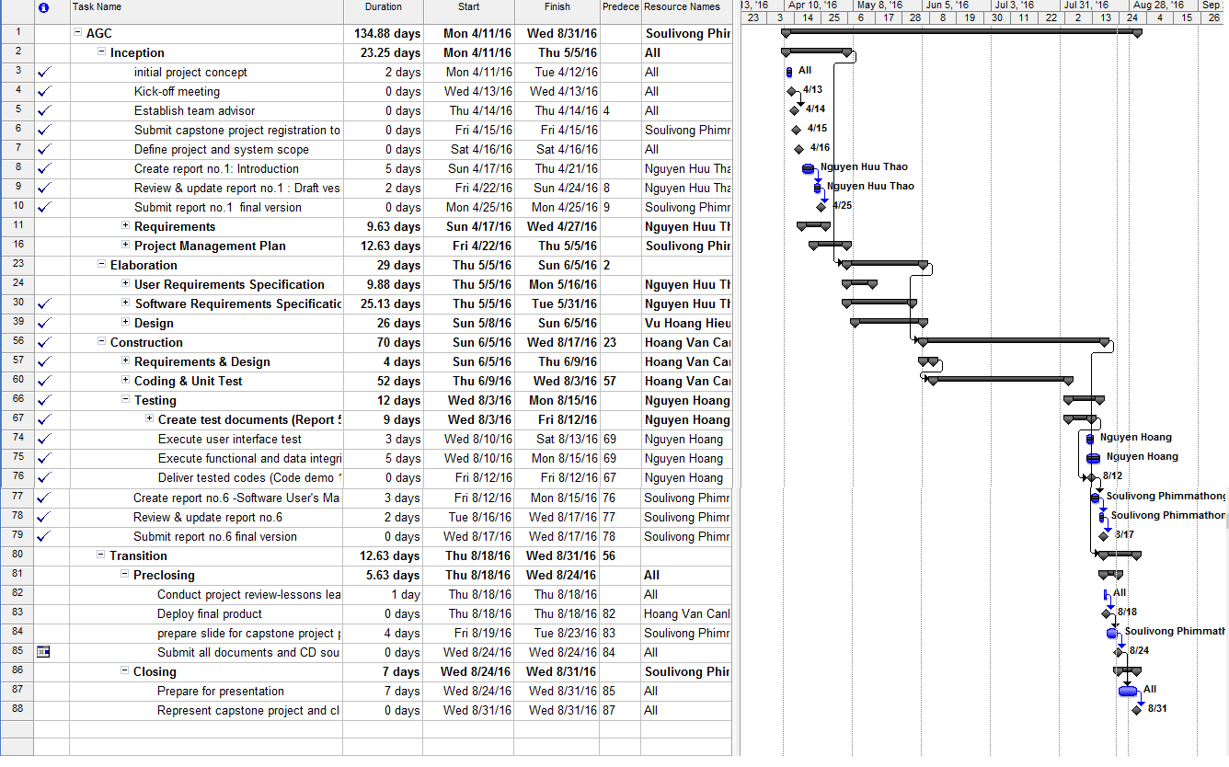

Figure 3: AGC_Project_Schedule

See AGC_WorkSchedule.mpp for details.

## Meeting Schedule

The meeting will normally held twice a week, In order to plan, and accomplish project’s objectives. We have the 2 following kind of meeting

1. **Tra Da with the Advisor**:

The advisor will call for the meeting once in a week on the weekday between 12:20 to 1:00 PM based on day available from 15 April to 12 June 2016. Then, from 13 June to 28 August 2016, the meeting will be hold on every Monday evening from 5:00 PM to 6:00 PM. Agenda includes guiding, reviewing, and giving recommendations from the advisor. Finally, questions from members are asked and answered instantly. The meeting result will be recorded in a note, then this note will be posted on Google Drive group folder.

1. **Team meeting**

This meeting is hold internally within Tra Da members (exclude an advisor). The meeting will be officially hold once a week, PM will create meeting agenda, specifically include reviewing the previous work, plan for incoming tasks and assign members to carry out the tasks. All team meeting result will be posted on Tra Da Facebook group.

Furthermore, we also have many minor meeting via instant messages on Facebook chat group.

## Effort Estimation

|  |  |  |  |
| --- | --- | --- | --- |
| **Task name** | **Worst case(days)** | **Best case(days)** | **Expected case(days)** |
| Inception | 25 | 17 | 24 |
| Elaboration | 40 | 23 | 30 |
| Construction | 80 | 60 | 70 |
| Transition | 25 | 13 | 20 |
| Total | 170 | 113 | 144 |

Table 7 Effort estimation

# RISK MANAGEMENT

## Risk Register

See AGC_Risk_Register.xlsx file for detail.

## Risk probability and impact matrix

See AGC_Risk_Probablity_and_Impact_Matric.xlsx for detail.

# QUALITY MANAGEMENT

## Quality Checklist

|  |  |  |  |  |  |
| --- | --- | --- | --- | --- | --- |
| **Quality Checklist** | | | | | |
| **Project: AGC101** | | | | **Date: 20 Aug 2016** | |
|  | **Verification** | | | | |
| **Quality Item** | **Yes** | **No** | **N/A** | | **Comments** |
| Does the project have an approved quality management plan? | Yes |  |  | |  |
| Has the quality management plan been reviewed by all stakeholders? | Yes |  |  | |  |
| Do all stakeholders have access to the quality management plan? | Yes |  |  | |  |
| Is the quality management plan consistent with the rest of the overall project plan? | Yes |  |  | |  |
| Have product quality metrics been established, reviewed, and agreed upon? | Yes |  |  | |  |
| Have process quality metrics been established, reviewed, and agreed upon? | Yes |  |  | |  |
| Is the project team familiar with the project's quality review process? |  | no |  | | QA still new to team members |
| Does the project have an appropriate number of resources assigned for quality assurance and control? | Yes |  |  | |  |
| Has the project team established a repository for all quality documentation? | Yes |  |  | |  |
| Do all team members have access to the quality documentation repository? | Yes |  |  | |  |
| Have all appropriate team members been notified of their required participation in quality reviews? | Yes |  |  | |  |
| Have quality responsibilities been assigned and documented and the applicable personnel notified? | Yes |  |  | |  |
| Have product and process quality standards been established, documented, and communicated? | Yes |  |  | |  |
| Have quality thresholds and limits been established, documented, and communicated? | Yes |  |  | |  |
| Does the change control process accommodate project changes based on quality improvements? | Yes |  |  | |  |
| Has a project quality manager been assigned? |  | no |  | | all members follow test cases |

Table 8 Quality checklist

## Quality Assurance

* Test coverage >= 90%
* 0 severity bug found, less than 10 bugs those are less harmful found.
* Passed unit test
* Passed integration test
* Accepted by the AGC advisor

## Quality Control

* Perform software testing level: Unit testing, Integration testing, System testing,
* Benchmarking by compare with the current website such as <http://pasgo.vn/>
* Use Check sheet to control defects as the template below:

|  |  |  |  |  |  |  |  |  |
| --- | --- | --- | --- | --- | --- | --- | --- | --- |
| **Defect** | **Mon** | **Tue** | **Wed** | **Thu** | **Fri** | **Sat** | **Sun** | **Total** |
| **Defect #1** |  |  |  |  |  |  |  |  |
| **Defect #2** |  |  |  |  |  |  |  |  |
| **Defect #3** |  |  |  |  |  |  |  |  |
| **Defect #4** |  |  |  |  |  |  |  |  |
| **Defect #5** |  |  |  |  |  |  |  |  |

Table 9 Defect check sheet

* ***Use scatter diagram for user satisfaction and age of respondent as the template below:***

|  |  |  |  |  |  |  |
| --- | --- | --- | --- | --- | --- | --- |
| **Age of Respondent** | **70** |  |  |  |  |  |
| **60** |  |  |  |  |  |
| **50** |  |  |  |  |  |
| **40** |  |  |  |  |  |
| **30** |  |  |  |  |  |
| **20** |  |  |  |  |  |
| **10** |  |  |  |  |  |
| **0** | **2** | **2.5** | **3** | **3.5** | **4** |
| **User Satisfaction rating** | | | | | |

Figure 4 QC scatter diagram

# CODING CONVENTION

## Php naming convention

Use meaningful English noun for variables and English verb for method and follow the following naming convention.

* ClassName – PascalCase
* methodName – camelCase
* propertyName – camelCase
* functionName – camelCase
* $variableName – camelCase

## File naming convention

Specified a meaningful name started each document with “AGC” and use underscores to separate spaces.

Ex: AGC _Report2_SPMP.docx