|  |  |
| --- | --- |
|  | **MINISTRY OF EDUCATION AND TRAINING** |

**FPT UNIVERSITY**

**CAPSTONE PROJECT DOCUMENT**

**Clinic Management**

**Report #2 – Software Project Management Plan**

|  |  |
| --- | --- |
| **ClinicManagement** | |
| **Group Member** | Phạm Khương Duy - 60195 |
| Nguyễn Văn Hơn - 60390 |
| Lê Ngọc Thành – SE60620 |
| Lê Văn Hùng - 60041 |
| **Supervisor** | Mr.Nguyễn Văn Sang |
| **Ext. Supervisor** |  |
| **Project Code** | ClinicManagement |

Table of Contents

1 INTRODUCTION 3

1.1 Purpose 3

1.2 Definition and Acronyms 3

1.3 References 3

2 PROJECT OVERVIEW 3

2.1 Project Description 3

2.2 Scope 3

2.3 Standard Objectives 3

2.4 Milestone and Deliverables 3

3 PROJECT ORGANIZATION 3

3.1 Software Process Model 3

3.2 Project lifecycle 3

3.3 Roles and Responsibilities 3

4 TOOLS AND INFRASTRUCTURES 4

4.1 Hardware 4

4.2 Software 4

5 SCHEDULE 4

5.1 Detailed Schedule 4

5.2 Meeting Schedule 4

5.3 Effort Estimation 4

6 RISK MANAGEMENT 4

7 QUALITY MANAGEMENT 4

8 CODING CONVENTION 4

# INTRODUCTION

## Purpose

Report2 is the document required in the process of graduation thesis of FPT University. It includes Introduction, Project Overview, Project Organization, Tools and infrastructures, schedule, risk management, quality management and coding convention. It helps the team members and the teachers understand our Capstone Project.

## Definition and Acronyms

|  |  |  |
| --- | --- | --- |
| Acronym & Abbreviation | Definition | Note |
| App | Application |  |
| RUP | Rational Unified Process |  |
| ERD | Entity-relationship Diagram |  |
| SRS | Software specification requirement |  |
| SAD | Software architectural design |  |
| SDD | Software detailed design |  |

Table 1-1: Definitions and Acronyms

## References

Wikipedia, 2012, IBM Rational Unified Process, viewed 30 September 2013, <http://en.wikipedia.org/wiki/IBM_Rational_Unified_Process>

# PROJECT OVERVIEW

## Project Description

Examination and treatment has always been of social concern. Today, the development of information technology has helped the clinic with the application process, but medical management software are the strengths and weaknesses. Our objective when developing the system will be based on the weaknesses. Patients easily treated and preserved medical history, examination schedule quickly. The office staff can manage patient records, appointments, medical examination done quickly and conveniently. Our systems help the interaction between patients and doctors easily because of the interaction of the patient to the system.

## Scope

Our project scope is included:

* Developing user requirement and software
* Develop architecture and detailed design documents
* Coding and unit test
* Develop test case and execute system test
* The developing software will have the following functions

|  |  |  |
| --- | --- | --- |
| **No** | **Group of Function** | **Function** |
| 1 | Patient Management | Add/Edit profile account |
| View history |
| Book medical examination |
| 2 | Clinic Management | Add/Edit medical examination |
| Add/Edit profile account of Patient |
| View history of Patient |
| Search Patient |
| Add/Export Bill |
| Add/Edit book medical examination |
| 3 | Admin | Add/Edit Account of clinic staff |
| Add/Edit room |
| Add/Edit medicine |
| Add/Edit service |
| 4 | Manager | View/Export Report |

Table 2-1: Function Group

## Standard Objectives

|  |  |  |  |  |
| --- | --- | --- | --- | --- |
| Metrics | Unit | Committed | Actual | Deviation |
| Start Date | dd-mm-yyyy | 09-05-2016 | 09-05-2016 | 0 days |
| End Date | dd-mm-yyyy | 27-08-2016 | 27-08-2016 | 0 days |
| Duration | elapsed days | 111 days | 111 days | 0 days |
| Maximum Team Size | Person | 5 | 5 | 0 |

Table 2-2: Project Standard Objectives

## Milestone and Deliverables

|  |  |  |  |  |  |  |
| --- | --- | --- | --- | --- | --- | --- |
| **No** | **Stage** | **Deliverable/ Milestone** | **Delivery Date** | **Inspect** | **Final** | **Delivery Location** |
| 1 | Inception | Deliver Report No.1 | 20-05-2016 |  |  | Project team |
| 2 | Inception | Project plan | 26-05-2016 |  |  | Project team |
| 3 | Inception | Deliver Report No.2 | 27-05-2016 |  |  | Supervisor |
| 4 | Elaboration | User Requirement Specification | 30-05-2016 |  |  | Supervisor |
| 5 | Elaboration | Complete ERD | 06-06-2016 |  |  | Supervisor |
| 6 | Elaboration | Software Requirement Specification | 10-06-2016 |  |  | Supervisor |
| 7 | Elaboration | Deliver Report No.3 | 10-06-2016 |  |  | Supervisor |
| 8 | Elaboration | Final Prototype | 13-06-2016 |  |  | Supervisor |
| 9 | Elaboration | System Architectural Design | 16-06-2016 |  |  | Supervisor |
| 10 | Elaboration | Deliver Report No.4 | 23-06-2016 |  |  | Supervisor |
| 11 | Construction | Complete Coding | 08-07-2016 |  |  | Supervisor |
| 12 | Construction | Deliver Report No.5 | 22-07-2016 |  |  | Supervisor |
| 13 | Construction | Deliver Report No.6 | 12-08-2016 |  |  | Supervisor |
| 15 | Transition | The last Document and CD source code | 23-08-2016 |  |  | FU |
| 16 | Transition | Project completed | 23-08-2016 |  |  | FU |

# PROJECT ORGANIZATION

## Software Process Model

The Rational Unified Process is a Software Engineering Process. It is a  
set of principles for software development. It is an iterative software development  
process framework created by the Rational Software Corporation, a division of IBM since  
2003. RUP is not a single concrete prescriptive process, but rather an adaptable  
process framework, intended to be tailored by the development organizations and software  
project teams that will select the elements of the process that are appropriate for their needs.  
RUP is a specific implementation of the Unified Process.” (Wikipedia, 2012, IBM Rational  
Unified Process, viewed 30 September 2013, <http://en.wikipedia.org/wiki/IBM_Rational_Unified_Process>)

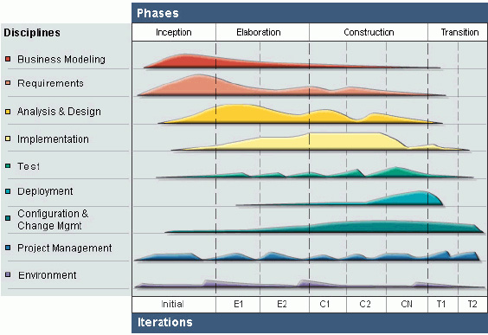

Figure 3-1: Rational Unified Process Model overview

RUP is based on a set of building blocks and content elements, describing what is to be  
produced, the necessary skills required and the step-by-step explanation describing how  
specific development goals are to be achieved. The main building blocks, or content elements,  
are the following:  
• Roles (who): defines a set of related skills, competencies and responsibilities of an  
individual or a group of individuals as a team.  
• Work Products (what): represents something resulting from a task, including all the  
documents and models produced while working through the process  
• Task (how): describes a unit of work assigned to a Role that provides a meaningful  
result.” (Wikipedia, 2012, IBM Rational Unified Process, viewed 30 September  
2013, http://en.wikipedia.org/wiki/IBM_Rational_Unified_Process)

RUP is based on a set of building blocks, or content elements, describing what is to be produced, the necessary skills required and the step – by – step explanation describing how specific development goals are to be achieved. The main building blocks, or content elements, are the following.

Workers (who):defines the behavior and responsibilities of an individual, or a group of individuals working together as a team.

Artifacts (what): An artifact is a piece of information that is produced, modified, or used by a process. Artifacts are the tangible products of the project, the things the project produces or uses while working towards the final product.

Activities (how):An activity of a specific worker is a unit of work that an individual in that role may be asked to perform.

Workflows (when): is a sequence of activities that produces a result of observable value.

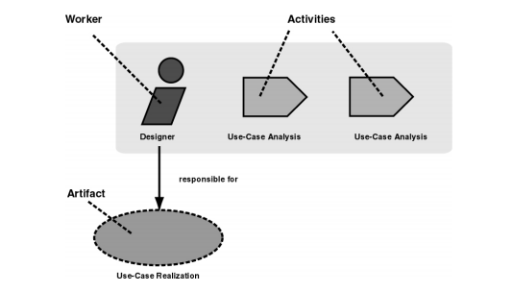

Figure 2-2: Workers, activities and artifacts

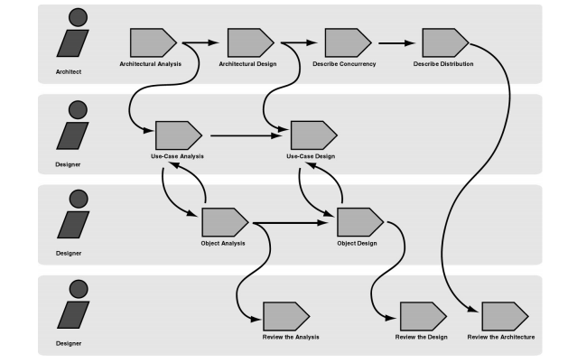

Figure 2-3: Example of workflow

The core process workflows are divided into six core “engineering” workflows

**- Six “engineering disciplines”:**

* + **Business modeling workflow**: In Business Modeling we document business processes using so called business use cases. This assures a common understanding among all stakeholders of what business process needs to be supported in the organization.
  + **Requirements workflow**: The goal of the Requirements workflow is to describe what the system should do and allows the developers and the customer to agree on that description.
  + **Analysis and design workflow**: The goal of the Analysis & Design workflow is to show how the system will be realized in the implementation phase.
  + **Implementation workflow**: The purpose of implementation is to define the organization of the code, to implement classes and objects in terms of components, to test the developed components as units, to integrate the results produced by individual implementers.
  + **Test workflow**: The purposes of testing are to verify the interaction between objects, to verify the proper integration of all components of the software, to verify that all requirements have been correctly implemented, to identify and ensure defects are addressed prior to the deployment of the software.
  + **Deployment workflow**: The purpose of the deployment workflow is to successfully produce product releases, and deliver the software to its end users. It covers a wide range of activities including.

**- Three supporting disciplines:**

* + **Configuration and change management workflow**: Software Project Management is the art of balancing competing objectives, managing risk, and overcoming constraints to deliver, successfully, a product in which meets the needs of both customers (the payers of bills) and the users.
  + **Project management workflow**: In this workflow we describe how to control the numerous artifacts produced by the many people who work on a common project.
  + **Environment workflow**: The purpose of the environment workflow is to provide the software development organization with the software development environment – both processes and tools – that are needed to support the development team.

## Project lifecycle

Apply RUP model, Project lifecycle has fours phase:

* Inception Phase: Inception is the first phase of process. In this startup phase, we should provide business case of the system and determine the scope of project. Besides, we have to create the project management plan that has project schedule, effort estimation and risk management etc. At the end of this phase, we should check the objectives of project and decide whether to continue development or not. Hence, Inception phase must be properly planned and done. Based activities of this phase:

Study business case and feasibility study of project

* Complete draft ERD of system
* Complete draft screen prototypes
* Complete draft requirements
* Determine project scopes
* Complete project management plan
* Elaboration Phase: The objectives of this phase are to determine appropriate architectural and construction plan for the project. The architectural decision needs to be made for the entire system, and to describe most of the requirements of system. At the end of this phase, we must examine the objectives and scopes, the choice of architecture and decide whether to proceed to the next phase. Based activities of this phases:
* Complete user requirement specification
* Complete ERD, final prototypes
* Complete Software Requirement Specification
* Complete database model
* Complete System Architecture Design
* Construction Phase: Construction is the third phase of RUP lifecycle. In this phase, we must have done all the coding and testing work. After coding, developers will do unit test themselves, then test team will do functional test and regression test when finishing all. Based activities of this phase:
* Complete coding and unit test
* Complete functional and regression test
* Complete user manual
* Transition Phase: Transition is the final phase of the RUP lifecycle. In this phase, project team has to deploy the application and give it to users. The next step is receiving feedback from users to identify the problems and then complete the system. Based activities of this phase:
* Deploy the system
* Deliver source code
* Complete all reports and documents

## Roles and Responsibilities



Figure 3-2: Project Organization

|  |  |  |
| --- | --- | --- |
| Member | Roles and Responsibilities | |
| Roles | Responsibilities |
| DuyPK | * Project Manager * Technical Leader * SRS Analysis Leader * Tester | * Create Work Breakdown Structure * Manage project stakeholders, project team, project risk, project schedule, project budget, project conflicts. * Track progress and adjust the work of the team members * Communication with other members and supervisor * Manage the technology of project * Co-operate with Developer to create software specification requirement (SRS), architectural design (SAD) and software detailed design (SDD). * Review document, product, and reports. * Unit test. * Write report * Support other team members. |
| HungLV | * Test Leader * Developer * SRS Analysis | * Coding * Create software specification requirement (SRS). * Create the test plan based on project plan and SRS, SDD documents. * Delegate testing tasks to testers and manage the rate of progress. * Create test data for all functions in both mobile and web application. * Create test cases for the system, both in document and script. * Write report * Execute test to ensure all functions fulfil requirements. * Support other team members. |
| HonNV | * Design Leader * Developer * QA Member | * Design and develop web interface * Create plan to Font-end * Project Quality Assurance * Coding * Write report * Support other team members. |
| ThanhLN | * QA Leader * Developer * Design Member | * Manage the quantity of project * Coding * Draw mock-up and design web font-end * Write Report * Support other team members. |

# TOOLS AND INFRASTRUCTURES

## Hardware

|  |  |  |  |
| --- | --- | --- | --- |
| No | Name | Purpose | Detail |
| 1 | Laptop | * Developing * Deploying * Testing | * HDD: 500GB * Ram: 4GB * Processor: Core I3 2.4 or Higher |
| 2 | Server Computer | Keep project source | Service from Github:  https://github.com/ |

## Software

|  |  |  |  |
| --- | --- | --- | --- |
| No | Name | | Version |
| 1 | Software | Microsoft Office | 2013 |
| Microsoft Project | 2013 |
| Visual Studio | 2015 update 2 |
| Microsoft SQL server | 2012 |
| Software Ideas Modeler | 10 |
| Microsoft Windows | 7, 8.1, 10 |
| 2 | Framework | .Net Framework | 4.6 |

# SCHEDULE

## Detailed Schedule

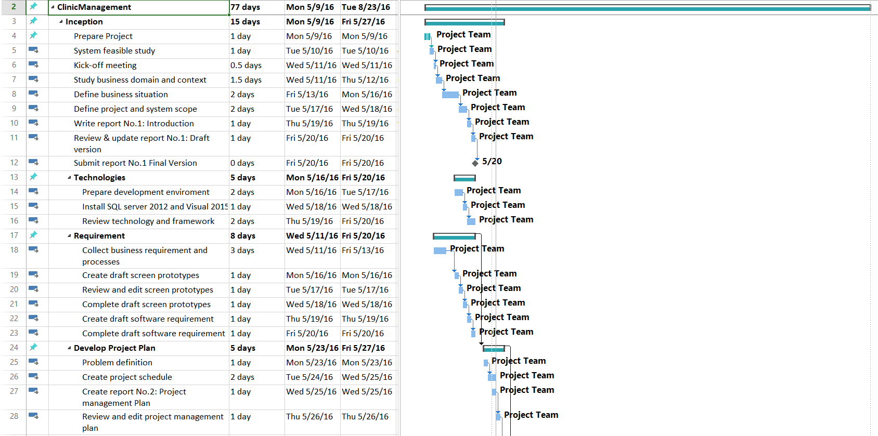

Figure 1: Project Plan-1

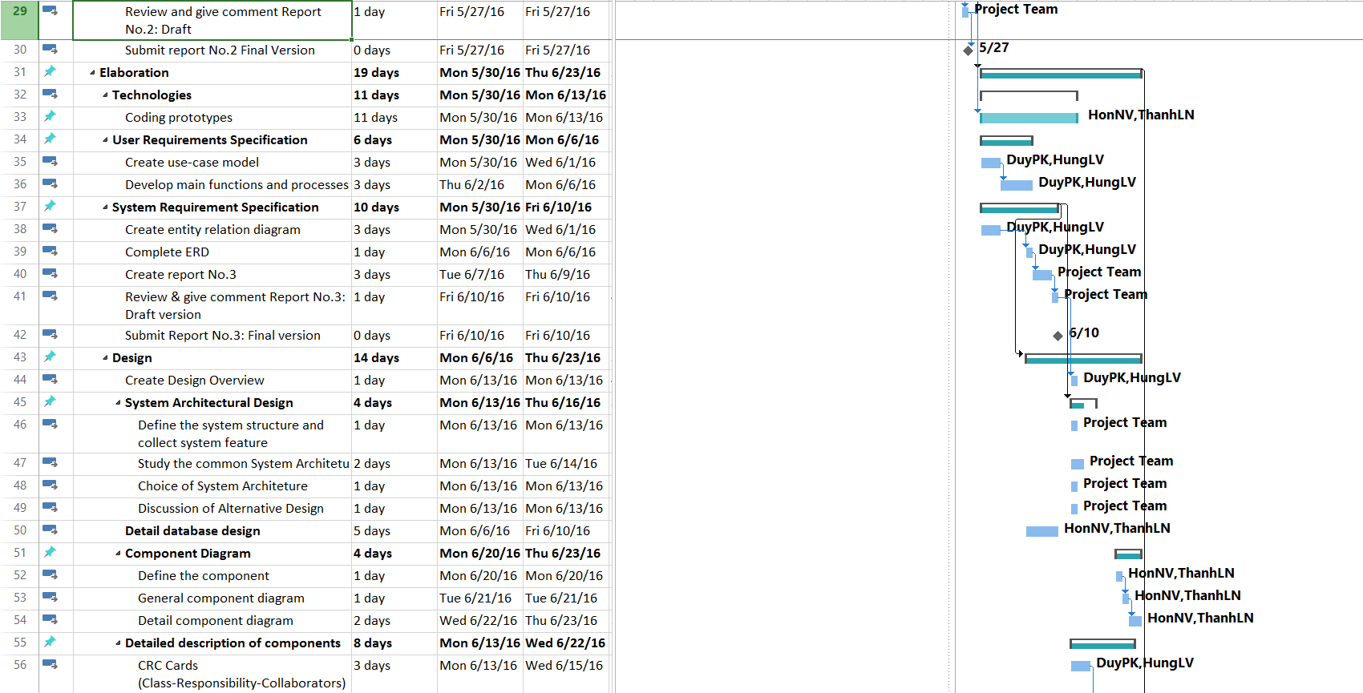

Figure 2: Project Plan-2

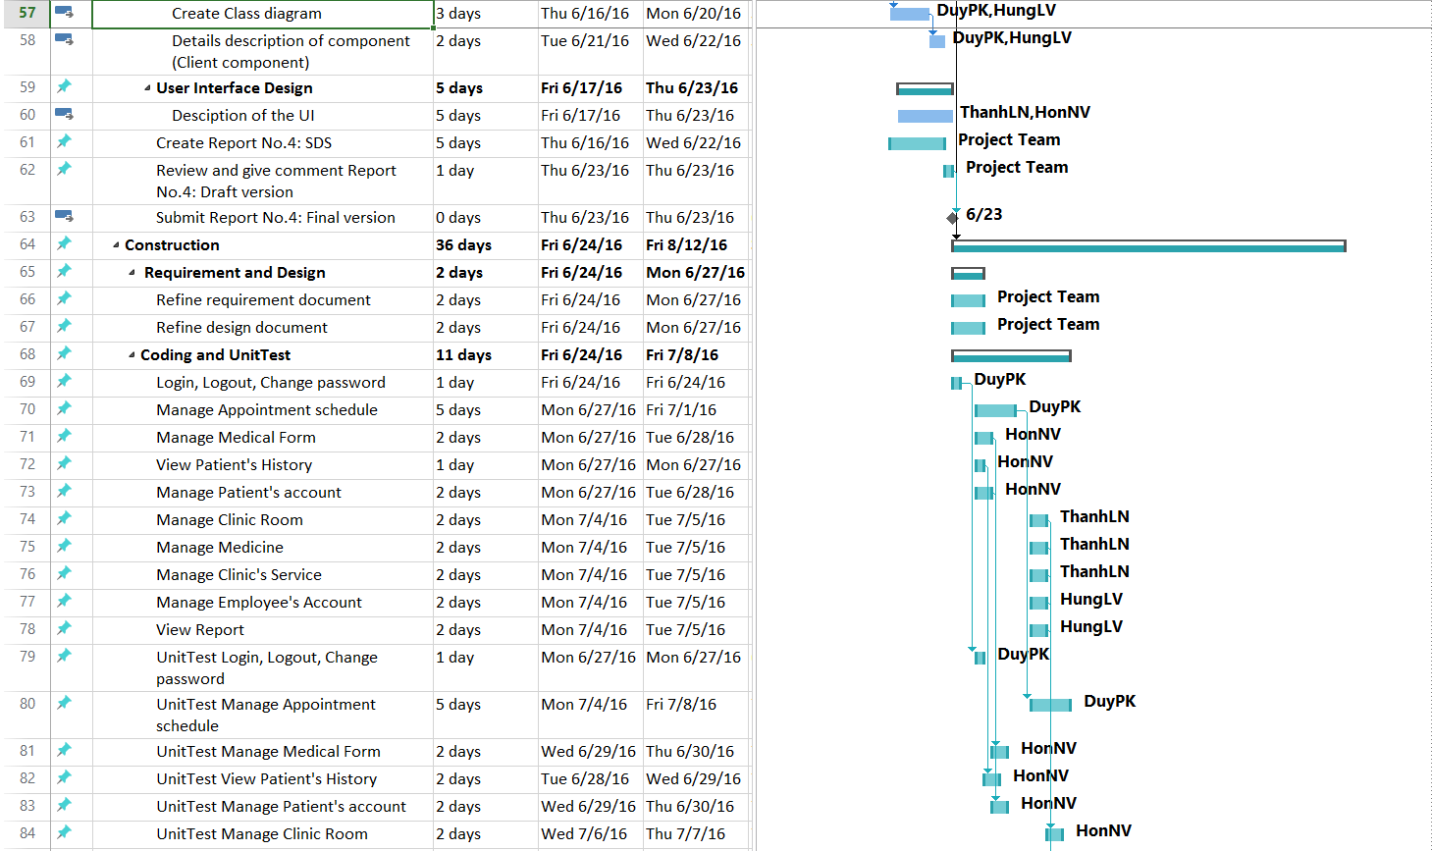

Figure 3: Project Plan-3

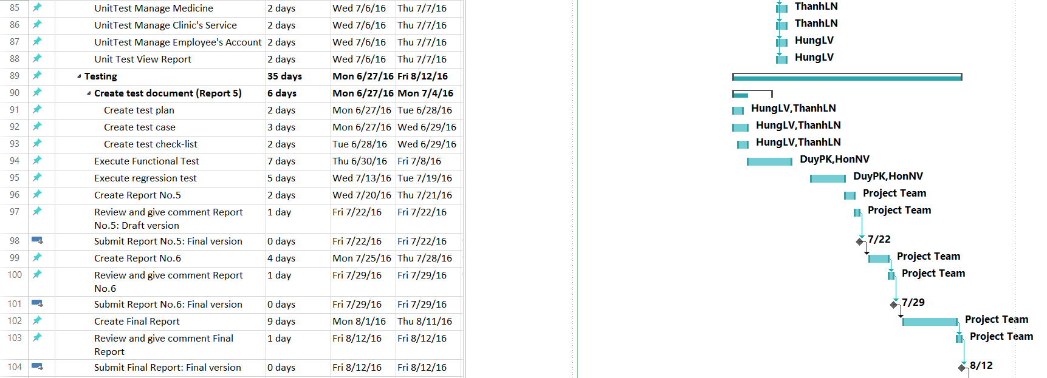

Figure 4: Project Plan-4

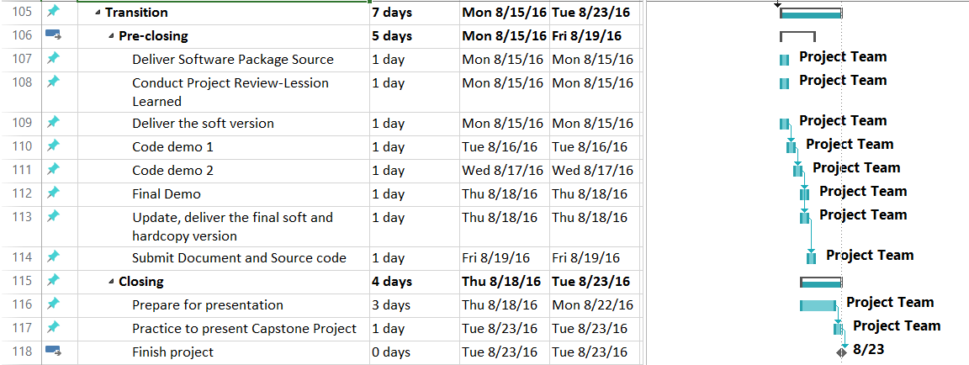

Figure 5: Project Plan-5

## Meeting Schedule

During our developed time, we have two types of meeting:

* **Meeting with supervisor**: we have meeting with our supervisor once a week in 12:45 PM Friday. In this meeting, we will report what we have done in last week, raise issues to discuss with supervisor and supervisor will give us advices to deal with these problems.
* **Meeting with team member**: we have team meeting three times a week in Monday, Wednesday and Friday. In this meeting, each member will report what he has done last week to others and the problems he meets (if have). All members will discuss about these problems and PM or technical leader will give the final solution for each. Finally, PM will give the tasks for all members to do and report in the next meeting.

Here is the meeting minute template will be used for the project:

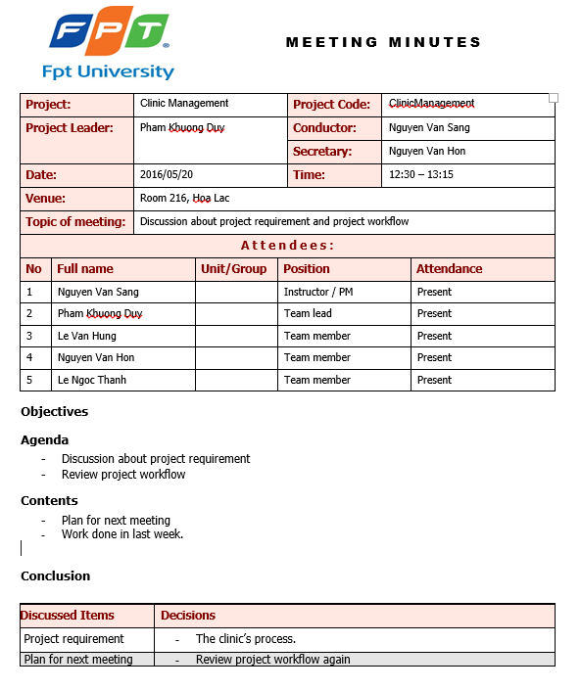

Figure 6: Meeting Template

## Effort Estimation

|  |  |  |  |  |
| --- | --- | --- | --- | --- |
| Task Name | Worst case  (days) | Best case  (days) | Most likely case  (days) | Expected case (days) |
| **Inception** | **68** | **56** | **64** | **60** |
| Technologies | 28 | 16 | 24 | 20 |
| Requirement | 40 | 28 | 36 | 32 |
| Develop Project Plan | 28 | 16 | 24 | 20 |
| **Elaboration** | **86** | **72** | **76** | **76** |
| Technologies | 26 | 20 | 22 | 22 |
| User Requirements Specification | 26 | 22 | 24 | 24 |
| System Requirement Specification | 14 | 12 | 12 | 12 |
| Design | 20 | 18 | 18 | 18 |
| **Construction** | **160** | **140** | **148** | **144** |
| Requirement and Design | 12 | 6 | 8 | 8 |
| Coding and Unit Test | 44 | 36 | 40 | 36 |
| Testing | 104 | 98 | 100 | 100 |
| **Transition** | **36** | **24** | **32** | **28** |
| Pre-closing | 24 | 18 | 22 | 20 |
| Closing | 12 | 6 | 10 | 8 |
| **Total** | **350** | **292** | **320** | **308** |

# RISK MANAGEMENT

|  |  |  |  |  |  |
| --- | --- | --- | --- | --- | --- |
| No | Risk | Description | Root Cause | Potential Response | Risk Owner |
| 1 | Over deadline | Some  members of  team do not  finish their  tasks before  deadline |  | * Set punishment   rules for members  who miss the  deadline   * PM must give   tasks for member  clearly, surely  they know  exactly what they  have to do | Project  team |
| The task and  schedule is  overload for  members | * PM must review   carefully the  project  management plan | PM |
| 2 | Technical risks | Some big  technical  problems  happens and  develop team  cannot handle  it | Short duration  of studying  C# technique | * Developers must   study hard to  know clearly  about C#  technique   * Project team has   some technical  supervisors who  can give advices  and solutions  about technical  problems | Project  team |
| 3 | Communication  risks | Members  misunderstand  others, leads  to the wrong  actions and  decisions | * Lack of   communicati  on skills   * Careless in   writing  emails,  talking with  others | * All members   must be careful in  talking with  others and writing  reports or emails   * PM assigns   member to write  meeting minute  after meeting or  take note after  discussing about  issues, then send  to all team  members | Project  team |
| 4 | Conflictions  between team  members | Members have  argued,  conflicted  with others,  leads to the  uncomfortable  environment | * Conflict in   team in a  long time   * High   pressure  when doing  a huge work  in a short  time | * Set up team-   building  frequently for  members to relax   * Set up open talk   when members  can truly talk  about their  uncomforted  things | Project  team |
| 5 | Misunderstand  the requirements | Members do  not understand  clearly about  the  requirements,  leads to the  wrong  solution when  designing and  coding | * Do not study   clearly about  the business  case, not  analyze  exactly  about the  system   * Members do   not have  experiences  in analyzing  requirements | * Spend enough   time and effort to  study about  business case,  system  requirements   * Receive advices   from supervisor  and experts when  collecting  requirements | Project  team |
| 6 | Unrealistic  project schedule | PM creates a  unrealistic  plan, so that members can  not follow it to  do their tasks | PM do not  have  experiences in  making  project  schedule | * Meeting with all   team to create  project schedule   * Receive advices   from supervisor  and experts when  creating project  schedule | PM |

# CODING CONVENTION

Follow C# Coding convention.

See the reference for all detail: https://msdn.microsoft.com/en-us/library/ff926074.aspx