|  |  |
| --- | --- |
| Logo_FPT_University_doc | **MINISTRY OF EDUCATION AND TRAINING** |

**FPT UNIVERSITY**

**CAPSTONE PROJECT DOCUMENT**

**ClinicManagement**

**Report #1 – Introduction**

|  |  |
| --- | --- |
| **ClinicManagement** | |
| **Group Member** | Phạm Khương Duy - 60195 |
| Nguyễn Văn Hơn - 60390 |
| Lê Ngọc Thành – SE60620 |
| Lê Văn Hùng - 60041 |
| **Supervisor** | Mr.Nguyễn Văn Sang |
| **Ext. Supervisor** |  |
| **Project Code** | ClinicManagement |

- Hanoi, 05/2012 -

Table of Contents

[1 INTRODUCTION 3](#_Toc364946586)

[1.1 Purpose 3](#_Toc364946587)

[1.2 Acronyms and Definitions 3](#_Toc364946588)

[2 ABSTRACT 3](#_Toc364946589)

[3 LITERATURE REVIEW 3](#_Toc364946590)

[4 PROPOSAL 3](#_Toc364946591)

[4.1 The idea 3](#_Toc364946592)

[4.2 Brief description about system 3](#_Toc364946593)

[4.3 System features 3](#_Toc364946594)

[5 BENEFIT FROM PROJECT 4](#_Toc364946595)

[5.1 For Organization 4](#_Toc364946596)

[5.2 For our group 4](#_Toc364946597)

[5.3 For Community 4](#_Toc364946598)

[6 CRITICAL ASSUMPTION AND CONSTRAINTS 4](#_Toc364946599)

[7 POTENTIAL RISKS 4](#_Toc364946600)

[8 REFERENCE 4](#_Toc364946601)

# INTRODUCTION

## Purpose

This document is introduction about our capstone project in FPT University – Clinic Management Project. This project will help the clinic easy to manage clinic’s information, patient’s information, patient’s medical examination history and patient’s appointment calendar. Besides, patients can know their medical examination history and schedule appointment with doctor in the clinic.

## Acronyms and Definitions

|  |  |  |
| --- | --- | --- |
| Acronym & Abbreviation | Definition | Note |
| CM | Clinic Management |  |

Table 1-1: Definitions and Acronyms

# ABSTRACT

Medical Overview in Viet Nam: Medical is one of the most important subject of developing the country. Yearly, there are millions patients who going to the hospital or the clinic have health check, try to be treated by doctor. Besides, the doctor has many works need to be handled everyday with hundreds patients and the only tools to support them are paper and pens. Moreover, the medical history of patient is saving to health records. It is easily to be lost because of human careless. The result of this situation, the clinic is always in overloaded situation, the amount of work is increasing day by day, it can easily affect to the staff that execute medical process (doctor, nurse …).

For all the limitation of existing disadvantages above, we expect to develop a web application for the clinic that overcome the weakness, improve the performance of medical staff.

# LITERATURE REVIEW

1. Through the network, I found plenty of group management software clinic as,EvoMed, iHIS, etc…

## EvoMed

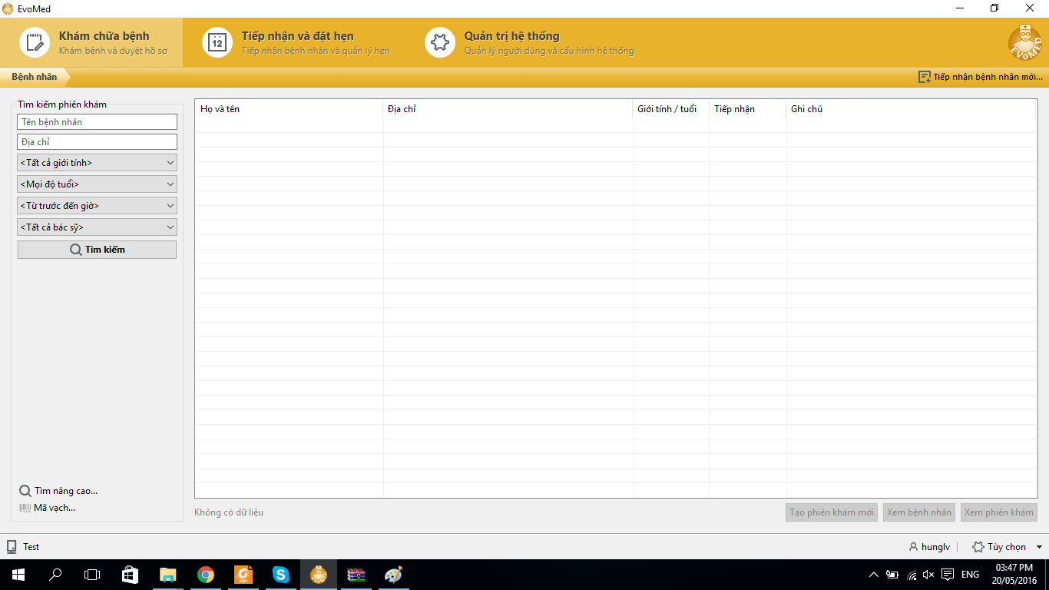

* Advantage:
  + Without networking
  + Support standard DICOM
  + Connect directly with laboratory management systems
  + Easy maintenance
* Disadvantage:
  + Patients do not interact with the system
  + Unable to connect to social networks
  + Patients easily loose history medical

## iHIS

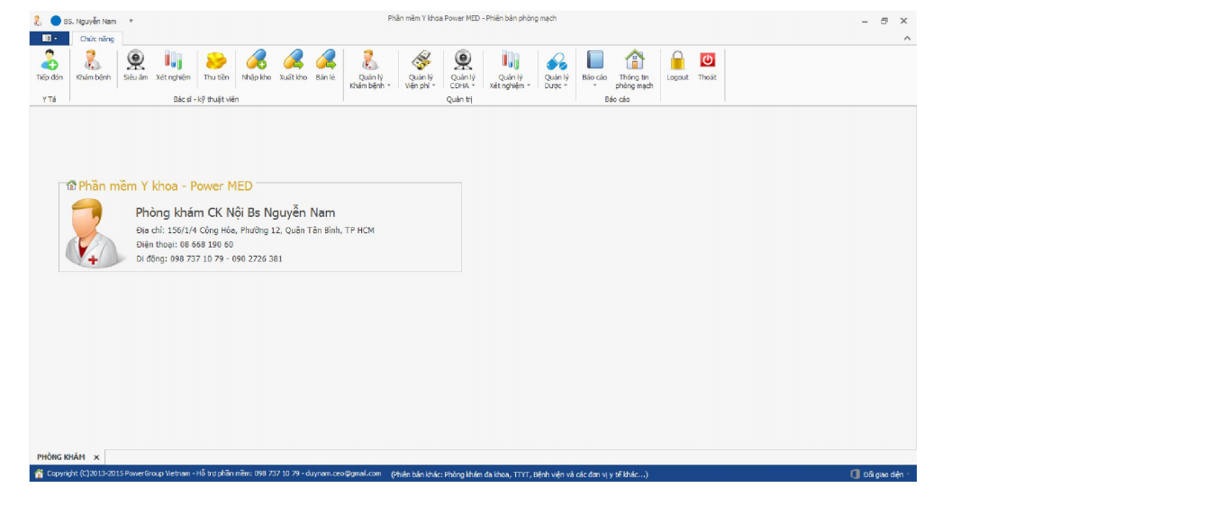

* Advantage:
  + Without networking
  + Support standard DICOM
  + Connect directly with laboratory management systems
  + Easy maintenance
* Disadvantage:
  + Patients do not interact with the system
  + Unable to connect to social networks
  + Patients easily loose history medical

# PROPOSAL

## The idea

The idea of creating a clinic management application for website is not new; there are many existing webs now. However, our expected clinic management application is included some main functions of current webs and add to some special features such as an appointment, basic knowledge about some Common diseases, translation of multi-language.

## Objectives

This project is the Capstone Project for all team members. We do this project to fulfill the requirements from FPT University studying program. During the time do this, we can learn how to develop a project, how to communicate with other team members, how to control time, how to do teamwork effectively. We also can work with some new technology such as develop for mobile, .NET technology etc. Therefore, after finishing this project, we can practice what we have learnt in university and learn so many new things. It is very necessary for our future work after graduating from FPT University.

## Brief description about system

This project has two part that use for website and mobile. Users can easily find the functions they want with friendly and simple interface. This application helps patient who book an appointment, view medical records or knowledge of common diseases online, help the staff to handle medical procedure. Besides, the polyclinics can manage patient records and many other services. If they face any problem, they can get help from User Instruction and Feedback function.

## System features

About the feature of clinic management system, it has main features of existing system such as create new medical record, open/view medical record, edit medical record, save medical record, delete medical record etc. Besides, it has some extra functions: change language to Vietnamese for Vietnamese users and book an appointment. There are the detailed functions of this system:

* **Create new appointment:** user create an appointment,
* **Create new medical records:** user creates medical record, it has all functions below:
  + **Add Profile** : fulfill patient individual information such as full name, birthday, gender, address, etc...
  + **Treatment** : a doctor checks the patient about health such as heart, blood pressure, blood group, etc... Then the doctor fill checked information.
* **Open/view existing medical records:** open medical records from storage and view it on screen.
* **Share knowledge of common diseases:** share knowledge of common diseases to some social network such as Facebook, Twitter or send via email.
* **Search medical records**: search medical records stored in Database by keyword.
* **Sort** **medical records**: sort all medical records stored in Database by alphabet or by modified time.
* **Delete medical records**: delete existing medical records stored in Database.
* **Save current medical records**: save a medical Records in Database.
* **Edit existing medical records**: edit existing medical records, it has all functions like when you create new medical records.
* **Report – Invoice**
  + Export Medical Examination Invoice
  + Export Medicine bill
  + Export Test bill
  + Report amount of patients in a period of time
  + Report total income in a period of time
* **Change language**: Vietnamese (default) or English.
* **Get feedback from users**: user can send feedback to develop team via email.
* **Help**: help user know clearly how to use all features of this application.

# BENEFIT FROM PROJECT

## For Organization

This project will help clinics reduce unnecessary tasks as well as improve productivity and operation of clinics. Also projects can be developed consistent expansion of hospitals and medical centers in the country and abroad.

## For our group

The benefits of the project to bring the group after being developed and implemented successfully:

* Enhance the ability teamwork: communication, conflict resolution, raise an opinion, to recognize strengths and weaknesses of each individual, etc...
* Enhance the experience and knowledge in project management: time management, job assignment and risks resolution, etc...
* The team members will enhance the technological knowledge and experience into practical use
* Understanding more about the medical knowledge.

## For Community

When users use the system, they can get more benefits from it:

* Patients can schedule without having to wait for hours to clinic
* Patients, doctors and relatives easily manage patient records
* Doctors and nurses interact easier and less time-consuming
* Doctors will easily diagnose by viewing the medical history
* Clinic managers easily check and adjust the clinic by the report

# CRITICAL ASSUMPTION AND CONSTRAINTS

There are some assumptions that we realize after analyzing this project. The first assumption is about team member, We assume that all the developers are good at C# .NET technology such as (MVC4, Jquery, Javasrcipt , Ajax ,LINQ …). We have to study hard for being good at all of technology and for not missing any deadline of project plan. Besides, we also assume all of members do not have any health problems, so they are not absent and can do their works.

There are also some constraints of our project. Firstly, about the deadline, we have to finish this project on time. It has no extra time for us to complete developing application. Besides, the reports need to summited before deadline.

# POTENTIAL RISKS

After analyzing this project, we may be facing some risks:

* We will not have enough time to do all things and miss the delivery deadline with the short duration (about 3 months).
* We don’t have any knowledge about Clinic Management, so we need a lot of time to research
* It is the first time we do the project big like this, we will meet some problems about team communication and members will miss information.
* We don’t have any experience about project management, risk management, etc. Thus, our project plan will be not good. We will meet the deadline and face to unknown risks.
* We will development in same project that make us easy to lose source code.

# REFERENCES

[1] http://evomed.vn/wiki/phan-mem-quan-ly-phong-kham-da-khoa/tinh-nang.html

[2] http://www.powersoft.vn/vi/news/San-pham/ihis-benh-vien-dien-tu-phien-ban-phong-kham-chuyen-khoa-9.html