 | MINISTRY OF EDUCATION AND TRAINING

FPT UNIVERSITY

CAPSTONE PROJECT DOCUMENT
<Project Code>
Report #3 – Software Requirement Specification
<Group Code>
Group Member | <ID - Name>
Group Member | <ID - Name>
Group Member | <ID - Name>
Group Member | <ID - Name>
Supervisor | <Name>
Ext. Supervisor
Project Code | <Code>

- Hanoi, 05/2012 -
Table of Contents
1 USER REQUIREMENTS SPECIFICATION 4
1.1 Introduction 4
1.1.1 Purposes 4
1.1.2 Definition and Acronyms 4
1.2 Overall Description 4
1.2.1 Business Process Overview 4
1.2.2 Product Features 4
1.2.3 User Characteristic 4
1.3 Functional Requirements 4
1.4 Non – Functional Requirements 4
2 SOFTWARE REQUIREMENTS SPECIFICATION 5
2.1 Introduction 5
2.1.1 Purposes 5
2.1.2 Definition and Acronyms 5
2.2 System Purpose 5
2.3 Scope 5
2.4 Overall Description 5
2.4.1 System overview 5
2.4.2 Product Features 5
2.4.3 User Characteristics 5
2.4.4 User Documentation 6
2.4.5 Assumption 6
2.5 Entity Relation Model 6
2.5.1 Entity-Relationship Diagram 6
2.5.2 Entity Detail 6
2.6 Functional Specification 6
2.6.1 UC<xxx>: <Use-Case Name> 6
2.6.2 UC<xxx>:<Use-Case Name> 6
2.6.3 UC<xxx>:<Use-Case Group Name – Dùng đề mô tả theo nhóm UC> 6
2.7 Non-functional Specification 7
2.7.1 Reliability 7
2.7.2 Performance Requirements 7
2.7.3 User Interface 7
2.7.4 Design Constraints 7
2.7.5 Usability 7
2.7.6 Security Requirements 7
2.7.7 Hardware/Software Requirements 7

USER REQUIREMENTS SPECIFICATION

Introduction

Purposes
This chapter outlines functional and non-functional requirements of our Clinic Management System.
By using this document, project team and other people can have an overview about the user requirement specification of the Clinic Management System.

Definition and Acronyms
Term | Description
Table 3-1: Definition and Acronyms

Overall Description

Business Process Overview
Firstly, this system provides anything concern about the patients feature, give necessary information, such as all about the process of medical when they come to the clinic (create medical record, being treated by doctor …)
Second, the system all supply full of process of the clinic to help everyone in charge can easily to control, execute the clinic operation smoothly. For example, the doctor can treat the patients well by reviewing the past of medical history which is saving in data. It also gives the manager the view of statistical reports of the clinic.

Product Features
The Clinic Management is a webpage. It’s designed for the audience is small or private clinics. We have research groups and consult different sources to produce energy rather than following the:
- Reception: This function is mainly the interaction between the patient and the clinic. The CM to ensure the registration of medical patients easily and quickly.
- Medical examination: This function is mainly to help doctors easily store the information needed to diagnose and treat disease. The CM supports storing the information of the patient, in addition to support doctors to prescribe medication.
- Reports: Export all reports to serve management needs, and operating of the clinic.
- Booking appointment: This feature can help the patient can easily book an appointment of service, doctor that suitable for their timeline. It will help the patients avoid wasting of their time.

User Characteristic
This system be used by four kind of user characteristics:
- The Administrator level: this user also has an experience in Software Engineer, IT knowledge and responsibility to maintain system when bugs occur.
- The staff of the clinic: have experience in using computer and information system, may be these staff need to be trained to use this system
- The manager level: they will use this system to supervise the clinic, they just need to look over the report function.
- The Patient: they will use this system to scheduled examination and medical history.

Functional Requirements

Users Management
Privilege: Administrator
Manage all the user of the system, add new user, edit user, delete user

Rooms Management
Privilege: Administrator
Manage all the rooms of the system, add new rooms, edit room, delete room

Services Management
Privilege: Administrator
Manage all the services of the system, add new service, edit service, delete service.

Medicines Management
Privilege: Administrator
Manage all the medicines of the system, add new medicine, edit medicine, delete medicine.

Medical record Management
Privilege: Reception
Manage all the patients ‘s medical record of the system, add medical record, edit patient information, view patient list and appointment list

Treatment Management
Privilege: Doctors
View the patients list in their room, execute treatment to the patients, update medical information, view the medical history of the patient, create the prescription for the patient.

Booking Management
Privilege: Patient
Booking online appointment about the services of the clinic.

Non – Functional Requirements
The user interface should be easy to learn, users of the website may immediately understand how to use the function clearly.
Important information should be easily to find and clearly visible.
All the items of the website should be consistency, they should be displayed the same way.

SOFTWARE REQUIREMENTS SPECIFICATION

External Interface Requirements

User Interfaces
The design of the system is so friendly and easily to use with the users. The homepage with the navigation at the left which can make the users easy to navigate to others view. Besides the navigation is the main content of the website which is show the main information. All the information in menu is grouped, it can help the users easily to find down and access the features

Communication Protocols
The main communication protocol of website is applied Hypertext Transfer Protocol (HTTP).

Functional Requirements
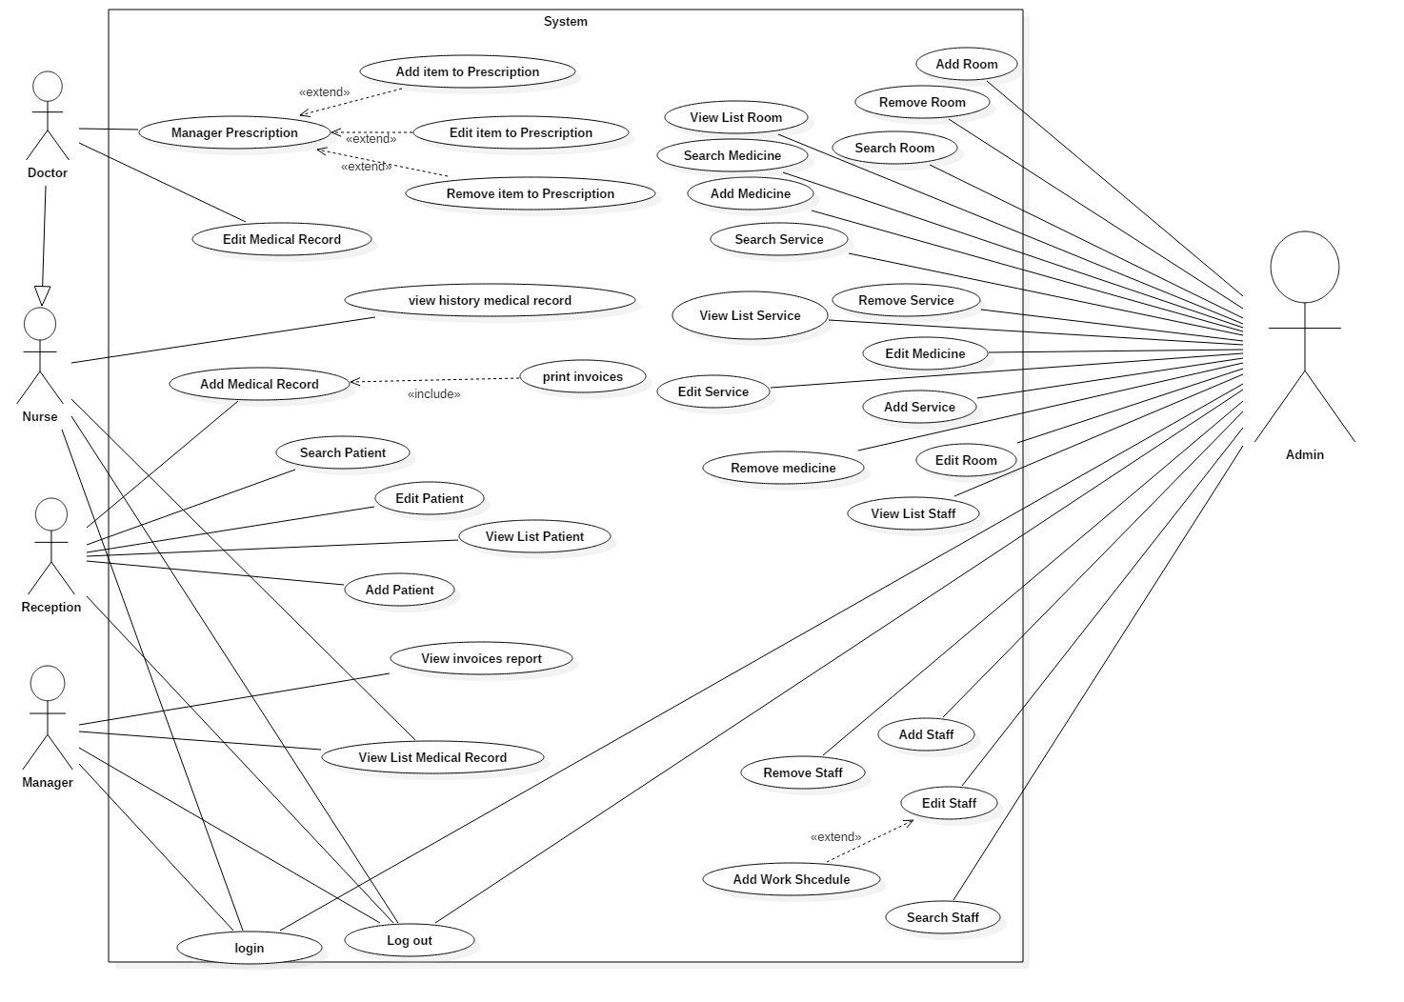
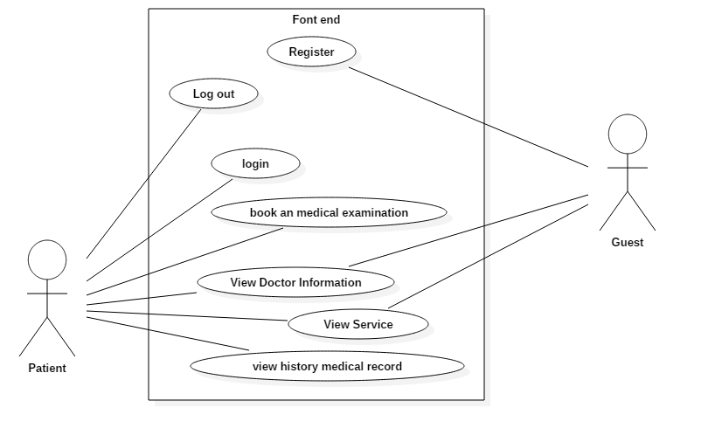

UC<001>: <Login>

Use Case Diagram
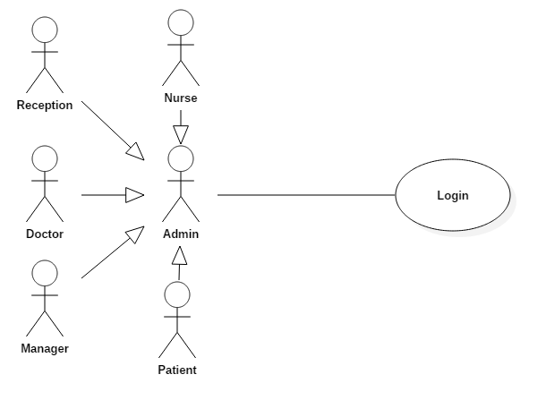

Use Case Specification

Use Case ID |  |  | UC001 |  | Version | 1.0
Use Name |  |  | Login
Actor |  |  | Admin, Patient, Doctor, Nurse, Reception, Manager
Description |  |  | The function allows a User Login to the system, when user have an account and account is still active
Precondition |  |  | User need navigate to Webpage and has his own account, which can be used to log-in to the system  The log-in panel will appear and let the user input and summit their account and password to the system.
Trigger |  |  | User click “Login” button
Post-Condition |  |  | System validation and accept account connect to system
Main flows
Step | Actor |  | Action
1 | User |  | Navigate to Font-end or Back-end web page
2 | System |  | Display Home page and Login form with the following fields:  - User name  - Password  - Login button
3 | User |  | Enter user name &amp; password into User Name & Password fields on the Login screen, then click on Login button.
4 | System |  | Validate the entered user name &amp; password and then display Home page
Alternative flows
AT1 |  | At step 2 in the main flows, if there is an internal error in the system
Step |  | Actor |  | Action
2.1 |  | System |  | Display error message
AT1 |  | At step 4 in the main flows, if System failed to validate user name & password
Step |  | Actor |  | Action
4.1 |  | System |  | Display error message

Business Rules
# | Rule Description
BR01 | N/A
BR02 | N/A

UC<002>: <Log Out>

Use Case Diagram
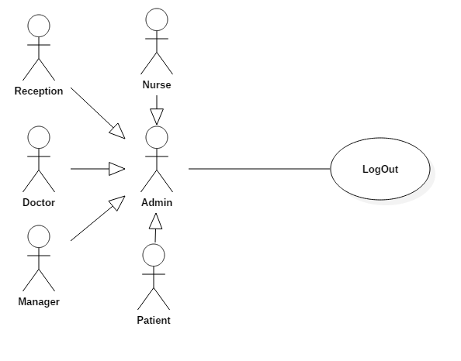

Use Case Specification

Use Case ID |  |  | UC002 |  | Version | 1.0
Use Name |  |  | Log Out
Actor |  |  | Admin, Patient, Doctor, Nurse, Reception, Manager
Description |  |  | The function allows a User log out of the system, when user have login to system.
Precondition |  |  | User had already logged in to the system before
Trigger |  |  | User click “Log Out” button
Post-Condition |  |  | System disconnect account
Main flows
Step | Actor |  | Action
1 | User |  | Click the “Log out” button from the user panel
2 | System |  | Display Home page  Disconnect account
Alternative flows
AT1 |  | N/A
Step |  | Actor |  | Action
N/A |  | N/A |  | N/A

Business Rules
# | Rule Description
BR01 | N/A
BR02 | N/A

UC<003>: <View List Staff>

Use Case Diagram
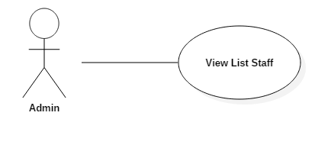

Use Case Specification

Use Case ID |  |  | UC003 |  | Version | 1.0
Use Name |  |  | View List Staff
Actor |  |  | Admin
Description |  |  | The function allows a Admin to view list staff in the system, when admin navigate to View List Staff page
Precondition |  |  | User login successful  User is admin
Trigger |  |  | Admin click “Staff” tab on menu tab
Post-Condition |  |  | System display view list staff page and list staff is active
Main flows
Step | Actor |  | Action
1 | Admin |  | Click to Admin tab on top menu
2 | System |  | Display list sub menu with the following sub menu:  - Staff  - Doctor  - Room  - Service  - Medicine
3 | Admin |  | Click to “Staff” sub menu
4 | System |  | Display list view staff, “Add” button, Search text box and “Search” button
Alternative flows
AT1 |  | At step 4 in the main flows, if List staff is empty
Step |  | Actor |  | Action
4.1 |  | System |  | Display message "Not found staff active"

Business Rules
# | Rule Description
BR01 | Display only staff is active
BR02

UC<004>:<Add New Staff>

Use Case Diagram

Use Case Specification

Use Case ID |  |  | UC004 |  | Version | 1.0
Use Name |  |  | Add New Staff
Actor |  |  | Admin
Description |  |  | The function allows a Admin create to new staff in the system.
Precondition |  |  | User login successful  User is admin  Admin go to List view page Staff
Trigger |  |  | Admin enter data correct into all field then click “Create” button
Post-Condition |  |  | System display message “Add new Staff successful” then system view new staff on view list staff page
Main flows
Step | Actor |  | Action
1 | Admin |  | Go to List View Staff page
2 | System |  | Display list view staff, “Add” button, Search text box and “Search” button
3 | Admin |  | Click “Add” button
4 | System |  | Display Add new staff page
5 | Admin |  | Enter data correct into all field then click “Create” button
6 | System |  | System validates data and save all data into database.
Alternative flows
AT1 |  | At step 1 in the main flows, if List staff is empty
Step |  | Actor |  | Action
1.1 |  | System |  | Display message "Not found staff active"
AT2 |  | At step 6 in the main flows, if data incorrect
Step |  | Actor |  | Action
6.1 |  | System |  | Display message "Data invalid" and don’t save all data into database
AT2 |  | At step 4 in the main flows, if Admin click “Cancel” button
Step |  | Actor |  | Action
6.2 |  | System |  | Display list view staff, “Add” button, Search text box and “Search” button

Business Rules
# | Rule Description
BR01 | Display only staff is active
BR02

UC<005>:<Edit Staff>

Use Case Diagram

Use Case Specification

Use Case ID |  |  | UC005 |  | Version | 1.0
Use Name |  |  | Edit Staff
Actor |  |  | Admin
Description |  |  | The function allows a Admin edit staff in the system.
Precondition |  |  | User login successful  User is admin  Admin go to List view page Staff
Trigger |  |  | Admin enter data correct into all field then click “Save” button
Post-Condition |  |  | System display message “Edit Staff successful” then display list view staff page
Main flows
Step | Actor |  | Action
1 | Admin |  | Go to List View Staff page
2 | System |  | Display list view staff, “Add” button, Search text box and “Search” button
3 | Admin |  | Click “Edit” button of staff item
4 | System |  | Display Edit staff page
5 | Admin |  | Edit data correct into all field then click “Save” button
6 | System |  | System validates data and save all data into database.
Alternative flows
AT1 |  | At step 6 in the main flows, if data incorrect
Step |  | Actor |  | Action
6.1 |  | System |  | Display message "Data invalid" and don’t save data in database
AT2 |  | At step 6 in the main flows, if Admin click “Cancel” button
Step |  | Actor |  | Action
6.2 |  | System |  | Display list view staff, “Add” button, Search text box and “Search” button

Business Rules
# | Rule Description
BR01 | Display only staff is active
BR02

UC<006>:<Search Staff>

Use Case Diagram

Use Case Specification
<Phần này là đặc tả chi tiết cho Use-Case>
Use Case ID |  |  | UC006 |  | Version | 1.0
Use Name |  |  | Search Staff
Actor |  |  | Admin
Description |  |  | The function allows a Admin search staff active in the system.
Precondition |  |  | User login successful  User is admin  Admin go to List view page Staff
Trigger |  |  | Admin enter data into search text box then click “Search” button
Post-Condition |  |  | System display result search
Main flows
Step | Actor |  | Action
1 | Admin |  | Go to List View Staff page
2 | System |  | Display list view staff, “Add” button, Search text box and “Search” button
3 | Admin |  | Enter data into search text box then click “Search” button
4 | System |  | Display result search on List view staff page
Alternative flows
AT1 |  | At step 4 in the main flows, if data incorrect or no result
Step |  | Actor |  | Action
4.1 |  | System |  | Display message "Not Found Staff valid"

Business Rules
# | Rule Description
BR01 | Display only staff is active
BR02

UC<007>:<Remove Staff>

Use Case Diagram
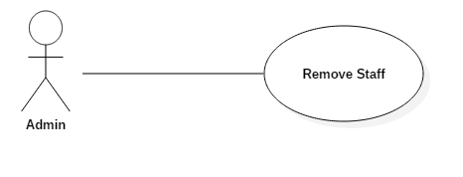

Use Case Specification

Use Case ID |  |  | UC007 |  | Version | 1.0
Use Name |  |  | Remove Staff
Actor |  |  | Admin
Description |  |  | The function allows a Admin remove staff active in the system.
Precondition |  |  | User login successful  User is admin  Admin go to List view page Staff
Trigger |  |  | Admin click “Remove” button of staff
Post-Condition |  |  | System deleted data of staff
Main flows
Step | Actor |  | Action
1 | Admin |  | Go to List View Staff page
2 | System |  | Display list view staff, “Add” button, Search text box and “Search” button
3 | Admin |  | Click “Remove” button of Staff
4 | System |  | Display Pop-up confirm:  - Are you want to delete?  - “OK” button  - “Cancel” button
5 | Admin |  | Click “OK” button
6 | System |  | Display message “Remove Successful” and system delete data of Staff in system.
Alternative flows
AT1 |  | At step 4 in the main flows, if admin click “Cancel” button
Step |  | Actor |  | Action
4.1 |  | System |  | Don’t not anything and display list view staff, “Add” button, Search text box and “Search” button

Business Rules
# | Rule Description
BR01 | Display only staff is active
BR02

UC<008>: <View List Room>

Use Case Diagram
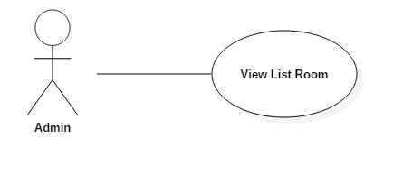

Use Case Specification

Use Case ID |  |  | UC008 |  | Version | 1.0
Use Name |  |  | View List Room
Actor |  |  | Admin
Description |  |  | The function allows a Admin to view list room in the system, when admin navigate to View List Room page
Precondition |  |  | User login successful  User is admin
Trigger |  |  | Admin click “Room” tab on menu tab
Post-Condition |  |  | System display view list room page and list room is active
Main flows
Step | Actor |  | Action
1 | Admin |  | Click to Admin tab on top menu
2 | System |  | Display list sub menu with the following sub menu:  - Staff  - Doctor  - Room  - Service  - Medicine
3 | Admin |  | Click to “Room” sub menu
4 | System |  | Display list view room, “Add” button, Search text box and “Search” button
Alternative flows
AT1 |  | At step 4 in the main flows, if List room is empty
Step |  | Actor |  | Action
4.1 |  | System |  | Display message "Not found room active"

Business Rules
# | Rule Description
BR01 | Display only room is active
BR02

UC<009>:<Add New Room>

Use Case Diagram
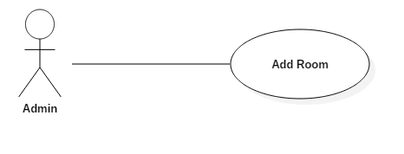

Use Case Specification

Use Case ID |  |  | UC009 |  | Version | 1.0
Use Name |  |  | Add New Room
Actor |  |  | Admin
Description |  |  | The function allows a Admin create to new room in the system.
Precondition |  |  | User login successful  User is admin  Admin go to List view page Room
Trigger |  |  | Admin enter data correct into all field then click “Create” button
Post-Condition |  |  | System display message “Add new room successful” then system view new room on view list room page
Main flows
Step | Actor |  | Action
1 | Admin |  | Go to List View Room page
2 | System |  | Display list view room, “Add” button, Search text box and “Search” button
3 | Admin |  | Click “Add” button
4 | System |  | Display Add new room page
5 | Admin |  | Enter data correct into all field then click “Create” button
6 | System |  | System validates data and save all data into database.
Alternative flows
AT1 |  | At step 1 in the main flows, if List room is empty
Step |  | Actor |  | Action
1.1 |  | System |  | Display message "Not found room active"
AT2 |  | At step 6 in the main flows, if data incorrect
Step |  | Actor |  | Action
6.1 |  | System |  | Display message "Data invalid" and don’t save all data into database
AT2 |  | At step 4 in the main flows, if Admin click “Cancel” button
Step |  | Actor |  | Action
6.2 |  | System |  | Display list view room, “Add” button, Search text box and “Search” button

Business Rules
# | Rule Description
BR01 | Display only room is active
BR02 | N/A

UC<010>:<Edit Room>

Use Case Diagram
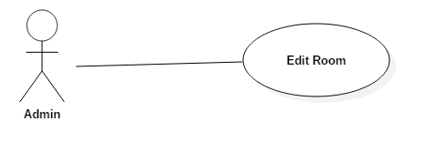

Use Case Specification

Use Case ID |  |  | UC010 |  | Version | 1.0
Use Name |  |  | Edit Room
Actor |  |  | Admin
Description |  |  | The function allows a Admin edit room in the system.
Precondition |  |  | User login successful  User is admin  Admin go to List view page Room
Trigger |  |  | Admin enter data correct into all field then click “Save” button
Post-Condition |  |  | System display message “Edit Staff successful” then display list view room page
Main flows
Step | Actor |  | Action
1 | Admin |  | Go to List View Room page
2 | System |  | Display list view room, “Add” button, Search text box and “Search” button
3 | Admin |  | Click “Edit” button of room item
4 | System |  | Display Edit room page
5 | Admin |  | Edit data correct into all field then click “Save” button
6 | System |  | System validates data and save all data into database.
Alternative flows
AT1 |  | At step 6 in the main flows, if data incorrect
Step |  | Actor |  | Action
6.1 |  | System |  | Display message "Data invalid" and don’t save data in database
AT2 |  | At step 6 in the main flows, if Admin click “Cancel” button
Step |  | Actor |  | Action
6.2 |  | System |  | Display list view room, “Add” button, Search text box and “Search” button

Business Rules
# | Rule Description
BR01 | Display only room is active
BR02 | N/A

UC<011>:<Search Room>

Use Case Diagram
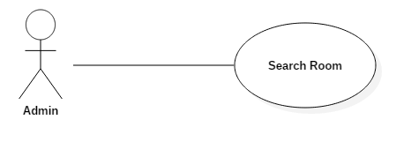

Use Case Specification

Use Case ID |  |  | UC011 |  | Version | 1.0
Use Name |  |  | Search Room
Actor |  |  | Admin
Description |  |  | The function allows a Admin search room active in the system.
Precondition |  |  | User login successful  User is admin  Admin go to List view page Room
Trigger |  |  | Admin enter data into search text box then click “Search” button
Post-Condition |  |  | System display result search
Main flows
Step | Actor |  | Action
1 | Admin |  | Go to List View Room page
2 | System |  | Display list view room, “Add” button, Search text box and “Search” button
3 | Admin |  | Enter data into search text box then click “Search” button
4 | System |  | Display result search on List view room page
Alternative flows
AT1 |  | At step 4 in the main flows, if data incorrect or no result
Step |  | Actor |  | Action
4.1 |  | System |  | Display message "Not Found Room valid"

Business Rules
# | Rule Description
BR01 | Display only room is active
BR02 | N/A

UC<012>:<Remove Room>

Use Case Diagram
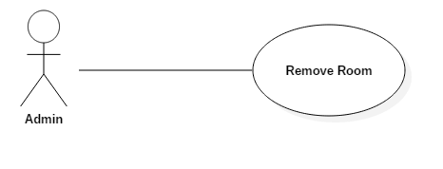

Use Case Specification

Use Case ID |  |  | UC012 |  | Version | 1.0
Use Name |  |  | Remove Room
Actor |  |  | Admin
Description |  |  | The function allows a Admin remove room active in the system.
Precondition |  |  | User login successful  User is admin  Admin go to List view page Room
Trigger |  |  | Admin click “Remove” button of room
Post-Condition |  |  | System deleted data of room
Main flows
Step | Actor |  | Action
1 | Admin |  | Go to List View Room page
2 | System |  | Display list view room, “Add” button, Search text box and “Search” button
3 | Admin |  | Click “Remove” button of Room
4 | System |  | Display Pop-up confirm:  - Are you want to delete?  - “OK” button  - “Cancel” button
5 | Admin |  | Click “OK” button
6 | System |  | Display message “Remove Successful” and system delete data of Room in system.
Alternative flows
AT1 |  | At step 4 in the main flows, if admin click “Cancel” button
Step |  | Actor |  | Action
4.1 |  | System |  | Don’t not anything and display list view room, “Add” button, Search text box and “Search” button

Business Rules
# | Rule Description
BR01 | Display only room is active
BR02

UC<013>: <View List Service>

Use Case Diagram
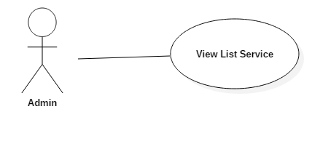

Use Case Specification

Use Case ID |  |  | UC013 |  | Version | 1.0
Use Name |  |  | View List Service
Actor |  |  | Admin
Description |  |  | The function allows a Admin to view list Service in the system, when admin navigate to View List Service page
Precondition |  |  | User login successful  User is admin
Trigger |  |  | Admin click “Service” tab on menu tab
Post-Condition |  |  | System display view list Service page and list Service is active
Main flows
Step | Actor |  | Action
1 | Admin |  | Click to Admin tab on top menu
2 | System |  | Display list sub menu with the following sub menu:  - Staff  - Doctor  - Room  - Service  - Medicine
3 | Admin |  | Click to “Service” sub menu
4 | System |  | Display list view Service, “Add” button, Search text box and “Search” button
Alternative flows
AT1 |  | At step 4 in the main flows, if List Service is empty
Step |  | Actor |  | Action
4.1 |  | System |  | Display message "Not found Service active"

Business Rules
# | Rule Description
BR01 | Display only Service is active
BR02

UC<014>:<Add New Service>

Use Case Diagram
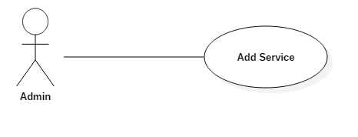

Use Case Specification

Use Case ID |  |  | UC014 |  | Version | 1.0
Use Name |  |  | Add New Service
Actor |  |  | Admin
Description |  |  | The function allows a Admin create to new Service in the system.
Precondition |  |  | User login successful  User is admin  Admin go to List view page Service
Trigger |  |  | Admin enter data correct into all field then click “Create” button
Post-Condition |  |  | System display message “Add new Service successful” then system view new Service on view list Service page
Main flows
Step | Actor |  | Action
1 | Admin |  | Go to List View Service page
2 | System |  | Display list view Service, “Add” button, Search text box and “Search” button
3 | Admin |  | Click “Add” button
4 | System |  | Display Add New Service page
5 | Admin |  | Enter data correct into all field then click “Create” button
6 | System |  | System validates data and save all data into database.
Alternative flows
AT1 |  | At step 1 in the main flows, if List Service is empty
Step |  | Actor |  | Action
1.1 |  | System |  | Display message "Not found Service active"
AT2 |  | At step 6 in the main flows, if data incorrect
Step |  | Actor |  | Action
6.1 |  | System |  | Display message "Data invalid" and don’t save all data into database
AT2 |  | At step 4 in the main flows, if Admin click “Cancel” button
Step |  | Actor |  | Action
6.2 |  | System |  | Display list view Service, “Add” button, Search text box and “Search” button

Business Rules
# | Rule Description
BR01 | Display only Service is active
BR02

UC<015>:<Edit Service>

Use Case Diagram
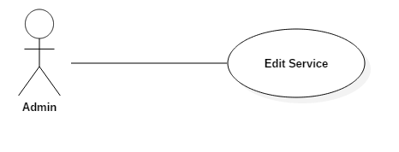

Use Case Specification

Use Case ID |  |  | UC015 |  | Version | 1.0
Use Name |  |  | Edit Service
Actor |  |  | Admin
Description |  |  | The function allows a Admin Edit Service in the system.
Precondition |  |  | User login successful  User is admin  Admin go to List view page Service
Trigger |  |  | Admin enter data correct into all field then click “Save” button
Post-Condition |  |  | System display message “Edit Service successful” then display list view Service page
Main flows
Step | Actor |  | Action
1 | Admin |  | Go to List View Service page
2 | System |  | Display list view Service, “Add” button, Search text box and “Search” button
3 | Admin |  | Click “Edit” button of Service item
4 | System |  | Display Edit Service page
5 | Admin |  | Edit data correct into all field then click “Save” button
6 | System |  | System validates data and save all data into database.
Alternative flows
AT1 |  | At step 6 in the main flows, if data incorrect
Step |  | Actor |  | Action
6.1 |  | System |  | Display message "Data invalid" and don’t save data in database
AT2 |  | At step 6 in the main flows, if Admin click “Cancel” button
Step |  | Actor |  | Action
6.2 |  | System |  | Display list view Service, “Add” button, Search text box and “Search” button

Business Rules
# | Rule Description
BR01 | Display only Service is active
BR02

UC<016>:<Search Service>

Use Case Diagram
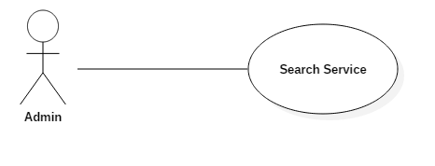

Use Case Specification

Use Case ID |  |  | UC016 |  | Version | 1.0
Use Name |  |  | Search Service
Actor |  |  | Admin
Description |  |  | The function allows a Admin Search Service active in the system.
Precondition |  |  | User login successful  User is admin  Admin go to List view page Service
Trigger |  |  | Admin enter data into search text box then click “Search” button
Post-Condition |  |  | System display result search
Main flows
Step | Actor |  | Action
1 | Admin |  | Go to List View Service page
2 | System |  | Display list view Service, “Add” button, Search text box and “Search” button
3 | Admin |  | Enter data into search text box then click “Search” button
4 | System |  | Display result search on List View Service page
Alternative flows
AT1 |  | At step 4 in the main flows, if data incorrect or no result
Step |  | Actor |  | Action
4.1 |  | System |  | Display message "Not Found Service valid"

Business Rules
# | Rule Description
BR01 | Display only Service is active
BR02

UC<017>:<Remove Service>

Use Case Diagram
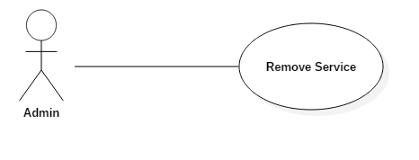

Use Case Specification

Use Case ID |  |  | UC017 |  | Version | 1.0
Use Name |  |  | Remove Service
Actor |  |  | Admin
Description |  |  | The function allows a Admin remove Service active in the system.
Precondition |  |  | User login successful  User is admin  Admin go to List view page Service
Trigger |  |  | Admin click “Remove” button of Service
Post-Condition |  |  | System deleted data of Service
Main flows
Step | Actor |  | Action
1 | Admin |  | Go to List View Service page
2 | System |  | Display list view Service, “Add” button, Search text box and “Search” button
3 | Admin |  | Click “Remove” button of Service
4 | System |  | Display Pop-up confirm:  - Are you want to delete?  - “OK” button  - “Cancel” button
5 | Admin |  | Click “OK” button
6 | System |  | Display message “Remove Successful” and system delete data of Service in system.
Alternative flows
AT1 |  | At step 4 in the main flows, if admin click “Cancel” button
Step |  | Actor |  | Action
4.1 |  | System |  | Don’t not anything and display list view Service, “Add” button, Search text box and “Search” button

Business Rules
# | Rule Description
BR01 | Display only Service is active
BR02

UC<018>: <View List Medicine>

Use Case Diagram
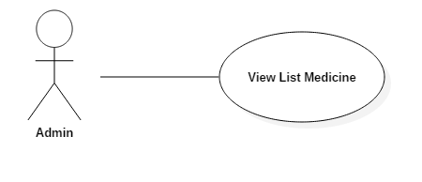

Use Case Specification

Use Case ID |  |  | UC018 |  | Version | 1.0
Use Name |  |  | View List Medicine
Actor |  |  | Admin
Description |  |  | The function allows a Admin to view list Medicine in the system, when admin navigate to View List Medicine page
Precondition |  |  | User login successful  User is admin
Trigger |  |  | Admin click “Medicine” tab on menu tab
Post-Condition |  |  | System display view list Medicine page and list Medicine is active
Main flows
Step | Actor |  | Action
1 | Admin |  | Click to Admin tab on top menu
2 | System |  | Display list sub menu with the following sub menu:  - Staff  - Doctor  - Room  - Service  - Medicine
3 | Admin |  | Click to “Medicine” sub menu
4 | System |  | Display list view Medicine, “Add” button, Search text box and “Search” button
Alternative flows
AT1 |  | At step 4 in the main flows, if List Medicine is empty
Step |  | Actor |  | Action
4.1 |  | System |  | Display message "Not found Medicine active"

Business Rules
# | Rule Description
BR01 | Display only Medicine is active
BR02

UC<012>:<Add New Medicine>

Use Case Diagram
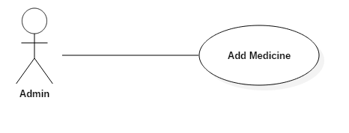

Use Case Specification

Use Case ID |  |  | UC017 |  | Version | 1.0
Use Name |  |  | Add New Medicine
Actor |  |  | Admin
Description |  |  | The function allows a Admin create to new Medicine in the system.
Precondition |  |  | User login successful  User is admin  Admin go to List view page Medicine
Trigger |  |  | Admin enter data correct into all field then click “Create” button
Post-Condition |  |  | System display message “Add new Medicine successful” then system view new Medicine on view list Medicine page
Main flows
Step | Actor |  | Action
1 | Admin |  | Go to List View Medicine page
2 | System |  | Display list view Medicine, “Add” button, Search text box and “Search” button
3 | Admin |  | Click “Add” button
4 | System |  | Display Add New Medicine page
5 | Admin |  | Enter data correct into all field then click “Create” button
6 | System |  | System validates data and save all data into database.
Alternative flows
AT1 |  | At step 1 in the main flows, if List Medicine is empty
Step |  | Actor |  | Action
1.1 |  | System |  | Display message "Not found Medicine active"
AT2 |  | At step 6 in the main flows, if data incorrect
Step |  | Actor |  | Action
6.1 |  | System |  | Display message "Data invalid" and don’t save all data into database
AT2 |  | At step 4 in the main flows, if Admin click “Cancel” button
Step |  | Actor |  | Action
6.2 |  | System |  | Display list view Medicine, “Add” button, Search text box and “Search” button

Business Rules
# | Rule Description
BR01 | Display only Medicine is active
BR02

UC<018>:<Edit Medicine>

Use Case Diagram
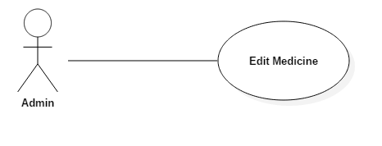

Use Case Specification

Use Case ID |  |  | UC018 |  | Version | 1.0
Use Name |  |  | Edit Medicine
Actor |  |  | Admin
Description |  |  | The function allows a Admin Edit Medicine in the system.
Precondition |  |  | User login successful  User is admin  Admin go to List view page Service
Trigger |  |  | Admin enter data correct into all field then click “Save” button
Post-Condition |  |  | System display message “Edit Medicine successful” then display list view Medicine page
Main flows
Step | Actor |  | Action
1 | Admin |  | Go to List View Medicine page
2 | System |  | Display list view Medicine, “Add” button, Search text box and “Search” button
3 | Admin |  | Click “Edit” button of Medicine item
4 | System |  | Display Edit Medicine page
5 | Admin |  | Edit data correct into all field then click “Save” button
6 | System |  | System validates data and save all data into database.
Alternative flows
AT1 |  | At step 6 in the main flows, if data incorrect
Step |  | Actor |  | Action
6.1 |  | System |  | Display message "Data invalid" and don’t save data in database
AT2 |  | At step 6 in the main flows, if Admin click “Cancel” button
Step |  | Actor |  | Action
6.2 |  | System |  | Display list view Medicine, “Add” button, Search text box and “Search” button

Business Rules
# | Rule Description
BR01 | Display only Medicine is active
BR02

UC<019>:<Search Medicine>

Use Case Diagram
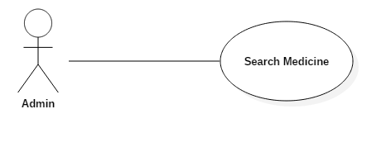

Use Case Specification

Use Case ID |  |  | UC019 |  | Version | 1.0
Use Name |  |  | Search Medicine
Actor |  |  | Admin
Description |  |  | The function allows a Admin Search Medicine active in the system.
Precondition |  |  | User login successful  User is admin  Admin go to List view page Medicine
Trigger |  |  | Admin enter data into search text box then click “Search” button
Post-Condition |  |  | System display result search
Main flows
Step | Actor |  | Action
1 | Admin |  | Go to List View Medicine page
2 | System |  | Display list view Medicine, “Add” button, Search text box and “Search” button
3 | Admin |  | Enter data into search text box then click “Search” button
4 | System |  | Display result search on List View Medicine page
Alternative flows
AT1 |  | At step 4 in the main flows, if data incorrect or no result
Step |  | Actor |  | Action
4.1 |  | System |  | Display message "Not Found Medicine valid"

Business Rules
# | Rule Description
BR01 | Display only Medicine is active
BR02

UC<020>:<Remove Medicine>

Use Case Diagram
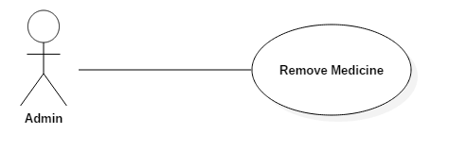

Use Case Specification

Use Case ID |  |  | UC020 |  | Version | 1.0
Use Name |  |  | Remove Medicine
Actor |  |  | Admin
Description |  |  | The function allows a Admin remove Medicine active in the system.
Precondition |  |  | User login successful  User is admin  Admin go to List view page Medicine
Trigger |  |  | Admin click “Remove” button of Medicine
Post-Condition |  |  | System deleted data of Medicine
Main flows
Step | Actor |  | Action
1 | Admin |  | Go to List View Medicine page
2 | System |  | Display list view Medicine, “Add” button, Search text box and “Search” button
3 | Admin |  | Click “Remove” button of Medicine
4 | System |  | Display Pop-up confirm:  - Are you want to delete?  - “OK” button  - “Cancel” button
5 | Admin |  | Click “OK” button
6 | System |  | Display message “Remove Successful” and system delete data of Medicine in system.
Alternative flows
AT1 |  | At step 4 in the main flows, if admin click “Cancel” button
Step |  | Actor |  | Action
4.1 |  | System |  | Don’t not anything and display list view Medicine, “Add” button, Search text box and “Search” button

Business Rules
# | Rule Description
BR01 | Display only Medicine is active
BR02

UC<021>: <View List Doctor>

Use Case Diagram
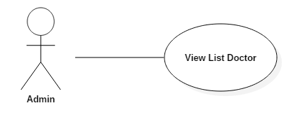

Use Case Specification

Use Case ID |  |  | UC021 |  | Version | 1.0
Use Name |  |  | View List Doctor
Actor |  |  | Admin
Description |  |  | The function allows a Admin to view list Doctor in the system, when admin navigate to View List Doctor page
Precondition |  |  | User login successful  User is admin
Trigger |  |  | Admin click “Doctor” tab on menu tab
Post-Condition |  |  | System display view list Doctor page and list Doctor is active
Main flows
Step | Actor |  | Action
1 | Admin |  | Click to Admin tab on top menu
2 | System |  | Display list sub menu with the following sub menu:  - Staff  - Doctor  - Room  - Service  - Medicine
3 | Admin |  | Click to “Doctor” sub menu
4 | System |  | Display list view Doctor, “Add” button, Search text box and “Search” button
Alternative flows
AT1 |  | At step 4 in the main flows, if List Doctor is empty
Step |  | Actor |  | Action
4.1 |  | System |  | Display message "Not found Doctor active"

Business Rules
# | Rule Description
BR01 | Display only Doctor is active
BR02

UC<022>:<Add New Doctor>

Use Case Diagram
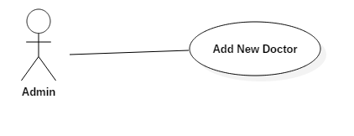

Use Case Specification
<Phần này là đặc tả chi tiết cho Use-Case>
Use Case ID |  |  | UC022 |  | Version | 1.0
Use Name |  |  | Add New Doctor
Actor |  |  | Admin
Description |  |  | The function allows a Admin create to new Doctor in the system.
Precondition |  |  | User login successful  User is admin  Admin go to List view page Doctor
Trigger |  |  | Admin enter data correct into all field then click “Create” button
Post-Condition |  |  | System display message “Add new Medicine successful” then system view new Doctor on view list Medicine page
Main flows
Step | Actor |  | Action
1 | Admin |  | Go to List View Doctor page
2 | System |  | Display list view Doctor, “Add” button, Search text box and “Search” button
3 | Admin |  | Click “Add” button
4 | System |  | Display Add New Doctor page
5 | Admin |  | Enter data correct into all field then click “Create” button
6 | System |  | System validates data and save all data into database.
Alternative flows
AT1 |  | At step 1 in the main flows, if List Doctor is empty
Step |  | Actor |  | Action
1.1 |  | System |  | Display message "Not found Doctor active"
AT2 |  | At step 6 in the main flows, if data incorrect
Step |  | Actor |  | Action
6.1 |  | System |  | Display message "Data invalid" and don’t save all data into database
AT2 |  | At step 4 in the main flows, if Admin click “Cancel” button
Step |  | Actor |  | Action
6.2 |  | System |  | Display list view Doctor, “Add” button, Search text box and “Search” button

Business Rules
# | Rule Description
BR01 | Display only Doctor is active
BR02

UC<023>:<Edit Doctor>

Use Case Diagram
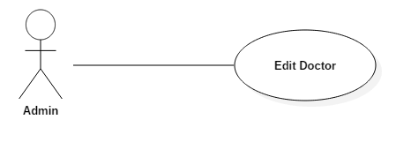

Use Case Specification

Use Case ID |  |  | UC023 |  | Version | 1.0
Use Name |  |  | Edit Doctor
Actor |  |  | Admin
Description |  |  | The function allows a Admin Edit Doctor in the system.
Precondition |  |  | User login successful  User is admin  Admin go to List view page Doctor
Trigger |  |  | Admin enter data correct into all field then click “Save” button
Post-Condition |  |  | System display message “Edit Service successful” then display list view Doctor page
Main flows
Step | Actor |  | Action
1 | Admin |  | Go to List View Doctor page
2 | System |  | Display list view Doctor, “Add” button, Search text box and “Search” button
3 | Admin |  | Click “Edit” button of Doctor item
4 | System |  | Display Edit Doctor page
5 | Admin |  | Edit data correct into all field then click “Save” button
6 | System |  | System validates data and save all data into database.
Alternative flows
AT1 |  | At step 6 in the main flows, if data incorrect
Step |  | Actor |  | Action
6.1 |  | System |  | Display message "Data invalid" and don’t save data in database
AT2 |  | At step 6 in the main flows, if Admin click “Cancel” button
Step |  | Actor |  | Action
6.2 |  | System |  | Display list view Doctor, “Add” button, Search text box and “Search” button

Business Rules
# | Rule Description
BR01 | Display only Doctor is active
BR02

UC<024>:<Search Doctor>

Use Case Diagram
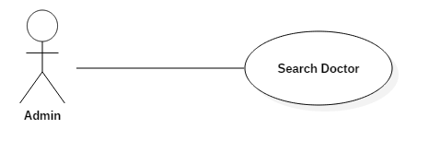

Use Case Specification

Use Case ID |  |  | UC024 |  | Version | 1.0
Use Name |  |  | Search Doctor
Actor |  |  | Admin
Description |  |  | The function allows a Admin Search Doctor active in the system.
Precondition |  |  | User login successful  User is admin  Admin go to List view page Doctor
Trigger |  |  | Admin enter data into search text box then click “Search” button
Post-Condition |  |  | System display result search
Main flows
Step | Actor |  | Action
1 | Admin |  | Go to List View Doctor page
2 | System |  | Display list view Doctor, “Add” button, Search text box and “Search” button
3 | Admin |  | Enter data into search text box then click “Search” button
4 | System |  | Display result search on List View Medicine page
Alternative flows
AT1 |  | At step 4 in the main flows, if data incorrect or no result
Step |  | Actor |  | Action
4.1 |  | System |  | Display message "Not Found Doctor valid"

Business Rules
# | Rule Description
BR01 | Display only Doctor is active
BR02

UC<025>:<Remove Doctor>

Use Case Diagram
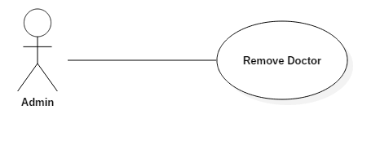

Use Case Specification

Use Case ID |  |  | UC025 |  | Version | 1.0
Use Name |  |  | Remove Doctor
Actor |  |  | Admin
Description |  |  | The function allows a Admin remove Doctor active in the system.
Precondition |  |  | User login successful  User is admin  Admin go to List view page Doctor
Trigger |  |  | Admin click “Remove” button of Doctor
Post-Condition |  |  | System deleted data of Doctor
Main flows
Step | Actor |  | Action
1 | Admin |  | Go to List View Doctor page
2 | System |  | Display list view Doctor, “Add” button, Search text box and “Search” button
3 | Admin |  | Click “Remove” button of Doctor
4 | System |  | Display Pop-up confirm:  - Are you want to delete?  - “OK” button  - “Cancel” button
5 | Admin |  | Click “OK” button
6 | System |  | Display message “Remove Successful” and system delete data of Doctor in system.
Alternative flows
AT1 |  | At step 4 in the main flows, if admin click “Cancel” button
Step |  | Actor |  | Action
4.1 |  | System |  | Don’t not anything and display list view Doctor, “Add” button, Search text box and “Search” button

Business Rules
# | Rule Description
BR01 | Display only Doctor is active
BR02

UC<026>:<Work Schedules of Doctor>

Use Case Diagram
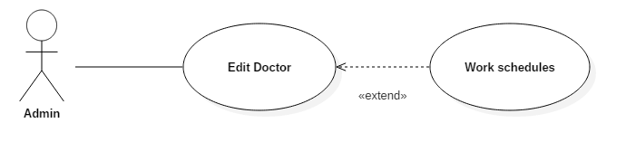

Use Case Specification
<Phần này là đặc tả chi tiết cho Use-Case>
Use Case ID |  |  | UC026 |  | Version | 1.0
Use Name |  |  | Work Schedules of Doctor
Actor |  |  | Admin
Description |  |  | The function allows a Admin set up work schedules Doctor active in the system.
Precondition |  |  | User login successful  User is admin  Admin go to List view page Doctor
Trigger |  |  | Admin click “Schedule” button of Doctor
Post-Condition |  |  | System save schedule data into database
Main flows
Step | Actor |  | Action
1 | Admin |  | Go to List View Doctor page
2 | System |  | Display list view Doctor, “Add” button, Search text box and “Search” button
3 | Admin |  | Click “Schedule” button of Doctor
4 | System |  | Display schedule page
5 | Admin |  | Select and setup date time then click “Save” button
6 | System |  | Display message “Setup Successful” and system save data of schedule in system.
Alternative flows
AT1 |  | At step 6 in the main flows, if admin click “Cancel” button
Step |  | Actor |  | Action
4.1 |  | System |  | Don’t not anything and display list view Doctor, “Add” button, Search text box and “Search” button

Business Rules
# | Rule Description
BR01 | Display only Doctor is active
BR02

UC<029>:<Register>

Use Case Diagram

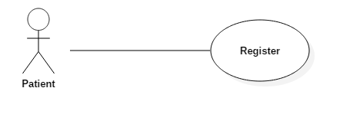

Use Case Specification

Use Case ID |  |  | UC030 |  | Version | 1.0
Use Name |  |  | Register
Actor |  |  | Patient
Description |  |  | The function allows a Patient register account to system. When user haven’t account.
Precondition |  |  | Patient navigate to Register page
Trigger |  |  | Patient input correct data all field then click “Register” button
Post-Condition |  |  | System save data into database
Main flows
Step | Actor |  | Action
1 | Patient |  | Go to Register page
2 | System |  | Display Register page with the following fields:  - Email  - Password  - Birthday  - Address  - Job  - Name  - Sex  - Phone Number  - Register button  - Cancel button
3 | Patient |  | Input correct data all field
4 | System |  | Validation data
5 | Patient |  | Click “Register” button
6 | System |  | Display message “Register Successful”  System save data into database
Alternative flows
AT1 |  | At step 3 in the main flows, if patient input invalid data
Step |  | Actor |  | Action
3.1 |  | System |  | Display error message
AT2 |  | At step 5 in the main flows, if patient “Cancel” button
Step |  | Actor |  | Action
5.1 |  | System |  | Don’t save data into System  Display Home page

Business Rules
# | Rule Description
BR01 | N/A
BR02 | N/A

UC<030>:<View History Medical Record>

Use Case Diagram

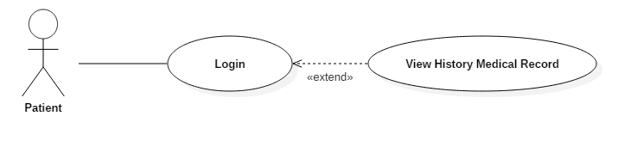

Use Case Specification

Use Case ID |  |  | UC030 |  | Version | 1.0
Use Name |  |  | View History Medical Record
Actor |  |  | Patient
Description |  |  | The function allows Patient can view history Medical Record on the system.
Precondition |  |  | Patient login to system  Patient navigate to edit medical record page
Trigger |  |  | Patient click to “History” tab
Post-Condition |  |  | System display all medical record have status is done
Main flows
Step | Actor |  | Action
1 | Patient |  | Navigate page History button on top menu
2 | System |  | Display edit medical record page
Alternative flows
AT1 |  | At step 2 in the main flows, if Patient haven’t medical record
Step |  | Actor |  | Action
2.1 |  | System |  | Display message: “Not Found Medical Record”

Business Rules
# | Rule Description
BR01 | Display medical record have status is done
BR02 | Display medical record by account

UC<030>:<Book Appointment>

Use Case Diagram

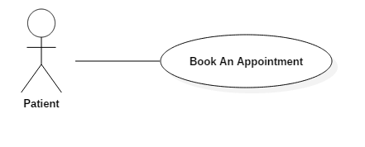

Use Case Specification

Use Case ID |  |  | UC030 |  | Version | 1.0
Use Name |  |  | Book Appointment
Actor |  |  | Patient
Description |  |  | The function allows a Patient create appointment to the system, when Patient have account.
Precondition |  |  | Patient navigate to Appointment page
Trigger |  |  | Patient input correct data all field then click “Book” button
Post-Condition |  |  | System save data into database
Main flows
Step | Actor |  | Action
1 | Patient |  | Go to Appointment page
2 | System |  | Display two option:  + Have medical examination at the clinic  + Have not medical examination at the clinic
3 | Patient |  | Paint selected one option
4 | System |  | Display all field of appointment, “Book” button, “Cancel” button
5 | Patient |  | Input correct data all field
6 | System |  | Validation data
7 | Patient |  | Click “Book” button
8 | System |  | Display message “Book Successful”  Save data Appointment
Alternative flows
AT1 |  | At step 7 in the main flows, if patient input invalid data
Step |  | Actor |  | Action
7.1 |  | System |  | Display error message

Business Rules
# | Rule Description
BR01 | N/A
BR02 | N/A

UC<028>:<Search Patient>

Use Case Diagram

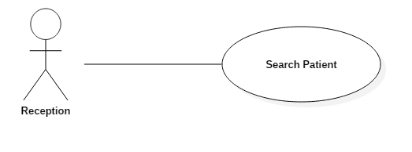

Use Case Specification

Use Case ID |  |  | UC028 |  | Version | 1.0
Use Name |  |  | Search Patient
Actor |  |  | Reception
Description |  |  | The function allows a Reception Search Patient on the system.
Precondition |  |  | Reception login to system
Trigger |  |  | Reception input data
Post-Condition |  |  | System display search result
Main flows
Step | Actor |  | Action
1 | Reception |  | Login to System
2 | System |  | Display list patient page, search text box, “Add” button
3 | Reception |  | Input data into search text box
4 | System |  | Auto search and display result
Alternative flows
AT1 |  | At step 4 in the main flows, if result is null
Step |  | Actor |  | Action
4.1 |  | System |  | Display message: Don’t have Patient
AT2 |  | At step 4 in the main flows, if Reception input is null
Step |  | Actor |  | Action
4.2 |  | System |  | Display all Patient into System

Business Rules
# | Rule Description
BR01 | Display Patient is active
BR02

UC<029>:<Add Patient>

Use Case Diagram

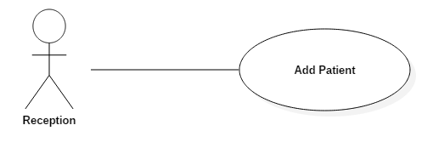

Use Case Specification

Use Case ID |  |  | UC029 |  | Version | 1.0
Use Name |  |  | Add Patient
Actor |  |  | Reception
Description |  |  | The function allows a Reception create new Patient on the system.
Precondition |  |  | Reception login to system
Trigger |  |  | Reception input data then click “Save” button
Post-Condition |  |  | System save to data of Patient into system
Main flows
Step | Actor |  | Action
1 | Reception |  | Login to System
2 | System |  | Display list patient page, search text box, “Add” button, “Edit” button
3 | Reception |  | Click “Add” button
4 | System |  | Display All filed create new patient, “Save” button, “Cancel” button
5 | Reception |  | Input correct data and click “Save” button
6 | System |  | Display message “Create successful” and save data of Patient into database
Alternative flows
AT1 |  | At step 5 in the main flows, if Reception input data incorrect
Step |  | Actor |  | Action
5.1 |  | System |  | Display error message
AT2 |  | At step 5 in the main flows, if Reception click “Cancel” button
Step |  | Actor |  | Action
5.2 |  | System |  | Don’t save data into system  Display list patient page, search text box, “Add” button

Business Rules
# | Rule Description
BR01 | Display Patient is active
BR02

UC<030>:<Edit Patient>

Use Case Diagram

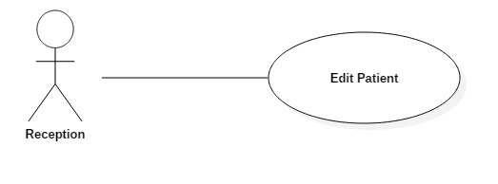

Use Case Specification

Use Case ID |  |  | UC030 |  | Version | 1.0
Use Name |  |  | Edit Patient
Actor |  |  | Reception
Description |  |  | The function allows a Reception can edit Patient info on the system.
Precondition |  |  | Reception login to system
Trigger |  |  | Reception edit data then click “Save” button
Post-Condition |  |  | System save to edit data of Patient into system
Main flows
Step | Actor |  | Action
1 | Reception |  | Login to System
2 | System |  | Display list patient page, search text box, “Add” button, “Edit” button
3 | Reception |  | Click “Edit” button
4 | System |  | Display All filed edit patient, “Save” button, “Cancel” button
5 | Reception |  | Input correct data and click “Save” button
6 | System |  | Display message “Edit successful” and save edit data of Patient into database
Alternative flows
AT1 |  | At step 5 in the main flows, if Reception input data incorrect
Step |  | Actor |  | Action
5.1 |  | System |  | Display error message
AT2 |  | At step 5 in the main flows, if Reception click “Cancel” button
Step |  | Actor |  | Action
5.2 |  | System |  | Don’t save data into system  Display list patient page, search text box, “Add” button, “Edit” button

Business Rules
# | Rule Description
BR01 | Display Patient is active
BR02

UC<031>:<Add Medical Record>

Use Case Diagram

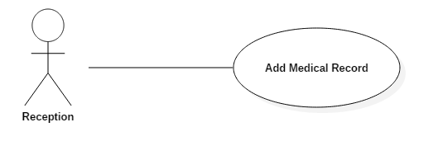

Use Case Specification

Use Case ID |  |  | UC031 |  | Version | 1.0
Use Name |  |  | Add Medical Record
Actor |  |  | Reception
Description |  |  | The function allows a Reception can create new Medical Record on the system.
Precondition |  |  | Reception login to system
Trigger |  |  | Reception input data then click “Save” button
Post-Condition |  |  | System save to data Medical Record of Patient into system
Main flows
Step | Actor |  | Action
1 | Reception |  | Login to System
2 | System |  | Display list patient page, search text box, “Add” button, “Edit” button, “Record” button
3 | Reception |  | Click “Record” button
4 | System |  | Display All filed add Medical Record, “Save” button, “Cancel” button
5 | Reception |  | Input correct data and click “Save” button
6 | System |  | Display message “Create successful” and save edit data of Patient into database
Alternative flows
AT1 |  | At step 5 in the main flows, if Reception input data incorrect
Step |  | Actor |  | Action
5.1 |  | System |  | Display error message
AT2 |  | At step 5 in the main flows, if Reception click “Cancel” button
Step |  | Actor |  | Action
5.2 |  | System |  | Don’t save data into system  Display list patient page, search text box, “Add” button, “Edit” button

Business Rules
# | Rule Description
BR01 | Display Patient is active
BR02

UC<032>:<View List New Medical Record>

Use Case Diagram

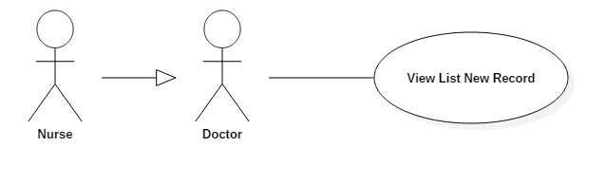

Use Case Specification
<Phần này là đặc tả chi tiết cho Use-Case>
Use Case ID |  |  | UC031 |  | Version | 1.0
Use Name |  |  | View List New Medical Record
Actor |  |  | Nurse, Doctor
Description |  |  | The function allows Nurse/Doctor can view list new Medical Record on the system.
Precondition |  |  | Nurse/Doctor login to system
Trigger |  |  | Nurse/Doctor click to “Room” button Top Menu
Post-Condition |  |  | System display list new Medical Record of Room
Main flows
Step | Actor |  | Action
1 | Nurse/Doctor |  | Login to System
2 | System |  | Display work schedule of Doctors/Nurse page
3 | Nurse/Doctor |  | Click “Room” button on Top menu
4 | System |  | Display list room
5 | Nurse/Doctor |  | Select room
6 | System |  | Display list view new record of room
Alternative flows
AT1 |  | At step 5 in the main flows, if list record is null
Step |  | Actor |  | Action
5.1 |  | System |  | Display error message

Business Rules
# | Rule Description
BR01 | Display medical record have status is new
BR02 | Display medical record by room

UC<033>:<Edit Medical Record>

Use Case Diagram

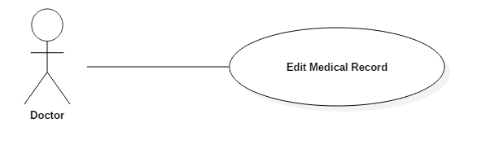

Use Case Specification

Use Case ID |  |  | UC031 |  | Version | 1.0
Use Name |  |  | Edit Medical Record
Actor |  |  | Nurse, Doctor
Description |  |  | The function allows Nurse/Doctor can edit Medical Record on the system.
Precondition |  |  | Nurse/Doctor login to system  Nurse/Doctor completed View List New Medical Record use case
Trigger |  |  | Nurse/Doctor edit data
Post-Condition |  |  | System saving data then navigate to create prescription page
Main flows
Step | Actor |  | Action
1 | Nurse/Doctor |  | Completed view list new medical record use case
2 | System |  | Display list view new record of room
3 | Nurse/Doctor |  | Click “Edit” button
4 | System |  | Display edit medical record page
5 | Nurse/Doctor |  | Edit data all field
6 | System |  | Validation data
7 | Nurse/Doctor |  | Click “Save” button
8 | System |  | System save data into system and navigate to create the prescription page
Alternative flows
AT1 |  | At step 8 in the main flows, if Doctor click “Cancel” button
Step |  | Actor |  | Action
8.1 |  | System |  | Save data but not change status

Business Rules
# | Rule Description
BR01 | Display medical record by room
BR02

UC<033>:<View History Medical Record>

Use Case Diagram

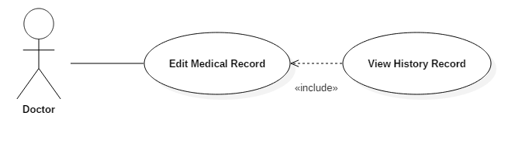

Use Case Specification

Use Case ID |  |  | UC031 |  | Version | 1.0
Use Name |  |  | View History Medical Record
Actor |  |  | Nurse, Doctor
Description |  |  | The function allows Nurse/Doctor can view history Medical Record on the system.
Precondition |  |  | Nurse/Doctor login to system  Nurse/Doctor navigate to edit medical record page
Trigger |  |  | Nurse/Doctor click to “History” tab
Post-Condition |  |  | System display all medical record have status is done
Main flows
Step | Actor |  | Action
1 | Nurse/Doctor |  | Navigate to edit page medical record
2 | System |  | Display edit medical record page
3 | Nurse/Doctor |  | Click “History” tab
4 | System |  | Display all medical record have status is done
Alternative flows
AT1 |  | At step 8 in the main flows, if Patient click “History” tab
Step |  | Actor |  | Action
8.1 |  | System |  | Display error message

Business Rules
# | Rule Description
BR01 | Display medical record have status is done
BR02 | Display medical record by account

UC<039>:<Report Invoice>

Use Case Diagram

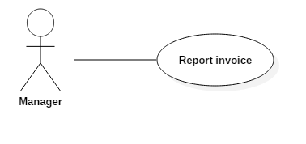

Use Case Specification

Use Case ID |  |  | UC039 |  | Version | 1.0
Use Name |  |  | Report invoice
Actor |  |  | Manger
Description |  |  | The function allows Manager can view report invoice.
Precondition |  |  | Manager login to system  Manager navigate to report page
Trigger |  |  | Manager click to “Record” tab
Post-Condition |  |  | System display all invoice have status is done
Main flows
Step | Actor |  | Action
1 | Manager |  | Navigate to report page
2 | System |  | Display List invoice
Alternative flows
AT1 |  | At step 8 in the main flows, if system have not invoice
Step |  | Actor |  | Action
8.1 |  | System |  | Display message: “Not Found Invoice”

Business Rules
# | Rule Description
BR01 | Display invoice have status is done
BR02

Non-functional Specification

Reliability
If the software is crashed, it should be repaired in 30 minutes.
Defect rate: we accept an average of 10 bugs per KLOC (kilo line of codes), however, this number should not exceed 15 bugs per KLOC

Performance Requirements

Availability
The system is approximately 99% and must be available 24 hours a day, 7 days a week.
User must have the ability to access website by any web browser in his or her computers.

Response time
- Web pages maximum loading is around 4 seconds
- Limit access must be 10000

User Interface
- Arrangement
- Have 2 website: patient page and clinic page.
- Patient page is public website for patient. This page is view information of clinic pubic.
- Clinic page is internal website. Clinic staff using the function on the website for easy work.
- Color
- The system has been designed to use less and simple color to make the page be fresh and clearly to user. Users can easily notice what they want
- Text
- All text bases on Times New Roman style. Their size and font style will rely on their type, their function. The text style will be divided into some specific types to make the website be unified

Design Constraints
<Phần đặc tả về yêu cẩu các rang buộc về mặt thiết kế của phần mềm>

Usability
<Phần đặc tả về yêu cẩu khả năng ứng dụng của phần mềm>

Security Requirements
<Phần đặc tả về yêu cẩu về bảo mật thông tin của phần mềm>

Hardware/Software Requirements
All data and applications installed at the servers, so it should be required the best equipment. When equipped servers, it is necessary to pay attention to the following element:
- Configuration suggestions of hardware:

# | Name | Configuration | Description
1 | Application Server | RAM: 8GB  Hard disk: 250GB  Chipset: Core i7 | Server for application server to deploy web application with the minimum configuration
2 | Client | RAM: 4GB  Hard disk: 150GB  Chipset: Core i3 | Notebooks for developing/testing with the minimum configuration

- Configured transmission line:
Depending on the actual topography of each deployment environment that function setting up the network will be able to use copper cable, optical cable or wireless.
- Configuration suggestions of software:

Software name | Version | Source
Chrome | 51 | Google
Operating System: Microsoft® Windows | 7, 8, 10 | Microsoft
.Net Framework | 4.0 | Microsoft
SQL Server | 2008 | Microsoft
Visual studio | 2015 | Microsoft

Entity Relationship Diagram

