|  |
| --- |
|  |
| Capstone Project Document |

**WINGS**

Report #1 - User Requirement Specification

|  |  |  |
| --- | --- | --- |
| **WingS** | | |
| **Group Members** | Đào Trọng Nghĩa | SE03220 |
| Hoàng Anh Tuấn | SE03108 |
| Tạ Ngọc Duy | SE03267 |
| Đỗ Văn Tuấn | SE03297 |
| Lê Hồng Nhiên | SE03377 |
| **Supervisor** | Mr. Nguyễn Văn Sang | |
| **Project code** | WS | |

**- Hanoi, 09/2016 –**

# SIGNATURE PAGE

AUTHOR: Hoàng Anh Tuấn 15/09/2016

Team member

REVIEWERS: Đào Trọng Nghĩa 16/09/2016

Project manager

APPROVAL: Nguyễn Văn Sang --/--/2016

Supervisor

Record of change

*A - Added M - Modified D – Deleted

|  |  |  |  |  |  |
| --- | --- | --- | --- | --- | --- |
| Effective Date | Changed Item | A,M,D | Change Description | Reason for Change | Rev. Number |
| 15/Sep/2016 | Create User Requirement Specification | A | First version | Create User Requirement Specification | 1.0 |
| 16/Sep/2016 | Create User Requirement Specification | M | First version | Update and modify more information | 1.0 |
|  |  |  |  |  |  |
|  |  |  |  |  |  |
|  |  |  |  |  |  |
|  |  |  |  |  |  |
|  |  |  |  |  |  |
|  |  |  |  |  |  |
|  |  |  |  |  |  |
|  |  |  |  |  |  |
|  |  |  |  |  |  |
|  |  |  |  |  |  |
|  |  |  |  |  |  |

Table Contents

SIGNATURE PAGE 1

1 USER REQUIREMENTS SPECIFICATION 3

1.1 Introduction 3

1.1.1 Purpose 3

1.1.2 Definition and Acronyms 3

1.2 Overall Description 3

1.2.1 Business Process Overview 3

1.2.2 Product Features 16

1.2.3 User characteristic 17

1.3 Functional Requirements 18

1.3.1 Common Function 18

1.3.2 Discover Projects 18

1.3.3 Create Project 18

1.3.4 Back Project 18

1.3.5 Send/Receive messages 18

1.3.6 Management profile 18

1.3.7 Management Member’s account 19

1.3.8 Management Project 19

1.3.9 Management Dashboard Overview 19

1.4 Non-functional Requirement 19

# USER REQUIREMENTS SPECIFICATION

## Introduction

### Purpose

This document will provide the describing of general requirement and non-functional requirements of our WS system. It also describes the requirement scope of each phase in the project.

### Definition and Acronyms

|  |  |
| --- | --- |
| Terms | Description |
| WS | WingS |
|  |  |

Table 1‑1: Definition and Acronyms

## Overall Description

### Business Process Overview

WS is a website. Therefore, that system will implement the following processes:

#### Approve/Suspend workflow

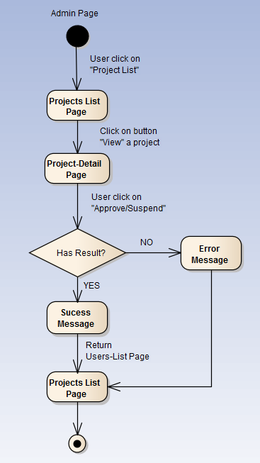

Figure 1‑1: Approve/Suspend workflow

Brief description: Admin can use this function. Steps:

* Step 1: User click on projects list.
* Step 2: System return projects list page.
* Step 3: User click on button view
* Step 4: System return project detail page.
* Step 5: User click on button Approved/Suspended
* Step 6: System return success message or error message.
* Step 7: System return projects list page.

#### Active/Inactive workflow

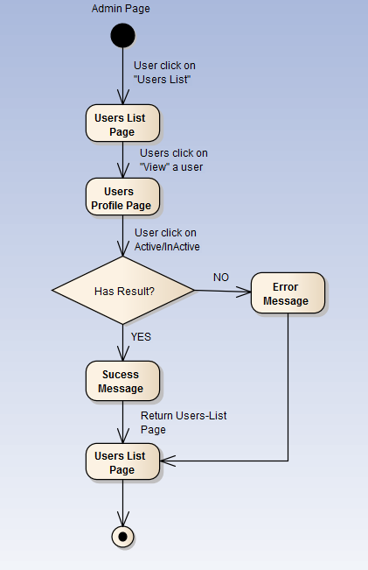

Figure 1‑2: Active/Inactive workflow

Brief description: Admin can use this function. Steps:

* Step 1: User click on users list.
* Step 2: System return users list page.
* Step 3: User click on button view a user
* Step 4: System return user profile page.
* Step 5: User click on button Active/Inactive
* Step 6: System return success message or error message.
* Step 7: System return users list page.

#### Add category workflow

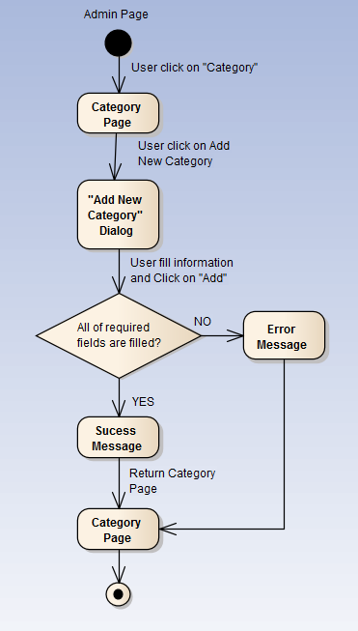

Figure 1‑3: Add category workflow

Brief description: Admin can use this function. Steps:

* Step 1: User click on Category.
* Step 2: System return category page.
* Step 3: User click on button new category
* Step 4: System return dialog “Add New Category”.
* Step 5: User fill information and click “Add”
* Step 6: System return success message or error message.
* Step 7: System return category page.

#### Add slider workflow

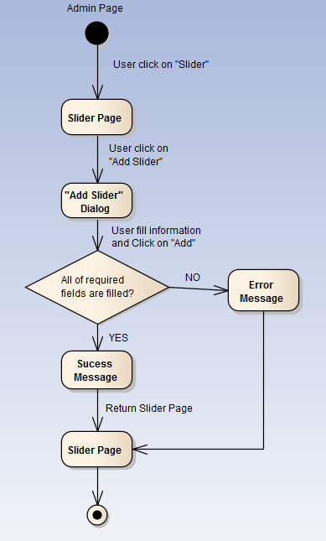

Figure 1‑4: Add slider workflow

Brief description: Admin can use this function. Steps:

* Step 1: User click on Slider.
* Step 2: System return slider page.
* Step 3: User click on button new slider.
* Step 4: System return dialog “Add New Slider”.
* Step 5: User fill information and click “Add”
* Step 6: System return success message or error message.
* Step 7: System return slider page.

#### Sent message workflow

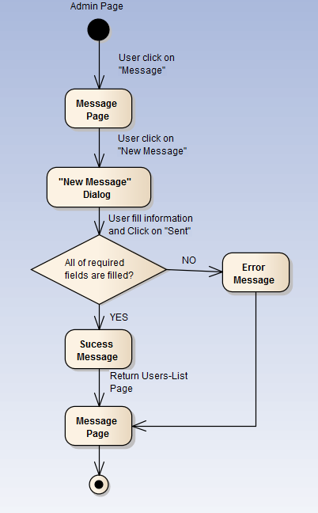

Figure 1‑5: Sent message workflow

Brief description: Admin or user can use this function. Steps:

* Step 1: User click on Message.
* Step 2: System return message page.
* Step 3: User click on “new message” button.
* Step 4: System return dialog “New Message”.
* Step 5: User fill information and click “Sent”
* Step 6: System return success message or error message.
* Step 7: System return message page.

#### Register workflow

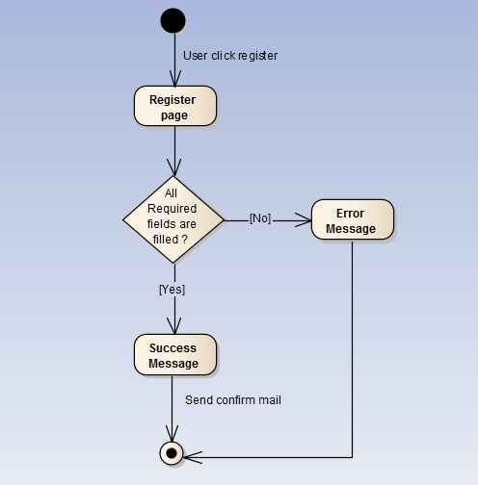

Figure 1‑6: Register workflow

Brief description: Guest can use this function. Steps:

* Step 1: User click register.
* Step 2: System return register page.
* Step 3: User fill all required fields and click Register or press Enter.
* Step 4: System return complete message.
* Step 5: System send confirm mail to user’s entered email.

#### Search workflow

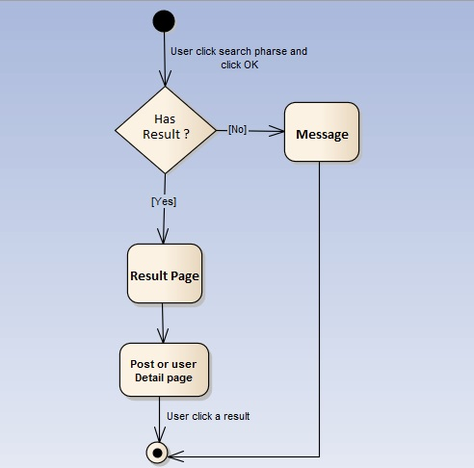

Figure 1‑7: Search workflow

Brief description: Guest and Member can use this function. Steps:

* Step 1: User input keyword into search text box and click Search or press Enter
* Step 2: System return search results or message if nothing found.
* Step 3: User can click returned results to view.

#### Comment workflow

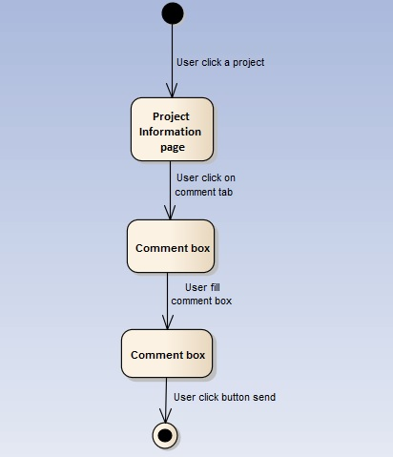

Figure 1‑8: Comment workflow

Brief description: Member can use this function. Steps:

* Step 1: User click on a project.
* Step 2: System return Project information page.
* Step 3: User click on comment tab.
* Step 4: System show comment tab.
* Step 5: User fill comment box.
* Step 6: User click sent.

#### Back a project workflow

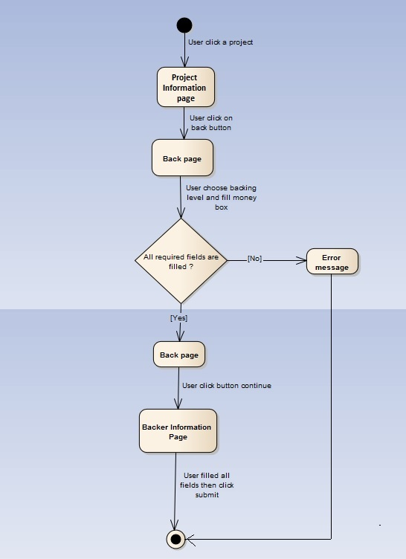

Figure 1‑9: Back a project workflow

Brief description: Guest and Member can use this function. Steps:

* Step 1: User click on a project.
* Step 2: System return Project information page.
* Step 3: User click on button back.
* Step 4: System return Back page.
* Step 5: User choose back level then click continue.
* Step 6: System return Backer information page.
* Step 7: User fill all fields then click submit.

#### Create a project workflow

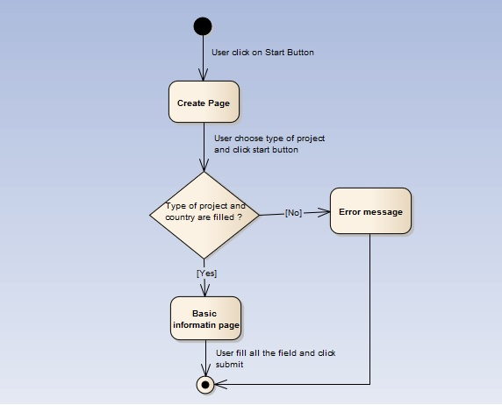

Figure 1‑10: Create a project workflow

Brief description: Member can use this function. Steps:

* Step 1: User click on start button.
* Step 2: System return Create page.
* Step 3: User choose type and country then click start.
* Step 4: System return Basic page.
* Step 5: User fill all the fields then click submit.
* Step 6: System return Backer information page.

#### Remind a project workflow

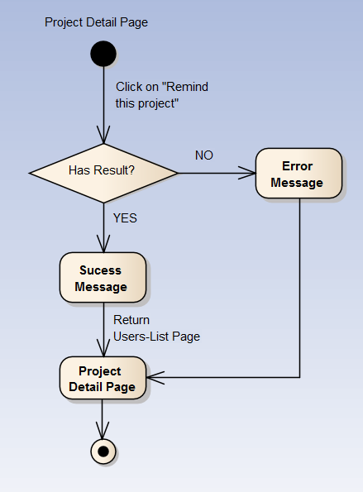

Figure 1‑11: Remind a project workflow

Brief description: Member can use this function. Steps:

* Step 1: User click on “Remind this project” button.
* Step 2: System return success message or error message.
* Step 3: System return Project Detail page.

#### Report a project workflow

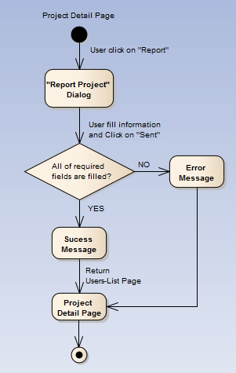

Figure 1‑12: Report a project workflow

Brief description: Member can use this function. Steps:

* Step 1: User click on report button.
* Step 2: System return “Report project” dialog.
* Step 3: User fill information and click “Sent”
* Step 4: System return success message or error message.
* Step 5: System return project detail page.

### Product Features

WS is a website, user only connect to internet to use website. System provides these main functions:

#### Client features

* **Register:** User can register an account and login to use all features of WS.
* **Login/Logout**: Users login/logout an account to use or exit system WS.
* **Search**: User and guest can search with title of posts, name of organization, and system will display all of post relate to keywords.
* **Search Advanced**: Search (Event, Discussion, Organization, User) follow location.
* **Raise Request:** User can request to create an Organization. Admin can accept or refuse.
* **Post:**
  + **Create New Post:** User (ORG) can create new post with basic info, timeline, clip and some pictures.
  + **Update Post Information**: User can change and update information of post which created.
  + **Comment/Remind/Like/Share**: Users can comment/remind/like/share a post to follow and discuss with another users.
  + **Report:** User can report a post or Organization which violate regulation to administrator.
* **Donate**: User can donate money, clothes or others for Organization to charity
* **Profile:**
  + Change password: User can change password to keep security.
  + Update profile: User can change or update information.
  + Manage created posts, reminded posts: User (ORG) can follow process of post, post reminded. View statistical post had created, reminded.
  + Sent/Receive message: Users can send to or receive from other users to discuss about projects.

#### Admin features

* **Login/Logout**: Admin login/logout an account to use or exit system WS
* **Manage user:**
  + Search user:Admin can search with name of user and system will display simple information about that user (name, email,...)
  + Ban/Unban user: admin can set user’s account to block or unblock.
* **Manage project:** 
  + Search post :
    - Search with post title:Admin can search with title of post and system will display all of post relate to keywords.
    - Search with name of ORG: Admin can search with name of ORG and system will display all of post relate to keywords.
  + Edit project status: Admin can set status of a project: Inactive/active depend on report.
* **Manage Donate:** Admin can view users who donated . Also, Admin can view amount of money, numbers of clothes.. to rank for users.
* **Manage Requests Of Users:** 
  + View/Accept/Decline: Admin can View/Accept/Decline requests : raise a ORG, report a post of users.
* **Manage Slider:** Slider list includes images what running at homepage.
  + Add new image: Admin can add new image to slider
  + Inactive/active: Admin can set image’s status to inactive or active on slider.
  + Delete image: Admin can delete image.
* **Message:** Admin can view received messages/sent messages.
  + Compose new message: Admin can compose new message to send to user.
  + Delete message: Admin can delete received messages/sent messages.

### User characteristic

WS makes connections that enable people to help themselves and each other. Website allows users (person or organizations) create charity topics or raise fund project as long as it follows our rules to help other people. Backers can also take part in a project by donating money through a single donation or supporting project as a regular donor publicly or privately, not to profit financially. Instead, project creators offer rewards to thank backers for their support. We hope our project can help as much people as we can in our country. If users want to use all function, they must be login.

There are 2 main actors that system support:

* **Member:** Have account on system, they can use all functions of website. For example: Searching, create post, donate etc…
* **Administrator:** They can use all functions of normal member and have an Administrator control panel to manage all configuration of system.

## Functional Requirements

### Common Function

**Access right: Guest and member**

This function is used to by guest and member. Guest or Member can search for their needs, results may be organization, post, discussion or members’ name.

### Discover Post

**Access right: Guest and member**

This function is used to view an overview of the post, event. They can read information then decided join that event, donate items… or not.

### Create Post

**Access right: Member**

This function is used to create new post. In this screen, users input event name, add media, information about event… and click on button create.

### Send/Receive messages

**Access right: Member and Administrator.**

This function is used to send and receive messages between users and users, users and admin. The system will display a Message Screen for users and admin to view message. In this screen, users can compose new message, search, filter and delete received messages/sent messages.

### Management profile

**Access right: Member**

This function is used to manage profile. The system will display a Profile Screen. In this screen, users can update, modify their information such as: name, password, age, phone number and choose which information would be public; users also can view many information such as recent joined event, donated money, user class,…

### Donate

**Access right: Member and Administrator.**

This function is used to donate money for organization. The system will display a Donate Screen that contain amount of money, information of donor, donate to which organization,…  
then click Donate button. The system will display another page that linked with Bao Kim to help user transfer money to mid-man Wing.

### Management Member’s account

**Access right: Administrator**

This function is used to manage member’s account. The system will display a Management Member Screen. In this screen, admin can view information about member, status of member (active or Inactive). When a member violates some rules of website, admin can block these member’ account temporarily, then these account cannot continue to use some functions of website. Locked account will be unlocked when lock is expired or they can send message to admin to request unban. If these’ account violate rules one more time, Admin can lock account permanently.

Warn: If member violate the rules (reported by others), admin can send message to warn this people from stopping violation and delete/modify violated post. If member still violate the rules, admin will ban them.

### Management Post

**Access right: Administrator**

This function is used to manage project. Admin can delete a post that violate the rules.

### Management Overview

**Access right: Administrator**

This function is used to manage report. The system will display a Dashboard Screen to have overview all of system. In this screen, admin can view information about user and projects such as the number of accessing, new users, active users, inactive users, number of post, amount of donate…

### Management Request

**Access right: Administrator**

This function is used to manage user request. The system will display a Request screen that contains all users’ request. Admin will check that request then decide accept or decline request.

## Non-functional Requirement

The system has to satisfy these principles:

* **Learnable**: The user interface must be easy to learn, even at the first time looking at the screen, user may immediately understand the function of each button or icon.
* **Efficiency**: The user interface must minimize the number of steps that the system takes to complete its task.
* **Memorable**: System contains some complex screens. Therefore, interface should be easier to use each time the user interacts with it.
* **Visibility**: Important information (example: text in nodes) should be clearly visible.
* **Consistency**: Like items should always be displayed and act the same way through the entire application.
* **Easy to maintain and upgrade**
* **Ensure data security capabilities, high performance**
* **Scalability system**