

|  |
| --- |
| Capstone Project Document |

**BOOKAHOLIC SOCIAL NETWORK**

Report #6 – Installation Guide

|  |  |  |
| --- | --- | --- |
| **Bookaholic Social Network** | | |
| **Group Members** | Phạm Thị Huyền | SE03416 |
| Thái Thị Cẩm Vân | SE03409 |
| Vũ Hải Đăng | SE03380 |
| Nguyễn Thị Hải Yến | SE03171 |
| Chu Minh Hải | SE03143 |
| **Supervisor** | Mr. Nguyễn Văn Sang | |
| **Project code** | BSN | |

**- Hanoi, 12/2016 -**

# SIGNATURE PAGE

AUTHOR: Vũ Hải Đăng 12/12/2016

Team member

REVIEWERS: Phạm Thị Huyền 13/12/2016

Project manager

APPROVAL: Nguyễn Văn Sang --/--/--16

Supervisor

Record of change

*A - Added M - Modified D – Deleted

|  |  |  |  |  |  |
| --- | --- | --- | --- | --- | --- |
| Effective Date | Changed Item | A,M,D | Change Description | Reason for Change | Rev. Number |
|  | Create Installation Guide | A | Create Installation Guide | First version | 1.0 |
|  |  |  |  |  |  |
|  |  |  |  |  |  |

**Table of Contents**

SIGNATURE PAGE 2

1 INTRODUCTION 4

1.1 Purpose 4

1.2 Environment 4

2 INSTALLATION GUIDELINE 4

2.1 Installation IIS on Windows 4

2.2 Creating Application Pool 6

2.3 Add BSN Web App into IIS 9

# INTRODUCTION

## Purpose

This document contains guide-lines step by step to deploy BSN Web App to local IIS Web Server.

## Environment

Following are the software required to start the BSN system:

* Operating System: Window 7, Window 8, Window 10
* Browser: Firefox 40, Chrome 44 or higher
* Database: MongoDB 3.0.12
* .NET Framework 4.5

# INSTALLATION GUIDELINE

## Installation IIS on Windows

**Step 1:** Open Control Panel and click on “Programs” as shown in the figure below:

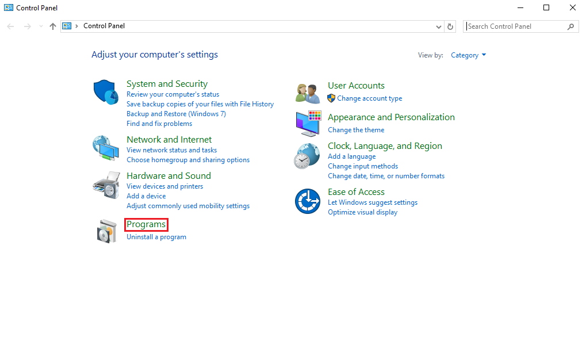

**Figure 1-1: Control Panel**

**Step 2:** Then click into “Programs and Features” and select “Turn Windows features on or off”. After that, “Windows features” dialog shows up as figure below:

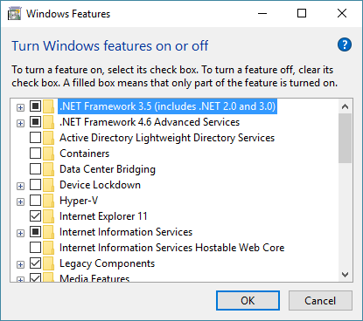

**Figure 1-2: Windows Feature Dialog**

**Step 3:** Scroll to “Internet Information Services” and expand it. Then check all components under “World Wide Web Service” > “Application Development Features” as shown in the figure below:

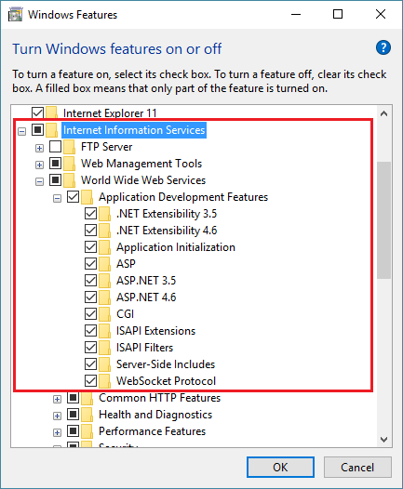

**Figure 1-3: Windows Features dialog**

**Step 4:** Click “OK” to let Windows install all required files. Once installed you may now close the dialog.

## Creating Application Pool

Open the Internet Information Services (IIS) Manager and follow the procedure given below:

**Step 1:** Select “Application Pool” => add new 2 Application Pools is: ASP .NET v4.0 (select Integrate) and select .NET Framework select v4.0.30319.

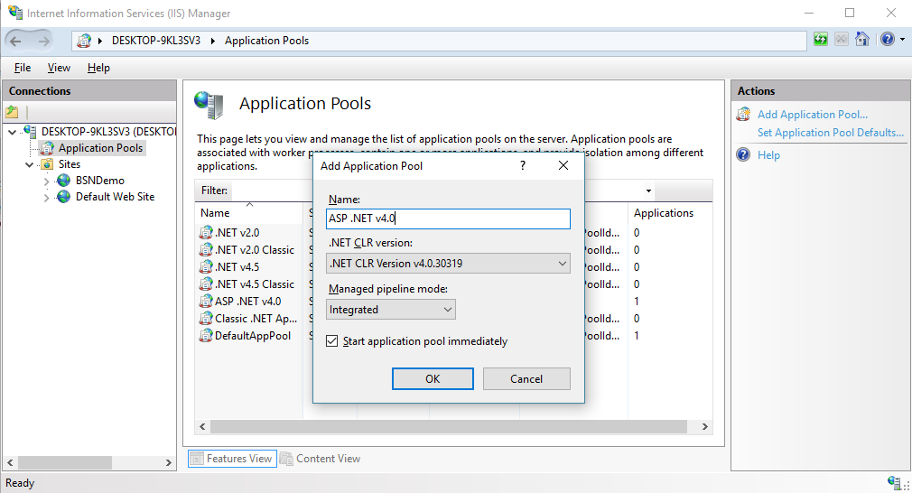

**Step 2:** Choose OK then back to Connection panel. After that Click “ISAPI and CGI Restrictions”.

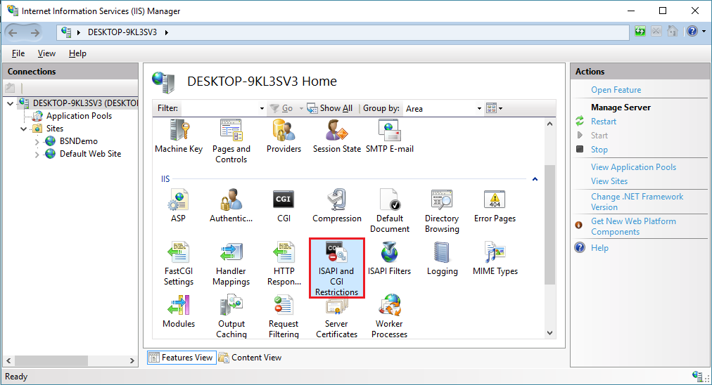

**Step 3:** Allow 2 items ASP .NET v4.0.

**Step 4:** Select “Application Pools” and select “ASP.NET v4.0” from the list since our app uses this default application pool. If you are using a different application pool for your app then select that instead. On the left panel, select the link “Advance Settings” as shown in the figure below:

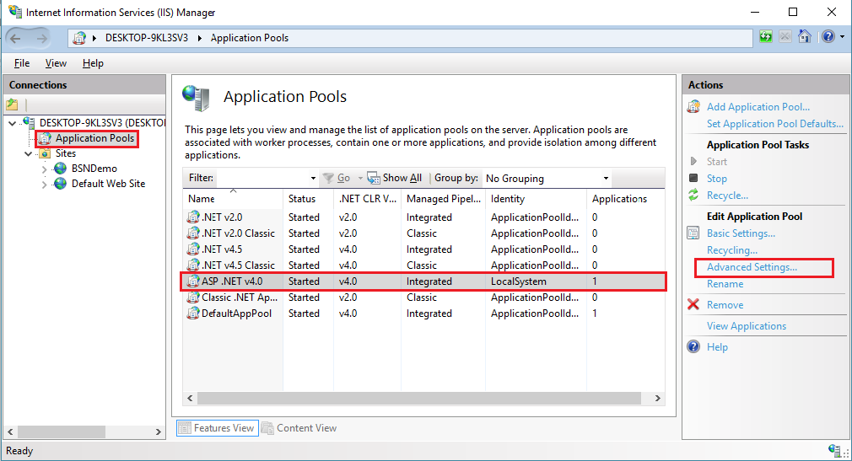

**Step 5:** Make sure that you select “Local System” as the Identity from the Advance Settings dialog as shown in the figure below:

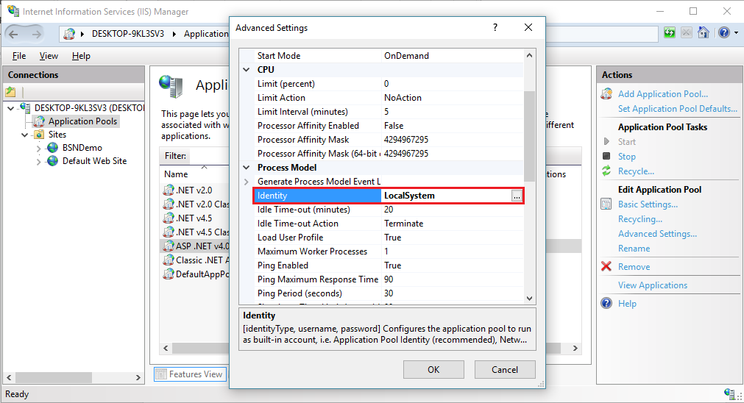

## Add BSN Web App into IIS

**Step 1:** Right click on “Sites -> select Add website…”.

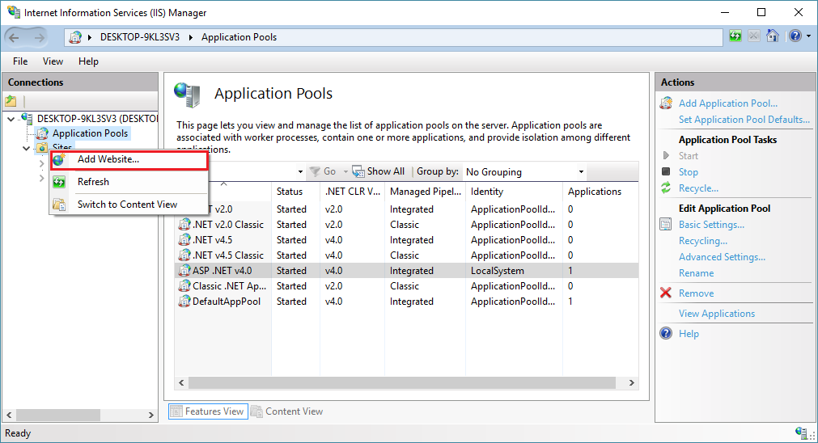

**Step 2:** Enter Site name and Select pool is ASP.NET v4.0. After that select Physical path (location store BSN Web App) and change default Port to 2710. Finally, click “OK” to finish add BSN Web App.

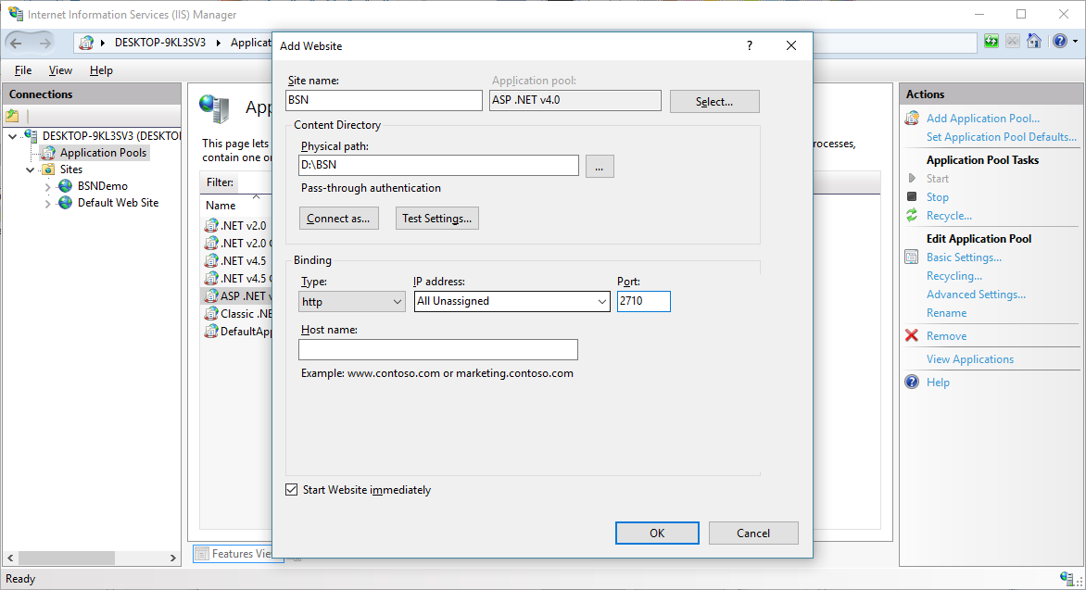

**Step 3:** Right click BSN (Site name is created), select “Manage Website -> Browse”.

