|  |
| --- |
|  |
| Capstone Project Document |

**FIRST AID VN**

**Report #1 – Project Introduction**

|  |  |  |
| --- | --- | --- |
| **First Aid VN** | | |
| **Group Members** | Đàm Huy Hùng | SE03431 |
| Nguyễn Duy Anh | 01525 |
| Mai Trung Kiên | SE02994 |
| Nguyễn Tiến Dũng | SE03272 |
| Nguyễn Phúc An | SE03118 |
| **Supervisor** | Mr. Nguyễn Văn Sang | |
| **Project code** | FAVN | |

**- Hanoi, 09/2016 –**

# SIGNATURE PAGE

AUTHOR: Nguyễn Duy Anh 06/09/2016

Team member

REVIEWERS: Đàm Huy Hùng 08/09/2016

Project manager

APPROVAL: Nguyễn Văn Sang --/--/--16

Supervisor

Record of change

*A - Added M - Modified D – Deleted

|  |  |  |  |  |  |
| --- | --- | --- | --- | --- | --- |
| Effective Date | Changed Item | A,M,D | Change Description | Reason for Change | Rev. Number |
| 06/Sep/2016 | Create Introduction | A | Create Introduction | First version | 1.0 |
|  |  |  |  |  |  |
|  |  |  |  |  |  |
|  |  |  |  |  |  |
|  |  |  |  |  |  |
|  |  |  |  |  |  |
|  |  |  |  |  |  |
|  |  |  |  |  |  |
|  |  |  |  |  |  |
|  |  |  |  |  |  |
|  |  |  |  |  |  |
|  |  |  |  |  |  |
|  |  |  |  |  |  |
|  |  |  |  |  |  |
|  |  |  |  |  |  |
|  |  |  |  |  |  |
|  |  |  |  |  |  |
|  |  |  |  |  |  |
|  |  |  |  |  |  |
|  |  |  |  |  |  |
|  |  |  |  |  |  |
|  |  |  |  |  |  |
|  |  |  |  |  |  |
|  |  |  |  |  |  |

Table Contents

SIGNATURE PAGE 1

1 INTRODUCTION 4

1.1 Purpose 4

1.2 Acronyms and Definitions 4

2 ABSTRACT 4

3 LITERATURE REVIEW 4

4 PROPOSAL 8

4.1 The idea 8

4.2 Objectives 8

4.3 Brief description about system 9

4.4 System features 9

4.4.1 Client features 9

4.4.2 Admin features 10

5 BENEFIT FROM PROJECT 10

5.1 For our group 10

5.2 For Community 10

6 CRITICAL ASSUMPTION AND CONSTRAINTS 10

7 POTENTIAL RISKS 11

8 REFERENCES 11

# INTRODUCTION

## Purpose

This document is created as the introduction for project First Aid VN – our Capstone Project at FPT University. In this document, we will descript the overview of some existing systems, the initial idea for our project, a brief description about our expected system, some critical assumptions, constrains and potential risks. Moreover, this document also shows opportunities what it offers for users.

## Acronyms and Definitions

|  |  |
| --- | --- |
| **Acronym & Abbreviation** | **Definition** |
| FAVN | First Aid VN |
| FU | FPT University |
| Q&A | Question and Answer |
|  |  |

**Table 1-1:** Definitions and Acronyms

# ABSTRACT

In everyday life, illness or injury may happen suddenly. There are many situations which may require first aid to prevent the condition from worsening off, save lives and minimize deaths. First aid does not necessarily require complex techniques or special knowledge. However, not many Vietnamese people have enough essential knowledge and/or skills about first aid. There are a lot of specific training documents in soft and hard copies but the disadvantages of them are about getting the right first aid methods, without visualization of information. There are also first aid applications on the market. But there are barriers to users such as language, lack of effective interaction. With the expectation of helping people deal with the above-mentioned limitations, we propose an application to provide people with simple instructions and other supported functions.

# LITERATURE REVIEW

Nowadays there are some first aid applications. However, according our research, these applications are not really useful for Vietnamese people. In this section, we focus on the three top rating applications which are our rivals.

* **Cẩm nang sơ cứu**

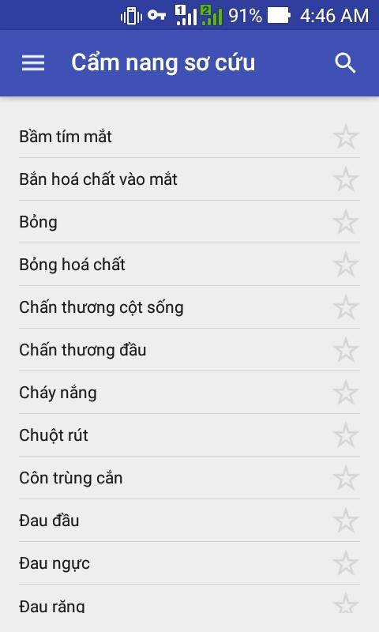

**Figure 1-2:** App Cẩm nang sơ cứu

“Cẩm nang sơ cứu” is the only application that provides knowledge about first aid instructions that developed on the Android platform for the Vietnamese.

* **Advantages:**
* Has Vietnamese language.
* A lot of first aid guide.
* Search function – easy to look up.
* **Disadvantages:**
* Instructions are difficult for following.
* Lack of visualization.
* **Hướng dẫn sơ cứu**

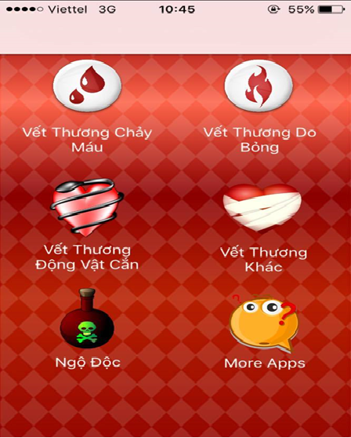

**Figure 1-3:** App Hướng dẫn sơ cứu

“Hướng dẫn sơ cứu” is the only application that provides knowledge about first aid instructions that developed on the iOS platform for the Vietnamese.

* **Advantages:**
* Friendly user interface – Vietnamese.
* First aid methods are grouped by topics.
* **Disadvantages:**
* A few first aid guide
* Do not have Search function
* **First Aid**

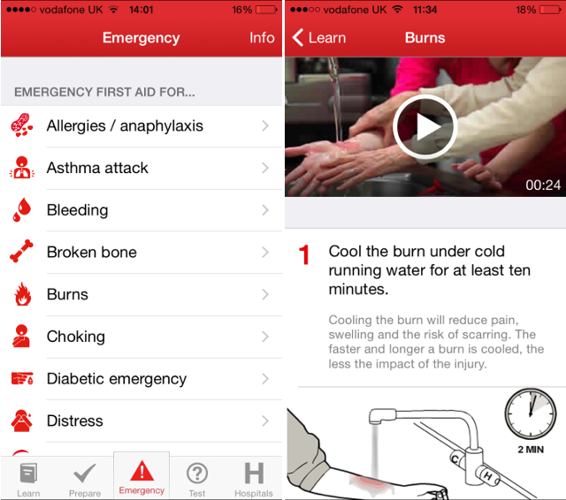

**Figure 1-4:** App First Aid

First Aid is the biggest application for first aid guide created by American Red Cross First, users can look up and learn about first aid, watch videos, take quizzes.

* **Advantages:**
* Simple step-by-step instructions guide you through everyday first aid scenarios.
* Fully integrated with 9-1-1 so you can call EMS from the app at any time.
* Videos and animations make learning first aid fun and easy.
* Preloaded content means you have instant access to all safety information at any time, even without reception or an Internet connection.
* First Aid has friendly interface, clear instructions.
* **Disadvantages:**
* Just have English and Spanish language.
* It is not popular in Vietnam.
* Do not have Search function.

# PROPOSAL

## The idea

For the purpose of offering Vietnamese people effective methods in emergencies, we would like to develop an application that can be like an assistance for users. In this application, we can solve the limitations of plain documents and other products. Besides, we provide first aid’s step-by-step instructions to make sure that even untrained people can understand and follow. In addition, users can make SOS calling and find nearby hospitals and other useful features for life saving.

## Objectives

This project is the Capstone Project in FPT University studying program.

This project is the result of our effort, as well as the responsibilities and obligations of all members of our group. We have to complete all the requirements of the instructors as well as the FPT university. Throughout the project, we have applied a lot of knowledge learned during four years of college. We have a change to apply our knowleadge, as well as learn more from instructor on how to develop and manage a project. Knowing more about the process and the technical diagrams, which are used in the actual project will look like and the benefits and difficulties of it. With the consultation of our instructor, as well as our self-understanding, we have additional knowledge of programming and study the programming language to use for the project. In addition, we will also use all soft skills that we had learned to connect members in the group, to promote and motivate members work hard to achieve the best results.

About the First Aid VN project, we have medical support to people who need help in the aid issue. For example, to help the community better understand what first aid is, the importance of first aid. We bring out a software that can help, protect and improve people’s lives and health more safely. In the future, besides the software on phone, we also intend to cooperate, connect with the hospital to develop the larger functions such as emergency rescue,… And especially in Vietnam, we believe that our mobile apps is the best application that has Vietnamese interface and more friendly to the user Vietnam.

## Brief description about system

First Aid VN application is developed on the android platform, data management system is developed on web platform. The most useful feature of this application is helping users easily perform first aid instructions step-by-step. In addition the application also provides some features that need for emergencies. Moreover users can study and test their first aid knowledge. In case of any questions or problems, users can send comments, reports to administrators. Beside these features, data management system also has administrative functions.

Technologies used to develop First Aid VN: Java, Bootstrap, and Laravel - PHP framework.

## System features

The main feature of First Aid VN is guides users to perform first aid with a simple step-by-step with images and text of each step. Reading instructions function may be used to perform first aid and listen to step of instructions at the same time. Other features for life saving such as searching by voice or text, S.O.S calling, emergency messaging, notifying users current location and finding nearby hospitals. Learning and testing features is available for users to learn and test their first aid knowledge. In addition users comment feature is used to communicate with the administrators. Data management feature allows administrators to manipulate and manage data such as data of the application, users’ comments.

There are detail descriptions of each feature:

### Client features

* **Searching:** Users can use voice or type text to search the symptoms or related keywords of injury. Full text search technique is used. Results will be returned in real time.
* **List of emergencies:** List of emergencies will be displayed and updated in main screen according to the statistics of what types of common injury in each time period or season.
* **First aid details:** Details of instructions steps will be shown in emergency screen. Each step contains text and pictures.On each step may include S.O.S calling,Reading steps of instructions or finding nearby hospitals function.
* **Reading steps of instructions:** Read steps of instructions for users. Users can perform first aid and listen to steps of instructions at the same time. When users finish a step they can confirm and move to the next step.
* **Current location:** Users can get their exact location via the map. In case there is no exact address, the users can get the nearest locations. This feature is necessary when users need to notify accident location to hospital or others.
* **S.O.S calling:** This feature will help users to call 115. In many cases when the user has done some step instructions, users will have to call 115 to notify and receive other instructions.
* **Emergency message:** When users use this feature, the application will automatically send a message with message content are notification and your accident location to a given phone number.
* **Finding nearby hospitals:** Users can find list of the nearest hospitals. Then they can call or see more details about those hospitals.
* **View Hospital Details:** users can select one of the nearest hospitals to see details such as address, distance, phone number, website, and directions to the hospital.
* **Learning:** In this function, information about instructions of each injury will be explained more clearly than the first aid instructions in emergency screen. This feature will help users to have more knowledge about first aid in emergency situations.
* **Testing:** Users can test their first aid knowledge with many different types of test.
* **More:** This feature is a collection of some other popular features for users :
  + Comments.
  + Organizations information.
  + Sharing.
  + Rating application.

### Admin features

* **Data Management:** Administrators can delete, update, or add new information about first aid.
* **Users’ comments management:** Administrators will receive notifications when there are comments or questions from users. Then take the comments and guidance from the experts and update data on application.

# BENEFIT FROM PROJECT

## For our group

After developing and implementing this project, our group will get some benefits:

* Have more experiences of software project management how to manage plan, time, member and risk.
* Have more knowledge and skill about Android and PHP programming.
* Know how to communicate with team members and how to teamwork more effective.
* If this application is developed, we will get a good mark in Capstone Project. It makes our grade better.

## For Community

Just need a mobile device that connect to the internet or not, user can:

* Easily perform first aid in emergencies
* Easily search for methods addressed in the specific case
* Learning the basic knowledge of first aid
* Search nearby hospitals and call 115
* Locate the accident position and send emergency SMS for family

# CRITICAL ASSUMPTION AND CONSTRAINTS

* Critical assumption:
  + For the Technical training: we assumed web developers can study about PHP and mobile developers can train about application development for Android platform in one week. Besides, testers also have enough knowledge about software testing process.
  + For the human resources: we assumed all members have a good healthy to do their tasks and meet the project plan's deadline.
* Constraints:
  + Time and deadline: we have to work 5 hours/day and 5 days/week to submit weekly report on time for the supervisor and finish entire project in 14 weeks.
  + Quality: We need to ensure that our product could be run well on android mobile devices with android OS version 4.4 or higher.
  + Process: We have to follow the software processing of FPT Software
  + Human resources: There are 5 member in our team, each member have to study 2 subjects (Japanese and JIT) at school.

# POTENTIAL RISKS

After studying about this project, we find out some problem that we may be encountered:

* Under-estimate scope and time or miss deadline because lack of experience in group working, managing and controlling work.
* Loss data, source code before uploading data to server because of careless.
* Equipment got broken because of careless or accident.
* Human resources: Team member cannot complete their works because of health reasons, key member leave team or un-cooperating on team.
* Change requirements: Requirement changed when some functions cannot be completed or some technologies is not suitable.

# REFERENCES

* **Cẩm nang sơ cứu at URL:** <https://play.google.com/store/apps/details?id=com.ss.stp.camnangsocuu>
* **Hướng dẫn sơ cứu at URL:**

<https://itunes.apple.com/vn/app/huong-dan-so-cuu/id588610279?mt=8>

* **First Aid at URL:**    
  https://itunes.apple.com/us/app/first-aid-by-american-red/id529160691?mt=8