|  |
| --- |
|  |
| Capstone Project Document |

**Carrier Trading Center**

Report #2 – Project Plan

|  |  |  |
| --- | --- | --- |
| **Carrier Trading Center** | | |
| **Group Members** | Lê Văn Dương | SE03290 |
| Vũ Văn Quyết | SE03344 |
| Đặng Lê Tuấn | SE03807 |
| Trịnh Đình Quyết | SE03159 |
| Lê Gia Hoàng | SE03200 |
| **Supervisor** | Mr. Nguyễn Văn Sang | |
| **Project code** | CTC | |

**- Hanoi, 02/2017-**

# SIGNATURE PAGE

AUTHOR: Trịnh Đình Quyết 15/01/2017

Team member

REVIEWERS: Lê Văn Dương 20/01/2017

Project manager

APPROVAL: Nguyễn Văn Sang --/--/2017

Supervisor

**Record of change**

*A - Added M - Modified D – Deleted

|  |  |  |  |  |  |
| --- | --- | --- | --- | --- | --- |
| Effective Date | Changed Item | A,M,D | Change Description | Reason for Change | Rev. Number |
| 15/01/2017 | Project plan | A | Create project plan | First version | 1.0 |
|  |  |  |  |  |  |
|  |  |  |  |  |  |
|  |  |  |  |  |  |
|  |  |  |  |  |  |
|  |  |  |  |  |  |
|  |  |  |  |  |  |
|  |  |  |  |  |  |
|  |  |  |  |  |  |
|  |  |  |  |  |  |
|  |  |  |  |  |  |
|  |  |  |  |  |  |
|  |  |  |  |  |  |
|  |  |  |  |  |  |
|  |  |  |  |  |  |
|  |  |  |  |  |  |
|  |  |  |  |  |  |
|  |  |  |  |  |  |
|  |  |  |  |  |  |
|  |  |  |  |  |  |
|  |  |  |  |  |  |
|  |  |  |  |  |  |
|  |  |  |  |  |  |
|  |  |  |  |  |  |

Table of Contents

SIGNATURE PAGE 1

1 Problem Definition 3

1.1 Name of this Capstone Project 3

1.2 Problem Overview 3

1.2.1 The Current System 3

1.2.2 The Proposed System 3

1.2.3 Boundaries of the System 4

1.2.4 Development Environment 4

2 Project Organization 4

2.1 Purpose 4

2.2 Software Process Model 5

2.3 Roles and Responsibilities 5

2.4 Organization Structure 5

2.5 Project Team Member 6

2.6 Tool and Techniques 6

3 Project Management Plan 7

3.1 Tasks 7

3.2 Meeting Minutes 7

3.3 Coding Conventions 8

3.4 Risk Management Plan 8

3.5 Communication Plan 9

# 

# 1 Problem Definition

## Name of this Capstone Project

The official and formal project name is Carrier Trading Center. The product name is Carrier Trading Center.

## Problem Overview

### The Current System

There is no current system. The product is building from scratch as a new idea.

### The Proposed System

The main system will be a Website Management.

#### Client User Module

##### Guest module

* **Register a new account:**
* Register a new account: guest can register a new account to become a new user for use CTC service.
* **Manage auction:**
* Search bill of lading: guest can search bill of lading on CTC with key word place to go, destination, sent date, arrival date, weigh, volumetric, form of packing.
* View bill of lading list: guest can view bill of lading are auctioning on CTC.
* **Manage Price list:**
* View price: guest can view price list on CTC.
* Reference price: guest can reference price actual price system updated.

##### Goods owner module

* **Manage auction:**
* View bill of lading list: goods owner can view bill of lading are auctioning on CTC.
* View bill of lading detail: goods owner can view bill of lading detail on CTC.
* Search bill of lading: goods owner can search bill of lading on CTC with key word place to go, destination, sent date, arrival date, weigh, volumetric, form of packing.
* View carrier auction success: When bill of lading of goods owner is successful, they can view how are get their bill of lading.
* Confirm complete transaction: when receiver got goods, goods owner have to confirm with system to get down payment.
* Register a new bill of lading: when goods owner have goods for transport they can create a bill of lading to post on CTC to find carrier.
* Cancel bill of lading: when goods owner don’t want to send their goods, they can be cancel bill of lading.
* **Manage profile:**
* Edit profile: goods owner can edit their profile on system.
* View profile: goods owner can view their profile on system.
* Change password: goods owner can change their password for raise security.
* Forget password: when goods owner do not remember their password, they can send request to system to reset password.
* **Manage report:**
* Send report: goods owner can send report to admin.
* Search report: goods owner can search report in their report list with title of report, time sent.
* View report list: goods owner can view their report on their report list.
* **Manage price list**
* Reference price: goods owner can view price list on CTC.
* View price list: goods owner can reference price actual price system updated.
* **Account recharge**
* Account recharge: goods owner can recharge to their account for use CTC’s services.
* **Transaction history**
* Transaction history: goods owner can check money in their account and check what did they do with their money.
* **User login**
* User login: goods owner can login to CTC to use CTC’s service.
* **User logout**
* User logout: goods owner can logout CTC.
* **Connect to carrier:** Connect to carrier: when goods owner is success on auction bill of lading, they can connect to carrier who bill ship their goods.

##### Carrier module

* **Manage auction:**
* View bill of lading list: carrier can view bill of lading are auctioning on CTC.
* Confirm complete transaction: when receiver got goods, carrier have to confirm with system to get down payment.
* View bill of lading detail: carrier can view bill of lading detail on CTC
* Auction bill of lading: when carrier want to transport goods, they can find a bill of lading and then auction it.
* Search bill of lading: carrier can search bill of lading on CTC with key word place to go, destination, sent date, arrival date, weigh, volumetric, form of packing.
* Cancel bill of lading: because some reason carrier can not transport continue, they can be cancel bill of lading.
* **Manage profile:**
* Edit profile: carrier can edit their profile on system.
* View profile: carrier can view their profile on system.
* Change password: carrier can change their password for raise security.
* Forget password: carrier owner do not remember their password, they can send request to system to reset password.
* **Manage report:**
* Send report: carrier can send report to admin.
* Search report: carrier can search report in their report list with title of report, time sent.
* View report list: carrier can view their report on their report list.
* **Manage price list:**
* Reference price: carrier can view price list on CTC.
* View price list: carrier can reference price actual price system updated.
* **Account recharge**
* Account recharge: carrier can recharge to their account for use CTC’s services.
* **Transaction history**
* Transaction history: carrier can check money in their account and check what did they do with their money.
* **User login**
* User login: carrier can login to CTC to use CTC’s service.
* **User logout**
* User logout: carrier can logout CTC.
* **Connect to** carrier
* Connect to carrier: when goods owner is success on auction bill of lading, they can connect to carrier who bill ship their goods.

#### Admin Module

* **Manage auction:**
* View bill of lading list: admin can view bill of lading are auctioning on CTC.
* View bill of lading detail: admin can view bill of lading detail on CTC.
* Search bill of lading: admin can search bill of lading on CTC with key word place to go, destination, sent date, arrival date, weigh, volumetric, form of packing.
* View carrier auction success: When bill of lading of goods owner is successful, admin can view how are get their bill of lading.
* Summary all bill of lading: admin can summary all bill of lading.
* View carrier list who are auctioning: admin can view how many carrier are auctioning a bill of lading and who are auctioning bill of lading.
* **Manage user**
* Search user: admin can search user with name of user, email address, province, kind of user keyword.
* View user profile: admin can view user profile.
* Edit user profile: admin can edit user profile.
* Active user: admin can active user to allow this user can user use CTC’s service.
* Deactivate user: admin can deactivate user to disallow user use CTC’s service.
* Add company: admin can add company’s information to user detail.
* Account recharge for user: admin can recharge directly to account of user.
* **Manage price list**
* Reference price: admin can view price list on CTC.
* View price list: admin can reference price actual price system updated.
* Add a new price: admin can add a new price to price list on CTC.
* Edit price list: admin can edit price on price list on CTC.
* View price table history: admin can view history of price table.
* **Manage report**
* Send report: admin can response report to goods owner and carrier.
* Search report: admin can search report in their report list with title of report, time sent.
* View report list: admin can view their report on their report list.
* **Transaction history**
* Transaction history: admin can check money in their account and check what did they do with their money.
* **User login**
* User login: admin can login to CTC to use CTC’s service.
* **User logout**
* User logout: admin can logout CTC.
* **Manage profile**
* Edit profile: admin can edit their profile on system.
* View profile: admin can view their profile on system.
* Change password: admin can change their password for raise security.
* Forget password: admin owner do not remember their password, they can send request to system to reset password.

### Boundaries of the System

The system under development of this Capstone Project will include:

- The Management Website

- All the process document involved

### Development Environment

Below is the list of hardware and software requirements needed for development environment:

**Hardware requirement:**

- Personal computers for developing with the recommended configuration: 4GB of Ram DDR3, 100GB of hard disk SSD, Processor: 2.4GHz Intel Core i5

- A sever computers for testing with the Recommended configuration: 4GB of Ram DDR3, 100GB of hard disk SSD, Processor: 2.4GHz Intel Core i5

**Software requirements:**

- Operating system: Window 8.1, 10

- Web server: Apache Tomcat

- IDE: Eclipse

- DBMS: MySQL

- Soured control: Microsoft Project Plan

- Design Graphic: Adobe Photoshop 6

- Contact tool: Skype

- Architecture design: Astah

# Project Organization

## Purpose

This chapter provides an overview of the project plan includes project organization and project management plan.

## Software Process Model

### FPT Software Process Model

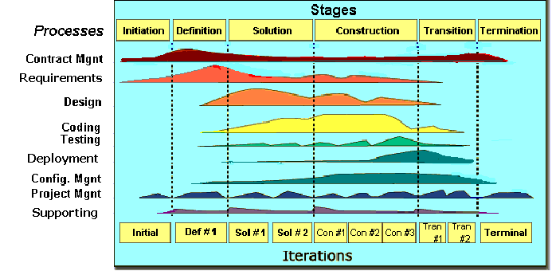

Figure 1: FPT Software process model

The software lifecycle is broken into *cycles*, each cycle working on a new generation of the product. The FPT Software process divides one development cycle in six consecutive *phases*:

1. Initiation phase
2. Definition phase
3. Solution phase
4. Construction phase
5. Transition
6. Termination

### Project Life Cycle

Basing on FPT Software process and real-world project, we decided to divide the project into 4 phases: Initiation, Solution, Construction, and Termination:

* **Initiation Phase:** This is the explanatory phase of the project. Project objective and description is described at this stage. The purpose of this phase is to collect and understand business requirements, detail the project plan and agree upon a high level statement of work. Our primary objectives are complete project identification and project plan. After these are completed, the project is checked against the following criteria:
  + Identify business functions of the system
  + Determining the scope, conditions and limitations of the project
  + List the main functions of the system
  + List one or more suitable architecture for the system
  + Identify project risks
  + Complete Report #1, and Report #2
* **Solution Phase**: In this phase, the architecture of the system is designed. The goal is to translate requirements and specification into a technical solution to produce Technical Design.
  + Our *primary objectives* are completeRequirement Specification, Architecture Design and Database Design.
  + Finally, the plan must be provided (including estimates of cost and time) for the construction phase. The plan must ensure proper and accurate based on experience.
  + Complete Report #3 and Report #4
* **Construction Phase**: This is the longest phase of a project life cycle.
  + In this phase, all functions of the system will be installed. The installation will be divided into small stages, each stage of the installation a few functions. The results of each phase will be the release of the module function can be executed.
  + Construction and improvement of products until the final product is ready to deliver to the user. During this phase, all the components and other features of the application is developed and integrated into the product.
  + This phase emphasizes the resource management and control operations to optimize cost, time and quality.
  + Complete software packages and Report #5
* **Termination Phase**: This is the final phase in the life cycle of a project.
  + Their products will be deployed to the client. The feedback received during the transfer process will be recorded and put on the new functional requirements or functionality enhancements in the next version of the product.
  + Phase transfer switch also includes the training system and the new system for the user.
  + Complete software packages and Report #6

## **Roles and Responsibilities**

## Organization Structure

|  |  |
| --- | --- |
| **Role** | **Responsibility** |
| Project Manager | Planning, developing schedules, coordinating communication, generally responsible for keeping the team’s focus on the main goal. |
| Technical Leader | Responsible for choosing and deciding what technologies should be used, as well as for overseeing the work being done by other developers. |
| Quality Assurance Manager | Ensuring the product meets the certain standards of quality from requirements. |
| Test Leader | Responsible for test execution, including test set-up and test run, evaluation of test run and error recovery, defect logging and test results recording. |
| Developer | Involve coding the product and reviewing code of other developers. |
| Designer | Involve designing product’s user interface. |
| Tester | Involve testing the product. |

Table 2‑1: Project Structure

## Project Team Member

|  |  |
| --- | --- |
| **Team Member** | **Role** |
| DuongLV | Project Manager, Developer |
| QuyetVV | Technical Leader, Developer |
| QuyetTD | Tester Leader, QA |
| HoangLG | Developer, Designer |
| TuanDL | Designer, Tester, Developer |

Table 2‑2: Project Team Member

## Tool and Techniques

|  |  |
| --- | --- |
| **Programming languages** | JavaScript, Java, Html |
| **Framework** | Java Server Face, Hibernate |
| **Software architecture** | Spring Framework |
| **Version control** | TortoiseGit |
| **IDEs/Editors** | Eclipse |
| **UML tools** | Astah Professional 7.0 |
| **Web server** | Apache Tomcat 7 |
| **DBMS** | MySQL |
| **Deployment server** | Apache Tomcat 7 |
| **Project management tool** | Microsoft Project 2010 |
| **Development process** | Rational Unified Process |

Table 2‑3: Project Team Member

# Project Management Plan

## Tasks

Refers to “CTC_Project_Schedule_v1.0_EN” file.

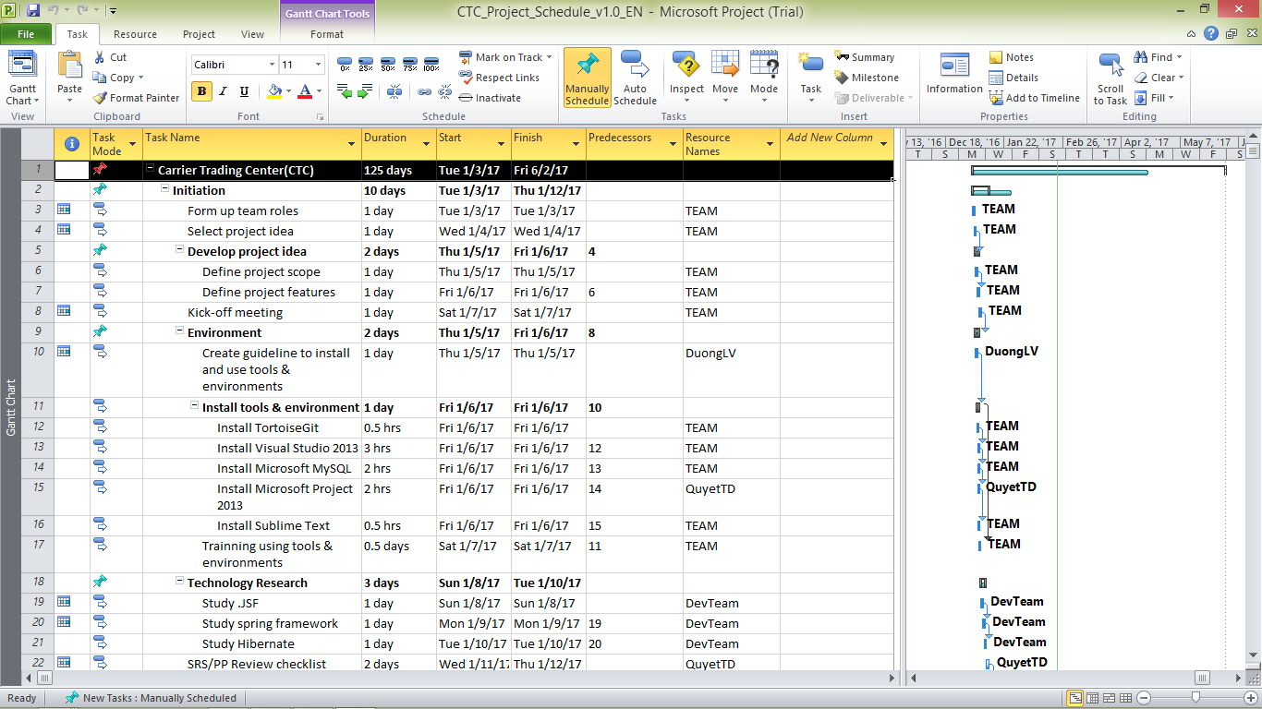

Figure 2‑2: CTC Project Management file

## Meeting Minutes

All meeting minutes will be written following this template:

| ***Meeting/Project Name:*** | *CTC* | | | |
| --- | --- | --- | --- | --- |
| ***Date of Meeting:*** |  | ***Time: (Type)*** | *hours (Face-to-face)* | |
| ***Meeting Called by:*** | *QuyetVV* | ***Location:*** | *FPT University‘s Library* | |
| ***Note Taker:*** | *QuyetTD* | ***Time Keeper:*** | *DuongLV* | |
| 1. Meeting Objective | | | | |
| * Choose names, ideas for project | | | | |
| 2. Attendance | | | | |
| ***Name*** | ***Roles*** | ***E-mail*** | | ***Phone*** |
| Lê Văn Dương | Project Manager | [DuongLVSE03190@fpt.edu.vn](mailto:DuongLVSE03190@fpt.edu.vn) | | 0166-977-5349 |
| Lê Gia Hoàng | Developer | [HoangLGSE03200@fpt.edu.vn](mailto:HoangLGSE03200@fpt.edu.vn) | | 0165-901-2428 |
| Đặng Lê Tuấn | Designer | [TuanDLSE03807@fpt.edu.vn](mailto:TuanDLSE03807@fpt.edu.vn) | | 0968-095-029 |
| Vũ Văn Quyết | Technical Leader | [QuyetVVSE03344@fpt.edu.vn](mailto:QuyetVVSE03344@fpt.edu.vn) | | 0972-381-151 |
| Trịnh Đình Quyết | Test Leader/QA | [QuyetTDSE03159@fpt.edu.vn](mailto:QuyetTDSE03159@fpt.edu.vn) | | 0964-657-385 |
| 3. Content | | | | |
|  | | | | |
| 4. Note | | | | |
|  | | | | |

Table 2‑4: Meeting Minutes Template

## Coding Conventions

Reference to CTC_Coding_Convention_Oracle_EN

## Risk Management Plan

|  |  |  |  |  |
| --- | --- | --- | --- | --- |
| **No** | **Description** | **Avoidance plan** | **Contigency plan** | **Status** |
| R1 | **Illness or absence of team members** | Member has to notice to the team about absence period and the plan of how to keep up with the work process. | Ensure that the absence of a member will not affect others and always have plans to deal with this problem. | Closed |
| R2 | **Business problem** | Any ideas are welcome but members have to discuss with others and always focus on the reality and possibility. | Make sure the business logic of any ideas is carefully analyzed. | Closed |
| R3 | **Change management overload** | A large number of change requests dramatically raises the complexity of the project and distracts key resources. | If there is a “must be changed” requirement, all team members must join the meeting to decide whether it should be implemented or not. | Closed |
| R4 | **Project team misunderstand requirements** | When the project team a gap misinterprets requirements develops between expectations, requirements and work packages. | Make sure any miscommunication has to be resolved. | Closed |
| R5 | **New technology** | Choosing technology based on member’s qualification. All team members must nurture by self-study. | When someone chooses a new technology, he/she has to explain to all team members about the decision. | Closed |

Table 2‑5: Risk Management

## Communication Plan

*Weekly meeting schedule:* We use Iterative and Incremental Process Model, then we divide the system into two sub-systems (CTC services and CTC Front-end), each sub-system is divided into a bunch of small tasks. Each task is recorded to Trello then estimated depending on difficulty and the amount of work by the whole team, after that the Team Leader will assign the task to team members and depending on difficulty, the Technical Leader will assign deadlines for each task. We will have a meeting every Monday to inform to all team about what each member finished last week, the status (fast, on time or slow), the issues met and how to solve them. If any member raises any issue, the whole team will help to find out a solution together. After that, the team will define detailed stories for next week tasks and estimate how long it takes to finish them.

*Daily discussing schedule*: Each sub-system has one development team with different schedule. Whenstarting work-day, each team will have a stand-up meeting to inform to others: “What did I do yesterday?”, “What will I do today?” and “Are there any impediments in my ways?”. By focusing on what each person accomplished yesterday and will accomplish today, the team gains an excellent understanding of what work has been done and what work remains.

*Unscheduled meeting*: If someone has an important problem that he wants to solve immediately, we will have a meeting for discussion, usually via some online channel: Facebook, Skype, or Phone.

*Communication channel*: Our main communication channels are sky. On the other hand, we used face-to-face meeting, Email, Messenger. However, we sometimes make a phone call or instant message if someone has a problem.