|  |
| --- |
|  |
| Capstone Project Document |

**Carrier Trading Center**

Report #1 – Project Introduction

|  |  |  |
| --- | --- | --- |
| **Carrier Trading Center** | | |
| **Group Members** | Lê Văn Dương | SE03290 |
| Vũ Văn Quyết | SE03344 |
| Đặng Lê Tuấn | SE03807 |
| Trịnh Đình Quyết | SE03159 |
| Lê Gia Hoàng | SE03200 |
| **Supervisor** | Mr. Nguyễn Văn Sang | |
| **Project code** | CTC | |

**- Hanoi, 01/2017-**

# SIGNATURE PAGE

AUTHOR: Trịnh Đình Quyết 10/01/2017

Team member

REVIEWERS: Lê Văn Dương 11/01/2017

Project manager

APPROVAL: Nguyễn Văn Sang --/--/2017

Supervisor

**Record of change**

*A - Added M - Modified D – Deleted

|  |  |  |  |  |  |
| --- | --- | --- | --- | --- | --- |
| Effective Date | Changed Item | A,M,D | Change Description | Reason for Change | Rev. Number |
| 10/01/2017 | Create Introduction | A | Create Introduction | First version | 1.0 |
|  |  |  |  |  |  |
|  |  |  |  |  |  |
|  |  |  |  |  |  |
|  |  |  |  |  |  |
|  |  |  |  |  |  |
|  |  |  |  |  |  |
|  |  |  |  |  |  |
|  |  |  |  |  |  |
|  |  |  |  |  |  |
|  |  |  |  |  |  |
|  |  |  |  |  |  |
|  |  |  |  |  |  |
|  |  |  |  |  |  |
|  |  |  |  |  |  |
|  |  |  |  |  |  |
|  |  |  |  |  |  |
|  |  |  |  |  |  |
|  |  |  |  |  |  |
|  |  |  |  |  |  |
|  |  |  |  |  |  |
|  |  |  |  |  |  |
|  |  |  |  |  |  |
|  |  |  |  |  |  |

Table Contents

SIGNATURE PAGE 1

1 INTRODUCTION 4

1.1 Purpose 4

1.2 Acronyms and Definitions 4

2 ABSTRACT 4

3 LITERATURE REVIEW 4

4 PROPOSAL 5

4.1 The idea 5

4.2 Objectives 5

4.3 Brief description about system 6

4.4 System features 6

4.4.1 Client features 6

4.4.2 Admin features 8

5 BENEFIT FROM PROJECT 9

5.1 For our group 9

5.2 For Community 9

6 CRITICAL ASSUMPTION AND CONSTRAINTS 9

7 POTENTIAL RISKS 10

8 REFERENCES 10

# INTRODUCTION

## Purpose

This document is created as the introduction for project Carrier Trading Center – our Capstone Project at FPT University. In this document, we will describe the overview of some existing systems, the initial idea for our project, a brief description about our expected system and some potential risks, critical assumptions, constrains. Moreover, this document also shows opportunities that it offers to users.

## Acronyms and Definitions

|  |  |
| --- | --- |
| **Acronym & Abbreviation** | **Definition** |
| CTC | Carrier Trading Center |
| FPTU | FPT University |
| Q&A | Question and Answer |
| Goods Owner | Everyone who has account and accessed into Carrier Trading Center Website to register bill of lading. |
| Carrier | Everyone who has account and accessed into Carrier Trading Center Website to auction bill of lading. |
| Guest | Everyone who does not have account and accessed into the websites. |
| Administrator | A person who has the highest permission level and is responsible for managing the website |

**Table 1-1:** **Definitions and Acronyms**

# ABSTRACT

In fact, in nowadays, when the business of carriage, with two-ways carriage especially, there is a high rate of empty trucks on return; it leads to low economic efficiency. Therefore, we create this software to resolve the problem. Our software which supports driver participates in an auction to transport cargo. Someone who interested in carriage will be served with the cheapest price as possible and drivers will not return on the empty trucks. Our software is a transport trading floor on internet. The owner of goods can post their cargo, ceiling price,.…on the trading floor and the drivers or transportation company can joint in the bidding. This is beneficial for both sides. We hope our software not only improve the economic efficiency but also the social life.

# LITERATURE REVIEW

There are some applications or websites have worked about this subject. You can post an article to looking for transport service or searching someone who have demand on carriage. For example: <http://sanvanchuyen.vn/>

“Sanvanchuyen.vn” is a social networking website which connects the owner of goods and carrier.

* Advantages:
* User can post bill of lading very quickly.
* Finding partner easily.
* User can use system free.
* Carrier can auction bill of lading in system
* Disadvantages:
* There is no reliable verified information
* It is difficult to auction.
* **Sanvanchuyen.vn**

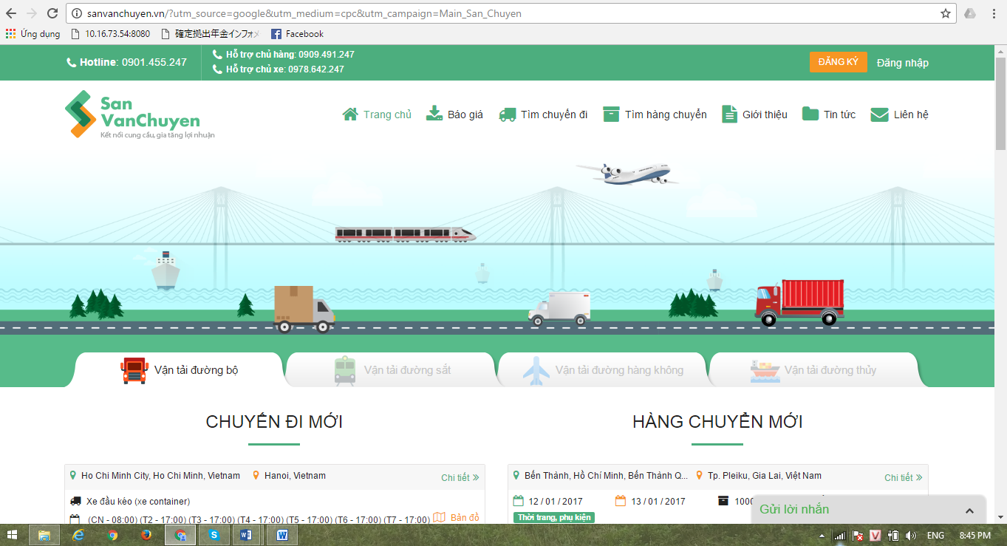

Figure 3‑1: Website sanvanchuyen

# PROPOSAL

## The idea

Today there are many who need freight but are not know how to transport as well as being subject to a relatively high fee for it. Not only this will make them just only don’t want to using carriage anymore, it will also make the price of the carriage will higher due to shortage of customers. It’s a dilemma. Our projects - Carrier Trading Center born to addressing these issues. Help people get higher economic profit.

## Objectives

This project is the Capstone Project in FPT University studying program.

First, this project is responsibility for all team members. We must complete all requirements from teacher and FU. During the time doing project, we can learn how to develop a project, how to manage project, how to communicate better between team member, how to control time, how to perform teamwork effectively. Moreover, we also have experience in Java technology, website designing, software testing. Therefore, we think this project is very necessary for us to improve skills, knowledge which we studied in FU. This project also makes our CV more beautiful after graduating from FU. This is also an opportunity for us to prove our abilities with recruiters.

We want to help people around us and we also want to improve the conditions of life. Also, if this project successfully, we will also contribute a bit on Vietnam’s carriage business, and help the trafficking issues in Vietnam gets better. Especially our website displayed entirely in Vietnamese. Vietnamese can use this website easier

## Brief description about system

This software is a major platform for crowdfunding with friendly and attractive interface, users can post their information goods to system to find carrier or carrier can find customer very easy. This greatly improves the economic productivity of the user.

CTC uses familiar technologies as: JSF, spring framework, Hibernate… And we are planning to develop a mobile version for easily connecting.

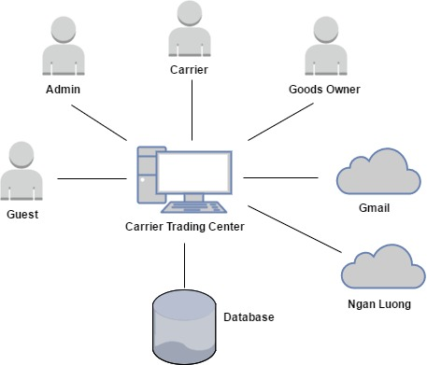

Figure 4‑1: Brief descriptions diagram of CTC system

## System features

About the features of CTC, we focus to provide for user main features as searching, filter project, create new project, return project, etc. Admin can manage members, manage projects, manage database, manage contribute database and manage Q&A.

In here, we focus on features which can help users can understand the best way what user want to have with features of CTC. There are the detailed features of CTC:

### Client features

#### Guest features

* **Register:**
* Register a new account: guest can register a new account to become a new user to use CTC service.
* **List bill of lading:**
* Search bill of lading: guest can search bill of lading on CTC with key words
* View bill of lading list: guest can view bill of lading are auctioning on CTC.
* **Price list:**
* View price: guest can view price list on CTC.
* Reference price: guest can reference price actual price system updated.

#### Goods owner features

* **List bill of lading:**
* View bill of lading list: goods owner can view bill of lading are auctioning on CTC.
* View bill of lading detail: goods owner can view bill of lading detail on CTC.
* Search bill of lading: goods owner can search bill of lading on CTC with key words.
* View carrier auction success: When bill of lading of goods owner is successful, they can view who got their bill of lading.
* Confirm complete transaction: when receiver received goods, goods owner had to confirm with system to get the arrange payment.
* Register a new bill of lading: when goods owner has goods for transport they can create a bill of lading to post on CTC to find carrier.
* Cancel bill of lading: when goods owner doesn’t want to send their goods, they can be using cancel function to remove their bill of lading.
* **Manage profile:**
* Edit profile: goods owner can edit their profile on system.
* View profile: goods owner can view their profile on system.
* Change password: goods owner can change their password for raise security.
* Forget password: when goods owner does not remember their password, they can send request to system to reset password.
* Add company: goods owner can add company’s information to their detail.
* **Manage report:**
* Send report: goods owner can send report to admin.
* Search report: goods owner can search report in their report list with title of report, time sent.
* View report list: goods owner can view their report on their report list.
* Cancel report: goods owner can cancel report if they want.
* **Price list:**
* Reference price: goods owner can view price list on CTC.
* View price list: goods owner can reference price actual price system updated.
* Account recharge: goods owner can recharge to their account for use CTC’s services.
* **Transaction history:**
* Transaction history: goods owner can check money in their account and check what did they do with their money.
* **Login:**
* User login: goods owner can login to CTC to use CTC’s service.
* **Logout:**
* User logout: goods owner can logout CTC.
* **Connect to carrier:**
* Connect to carrier: when goods owner is success on auction bill of lading, they can contact to carrier who got the auction and will carry their goods.

#### Carrier feature

* **List bill of lading**
* View bill of lading list: carrier can view bill of lading are auctioning on CTC.
* Confirm complete transaction: when receiver got goods, carrier have to confirm with system to get down payment.
* View bill of lading detail: carrier can view bill of lading detail on CTC
* Auction bill of lading: when carrier want to transport goods, they can find a bill of lading and then auction it.
* Search bill of lading: carrier can search bill of lading on CTC with key words.
* Cancel bill of lading: because some reason carrier cannot transport continue, they can be cancel bill of lading.
* **Manage profile:**
* Edit profile: carrier can edit their profile on system.
* View profile: carrier can view their profile on system.
* Change password: carrier can change their password for raise security.
* Forget password: carrier do not remember their password, they can send request to system to reset password.
* Add company: carrier can add company’s information to their detail.
* **Manage report:**
* Send report: carrier can send report to admin.
* Search report: carrier can search report in their report list with title of report, time sent.
* View report list: carrier can view their report on their report list.
* Cancel report: carrier can cancel report if they want.
* **Price list:**
* Reference price: carrier can view price list on CTC.
* View price list: carrier can reference price actual price system updated.
* **Account recharge:**
* Account recharge: carrier can recharge to their account for use CTC’s services.
* Transaction history: carrier can check money in their account and keep track what did they do with their money.
* **Login:**
* User login: carrier can login to CTC to use CTC’s service.
* **Logout:**
* User logout: carrier can logout CTC.
* **Connect to goods owner:**
* Connect to goods owner: when goods owner is success on auction bill of lading, they can connect to goods owner who have goods they carry.

### Admin features

* **List bill of lading:**
* View bill of lading list: admin can view bill of lading are auctioning on CTC.
* View bill of lading detail: admin can view bill of lading detail on CTC.
* Search bill of lading: admin can search bill of lading on CTC with key words.
* View carrier auction success: When bill of lading of goods owner is successful, admin can view how are get their bill of lading.
* Summary all bill of lading: admin can summary all bill of lading.
* View carrier list who are auctioning: admin can view how many carrier are auctioning a bill of lading and who are auctioning bill of lading.
* **Manage user:**
* Search user: admin can search user with name of user, email address, province, role of user keyword.
* View user profile: admin can view user profile.
* Edit user profile: admin can edit user profile.
* Active user: admin can active user to allow this user can use CTC’s service.
* Deactivate user: admin can deactivate user to disallow user use CTC’s service.
* Add company: admin can add company’s information to user detail.
* Account recharge for user: admin can recharge directly to account of user.
* Edit company information: admin can edit user’s company’s information.
* **Price list:**
* Reference price: admin can view price list on CTC.
* View price list: admin can reference price actual price system updated.
* Add a new price: admin can add a new price to price list on CTC.
* Edit price list: admin can edit price on price list on CTC.
* View price table history: admin can view history of price table.
* Edit reference price: admin can edit reference price.
* **Manage report:**
* Send report: admin can response report to goods owner and carrier.
* Search report: admin can search report in their report list with title of report, time sent.
* View report list: admin can view their report on their report list.
* **Transaction history:**
* Transaction history: admin can check money in their account and keep track what did they do with their money.
* **Login:**
* User login: admin can login to CTC to use CTC’s service.
* **Logout:**
* User logout: admin can logout CTC.
* **Manage profile:**
* Edit profile: admin can edit their profile on system.
* View profile: admin can view their profile on system.
* Change password: admin can change their password for raise security.
* Forget password: admin do not remember their password, they can send request to system to reset password.

# BENEFIT FROM PROJECT

## For our group

After developing and implementing this project, our group will get some benefits:

* Have more experiences of software project management how to manage plan, time, member and risk.
* Have more knowledge and skill about JSF, spring framework, Hibernate.
* Know how to communicate with team members and how to teamwork more effective.

## For Community

Just need to have a device that connects to the internet and any web browser and personal information user can:

* Easy create a new transaction
* Easy join to Carrier Trading Center
* Easy search for detail transaction information
* Easy to auction new transaction

# CRITICAL ASSUMPTION AND CONSTRAINTS

* Critical assumption:
* Human resources: Assume that all members in team have a good healthy to do their tasks.
* Constraints:
* Time and deadline: We must complete task on time. We work on 14 weeks, each member works 5 hours/day and 5 days/week. We do not have more time for us to complete developing and deliver application to teachers. Besides, we must submit report documents before deadline to teacher so teacher can have a final review.
* Quality: The products must be run well when users perform main functions in Google Chrome 40 and Firefox 30 or higher.
* Process: We have to follow the software processing of FPT Software
* Human resources: There are 5 members in our team, each member must study 3 subjects at school.

# POTENTIAL RISKS

After studying about this project, we find out some problem that we may be encountered:

* Underestimate scope and time or miss deadline because lack of experience in group working, managing and controlling work.
* Loss data, source code before uploading data to server because of careless.
* Equipment got broken because of careless or accident.
* Human resources: Team member cannot complete their works because of health reasons, key member leaves team or un-cooperating on team.
* Change requirements: Requirement changed when some functions cannot be completed or some technologies is not suitable.
* Some issues related to legislation.

# REFERENCES

* **Sanvanchuyen: “San Van Chuyen”. Updated 19/02/2017.** <http://sanvanchuyen.vn/>
* **Trucking:** “Trucking”. Updated 19/02/2017. http://trucking.vn/