|  |
| --- |
|  |
| Capstone Project Document |

**Carrier Trading Center**

Report #2 – Project Plan

|  |  |  |
| --- | --- | --- |
| **Carrier Trading Center** | | |
| **Group Members** | Lê Văn Dương | SE03290 |
| Vũ Văn Quyết | SE03344 |
| Đặng Lê Tuấn | SE03807 |
| Trịnh Đình Quyết | SE03159 |
| Lê Gia Hoàng | SE03200 |
| **Supervisor** | Mr. Nguyễn Văn Sang | |
| **Project code** | CTC | |

**- Hanoi, 02/2017-**

# SIGNATURE PAGE

AUTHOR: Trịnh Đình Quyết 15/01/2017

Team member

REVIEWERS: Lê Văn Dương 20/01/2017

Project manager

APPROVAL: Nguyễn Văn Sang --/--/2017

Supervisor

**Record of change**

*A - Added M - Modified D – Deleted

|  |  |  |  |  |  |
| --- | --- | --- | --- | --- | --- |
| Effective Date | Changed Item | A,M,D | Change Description | Reason for Change | Rev. Number |
| 15/01/2017 | Project plan | A | Create project plan | First version | 1.0 |
|  |  |  |  |  |  |
|  |  |  |  |  |  |
|  |  |  |  |  |  |
|  |  |  |  |  |  |
|  |  |  |  |  |  |
|  |  |  |  |  |  |
|  |  |  |  |  |  |
|  |  |  |  |  |  |
|  |  |  |  |  |  |
|  |  |  |  |  |  |
|  |  |  |  |  |  |
|  |  |  |  |  |  |
|  |  |  |  |  |  |
|  |  |  |  |  |  |
|  |  |  |  |  |  |
|  |  |  |  |  |  |
|  |  |  |  |  |  |
|  |  |  |  |  |  |
|  |  |  |  |  |  |
|  |  |  |  |  |  |
|  |  |  |  |  |  |
|  |  |  |  |  |  |
|  |  |  |  |  |  |

Table of Contents

SIGNATURE PAGE 1

1 INTRODUCTION 4

1.1 Purpose 4

1.2 Definitions and Acronyms 4

2 PROJECT OVERVIEW 4

2.1 Project description 4

2.2 Scope 4

2.3 Standard objectives 6

2.4 Milestones and deliverables 6

3 PPROJECT ORGANIZATION 7

3.1 Software Process Model 7

3.1.1 FPT Software Process Model 7

3.1.2 Project Life Cycle 9

3.2 Roles and Responsibilities 10

3.3 Organization Structure 10

3.4 Project Team Member 10

4 TOOLS AND INFRASTRUCTURES 11

4.1 Tool and Techniques 11

4.2 Hardware requirement 11

4.3 Software requirements 11

5 SCHEDULE 12

5.1 Detailed schedule 12

5.2 Meeting Minutes 13

5.3 Communication Plan 13

6 RISK MANAGEMENT PLAN 14

7 EFFORT ESTIMATION 15

8 CODING CONVENTION 15

# 1 INTRODUCTION

## Purpose

This part is the project management plan of Carrier Trading Center (CTC) Project – our Capstone Project in FPT University. It is included the project overview, project organization, tools and infrastructures, schedule, risk management, quality management and some coding convention of this project

## Definitions and Acronyms

|  |  |  |
| --- | --- | --- |
| Acronym &  Abbreviation | Definition | Note |
| CTC | Carrier Trading Center |  |
| FU | FPT University |  |
| ERD | Entity Relationship Diagram |  |
| RUP | Rational Unified Process |  |
| SRS | Software Requirement Specification |  |
| SAD | Software Architecture Design |  |

**Table 1-1**: **Definitions and Acronyms**

# PROJECT OVERVIEW

## Project description

|  |  |  |  |
| --- | --- | --- | --- |
| Project Code | **CTC** | Contract Type | **None** |
| Customer | FPT University | 2nd Customer | None |
| Project Level | Group | Project Rank | None |
| Application Type | Website | Project Manager | Lê Văn Dương |
| Project Category | Development | Business Domain | E-commerce |

Table 2-1: Project Description

## Scope

|  |  |  |  |
| --- | --- | --- | --- |
| UC No. | Group Of Functions | Function | Glossary |
| **Guest** | | | |
| UC001 | **Register** | Register a new account |  |
| UC002 | **Bill of lading list** | Search bill of lading |  |
| UC003 | View bill of lading list |  |
| UC004 | **Price list** | View price |  |
| UC005 | Reference price |  |
| **Admin** | | | |
| UC006 | **Bill of lading list** | View bill of lading detail |  |
| UC007 | Search bill of lading |  |
| UC008 | View bill of lading list |  |
| UC009 | View carrier auction success |  |
| UC010 | Summary all bill of lading |  |
| UC011 | View carrier list who are auctioning |  |
| UC012 | **Manage user** | Search user |  |
| UC013 | View user profile |  |
| UC014 | Edit user profile |  |
| UC015 | Add company |  |
| UC016 | Account recharge for user |  |
| UC017 | Active user |  |
| UC018 | Deactivate user |  |
| UC019 | Edit company information |  |
| UC020 | View user list |  |
| UC021 | **Price list** | View price list |  |
| UC022 | Add a new price |  |
| UC023 | View price table history |  |
| UC024 | Edit price list |  |
| UC025 | Reference price |  |
| UC026 | Edit reference price |  |
| UC027 | **Transaction history** | Transaction History |  |
| UC028 | **User login** | User login |  |
| UC029 | **Use logout** | Use logout |  |
| UC030 | **Manage report** | Search report |  |
| UC031 | Response report |  |
| UC032 | View report list |  |
| UC033 | **Manage profile** | View profile |  |
| UC034 | Edit profile |  |
| UC035 | Forget password |  |
| UC036 | Change password |  |
| **Goods owner** | | | |
| UC037 | **Bill of lading list** | View bill of lading list |  |
| UC038 | View bill of lading detail |  |
| UC039 | Search bill of lading |  |
| UC040 | View carrier auction success |  |
| UC041 | Confirm complete transaction |  |
| UC042 | Post a new bill of lading |  |
| UC043 | Cancel bill of lading |  |
| UC044 | **Manage profile** | Edit profile |  |
| UC045 | View profile |  |
| UC046 | Change password |  |
| UC047 | Forget password |  |
| UC048 | Add company |  |
| UC049 | **Manage report** | Send report |  |
| UC050 | Search report |  |
| UC051 | Cancel report |  |
| UC052 | View report list |  |
| UC053 | **Price list** | Reference price |  |
| UC054 | View price list |  |
| UC055 | **Account recharge** | Account recharge |  |
| UC056 | **Transaction history** | Transaction history |  |
| UC057 | **User login** | User login |  |
| UC058 | **User logout** | User logout |  |
| UC059 | **Connect to carrier** | Connect to carrier |  |
| **Carrier** | | | |
| UC060 | **Bill of lading list** | View bill of lading list |  |
| UC061 | Confirm complete transaction |  |
| UC062 | View bill of lading detail |  |
| UC063 | Auction bill of lading |  |
| UC064 | Search bill of lading |  |
| UC065 | Cancel bill of lading |  |
| UC066 | **Manage profile** | Edit profile |  |
| UC067 | View profile |  |
| UC068 | Change password |  |
| UC069 | Forget password |  |
| UC070 | Add company |  |
| UC071 | **Manage report** | View report list |  |
| UC072 | Search report |  |
| UC073 | Cancel report |  |
| UC074 | Send report |  |
| UC075 | **Price list** | Reference price |  |
| UC076 | View pricing list |  |
| UC077 | **Transaction history** | Transaction history |  |
| UC078 | **User login** | User login |  |
| UC079 | **User logout** | User logout |  |
| UC080 | **Connect to goods owner** | Connect to goods owner |  |
| UC081 | **Account recharge** | Account recharge |  |

Figure 2‑1: Scope of CTC

## Standard objectives

|  |  |  |  |  |
| --- | --- | --- | --- | --- |
| Metrics | Unit | Committed | Re-committed | Note |
| Start Date |  | 03/01/2017 |  |  |
| End Date |  | 19/04/2017 |  |  |
| Duration | Day | 78 |  |  |
| Team Size | Person | 5 |  |  |
| Billable Effort | Person-day | 390 |  |  |
| Calendar effort | Person-day | 390 |  |  |
| Effort Usage | % | 100 |  |  |

Figure 2‑2: Standard objectives

## Milestones and deliverables

|  |  |  |  |  |  |  |
| --- | --- | --- | --- | --- | --- | --- |
| No | Stage | Deliverable/ Milestone | Delivery Date | Inspect | Final | Delivery Location |
| 1 | Initiation | Deliver Report No.1 | 09/01/2017 |  |  | Supervisor |
| 3 | Initiation | Deliver Report No.2 | 16/01/2017 |  |  | Supervisor |
| 4 | Solution | Software  Requirement  Specification | 10/02/2017 |  |  | Supervisor |
| 7 | Solution | System  Architectural Design | 24/02/2017 |  |  | Supervisor |
| 11 | Construction | Complete Coding | 18/03/2017 |  |  | Supervisor |
| 12 | Construction | Deliver Report No.5 | 24/03/2017 |  |  | Supervisor |
| 13 | Construction | Deliver Report No.6 | 13-12-2013 |  |  | Supervisor |
| 14 | Termination | The last  Document and  CD source code | 17/04/2017 |  |  | FU |
| 15 | Termination | Project completed | 26/04/2017 |  |  | FU |

Figure 2‑3: Milestones and deliverables

# PPROJECT ORGANIZATION

## Software Process Model

### FPT Software Process Model

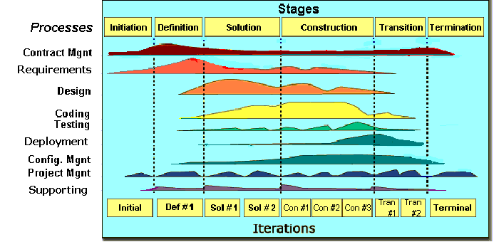

Figure 3‑1: FPT Software process model

The software lifecycle is broken into *cycles*, each cycle working on a new generation of the product. The FPT Software process divides one development cycle in six consecutive *phases*:

1. Initiation phase
2. Definition phase
3. Solution phase
4. Construction phase
5. Transition
6. Termination

### Project Life Cycle

Basing on FPT Software process and real-world project, we decided to divide the project into 4 phases: Initiation, Solution, Construction, and Termination:

* **Initiation Phase:** This is the explanatory phase of the project. Project objective and description is described at this stage. The purpose of this phase is to collect and understand business requirements, detail the project plan and agree upon a high level statement of work. Our primary objectives are complete project identification and project plan. After these are completed, the project is checked against the following criteria:
  + Identify business functions of the system
  + Determining the scope, conditions and limitations of the project
  + List the main functions of the system
  + List one or more suitable architecture for the system
  + Identify project risks
  + Complete Report #1, and Report #2
* **Solution Phase**: In this phase, the architecture of the system is designed. The goal is to translate requirements and specification into a technical solution to produce Technical Design.
  + Our *primary objectives* are completeRequirement Specification, Architecture Design and Database Design.
  + Finally, the plan must be provided (including estimates of cost and time) for the construction phase. The plan must ensure proper and accurate based on experience.
  + Complete Report #3 and Report #4
* **Construction Phase**: This is the longest phase of a project life cycle.
  + In this phase, all functions of the system will be installed. The installation will be divided into small stages, each stage of the installation a few functions. The results of each phase will be the release of the module function can be executed.
  + Construction and improvement of products until the final product is ready to deliver to the user. During this phase, all the components and other features of the application is developed and integrated into the product.
  + This phase emphasizes the resource management and control operations to optimize cost, time and quality.
  + Complete software packages and Report #5 and report #6
* **Termination Phase**: This is the final phase in the life cycle of a project.
  + Their products will be deployed to the client. The feedback received during the transfer process will be recorded and put on the new functional requirements or functionality enhancements in the next version of the product.
  + Phase transfer switch also includes the training system and the new system for the user.
  + Complete capstone project

## **Roles and Responsibilities**

Figure 3‑2: Roles and responsibilities

## Organization Structure

|  |  |
| --- | --- |
| **Role** | **Responsibility** |
| Project Manager | Planning, developing schedules, coordinating communication, generally responsible for keeping the team’s focus on the main goal. |
| Technical Leader | Responsible for choosing and deciding what technologies should be used, as well as for overseeing the work being done by other developers. |
| Quality Assurance Manager | Ensuring the product meets the certain standards of quality from requirements. |
| Test Leader | Responsible for test execution, including test set-up and test run, evaluation of test run and error recovery, defect logging and test results recording. |
| Developer | Involve coding the product and reviewing code of other developers. |
| Designer | Involve designing product’s user interface. |
| Tester | Involve testing the product. |

Table 3‑1: Project Structure

## Project Team Member

|  |  |
| --- | --- |
| **Team Member** | **Role** |
| DuongLV | Project Manager, Developer |
| QuyetVV | Technical Leader, Developer |
| QuyetTD | Tester Leader, QA |
| HoangLG | Developer, Designer |
| TuanDL | Designer, Tester, Developer |

Table 3‑2: Project Team Member

# TOOLS AND INFRASTRUCTURES

## Tool and Techniques

|  |  |
| --- | --- |
| **Programming languages** | JavaScript, Java, Html |
| **Framework** | Java Server Face, Hibernate |
| **Software architecture** | Java Server Face |
| **Version control** | SVN |
| **IDEs/Editors** | Eclipse |
| **UML tools** | Astah Professional 7.0 |
| **Web server** | Apache Tomcat 7 |
| **DBMS** | MySQL |
| **Deployment server** | Apache Tomcat 7 |
| **Project management tool** | Microsoft Project 2016 |
| **Development process** | Rational Unified Process |

Table 4‑1: Project Team Member

## Hardware requirement

- Personal computers for developing with the recommended configuration: 4GB of Ram DDR3, 100GB of hard disk SSD, Processor: 2.4GHz Intel Core i5

- A sever computers for testing with the Recommended configuration: 4GB of Ram DDR3, 100GB of hard disk SSD, Processor: 2.4GHz Intel Core i5

## Software requirements

- Operating system: Window 8.1, 10

- Web server: Apache Tomcat

- IDE: Eclipse

- DBMS: MySQL

- Soured control: Microsoft Project Plan

- Design Graphic: Adobe Photoshop 6

- Contact tool: Skype

- Architecture design: Astah

# SCHEDULE

## Detailed schedule

Refers to “CTC_Project_Schedule_v1.0_EN” file.

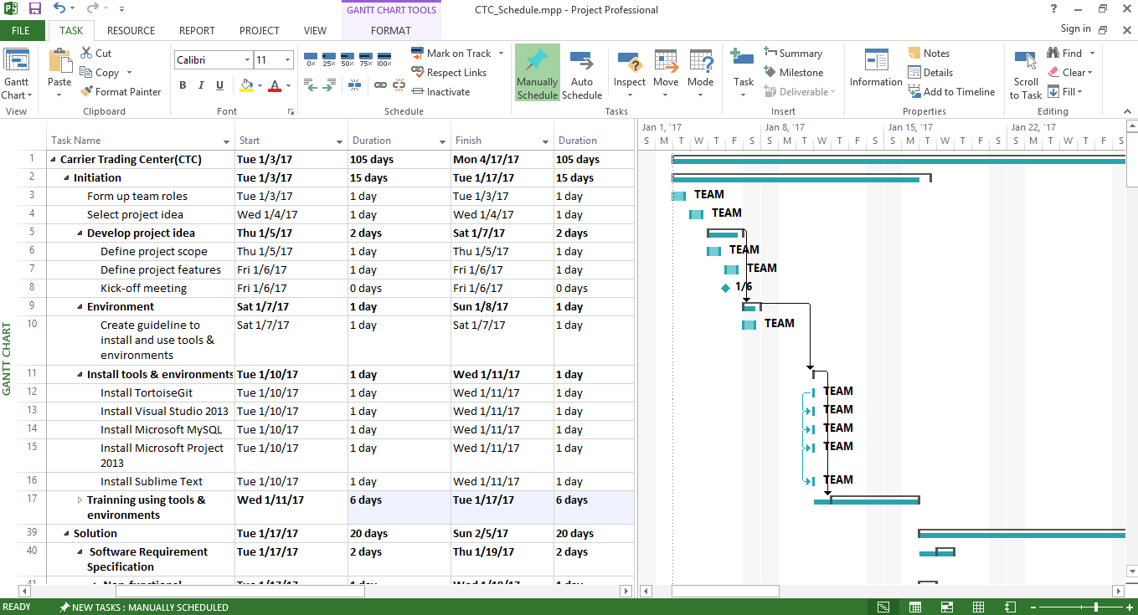

Figure 5‑1: CTC Project Management file

## Meeting Minutes

All meeting minutes will be written following this template:

| ***Meeting/Project Name:*** | *CTC* | | | |
| --- | --- | --- | --- | --- |
| ***Date of Meeting:*** |  | ***Time: (Type)*** | *hours (Face-to-face)* | |
| ***Meeting Called by:*** | *QuyetVV* | ***Location:*** | *FPT University‘s Library* | |
| ***Note Taker:*** | *QuyetTD* | ***Time Keeper:*** | *DuongLV* | |
| 1. Meeting Objective | | | | |
| * Choose names, ideas for project | | | | |
| 2. Attendance | | | | |
| ***Name*** | ***Roles*** | ***E-mail*** | | ***Phone*** |
| Lê Văn Dương | Project Manager | [DuongLVSE03190@fpt.edu.vn](mailto:DuongLVSE03190@fpt.edu.vn) | | 0166-977-5349 |
| Lê Gia Hoàng | Developer | [HoangLGSE03200@fpt.edu.vn](mailto:HoangLGSE03200@fpt.edu.vn) | | 0165-901-2428 |
| Đặng Lê Tuấn | Designer | [TuanDLSE03807@fpt.edu.vn](mailto:TuanDLSE03807@fpt.edu.vn) | | 0968-095-029 |
| Vũ Văn Quyết | Technical Leader | [QuyetVVSE03344@fpt.edu.vn](mailto:QuyetVVSE03344@fpt.edu.vn) | | 0972-381-151 |
| Trịnh Đình Quyết | Test Leader/QA | [QuyetTDSE03159@fpt.edu.vn](mailto:QuyetTDSE03159@fpt.edu.vn) | | 0964-657-385 |
| 3. Content | | | | |
|  | | | | |
| 4. Note | | | | |
|  | | | | |

Table 5‑1: Meeting Minutes Template

## Communication Plan

*Weekly meeting schedule:* We use Iterative and Incremental Process Model, then we divide the system into two sub-systems (CTC services and CTC Front-end), each sub-system is divided into a bunch of small tasks. Each task is recorded to Trello then estimated depending on difficulty and the amount of work by the whole team, after that the Team Leader will assign the task to team members and depending on difficulty, the Technical Leader will assign deadlines for each task. We will have a meeting every Monday to inform to all team about what each member finished last week, the status (fast, on time or slow), the issues met and how to solve them. If any member raises any issue, the whole team will help to find out a solution together. After that, the team will define detailed stories for next week tasks and estimate how long it takes to finish them.

*Daily discussing schedule*: Each sub-system has one development team with different schedule. Whenstarting work-day, each team will have a stand-up meeting to inform to others: “What did I do yesterday?”, “What will I do today?” and “Are there any impediments in my ways?”. By focusing on what each person accomplished yesterday and will accomplish today, the team gains an excellent understanding of what work has been done and what work remains.

*Unscheduled meeting*: If someone has an important problem that he wants to solve immediately, we will have a meeting for discussion, usually via some online channel: Facebook, Skype, or Phone.

# RISK MANAGEMENT PLAN

|  |  |  |  |  |
| --- | --- | --- | --- | --- |
| **No** | **Description** | **Avoidance plan** | **Contigency plan** | **Status** |
| R1 | **Illness or absence of team members** | Member has to notice to the team about absence period and the plan of how to keep up with the work process. | Ensure that the absence of a member will not affect others and always have plans to deal with this problem. | Closed |
| R2 | **Business problem** | Any ideas are welcome but members have to discuss with others and always focus on the reality and possibility. | Make sure the business logic of any ideas is carefully analyzed. | Closed |
| R3 | **Change management overload** | A large number of change requests dramatically raises the complexity of the project and distracts key resources. | If there is a “must be changed” requirement, all team members must join the meeting to decide whether it should be implemented or not. | Closed |
| R4 | **Project team misunderstand requirements** | When the project team a gap misinterprets requirements develops between expectations, requirements and work packages. | Make sure any miscommunication has to be resolved. | Closed |
| R5 | **New technology** | Choosing technology based on member’s qualification. There are some issues canot resolve | When someone chooses a new technology, he/she has to explain to all team members about the decision. | Closed |

Table 6‑1: Risk Management

*Communication channel*: Our main communication channels are sky. On the other hand, we used face-to-face meeting, Email, Messenger. However, we sometimes make a phone call or instant message if someone has a problem.

# EFFORT ESTIMATION

|  |  |  |  |  |
| --- | --- | --- | --- | --- |
| Task name | Worst case (days) | Best case (days) | Most likely (days) | Expected case (days) |
| **Initiation** | **95** | **92** | **93** | **93** |
| **Solution** | **95** | **92** | **92** | **93** |
| **Construction** | **150** | **145** | **147** | **148** |
| **Termination** | **40** | **35** | **38** | **39** |
| Total | 380 | 348 | 370 | 373 |

Table 7‑1: Effort Estimation

# CODING CONVENTION

Reference to CTC_Coding_Convention_Oracle_EN