|  |  |
| --- | --- |
| Logo_FPT_University_doc | **MINISTRY OF EDUCATION AND TRAINING** |

**FPT UNIVERSITY**

**CAPSTONE PROJECT DOCUMENT**

**BUS BOOKING**

**Report #1 – Introduction**

|  |  |
| --- | --- |
| **Bus Booking** | |
| **Group Member** | SE04603 – Trần Minh Đức |
| HE141770 – Nguyễn Bá Trọng |
| SE04673 – Nguyễn Anh Hiệp |
| SE04085 – Lã Trung Nam |
| **Supervisor** | Nguyễn Văn Sang |
| **Ext. Supervisor** |  |
| **Project Code** | BB |

- Hanoi, 09/2019 -

Table of Contents

[1 INTRODUCTION 4](#_Toc20060059)

[1.1 Purpose 4](#_Toc20060060)

[1.2 Acronyms and Definitions 4](#_Toc20060061)

[2 ABSTRACT 4](#_Toc20060062)

[3 LITERATURE REVIEW 4](#_Toc20060063)

[3.1 Website Vexere.com 4](#_Toc20060064)

[3.2 Website easybook.com 6](#_Toc20060065)

[3.3 XEP company’s bus management system 7](#_Toc20060066)

[4 PROPOSAL 9](#_Toc20060067)

[4.1 The idea 9](#_Toc20060068)

[4.2 Objectives 9](#_Toc20060069)

[4.3 Brief description about system 9](#_Toc20060070)

[4.4 System features 10](#_Toc20060071)

[5 BENEFIT FROM PROJECT 10](#_Toc20060072)

[5.1 For Organization 10](#_Toc20060073)

[5.2 For our group 11](#_Toc20060074)

[5.3 For Community 11](#_Toc20060075)

[6 CRITICAL ASSUMPTION AND CONSTRAINTS 11](#_Toc20060076)

[7 POTENTIAL RISKS 12](#_Toc20060077)

[REFERENCES 13](#_Toc20060078)

# 1 INTRODUCTION

## Purpose

This document is prepared as the introduction for project Bus Booking, in scope of Capstone Project at FPT University. It does not only explain the basic concept and idea for our project but also discuss what project’s benefits and threats are, what opportunities it offers and what existing problem it solves.

## Acronyms and Definitions

|  |  |  |
| --- | --- | --- |
| Acronym & Abbreviation | Definition | Note |
|  |  |  |
|  |  |  |
|  |  |  |
|  |  |  |
|  |  |  |
|  |  |  |
|  |  |  |

Table 1-1: Definitions and Acronyms

# ABSTRACT

Travelling is a large growing business across all countries. Bus reservation system deals with maintaince of records of details of each passenger. It also includes maintaince of information like schedule and details of each bus. We have observed the working of the Bus reservation system and after going through it, we get to know that there are many operations, which they have to do it manually. It takes a lot of time and causing many errors while data entry. Due to this, sometimes a lot of problems occur and they were facing many disputes with customers.

For example, in the existing system, all the booking process and the maintance of the records is done manually. Users who are interested in inquiring about the bus type, tickets price, available seats, facility of the bus etc… have to walk to the booking office. This creates a lot of time waste for the users.

To solve the above problems, and further maintaining records of passenger details, seat availability, price per seat, bill generation and other things, we are offering an Bus Booking system which provides a portal for bus ticket reservation. This application will allows users to book bus tickets anywhere and anytime if the bus has available reserve slots. The user will be able to view all the details of the website, bus, drive and also view the details of the journey and the details of journey timings.  We can come up with features like saving favorite routes and providing discounts for the same. We can provide a feature that will allow the customer to get a ticket booked without much hassle.

The other ideas is to solve every company problems in management. The website is also designed for Bus’s company so they can easily manage and stored passenger’s information who booked their Bus ticket on the websites.

Besides, people are surfing on internet and visiting websites everyday. This is why we choose to do this Online Bus Ticket Reservation as a website. Because it is more convienience for the users because you can access anytime you want as long as you have an internet connection.

For all the limitation of existing similar application, we expected to create an website for Online Bus Ticket Reservation that improves and enhances current state, to overcomes the weaknesses

# LITERATURE REVIEW

## Website Vexere.com

Vexere.com is a reliable website for buying car tickets online. It is easier for travelers to book tickets through clear information about the car companies, departure times, addresses, and phone numbers. Additionally, the website also supports cars owners to register and manage their rides.

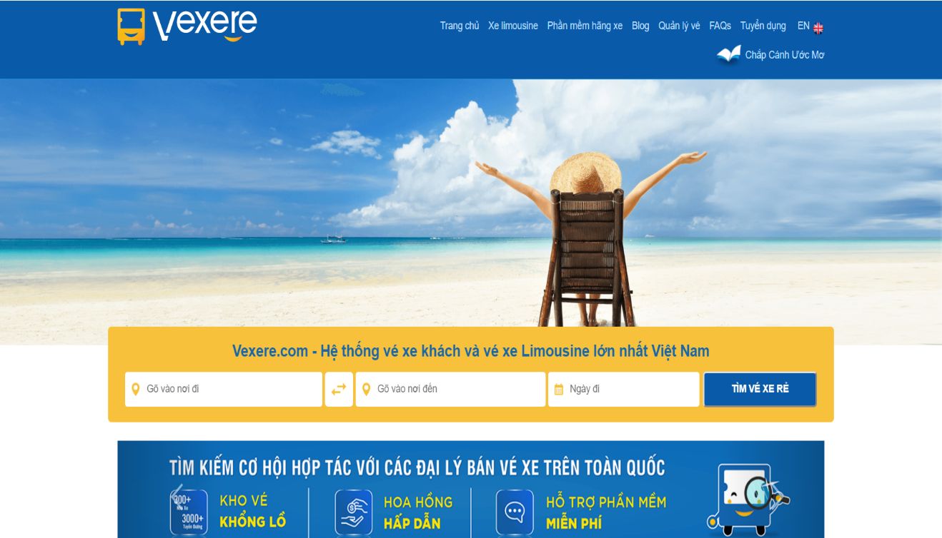

**Figure 1-1:** Vexere interface

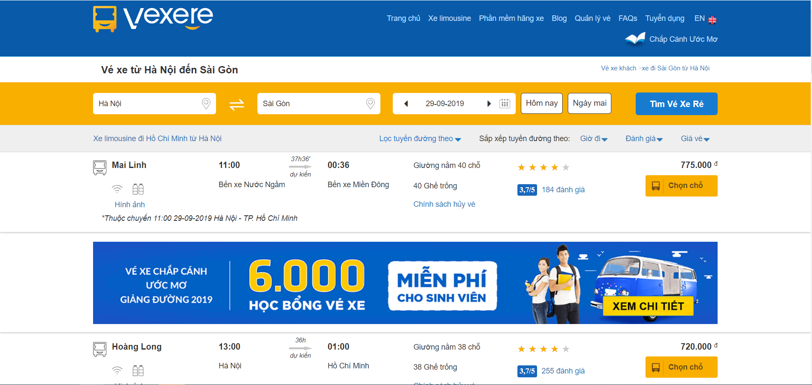

**Figure 1-2:** Vexere booking interface

**Advantages:**

* User interface is very nice and easy to use.
* Support many functions.
* Quick response for user’s action.
* Users can find trips and book tickets.
* Support the cars owner to manage the trips and tickets.
* Supporting two languages English and Vietnamese.
* Users can comment and rate.
* Share facebook, zing.

**Disadvantages:**

* Do not have login, logout and registration for the user.
* Car’s owner does not have private management account.
* Do not support online.
* Tickets cannot be canceled online.

## Website easybook.com

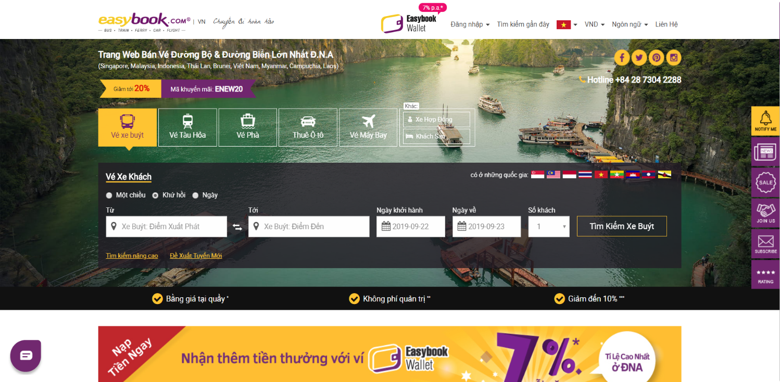

**Figure 1-3**: easybook.com interface

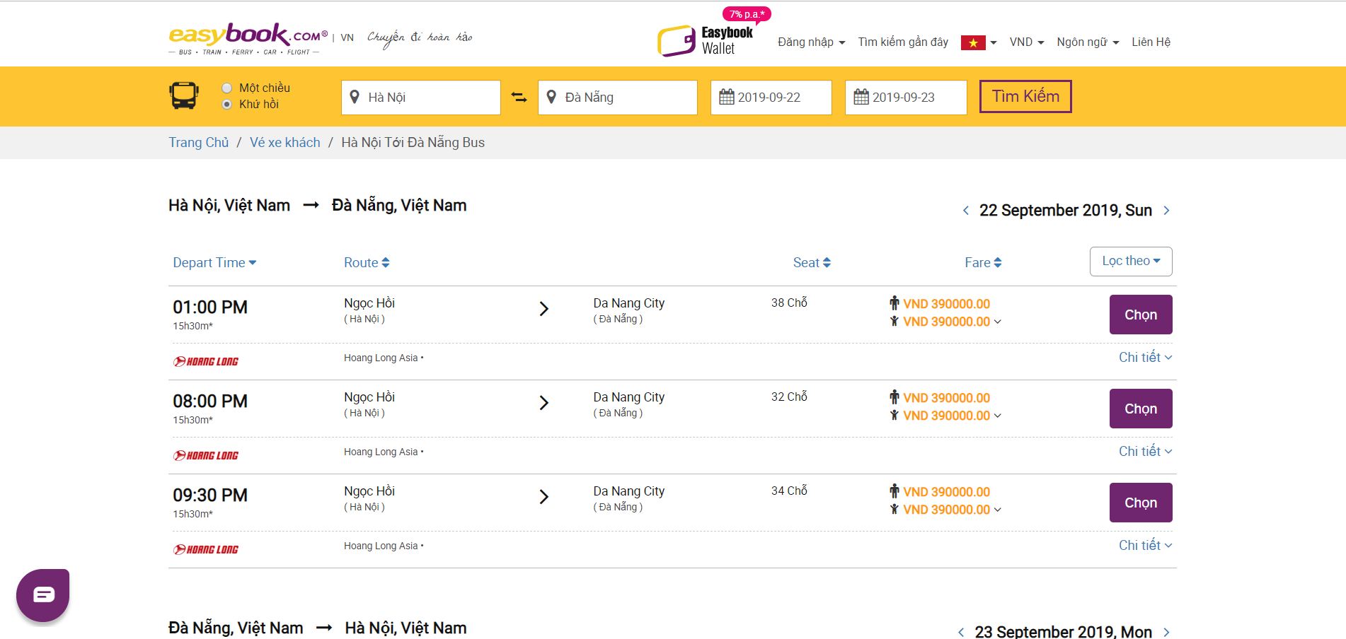

**Figure 1-4**: easybook.com booking interface

**Advantages:**

* User interface is very nice and easy to use.
* Support many functions: booking cars tickets, flight tickets, train tickets...
* Quick response for user’s action.
* Users can find trips and book tickets.
* Support the cars owner to manage the trips and tickets.
* Supporting three languages English, Vietnamese and Chinese.
* Users can comment and rate.
* Support many countries.
* Support searching for trips by time, seat and carrier

**Disadvantages:**

* Car’s owner does not have private management account.
* Tickets cannot be canceled online.
* User's does not have drivers information

## XEP company’s bus management system

There’s very little system we can find on internet that support the bus owners to management their business. And among all we finded, this system of XEP company is such a very well-produced system that it support many important functions (Ex:management tickets,management drivers,management bus,business statistic,… ) for the bus owners to run their business in efficiency way

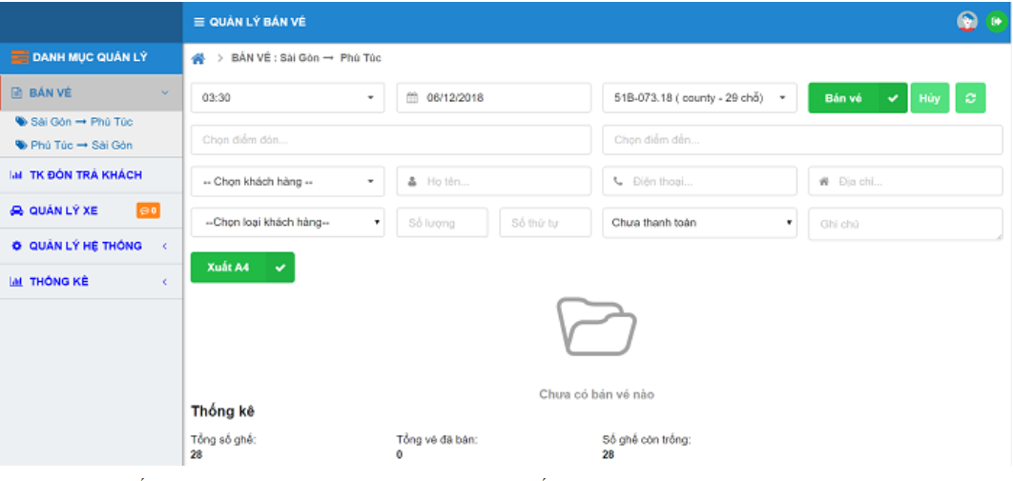

**Figure 1-5**: Vexere interface

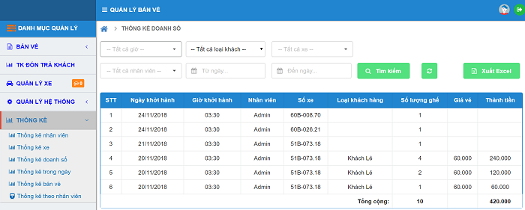

**Figure 1-6**: Vexere interface

**Advantages:**

* User interface is very nice and easy to use.
* Easy tracking business information and statistic
* Support exporting statistic to excel for storage
* Support variety of functions in business management like HR management, drivers, bus management and also
* Searching information with useful filter
* Suport function login and log out for user

**Disadvantages:**

* It’s not a free product, only a demo was provide
* Do not have function support schedule bus journey schedule.

# PROPOSAL

## The idea

The idea of creating a portal for booking system is not new. In facts, there are a lot of existing online booking systems for different purpose(Like Online Hotel Reservation, online Plane tickets Reservation ). The Bus Booking system will have similar main functions of current booking apps and will be used for booking Bus tickets. We are adding some other features so the owners of the bus themself can manage their records of passengers, records of moved trips.

## Objectives

This project is the Capstone Project for all team members.

Firstly, we do this project to fulfill the re quirements from FPT University studying program. During the time do this, we can learn how to develop a project, how to communicate with other team members, and how to control time, how to do teamwork effectively. We can also work with new technology, framework such as AngulaJS,… Theofore after finishing this project, we can practice what we have learnt in university and learn so many new things. It is very necessary for our future work after graduating from FPT University.

Secondly, we want to create an Online Bus Ticket Reservation that helps users to be able to book bus ticket anywhere and anytime. The proposed system is a new system which is helpful to both employees as well as the users.  This system provides help to the users as they can inquire about the bus model, its ticket price, available Seats, facility of the bus etc. and they don’t need to walk to the office.  There are login and password service for employee and regular customers to use this system.

## Brief description about system

Bus Booking system is a web base system with a friendly and easy to use. User can search bus journey then book the ticket and pay for it, also they can track and cancel the tichket. Moreover, our system will have some features for supporting the bus owner to manage their business. They can track the information of buses, drivers, customer and the sales statistic by month, by day, by bus,... And we have the features of the website administrator to get the fee and manage the bus owner companys, provide voucher and coupon for customer, and track information of bus owner, driver, customer, and sales statistics.

Bus Booking system uses familiar technologies as: JavaScript, Strut 2, Spring, Hibernate, AngularJS, Bootstrap,..It is support operating systems such as windows and current browsers as Firefox, Chrome.

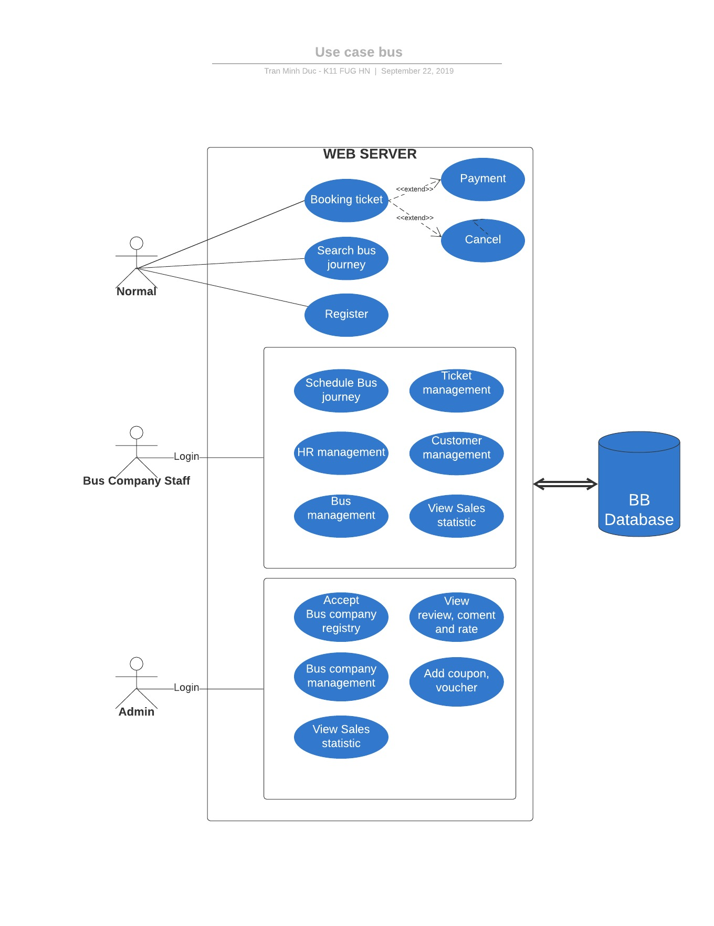**Figure 1-7**: Global picture

## System features

About the feature of Bus Booking website, it has main features of website for user buying car tickets online, login, logout and register account. Additionally, the website also supports cars owners to register and manage their rides. There are the detailed functions of this application:

* **User:**
* Login, logout and register: create new and edit account.
* Online payment : atm, visa
* Find a trip, book a ticket, cancel a ticket : Search by date and time, location.
* View transaction history.
* Select a payment method.
* Comment and rate the quality of service.
* View details of the trip : time, driver who and license plate.
* View ticket cancellation rules : Penalty or compensation.
* Chat box: chat with management staff.
* **Cars owners:**
* Login, logout and register: account management.
* Register business or private:
  + Business : Register multiple accounts, allow multiple roles, multiple administrators, management.
  + Private: Register account.
* Add train schedule, tickets, trip information.
* Input information : driver’s license
* View passenger information: phone number, address, and booking a char.
* Cancel trip schedule.
* Accept other passengers, refuse passengers.
* View account information: Statistics the number of trips, the amount collected and review statistical history in 1 month.
* **Admin:**
* Accepting car’s owner account
* Following history of car’s trip, feedback and report.
* Edit cars owners information.
* User information management
* Reporting the number of cars on registering and proceeds.
* Track schedule information.

# BENEFIT FROM PROJECT

If the system Bus Booking is in operationak it will bring the benefits listed below

## For Organization

This project will provide there benefit for organization using it:

* Bus Booking helps bus companies to control bus routes, schedules and drivers
* Bus Booking helps companies to control customers who booked the ticket and amount people in each bus
* Bus Booking helps companies to advertise their company to customers and notify promotions for customers
* Bus Booking is a an intermediary website that brings customers closer to the coach company.
* Save time, help operators access information to control the car easily.
* Cost savings, thanks to technology and enterprise applications can reduce the costs incurred during operation
* Increasing professionalism - increasing the trust of customers for businesses, creating a reputable private brand in the transport industry.

## For our group

After the site is completed, each team member has gained

* Each member learns how to use some framework like Angular JS, Bootstrap, Spring Java
* Member improved skill use JAVA and HTML
* Member improved how to work with group
* Each member learned about manage a project, manage risk and cost to complete
* Each member has experience for future when apply a job in a new company

## For Community

Ticket booking web helps transportation become smarter, more modern and closer to customers. The website helps the domestic transport industry develop significantly and the management becomes more convenient and transparent.

# CRITICAL ASSUMPTION AND CONSTRAINTS

The bus ticketing system has the main function of helping customers book tickets for bus routes and helps the garage control their schedules and passengers. Therefore, the system only works when connected to the server via internet or intranet. Therefore, the system must operate flexibly on all types of networks and have good communication algorithms between the reservationist and the ticket controller.

Each garage has its own route schedule and the number of vehicles and the number of passengers is different. Not only that, each customer also has different ticket orders. Therefore, the system must have appropriate arrangements with companies and customers to avoid confusion.

The test run and put the system into operation officially requires the supervision of the stakeholders and technical support from the project team.

# POTENTIAL RISKS

**7.1: Potential Risks**

|  |  |  |  |  |
| --- | --- | --- | --- | --- |
| **ID** | **RISK** | **TYPE** | **PROBABILITY** | **SOLUTION** |
| 1 | The project was delayed because the project team planned to be completed in time, which made the handover delayed | Schedule | HIGH | -The project team uses project time management software like prolibre to rearrange work time.  -Redistribute each task and accelerate the project schedule to timely hand over the project.  -Explain the reasons behind the schedule and draw experience for the project to be completed on time |
| 2 | Member shortages for external reasons(sick, change team,…) | Personnel | HIGH | -Each member must be aware of the work which they are doing and must not leave when unfinished.  -Project team members should know how to communicate and motivate each other to achieve project success.  -Members must know how to protect their health and keep the project schedule reasonable |
| 3 | Project team members lack the skills to use software and programming languages ​​for the project | Technical | Moderate | -Each project team member needs to improve their programming skills as well as use the support tools.  -Members help each other in programming projects and offer optimal solutions to achieve the best results |
| 4 | Lack of operational analysis capabilities of bus companies because there is no basis for information collection | Technical | Moderate | The project team contacts transportation companies and deals with them to learn more about current vehicle management and contingency plans. |

**7.2: Limitations**

Bus booking system is researched and developed under the schedule of CAPSTONE Project with limitations about time, resource and budget so that the system cannot complete with full and at high perfection level.

# REFERENCES

[1] Vexere.com, Vexere Joint Stock Company,

<https://vexere.com/>

[2] Easybook.com, Larget Land & Sea Ticketing Website in SE Asia,

<https://www.easybook.com/vi-vn>

[3] XEP company’s bus management system, XEP Software Co.,Ltd

<https://xep.vn/>