

USEFUL JAPANESE DICTIONARY FOR VIETNAMESE
Capstone Project Document
USEFUL JAPANESE DICTIONARY FOR VIETNAMESE
Report #3

Project Code: UJD_VN
Document Code: UJD_VN_ Report3_Final_EN

- Hanoi, 06/2014 -
Table of Contents
1 USER REQUIREMENTS SPECIFICATION 4
1.1 Introduction 4
1.1.1 Purposes 4
1.1.2 Definition and Acronyms 4
1.2 Overall Description 4
1.2.1 Business Process Overview 4
1.2.2 Product Features 7
1.2.3 User Characteristic 9
1.3 Functional Requirements 9
1.3.1 Common Module 9
1.3.2 Account management Module 9
1.3.3 Practice management Module 9
1.3.4 Contact admin Module 10
1.3.5 Admin’s account management 10
1.3.6 Management Member’s account 10
1.3.7 Vocabulary Management 10
1.3.8 Grammar Management 10
1.3.9 Reading Document Management 11
1.3.10 Conversation management 11
1.3.11 Video Management 11
1.3.12 Listening article management 11
1.3.13 Doing test management 11
1.3.14 Contribute content management 12
1.3.15 Contribute opinion management 12
1.3.16 Q&A management 12
1.4 Non – Functional Requirements 12
2 SOFTWARE REQUIREMENTS SPECIFICATION 12
2.1 System Purpose 12
2.2 Scope 12
2.3 Overall Description 12
2.3.1 System overview 12
2.3.2 Product Features 13
2.3.3 User Characteristics 17
2.3.4 User Documentation 17
2.3.5 Assumption 17
2.4 Entity Relation Model 17
2.4.1 Entity-Relationship Diagram 17
2.4.2 Entity Detail 18
2.5 Functional Specification 29
2.5.1 Common Module 29
2.5.2 Account management Module 38
2.5.3 Contact admin Module 50
2.5.4 Practice management Module 59
2.5.5 Admin’s account management 70
2.5.6 Management Member’s account 77
2.5.7 Vocabulary Management 84
2.5.8 Grammar Management 97
2.5.9 Reading Document Management 108
2.5.10 Conversation management 116
2.5.11 Video Management 130
2.5.12 Listening Article Management 140
2.5.13 Doing test management 152
2.5.14 Contributed content management 166
2.5.15 Contributed opinion management 178
2.6 Non-functional Specification 184
2.6.1 Reliability 184
2.6.2 Performance Requirements 185
2.6.3 User Interface 185
2.6.4 Maintainability 185
2.6.5 Usability 185
2.6.6 Security Requirements 185
2.6.7 Hardware/Software Requirements 186

USER REQUIREMENTS SPECIFICATION

Introduction

Purposes
This document will provide the describing of general requirement and non-functional requirements of our UJD system. It also describes the requirement scope of each phase in the project.

Definition and Acronyms
Term | Description
UJD | Useful Japanese Dictionary
Table 3-1: Definition and Acronyms

Overall Description

Business Process Overview
UJD is an online dictionary about. Therefore, that system will implement the following processes

Search workflow
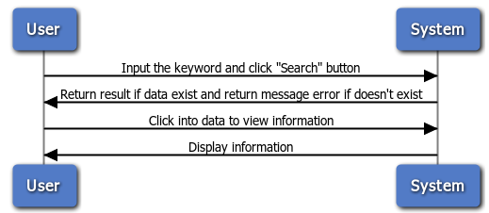
Figure 1-1: Search

Brief description: Everyone can do that search process. It is divided into these steps:
Step 1: User choose the type of search and input the key word into text box.
Step 2: After user click on search button, system will return result match with key word if it exists, and return error message if it does’n exist
Step 3: User can click on result to view information of key word.

Doing test workflow
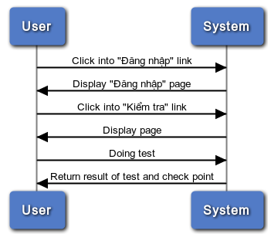
Figure 1-2: Doing test
Brief description: Only member can do test. It divided into these steps:
Step 1: Member click on the “Kiểm tra” link
Step 2: After member click on link, system will display all test on the website
Step 3: User click on any test link and doing test
Step 4: After member successful the test, system will return result of test and check point

Register workflow
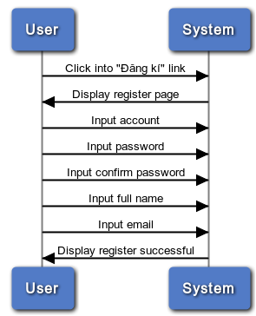
Figure 1-3: Register
Brief description: Only guest can register. It divided into these steps:
Step 1: User (Guest) click on register link
Step 2: System will display register page
Step 3: User insert into all required fields then click on register button. System will check the validation of all inserted fields. If it is invalid, display error message beside wrong fields. If ok, display successful message

Listening conversation
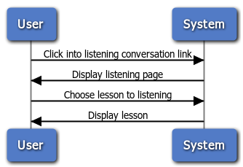
Figure 1-4: Listening conversation
Brief description: Member and guest can train listening. It divided into these steps:
Step 1: User click on listening conversation link
Step 2: System will display listening lesson page
Step 3: User click on any link and listening

Contact admin
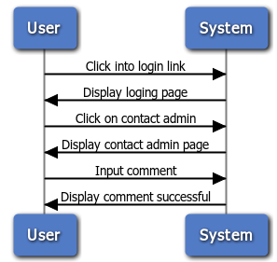
Figure 1-4: Contact admin
Brief description: Only member can contact admin. It is divided into these steps:
Step 1: Member click on contact admin link
Step 2: System will display contact page
Step 3: User input comment
Step 4: System will receive comments and display successful message

Product Features
UJD_VN is an online system, user only connect to internet to use website. System provides these main functions:
  - Manage admin account
System just allows user who logins as Administrator have permission to manage admin account. So that they can add new admin, edit profile, delete admin as they want.
  - Manage member account
System just allows user who logins as Administrator have permission to manage member account. So that they can search member, ban/ unban member, delete member as they want.
  - Manage vocabulary
System just allows user who logins as Administrator have permission to manage vocabulary. So that they can search, add, edit, delete vocabulary as they want.
  - Manage grammar
System just allows user who logins as Administrator have permission to manage grammar. So that they can search, add, edit, delete grammar as they want.
  - Manage reading document
System just allows user who logins as Administrator have permission to manage reading document. So that they can search, add, edit, delete reading document as they want
  - Manage conversation
System just allows user who logins as Administrator have permission to manage conversation. So that they can search, add, edit, delete conversation when they want
  - Manage video
System just allows user who logins as Administrator have permission to manage video. So that they can search, add, edit, delete video as they want
  - Manage listening article
System just allows user who logins as Administrator have permission to manage listening article. So that they can search, add, edit, delete listening article as they want
  - Manage doing test
System just allows user who logins as Administrator have permission to manage doing test. So that they can search, add, edit, delete doing test as they want
  - Manage contributed content
System just allows user who logins as Administrator have permission to manage contributed content. So that they can search, approve, reply, delete
contributed content as they want
  - Manage contributed opinion
System just allows user who logins as Administrator have permission to manage contributed opinion. So that they can search, reply, delete contributed opinion as they want
  - Manage Q&A
System just allows user who logins as Administrator have permission to manage Q&A. So that they can search, reply, delete Q&A as they want
  - Search
Everyone who uses that system can make search with five options: search sentences, search conversation, search grammar, search video, search specialized Japanese.
  - Training listening
Everyone who uses that system can make training listening.
  - Listening conversation
Everyone who uses that system can make listening conversation
  - Reading document
Everyone who uses that system can make reading document such as: Fundamental Japanese document, Intermediate Japanese document, review Japanese document.
  - Doing test
When user registered successfully, user can make doing test then tracking their mark.
  - Contact admin
When user registered successfully, user can make contact admin such as: contribute content, contribute opinion and send any question to admin.
  - Log in/ Log out
When user registered successfully, user can make log in.
  - Edit Profile
When user registered successfully, user can make log in, when logged in, user can edit their profile, change password and track their mark.
  - Forgot password
If user forgot password, user can retake new password.
  - Register
If user do not have account on system, user can use make register.

User Characteristic
There are three main actors that system support:
- Guest: Do not have account on system. In general, they can use almost function of system, exception doing test, contact admin.
- Member: Have account on system, they can use all functions of website. For example: Search, test, train, review …
- Administrator: They can use all functions of normal member and have an Administrator control panel to manage all configuration of system.

Functional Requirements

Common Module
Access right: Guest, Member
That function displays on web and it is used for Guest, Member. They can search by conversation, video, sentences, grammar, specialized japanese.

Account management Module
Access right: Member
That function displays on web and it is used only for Member. Thay can login, logout, edit profile. If they forgot password, they need input right e-mail and login name, and system will sent the passwork to them email.

Practice management Module
Access right: Guest, Member
That function displays on web and it is used for Member and Guest. They can training listening and reading document with materials available on website

Contact admin Module
Access right: Member
That function is used only for member. They have full permissions on contact admin. They can contribute content for database, contribute opinion for website better, send question if member have trouble.

Admin’s account management
Access right: Administrator
This function is only used for Administrator User. Admin can add a new admin, edit information of account or delete an admin to manage system easily and appropriate with system features.

Management Member’s account
Access right: Administrator
This function is only used for Administrator User.
- Search Member: With search function, Admin can look up Member’s account quickly. Admin can search member account by typing member’s id, member’s username, member’s email to look up.
- Ban/Unban Member’s Account: With this function, when a member violate some rules of website, Admin can block these member’s account temporarily, then these account cannot continue to use functions of website. Blocked account will be un-blocked after 3 days. If these account violate rules one more time, Admin can block account permanently.
- Delete Member’s Account: When member’s account is not used a long time, Admin can delete this account from system.

Vocabulary Management
Access right: Administrator
This function is only used for Administrator User.
- Search vocabulary: Admin can search vocabulary by entering hiragana, romaji of vocabulary easily and quickly.
- Add, Edit, Delete Vocabulary: Admin can add a new vocabulary to database, edit information of vocabulary or delete vocabulary from database.

Grammar Management
Access right: Administrator
This function is only used for Administrator User.
- Search Grammar: Admin can search grammar by entering hiragana, romaji of grammar easily and quickly.
- Add, Edit, Delete Grammar: Admin can add a new grammar to database, edit information of grammar or delete grammar from database.

Reading Document Management
Access right: Administrator
This function is only used for Administrator User.
- Search reading document: Admin can search reading document by entering hiragana, romaji of title of article easily and quickly.
- Add, Edit, Delete Reading Document: Admin can add a new article into database to provide reading document for member, edit title, content of article or delete article from database.

Conversation management
Access right: Administrator
This function is only used for Administrator User.
- Search Conversation: Admin can search conversation by entering hiragana and romaji of conversation’s title to manage easier.
- Add, Edit, Delete Conversation: Admin can add a new conversation include information as title, content, Vietnamese meaning. Admin can edit information of a conversation, delete a conversation from database.

Video Management
Access right: Administrator
This function is only used for Administrator User.
- Search Video: Admin can search video by entering hiragana and romaji of video’s title to manage easier.
- Add, Edit, Delete Video: Admin can add a new video’s link and its description to database to provide for member, edit video’s link or delete video’s link.

Listening article management
Access right: Administrator
That function displays only on web version and it is used only for Administrator. They have full permissions on search/add/ edit/ delete Listening Article information as they want.

Doing test management
Access right: Administrator
That function displays only on web version and it is used only for Administrator. They have full permissions on search/add/ edit/ delete Test information as they want.

Contribute content management
Access right: Administrator
That function displays only on web version and it is used only for Administrator. They have full permissions on search/accept/ reply to user/ delete Contributed content as they want.

Contribute opinion management
Access right: Administrator
That function displays only on web version and it is used only for Administrator. They have full permissions on search/ reply to user/ delete Contributed opinion as they want.

Q&A management
Access right: Administrator
That function displays only on web version and it is used only for Administrator. They have full permissions on search/ reply to user / delete Q & A information as they want.

Non – Functional Requirements
- Easy to maintain and upgrade
- Ensure data security capabilities, high performance
- GUI is clear, friendly and easy to use.
- System has clear permission for user and can support for user with multi roles.

SOFTWARE REQUIREMENTS SPECIFICATION

System Purpose
That system is developed to help user easily find out information about Japanese (grammar, vocabulary, etc...) and training skill, doing test.

Scope
The scope of this project contains Requirement Analysis, Design, Coding and Testing (Unit Test, Integration Test, and System Test).

Overall Description

System overview
Nowadays, there are many dictionaries which support Japanese. That can be a website or mobile application. All of them have been created for the purpose of helping users search vocabulary or studying Japanese more easily. But we found some disadvantages which existing in website which support users studying Japanese. So, our project – UJD_VN will include some main functions of existing dictionary website and add some special features such as showing examples by Vietnamese, supporting searching specialized vocabulary or users can contribute idea, good knowledge to make our database become larger. Moreover, we will provide freely website to users. Here, we toward provide website for Vietnamese who want to studying Japanese communication or who want to join Japanese certification exams.
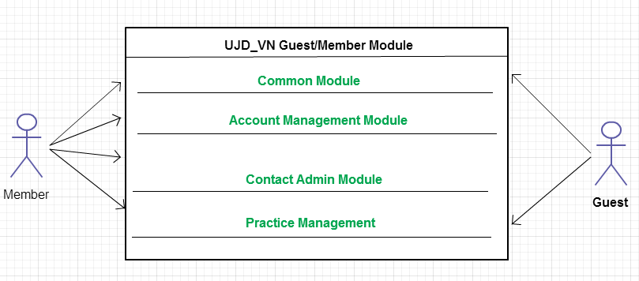
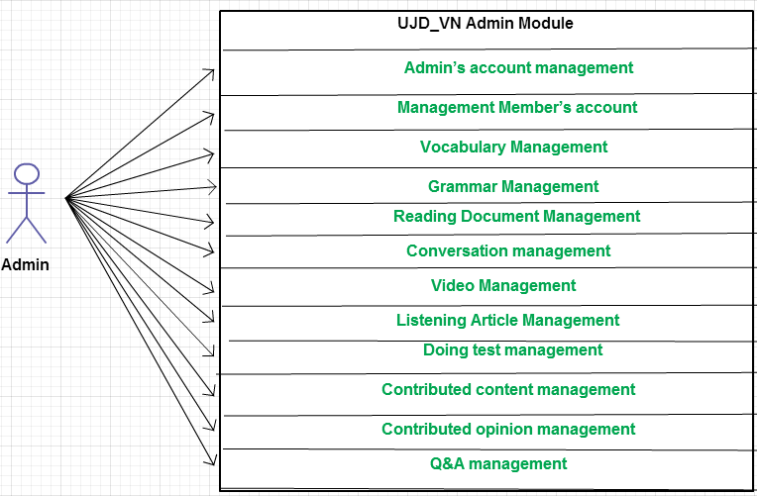

Product Features
Use Case No. | Group of functions | Functions | Glossary
UJD_VN GUEST/MEMBER MODULE
Common Module
 | Search | Search sentences | Tìm kiếm các mẫu câu ví dụ
 | Search | Search conversation | Tìm kiếm các đoạn hội thoại
 | Search | Search grammar | Tìm kiếm ngữ pháp
 | Search | Search video | Tìm kiếm Video tiếng Nhật
 | Search | Search specialized Japanese | Tìm kiếm Tiếng Nhật chuyền ngành
Account Management Module
 | Login | Login by Facebook account | Đăng nhập bằng tài khoản Facebook
 | Login | Login by Google account | Đăng nhập bằng tài khoản Google
 | Login | Login by registered account | Đăng nhập bằng tài khoản tự đăng kí
 |  | Logout | Đăng xuất
 |  | Register | Đăng kí tài khoản cho khách để sử dụng nhiều chức năng hơn của website
 |  | Edit Profile | Chỉnh sửa thông tin cá nhân
 |  | Forgot Password | Quên mật khẩu
Contact Admin Module
 | Contact Admin | Contribute content | Đóng góp database hữu ích cho website
 | Contact Admin | Contribute opinion | Đóng góp ý kiến để phát triển trang web
 | Contact Admin | Send Q & A | Gửi câu hỏi thắc mắc trong quá trình sử dụng Website
Practice Management
 | Doing Test | Test | Làm bài kiểm tra trắc nghiệm
 | Doing Test | Tracking mark | Theo dõi quá trình học tập
 |  | Training Listening | Luyện Nghe trình độ N2,N3,N4
 |  | Listening conversation | Nghe hội thoại
 |  | Reading Document | Đọc tài liệu
UJD_VN ADMIN MODULE
 | Admin’s account management | Add new admin | Thêm mới admin
 | Admin’s account management | Edit profile | Chỉnh sửa thông tin admin
 | Admin’s account management | Delete admin | Xóa thông tin admin
 | Management Member’s account | Search member | Tìm kiếm thành viên
 | Management Member’s account | Ban/Unban Member’s account | Khóa/Mở khóa tài khoản thành viên
 | Management Member’s account | Delete member | Xóa thành viên
 | Vocabulary Management | Search vocabulary | Tìm kiếm từ vựng
 | Vocabulary Management | Add vocabulary | Thêm mới từ vựng
 | Vocabulary Management | Edit vocabulary | Chỉnh sửa thông tin từ vựng
 | Vocabulary Management | Delete vocabulary | Xóa từ vựng
 | Grammar Management | Search grammar | Tìm kiếm ngữ pháp
 | Grammar Management | Add Grammar | Thêm ngữ pháp mới
 | Grammar Management | Edit grammar | Chỉnh sửa ngữ pháp
 | Grammar Management | Delete Grammar | Xóa ngứ pháp
 | Reading Document Management | Search reading document | Tìm kiếm các bài đọc
 | Reading Document Management | Add reading document | Thêm mới các bài đọc
 | Reading Document Management | Edit reading document | Chỉnh sửa thông tin các bài đọc
 | Reading Document Management | Delete reading document | Xóa các bài đọc
 | Conversation management | Search conversation | Tìm kiếm các bài hội thoại
 | Conversation management | Add conversation | Thêm mới bài hội thoại
 | Conversation management | Edit conversation | Chỉnh sửa bài hội thoại
 | Conversation management | Delete conversation | Xóa bài hội thoại
 | Video Management | Search Video | Tìm kiếm Video bằng tiêu đề
 | Video Management | Add Video | Thêm mới video
 | Video Management | Edit Video | Chỉnh sửa nội dung liên quan đến video như tiêu đề.
 | Video Management | Delete Video | Xóa video
 | Listening Article Management | Search listening article | Tìm kiếm các bài nghe
 | Listening Article Management | Add listening article | Thêm mới các bài nghe
 | Listening Article Management | Edit listening article | Chỉnh sửa các bài nghe
 | Listening Article Management | Delete listening article | Xóa các bài nghe
 | Doing test management | Search test | Tìm kiếm bài kiểm tra
 | Doing test management | Add test | Thêm mới bài kiểm tra
 | Doing test management | Edit test | Chỉnh sửa bài kiếm tra
 | Doing test management | Delete test | Xóa bài kiểm tra
Contact’s Content Management
 | Contributed content management | Search contribute content | Tìm kiếm nội dung đóng góp
 | Contributed content management | Approve content | Chấp nhận ý kiến đóng góp
 | Contributed content management | Reply user | Trả lời người dùng
 | Contributed content management | Delete content | Xóa nội dung đóng góp
 | Contributed opinion management | Search contribute opinion | Tìm kiếm ý kiến đóng góp
 | Contributed opinion management | Reply user | Phản hồi lại ý kiến người dùng
 | Contributed opinion management | Delete opinion | Xóa ý kiến đóng góp
 | Q & A Management | Search Q & A | Tìm kiếm Q & A
 | Q & A Management | Reply Q & A | Trả lời Q & A
 | Q & A Management | Delete Q & A | Xóa Q & A

User Characteristics
This website developed towards those who have achieved elementary level Japanese and want to improve intermediate level. The website requires users to have the ability to use a browser with an internet connection. Use can easy use the functions in website, but if they want to use all function, they must be login.

User Documentation
List of document when delivering this application is in the table below:
Name | Description
User Manual | Provide detailed explanation about the system, screens and guide users how to use all features of UJD_VN website.

Assumption
- Receive the guidance and good support of teacher.
- No one of member got sick in the software development process.
- In the development process, no device got fail.
- Every report meets the deadline.
- Team member do not conflict in the work process.

Entity Relation Model

Entity-Relationship Diagram
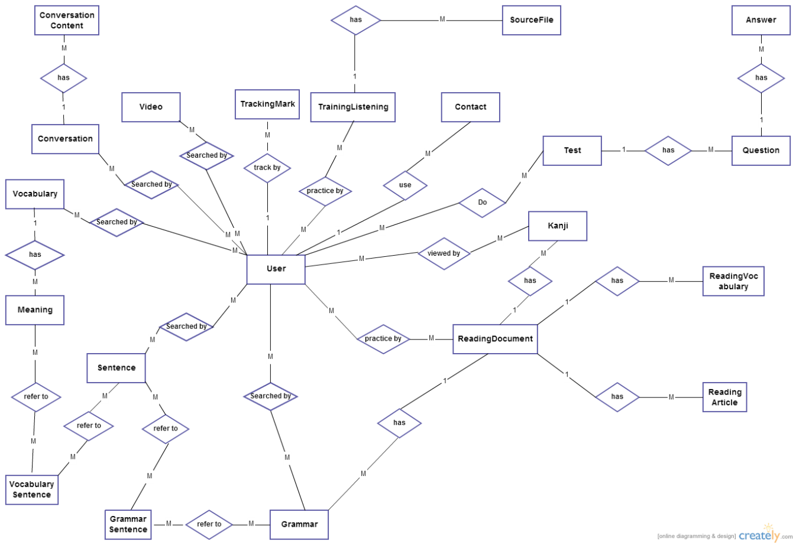

Entity Detail

Vocabulary
No | Field Name | Type | Length | Size | Null | Unique | P/F Key | Default | Description
 | v_id | Int |  |  |  |  | P |  | PRIMARY KEY  This is automatically increase value 1
 | v_hiragana | varchar | 200 |  |  |  |  |  | Vocabulary’s hiragana
 | v_romaji | Varchar | 200 |  |  |  |  |  | Vocabulary’s romaji
 | v_status | int |  |  |  |  |  |  | Vocabulary’s status

Meaning
No | Field Name | Type | Length | Size | Null | Unique | P/F Key | Default | Description
 | m_id | Int |  |  |  |  | P |  | PRIMARY KEY  This is automatically increase value 1
 | v_id | Int |  |  |  |  | FK |  | Foreign key to Vocabulary
 | m_meaningvn | varchar | 500 |  |  |  |  |  | Meaning of vocabulary
 | m_category | Varchar | 10 |  |  |  |  |  | Category of vocabulary
 | m_kanji | Varchar | 10 |  | Y |  |  |  | Kanji of vocabulary
 | m_specialized | varchar | 200 |  |  |  |  |  | Vocabulary’s specialized

Vocabulary sentences
No | Field Name | Type | Length | Size | Null | Unique | P/F Key | Default | Description
 | m_id | Int |  |  |  |  | FK |  | Foreign key to Meaning
 | s_id | Int |  |  |  |  | FK |  | Foreign key to Sentence

Sentence
No | Field Name | Type | Length | Size | Null | Unique | P/F Key | Default | Description
 | s_id | Int |  |  |  |  | P |  | PRIMARY KEY  This is automatically increase value 1
 | s_hiragana | varchar | 1000 |  |  |  |  |  | Sentence’s hiragana
 | s_romaji | Varchar | 1000 |  |  |  |  |  | Sentence’s romaji
 | s_meaning | varchar | 1000 |  |  |  |  |  | Sentence’s meaning
 | s_kanji | varchar | 1000 |  |  |  |  |  | Sentence’s kanji

Grammar
No | Field Name | Type | Length | Size | Null | Unique | P/F Key | Default | Description
 | g_id | Int |  |  |  |  | P |  | PRIMARY KEY  This is automatically increase value 1
 | g_hiragana | varchar | 200 |  |  |  |  |  | Grammar’s hiragana
 | g_romaji | Varchar | 200 |  |  |  |  |  | Grammar’s romaji
 | g_level | Varchar | 10 |  |  |  |  |  | Grammar’s level
 | g_meaning | varchar | 200 |  |  |  |  |  | Grammar’s meaning
 | g_use | varchar | 1000 |  |  |  |  |  | Grammar’s use
 | g_status | int |  |  |  |  |  |  | Grammar’s status
 | reading_id | Varchar | 20 |  |  |  | FK |  | Foreign key to ReadingDocument

Grammar sentences
No | Field Name | Type | Length | Size | Null | Unique | P/F Key | Default | Description
 | m_id | Int |  |  |  |  | FK |  | Foreign key to Meaning
 | s_id | Int |  |  |  |  | FK |  | Foreign key to Sentence

Video
No | Field Name | Type | Length | Size | Null | Unique | P/F Key | Default | Description
 | vi_id | Int |  |  |  |  | P |  | PRIMARY KEY  This is automatically increase value 1
 | vi_title | varchar | 200 |  |  |  |  |  | Video’s title
 | vi_link | varchar | 200 |  |  |  |  |  | Video’s link

Kanji
No | Field Name | Type | Length | Size | Null | Unique | P/F Key | Default | Description
 | k_id | Int |  |  |  |  | P |  | PRIMARY KEY  This is automatically increase value 1
 | k_kanji | varchar | 10 |  |  |  |  |  | Kanji in Japanese
 | k_hanviet | varchar | 50 |  |  |  |  |  | Kanji’s Vietnamese-Han
 | k_onyomi | varchar | 100 |  |  |  |  |  | Kanji’s onyomi
 | k_kunyomi | varchar | 100 |  |  |  |  |  | Kanji’s kunyomi
 | k_meaning | varchar | 200 |  |  |  |  |  | Kanji’s meaning
 | k_level | varchar | 10 |  |  |  |  |  | Kanji’s level
 | k_status | int |  |  |  |  |  |  | Kanji’s status
 | reading_id | Varchar | 20 |  |  |  |  |  | Kanji’s readingdocument

Conversation
No | Field Name | Type | Length | Size | Null | Unique | P/F Key | Default | Description
 | c_id | Varchar | 10 |  |  |  | P |  | PRIMARY KEY  This is automatically increase value 1
 | c_level | varchar | 10 |  |  |  |  |  | Conversation’s level
 | c_title | varchar | 100 |  |  |  |  |  | Conversation’s title
- C_ | c_image | Varchar | 200 |  |  |  |  |  | Conversation’s image

Conversation content
No | Field Name | Type | Length | Size | Null | Unique | P/F Key | Default | Description
 | con_id | Int |  |  |  |  | P |  | PRIMARY KEY  This is automatically increase value 1
 | c_id | Varchar | 10 |  |  |  | FK |  | Foreign key to Sentence
 | con_title | Varchar | 200 |  |  |  |  |  | Content’s title
 | con_hiragana | varchar | 5000 |  |  |  |  |  | Conversation’s hiragana
 | con_romaji | Varchar | 5000 |  |  |  |  |  | Conversation’s romaji
 | con_meaning | varchar | 5000 |  |  |  |  |  | Conversation’s meaning
- c | con_file | Varchar | 200 |  |  |  |  |  | File listen of conversation

User
No | Field Name | Type | Length | Size | Null | Unique | P/F Key | Default | Description
 | u_id | Int |  |  |  |  | P |  | PRIMARY KEY  This is automatically increase value 1
 | u_username | Varchar | 32 |  |  | Y |  |  | Username login
 | u_password | Varchar | 32 |  |  |  |  |  | Store password login of user.  Using md5 algorithm.
 | u_role | int |  |  |  |  |  |  | Admin can assign permission for user
 | u_fullname | Varchar | 100 |  |  |  |  |  | User’s name display
 | u_email | Varchar | 100 |  |  | Y |  |  | User’s email
 | u_registerdate | Date |  |  |  |  |  |  | Date register
 | u_status | Int |  |  |  |  |  |  | Active or deactive

Contact
No | Field Name | Type | Length | Size | Null | Unique | P/F Key | Default | Description
 | contact_id | Int |  |  |  |  | P |  | PRIMARY KEY  This is automatically increase value 1
 | contact_email | varchar | 100 |  |  |  |  |  | Contact’s email
 | contact_content | varchar | 5000 |  |  |  |  |  | Contact’s content
 | contact_type | Varchar | 10 |  |  |  |  |  | Contact’s type
 | contact_status | int |  |  |  |  |  |  | Contact’s status

Training Listening
No | Field Name | Type | Length | Size | Null | Unique | P/F Key | Default | Description
 | lis_id | int |  |  |  |  | P |  | PRIMARY KEY  This is automatically increase value 1
 | lis_title | Varchar | 500 |  |  |  |  |  | Listening’s title
 | lis_level | varchar | 10 |  |  |  |  |  | Listening’s level

Source file
No | Field Name | Type | Length | Size | Null | Unique | P/F Key | Default | Description
 | sourcefile_id | varchar | 100 |  |  |  | P |  | PRIMARY KEY
 | lis_id | Int |  |  |  |  | FK |  | Foreign key to TrainingListening
 | sourcefile_ question | varchar | 5000 |  |  |  |  |  | Listen’s question
 | sourcefile_ script | varchar | 5000 |  |  |  |  |  | Listen’s script
 | sourcefile_ meaning | varchar | 5000 |  |  |  |  |  | Listen’s meaning
 | sourcefile_ answer | Varchar | 100 |  |  |  |  |  | Listen’s answer

Reading document
No | Field Name | Type | Length | Size | Null | Unique | P/F Key | Default | Description
 | reading_id | Varchar | 20 |  |  |  | P |  | PRIMARY KEY
 | reading_title | varchar | 100 |  |  |  |  |  | Reading’s title
 | reading_level | Varchar | 10 |  |  |  |  |  | Reading’s level

Reading vocabulary
No | Field Name | Type | Length | Size | Null | Unique | P/F Key | Default | Description
 | readingvocabulary_id | Int |  |  |  |  | P |  | PRIMARY KEY  This is automatically increase value 1
 | reading_id | Varchar | 20 |  |  |  | FK |  | Foreign key to ReadingDocument
 | readingvocabulary_ hiragana | varchar | 100 |  |  |  |  |  | Vocabulary’s hiragana
 | readingvocabulary_ meaning | varchar | 100 |  |  |  |  |  | Vocabulary’s meaning
 | readingvocabulary_kanji | varchar | 10 |  |  |  |  |  | Vocabulary’s kanji
 | readingvocabulary_type | Varchar | 50 |  |  |  |  |  | Type of readingvocabulary

Reading article
No | Field Name | Type | Length | Size | Null | Unique | P/F Key | Default | Description
 | readingarticle_id | Int |  |  |  |  | P |  | PRIMARY KEY  This is automatically increase value 1
 | reading_id | Varchar | 20 |  |  |  | FK |  | Foreign key to ReadingDocument
 | readingarticle_content | Varchar | 5000 |  |  |  |  |  | Article’s content
 | readingarticle_ question | Varchar | 5000 |  |  |  |  |  | Artcle’s question
 | readingarticle_ answer | Varchar | 5000 |  |  |  |  |  | Article’s answer
 | readingarticle_mening | Varhar | 5000 |  |  |  |  |  | Translate of article

Tracking mark
No | Field Name | Type | Length | Size | Null | Unique | P/F Key | Default | Description
 | tm_id | Int |  |  |  |  | P |  | PRIMARY KEY  This is automatically increase value 1
 | u_id | Int |  |  |  |  | FK |  | Foreign key to User
 | test_id | Varchar | 20 |  |  |  | FK |  | Foreign key to Test
 | tm_mark | Int |  |  |  |  |  |  | Test’s mark
 | tm_date | Datetime |  |  |  |  |  |  | Test’s date

Test
No | Field Name | Type | Length | Size | Null | Unique | P/F Key | Default | Description
 | test_id | Varchar | 20 |  |  |  | P |  | PRIMARY KEY
 | test_ category | varchar | 50 |  |  |  |  |  | Test’s category
 | test_level | Varchar | 10 |  |  |  |  |  | Test’s level
 | test_content | varchar | 5000 |  |  |  |  |  | Test’s content

Question
No | Field Name | Type | Length | Size | Null | Unique | P/F Key | Default | Description
 | question_id | Int |  |  |  |  | P |  | PRIMARY KEY  This is automatically increase value 1
 | test_id | Varchar | 20 |  |  |  | FK |  | Foreign key to Test
 | question_ content | varchar | 200 |  |  |  |  |  | Question’s content

Answer
No | Field Name | Type | Length | Size | Null | Unique | P/F Key | Default | Description
 | answer_id | Int |  |  |  |  | P |  | PRIMARY KEY  This is automatically increase value 1
 | question_id | Int |  |  |  |  | FK |  | Foreign key to Question
 | answer_ content | varchar | 200 |  |  |  |  |  | Answer’s content
 | answer_ correct | int |  |  |  |  |  |  | Answer’s correct

Functional Specification

Common Module

Use Case Diagram
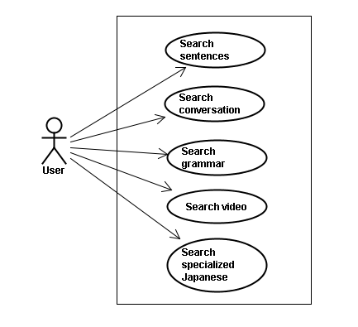

Screen description
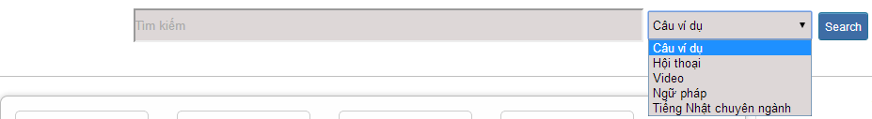
Figure 1: Search
Table 1: Search’s screen description:
No | Field name | Field name in Vietnamese | Type | Require | Mandatory | Length | Description
1 | Searcharea | Tìm kiếm | Text | Text | Y | 255 | User input a new word with length less than 255 characters
2 | SearchOption | Kiểu tìm kiếm | Drop-down list | Click | Y |  | User choose type of search
2 | Search | Search | Button | Click | Y |  | User click on search button

Use Case Specification

UC001: <Common module> Search sentences
UC001 – Search sentences
Use-case No. | <UC001> | Use-case Version |  | <1.0>
Use-case Name | Search sentences
Author | Tuan NN
Date | 09/06/2014 | Priority | <High >
Actor:
Guest, Member, Administrator
Summary:
When Guest, Member, Administrator want to search by sentences in database successfully if it is existed
Triggers
Click on search area , input sentences in the text area, choose type of search and then click “Search” button
Preconditions:
- Website is available
- User have to input data in search area
Post Conditions:
Display detail information of sentences
Main Success Scenario:
Step | User | System
1 | Enter website link on web browser | Display Home page screen
2 | Input data in search area and choose “Câu ví dụ” type then click button Search | Display “sentences information” screen that contains the information of chosen sentences with these elements:  - Serial number  - Name of sentences by hiragana  - Name of sentences by romaji  - Meaning of sentences

Alternative Scenario:
At Step | User | System
2 | Input data in search area and choose “Câu ví dụ” type then click on another link | Switch to selected page

Exceptions:
At Step | User | System
2 | Fill data that they want to find (that do not exist in database) into these fields then click “Search” button | Return Error message to in
orm that sentences cannot be found

UC002: <Common module> Search conversation
UC002 – Search conversation
Use-case No. | <UC002> | Use-case Version |  | <1.0>
Use-case Name | Search conversation
Author | Tuan NN
Date | 09/06/2014 | Priority | <High >
Actor:
Guest, Member, Administrator
Summary:
When Guest, Member, Administrator want to search by conversation in database successfully if it is existed
Triggers
Click on search area , input conversation in the text area, choose type of search and then click “Search” button
Preconditions:
- Website is available
- User have to input data in search area
Post Conditions:
Display detail information of conversation
Main Success Scenario:
Step | User | System
1 | Enter website link on web browser | Display Home page screen
2 | Input data in search area and choose “Hội thoại” type then click button Search | Display “conversation information” screen that contains the information of chosen conversation with these elements:  - Serial number  - Name of conversation by hiragana  - Name of conversation by romaji  - Meaning of conversation

Alternative Scenario:
At Step | User | System
2 | Input data in search area and choose “Hội thoại” type then click on another link | Switch to selected page

Exceptions:
At Step | User | System
2 | Fill data that they want to find (that do not exist in database) into these fields then click “Search” button | Return Error message to inform that conversation cannot be found

UC003: <Common module> Search grammar
UC003 – Search grammar
Use-case No. | <UC003> | Use-case Version |  | <1.0>
Use-case Name | Search grammar
Author | Tuan NN
Date | 09/06/2014 | Priority | <High >
Actor:
Guest, Member, Administrator
Summary:
When Guest, Member, Administrator want to search by grammar in database successfully if it is existed
Triggers
Click on search area , input grammar in the text area, choose type of search and then click “Search” button
Preconditions:
- Website is available
- User have to input data in search area
Post Conditions:
Display detail information of grammar
Main Success Scenario:
Step | User | System
1 | Enter website link on web browser | Display Home page screen
2 | Input data in search area and choose “Ngữ pháp” type then click button Search | Display “grammar information” screen that contains the information of chosen grammar with these elements:  - Serial number  - Name of grammar by hiragana  - Name of grammar by romaji  - Meaning of grammar

Alternative Scenario:
At Step | User | System
2 | Input data in search area and choose “Ngữ pháp” type then click on another link | Switch to selected page

Exceptions:
At Step | User | System
2 | Fill data that they want to find (that do not exist in database) into these fields then click “Search” button | Return Error message to inform that grammar cannot be found

UC004: <Common module> Search video
UC004 – Search video
Use-case No. | <UC004> | Use-case Version |  | <1.0>
Use-case Name | Search video
Author | Tuan NN
Date | 09/06/2014 | Priority | <High >
Actor:
Guest, Member, Administrator
Summary:
When Guest, Member, Administrator want to search by video in database successfully if it is existed
Triggers
Click on search area , input video in the text area, choose type of search and then click “Search” button
Preconditions:
- Website is available
- User have to input data in search area
Post Conditions:
Display detail information of video
Main Success Scenario:
Step | User | System
1 | Enter website link on web browser | Display Home page screen
2 | Input data in search area and choose “Video” type then click button Search | Display “video information” screen that contains the information of chosen video with these elements:  - Serial number  - Name of video by hiragana  - Name of video by romaji  - Meaning of video

Alternative Scenario:
At Step | User | System
2 | Input data in search area and choose “Video” type then click on another link | Switch to selected page

Exceptions:
At Step | User | System
2 | Fill data that they want to find (that do not exist in database) into these fields then click “Search” button | Return Error message to inform that video cannot be found

UC005: <Common module> Search specialized Japanese
UC005 – Search specialized Japanese
Use-case No. | <UC005> | Use-case Version |  | <1.0>
Use-case Name | Search specialized Japanese
Author | Tuan NN
Date | 09/06/2014 | Priority | <High >
Actor:
Guest, Member, Administrator
Summary:
When Guest, Member, Administrator want to search by specialized Japanese in database successfully if it is existed
Triggers
Click on search area , input specialized Japanese in the text area, choose type of search and then click “Search” button
Preconditions:
- Website is available
- User have to input data in search area
Post Conditions:
Display detail information of video
Main Success Scenario:
Step | User | System
1 | Enter website link on web browser | Display Home page screen
2 | Input data in search area and choose “Tiếng Nhật chuyên ngành” type then click button Search | Display “specialized Japanese information” screen that contains the information of chosen specialized Japanese with these elements:  - Serial number  - Name of specialized Japanese by hiragana  - Name of specialized Japanese by romaji  - Meaning of specialized Japanese

Alternative Scenario:
At Step | User | System
2 | Input data in search area and choose “Tiếng Nhật chuyên ngành” type then click on another link | Switch to selected page

Exceptions:
At Step | User | System
2 | Fill data that they want to find (that do not exist in database) into these fields then click “Search” button | Return Error message to inform that specialized Japanese cannot be found

Account management Module

Use Case Diagram
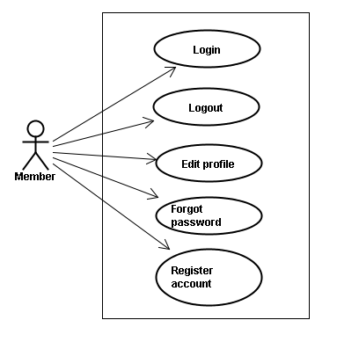

Use Case Specification

UC006: <Account management module> Login
Figure 2.1: Login
Table 2.1: Login’s screen description:
No | Field name | Field name in Vietnamese | Type | Require | Mandatory | Max-Length | Description
1 | Username | Tên đăng nhập | Text | Text | Y | 32 | User input username with length less than 32 character
2 | Password | Mật khẩu | Password | Text | Y | 32 | User input their password with length less than 32 characters
3 | Login | Đăng nhập | Button | Click | Y |  | User click on Login button

UC006 – Login
Use-case No. | <UC006> | Use-case Version |  | <1.0>
Use-case Name | Login
Author | Tuan NN
Date | 09/06/2014 | Priority | <High >
Actor:
Member, Administrator
Summary:
When Member, Administrator want to login by Facebook/Google/Register account to use more functions in website
Triggers
User choose the login method, input data and click on login button
Preconditions:
- Website is available
- Account Facebook/Google/Register must be exist and correctly
Post Conditions:
Login successfully and redirect user to previous page.
Main Success Scenario:
Step | User | System
1 | Enter website link on web browser | Display Homepage screen
2 | Choose login method ( login by Facebook/Google/register account), input account and password and then click “Đăng nhập” button | Validate information and log user into system.

Alternative Scenario:
At Step | User | System
2 | Input data in username and password area then click on another link | Switch to selected page

Exceptions:
At Step | User | System
3 | Fill incorrect or missing information “Tên đăng nhập”/ “Mật khẩu” field | Return Error message beside “Tên đăng nhập”/ “Mật khẩu” field.

UC007: <Account management module> Logout
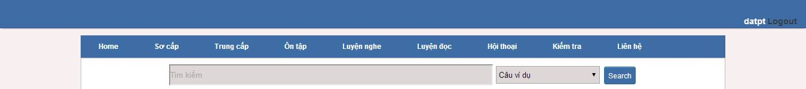
Figure 2.2: Logout
Table 2.2: Logout’s screen description:
No | Field name | Type | Require | Mandatory | Max-Length | Description
1 | Logout | Button | Click | Y |  | User click on Logout button

UC007 – Logout
Use-case No. | <UC007> | Use-case Version |  | <1.0>
Use-case Name | Logout
Author | Tuan NN
Date | 09/06/2014 | Priority | <High >
Actor:
Member, Admin
Summary:
When Member, Admin want to logout their account
Triggers
Click on logout button
Preconditions:
- Website is available
- Member, Admin must be login
Post Conditions:
Redirect user to previous page.
Main Success Scenario:
Step | User | System
1 | Click on logout button | Redirect to homepage

UC008: <Account management Module>: Register account
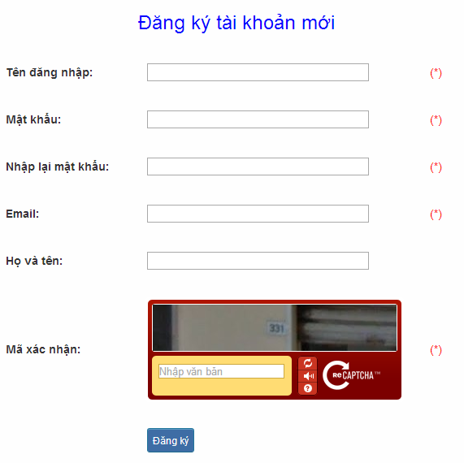
Figure 2.3: Register
Table 2.3: Register’s screen description:
No | Field name | Field name in Vietnamese | Type | Require | Mandatory | Max-Length | Description
1 | Username | Tên đăng nhập | Text | Text | Y | 32 | User input username with length less than 32 characters
2 | Password | Mật khẩu | Password | Text | Y | 32 | User input their password with length less than 32 characters
3 | Re-password | Nhập lại mật khẩu | Password | Text | Y | 32 | User re-input password with length less than 32 characters
4 | Name | Họ và tên | Text | Text | Y | 50 | User input their name with length less than 50 characters
5 | Email | Email | Text | Text | Y | 100 | User input email with length less than 32 characters
6 | Capcha | Mã xác nhận | Text | Text | Y | 100 | User input the verification code
7 | Register | Đăng ký | Button | Click | Y |  | User click Register button

UC008 – Register account
Use-case No. | <UC008> | Use-case Version |  | <1.0>
Use-case Name | Register
Author | Tuan NN
Date | 09/06/2014 | Priority | <High >
Actor:
Guest
Summary:
Visitor can create new account to use more function as a register user
Triggers
Click on register link on the website
Preconditions:
- Website is available
Post Conditions:
Create account for guest
Main Success Scenario:
Step | User | System
1 | Enter website link on web browser | Display Homepage screen
2 | Click on register link | Display register form
3 | Enter necessary and mandatory information and click "Đăng kí" button. | Display message to register successfully and redirect to homepage

Alternative Scenario:
At Step | User | System
3 | Enter necessary and mandatory information and click another link | Switch to selected page

Exceptions:
At Step | User | System
3 | Missing “Tên đăng nhập” field and click “Đăng kí” button | Display error message beside “Tên đăng nhập” field.
3 | Enter incorrect information or missing “Mật khẩu” field and click “Đăng kí” button | Display error message beside “Mật khẩu” field.
3 | Missing “Họ và tên” field and click “Đăng kí” button | Display error message beside “Họ và tên” field.
3 | Missing “Email” field and click “Đăng kí” button | Display error message
3eside “Email” field. | Enter incorrect information or missing “Mã xác nhận” field and click “Đăng kí” button | Display error message beside “Mã xác nhận” field.

UC009: <Account management Module>: Edit profile
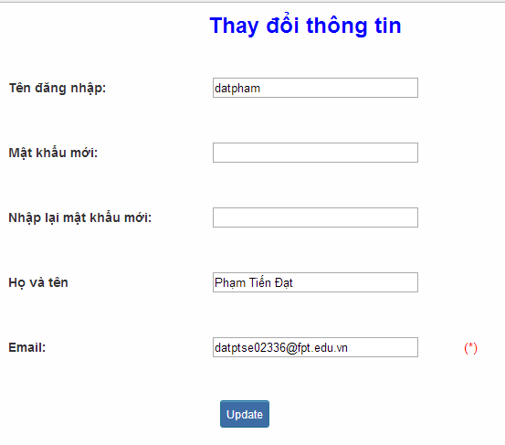
Figure 2.4: Edit profile
Table 2.4: Edit profile’s screen description:
No | Field name | Field name in Vietnamese | Type | Require | Mandatory | Max-Length | Description
1 | Name | Họ và tên | Text | Text | Y | 32 | User input their name with length less than 32 characters
2 | Old-Password | Mật khẩu cũ | Password | Text | Y | 32 | User input their old password with length less than 32 characters
3 | New-password | Mật khẩu mới | Password | Text | Y | 32 | User input new password with length less than 32 characters
4 | Re-password | Nhập lại mật khẩu mới | Password | Text | Y | 32 | User re-input password with length less than 32 characters
5 | Email | Email | Text | Text | Y | 100 | User input email to with length less than 100 characters
6 | Edit | Thay đổi thông tin | Button | Click | Y |  | User click on Edit button

UC009 – Edit profile
Use-case No. | <UC009> | Use-case Version |  | <1.0>
Use-case Name | Edit profile
Author | Tuan NN
Date | 09/06/2014 | Priority | <High >
Actor:
Member
Summary:
When member want to change their profile
Triggers
Login the website and click on the edit profile link
Preconditions:
- Website is available
- Member login the website
Post Conditions:
Edit profile successful and redirect user to edited profile page
Main Success Scenario:
Step | User | System
1 | Enter website link on web browser | Display Homepage screen
2 | Enter necessary and mandatory information and click "Login” | Redirect to previous page and logged user into system.
3 | Click on "Trang cá nhân" link. | Display “Trang cá nhân” page
4 | User changes profile and click “Lưu” button | Update new profile

Alternative Scenario:
 | t Step  User | System
4 | Enter necessary and mandatory information and click another link | Switch to selected page

Exceptions:
At Step | User | System
4 | Enter new password that incorrect form or missing information and click “Lưu” button | Displa
4 er  o  message | Enter new email that incorrect form or missing information and click “Lưu” button | Display error message

UC010: <Account management Module>: Forgot password
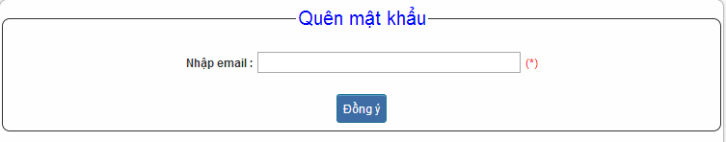
Figure 2.5: Forgot password
Table 2.5: Forgot password’s screen description:
No | Field name | Field name in Vietnamese | Type | Require | Mandatory | Max-Length | Description
1 | Email | Email | Text | Text | Y | 32 | User input email with length less than 100 characters
2 | Send | Đồng ý | Button | Click | Y |  | Click to receive password

UC010 – Forgot password
Use-case No. | <UC010> | Use-case Version |  | <1.0>
Use-case Name | Forgot password
Author | Tuan NN
Date | 09/06/2014 | Priority | <High >
Actor:
Member, Admin
Summary:
When Member, Admin forgot their password to login the system, this function will receiving their password to email
Triggers
Click on forgot password link on the website
Preconditions:
- Website is available
Post Conditions:
Receiving their password to their email
Main Success Scenario:
Step | User | System
1 | Enter website link on web browser | Display Homepage screen
2 | Click on “Quên mật khẩu | ink.  Display “Quên mật khẩu” page
3 | Enter necessary and mandatory information in the “Quên mật khẩu” form and click "Gửi yêu cầu" button. | System will send the password into your em
i
Alternative Scenario:
At Step | User | Syste
3 | Enter necessary and mandatory information and click another link | Switch to selected page

Exceptions:
At Step | User | System
3 | Enter email incorrect with email that use to register account | Display error message and request to re-enter email

.

Contact admin Module

Use case diagram
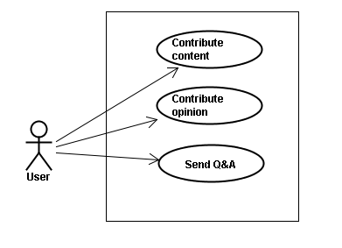

Use Case Specification

UC011 <Contact admin Module>: Contribute content
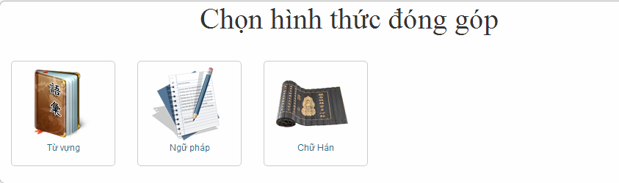
Figure 3.1: Contribute content
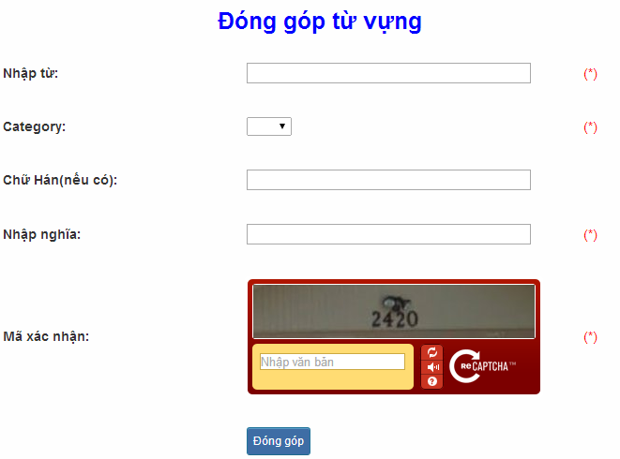
Figure 3.1.1: Contribute vocabulary
Table 3.1: Contribute vocabulary’s screen description:
No |  | Field name | Field name in Vietnamese |  | Type | Require | Mandatory |  | Max-Length |  | Description
1 |  | Vocabulary | Từ |  | Text | Text | Y |  | 200 |  | User input vocabulary with length less than 200 characters
2 |  | Category | Loại từ |  | Drop-down list | Click | Y |  |  |  | User choose type of category
3 |  | Kanji | Chữ Hán |  | Text | Text | Y |  | 10 |  | User input kanji of vocabulary (if exist) with length less than 10 characters
4 |  | Mean | Nhập nghĩa |  | Text | Text | Y |  | 500 |  | User input mean of vocabulary with length less than 500 characters
5 |  | Capcha | Mã xác nhận |  | Text | Text | Y |  |  |  | User input the verification code
6 |  | Contribute | Đóng góp |  | Button | Click | Y |  |  |  | User click on contribute button
 | UC011 – Contribute content
 | Use-case No. |  |  | <UC011> |  |  |  | Use-case Version |  |  |  | <1.0>
 | Use-case Name |  |  | Contribute content
 | Author |  |  | Tuan NN
 | Date |  |  | 09/06/2014 |  |  |  | Priority |  | <High >
Actor:
Member
Summary:
When Member want to contribute content for website
Triggers
User enter website link and click on “Liên hệ” link on the website
Preconditions:
- Website is available
- User must be login to the website
Post Conditions:
Receive opinions and redirect user to contact page
Main Success Scenario:
Step | User | System
1 | Enter website link on web browser | Display Homepage screen
2 | Enter necessary and mandatory information and click "Login” | Redirect to previous page and logged user into system.
3 | Click on “Liên hệ”->”Đóng góp database” section | Display “Đóng góp database” page
4 | Enter information that member want to contribute for the website then click “Đóng góp” | System will receive contributions

Alternative Scenario:
At Step | User
4ystem | Enter necessary and mandatory information and click another link | Switch to selected page

Exceptions:
At Step | User | System
4 | Missing “Nhập từ” field and click “Đóng góp” button | Display error message beside “Nhập từ” field.
4 | Missing “Loại từ” field and click “Đóng góp” button | Display error message beside “Loại từ” field.
4 | Missing “Nhập nghĩa” field and click “Đóng góp” button | Display error message beside “Nhập nghĩa” field.
4 | Enter incorrect information or missing “Mã xác nhận” field and click “Đóng góp” button | Display error message beside “Mã xác nhận” field.

UC012 <Contact admin Module>: Contribute opinion
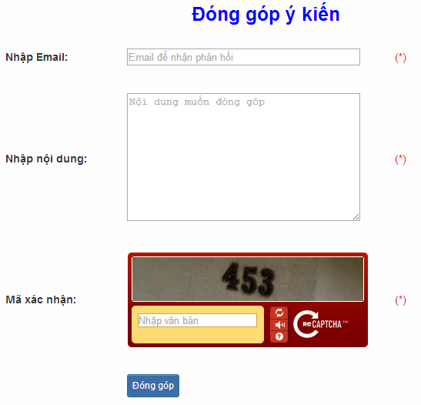
Figure 3.2: Contribute opinion
Table 3.2 : Contribute opinion’s screen description:
No | Field name | Field name in Vietnamese | Type | Require | Mandatory | Max-Length | Description
1 | Email | Email | Text | Text | Y | 100 | User input email with length less than100 characters
2 | Content | Nhập nội dung | Text | Text | Y | 1000 | User input content with length less than1000 characters
3 | Capcha | Mã xác nhận | Text | Text | Y |  | User input the verification code
4 | Contribute | Đóng góp | Button | Click | Y |  | User click on contribute button

UC012 – Contribute opinion
Use-case No. | <UC012> | Use-case Version |  | <1.0>
Use-case Name | Contribute opinion
Author | Tuan NN
Date | 09/06/2014 | Priority | <High >
Actor:
Member
Summary:
When Member want to contribute opinion for website
Triggers
User enter website link and click on “Liên hệ” link on the website
Preconditions:
- Website is available
- User must be login to the website
Post Conditions:
Receive opinions and redirect user to contact page
Main Success Scenario:
Step | Use | System
1 | Enter website link on web | browser  Display Homepage screen
2 | Enter necessary and mandatory information and click "Login” | Redirect to previous page and logged user into system.
3 | Click on “Liên hệ”->”Đóng góp ý kiến” section | Display “Đóng góp ý kiến” page
4 | Enter information that member want to contribute for the website then click “Đóng góp” | System will receive contributions
Alternative Scenario:
At Step | User | System
4 | Enter necessary and mandatory information and click another link | Switch to selected page

Exceptions:
At Step | User | System
4 | Missing “Nhập email” field and click “Đóng góp” button | Display error message beside “Nhập email” field.
4 | Missing “Nhập nội dung:” field and click “Đóng góp” button | Display error message beside “Nhập nội dung:” field.
4 | Enter incorrect information or missing “Mã xác nhận” field and click “Đóng góp” button | Display error message beside “Mã xác nhận” field.

UC013 <Contact admin Module>: Send Q&A
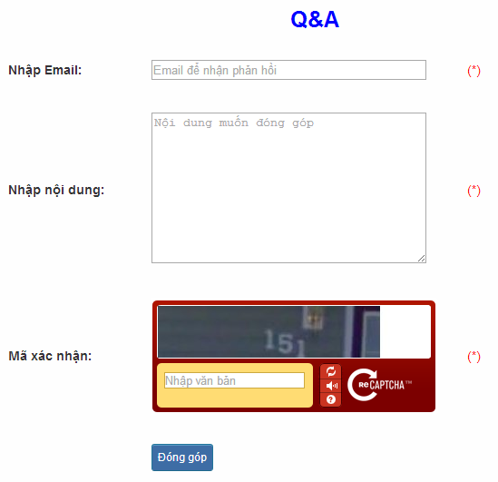
Figure 3.3: Send Q&A
Table 3.3: Send Q&A’s screen description:
No | Field name | Field name in Vietnamese | Type | Require | Mandatory | Max-Length | Description
1 | QA | Q&A | Text | Text | Y | 1000 | User input Q&A with length less than 1000 characters
2 | Email | Email | Text | Text | Y | 100 | User input email with length less than 100 characters
3 | Capcha | Mã xác nhận | Text | Text | Y |  | User input the verification code
4 | Contribute | Đóng góp | Button | Click | Y |  | User click on contribute button

UC013 – Send Q&A
Use-case No. | <UC013> | Use-case Version |  | <1.0>
Use-case Name | Send Q&A
Author | Tuan NN
Date | 09/06/2014 | Priority | <High >
Actor:
Member
Summary:
When Member have the question, they can create Q&A
Triggers
Click on “Liên hệ” link on the website
Preconditions:
- Website is available
- User must be login to the website
Post Conditions:
Add new Q&A into the website
Main Success Scenario:
Step | User | System
1 | Enter website link on web browser | Display Homepage screen
2 | Enter necessary and mandatory information and click "Login” | Redirect to previous page and logged user into system.
3 | Click on “Q&A” section | Display “Q&A” page
4 | Enter necessary and mandatory information in the “Q&A” form and click "Gửi" button. | Display this Q&A in the “Q&A”section.

Alternative Scenario:
At Step | User | System
4 | Enter necessary and mandatory information and click another link | Switch to selected page

Exceptions:
At Step | User | System
4 | Missing “Nhập email” field and click “Đóng góp” button | Display error message beside “Nhập email” field.
4 | Missing “Q&A” field and click “Đóng góp” button | Display error message beside “Q&A” field.
4 | Enter incorrect information or missing “Mã xác nhận” field and click “Đóng góp” button | Display error message beside “Mã xác nhận” field.

Practice management Module

Use case diagram
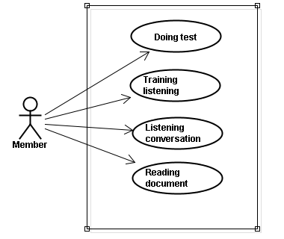

Use case specification

UC014 <Practice management Module>: Doing test
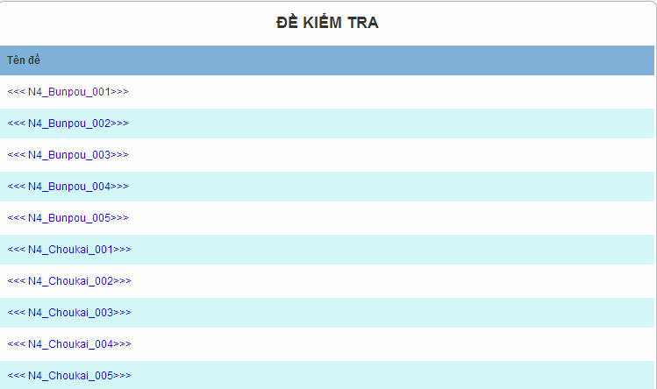
Figure 4.1: Doing test
Screen description: This is doing test screen ( N4 test screen). At here, user can doing test in the website, they click on one of test link
UC014 – Doing test
Use-case No. | <UC014> | Use-case Version |  | <1.0>
Use-case Name | Doing test
Author | Tuan NN
Date | 09/06/2014 | Priority | <High >
Actor:
Member
Summary:
This function will help users do the online quiz and check the answers, grading and evaluation capabilities
Triggers
User going to website, login and then click on “Kiểm tra” link on the website
Preconditions:
- Website is available
- User must be login to the website
Post Conditions:
Doing test in the website
Main Success Scenario:
Step | User | System
1 | Enter website link on web browser | Display Homepage screen
2 | Enter necessary and mandatory information and click "Login” | Redirect to previous page and logged user into system.
3 | Click on “Kiểm tra” section | Display “Kiểm tra” page
4 | Choose one of items that you want to doing test | Display that item’s page
5 | Doing test | Check the answer, grading after finish

Alternative Scenario:
At Step | User | System
5 | While doing test, click another link | Switch to selected page

UC015 <Practice management Module>: Trainng listening
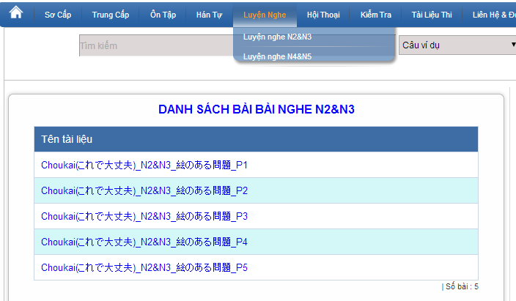
Figure 4.2: Training listening
Screen description:
No | Field name | Type | Require | Mandatory | Max-Length | Description
1 | Choukai_P1 | Hyperlink | Click | N |  | Display information of listening
2 | Choukai_P2 | Hyperlink | Click | N |  | Display information of listening
3 | Choukai_P3 | Hyperlink | Click | N |  | Display information of listening
4 | Choukai_P4 | Hyperlink | Click | N |  | Display information of listening
5 | Choukai_P5 | Hyperlink | Click | N |  | Display information of listening

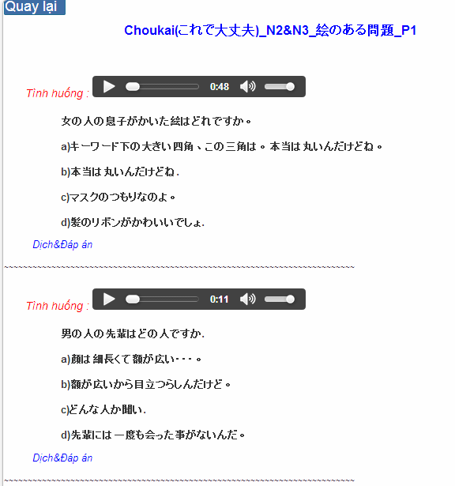
Figure 4.2.1: Training listening content
Table 4.2.1 : Training listening content’s screen description:
No | Field name | Field name in Vietnamese | Type | Require | Mandatory | Description
1 | Audio | Audio | Audio | Click | Y | User click play button
2 | Translation and Answer | Dịch và đáp án | Link | Click | Y | User click to display translation and answer

UC015 – Training listening
Use-case No. | <UC015> | Use-case Version |  | <1.0>
Use-case Name | Training listening
Author | Tuan NN
Date | 09/06/2014 | Priority | <High >
Actor:
Guest, Member
Summary:
This function provide users some the listening of level N2, N3, N4 to help users training listening skill
Triggers
User going to website and click on “Luyện nghe” link on the website
Preconditions:
- Website is available
Post Conditions:
Training listening in the website
Main Success Scenario:
Step | User | System
1 | Enter website link on web browser | Display Homepage screen
2 | Click on “Luyện nghe” section | Display “Luyện nghe” page

Alternative Scenario:
At St | p  User | System
4 | While listening, click another link | Switch to selected page

UC016 <Practice management Module>: Listening conversation
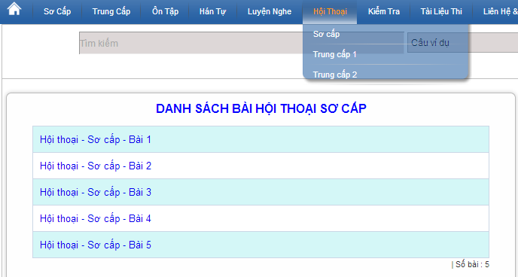
Figure 4.3: Listening conversation
Screen description:
No | Field name | Type | Require | Mandatory | Description
1 | SC_P1 | Hyperlink | Click | N | Display information of conversation
2 | SC_P2 | Hyperlink | Click | N | Display information of conversation
3 | SC_P3 | Hyperlink | Click | N | Display information of conversation
4 | SC_P4 | Hyperlink | Click | N | Display information of conversation
5 | SC_P5 | Hyperlink | Click | N | Display information of conversation

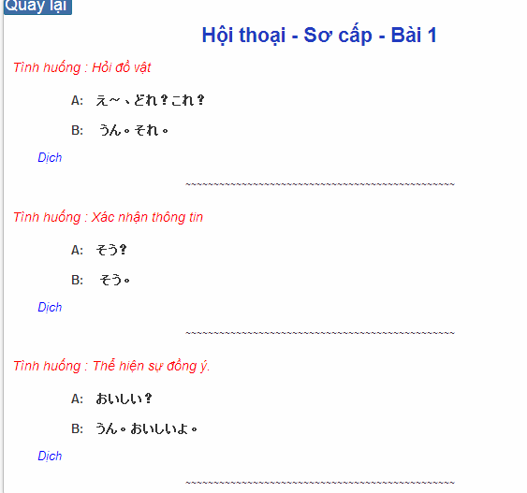
Figure 4.3.1: Conversation content
Table 4.2.1 : Training listening content’s screen description:
No | Field name | Field name in Vietnamese | Type | Require | Mandatory | Description
1 | Translation | Dịch | Link | Click | Y | User click to display translation

UC016 – Listening conversation
Use-case No. | <UC016> | Use-case Version |  | <1.0>
Use-case Name | Listening conversation
Author | Tuan NN
Date | 09/06/2014 | Priority | <High >
Actor:
Guest, Member
Summary:
This function provide users some the conversation in everyday life and common situations (eg: restaurants, shopping, in hospital ..)
Triggers
Click on “Hội thoại” link on the website
Preconditions:
- Website is available
Post Conditions:
Listening conversation in the website
Main Success Scenario:
Step | User | System
1 | Enter websi | e link  n web browser  Display Homepage screen
2 | Click on “Hội thoại” section | Display “Hội thoại” page

Alternative Scenario:
At Step | User | System
4 | While listening, click another link | Switch to selected page

UC017 < Practice management Module>: Reading document
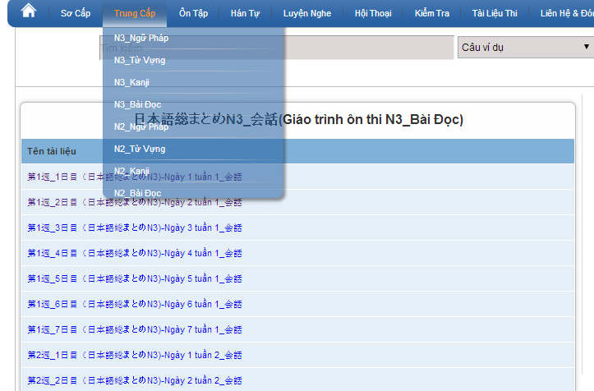
Figure 4.4: Reading document
Screen description: This is reading screen. At here, user can read document in the website, there are some lesson to reading in the reading document.
UC017 – Reading document
Use-case No. | <UC017> | Use-case Version |  | <1.0>
Use-case Name | Reading document
Author | Tuan NN
Date | 09/06/2014 | Priority | <High >
Actor:
Guest, Member
Summary:
This function provide users some document : elementary, intermediate and review.
Triggers
Click on “N3/N2 Bài đọc” link on the website
Preconditions:
- Website is available
Post Conditions:
Reading document in the website
Main Success Scenario:
Step | User | System
1 | Enter website link on web browser | Display Homepage screen
2 | Click on “Bài đọc” section | Display “Bài đọc” page

Alternative Scenario:
At Step | User | System
4 | While reading, click another link | Switch to selected page

Admin’s account management

Use case diagram
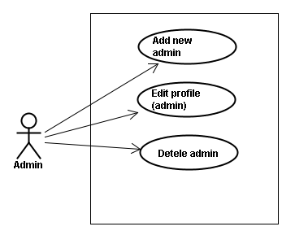

Use case specifications

UC018 <Admin’s account management>: Add new admin
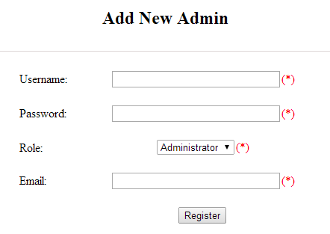
Figure 5.1: Add new admin
Table 5.1: Add new admin’s screen description:
No | Field name | Type | Require | Mandatory | Max-Length | Description
1 | Username | Text | Text | Y | 32 | Admin input username of admin’s account with length less than 32 characters
2 | Password | Text | Text | Y | 100 | Admin input password of admin’s account with length less than 32 characters
3 | Roll | Drop-down list | Choose | Y |  | Admin choose the roll of account
4 | Email | Text | Text | Y | 100 | Admin input email of admin’s account with length less than 100 characters
5 | Register | Button | Click | Y |  | Admin add new admin

UC018 – Add new admin
Use-case No. | <UC018> | Use-case Version |  | <1.0>
Use-case Name | Add new admin
Author | Tuan NN
Date | 09/06/2014 | Priority | <High >
Actor:
Admin
Summary:
Administrator can add new admin
Triggers
Admin login the website and click on add new admin link on the website
Preconditions:
- Website is available
- Admin login to the website
Post Conditions:
New admin be added successfully
Main Success Scenario:
Step | User | System
1 | Enter website link on web browser | Display Homepage screen
2 | Enter necessary and mandatory information and click "Login” | Redirect to previous page and logged admin into system.
3 | Click on add new admin button | Display “Add New Admin” screen that contains these elements:  - Username  - Password  - Roll  - Email
4 | Fill test information into all necessary or mandatory fields and click “Add” button | The system validates the input data and then save new test data into database

Alternative Scenario:
At Step | User | System
4 | Input data in account area then click on another link | Switch to selected page

Exceptions:
At Step | User | System
4 | Fill incorrect account name | Return Error message

UC019 <Admin’s account management>: Edit profile (admin)
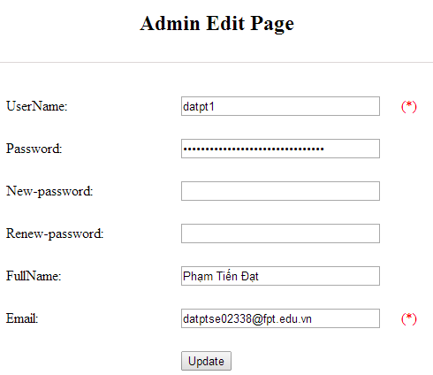
Figure 5.2: Edit profile admin
Table 5.2: Edit profile admin’s screen description:
No | Field name | Type | Require | Mandatory | Max-Length | Description
1 | Username | Text | Text | N |  | Username of admin’s account
2 | New-password | Text | Text | Y | 32 | Admin input new password with length less than 32 characters
3 | Renew-password | Text | Text | Y | 32 | Admin re-input new password with length less than 32 characters
4 | Fullname | Text | Text | Y | 100 | Admin input full name with length less than 100 characters
5 | Email | Text | Text | Y | 100 | Admin input email with length less than 100 characters
6 | Update | Button | Click | Y |  | User click to edit vocabulary

UC019 – Edit profile(admin)
Use-case No. | <UC019> | Use-case Version |  | <1.0>
Use-case Name | Edit profile admin
Author | Tuan NN
Date | 09/06/2014 | Priority | <High >
Actor:
Administrator
Summary:
Administrator want to change their profile
Triggers
Administrator login the website and click on the edit profile link
Preconditions:
- Website is available
- Administrator login the website
Post Conditions:
Edit admin profile and redirect to edited profile page
Main Success Scenario:
Step | User | System
1 | Enter website link on web browser | Display Homepage screen
2 | Enter necessary and mandatory information and click "Login” | Redirect to previous page and logged admin into system.
3 | Click on edit profile tab | Display “Edit profile” screen that contains these elements:  - Username  - Password  - New-Password  - Renew-Password  - Full name  - Email
4 | Fill test information into all necessary or mandatory fields and click “Add” button | The system validates the input data and then save new test data into database
Alternative Scenario:
At Step | User | System
4 | Enter necessary and mandatory information and click another link | Switch to selected page

Exceptions:
At Step | User | System
4 | Enter new password that incorrect form or missing information and click “Lưu” button | Display error message
4 | Enter new email that incorrect form or missing information and click “Lưu” button | Display error message

UC020 <Admin’s account management>: Delete admin
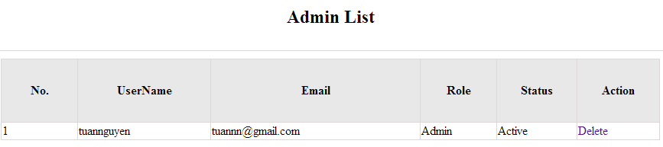
Figure 5.3: Delete admin
UC020 – Delete admin
Use-case No. | <UC020> | Use-case Version |  | <1.0>
Use-case Name | Delete admin
Author | Tuan NN
Date | 09/06/2014 | Priority | <High >
Actor:
Administrator
Summary:
Administrators can remove administrator rights of other admin
Triggers
Login the website and click on the delete admin link
Preconditions:
- Website is available
- Admin login the website
Post Conditions:
Admin will be remove administrator rights
Main Success Scenario:
Step | User | System
1 | Enter website link on web browser | Display Homepage screen
2 | Enter necessary and mandatory information and click "Login” | Redirect to previous page and logged admin into system.
3 | Click on delete admin link. | Display delete admin page
4 | Enter the account that you want to remove administrator rights | Remove administrator rights of account and display message to remove successfully

Alternative Scenario:
At Step | User | System
4 | Input data in account area then click on another link | Switch to selected page

Exceptions:
At Step | User | System
4 | Fill incorrect account name | Return Error message

Management Member’s account

Use case diagram
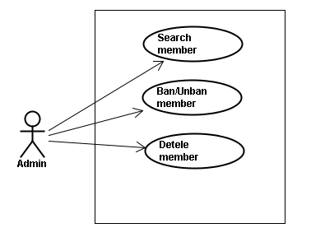

Screen description
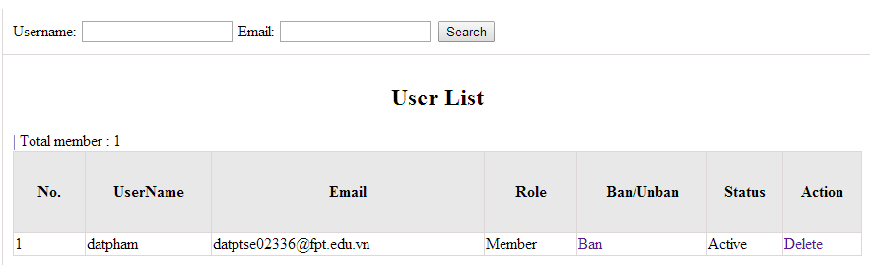
Figure 6: Management Member
Table 6: Management member’s screen description:
No | Field name | Type | Require | Mandatory | Max-Length | Description
1 | Username | Text | Text | Y | 32 | Admin input username to search member by username
2 | Email | Text | Text | Y | 100 | Admin input email to search member by email
3 | Ban/Unban | Button | Click | N |  | Admin click ban/unban member
4 | Delete | Button | Click | N |  | Admin click delete member

Use case specifications

UC021 <Management Member’s account>: Search member
Search member screen:
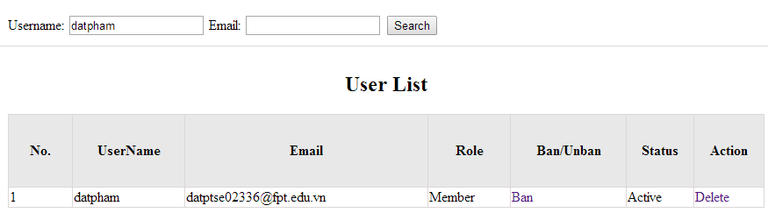
UC021 – Search member
Use-case No. | <UC021> | Use-case Version |  | <1.0>
Use-case Name | Search member
Author | Tuan NN
Date | 09/06/2014 | Priority | <High >
Actor:
Admin
Summary:
When admin want to search by member’s account in database successfully if it is existed
Triggers
Admin login the website and click on search member , input member’s account in the right text box then click “Search” button
Preconditions:
- Website is available
- Admin must be login
- Input data must be correctly
Post Conditions:
Display detail information of member
Main Success Scenario:
Step | User | System
1 | Enter website link on web browser | Display Homepage screen
2 | Enter necessary and mandatory information and click "Login” | Redirect to previous page and logged admin into system.
3 | Click on "Search member" button and input member’s account or email | Display “member information” screen that contains the information :  - No  - User Name  - Email  - Roll  - Ban/Unban  - Status  - Delete

Alternative Scenario:
At Step | User | System
3 | Fill information of the member that they want to find into these fields then click on another link | Switch to selected page

Exceptions:
At Step | User | System
3 | Fill information of the member that they want to find (that do not exist in database) into these fields then click “Search” button | Return Error message to inform that member cannot be found

UC022 <Management Member’s account>: Ban/Unban member
UC022 – Search member
Use-case No. | <UC022> | Use-case Version |  | <1.0>
Use-case Name | Ban/Unban member
Author | Tuan NN
Date | 09/06/2014 | Priority | <High >
Actor:
Admin
Summary:
When admin can ban user who violated rule of website and unban member
Triggers
Admin login the website and click on member’s account and then click “Ban/Unban” button
Preconditions:
- Website is available
- Admin must be login
- Input data must be correctly
Post Conditions:
Member’s account will be ban/unban by administrator
Main Success Scenario:
Step | User | System
1 | Enter website link on web browser | Display Homepage screen
2 | Enter necessary and mandatory information and click "Login” | Redirect to previous page and logged admin into system.
3 | Click on "Search member" button and input member’s account or email | Display “member information” screen that contains the information
4 | Click “Ban/Unban” link | Ban/Unban member
Alternative Scenario:
At Step | User | System
3 | Fill information of the member that they want to find into these fields then click on another link | Switch to selected page

Exceptions:
At Step | User | System
3 | Fill information of the member that they want to find (that do not exist in database) into these fields then click “Search” button | Return Error message to inform that member cannot be found

UC023 <Management Member’s account>: Delete member
UC023 – Delete member
Use-case No. | <UC023> | Use-case Version |  | <1.0>
Use-case Name | Delete member
Author | Tuan NN
Date | 09/06/2014 | Priority | <High >
Actor:
Admin
Summary:
Administrators can delete member who violated rule of website
Triggers
Admin login the website and click on the delete member link
Preconditions:
- Website is available
- Admin must be login
- Input data must be correctly
Post Conditions:
Member’s account will be removed from system
Main Success Scenario:
Step | User | System
1 | Enter website link on web browser | Display Homepage screen
2 | Enter necessary and mandatory information and click "Login” | Redirect to previous page and logged admin into system.
3 | Click on "Search member" button and input member’s account or email | Display information of member
4 | Click on delete link corresponding with member want to delete | Remove member from list

Alternative Scenario:
At Step | User | System
3 | Fill information of the member that they want to find into these fields then click on another link | Switch to selected page

Exceptions:
At Step | User | System
3 | Fill information of the member that they want to find (that do not exist in database) into these fields then click “Search” button | Return Error message to inform that member cannot be found

Vocabulary Management

Use case diagram
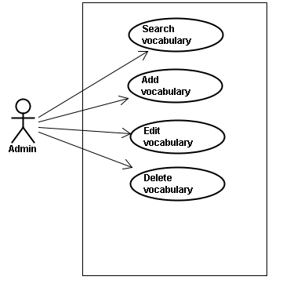

Screen description
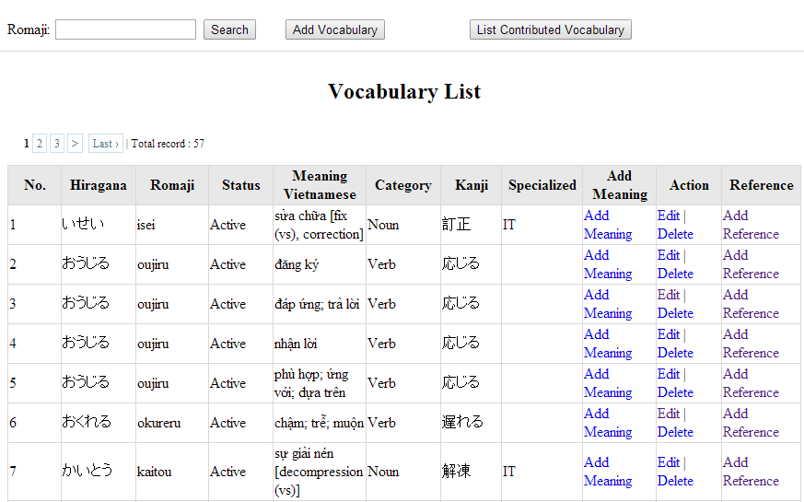
Figure 7: Vocabulary management
Table 7.1: Vocabulary management’s screen description:
No | Field name | Type | Require | Mandatory | Max-Length | Description
1 | Romaji | Text | Text | Y | 100 | Admin input romaji with length less than 100 character
2 | Search | Button | Click | Y |  | Admin click to search vocabulary
2 | Add-new | Button | Click | N |  | Admin add new vocabulary into database
3 | Add meaning | Button | Click | Y |  | Admin add meaning of vocabulary
4 | Edit | Button | Click | N |  | Admin click edit vocabulary
5 | Delete | Button | Click | N |  | Admin click delete vocabulary
6 | Add-reference | Button | Click | N |  | Admin add reference of vocabulary if reference exist
7 | List-contribute | Button | Click | N |  | Admin click to view list contribute

Use case specifications

UC024 <Vocabulary Management>: Search vocabulary
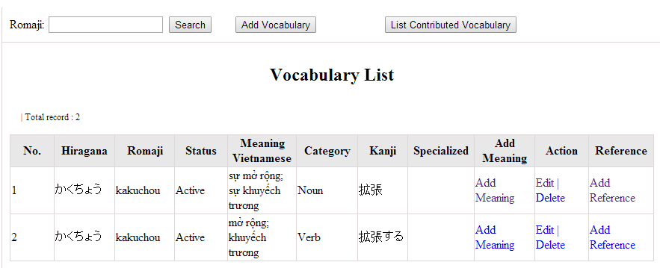
Figure 7.1: Search vocabulary

UC0024 – Specification
Use-case No. | <UC0024> | Use-case Version |  | <1.0>
Use-case Name | Search vocabulary
Author | TuanNN
Date | 09/06/2014 | Priority | <High >
Actor:
Admin
Summary:
When Administrator want to search a vocabulary on database
Goal:
Administrator can search vocabulary in database successfully if it is existed
Triggers
Admin login the website and click on “Vocabulary management” tab, input vocabulary in the right text box then click “Search” button
Preconditions:
- Website is available
- Admin must be login
- Input data must be correctly
Post Conditions:
Display detail information of vocabulary
Main Success Scenario:
Step | User | System
1 | Enter website link on web browser | Display Homepage screen
2 | Enter necessary and mandatory information and click "Login” | Redirect to previous page and logged admin into system.
4 | Click on “vocabulary management” tab | Displays criteria search screen
5 | Fill information of the vocabulary that they want to find into these fields then click “Search” button | Displays search result as a table with these elements:  - No  - Hiragana  - Romaji  - Status  - Meaning  - Category  - Kanji  - Specialized  - Add meaning  - Edit  - Delete  - Add reference

Alternative Scenario:
At Step | User | System
5 | Fill information of the vocabulary that they want to find into these fields then click on another link | Switch to selected page

Exceptions:
At Step | User | System
5 | Fill information of the vocabulary that they want to find (that do not exited in database) into these fields then click “Search” button | Return Error message to inform that vocabulary structure cannot be found

UC025 <Vocabulary Management>: Add vocabulary
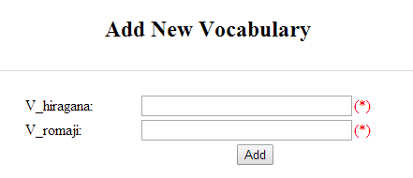
Figure 7.2: Add new vocabulary
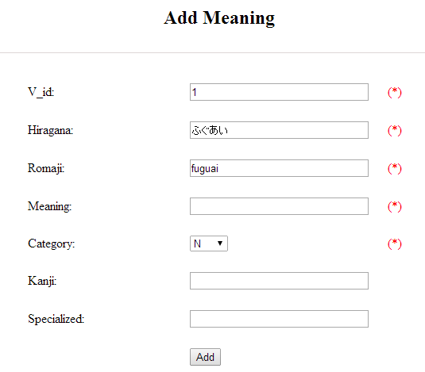
Figure 7.2.1: Add vocabulary meaning
Table 7.2: Add new vocabulary & meaning’s screen description:
No | Field name | Type | Require | Mandatory | Max-Length | Description
1 | Hiragana | Text | Text | Y | 200 | Admin input vocabulary by hiragana with length less than 200 characters
2 | Romaji | Text | Text | Y | 200 | Admin input vocabulary by romaji with length less than 200 characters
3 | Meaning | Text | Text | Y | 500 | Admin input mean of vocabulary with length less than 500 characters
4 | Category | Drop-down list | Click | Y |  | Admin choose category of vocabulary
5 | Kanji | Text | Text | Y | 10 | Admin input vocabulary by kanji with length less than 10 characters
6 | Specialized | Text | Text | Y | 200 | Admin input specialized of vocabulary with leng less than 200 characters
7 | Add | Button | Click | Y |  | Admin add new vocabulary

UC0025 - Specification
Use-case No. | <UC0025> | Use-case Version |  | <1.0>
Use-case Name | Add vocabulary
Author | Tuan NN
Date | 09/06/2014 | Priority | <High >
Actor:
Admin
Summary:
When Administrator want to add a vocabulary into database. They have to insert all necessary data of vocabulary into “Add new vocabulary” screen
Goal:
Administrator can add new vocabulary information in database successfully
Triggers
User must click on “Vocabulary management/ Add new” tab and input all necessary information of vocabulary into the right fields then click on “Add new” button
Preconditions:
- Website is available
- User have logged into system as an admin.
- All mandatory fields have been filled
- All input data must be valid and have not existed in system
Post Conditions:
New vocabulary has been saved into system database successfully
Main Success Scenario:
Step | User | System
1 | Enter website link on web browser | Display Homepage screen
2 | Enter necessary and mandatory information and click "Login” | Redirect to previous page and logged admin into system.
3 | Click on “Vocabulary management/Add new” tab | Display “Add New Vocabulary” screen that contains these elements:  - Hiragana  - Romaji
4 | Fill information into all necessary or mandatory fields and click “Add” button | The system validates the input data and then save new vocabulary data into database
5 | Click on “Vocabulary management/Add meaning” tab | Display “Add meaning” screen that contains these elements:  - Hiragana  - Romaji  - Meaning  - Category  - Kanji  - Specialized
6 | Fill information into all necessary or mandatory fields and click “Add” button | The system validates the input data and then save new vocabulary data into database
7 | Click on “Vocabulary management/Add reference” tab | Display “Add meaning” screen that contains these elements:  - Vocabulary  - Meaning  - Sentence
8 | Choose sentence and click “Add” button | The system validates the input data and then save new vocabulary data into database

Alternative Scenario:
At Step | User | System
4 | Click on another link | Do not save new vocabulary data into database then redirect to selected page
6 | Click on another link | Do not save meaning data into database then redirect to selected page
8 | Click on another link | Do not save reference into database then redirect to selected page

Exceptions:
At Step | User | System
4 | Do not fill full information into fields then click “Add” button | Return Error message beside empty field and ask if user want to add with empty field.
6 | Do not fill full information into fields then click “Add” button | Return Error message beside empty field and ask if user want to add with empty field.
8 | Do not fill full information into fields then click “Add” button | Return Error message beside empty field and ask if user want to add with empty field.

UC026 <Vocabulary Management>: Edit vocabulary
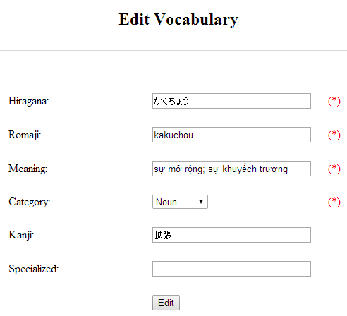
Figure 7.3: Edit vocabulary
Table 7.3: Edit vocabulary’s screen description:
No | Field name | Type | Require | Mandatory | Max-Length | Description
1 | Hiragana | Text | Text | Y | 200 | Admin input vocabulary by hiragana with length less than 200 characters
2 | Romaji | Text | Text | Y | 200 | Admin input vocabulary by romaji with length less than 200 characters
3 | Meaning | Text | Text | Y | 500 | Admin input mean of vocabulary with length less than 500 characters
4 | Category | Drop-down list | Click | Y |  | Admin choose category of vocabulary
5 | Kanji | Text | Text | Y | 10 | Admin input vocabulary by kanji with length less than 10 characters
6 | Specialized | Text | Text | Y | 200 | Admin input specialized of vocabulary with leng less than 200 characters
7 | Edit | Button | Click | Y |  | Admin edit vocabulary

UC0026 - Specification
Use-case No. | <UC0026> | Use-case Version |  | <1.0>
Use-case Name | Edit vocabulary
Author | TuanNN
Date | 09/06/2014 | Priority | <High >
Actor:
Admin
Summary:
When Administrator want to edit a vocabulary on database which has some new meanings or errors
Goal:
Administrator can edit vocabulary information in database successfully
Triggers
User must click on “Vocabulary management” then search for the vocabulary. User click on “Edit” link on corresponding vocabulary. They edit necessary information in the right fields then click on “Edit” button.
Preconditions:
- Website is available
- User have logged into system as an admin.
- All mandatory fields have been filled
- All input data must be valid and have not existed in system
Post Conditions:
Changed information of vocabulary has been saved into system database successfully
Main Success Scenario:
Step | User | System
1 | Enter website link on web browser | Display Homepage screen
2 | Enter necessary and mandatory information and click "Login” | Redirect to previous page and logged admin into system.
3 | Click on “Vocabulary management ” then search for the vocabulary that they want to edit | Displays search result as a table
4 | Click on “Edit” link | Display “Edit Vocabulary” screen that contains the information of chosen vocabulary with these elements:  - Hiragana  - Romaji  - Meaning  - Category  - Kanji  - Specialized
5 | Edit vocabulary information and click “Edit” button | The system validates the input data and then save data into database

Alternative Scenario:
At Step | User | System
4 | Edit vocabulary information then click to another link | Do not save edited data then redirect to selected page

Exceptions:
At Step | User | System
4 | Edit vocabulary information to be similar to another existed grammar and click “Edit” button | The system validates the input data and return Error message and do not save edited data into database
Reference:
UC0024 - Search Vocabulary

UC027 <Vocabulary Management>: Delete vocabulary

UC0027 - Specification
Use-case No. | <UC0027> | Use-case Version |  | <1.0>
Use-case Name | Delete vocabulary
Author | TuanNN
Date | 09/06/2014 | Priority | <High >
Actor:
Admin
Summary:
When Administrator want to delete a vocabulary on database
Goal:
Administrator can delete selected vocabulary in database successfully
Triggers
User must click on “Vocabulary management” then search for the vocabulary. User click on “Delete” link on corresponding vocabulary.
Preconditions:
- Website is available
- User have logged into system as an admin.
- All mandatory fields have been filled
- All input data must be valid and have existed in system
Post Conditions:
Vocabulary has been deleted from system database successfully
Main Success Scenario:
Step | User | System
1 | Enter website link on web browser | Display Homepage screen
2 | Enter necessary and mandatory information and click "Login” | Redirect to previous page and logged admin into system.
3 | Click on “Vocabulary management ” then search for the vocabulary that they want to delete | Displays search result as a table
4 | Click on “Delete” link beside that vocabulary row | Remove that vocabulary from list
Exceptions:
At Step | User | System
Reference:
UC0024 - Search vocabulary

Grammar Management

Use case diagram
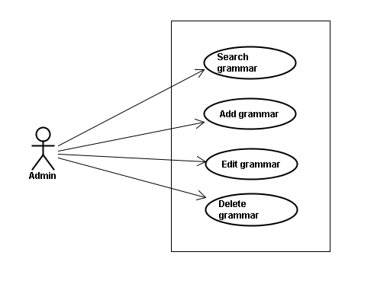

Screen description
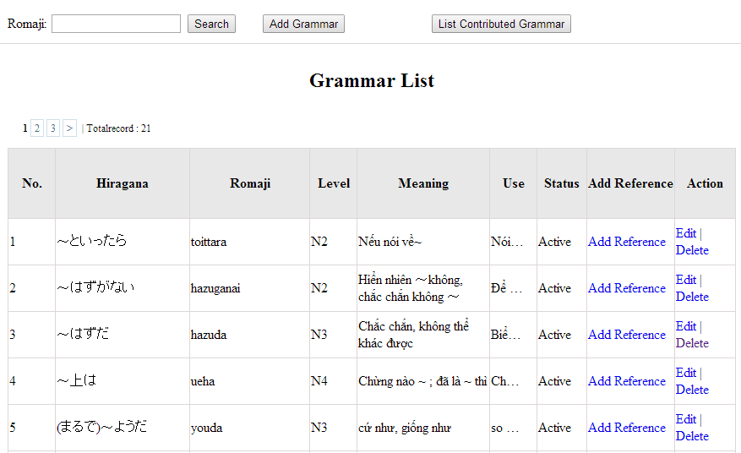
Figrure 8: Grammar management
Table 8.1: Grammar management’s screen description:
No | Field name | Type | Require | Mandatory | Max-Length | Description
1 | Romaji | Text | Text | Y | 100 | Admin input romaji with length less than 100 character
2 | Add-new | Button | Click | N |  | Admin add new grammar into database
3 | Edit | Button | Click | N |  | Admin click edit grammar
4 | Delete | Button | Click | N |  | Admin click delete grammar
5 | Add-reference | Button | Click | N |  | Admin add reference of grammar
6 | List-contribute | Button | Click | N |  | Admin click to view list contribute

Use case specifications

UC0028: <Admin> Search grammar
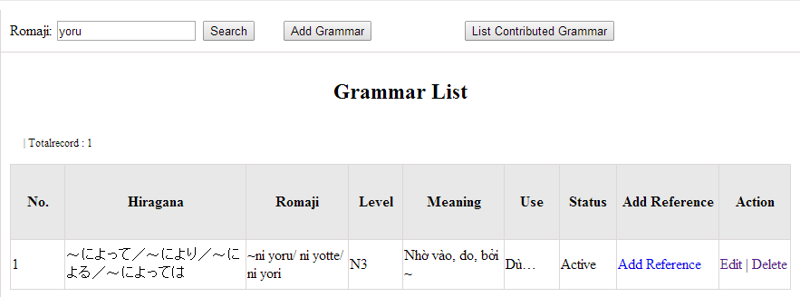
Figure 8.1: Search grammar
UC0028 - Specification
Use-case No. | <UC0028> | Use-case Version |  | <1.0>
Use-case Name | Search grammar
Author | Minh PT
Date | 09/06/2014 | Priority | <High >
Actor:
Admin
Summary:
When Administrator wants to search a grammatical structure in database, Admin can input a grammatical structure by “romaji” letter then click button “Search”. If that grammatical structure is existed, system will return meaning.
Triggers
Click on “Grammar management” tab, input grammatical structure in the right text box then click “Search” button
Preconditions:
- Website is available
- User has to login as Administrator
- User has to input data in search area
Post Conditions:
Display detail information of grammatical structure
Main Success Scenario:
Step | User | System
1 | Have logged into system as an admin
2 | Click on “Grammar management” tab | Displays criteria search screen
3 | Fill information of the grammatical structure that they want to find into these fields then click “Search” button | Displays search result as a table with these elements:  - No  - Hiragana  - Romaji  - Level  - Meaning  - Use  - Status  - Add reference  - Edit  - Delete

Alternative Scenario:
At Step | User | System
3 | Fill information of the grammatical structure that they want to find into these fields then click on another link | Switch to selected page

Exceptions:
At Step | User | System
3 | Fill information of the grammatical structure that they want to find (that do not exited in database) into these fields then click “Search” button | Return Error message to inform that grammatical structure cannot be found

UC0029: <Admin> Add grammar
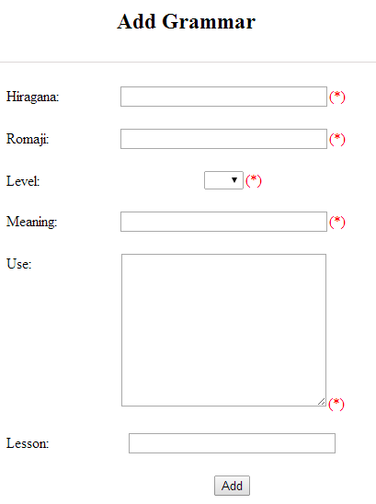
Figure 8.2: Add grammar
Table 8.2: Add grammar’s screen description:
No | Field name | Type | Require | Mandatory | Max-Length | Description
1 | Hiragana | Text | Text | Y | 200 | Admin input grammar by hiragana with length less than 200 characters
2 | Romaji | Text | Text | Y | 200 | Admin input grammar by romaji with length less than 200 characters
3 | Meaning | Text | Text | Y | 200 | Admin input mean of grammar with length less than 200 characters
4 | Use | Text | Text | Y | 1000 | Admin input use of grammar with length less than 1000 characters
5 | Level | Drop-down list | Choose | Y |  | Admin choose level of grammar
6 | Lesson | Text | Text | Y | 20 | Admin input lesson
7 | Add | Button | Click | Y |  | Admin add new grammar

UC0029 - Specification
Use-case No. | <UC0029> | Use-case Version |  | <1.0>
Use-case Name | Add grammar
Author | Minh PT
Date | 09/06/2014 | Priority | <High >
Actor:
Admin
Summary:
When Administrator wants to add a grammar into database. They have to insert all necessary data of grammar into “Add Grammar” screen then click “Add” button
Triggers
User must click on “Grammar management/ Add New” and input all necessary information of grammar into the right fields then click on “Add” button
Preconditions:
- Website is available
- User has to login as Administrator
- All mandatory fields have been filled
- All input data must be valid and have not existed in system
Post Conditions:
New grammatical structure has been saved into system database successfully
Main Success Scenario:
Step | User | System
1 | Have logged into system as an admin
2 | Click on “Grammar management/Add New” | Display “Add Grammar” screen that contains these elements:  - Hiragana  - Romaji  - Level  - Meaning  - Use  - Lesson
3 | Fill grammar information into all necessary or mandatory fields and click “Add” button | The system validates the input data and then save new grammar data into database
4 | Click on “Grammar management/Add Reference” | Display “Add Grammar” screen that contains these elements:  - Grammar  - Meaning  - Reference
5 | Fill grammar information into all necessary or mandatory fields and click “Add” button | The system validates the input data and then save new grammar data into database

Alternative Scenario:
At Step | User | System
3 | Click on another link | Do not save new grammar data into database then redirect to selected page
5 | Click on another link | Do not save new reference data into database then redirect to selected page

Exceptions:
At Step | User | System
3 | Do not fill full information into fields then click “Add” button | Return Error message and request user input data into all fields
5 | Do not fill full information into fields then click “Add” button | Return Error message and request user input data into all fields

UC0030: <Admin> Edit grammar
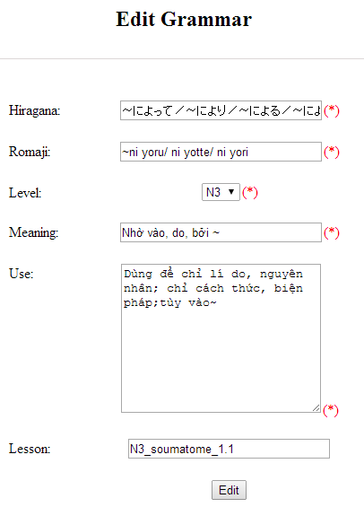
Figure 8.3: Edit grammar
Table 8.3: Edit vocabulary’s screen description:
No | Field name | Type | Require | Mandatory | Max-Length | Description
1 | Hiragana | Text | Text | Y | 200 | Admin input grammar by hiragana with length less than 200 characters
2 | Romaji | Text | Text | Y | 200 | Admin input grammar by romaji with length less than 200 characters
3 | Meaning | Text | Text | Y | 200 | Admin input mean of grammar with length less than 200 characters
4 | Use | Text | Text | Y | 1000 | Admin input use of grammar with length less than 1000 characters
5 | Level | Drop-down list | Choose | Y |  | Admin choose level of grammar
6 | Lesson | Text | Text | Y | 20 | Admin input lesson
7 | Add | Button | Click | Y |  | Admin add new grammar

UC0030 - Specification
Use-case No. | <UC0030> | Use-case Version |  | <1.0>
Use-case Name | Edit grammar
Author | Minh PT
Date | 09/06/2014 | Priority | <High >
Actor:
Admin
Summary:
When Administrator want to edit a grammatical structure in database which has some new meanings or errors. Admin will search that grammar then click “Edit” link. When edit finished, new meaning of that grammar will be updated.
Triggers
User must click on “Grammar management” then search for the grammatical structure. User click on “Edit” link corresponding with grammar which want to edit. User edit necessary information of grammar in the right fields then click on “Edit” button.
Preconditions:
- Website is available
- User has to login as Administrator
- All mandatory fields have been filled
- All input data must be valid and have not existed in system
Post Conditions:
Changed information of grammar has been saved into system database successfully
Main Success Scenario:
Step | User | System
1 | Have logged into system as an admin
2 | Click on “Management grammar ” then search for the grammatical structure that they want to edit | Displays search result as a table
3 | Click on “Edit” link corresponding with grammar | Display “Edit Grammar” screen that contains the information of chosen grammar with these elements:  - Hiragana  - Romaji  - Level  - Meaning  - Use  - Lesson
4 | Edit grammar information and click “Edit” button | The system validates the input data and then save data into database

Alternative Scenario:
At Step | User | System
4 | Edit grammar information then click to another link | Do not save edited data then redirect to selected page

Exceptions:
At Step | User | System
4 | Edit grammar information to be similar to another existed grammar and click “Edit” button | The system validates the input data and return Error message and do not save edited data into database
Reference:
UC0028 - <Admin> Search Grammar

UC0031: <Admin> Delete grammar
UC0031 - Specification
Use-case No. | <UC0031> | Use-case Version |  | <1.0>
Use-case Name | Delete grammar
Author | Minh PT
Date | 09/06/2014 | Priority | <High >
Actor:
Admin
Summary:
When Administrator want to delete a grammar in database. Admin will search that grammar then click “Delete” link. When deleted finished, that grammar no longer exist in database.
Triggers
User must click on “Grammar management” then search for the grammatical structure. User click on “Delete” link corresponding with grammar which want to delete.
Preconditions:
- Website is available
- User has to login as Administrator
Post Conditions:
Grammar has been deleted from system database successfully
Main Success Scenario:
Step | User | System
1 | Have logged into system as an admin
2 | Click on “Grammar management ” then search for the grammar that they want to delete | Displays search result as a table
3 | Click on “Delete” link corresponding with grammar | Remove that grammar in database
Reference: UC0028 - <Admin> Search grammar

Reading Document Management

Use case diagram
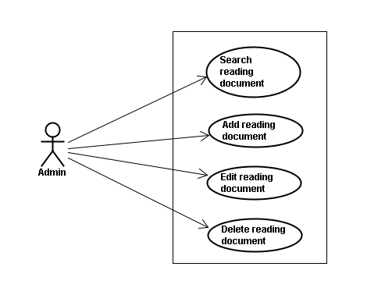

Screen description
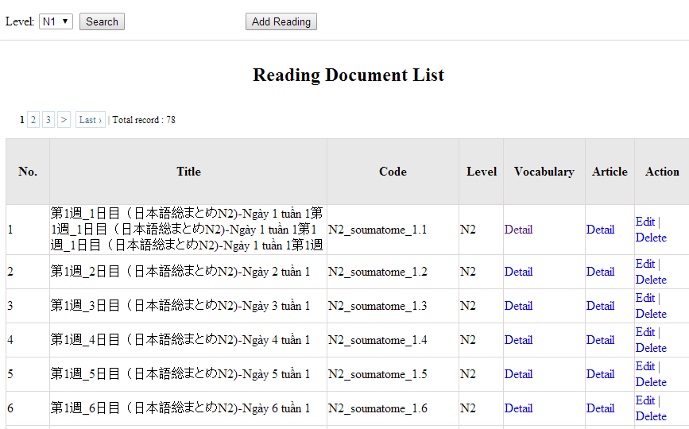
Figure 9: Reading document
Table 9: Reading document’s screen description:
No | Field name | Type | Require | Mandatory | Max-Length | Description
1 | Level | Drop-down list | Click | Y |  | Admin choose the level
2 | Search | Button | Click | Y |  | Admin click to search
3 | Add-new | Button | Click | N |  | Admin add new into database
4 | Edit | Button | Click | N |  | Admin click edit grammar
5 | Delete | Button | Click | N |  | Admin click delete grammar
6 | Detail-Vocab | Hyperlink | Click | N |  | Details of vocabulary
7 | Detail-Article | Hyperlink | Click | N |  | Details of article

Use case specifications

UC0032: <Admin> Search reading document
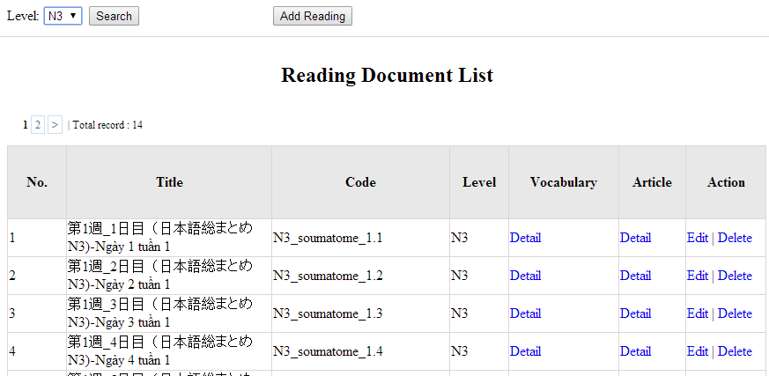
Figure 9.1 : Search reading document
UC0032 - Specification
Use-case No. | <UC0032> | Use-case Version |  | <1.0>
Use-case Name | Search document
Author | Minh PT
Date | 09/06/2014 | Priority | <High >
Actor:
Admin
Summary:
When Administrator want to search reading document in database and Administrator can search reading document in database successfully if it is existed
Triggers
Click on “Reading management” tab, input name of reading document in the right text box then click “Search” button
Preconditions:
Input data must be correctly and User has to login as Administrator user
Post Conditions:
Display detail information of reading document
Main Success Scenario:
Step | User | System
1 | Have logged into system as an admin
2 | Click on “Reading management” tab | Displays criteria search screen
3 | Fill information of the reading document that they want to find into these fields then click “Search” button | Displays search result as a table with these elements:  - No  - Title  - Code  - Level  - Vocabulary  - Article  - Edit  - Delete

Alternative Scenario:
At Step | User | System
3 | Fill information of the reading document that they want to find into these fields then click on another link | Switch to selected page

Exceptions:
At Step | User | System
3 | Fill information of the reading document that they want to find (that do not exited in database) into these fields then click “Search” button | Return Error message to inform that reading document cannot be found

UC0033: <Admin> Add reading document
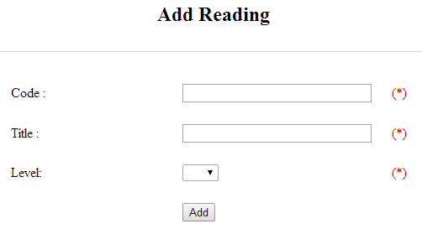
Figure 9.2 : Add reading document
Table 9.2 : Add reading document’s screen description:
No | Field name | Type | Require | Mandatory | Max-Length | Description
1 | Code | Text | Text | Y | 50 | Admin input code with length less than 50 character
2 | Title | Text | Text | Y | 100 | Admin input title with length less than 100 characters
3 | Level | Drop-down list | Click | Y |  | Admin choose the level
4 | Add | Button | Click | Y |  | Admin click to add reading

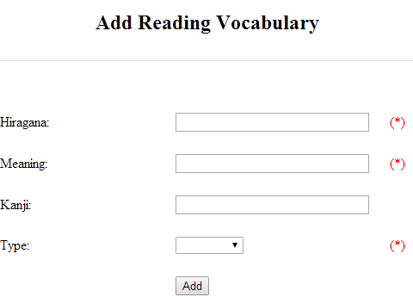
Figure 9.2.1 : Add reading vocabulary
Table 9.2.1 : Add reading vocabulary’s screen description:
No | Field name | Type | Require | Mandatory | Max-Length | Description
1 | Hiragana | Text | Text | Y | 100 | Admin input hiragana with length less than 100 character
2 | Meaning | Text | Text | Y | 100 | Admin input meaning with length less than 100 characters
3 | Kanji | Text | Text | N | 10 | Admin input kanji with length less than 10 characters
4 | Type | Drop-down list | Click | Y |  | Admin choose the type
5 | Add | Button | Click | Y |  | Admin click to add reading vocabulary

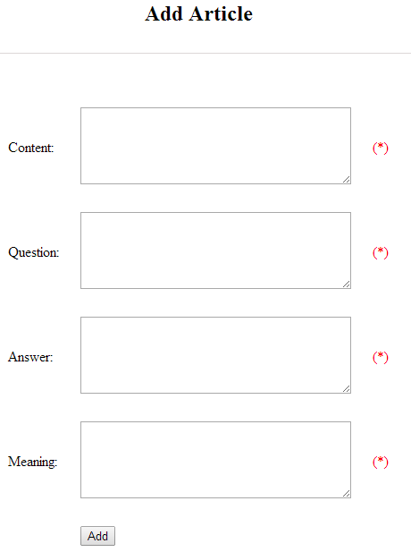
Figure 9.2.2 : Add article
Table 9.2.2 : Add article’s screen description:
No | Field name | Type | Require | Mandatory | Max-Length | Description
1 | Content | Text | Text | Y | 5000 | Admin input content with length less than 5000 character
2 | Question | Text | Text | Y | 5000 | Admin input question with length less than 5000 characters
3 | Answer | Text | Text | Y | 5000 | Admin input answer with length less than 5000 characters
4 | Meaning | Text | Text | Y | 5000 | Admin input meaning with length less than 5000 characters
5 | Add | Button | Click | Y |  | Admin click to add article

UC0030 - Specification
Use-case No. | <UC0030> | Use-case Version |  | <1.0>
Use-case Name | Add document
Author | Minh PT
Date | 09/06/2014 | Priority | <High >
Actor:
Admin
Summary:
When Administrator want to add new reading document into database. They have to insert all necessary data of reading document into “Add new reading” screen
Triggers
User must click on “Reading management/ Add new” tab and input all necessary information of grammar into the right fields then click on “Add new” button
Preconditions:
- User have logged into system as an admin.
- All mandatory fields have been filled
- All input data must be valid and have not existed in system
Post Conditions:
New reading document has been saved into system database successfully
Main Success Scenario:
Step | User | System
1 | Have logged into system as an admin
2 | Click on “Reading management/Add new” tab | Display “Add New Reading” screen that contains these elements:  - Code  - Title  - Level
3 | Fill reading document information into all necessary or mandatory fields and click “Add ” button | The system validates the input data and then save new reading document data into database
4 | Click on “Reading management/VocabularyDetails” | Display “Vocabulary_Details” screen that contains these elements:  - Hiragana  - Meaning  - Kanji  - Type
5 | Fill reading document information into all necessary or mandatory fields and click “Add ” button | The system validates the input data and then save new reading document data into database
6 | Click on “Reading management/ArticleDetails” | Display “Article_Details” screen that contains these elements:  - Cotent  - Question  - Answer  - Meaning
7 | Fill reading document information into all necessary or mandatory fields and click “Add ” button | The system validates the input data and then save new reading document data into database

Alternative Scenario:
At Step | User | System
3 | Click on another link | Do not save new reading document data into database then redirect to selected page
5 | Click on another link | Do not save vocabulary details data into database then redirect to selected page
7 | Click on another link | Do not save article details data into database then redirect to selected page

Exceptions:
At Step | User | System
3 | Do not fill full information into fields then click “Add new” button | Return Error message beside empty field and ask if user want to add with empty field.
5 | Do not fill full information into fields then click “Add new” button | Return Error message beside empty field and ask if user want to add with empty field.
7 | Do not fill full information into fields then click “Add new” button | Return Error message beside empty field and ask if user want to add with empty field.

UC0034: <Admin> Edit reading document
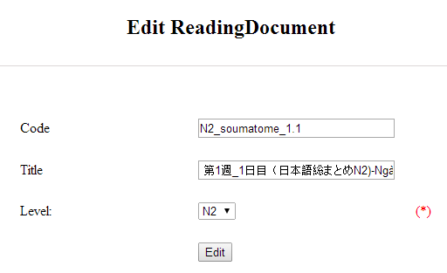
Figure 9.3 : Edit reading document
Table 9.3 : Edit reading document’s screen description:
No | Field name | Type | Require | Mandatory | Max-Length | Description
1 | Code | Text | Text | Y | 50 | Admin input code with length less than 50 character
2 | Title | Text | Text | Y | 100 | Admin input title with length less than 100 characters
3 | Level | Drop-down list | Click | Y |  | Admin choose the level
4 | Edit | Button | Click | Y |  | Admin click to edit reading

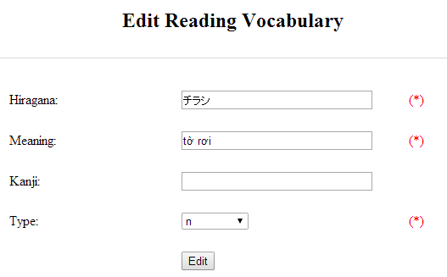
Figure 9.3.1 : Add reading vocabulary
Table 9.3.1 : Add reading vocabulary’s screen description:
No | Field name | Type | Require | Mandatory | Max-Length | Description
1 | Hiragana | Text | Text | Y | 100 | Admin input hiragana with length less than 100 character
2 | Meaning | Text | Text | Y | 100 | Admin input meaning with length less than 100 characters
3 | Kanji | Text | Text | N | 10 | Admin input kanji with length less than 10 characters
4 | Type | Drop-down list | Click | Y |  | Admin choose the type
5 | Edit | Button | Click | Y |  | Admin click to edit reading vocabulary

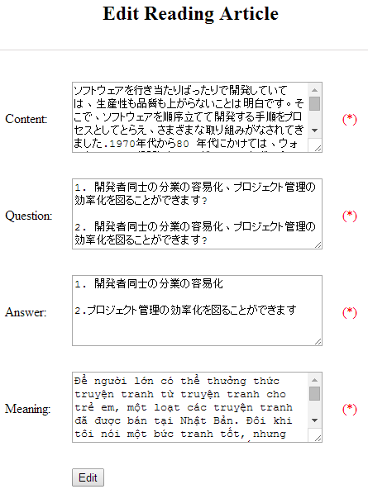
Figure 9.3.2 : Add article
Table 9.3.2 : Add article’s screen description:
No | Field name | Type | Require | Mandatory | Max-Length | Description
1 | Content | Text | Text | Y | 5000 | Admin input content with length less than 5000 character
2 | Question | Text | Text | Y | 5000 | Admin input question with length less than 5000 characters
3 | Answer | Text | Text | Y | 5000 | Admin input answer with length less than 5000 characters
4 | Meaning | Text | Text | Y | 5000 | Admin input meaning with length less than 5000 characters
5 | Edit | Button | Click | Y |  | Admin click to edit article

UC0034 - Specification
Use-case No. | <UC0034> | Use-case Version |  | <1.0>
Use-case Name | Edit reading document
Author | Minh PT
Date | 09/06/2014 | Priority | <High >
Actor:
Admin
Summary:
When Administrator want to edit reading document on database which has some new meanings or errors
Triggers
User must click on “Reading management” then search for the reading document. User click on “Edit” link on corresponding reading document. They edit necessary information of reading document in the right fields then click on “Edit” button.
Preconditions:
- User have logged into system as an admin.
- All mandatory fields have been filled
- All input data must be valid and have not existed in system
Post Conditions:
Changed information of reading document has been saved into system database successfully
Main Success Scenario:
Step | User | System
1 | Have logged into system as an admin
2 | Click on “Reading management ” then search for the reading document that they want to edit | Displays search result as a table
3 | Click on “Edit” link | Display “Edit reading” screen that contains the information of chosen reading with these elements:  - Code  - Title  - Level
4 | Edit reading document information and click “Edit” button | The system validates the input data and then save data into database
5 | Click on “VocabularyEdit” link | Display “Edit vocabulary” screen that contains the information of chosen reading with these elements:  - Hiragana  - Meaning  - Kanji  - Type
6 | Edit reading document information and click “Edit” button | The system validates the input data and then save data into database
7 | Click on “ArticleEdit” link | Display “Edit article” screen that contains the information of chosen reading with these elements:  - Content  - Question  - Answer  - Meaning
8 | Edit reading document information and click “Edit” button | The system validates the input data and then save data into database

Alternative Scenario:
At Step | User | System
4 | Edit reading information then click to another link | Do not save edited data then redirect to selected page
6 | Edit reading information then click to another link | Do not save edited data then redirect to selected page
8 | Edit reading information then click to another link | Do not save edited data then redirect to selected page

Exceptions:
At Step | User | System
4 | Edit reading information to be similar to another existed reading and click “Edit” button | The system validates the input data and return Error message and do not save edited data into database
6 | Edit reading information to be similar to another existed reading and click “Edit” button | The system validates the input data and return Error message and do not save edited data into database
8 | Edit reading information to be similar to another existed reading and click “Edit” button | The system validates the input data and return Error message and do not save edited data into database
Reference:
UC0032- <Admin> Search reading document

UC0035: <Admin> Delete reading document
UC0035 - Specification
Use-case No. | <UC0035> | Use-case Version |  | <1.0>
Use-case Name | Delete reading document
Author | Minh PT
Date | 09/06/2014 | Priority | <High >
Actor:
Admin
Summary:
When Administrator want to delete reading document on database
Triggers
User must click on “Reading management” then search for the reading document. User click on “Delete” link on corresponding reading document.
Preconditions:
- User have logged into system as an admin.
- All mandatory fields have been filled
- All input data must be valid and have existed in system
Post Conditions:
Reading document has been deleted from system database successfully
Main Success Scenario:
Step | User | System
1 | Have logged into system as an admin
2 | Click on “Reading management ” then search for the reading document that they want to delete | Displays search result as a table
3 | Click on “Delete” link beside that reading document row | Displays pop up to confirm if they really want to remove that reading document
4 | Click “Yes” button on popup | Closes the popup then remove that reading document name from reading list

Alternative Scenario:
At Step | User | System
4 | Click close icon of the popup | Only closes the popup, does not remove that reading document

Exceptions:
At Step | User | System
4 | Click “Cancel” button on popup | Only closes the popup, does not remove that reading document
Reference:
UC0032 - <Admin> Search reading document

Conversation management

Use case diagram
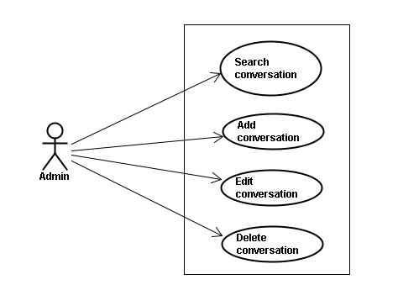

Screen description
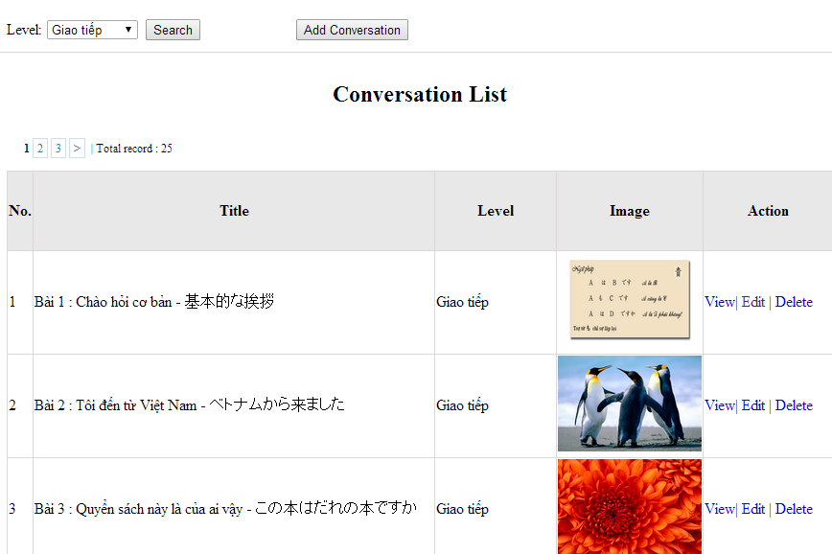
Figure 10: Conversation management
Table 10: Conversation management’s screen description:
No | Field name | Type | Require | Mandatory | Max-Length | Description
1 | Level | Drop-down list | Click | N |  | Admin choose the level
2 | Search | Button | Click | N |  | Admin click to search conversation
3 | Add-new | Button | Click | N |  | Admin click to add new conversation
4 | View | Hyperlink | Click | N |  | Admin click to view content
5 | Edit | Hyperlink | Click | N |  | Admin click edit conversation
6 | Delete | Hyperlink | Click | N |  | Admin click delete conversation

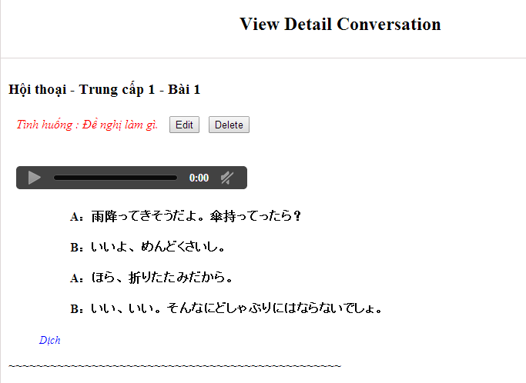

Use case specifications

UC0036: <Admin> Search conversation
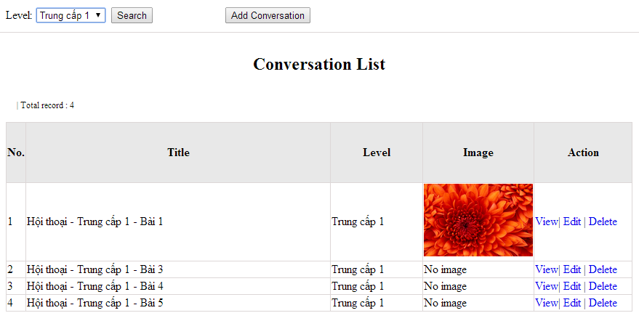
Figure 10.1: Search conversation
UC0036 - Specification
Use-case No. | <UC0036> | Use-case Version |  | <1.0>
Use-case Name | Search conversation
Author | Minh PT
Date | 09/06/2014 | Priority | <High >
Actor:
Admin
Summary:
When Administrator wants to search conversation in database. User input name of conversation or level then click “Search” button
Triggers
Click on “Conversation management” tab, input name of conversation in the right text box then click “Search” button
Preconditions:
- Website is available
- User has to login as Administrator
- User has to input data in search area
Post Conditions:
Display detail information of conversation
Main Success Scenario:
Step | User | System
1 | Have logged into system as an admin
2 | Click on “Conversation management” tab | Displays criteria search screen
3 | Fill information of the conversation that they want to find into fields: C_id or Level then click “Search” button | Displays search result as a table with these elements:  - No  - Title  - Level  - Image  - View  - Edit  - Delete

Alternative Scenario:
At Step | User | System
3 | Fill information of the conversation that they want to find into these fields then click on another link | Switch to selected page

Exceptions:
At Step | User | System
3 | Fill information of the conversation that they want to find (that do not exited in database) into these fields then click “Search” button | Return Error message to inform that conversation cannot be found

UC0037: <Admin> Add conversation
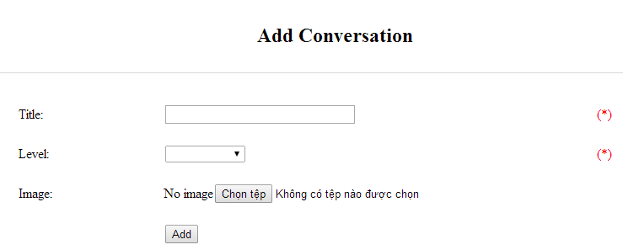
Figure 10.2.1: Add conversation
Table 10.2.1: Add conversation’s screen description:
No | Field name | Type | Require | Mandatory | Max-Length | Description
1 | Title | Text | Text | Y | 100 | Admin input title of conversation with length less than 100 characters
3 | Level | Drop-down list | Text | Y |  | Admin choose the level
4 | Image | Button | Click | N |  | Admin choose the image
5 | Add | Button | Click | Y |  | Admin add new conversation

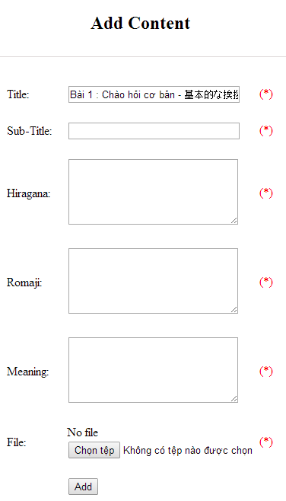
Figure 10.2.2: Add new conversation content
Table 10.2.2: Add conversation content’s screen description:
No | Field name | Type | Require | Mandatory | Max-Length | Description
1 | Title
2 | Sub-title | Text | Text | Y | 200 | Admin input subtitle with length less than 200 characters
3 | Hiragana | Text | Text | Y | 5000 | Admin input hiragana with length less than 5000 characters
4 | Romaji | Text | Text | Y | 5000 | Admin input conversation by romaji with length less than 5000 characters
5 | Meaning | Text | Text | Y | 5000 | Admin input conversation’s meaning with length less than 5000 characters
6 | File | Button | Click | Y |  | Admin choose the file
7 | Add | Button | Click | Y |  | Admin add new content

UC0037 - Specification
Use-case No. | <UC0037> | Use-case Version |  | <1.0>
Use-case Name | Add conversation
Author | Minh PT
Date | 09/06/2014 | Priority | <High >
Actor:
Admin
Summary:
When Administrator wants to add new conversation into database. They have to insert all necessary data of conversation into “Add Conversation” screen
Triggers
User must click on “Conversation management/ Add New” and input all necessary information of conversation into the right fields then click on “Add” button
Preconditions:
- Website is available
- User have logged into system as an admin.
- All mandatory fields have been filled
- All input data must be valid and have not existed in system
Post Conditions:
New conversation has been saved into system database successfully
Main Success Scenario:
Step | User | System
1 | Have logged into system as an admin
2 | Click on “Conversation management/Add New” | Display “Add Conversation” screen that contains these elements:  - Title  - Level  - Image
3 | Fill conversation information into all necessary or mandatory fields and click “Add” button | The system validates the input data and then save new conversation data into database
4 | Click on “Conversation management/View/Add new content” | Display “Add Content” screen that contains these elements:  - Title  - Subtitle  - Hiragana  - Romaji  - Meaning  - File
5 | Fill conversation information into all necessary or mandatory fields and click “Add” button | The system validates the input data and then save new conversation data into database

Alternative Scenario:
At Step | User | System
3 | Click on another link | Do not save new conversation data into database then redirect to selected page
5 | Click on another link | Do not save new content conversation data into database then redirect to selected page

Exceptions:
At Step | User | System
3 | Do not fill full information into fields then click “Add” button | Return Error message and request user input data into all fields
5 | Do not fill full information into fields then click “Add” button | Return Error message and request user input data into all fields
8 | C_id (that do not exited in database then click “Add” button | Return Error message and request user create name of conversation first

UC0038: <Admin> Edit conversation
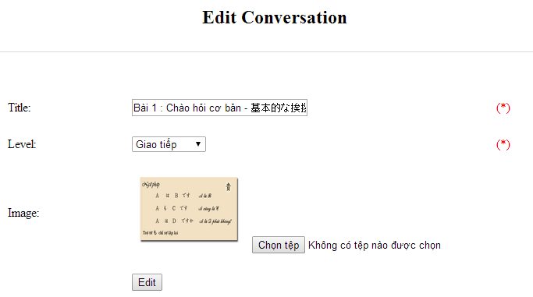
Figure 10.3.1: Edit conversation
Table 10.3.1: Edit conversation’s screen description
No | Field name | Type | Require | Mandatory | Max-Length | Description
1 | Title | Text | Text | Y | 100 | Admin input title of conversation with length less than 100 characters
3 | Level | Drop-down list | Text | Y |  | Admin choose the level
4 | Image | Button | Click | N |  | Admin choose the image
5 | Edit | Button | Click | Y |  | Admin add edit conversation

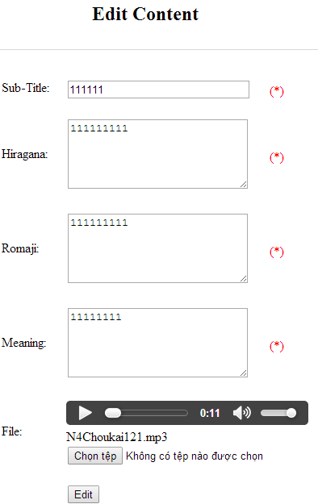
Figure 10.3.2: Edit new conversation content
Table 10.3.2: Edit conversation content’s screen description:
No | Field name | Type | Require | Mandatory | Max-Length | Description
1 | Sub-title | Text | Text | Y | 200 | Admin input subtitle with length less than 200 characters
2 | Hiragana | Text | Text | Y | 5000 | Admin input hiragana with length less than 5000 characters
3 | Romaji | Text | Text | Y | 5000 | Admin input conversation by romaji with length less than 5000 characters
4 | Meaning | Text | Text | Y | 5000 | Admin input conversation’s meaning with length less than 5000 characters
5 | File | Button | Click | Y |  | Admin choose the file
6 | Edit | Button | Click | Y |  | Admin edit conversation

UC0038 - Specification
Use-case No. | <UC0038> | Use-case Version |  | <1.0>
Use-case Name | Edit conversation
Author | Minh PT
Date | 09/06/2014 | Priority | <High >
Actor:
Admin
Summary:
When Administrator want to edit conversation in database which has some new meanings or errors. When edit finished, new meaning will be updated
Triggers
User must click on “Conversation management” then search for the conversation. User click on “Edit” link on corresponding conversation. They edit necessary information of conversation in the right fields then click on “Edit” button.
Preconditions:
- Website is available
- User have logged into system as an admin.
- All mandatory fields have been filled
- All input data must be valid and have not existed in system
Post Conditions:
Changed information of conversation has been saved into system database successfully
Main Success Scenario:
Step | User | System
1 | Have logged into system as an admin
2 | Click on “Conversation management ” then search for the conversation that they want to edit | Displays search result as a table
3 | Click on “Edit” link corresponding | Display “Edit conversation” screen that contains the information of chosen conversation with these elements:  - C_id  - Level  - Title
4 | Edit conversation information
5 | Click “Edit” button | The system validates the input data and then save data into database
5 | Click “Reset” button | The system clear all data in text fields
6 | Click “Conversation Content Management” then search for the conversation content that they want to edit | Displays search result as a table
7 | Click on “Edit” link corresponding | Display “Edit Conversation Content” screen that contains the information of chosen conversation with these elements:  - C_id  - Con_hiragana  - Con_romaji  - Con_meaning
8 | Edit conversation content information
9 | Click “Edit” button | The system validates the input data and then save data into database
9 | Click “Reset” button | The system clear all data in text fields

Alternative Scenario:
At Step | User | System
4 | Edit conversation then click to another link | Do not save edited data then redirect to selected page
8 | Edit conversation content then click to another link | Do not save edited data then redirect to selected page

Exceptions:
At Step | User | System
4 | Edit conversation to be similar to another existed conversation
5 | Click “Edit” button | The system validates the input data and return Error message and do not save edited data into database
8 | Edit conversation content to be similar to another existed conversation content
9 | Click “Edit” button | The system validates the input data and return Error message and do not save edited data into database

Reference:
UC0036- <Admin> Search conversation

UC0039: <Admin> Delete conversation
UC0039 - Specification
Use-case No. | <UC0039> | Use-case Version |  | <1.0>
Use-case Name | Delete conversation
Author | Minh PT
Date | 09/06/2014 | Priority | <High >
Actor:
Admin
Summary:
When Administrator want to delete conversation in database
Triggers
User must click on “Conversation management” then search for the conversation. User click on “Delete” link on corresponding conversation.
Preconditions:
- Website is available
- User have logged into system as an admin.
Post Conditions:
Conversation has been deleted from system database successfully
Main Success Scenario:
Step | User | System
1 | Have logged into system as an admin
2 | Click on “Conversation management ” then search for the conversation that they want to delete | Displays search result as a table
3 | Click on “Delete” link corresponding with conversation | Remove that conversation in database

Exceptions:
At Step | User | System
3 | Click on “Delete” link corresponding with conversation (conversation content is existing) | Return Error message and request user remove conversation content first

Reference:
UC0036 - <Admin> Search conversation

Video Management

Use case diagram
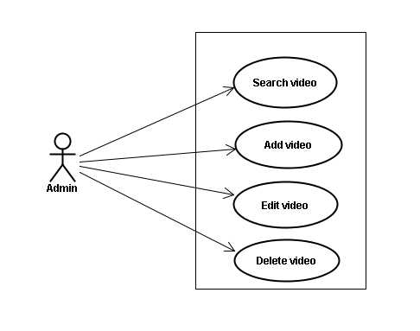

Screen description
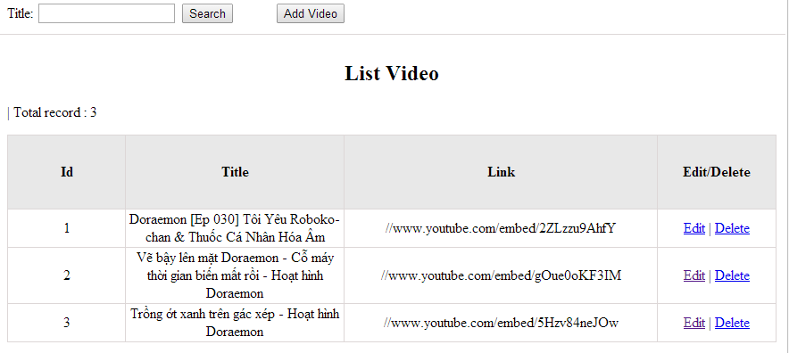
Figrure 11: Video management
Table 11.1: Video management’s screen description:
No | Field name | Type | Require | Mandatory | Max-Length | Description
1 | Title | Text | Text | Y | 100 | Admin input title with length less than 100 character
2 | Addnew | Button | Click | N |  | Admin add new video into database
3 | Edit | Button | Click | N |  | Admin click edit video
4 | Delete | Button | Click | N |  | Admin click delete video

Use case specifications

UC040 <Video management>: Search video
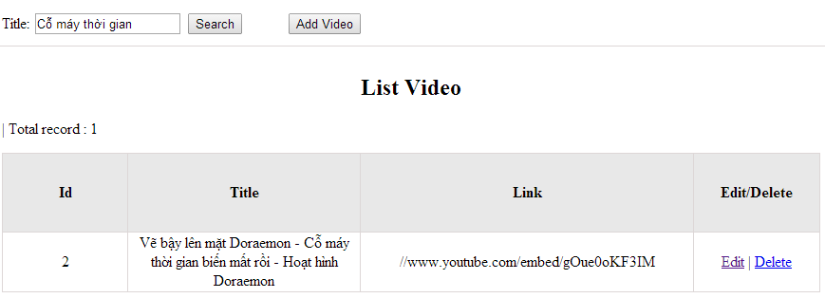
Figure 11.1: Search video
UC0040 - Specification
Use-case No. | <UC0040> | Use-case Version |  | <1.0>
Use-case Name | Search video
Author | Minh PT
Date | 09/06/2014 | Priority | <High >
Actor:
Admin
Summary:
When Administrator wants to search video in database. User input name of video then click “Search” button
Triggers
Click on “Video management” tab, input name of video in the right text box then click “Search” button
Preconditions:
- Website is available
- User has to login as Administrator
- User has to input data in search area
Post Conditions:
Display detail information of video
Main Success Scenario:
Step | User | System
1 | Have logged into system as an admin
2 | Click on “Video management” tab | Displays criteria search screen
3 | Fill information of the video that they want to find into these fields then click “Search” button | Displays search result as a table with these elements:  - No  - Title  - Link  - Edit  - Delete

Alternative Scenario:
At Step | User | System
3 | Fill information of the video that they want to find into these fields then click on another link | Switch to selected page

Exceptions:
At Step | User | System
3 | Fill information of the video that they want to find (that do not exited in database) into these fields then click “Search” button | Return Error message to inform that video cannot be found

UC041 <Video management>: Add video
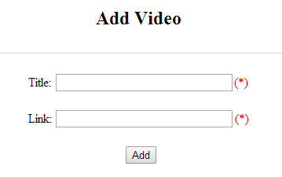
Figure 11.2: Add video
Table 11.2: Add video’s screen description:
No | Field name | Type | Require | Mandatory | Max-Length | Description
1 | Title | Text | Text | Y | 200 | Admin input title with length less than 200 characters
2 | Link | Text | Text | Y |  | Admin input hyperlink
3 | Add | Button | Click | Y |  | Admin add new video
4 | Reset | Button | Click | N |  | Admin reset information

UC0041 - Specification
Use-case No. | <UC0041> | Use-case Version |  | <1.0>
Use-case Name | Add video
Author | Minh PT
Date | 09/06/2014 | Priority | <High >
Actor:
Admin
Summary:
When Administrator wants to add new video into database. They have to insert all necessary data of video into “Add Video” screen
Triggers
User must click on “Video management/ Add New” tab and input all necessary information of video into the right fields then click on “Add” button
Preconditions:
- Website is available
- User have logged into system as an admin.
- All mandatory fields have been filled
- All input data must be valid and have not existed in system
Post Conditions:
New video has been saved into system database successfully
Main Success Scenario:
Step | User | System
1 | Have logged into system as an admin
2 | Click on “Video management/Add New” tab | Display “Add Video” screen that contains these elements:  - Title  - Link
3 | Fill video information into all necessary or mandatory fields and click “Add” button | The system validates the input data and then save new video data into database

Alternative Scenario:
At Step | User | System
3 | Click on another link | Do not save new video data into database then redirect to selected page

Exceptions:
At Step | User | System
3 | Do not fill full information into fields then click “Add” button | Return Error message and request user input data into all fields

UC042 <Video management>: Edit video
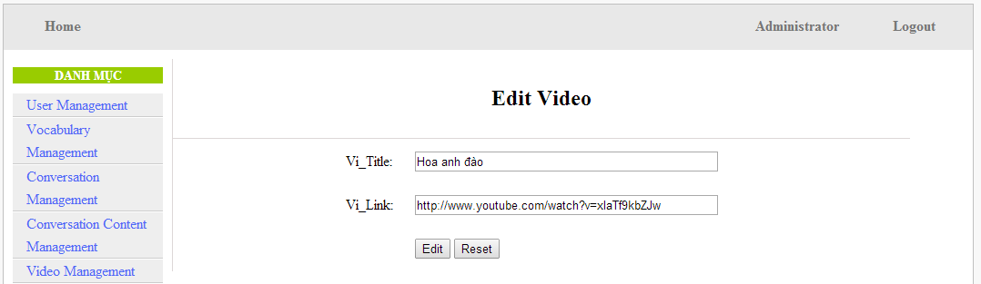
Figure 11.3: Edit video
Table 11.3: Edit video’s screen description:
No | Field name | Type | Require | Mandatory | Max-Length | Description
1 | Title | Text | Text | Y | 200 | Admin input title with length less than 200 characters
2 | Link | Text | Text | Y | 1000 | Admin input hyperlink
3 | Add | Button | Click | Y |  | Admin edit video

UC0042 - Specification
Use-case No. | <UC0042> | Use-case Version |  | <1.0>
Use-case Name | Edit video
Author | Minh PT
Date | 09/06/2014 | Priority | <High >
Actor:
Admin
Summary:
When Administrator wants to edit video in database which has some new meanings or errors. When edit finished, new meaning will be updated
Triggers
User must click on “Video management” then search for the video. User click on “Edit” link corresponding with video. User edit necessary information of video in the right fields then click on “Edit” button.
Preconditions:
- Website is available
- User have logged into system as an admin.
- All mandatory fields have been filled
- All input data must be valid and have not existed in system
Post Conditions:
Changed information of video has been saved into system database successfully
Main Success Scenario:
Step | User | System
1 | Have logged into system as an admin
2 | Click on “Video management ” then search for the video that they want to edit | Displays search result as a table
3 | Click on “Edit” link corresponding | Display “Edit video” screen that contains the information of chosen video with these elements:  - Title  - Link
4 | Edit video information and click “Edit” button | The system validates the input data and then save data into database

Alternative Scenario:
At Step | User | System
4 | Edit video then click to another link | Do not save edited data then redirect to selected page

Exceptions:
At Step | User | System
4 | Edit video to be similar to another existed video and click “Edit” button | The system validates the input data and return Error message and do not save edited data into database
Reference:
UC0040- <Admin> Search video

UC043 <Video management>: Delete video
UC0043 - Specification
Use-case No. | <UC0043> | Use-case Version |  | <1.0>
Use-case Name | Delete video
Author | Minh PT
Date | 09/06/2014 | Priority | <High >
Actor:
Admin
Summary:
When Administrator wants to delete video in database
Triggers
User must click on “Video management” then search for the video. User click on “Delete” link on corresponding video.
Preconditions:
- Website is available
- User have logged into system as an admin.
Post Conditions:
Video has been deleted from system database successfully
Main Success Scenario:
Step | User | System
1 | Have logged into system as an admin
2 | Click on “Video management ” then search for the video that they want to delete | Displays search result as a table
3 | Click on “Delete” link corresponding with conversation | Remove that video in database

Reference:
UC0040 - <Admin> Search video

Training Listening Management

Use case diagram
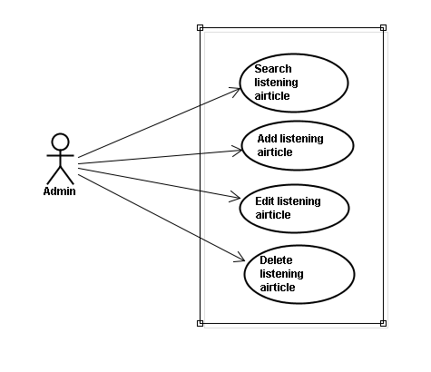

Screen description
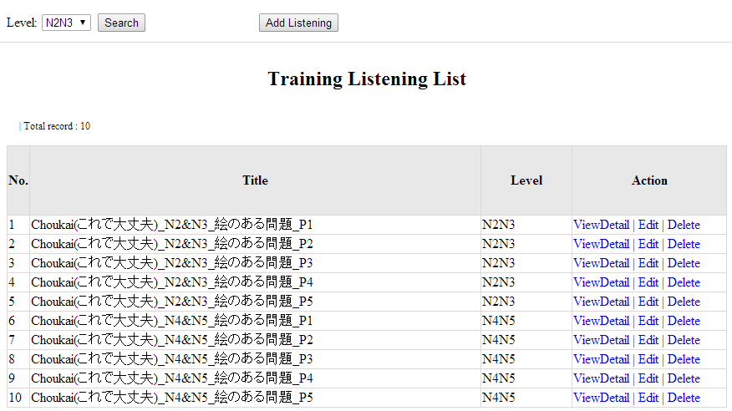
Figure 12: Listening article management
Table 12.1: Conversation management’s screen description:
No | Field name | Type | Require | Mandatory | Max-Length | Description
1 | Level | Drop-down list | Click | Y |  | Admin choose the level
2 | Search | Button | Click | Y |  | Admin click to search
3 | Addnew | Button | Click | N |  | Admin add new listening into database
4 | ViewDetail | Hyperlink | Click | N |  | Admin click to view details of listening
5 | Edit | Button | Click | N |  | Admin click edit listening article
6 | Delete | Button | Click | N |  | Admin click delete article

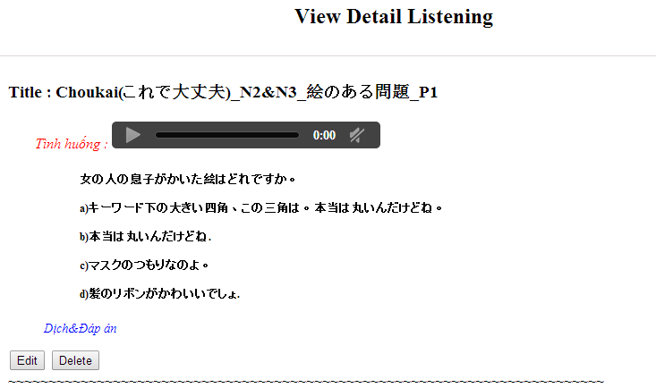

Use case specifications

UC044 <Listening Article Management>: Search listening article
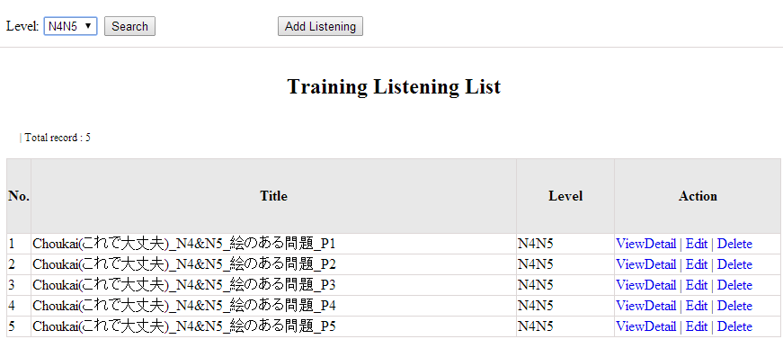
Figure 12.1: Search listening article
UC0044 - Specification
Use-case No. | <UC0044> | Use-case Version |  | <1.0>
Use-case Name | Search listening article
Author | Minh PT
Date | 09/06/2014 | Priority | <High >
Actor:
Admin
Summary:
When Administrator wants to search listening article in database. User input listening id or listening level then click “Search” button
Triggers
Click on “Listening practice management” tab, input listening id or level in the right text box then click “Search” button
Preconditions:
- Website is available
- User has to login as Administrator
- User has to input data in search area
Post Conditions:
Display detail information of listening article
Main Success Scenario:
Step | User | System
1 | Have logged into system as an admin
2 | Click on “Listening article management” tab | Displays criteria search screen
3 | Fill information of the listening article that they want to find into lis_id or lis_level then click “Search” button | Displays search result as a table with these elements:  - No  - Title  - Level  - View details  - Edit  - Delete

Alternative Scenario:
At Step | User | System
3 | Fill information of the listening article that they want to find into these fields then click on another link | Switch to selected page

Exceptions:
At Step | User | System
3 | Fill information of the listening article that they want to find (that do not exited in database) into these fields then click “Search” button | Return Error message to inform that listening article cannot be found

UC045 <Listening Article Management>: Add listening article
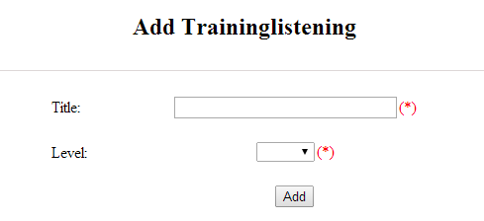
Figure 12.2: Add listening :
Table 12.2: Add listening’s screen description:
No | Field name | Type | Require | Mandatory | Max-Length | Description
1 | Title | Text | Text | Y | 500 | Admin input id with length less than 500 characters
2 | Level | Drop-down list | Choose | Y |  | Admin choose level
3 | Add | Button | Click | Y |  | Admin add new listening

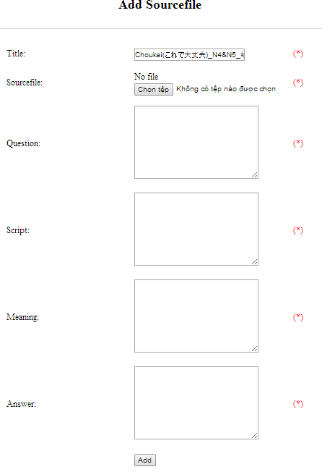
Figure 12.2.1: Add listening source file:
Table 12.2.1: Add listening source file’s screen description:
No | Field name | Type | Require | Mandatory | Max-Length | Description
1 | Source_file | Button | Click | Y |  | Admin choose the file
2 | Question | Text | Text | Y | 5000 | Admin input question of listening with length less than 5000 characters
3 | Script | Text | Text | Y | 5000 | Admin input script of listening with length less than 5000 characters
4 | Meaning | Text | Text | Y | 5000 | Admin input meaning of listening with length less than 5000 characters
5 | Answer | Text | Text | Y | 5000 | Admin input answer of listening with length less than 5000 characters
6 | Add | Button | Click | Y |  | Admin add source file

UC0045 - Specification
Use-case No. | <UC0045> | Use-case Version |  | <1.0>
Use-case Name | Add listening article
Author | Minh PT
Date | 09/06/2014 | Priority | <High >
Actor:
Admin
Summary:
When Administrator wants to add new listening article into database. They have to insert all necessary data of listening article into “Add new listening” screen
Triggers
User must click on “Listening management/ Add New” and input all necessary information of listening article into the right fields then click on “Add” button
Preconditions:
- Website is available
- User have logged into system as an admin.
- All mandatory fields have been filled
- All input data must be valid and have not existed in system
Post Conditions:
New listening article has been saved into system database successfully
Main Success Scenario:
Step | User | System
1 | Have logged into system as an admin
2 | Click on “Listening article management/Add New” | Display “Add New Listening” screen that contains these elements:  - Title  - Level
3 | Fill listening article information into all necessary or mandatory fields click “Add” button | The system validates the input data and then save new listening article data into database
4 | Click on “Listening article management/View details/ Add source file” | Display “Add source file” screen that contains these elements:  - Title  - Source file  - Question  - Script  - Meaning  - Answer
5 | Fill listening article information into all necessary or mandatory fields click “Add” button | The system validates the input data and then save new listening article data into database

Alternative Scenario:
At Step | User | System
3 | Click on another link | Do not save new listening article data into database then redirect to selected page
5 | Click on another link | Do not save new source file data into database then redirect to selected page

Exceptions:
At Step | User | System
3 | Do not fill full information into fields then click “Add” button | Return Error message and request user input data into all fields
5 | Do not fill full information into fields then click “Add” button | Return Error message and request user input data into all fields

UC046 <Listening Article Management>: Edit listening article
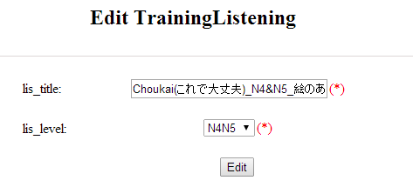
Figure 12.3: Edit listening:
Table 12.3: Edit listening ’s screen description:
No | Field name | Type | Require | Mandatory | Max-Length | Description
1 | Title | Text | Text | Y | 500 | Admin input id with length less than 500 characters
2 | Level | Drop-down list | Choose | Y |  | Admin choose level
3 | Edit | Button | Click | Y |  | Admin edit listening

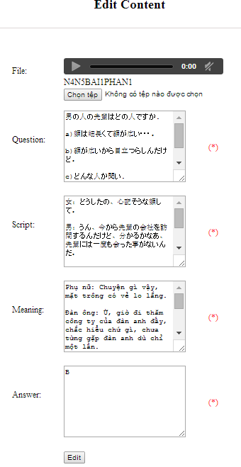
Figure 12.3.1: Edit listening source file:
Table 12.3.1: Edit listening source file’s screen description:
No | Field name | Type | Require | Mandatory | Max-Length | Description
1 | Source_file | Button | Click | Y |  | Admin choose the file
2 | Question | Text | Text | Y | 5000 | Admin input question of listening with length less than 5000 characters
3 | Script | Text | Text | Y | 5000 | Admin input script of listening with length less than 5000 characters
4 | Meaning | Text | Text | Y | 5000 | Admin input meaning of listening with length less than 5000 characters
5 | Answer | Text | Text | Y | 5000 | Admin input answer of listening with length less than 5000 characters
6 | Edit | Button | Click | Y |  | Admin edit source file

UC0046 - Specification
Use-case No. | <UC0046> | Use-case Version |  | <1.0>
Use-case Name | Edit listening article
Author | Minh PT
Date | 09/06/2014 | Priority | <High >
Actor:
Admin
Summary:
When Administrator wants to edit listening article in database which has some new meanings or errors. When edit finished, new meaning will be updated

Triggers
User must click on “Listening management” then search for the listening article. User click on “Edit” link corresponding with listening article. They edit necessary information of listening article in the right fields then click on “Edit” button.
Preconditions:
- Website is available
- User have logged into system as an admin.
- All mandatory fields have been filled
- All input data must be valid and have not existed in system
Post Conditions:
Changed information of listening article has been saved into system database successfully
Main Success Scenario:
Step | User | System
1 | Have logged into system as an admin
2 | Click on “Trainig listening” then search for the listening article that they want to edit | Displays search result as a table
3 | Click on “Edit” link corresponding | Display “Edit listening” screen that contains the information of chosen listening article with these elements:  - Title  - Level
4 | Edit listening article information and click “Edit” button | The system validates the input data and then save data into database
5 | Click on “View details/ Edit” link corresponding | Display “Edit listening” screen that contains the information of chosen listening article with these elements:  - File  - Question  - Script  - Meaning  - Answer
6 | Edit listening article information and click “Edit” button | The system validates the input data and then save data into database

Alternative Scenario:
At Step | User | System
4 | Edit listening article then click to another link | Do not save edited data then redirect to selected page
6 | Edit listening article then click to another link | Do not save edited data then redirect to selected page

Exceptions:
At Step | User | System
4 | Edit listening article to be similar to another existed listening article click “Edit” button | The system validates the input data and return Error message and do not save edited data into database
6 | Edit listening article to be similar to another existed listening article click “Edit” button | The system validates the input data and return Error message and do not save edited data into database
Reference:
UC0044- <Admin> Search listening article

UC047 <Listening Article Management>: Delete listening article
UC0047 - Specification
Use-case No. | <UC0047> | Use-case Version |  | <1.0>
Use-case Name | Delete listening article
Author | Minh PT
Date | 09/06/2014 | Priority | <High >
Actor:
Admin
Summary:
When Administrator want to delete listening article inn database
Triggers
User must click on “Listening article management” then search for the listening article. User click on “Delete” link corresponding with listening article.
Preconditions:
- Website is available
- User have logged into system as an admin.
Post Conditions:
Listening article has been deleted from system database successfully
Main Success Scenario:
Step | User | System
1 | Have logged into system as an admin
2 | Click on “Listening article management ” then search for the listening article that they want to delete | Displays search result as a table
3 | Click on “Delete” link corresponding | Remove that listening article in database

Reference:
UC0044 - <Admin> Search listening article

Test management

Use case diagram
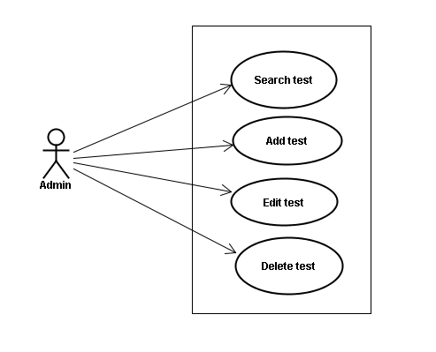

Screen description
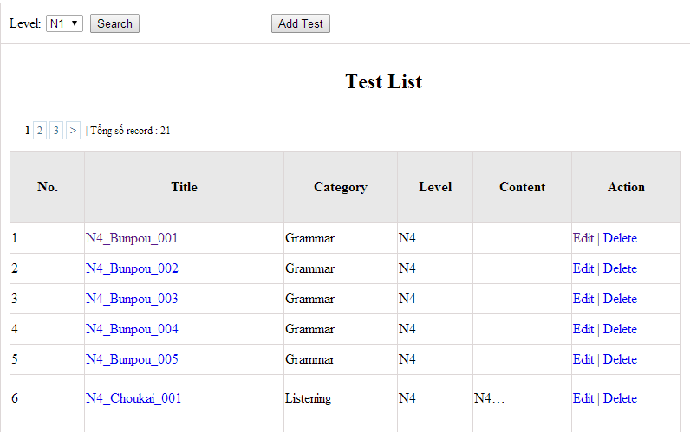
Figure 13: Doing test management
Table 13.1: Doing test management’s screen description:
No | Field name | Type | Require | Mandatory | Max-Length | Description
1 | Level | Drop-down list | Click | N |  | Admin choose the level
2 | Search | Button | Click | N |  | Admin click to search
3 | List | Hyperlink | Click | N |  | Admin click to view details
4 | Edit | Button | Click | N |  | Admin click edit test
5 | Delete | Button | Click | N |  | Admin click delete test

Use case specifications

UC048 <Test management>: Search test
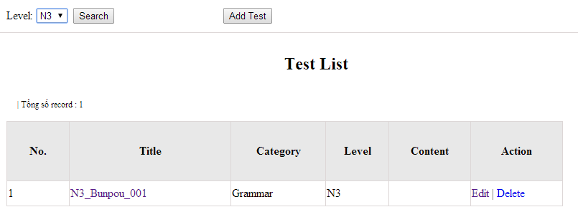
Figure 13.1: Search test:
UC0048 - Specification
Use-case No. | <UC0048> | Use-case Version |  | <1.0>
Use-case Name | Search test
Author | Minh PT
Date | 09/06/2014 | Priority | <High >
Actor:
Admin
Summary:
When Administrator wants to search test article in database. User input test id or test category then click “Search” button.
Triggers
Click on “Test management” tab, input Test_id or test_ in the right text box then click “Search” button
Preconditions:
- Website is available
- User has to login as Administrator
- User has to input data in search area
Post Conditions:
Display detail information of that test
Main Success Scenario:
Step | User | System
1 | Have logged into system as an admin
2 | Click on “Test management” tab | Displays criteria search screen
3 | Fill information of the test that they want to find into test_id or test_catagory then click “Search” button | Displays search result as a table with these elements:  - No  - Title  - Category  - Level  - Content  - Edit  - Delete

Alternative Scenario:
At Step | User | System
3 | Fill information of the test that they want to find into these fields then click on another link | Switch to selected page

Exceptions:
At Step | User | System
3 | Fill information of the test that they want to find (that do not exited in database) into these fields then click “Search” button | Return Error message to inform that test cannot be found

UC049 <Test management>: Add test
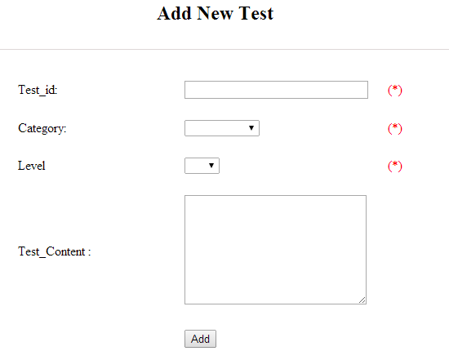
Figure 13.2: Add test
Table 13.2 : Add test’s screen description:
No | Field name | Type | Require | Mandatory | Max-Length | Description
1 | ID | Text | Text | Y | 100 | Admin input id with length less than 100 characters
2 | Category | Drop-down list | Click | Y |  | Admin choose category
3 | Level | Drop-down list | Click | Y |  | Admin choose level of test
4 | Test content | Text | Text | Y | 5000 | Admin input content with length less than 5000 characters
5 | Add | Button | Click | Y |  | Admin click to add test
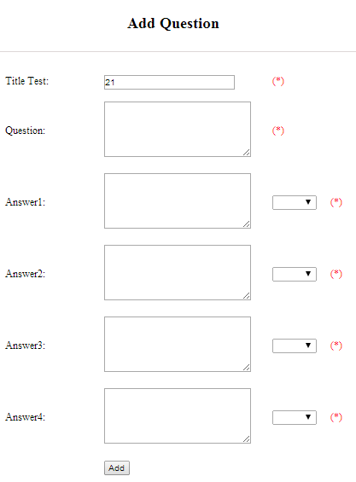
Figure 13.2.1: Add question
Table 13.2.1: Add question’s screen description:
No | Field name | Type | Require | Mandatory | Max-Length | Description
1 | Question | Text | Text | Y | 200 | Admin input question with length less than 200 characters
2 | Answer 1 | Text | Text | Y | 200 | Admin input answer 1 with length less than 200 characters
3 | Correct answer 1 | Drop-down list | Click | Y |  | Admin choose correct answer
4 | Answer 2 | Text | Text | Y | 200 | Admin input answer 2 with length less than 200 characters
5 | Correct answer 2 | Drop-down list | Click | Y |  | Admin choose correct answer
6 | Answer 3 | Text | Text | Y | 200 | Admin input answer 3 with length less than 200 characters
7 | Correct answer 3 | Drop-down list | Click | Y |  | Admin choose correct answer
8 | Answer 4 | Text | Text | Y | 200 | Admin input answer 4 with length less than 200 characters
9 | Correct answer 4 | Drop-down list | Click | Y |  | Admin choose correct answer
10 | Add | Button | Click | Y |  | Admin click to add

UC0049 - Specification
Use-case No. | <UC0049> | Use-case Version |  | <1.0>
Use-case Name | Add test
Author | Minh PT
Date | 09/06/2014 | Priority | <High >
Actor:
Admin
Summary:
When Administrator want to add new test into database. They have to insert all necessary data of test into “Add new test” screen
Triggers
User must click on “Test management/ Add New” and input all necessary information of test into the right fields then click on “Add” button
Preconditions:
- Website is available
- User have logged into system as an admin.
- All mandatory fields have been filled
- All input data must be valid and have not existed in system
Post Conditions:
New test has been saved into system database successfully
Main Success Scenario:
Step | User | System
1 | Have logged into system as an admin
2 | Click on “Test management/Add New” | Display “Add New Test” screen that contains these elements:  - Title  - Category  - Level  - Content
3 | Fill test information into all necessary or mandatory fields and click “Add” button | The system validates the input data and then save new test data into database
4 | Click on “Title link/Add new question” | Display “Add New Question” screen that contains these elements:  - Title  - Question  - Answer 1  - Correct answer 1  - Answer 2  - Correct answer 2  - Answer 3  - Correct answer 3  - Answer 4  - Correct answer 4
5 | Fill test information into all necessary or mandatory fields and click “Add” button | The system validates the input data and then save new test data into database

Alternative Scenario:
At Step | User | System
3 | Click on another link | Do not save new test data into database then redirect to selected page
5 | Click on another link | Do not save new question data into database then redirect to selected page

Exceptions:
At Step | User | System
3 | Do not fill full information into fields then click “Add” button | Return Error message and request user input data into all fields
5 | Do not fill full information into fields then click “Add” button | Return Error message and request user input data into all fields

UC050 <Test management>: Edit test
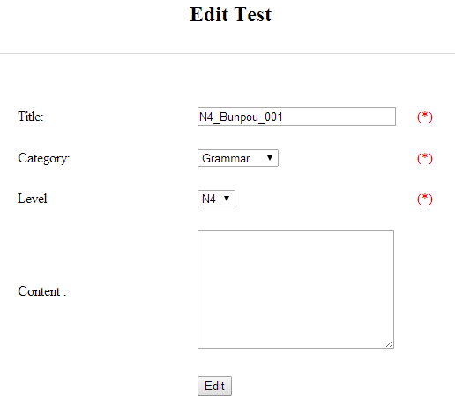
Figure 13.3: Edit test
Table 13.3: Edit test’s screen description:
No | Field name | Type | Require | Mandatory | Max-Length | Description
1 | ID | Text | Text | Y | 100 | Admin input id with length less than 100 characters
2 | Category | Drop-down list | Click | Y |  | Admin choose category
3 | Level | Drop-down list | Click | Y |  | Admin choose level of test
4 | Test content | Text | Text | Y | 5000 | Admin input content with length less than 5000 characters
5 | Edit | Button | Click | Y |  | Admin click to edit test

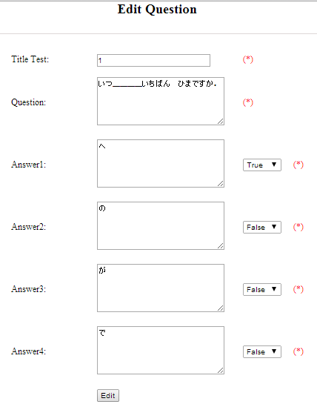
Figure 13.3.1: Edit question
Table 13.3.1: Edit question’s screen description:
No | Field name | Type | Require | Mandatory | Max-Length | Description
1 | Question | Text | Text | Y | 200 | Admin input question with length less than 200 characters
2 | Answer 1 | Text | Text | Y | 200 | Admin input answer 1 with length less than 200 characters
3 | Correct answer 1 | Drop-down list | Click | Y |  | Admin choose correct answer
4 | Answer 2 | Text | Text | Y | 200 | Admin input answer 2 with length less than 200 characters
5 | Correct answer 2 | Drop-down list | Click | Y |  | Admin choose correct answer
6 | Answer 3 | Text | Text | Y | 200 | Admin input answer 3 with length less than 200 characters
7 | Correct answer 3 | Drop-down list | Click | Y |  | Admin choose correct answer
8 | Answer 4 | Text | Text | Y | 200 | Admin input answer 4 with length less than 200 characters
9 | Correct answer 4 | Drop-down list | Click | Y |  | Admin choose correct answer
10 | Edit | Button | Click | Y |  | Admin click to edit

UC0050 - Specification
Use-case No. | <UC0050> | Use-case Version |  | <1.0>
Use-case Name | Edit test
Author | Minh PT
Date | 09/06/2014 | Priority | <High >
Actor:
Admin
Summary:
When Administrator want to edit test in database which has some new meanings or errors. When edit finished, new meaning will be updated
Triggers
User must click on “Test management” then search for the test. User click on “Edit” link on corresponding test. User edit necessary information of test in the right fields then click on “Edit” button.
Preconditions:
- Website is available
- User have logged into system as an admin.
- All mandatory fields have been filled
- All input data must be valid and have not existed in system
Post Conditions:
Changed information of test has been saved into system database successfully
Main Success Scenario:
Step | User | System
1 | Have logged into system as an admin
2 | Click on “Test management ” then search for the test that they want to edit | Displays search result as a table
3 | Click on “Edit” link corresponding | Display “Edit Test” screen that contains the information of chosen test with these elements:  - Title  - Category  - Level  - Content
4 | Edit test information and click “Edit” button | The system validates the input data and then save data into database

Alternative Scenario:
At Step | User | System
4 | Edit test then click to another link | Do not save edited data then redirect to selected page

Exceptions:
At Step | User | System
4 | Edit test to be similar to another existed test and click “Edit” button | The system validates the input data and return Error message and do not save edited data into database
Reference:
UC0048- <Admin> Search test

UC051 <Test management>: Delete test
UC0051 - Specification
Use-case No. | <UC0051> | Use-case Version |  | <1.0>
Use-case Name | Delete test
Author | Minh PT
Date | 09/06/2014 | Priority | <High >
Actor:
Admin
Summary:
When Administrator want to delete test in database
Triggers
User must click on “Test management” then search for the test. User click on “Delete” link corresponding with test.
Preconditions:
- Website is available
- User have logged into system as an admin.
Post Conditions:
Test has been deleted from system database successfully
Main Success Scenario:
Step | User | System
1 | Have logged into system as an admin
2 | Click on “Test management ” then search for the test that they want to delete | Displays search result as a table
3 | Click on “Delete” link corresponding | Remove that test in database

Reference:
UC0048 - <Admin> Search test

Contact management

Use case diagram
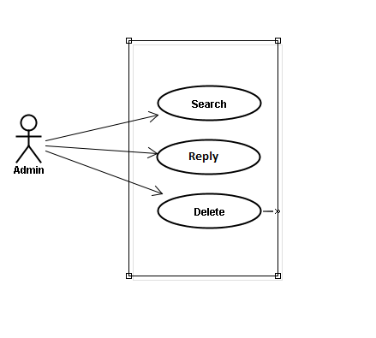

Use case specifications

UC052 <Opinion/Q&A Management>: Search question
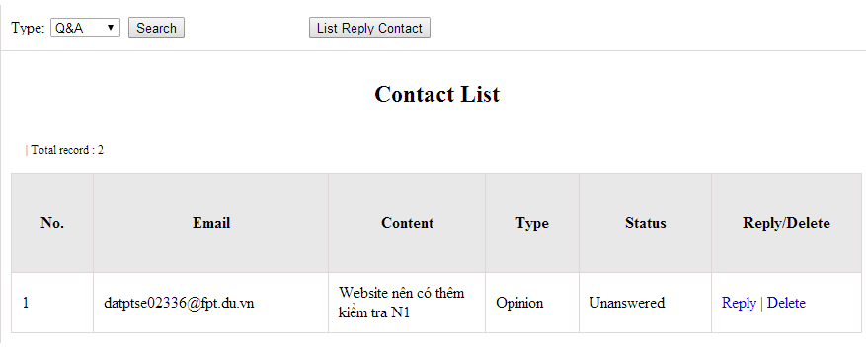
Figure 14.1: Search contact management’s screen
Table 14.1: Search contact management’s screen description
No | Field name | Type | Require | Mandatory | Max-Length | Description
1 | Type | Drop-down list | Click | N |  | Admin choose the typ
2 | Search | Button | Click | N |  | Admin click to search
3 | Reply | Button | Click | N |  | Admin click reply the question
4 | Delete | Button | Click | N |  | Admin click delete question
5 | List reply | Button | Click | N |  | Admin click to view list reply

UC0055 – Specification
Use-case No. | <UC0055> | Use-case Version |  | <1.0>
Use-case Name | Search question
Author | Minh PT
Date | 09/06/2014 | Priority | <High >
Actor:
Admin
Summary:
When administrator wants to search question from member. User input data then click “Search” button.
Triggers
Click on “Contact Management ” tab, input data in the right text box then click “Search” button
Preconditions:
- Website is available
- User has to login as Administrator
- User has to input data in search area
Post Conditions:
Display detail information of question
Main Success Scenario:
Step | User | System
1 | Have logged into system as an admin
2 | Click on “Contact Management ” tab | Displays criteria search screen
3 | Fill information that they want to find into text box then click “Search” button | Displays search result as a table with these elements:  - No  - Email  - Content  - Type  - Status  - Reply  - Delete

Alternative Scenario:
At Step | User | System
3 | Fill information that they want to find into these fields then click on another link | Switch to selected page

Exceptions:
At Step | User | System
3 | Fill information that they want to find (that do not exited in database) into these fields then click “Search” button | Return Error message to inform that cannot be found

UC053 <Opinion/Q&A Management>: Reply question
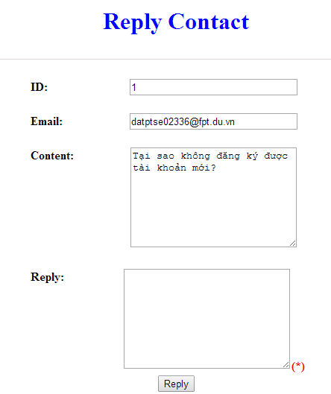
Figure 16.2 : Reply contact
Table 16.2: Reply contact’s screen description:
No | Field name | Type | Require | Mandatory | Max-Length | Description
1 | Email |  |  |  |  | Email of admin’s account
2 | Content |  |  |  |  | Question
3 | Reply | Text | Text | Y |  | Admin input reply of question
4 | Reply | Button | Click | N |  | Admin click send reply question

UC0056 - Specification
Use-case No. | <UC0056> | Use-case Version |  | <1.0>
Use-case Name | Search question
Author | Minh PT
Date | 09/06/2014 | Priority | <High >
Actor:
Admin
Summary:
When administrator wants to reply question from member.
Triggers
Click on “Opinion/Q&A Management ” tab, User search question then click “Reply” link corresponding
Preconditions:
- Website is available
- User has to login as Administrator
- User has to input answer
Post Conditions:
Answer be sent to user
Main Success Scenario:
Step | User | System
1 | Have logged into system as an admin
2 | Click on “Opinion/Q&A Management ” tab | Displays criteria search screen
3 | Click “Reply” link corresponding | Displays Reply screen with these elements:  - Email  - Content  - Reply
4 | Input the answer and click “Reply” button | The answer of question will be sent to member

Alternative Scenario:
At Step | User | System
4 | Input answer then click on another link | Switch to selected page

Exceptions:
At Step | User | System
Reference:
UC0052 - < Opinion/Q&A Management > Search question

UC054 <Opinion/Q&A Management>: Delete question
UC0054 - Specification
Use-case No. | <UC0051> | Use-case Version |  | <1.0>
Use-case Name | Delete question
Author | Minh PT
Date | 09/06/2014 | Priority | <High >
Actor:
Admin
Summary:
When Administrator want to delete question
Triggers
User must click on “Contact management” then search for the test. User click on “Delete” link corresponding with test.
Preconditions:
- Website is available
- User have logged into system as an admin.
Post Conditions:
Question has been deleted from system database successfully
Main Success Scenario:
Step | User | System
1 | Have logged into system as an admin
2 | Click on “Contact management ” then search for the test that they want to delete | Displays search result as a table
3 | Click on “Delete” link corresponding | Remove that test in database

Reference:
UC0052 - <Admin> Search contact

Contributed content management

Use case diagram
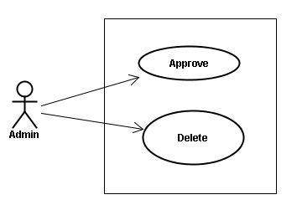

Use case specifications

UC055 <Contact’s content Management>: Approve contribute content
Approve contribute content screen:
- Approve contribute kanji screen:
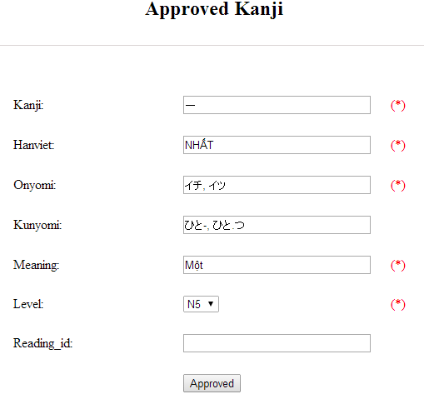
Figure 15.1: Approved kanji’s screen
Table 15.1: Approved kanji’s screen description
No | Field name | File name in Vietnamese | Type | Require | Mandatory | Max-Length | Description
1 | Kanji | Kanji | Text | Text | Y | 10 | Admin input kanji with length less than 10 characters
2 | HanViet | Hán Việt | Text | Text | N | 50 | Admin input to the field with length less than 50 characters
3 | Onyomi | Âm Onyomi | Text | Text | Y | 100 | Admin input onyomi with length less than 100 characters
4 | Kunyomi | Âm kunyomi | Text | Text | Y | 100 | Admin input kunyomi with length less than 100 characters
5 | Meaning | Nghĩa | Text | Text | Y | 200 | Admin input meaning with length less than 200 characters
6 | Level | Level | Drop-down list | Click | Y |  | Admin choose the level
7 | Reading_id |  | Text | Text | N | 20 | Admin input reading id with length less than 20 characters
8 | Approved | Approved | Button | Click | Y |  | Admin click to approved contribute

- Approve contribute grammar screen:
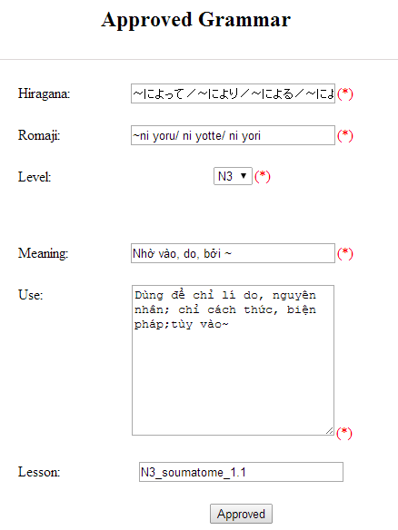
Figure 15.2: Approved grammar screen
Table 15.2: Approved grammar’s screen description:
No | Field name | Type | Require | Mandatory | Max-Length | Description
1 | Hiragana | Text | Text | Y | 200 | Admin input hiragana with length less than 200 characters
2 | Romaji | Text | Text | Y | 200 | Admin input romaji with length less than 200 characters
3 | Meaning | Text | Text | Y | 200 | Admin input meaning with length less than 200 characters
4 | Level | Drop-down list | Click | Y |  | Admin choose the level
5 | Use | Text | Text | Y | 1000 | Admin input how to use with length less than 1000 characters
6 | Lesson | Text | Text | N | 20 | Admin input lesson with length less than 20 characters
7 | Approved | Button | Click | Y |  | Admin click to approved contribute

- Approve contribute vocabulary screen:
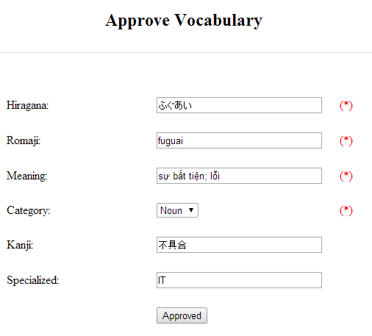
Table 15.3: Approved vocabulary
Table 15.3: Approved vocabulary’s screen description:
No | Field name | Type | Require | Mandatory | Max-Length | Description
1 | Hiragana | Text | Text | Y | 200 | Admin input hiragana with length less than 200 characters
2 | Romaji | Text | Text | N | 200 | Admin input romaji with length less than 200 characters
3 | Meaning | Text | Text | Y | 500 | Admin input meaning with length less than 500 characters
4 | Category | Drop-down list | Click | Y | 10 | Admin choose category
5 | Kanji | Text | Text | N | 10 | Admin input kanji with length less than 10 characters
6 | Specialized | Text | Text | N | 200 | Admin input specialized with length less than 200 characters
7 | Approved | Button | Click | Y |  | Admin click to approved contribute

UC0053 - Specification
Use-case No. | <UC0053> | Use-case Version |  | <1.0>
Use-case Name | Approve contribute content
Author | Minh PT
Date | 09/06/2014 | Priority | <High >
Actor:
Admin
Summary:
When administrator wants to approve contribute content include kanji, grammar, vocabulary in database. User click on link corresponding with kanji, grammar, vocabulary
Triggers
Click on “Contribute Kanji Management” or “Contribute Grammar Management” or “Contribute Vocabulary Management” tab, input data in the right text box then click “Search” button. Click on link corresponding with kanji, grammar, vocabulary which want to approve to database
Preconditions:
- Website is available
- User has to login as Administrator
- All mandatory fields have been filled
- All input data must be valid and have not existed in system
Post Conditions:
Display detail information of contribute content
Main Success Scenario:
Step | User | System
1 | Have logged into system as an admin
2 | Click on “Kanji Management/List contribute kanji” or “Grammar Management/List contribute grammar” or “Vocabulary/List contribute vocabulary” tab | Displays criteria search screen
3 | Fill information that they want to find into text box then click “Search” button | Displays search result
4 | Click “Approved” link corresponding want to update into database | Display Approve kanji screen with these elements:  - Kanji  - Kanji  - Âm hán  - Âm Onyomi  - Âm Kunyoumi  - Meaning  - level  - Reading_id  - Approved  - Grammar:  - Hiragana  - Romaji  - Level  - Meaning  - Use  - Lesson  - Approved  - Vocabulary:  - Hiragana  - Romaji  - Meaning  - Category  - Kanji  - Specialized  - Approved
5 | Edit or add more information and Click “Approved” button | The system validates the input data and then save data into database

Alternative Scenario:
At Step | User | System
5 | Fill information then click on another link | Switch to selected page

Exceptions:
At Step | User | System
5 | Fill information that exited in database into fields then click “Approved” button | Return Error message to inform that data is exiting in database
Reference:

UC0056: < Contact’s content Management > Delete contribute content
UC0054 - Specification
Use-case No. | <UC0054> | Use-case Version |  | <1.0>
Use-case Name | Delete contribute content
Author | Minh PT
Date | 09/06/2014 | Priority | <High >
Actor:
Admin
Summary:
When Administrator wants to delete a contribute content. Admin will search that content then click “Delete” link corresponding.
Triggers
User must click on “Contribute Kanji Management” or “Contribute Grammar Management” or “Contribute Vocabulary Management” tab then search for the contribute content. User click on “Delete” link corresponding with kanji, grammar, vocabulary which want to delete.
Preconditions:
- Website is available
- User has to login as Administrator
Post Conditions:
Kanji, grammar, vocabulary have been deleted from list successfully
Main Success Scenario:
Step | User | System
1 | Have logged into system as an admin
2 | Click on “Contribute Kanji Management ” or “Contribute Grammar Management ” or “Contribute Vocabulary Management ” tab | Displays search result as a table
3 | Click on “Delete” link corresponding with kanji, grammar, vocabulary | Remove that kanji, grammar, vocabulary from list
Reference:

Non-functional Specification

Reliability
- Mean time between failures: The mean time between each failure is expected to be about 480 hours of using.
- Mean time to repair: Immediately when Administrator finds out problem or website is attacked/hacked by someone. Average 1 day.
- The maximum bugs per function are 2 bugs/a function when user uses software within 2 months. The average number of bugs in the software during system testing is about to be around 1 bugs/1000 LOC.
- The database must be backed up daily and can be recovered if necessary

Performance Requirements

Availability
The application must be available 95% of time. Users can access to it everywhere from their
Web browser with internet connection.

Response time
In term of response time, waiting time of processing will be 2 to 5 seconds; time to process any functions will not exceed 7 seconds.

User Interface
● Color: The background color will be white and blue in default. The color of text will
be black or white.
● Text: All texts bases on Helvetica style and title or label will use upper case with the
first letter.

Maintainability
- Coding standards and naming conventions
  - Output of the project must include coding standards and naming conventions documentations. Implementation code must be easy to maintain.
  - All code must be clearly commented, including class, method documentations.
  - If some components are reused, the documentations of those components must also be included.
- Design
  - The design of the system must be loosely coupled that chances on some module will not affect others.
- Logging
  - All the errors should be logged, supporting for bug fixing and maintenance.
  - All strange or sensitive situations should also be logged.

Usability
Usability Requirements support the following from the perspective of its primary users:
● Efficiency of use: user can complete each function in less than 12 actions
● Intuitiveness: all help/error messages are simple to understand; user can know exactly how to do each feature after one time using it.

Security Requirements
In order to avoid unwanted access by strangers, the security implemented in various ways:
- User layer: Each function must be distributed system access and manipulate the individual parts. To edit information, user must declare their username and password before the operation. Functions will be show after users login dependencies user’s role and permission of each user.
- Manage Data Layer: Only Administrator can modify database system.
- Stored Data: All data about information of user, tested, etc.. will be saved in My SQL Server, and be easy for data classification or backup..

Hardware/Software Requirements
● Hardware requirement: PC/Laptop (window 7, window 8, window XP…)
● Software requirements: Web browser (Chrome, Firefox, IE…) with internet connection

