

FPT UNIVERSITY
Capstone Project Document
USEFUL JAPANESE DICTIONARY FOR VIETNAMESE
Report #3 – User Requirement Specification

USEFUL JAPANESE DICTIONARY FOR VIETNAMESE
Group Members
  Lê Đình Nam | SE02316
  Phạm Thị Minh | SE02300
  Nguyễn Ngọc Tuấn | SE02189
  Phạm Tiến Đạt | SE02336
Supervisor | Mr. Nguyễn Văn Sang
Project code | UJD_VN
- Hanoi, 06/2014 -

Table of Contents
1 USER REQUIREMENTS SPECIFICATION 5
1.1 Introduction 5
1.1.1 Purposes 5
1.1.2 Definition and Acronyms 5
1.2 Overall Description 5
1.2.1 Business Process Overview 5
1.2.2 Product Features 8
1.2.3 User Characteristic 10
1.3 Functional Requirements 11
1.3.1 Common Module 11
1.3.2 Account management Module 11
1.3.3 Practice management Module 11
1.3.4 Contact admin Module 11
1.3.5 Admin’s account management 11
1.3.6 Management Member’s account 11
1.3.7 Vocabulary Management 12
1.3.8 Grammar Management 12
1.3.9 Reading Document Management 12
1.3.10 Conversation management 12
1.3.11 Video Management 13
1.3.12 Listening article management 13
1.3.13 Doing test management 13
1.3.14 Contribute content management 13
1.3.15 Contribute opinion management 13
1.3.16 Q&A management 13
1.4 Non – Functional Requirements 13
2 SOFTWARE REQUIREMENTS SPECIFICATION 14
2.1 Introduction 14
2.1.1 Purposes 14
2.1.2 Definition and Acronyms 14
2.2 System Purpose 14
2.3 Scope 14
2.4 Overall Description 14
2.4.1 System overview 14
2.4.2 Product Features 16
2.4.3 User Characteristics 19
2.4.4 User Documentation 19
2.4.5 Assumption 19
2.5 Entity Relation Model 20
2.5.1 Entity-Relationship Diagram 20
2.5.2 Entity Detail 20
2.6 Functional Specification 27
2.6.1 Common Module 27
2.6.2 Account management Module 37
2.6.3 Contact admin Module 49
2.6.4 Practice management Module 58
2.6.5 Admin’s account management 67
2.6.6 Management Member’s account 74
2.6.7 Vocabulary Management 80
2.6.8 Grammar Management 92
2.6.9 Reading Document Management 101
2.6.10 Conversation management 109
2.6.11 Video Management 120
2.6.12 Listening Article Management 129
2.6.13 Doing test management 137
2.6.14 Contributed content management 146
2.6.15 Contributed opinion management 155
2.7 Non-functional Specification 161
2.7.1 Reliability 161
2.7.2 Performance Requirements 161
2.7.3 User Interface 161
2.7.4 Maintainability 161
2.7.5 Usability 162
2.7.6 Security Requirements 162
2.7.7 Hardware/Software Requirements 162

USER REQUIREMENTS SPECIFICATION

Introduction

Purposes
This document will provide the describing of general requirement and non-functional requirements of our UJD system. It also describes the requirement scope of each phase in the project.

Definition and Acronyms
Term | Description
UJD | Useful Japanese Dictionary
Table 3-1: Definition and Acronyms

Overall Description

Business Process Overview
UJD is an online dictionary about. Therefore, that system will implement the following processes

Search workflow
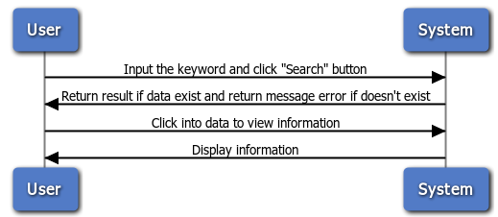
Figure 1-1: Search

Brief description: Everyone can do that search process. It is divided into these steps:
Step 1: User choose the type of search and input the key word into text box.
Step 2: After user click on search button, system will return result match with key word if it exists, and return error message if it does’n exist
Step 3: User can click on result to view information of key word.

Doing test workflow
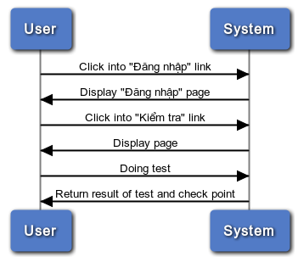
Figure 1-2: Doing test
Brief description: Only member can do test. It divided into these steps:
Step 1: Member click on the “Kiểm tra” link
Step 2: After member click on link, system will display all test on the website
Step 3: User click on any test link and doing test
Step 4: After member successful the test, system will return result of test and check point

Register workflow
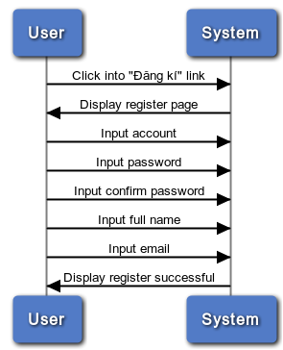
Figure 1-3: Register
Brief description: Only guest can register. It divided into these steps:
Step 1: User (Guest) click on register link
Step 2: System will display register page
Step 3: User insert into all required fields then click on register button. System will check the validation of all inserted fields. If it is invalid, display error message beside wrong fields. If ok, display successful message

Listening conversation
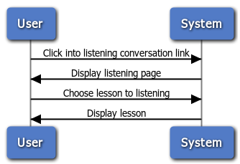
Figure 1-4: Listening conversation
Brief description: Member and guest can train listening. It divided into these steps:
Step 1: User click on listening conversation link
Step 2: System will display listening lesson page
Step 3: User click on any link and listening

Contact admin
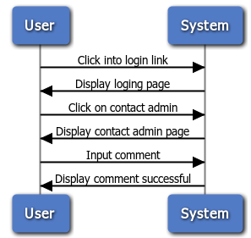
Figure 1-4: Contact admin
Brief description: Only member can contact admin. It is divided into these steps:
Step 1: Member click on contact admin link
Step 2: System will display contact page
Step 3: User input comment
Step 4: System will receive comments and display successful message

Product Features
UJD_VN is an online system, user only connect to internet to use website. System provides these main functions:
  - Manage admin account
System just allows user who logins as Administrator have permission to manage admin account. So that they can add new admin, edit profile, delete admin as they want.

  - Manage member account
System just allows user who logins as Administrator have permission to manage member account. So that they can search member, ban/ unban member, delete member as they want.
  - Manage vocabulary
System just allows user who logins as Administrator have permission to manage vocabulary. So that they can search, add, edit, delete vocabulary as they want.
  - Manage grammar
System just allows user who logins as Administrator have permission to manage grammar. So that they can search, add, edit, delete grammar as they want.
  - Manage reading document
System just allows user who logins as Administrator have permission to manage reading document. So that they can search, add, edit, delete reading document as they want
  - Manage conversation
System just allows user who logins as Administrator have permission to manage conversation. So that they can search, add, edit, delete conversation when they want
  - Manage video
System just allows user who logins as Administrator have permission to manage video. So that they can search, add, edit, delete video as they want
  - Manage listening article
System just allows user who logins as Administrator have permission to manage listening article. So that they can search, add, edit, delete listening article as they want
  - Manage doing test
System just allows user who logins as Administrator have permission to manage doing test. So that they can search, add, edit, delete doing test as they want
  - Manage contributed content
System just allows user who logins as Administrator have permission to manage contributed content. So that they can search, approve, reply, delete
contributed content as they want
  - Manage contributed opinion
System just allows user who logins as Administrator have permission to manage contributed opinion. So that they can search, reply, delete contributed opinion as they want
  - Manage Q&A
System just allows user who logins as Administrator have permission to manage Q&A. So that they can search, reply, delete Q&A as they want
  - Search
Everyone who uses that system can make search with five options: search sentences, search conversation, search grammar, search video, search specialized Japanese.
  - Training listening
Everyone who uses that system can make training listening.
  - Listening conversation
Everyone who uses that system can make listening conversation
  - Reading document
Everyone who uses that system can make reading document such as: Fundamental Japanese document, Intermediate Japanese document, review Japanese document.
  - Doing test
When user registered successfully, user can make doing test then tracking their mark.
  - Contact admin
When user registered successfully, user can make contact admin such as: contribute content, contribute opinion and send any question to admin.
  - Log in/ Log out
When user registered successfully, user can make log in.
  - Edit Profile
When user registered successfully, user can make log in, when logged in, user can edit their profile, change password and track their mark.
  - Forgot password
If user forgot password, user can retake new password.
  - Register
If user do not have account on system, user can use make register.

User Characteristic
There are three main actors that system support:
- Guest: Do not have account on system. In general, they can use almost function of system, exception doing test, contact admin.
- Member: Have account on system, they can use all functions of website. For example: Search, test, train, review …
- Administrator: They can use all functions of normal member and have an Administrator control panel to manage all configuration of system.

Functional Requirements

Common Module
Access right: Guest, Member
That function displays on web and it is used for Guest, Member. They can search by conversation, video, sentences, grammar, specialized japanese.

Account management Module
Access right: Member
That function displays on web and it is used only for Member. Thay can login, logout, edit profile. If they forgot password, they need input right e-mail and login name, and system will sent the passwork to them email.

Practice management Module
Access right: Guest, Member
That function displays on web and it is used for Member and Guest. They can training listening and reading document with materials available on website

Contact admin Module
Access right: Member
That function is used only for member. They have full permissions on contact admin. They can contribute content for database, contribute opinion for website better, send question if member have trouble.

Admin’s account management
Access right: Administrator
This function is only used for Administrator User. Admin can add a new admin, edit information of account or delete an admin to manage system easily and appropriate with system features.

Management Member’s account
Access right: Administrator
This function is only used for Administrator User.
- Search Member: With search function, Admin can look up Member’s account quickly. Admin can search member account by typing member’s id, member’s username, member’s email to look up.
- Ban/Unban Member’s Account: With this function, when a member violate some rules of website, Admin can block these member’s account temporarily, then these account cannot continue to use functions of website. Blocked account will be un-blocked after 3 days. If these account violate rules one more time, Admin can block account permanently.
- Delete Member’s Account: When member’s account is not used a long time, Admin can delete this account from system.

Vocabulary Management
Access right: Administrator
This function is only used for Administrator User.
- Search vocabulary: Admin can search vocabulary by entering hiragana, romaji of vocabulary easily and quickly.
- Add, Edit, Delete Vocabulary: Admin can add a new vocabulary to database, edit information of vocabulary or delete vocabulary from database.

Grammar Management
Access right: Administrator
This function is only used for Administrator User.
- Search Grammar: Admin can search grammar by entering hiragana, romaji of grammar easily and quickly.
- Add, Edit, Delete Grammar: Admin can add a new grammar to database, edit information of grammar or delete grammar from database.

Reading Document Management
Access right: Administrator
This function is only used for Administrator User.
- Search reading document: Admin can search reading document by entering hiragana, romaji of title of article easily and quickly.
- Add, Edit, Delete Reading Document: Admin can add a new article into database to provide reading document for member, edit title, content of article or delete article from database.

Conversation management
Access right: Administrator
This function is only used for Administrator User.
- Search Conversation: Admin can search conversation by entering hiragana and romaji of conversation’s title to manage easier.
- Add, Edit, Delete Conversation: Admin can add a new conversation include information as title, content, Vietnamese meaning. Admin can edit information of a conversation, delete a conversation from database.

Video Management
Access right: Administrator
This function is only used for Administrator User.
- Search Video: Admin can search video by entering hiragana and romaji of video’s title to manage easier.
- Add, Edit, Delete Video: Admin can add a new video’s link and its description to database to provide for member, edit video’s link or delete video’s link.

Listening article management
Access right: Administrator
That function displays only on web version and it is used only for Administrator. They have full permissions on search/add/ edit/ delete Listening Article information as they want.

Doing test management
Access right: Administrator
That function displays only on web version and it is used only for Administrator. They have full permissions on search/add/ edit/ delete Test information as they want.

Contribute content management
Access right: Administrator
That function displays only on web version and it is used only for Administrator. They have full permissions on search/accept/ reply to user/ delete Contributed content as they want.

Contribute opinion management
Access right: Administrator
That function displays only on web version and it is used only for Administrator. They have full permissions on search/ reply to user/ delete Contributed opinion as they want.

Q&A management
Access right: Administrator
That function displays only on web version and it is used only for Administrator. They have full permissions on search/ reply to user / delete Q & A information as they want.

Non – Functional Requirements
- Easy to maintain and upgrade
- Ensure data security capabilities, high performance
- GUI is clear, friendly and easy to use.
- System has clear permission for user and can support for user with multi roles.

SOFTWARE REQUIREMENTS SPECIFICATION

Introduction

Purposes
This document is created as the introduction for project Useful Japanese Dictionary for Vietnamese – our Capstone Project at FPT University. In this document, we will descript the overview of some existing systems, the initial idea for our project, a brief description about our expected system and some potential risks, critical assumptions, constrains. Moreover, this document also shows opportunities what it offers for users.

Definition and Acronyms
This section describes the definitions, terms, and acronyms that are used in software requirements specification.
Items | Description
UJD_VN | Useful Japanese dictionary for Vietnamese
Table 3-1: Definition and Acronyms

System Purpose
That system is developed to help user easily find out information about Japanese (grammar, vocabulary, etc...) and training skill, doing test.

Scope
The scope of this project contains Requirement Analysis, Design, Coding and Testing (Unit Test, Integration Test, and System Test).

Overall Description

System overview
Nowadays, there are many dictionaries which support Japanese. That can be a website or mobile application. All of them have been created for the purpose of helping users search vocabulary or studying Japanese more easily. But we found some disadvantages which existing in website which support users studying Japanese. So, our project – UJD_VN will include some main functions of existing dictionary website and add some special features such as showing examples by Vietnamese, supporting searching specialized vocabulary or users can contribute idea, good knowledge to make our database become larger. Moreover, we will provide freely website to users. Here, we toward provide website for Vietnamese who want to studying Japanese communication or who want to join Japanese certification exams.
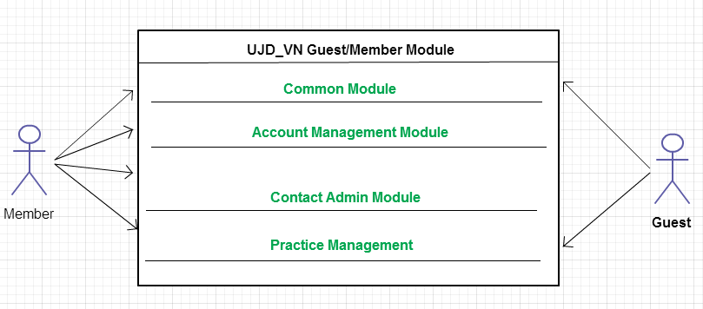
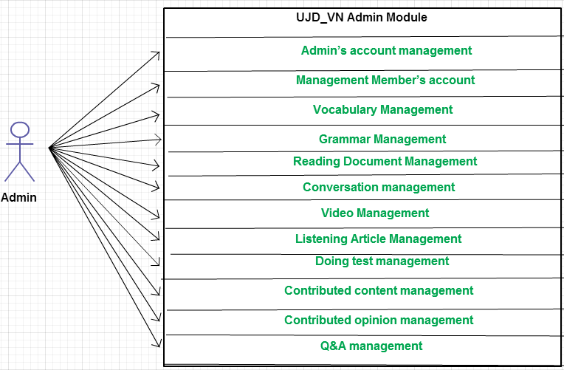

Product Features
Use Case No. | Group of functions | Functions | Glossary | Page
UJD_VN GUEST/MEMBER MODULE
Common Module
 | Search | Search sentences | Tìm kiếm các mẫu câu ví dụ
 | Search | Search conversation | Tìm kiếm các đoạn hội thoại
 | Search | Search grammar | Tìm kiếm ngữ pháp
 | Search | Search video | Tìm kiếm Video tiếng Nhật
 | Search | Search specialized Japanese | Tìm kiếm Tiếng Nhật chuyền ngành
Account Management Module
 | Login | Login by Facebook account | Đăng nhập bằng tài khoản Facebook
 | Login | Login by Google account | Đăng nhập bằng tài khoản Google
 | Login | Login by registered account | Đăng nhập bằng tài khoản tự đăng kí
 |  | Logout | Đăng xuất
 |  | Register | Đăng kí tài khoản cho khách để sử dụng nhiều chức năng hơn của website
 |  | Edit Profile | Chỉnh sửa thông tin cá nhân
 |  | Forgot Password | Quên mật khẩu
Contact Admin Module
 | Contact Admin | Contribute content | Đóng góp database hữu ích cho website
 | Contact Admin | Contribute opinion | Đóng góp ý kiến để phát triển trang web
 | Contact Admin | Send Q & A | Gửi câu hỏi thắc mắc trong quá trình sử dụng Website
Practice Management
 | Doing Test | Test | Làm bài kiểm tra trắc nghiệm
 | Doing Test | Tracking mark | Theo dõi quá trình học tập
 |  | Training Listening | Luyện Nghe trình độ N2,N3,N4
 |  | Listening conversation | Nghe hội thoại
 |  | Reading Document | Đọc tài liệu
UJD_VN ADMIN MODULE
 | Admin’s account management | Add new admin | Thêm mới admin
 | Admin’s account management | Edit profile | Chỉnh sửa thông tin admin
 | Admin’s account management | Delete admin | Xóa thông tin admin
 | Management Member’s account | Search member | Tìm kiếm thành viên
 | Management Member’s account | Ban/Unban Member’s account | Khóa/Mở khóa tài khoản thành viên
 | Management Member’s account | Delete member | Xóa thành viên
 | Vocabulary Management | Search vocabulary | Tìm kiếm từ vựng
 | Vocabulary Management | Add vocabulary | Thêm mới từ vựng
 | Vocabulary Management | Edit vocabulary | Chỉnh sửa thông tin từ vựng
 | Vocabulary Management | Delete vocabulary | Xóa từ vựng
 | Grammar Management | Search grammar | Tìm kiếm ngữ pháp
 | Grammar Management | Add Grammar | Thêm ngữ pháp mới
 | Grammar Management | Edit grammar | Chỉnh sửa ngữ pháp
 | Grammar Management | Delete Grammar | Xóa ngứ pháp
 | Reading Document Management | Search reading document | Tìm kiếm các bài đọc
 | Reading Document Management | Add reading document | Thêm mới các bài đọc
 | Reading Document Management | Edit reading document | Chỉnh sửa thông tin các bài đọc
 | Reading Document Management | Delete reading document | Xóa các bài đọc
 | Conversation management | Search conversation | Tìm kiếm các bài hội thoại
 | Conversation management | Add conversation | Thêm mới bài hội thoại
 | Conversation management | Edit conversation | Chỉnh sửa bài hội thoại
 | Conversation management | Delete conversation | Xóa bài hội thoại
 | Video Management | Search Video | Tìm kiếm Video bằng tiêu đề
 | Video Management | Add Video | Thêm mới video
 | Video Management | Edit Video | Chỉnh sửa nội dung liên quan đến video như tiêu đề.
 | Video Management | Delete Video | Xóa video
 | Listening Article Management | Search listening article | Tìm kiếm các bài nghe
 | Listening Article Management | Add listening article | Thêm mới các bài nghe
 | Listening Article Management | Edit listening article | Chỉnh sửa các bài nghe
 | Listening Article Management | Delete listening article | Xóa các bài nghe
 | Doing test management | Search test | Tìm kiếm bài kiểm tra
 | Doing test management | Add test | Thêm mới bài kiểm tra
 | Doing test management | Edit test | Chỉnh sửa bài kiếm tra
 | Doing test management | Delete test | Xóa bài kiểm tra
Contact’s Content Management
 | Contributed content management | Search contribute content | Tìm kiếm nội dung đóng góp
 | Contributed content management | Approve content | Chấp nhận ý kiến đóng góp
 | Contributed content management | Reply user | Trả lời người dùng
 | Contributed content management | Delete content | Xóa nội dung đóng góp
 | Contributed opinion management | Search contribute opinion | Tìm kiếm ý kiến đóng góp
 | Contributed opinion management | Reply user | Phản hồi lại ý kiến người dùng
 | Contributed opinion management | Delete opinion | Xóa ý kiến đóng góp
 | Q & A Management | Search Q & A | Tìm kiếm Q & A
 | Q & A Management | Reply Q & A | Trả lời Q & A
 | Q & A Management | Delete Q & A | Xóa Q & A

User Characteristics
This website developed towards those who have achieved elementary level Japanese and want to improve intermediate level. The website requires users to have the ability to use a browser with an internet connection. Use can easy use the functions in website, but if they want to use all function, they must be login.

User Documentation
List of document when delivering this application is in the table below:
Name | Description
User Manual | Provide detailed explanation about the system, screens and guide users how to use all features of UJD_VN website.

Assumption
- Receive the guidance and good support of teacher.
- No one of member got sick in the software development process.
- In the development process, no device got fail.
- Every report meets the deadline.
- Team member do not conflict in the work process.

Entity Relation Model

Entity-Relationship Diagram
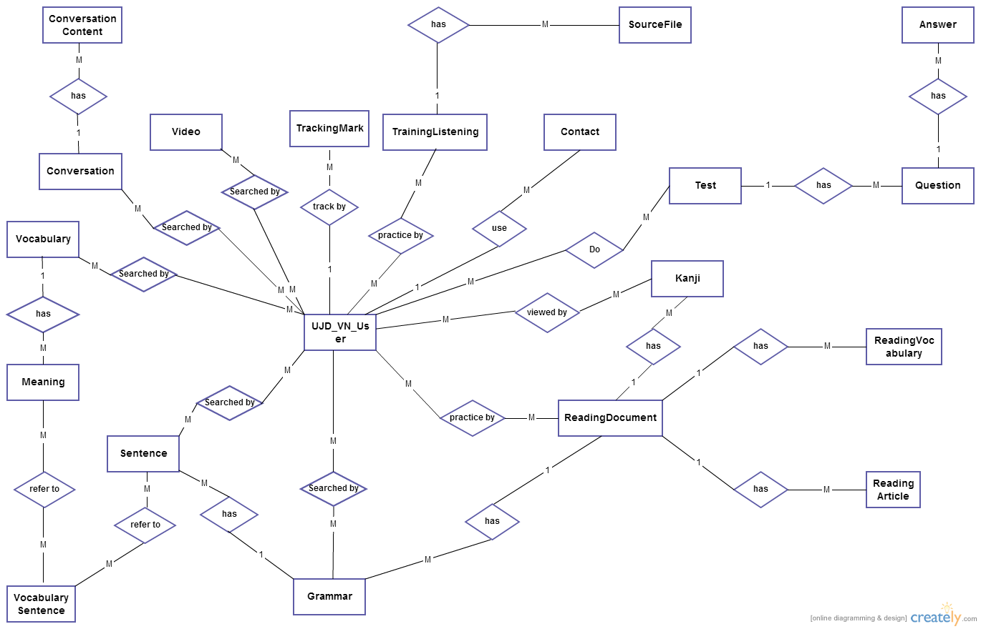

Entity Detail

Vocabulary
Attribute | Type | Mandatory | Description
V_id | Number | PK, Y | The primary key auto generated by the system
V_hiragana | String | Y | Hiragana of vocabulary
V_romaji | String | Y | Romaji of vocabulary
V_specialized | String | N | Specialized Japanese
V_status | Number | N | Status of vocabulary: 0 or 1  + 0: not approved  + 1: approved

Meaning
Attribute | Type | Mandatory | Description
M_id | Number | PK, Y | The primary key auto generated by the system
V_id | Number | FK, Y | Number of vocabulary
M_meaningvn | String | Y | Meaning of vocabulary
M_category | String | Y | Category of vocabulary as noun, verb , adjective.
M_kanji | String | N | Kanji of vocabulary

Vocabulary sentences
Attribute | Type | Mandatory | Description
M_id | Number | FK, Y | Number of Meaning
S_id | Number | FK, Y | Number of vocabulary

Sentence
Attribute | Type | Mandatory | Description
S_id | Number | PK, Y | The primary key auto generated by the system
G_id | Number | FK, Y | Number of Grammar
S_hiragana | String | Y | Hiragana of sentence
S_romaji | String | Y | Romaji of sentence.
S_meaning | String | Y | Meaning of sentence in Vietnamese
S_kanji | String | N | Kanji of sentence

Grammar
Attribute | Type | Mandatory | Description
G_id | Number | PK, Y | The primary key auto generated by the system
G_hiragana | String | Y | Hiragana of Grammar
G_romaji | String | Y | Romaji of Grammar
G_level | String | Y | Level Grammar as N1, N2, N3, N4, N5
G_meaning | String | Y | Meaning of Grammar
G_use | String | Y | Using of Grammar
G_status | Number | N | Status of grammar: 0 or 1  + 0: not approved  + 1: approved
Reading_id | String | FK, Y | The foreign key of ReadingDocument

Video
Attribute | Type | Mandatory | Description
Vi_id | Number | PK, Y | The primary key auto generated by the system
Vi_title | String | Y | Title of Video
Vi_link | String | Y | Link of Video

Kanji
Attribute | Type | Mandatory | Description
K_id | Number | PK, Y | The primary key auto generated by the system
K_kanji | String | Y | Kanji
K_hanviet | String | Y | “Âm hán việt”
K_onyomi | String | Y
K_kunyomi | String | N
K_meaning | String | Y
K_level | String | Y
K_status | Number | N
Reading_id | String | FK, Y | The foreign key of ReadingDocument

Conversation
Attribute | Type | Mandatory | Description
C_id | String | PK, Y | The primary key to identify conversations
C_level | String | Y | Level of conversation as elementary, intermediate
C_title | String | Y | Title of conversation

Conversation content
Attribute | Type | Mandatory | Description
Con_id | Number | PK, Y | The primary key auto generated by the system
C_id | String | Y | Foreign key
Con_hiragana | String | Y | Hiragana of conversation
Con_romaji | String | Y | Romaji of conversation
Con_meaning | String | Y | Meaning of conversation

User
Attribute | Type | Mandatory | Description
U_id | Number | PK, Y | The primary key auto generated by the system
U_username | String | Y | Username to login system
U_password | String | Y | Password to login system
U_role | Number | Y | Role of user as member, admin
U_fullname | String | N | Fullname of user
U_email | String | Y | Email of user
U_registerdate | String | Y | Date which user register account
U_status | Number | N | Status of user
U_repass | String | N | Require re-new password when user forgot password

Contact
Attribute | Type | Mandatory | Description
Contact_id | Number | PK, Y | The primary key auto generated by the system
Contact_email | String | Y | Email which user can use to contact admin
Contact_content | String | Y | Content of contact
Contact_type | String | Y | Type of contact as contribute opinion or Q & A
Contact_status | Number | Y | Status of contact: 0 or 1  + 0: not reply  + 1: replied

Training Listening
Attribute | Type | Mandatory | Description
Lis_id | String | PK, Y | The primary key to identify Training Listening
Lis_level | String | Y | Level of Listening as N1, N2, N3, N4, N5

Source file
Attribute | Type | Mandatory | Description
Sourcefile_id | String | PK, Y | The primary key to identify Sourcefile
Lis_id | Number | FK,Y | Foreign key, id of TrainingListening
Sourcefile_question | String | Y | Question of listening file
Sourcefile_script | String | Y | Script of content file
Sourcefile_meaning | String | Y | Meaning of content file

Reading document
Attribute | Type | Mandatory | Description
Reading_id | String | PK, Y | The primary key to identify ReadingDocument
Reading_title | String | Y | Title of Reading Document
Reading_level | String | Y | Level of Reading Document as N1, N2, N3, N4, N5

Reading vocabulary
Attribute | Type | Mandatory | Description
Readingvocabulary_id | Number | PK, Y | The primary key auto generated by the system
Reading_id | String | FK, Y | Foreign key, id of ReadingDocument
Readingvocabulary_hiragana | String | Y | Hiragana of vocabulary
Readingvocabulary_meaning | String | Y | Meaning of vocabulary
Readingvocabulary_kanji | String | N | Kanji of vocabulary

Reading article
Attribute | Type | Mandatory | Description
Readingarticle_id | Number | PK, Y | The primary key auto generated by the system
Reading_id | String | FK, Y | Foreign key, id of ReadingDocument
Readingarticle_content | String | Y | Content of Reading Article
Readingarticle_question | String | Y | Question of Reading Article
Reading_answer | String | N | Answer of Reading Article

Tracking mark
Attribute | Type | Mandatory | Description
Tm_id | Number | PK, Y | The primary key auto generated by the system
U_id | Number | FK, Y | Foreign key, id of ReadingDocument
Test_id | String | FK, Y | Foreign key, id of Test
Tm_mark | Number | Y | Mark of Test
Tm_date | String | Y | Date of doing test

Test
Attribute | Type | Mandatory | Description
Test_id | String | PK, Y | The primary key to identify tests
Test_category | String | Y | Category of Test as Reading, Grammar, Kanji, Vocabulary
Test_level | String | Y | Level of Test as N1, N2, N3, N4, N5
Test_content | String | Y | Content of Test

Question
Attribute | Type | Mandatory | Description
Question_id | Number | PK, Y | The primary key auto generated by the system
Test_id | String | FK, Y | Foreign key, id of Test
Question_content | String | Y | Content of question

Answer
Attribute | Type | Mandatory | Description
Answer_id | Number | PK, Y | The primary key auto generated by the system
Question_id | Number | FK, Y | Foreign key, id of Question
Answer_content | String | Y | Content of answer
Answer_correct | Number | Y | Correct answer

Functional Specification

Common Module

Use Case Diagram
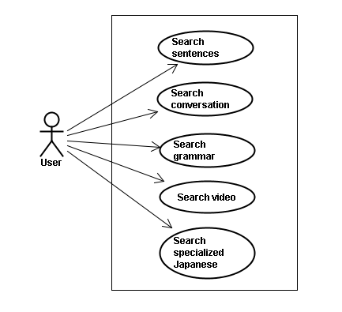

Use Case Specification
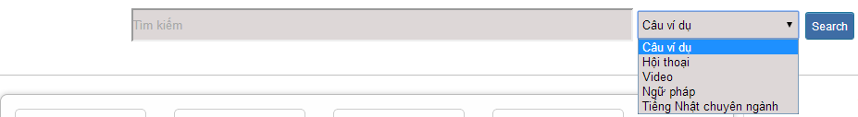
No | Field name | Type | Require | Mandatory | Length | Description
1 | Searcharea | Text | Text | Y | 200 | User input a new word with length less than 200 characters
2 | SearchOption | Drop-down list | Click | Y |  | User choose type of search
2 | Search | Button | Click | Y |  | User click on search button

UC001: <Common module> Search sentences
UC001 – Search sentences
Use-case No. | <UC001> | Use-case Version |  | <1.0>
Use-case Name | Search sentences
Author | Tuan NN
Date | 09/06/2014 | Priority | <High >
Actor:
Guest, Member, Administrator
Summary:
When Guest, Member, Administrator want to search by sentences in database successfully if it is existed
Triggers
Click on search area , input sentences in the text area, choose type of search and then click “Search” button
Preconditions:
- Website is available
- User have to input data in search area
Post Conditions:
Display detail information of sentences
Main Success Scenario:
Step | User | System
1 | Enter website link on web browser | Display Home page screen
2 | Input data in search area and choose “Câu ví dụ” type then click button Search | Display “sentences information” screen that contains the information of chosen sentences with these elements:  - Serial number  - Name of sentences by hiragana  - Name of sentences by romaji  - Meaning of sentences

Alternative Scenario:
At Step | User | System
2 | Input data in search area and choose “Câu ví dụ” type then click on another link | Switch to selected page

Exceptions:
At Step | User | System
2 | Fill data that they want to find (that do not exist in database) into these fields then click “Search” button | Return Error message to inform that sentences cannot be found

UC002: <Common module> Search conversation
UC002 – Search conversation
Use-case No. | <UC002> | Use-case Version |  | <1.0>
Use-case Name | Search conversation
Author | Tuan NN
Date | 09/06/2014 | Priority | <High >
Actor:
Guest, Member, Administrator
Summary:
When Guest, Member, Administrator want to search by conversation in database successfully if it is existed
Triggers
Click on search area , input conversation in the text area, choose type of search and then click “Search” button
Preconditions:
- Website is available
- User have to input data in search area
Post Conditions:
Display detail information of conversation
Main Success Scenario:
Step | User | System
1 | Enter website link on web browser | Display Home page screen
2 | Input data in search area and choose “Hội thoại” type then click button Search | Display “conversation information” screen that contains the information of chosen conversation with these elements:  - Serial number  - Name of conversation by hiragana  - Name of conversation by romaji  - Meaning of conversation

Alternative Scenario:
At Step | User | System
2 | Input data in search area and choose “Hội thoại” type then click on another link | Switch to selected page

Exceptions:
At Step | User | System
2 | Fill data that they want to find (that do not exist in database) into these fields then click “Search” button | Return Error message to inform that conversation cannot be found

UC003: <Common module> Search grammar
UC003 – Search grammar
Use-case No. | <UC003> | Use-case Version |  | <1.0>
Use-case Name | Search grammar
Author | Tuan NN
Date | 09/06/2014 | Priority | <High >
Actor:
Guest, Member, Administrator
Summary:
When Guest, Member, Administrator want to search by grammar in database successfully if it is existed
Triggers
Click on search area , input grammar in the text area, choose type of search and then click “Search” button
Preconditions:
- Website is available
- User have to input data in search area
Post Conditions:
Display detail information of grammar
Main Success Scenario:
Step | User | System
1 | Enter website link on web browser | Display Home page screen
2 | Input data in search area and choose “Ngữ pháp” type then click button Search | Display “grammar information” screen that contains the information of chosen grammar with these elements:  - Serial number  - Name of grammar by hiragana  - Name of grammar by romaji  - Meaning of grammar

Alternative Scenario:
At Step | User | System
2 | Input data in search area and choose “Ngữ pháp” type then click on another link | Switch to selected page

Exceptions:
At Step | User | System
2 | Fill data that they want to find (that do not exist in database) into these fields then click “Search” button | Return Error message to inform that grammar cannot be found

UC004: <Common module> Search video
UC004 – Search video
Use-case No. | <UC004> | Use-case Version |  | <1.0>
Use-case Name | Search video
Author | Tuan NN
Date | 09/06/2014 | Priority | <High >
Actor:
Guest, Member, Administrator
Summary:
When Guest, Member, Administrator want to search by video in database successfully if it is existed
Triggers
Click on search area , input video in the text area, choose type of search and then click “Search” button
Preconditions:
- Website is available
- User have to input data in search area
Post Conditions:
Display detail information of video
Main Success Scenario:
Step | User | System
1 | Enter website link on web browser | Display Home page screen
2 | Input data in search area and choose “Video” type then click button Search | Display “video information” screen that contains the information of chosen video with these elements:  - Serial number  - Name of video by hiragana  - Name of video by romaji  - Meaning of video

Alternative Scenario:
At Step | User | System
2 | Input data in search area and choose “Video” type then click on another link | Switch to selected page

Exceptions:
At Step | User | System
2 | Fill data that they want to find (that do not exist in database) into these fields then click “Search” button | Return Error message to inform that video cannot be found

UC005: <Common module> Search specialized Japanese
UC005 – Search specialized Japanese
Use-case No. | <UC005> | Use-case Version |  | <1.0>
Use-case Name | Search specialized Japanese
Author | Tuan NN
Date | 09/06/2014 | Priority | <High >
Actor:
Guest, Member, Administrator
Summary:
When Guest, Member, Administrator want to search by specialized Japanese in database successfully if it is existed
Triggers
Click on search area , input specialized Japanese in the text area, choose type of search and then click “Search” button
Preconditions:
- Website is available
- User have to input data in search area
Post Conditions:
Display detail information of video
Main Success Scenario:
Step | User | System
1 | Enter website link on web browser | Display Home page screen
2 | Input data in search area and choose “Tiếng Nhật chuyên ngành” type then click button Search | Display “specialized Japanese information” screen that contains the information of chosen specialized Japanese with these elements:  - Serial number  - Name of specialized Japanese by hiragana  - Name of specialized Japanese by romaji  - Meaning of specialized Japanese

Alternative Scenario:
At Step | User | System
2 | Input data in search area and choose “Tiếng Nhật chuyên ngành” type then click on another link | Switch to selected page

Exceptions:
At Step | User | System
2 | Fill data that they want to find (that do not exist in database) into these fields then click “Search” button | Return Error message to inform that specialized Japanese cannot be found

Account management Module

Use Case Diagram
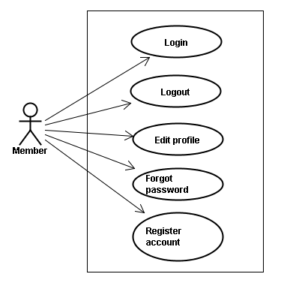

Use Case Specification

UC006: <Account management module> Login
No |  | Field name | Type |  | Require | Mandatory |  | Length |  |  | Description
1 |  | Username | Text |  | Text | Y |  | 32 |  |  | User input username with length less than 32 character
2 |  | Password | Password |  | Text | Y |  | 32 |  |  | User input their password with length less than 32 characters
3 |  | Login | Button |  | Click | Y |  |  |  |  | User click on Login button
 | UC006 – Login
 | Use-case No. |  |  | <UC006> |  |  | Use-case Version |  |  | <1.0>
 | Use-case Name |  |  | Login
 | Author |  |  | Tuan NN
 | Date |  |  | 09/06/2014 |  |  | Priority |  | <High >
Actor:
Member, Administrator
Summary:
When Member, Administrator want to login by Facebook/Google/Register account to use more functions in website
Triggers
User choose the login method, input data and click on login button
Preconditions:
- Website is available
- Account Facebook/Google/Register must be exist and correctly
Post Conditions:
Login successfully and redirect user to previous page.
Main Success Scenario:
Step | User | System
1 | Enter website link on web browser | Display Homepage screen
2 | Choose login method ( login by Facebook/Google/register account), input account and password and then click “Đăng nhập” button | Validate information and log user into system.

Alternative Scenario:
At Step | User | System
2 | Input data in username and password area then click on another link | Switch to selected page

Exceptions:
At Step | User | System
3 | Fill incorrect or missing information “Tên đăng nhập”/ “Mật khẩu” field | Return Error message beside “Tên đăng nhập”/ “Mật khẩu” field.

UC007: <Account management module> Logout
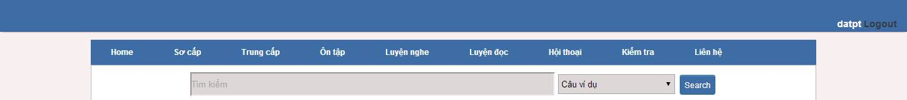
No | Field name | Type | Require | Mandatory | Length | Description
1 | Logout | Button | Click | Y |  | User click on Logout button

UC007 – Logout
Use-case No. | <UC007> | Use-case Version |  | <1.0>
Use-case Name | Logout
Author | Tuan NN
Date | 09/06/2014 | Priority | <High >
Actor:
Member, Admin
Summary:
When Member, Admin want to logout their account
Triggers
Click on logout button
Preconditions:
- Website is available
- Member, Admin must be login
Post Conditions:
Redirect user to previous page.
Main Success Scenario:
Step | User | System
1 | Click on logout button | Redirect to homepage

UC008: <Account management Module>: Register account
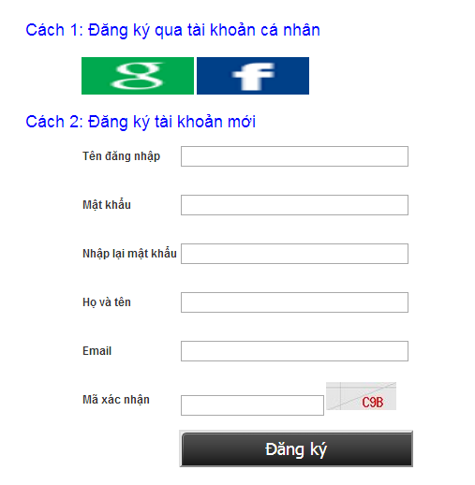
No | Field name | Type | Require | Mandatory | Length | Description
1 | Username | Text | Text | Y | 32 | User input username with length less than 32 characters
2 | Password | Password | Text | Y | 32 | User input their password with length less than 32 characters
3 | Repassword | Password | Text | Y | 32 | User re-input password with length less than 32 characters
4 | Name | Text | Text | Y | 50 | User input their name with length less than 50 characters
5 | Email | Text | Text | Y | 100 | User input email with length less than 32 characters
6 | Capcha | Text | Txt | Y | 100 | User input the verification code
7 | Register | Button | Click | Y |  | User click Register button

UC008 – Register account
Use-case No. | <UC008> | Use-case Version |  | <1.0>
Use-case Name | Register
Author | Tuan NN
Date | 09/06/2014 | Priority | <High >
Actor:
Guest
Summary:
Visitor can create new account to use more function as a register user
Triggers
Click on register link on the website
Preconditions:
- Website is available
Post Conditions:
Create account for guest
Main Success Scenario:
Step | User | System
1 | Enter website link on web browser | Display Homepage screen
2 | Click on register link | Display register form
3 | Enter necessary and mandatory information and click "Đăng kí" button. | Display message to register successfully and redirect to homepage

Alternative Scenario:
At Step | User | System
3 | Enter necessary and mandatory information and click another link | Switch to selected page

Exceptions:
At Step | User | System
3 | Missing “Tên đăng nhập” field and click “Đăng kí” button | Display error message beside “Tên đăng nhập” field.
3 | Enter incorrect information or missing “Mật khẩu” field and click “Đăng kí” button | Display error message beside “Mật khẩu” field.
3 | Missing “Họ và tên” field and click “Đăng kí” button | Display error message beside “Họ và tên” field.
3 | Missing “Email” field and click “Đăng kí” button | Display error message
3eside “Email” field. | Enter incorrect information or missing “Mã xác nhận” field and click “Đăng kí” button | Display error message beside “Mã xác nhận” field.

UC009: <Account management Module>: Edit profile
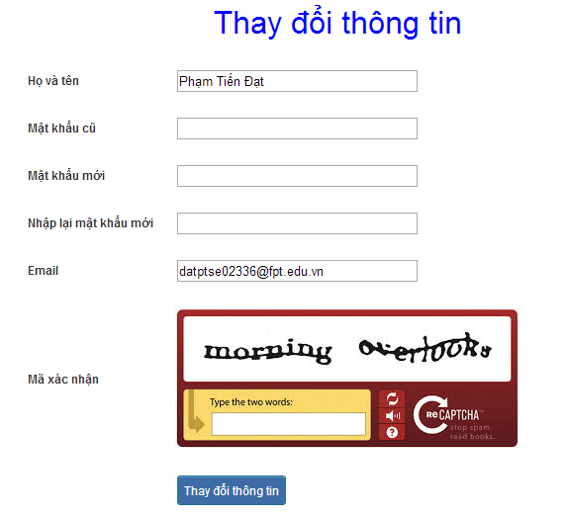
No | Field name | Type | Require | Mandatory | Length | Description
1 | Name | Text | Text | Y | 32 | User input their name with length less than 32 characters
2 | Old-Password | Password | Text | Y | 32 | User input their old password with length less than 32 characters
3 | New-password | Password | Text | Y | 32 | User input new password with length less than 32 characters
4 | Repassword | Password | Text | Y | 32 | User re-input password with length less than 32 characters
5 | Email | Text | Text | Y | 100 | User input email to with length less than 100 characters
6 | Capcha | Text | Text | Y | 100 | User input the verification code
7 | Edit | Button | Click | Y |  | User click on Edit button

UC009 – Edit profile
Use-case No. | <UC009> | Use-case Version |  | <1.0>
Use-case Name | Edit profile
Author | Tuan NN
Date | 09/06/2014 | Priority | <High >
Actor:
Member
Summary:
When member want to change their profile
Triggers
Login the website and click on the edit profile link
Preconditions:
- Website is available
- Member login the website
Post Conditions:
Edit profile successful and redirect user to edited profile page
Main Success Scenario:
Step | User | System
1 | Enter website link on web browser | Display Homepage screen
2 | Enter necessary and mandatory information and click "Login” | Redirect to previous page and logged user into system.
3 | Click on "Trang cá nhân" link. | Display “Trang cá nhân” page
4 | User changes profile and click “Lưu” button | Update new profile

Alternative Scenario:
 | t Step  User | System
4 | Enter necessary and mandatory information and click another link | Switch to selected page

Exceptions:
At Step | User | System
4 | Enter new password that incorrect form or missing information and click “Lưu” button | Display er
4o  message | Enter new email that incorrect form or missing information and click “Lưu” button | Display error message

UC010: <Account management Module>: Forgot password
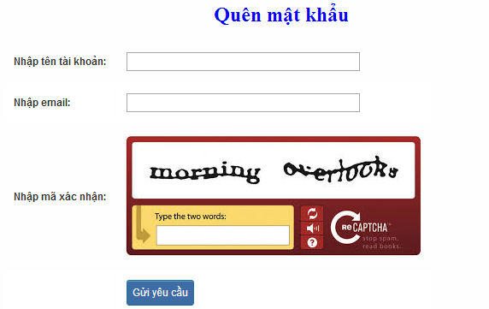
No | Field name | Type | Require | Mandatory | Length | Description
1 | Username | Text | Text | Y | 32 | User input username with length less than 100 characters
2 | Email | Text | Text | Y | 100 | User input email with length less than 100 characters
3 | Capcha | Text | Text | Y | 100 | User input the verification code
4 | Send | Button | Click | Y |  | User click on Send button

UC010 – Forgot password
Use-case No. | <UC010> | Use-case Version |  | <1.0>
Use-case Name | Forgot password
Author | Tuan NN
Date | 09/06/2014 | Priority | <High >
Actor:
Member, Admin
Summary:
When Member, Admin forgot their password to login the system, this function will receiving their password to email
Triggers
Click on forgot password link on the website
Preconditions:
- Website is available
Post Conditions:
Receiving their password to their email
Main Success Scenario:
Step | User | System
1 | Enter website link on web browser | Display Homepage screen
2 | Click on “Quên mật khẩu | link.  Display “Quên mật khẩu” page
3 | Enter necessary and mandatory information in the “Quên mật khẩu” form and click "Gửi yêu cầu" button. | System will send the password into your email.

Alternative Scenario:
At Step | User | Syste
3 | Enter necessary and mandatory information and click another link | Switch to selected page

Exceptions:
At Step | User | System
3 | Enter email incorrect with email that use to register account | Display error message and request to re-enter email
3 | Enter account incorrect | Display error message and request to re-enter account

Contact admin Module

Use case diagram
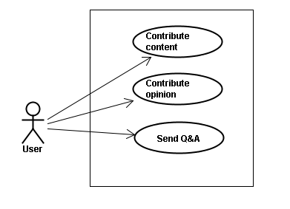

Use Case Specification

UC011 <Contact admin Module>: Contribute content
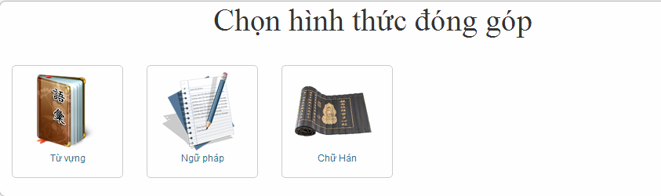
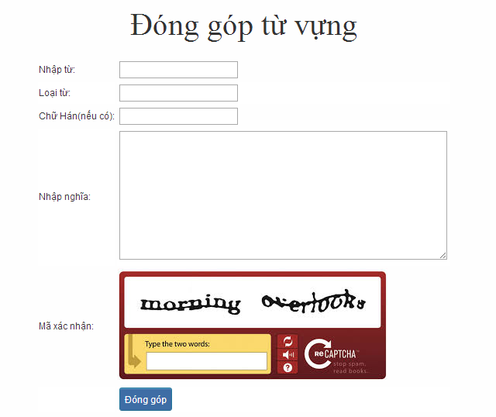
No |  | Field name | Type |  | Require | Mandatory |  | Length |  | Description
1 |  | Tu | Text |  | Text | Y |  | 100 |  | User input vocabulary with length less than 100 characters
2 |  | Loaitu | Text |  | Text | Y |  | 100 |  | User input kind of vocabulary with length less than 100 characters
3 |  | Kanji | Text |  | Text | Y |  | 100 |  | User input kanji of vocabulary (if exist) with length less than 100 characters
4 |  | Mean | Text |  | Text | Y |  | 100 |  | User input mean of vocabulary with length less than 100 characters
5 |  | Capcha | Text |  | Text | Y |  | 100 |  | User input the verification code
6 |  | Donggop | Button |  | Click | Y |  |  |  | User click on Donggop button
 | UC011 – Contribute content
 | Use-case No. |  |  | <UC011> |  |  | Use-case Version |  |  |  | <1.0>
 | Use-case Name |  |  | Contribute content
 | Author |  |  | Tuan NN
 | Date |  |  | 09/06/2014 |  |  | Priority |  | <High >
Actor:
Member
Summary:
When Member want to contribute content for website
Triggers
User enter website link and click on “Liên hệ” link on the website
Preconditions:
- Website is available
- User must be login to the website
Post Conditions:
Receive opinions and redirect user to contact page
Main Success Scenario:
Step | User | System
1 | Enter website link on web browser | Display Homepage screen
2 | Enter necessary and mandatory information and click "Login” | Redirect to previous page and logged user into system.
3 | Click on “Liên hệ”->”Đóng góp database” section | Display “Đóng góp database” page
4 | Enter information that member want to contribute for the website then click “Đóng góp” | System will receive contributions

Alternative Scenario:
At Step | User | System
4 | Enter necessary and mandatory information and click another link | Switch to selected page

Exceptions:
At Step | User | System
4 | Missing “Nhập từ” field and click “Đóng góp” button | Display error message beside “Nhập từ” field.
4 | Missing “Loại từ” field and click “Đóng góp” button | Display error message beside “Loại từ” field.
4 | Missing “Nhập nghĩa” field and click “Đóng góp” button | Display error message beside “Nhập nghĩa” field.
4 | Enter incorrect information or missing “Mã xác nhận” field and click “Đóng góp” button | Display error message beside “Mã xác nhận” field.

UC012 <Contact admin Module>: Contribute opinion
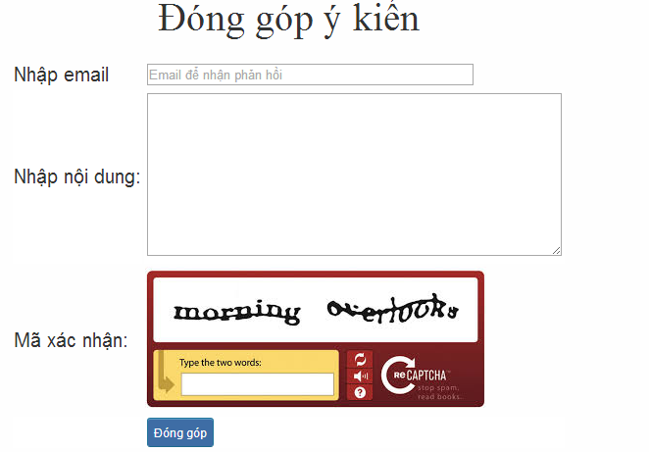
No | Field name | Type | Require | Mandatory | Length | Description
1 | Email | Text | Text | Y | 100 | User input email with length less than100 characters
2 | Content | Text | Text | Y | 1000 | User input content with length less than1000 characters
3 | Capcha | Text | Text | Y | 100 | User input the verification code
4 | Donggop | Button | Click | Y |  | User click on Donggop button

UC012 – Contribute opinion
Use-case No. | <UC012> | Use-case Version |  | <1.0>
Use-case Name | Contribute opinion
Author | Tuan NN
Date | 09/06/2014 | Priority | <High >
Actor:
Member
Summary:
When Member want to contribute opinion for website
Triggers
User enter website link and click on “Liên hệ” link on the website
Preconditions:
- Website is available
- User must be login to the website
Post Conditions:
Receive opinions and redirect user to contact page
Main Success Scenario:
Step | Use | System
1 | Enter website link on web browser | Display Homepage screen
2 | Enter necessary and mandatory information and click "Login” | Redirect to previous page and logged user into system.
3 | Click on “Liên hệ”->”Đóng góp ý kiến” section | Display “Đóng góp ý kiến” page
4 | Enter information that member want to contribute for the website then click “Đóng góp” | System will receive contributions
Alternative Scenario:
At Step | User | Syst
4m | Enter necessary and mandatory information and click another link | Switch to selected page

Exceptions:
At Step | User | System
4 | Missing “Nhập email” field and click “Đóng góp” button | Display error message beside “Nhập email” field.
4 | Missing “Nhập nội dung:” field and click “Đóng góp” button | Display error message beside “Nhập nội dung:” field.
4 | Enter incorrect information or missing “Mã xác nhận” field and click “Đóng góp” button | Display error message beside “Mã xác nhận” field.

UC013 <Contact admin Module>: Send Q&A
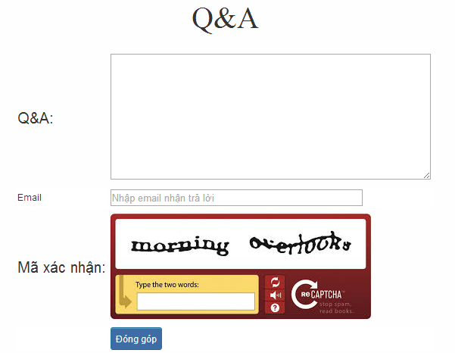
No | Field name | Type | Require | Mandatory | Length | Description
1 | QA | Text | Text | Y | 1000 | User input Q&A with length less than 1000 characters
2 | Email | Text | Text | Y | 100 | User input email with length less than 100 characters
3 | Capcha | Text | Text | Y | 100 | User input the verification code
4 | Donggop | Button | Click | Y |  | User click on Donggop button

UC013 – Send Q&A
Use-case No. | <UC013> | Use-case Version |  | <1.0>
Use-case Name | Send Q&A
Author | Tuan NN
Date | 09/06/2014 | Priority | <High >
Actor:
Member
Summary:
When Member have the question, they can create Q&A
Triggers
Click on “Liên hệ” link on the website
Preconditions:
- Website is available
- User must be login to the website
Post Conditions:
Add new Q&A into the website
Main Success Scenario:
Step | User | System
1 | Enter website link on web browser | Display Homepage screen
2 | Enter necessary and mandatory information and click "Login” | Redirect to previous page and logged user into system.
3 | Click on “Q&A” section | Display “Q&A” page
4 | Enter necessary and mandatory information in the “Q&A” form and click "Gửi" button. | Display this Q&A in the “Q&A”section.

Alternative Scenario:
At Step | User | System
4 | Enter necessary and mandatory information and click another link | Switch to selected page

Exceptions:
At Step | User | System
4 | Missing “Nhập email” field and click “Đóng góp” button | Display error message beside “Nhập email” field.
4 | Missing “Q&A” field and click “Đóng góp” button | Display error message beside “Q&A” field.
4 | Enter incorrect information or missing “Mã xác nhận” field and click “Đóng góp” button | Display error message beside “Mã xác nhận” field.

Practice management Module

Use case diagram
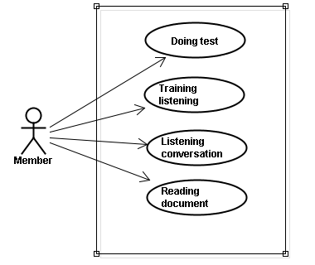

Use case specification

UC014 <Practice management Module>: Doing test
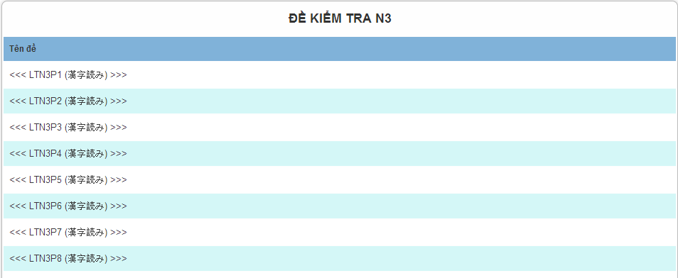
Screen description: This is doing test screen ( N3 test screen). At here, user can doing test in the website, they click on one of test link
UC014 – Doing test
Use-case No. | <UC014> | Use-case Version |  | <1.0>
Use-case Name | Doing test
Author | Tuan NN
Date | 09/06/2014 | Priority | <High >
Actor:
Member
Summary:
This function will help users do the online quiz and check the answers, grading and evaluation capabilities
Triggers
User going to website, login and then click on “Kiểm tra” link on the website
Preconditions:
- Website is available
- User must be login to the website
Post Conditions:
Doing test in the website
Main Success Scenario:
Step | User | System
1 | Enter website link on web browser | Display Homepage screen
2 | Enter necessary and mandatory information and click "Login” | Redirect to previous page and logged user into system.
3 | Click on “Kiểm tra” section | Display “Kiểm tra” page
4 | Choose one of items that you want to doing test | Display that item’s page
5 | Doing test | Check the answer, grading after finish

Alternative Scenario:
At Step | User | System
5 | While doing test, click another link | Switch to selected page

Exceptions:
At Step | User | System

UC015 <Practice management Module>: Trainng listening
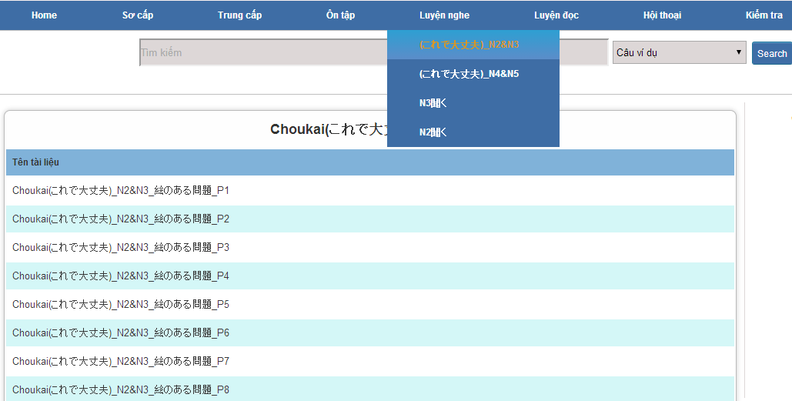
Screen description: This is training listening screen. At here, user can training listening in the website, there are some lesson to traning in the training listening.
UC015 – Training listening
Use-case No. | <UC015> | Use-case Version |  | <1.0>
Use-case Name | Training listening
Author | Tuan NN
Date | 09/06/2014 | Priority | <High >
Actor:
Guest, Member
Summary:
This function provide users some the listening of level N2, N3, N4 to help users training listening skill
Triggers
User going to website and click on “Luyện nghe” link on the website
Preconditions:
- Website is available
Post Conditions:
Training listening in the website
Main Success Scenario:
Step | User | System
1 | Enter website link on web browser | Display Homepage screen
2 | Click on “Luyện nghe” section | Display “Luyện nghe” page

Alternative Scenario:
At Step | User | System
4 | While listening, click another link | Switch to selected page

Exceptions:
At Step | User | System

UC016 <Practice management Module>: Listening conversation
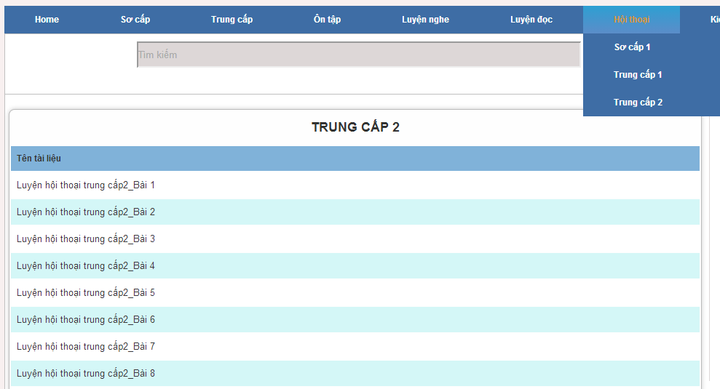
Screen description: This is listening conversation screen. At here, user can training listening conversation in the website, there are some lesson to traning in the listening conversation.
UC016 – Listening conversation
Use-case No. | <UC016> | Use-case Version |  | <1.0>
Use-case Name | Listening conversation
Author | Tuan NN
Date | 09/06/2014 | Priority | <High >
Actor:
Guest, Member
Summary:
This function provide users some the conversation in everyday life and common situations (eg: restaurants, shopping, in hospital ..)
Triggers
Click on “Hội thoại” link on the website
Preconditions:
- Website is available
Post Conditions:
Listening conversation in the website
Main Success Scenario:
Step | User | System
1 | Enter websi | e link on web browser  Display Homepage screen
2 | Click on “Hội thoại” section | Display “Hội thoại” page

Alternative Scenario:
At Step | User | System
4 | While listening, click another link | Switch to selected page

Exceptions:
At Step | User | System

UC017 < Practice management Module>: Reading document
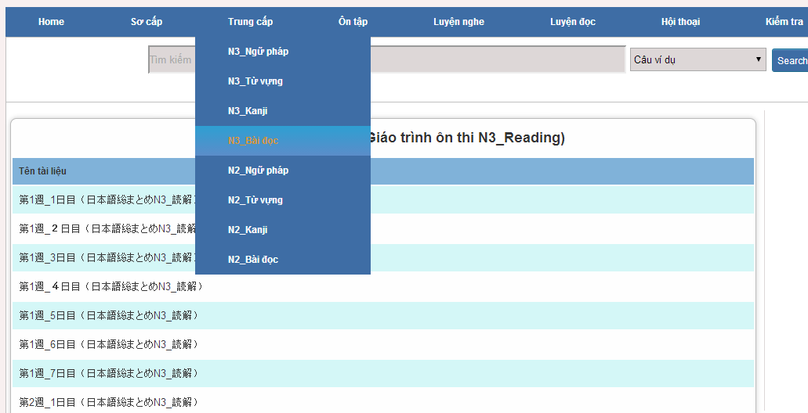
Screen description: This is reading screen. At here, user can read document in the website, there are some lesson to reading in the reading document.
UC017 – Reading document
Use-case No. | <UC017> | Use-case Version |  | <1.0>
Use-case Name | Reading document
Author | Tuan NN
Date | 09/06/2014 | Priority | <High >
Actor:
Guest, Member
Summary:
This function provide users some document : elementary, intermediate and review.
Triggers
Click on “N3/N2 Bài đọc” link on the website
Preconditions:
- Website is available
Post Conditions:
Reading document in the website
Main Success Scenario:
Step | User | System
1 | Enter website link on web browser | Display Homepage screen
2 | Click on “Bài đọc” section | Display “Bài đọc” page

Alternative Scenario:
At Step | User | System
4 | While reading, click another link | Switch to selected page

Exceptions:
At Step | User | System

Admin’s account management

Use case diagram
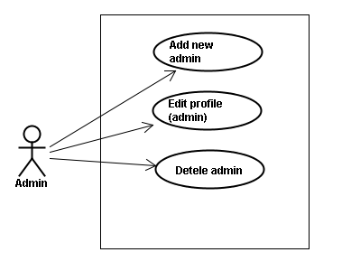

Use case specifications

UC018 <Admin’s account management>: Add new admin
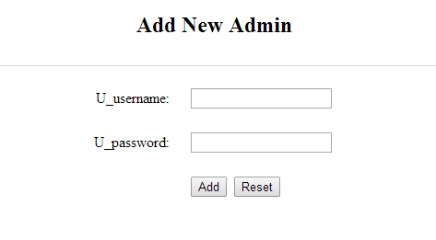
No | Field name | Type | Require | Mandatory | Length | Description
1 | Username | Text | Text | Y | 100 | Admin input username of admin’s account with length less than 100 characters
2 | Password | Text | Text | Y | 100 | Admin input password of admin’s account with length less than 100 characters
3 | Add | Button | Click | Y |  | Admin add new admin
4 | Reset | Button | Click | N |  | Admin reset information that input to add

UC018 – Add new admin
Use-case No. | <UC018> | Use-case Version |  | <1.0>
Use-case Name | Add new admin
Author | Tuan NN
Date | 09/06/2014 | Priority | <High >
Actor:
Admin
Summary:
Administrator can add new admin
Triggers
Admin login the website and click on add new admin link on the website
Preconditions:
- Website is available
- Admin login to the website
Post Conditions:
New admin be added successfully
Main Success Scenario:
Step | User | System
1 | Enter website link on web browser | Display Homepage screen
2 | Enter necessary and mandatory information and click "Login” | Redirect to previous page and logged admin into system.
3 | Click on add new admin section | Display add new admin page
4 | Enter account that you want to add | Add new admin and display message to add new successfully

Alternative Scenario:
At Step | User | System
4 | Input data in account area then click on another link | Switch to selected page

Exceptions:
At Step | User | System
4 | Fill incorrect account name | Return Error message

UC019 <Admin’s account management>: Edit profile (admin)
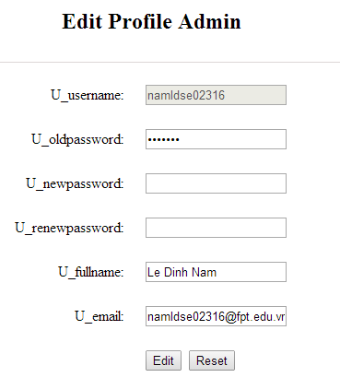
No | Field name | Type | Require | Mandatory | Length | Description
1 | Username | Text | Text | N |  | Username of admin’s account
2 | Oldpassword | Text | Text | Y | 100 | Admin input old password with length less than 100 characters
3 | Newpassword | Text | Text | Y | 1000 | Admin input new password with length less than 1000 characters
4 | Renewpassword | Text | Text | Y | 100 | Admin re-input new password with length less than 100 characters
5 | Fullname | Text | Text | Y | 100 | Admin input full name with length less than 100 characters
6 | Email | Text | Text | Y | 100 | Admin input email with length less than 100 characters
7 | Edit | Button | Click | Y |  | User click to edit vocabulary
8 | Reset | Button | Click | Y |  | User click to cancel edit

UC019 – Edit profile(admin)
Use-case No. | <UC019> | Use-case Version |  | <1.0>
Use-case Name | Edit profile admin
Author | Tuan NN
Date | 09/06/2014 | Priority | <High >
Actor:
Administrator
Summary:
Administrator want to change their profile
Triggers
Administrator login the website and click on the edit profile link
Preconditions:
- Website is available
- Administrator login the website
Post Conditions:
Edit admin profile and redirect to edited profile page
Main Success Scenario:
Step | User | System
1 | Enter website link on web browser | Display Homepage screen
2 | Enter necessary and mandatory information and click "Login” | Redirect to previous page and logged admin into system.
3 | Click on "Trang cá nhân" link. | Display “Trang cá nhân” page
4 | Admin changes profile and click “Lưu” button | Update new profile
Alternative Scenario:
At Step | User | System
4 | Enter necessary and mandatory information and click another link | Switch to selected page

Exceptions:
At Step | User | System
4 | Enter new password that incorrect form or missing information and click “Lưu” button | Display error message
4 | Enter new email that incorrect form or missing information and click “Lưu” button | Display error message

UC020 <Admin’s account management>: Delete admin
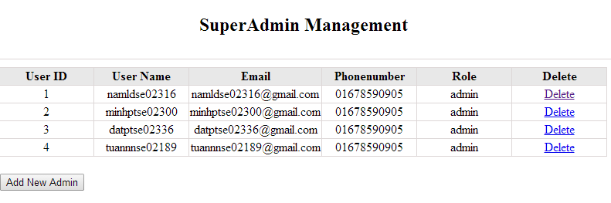
UC020 – Delete admin
Use-case No. | <UC020> | Use-case Version |  | <1.0>
Use-case Name | Delete admin
Author | Tuan NN
Date | 09/06/2014 | Priority | <High >
Actor:
Administrator
Summary:
Administrators can remove administrator rights of other admin
Triggers
Login the website and click on the delete admin link
Preconditions:
- Website is available
- Admin login the website
Post Conditions:
Admin will be remove administrator rights
Main Success Scenario:
Step | User | System
1 | Enter website link on web browser | Display Homepage screen
2 | Enter necessary and mandatory information and click "Login” | Redirect to previous page and logged admin into system.
3 | Click on delete admin link. | Display delete admin page
4 | Enter the account that you want to remove administrator rights | Remove administrator rights of account and display message to remove successfully

Alternative Scenario:
At Step | User | System
4 | Input data in account area then click on another link | Switch to selected page

Exceptions:
At Step | User | System
4 | Fill incorrect account name | Return Error message

Management Member’s account

Use case diagram
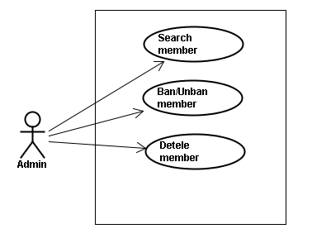

Use case specifications
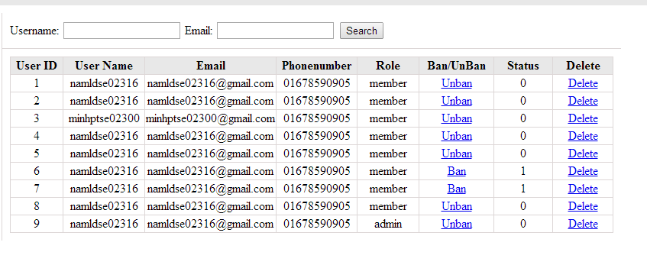
No | Field name | Type | Require | Mandatory | Length | Description
1 | Username | Text | Text | Y | 32 | Admin input username to search member by username
2 | Email | Text | Text | Y | 100 | Admin input email to search member by email
3 | Ban/Unban | Button | Click | N |  | Admin click ban/unban member
4 | Delete | Button | Click | N |  | Admin click delete member

UC021 <Management Member’s account>: Search member
Search member screen:
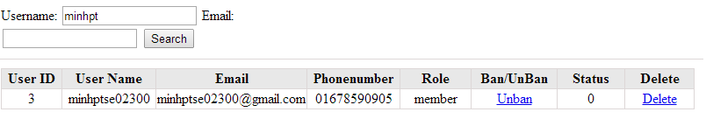
UC021 – Search member
Use-case No. | <UC021> | Use-case Version |  | <1.0>
Use-case Name | Search member
Author | Tuan NN
Date | 09/06/2014 | Priority | <High >
Actor:
Admin
Summary:
When admin want to search by member’s account in database successfully if it is existed
Triggers
Admin login the website and click on search member , input member’s account in the right text box then click “Search” button
Preconditions:
- Website is available
- Admin must be login
- Input data must be correctly
Post Conditions:
Display detail information of member
Main Success Scenario:
Step | User | System
1 | Enter website link on web browser | Display Homepage screen
2 | Enter necessary and mandatory information and click "Login” | Redirect to previous page and logged admin into system.
3 | Click on "Search member" button and input member’s account or email | Display “member information” screen that contains the information :  - User ID  - User Name  - Email  - Phone number  - Role  - Ban/Unban  - Status  - Delete

Alternative Scenario:
At Step | User | System
3 | Fill information of the member that they want to find into these fields then click on another link | Switch to selected page

Exceptions:
At Step | User | System
3 | Fill information of the member that they want to find (that do not exist in database) into these fields then click “Search” button | Return Error message to inform that member cannot be found

UC022 <Management Member’s account>: Ban/Unban member
UC022 – Search member
Use-case No. | <UC022> | Use-case Version |  | <1.0>
Use-case Name | Ban/Unban member
Author | Tuan NN
Date | 09/06/2014 | Priority | <High >
Actor:
Admin
Summary:
When admin can ban user who violated rule of website and unban member
Triggers
Admin login the website and click on member’s account and then click “Ban/Unban” button
Preconditions:
- Website is available
- Admin must be login
- Input data must be correctly
Post Conditions:
Member’s account will be ban/unban by administrator
Main Success Scenario:
Step | User | System
1 | Enter website link on web browser | Display Homepage screen
2 | Enter necessary and mandatory information and click "Login” | Redirect to previous page and logged admin into system.
3 | Click on "Search member" button and input member’s account or email | Display “member information” screen that contains the information
4 | Click “Ban/Unban” link | Ban/Unban member
Alternative Scenario:
At Step | User | System
3 | Fill information of the member that they want to find into these fields then click on another link | Switch to selected page

Exceptions:
At Step | User | System
3 | Fill information of the member that they want to find (that do not exist in database) into these fields then click “Search” button | Return Error message to inform that member cannot be found

UC023 <Management Member’s account>: Delete member
UC023 – Delete member
Use-case No. | <UC023> | Use-case Version |  | <1.0>
Use-case Name | Delete member
Author | Tuan NN
Date | 09/06/2014 | Priority | <High >
Actor:
Admin
Summary:
Administrators can delete member who violated rule of website
Triggers
Admin login the website and click on the delete member link
Preconditions:
- Website is available
- Admin must be login
- Input data must be correctly
Post Conditions:
Member’s account will be removed from system
Main Success Scenario:
Step | User | System
1 | Enter website link on web browser | Display Homepage screen
2 | Enter necessary and mandatory information and click "Login” | Redirect to previous page and logged admin into system.
3 | Click on "Search member" button and input member’s account or email | Display information of member
4 | Click on delete link corresponding with member want to delete | Remove member from list

Alternative Scenario:
At Step | User | System
3 | Fill information of the member that they want to find into these fields then click on another link | Switch to selected page

Exceptions:
At Step | User | System
3 | Fill information of the member that they want to find (that do not exist in database) into these fields then click “Search” button | Return Error message to inform that member cannot be found

Vocabulary Management

Use case diagram
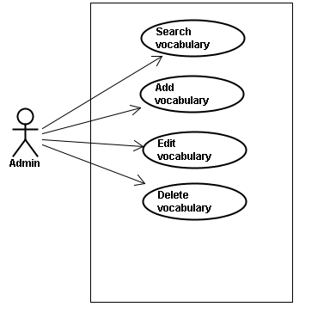

Use case specifications
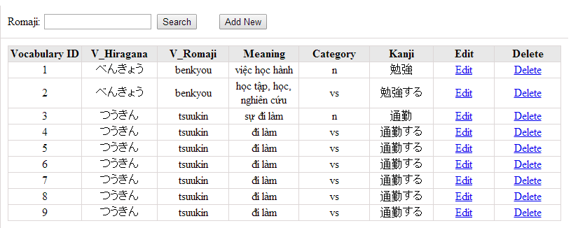
No | Field name | Type | Require | Mandatory | Length | Description
1 | Romaji | Text | Text | Y | 100 | Admin input romaji with length less than 100 character
2 | Addnew | Button | Click | N |  | Admin add new vocabulary into database
3 | Edit | Button | Click | N |  | Admin click edit vocabulary
4 | Delete | Button | Click | N |  | Admin click delete vocabulary

UC024 <Vocabulary Management>: Search vocabulary
Search vocabulary screen:
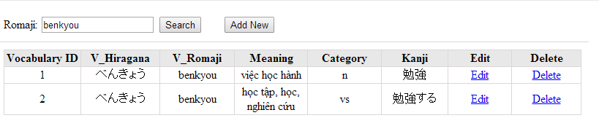
UC0024 – Specification
Use-case No. | <UC0024> | Use-case Version |  | <1.0>
Use-case Name | Search vocabulary
Author | TuanNN
Date | 09/06/2014 | Priority | <High >
Actor:
Admin
Summary:
When Administrator want to search a vocabulary on database
Goal:
Administrator can search vocabulary in database successfully if it is existed
Triggers
Admin login the website and click on “Vocabulary management” tab, input vocabulary in the right text box then click “Search” button
Preconditions:
- Website is available
- Admin must be login
- Input data must be correctly
Post Conditions:
Display detail information of vocabulary
Main Success Scenario:
Step | User | System
1 | Enter website link on web browser | Display Homepage screen
2 | Enter necessary and mandatory information and click "Login” | Redirect to previous page and logged admin into system.
4 | Click on “vocabulary management” tab | Displays criteria search screen
5 | Fill information of the vocabulary that they want to find into these fields then click “Search” button | Displays search result as a table with these elements:  - Vocabulary ID  - V_Hiragana  - V_Romaji  - Meaning  - Category  - Kanji  - Edit  - Delete

Alternative Scenario:
At Step | User | System
5 | Fill information of the vocabulary that they want to find into these fields then click on another link | Switch to selected page

Exceptions:
At Step | User | System
5 | Fill information of the vocabulary that they want to find (that do not exited in database) into these fields then click “Search” button | Return Error message to inform that vocabulary structure cannot be found

UC025 <Vocabulary Management>: Add vocabulary
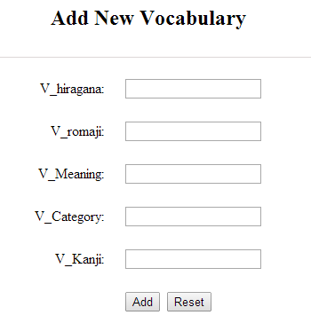
No |  | Field name | Type |  | Require | Mandatory |  | Length |  | Description
1 |  | Hiragana | Text |  | Text | Y |  | 100 |  | Admin input vocabulary by hiragana with length less than 100 characters
2 |  | Romaji | Text |  | Text | Y |  | 100 |  | Admin input vocabulary by romaji with length less than 100 characters
3 |  | Meaning | Text |  | Text | Y |  | 1000 |  | Admin input mean of vocabulary with length less than 1000 characters
4 |  | Category | Text |  | Text | Y |  | 100 |  | Admin category of vocabulary with length less than 100 characters
5 |  | Kanji | Text |  | Text | Y |  | 100 |  | Admin input vocabulary by kanji with length less than 100 characters
6 |  | Add | Button |  | Click | Y |  |  |  | Admin add new vocabulary
7 |  | Reset | Button |  | Click | N |  |  |  | Admin reset information that input to add
 | UC0025 - Specification
 | Use-case No. |  |  | <UC0025> |  |  | Use-case Version |  |  |  | <1.0>
 | Use-case Name |  |  | Add vocabulary
 | Author |  |  | Tuan NN
 | Date |  |  | 09/06/2014 |  |  | Priority |  | <High >
Actor:
Admin
Summary:
When Administrator want to add a vocabulary into database. They have to insert all necessary data of vocabulary into “Add new vocabulary” screen
Goal:
Administrator can add new vocabulary information in database successfully
Triggers
User must click on “Vocabulary management/ Add new” tab and input all necessary information of vocabulary into the right fields then click on “Add new” button
Preconditions:
- Website is available
- User have logged into system as an admin.
- All mandatory fields have been filled
- All input data must be valid and have not existed in system
Post Conditions:
New vocabulary has been saved into system database successfully
Main Success Scenario:
Step | User | System
1 | Enter website link on web browser | Display Homepage screen
2 | Enter necessary and mandatory information and click "Login” | Redirect to previous page and logged admin into system.
3 | Click on “Vocabulary management/Add new” tab | Display “Add New Vocabulary” screen that contains these elements:  - V_Vocabulary  - V_Romaji  - V_Meaning  - V_Category  - V_Kanji
4 | Fill information into all necessary or mandatory fields and click “Add” button | The system validates the input data and then save new vocabulary data into database
4 | Click “Reset” | Clear all data in fields

Alternative Scenario:
At Step | User | System
4 | Click on another link | Do not save new vocabulary data into database then redirect to selected page

Exceptions:
At Step | User | System
4 | Do not fill full information into fields then click “Add” button | Return Error message beside empty field and ask if user want to add with empty field.

UC026 <Vocabulary Management>: Edit vocabulary
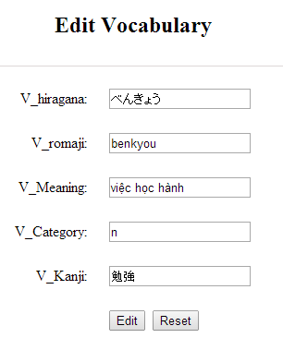
No | Field name | Type | Require | Mandatory | Length | Description
1 | Hiragana | Text | Text | Y | 100 | Admin input vocabulary by hiragana with length less than 100 characters
2 | Romaji | Text | Text | Y | 100 | Admin input vocabulary by romaji with length less than 100 characters
3 | Meaning | Text | Text | Y | 1000 | Admin input mean of vocabulary with length less than 1000 characters
4 | Category | Text | Text | Y | 100 | Admin category of vocabulary with length less than 100 characters
5 | Kanji | Text | Text | Y | 100 | Admin input vocabulary by kanji with length less than 100 characters
6 | Edit | Button | Click | Y |  | User click to edit vocabulary
7 | Reset | Button | Click | Y |  | User click to cancel edit

UC0026 - Specification
Use-case No. | <UC0026> | Use-case Version |  | <1.0>
Use-case Name | Edit vocabulary
Author | TuanNN
Date | 09/06/2014 | Priority | <High >
Actor:
Admin
Summary:
When Administrator want to edit a vocabulary on database which has some new meanings or errors
Goal:
Administrator can edit vocabulary information in database successfully
Triggers
User must click on “Vocabulary management” then search for the vocabulary. User click on “Edit” link on corresponding vocabulary. They edit necessary information in the right fields then click on “Edit” button.
Preconditions:
- Website is available
- User have logged into system as an admin.
- All mandatory fields have been filled
- All input data must be valid and have not existed in system
Post Conditions:
Changed information of vocabulary has been saved into system database successfully
Main Success Scenario:
Step | User | System
1 | Enter website link on web browser | Display Homepage screen
2 | Enter necessary and mandatory information and click "Login” | Redirect to previous page and logged admin into system.
3 | Click on “Vocabulary management ” then search for the vocabulary that they want to edit | Displays search result as a table
4 | Click on “Edit” link | Display “Edit Vocabulary” screen that contains the information of chosen vocabulary with these elements:  - V_Vocabulary  - V_Romaji  - V_Meaning  - V_Category  - V_Kanji
5 | Edit vocabulary information and click “Edit” button | The system validates the input data and then save data into database

Alternative Scenario:
At Step | User | System
5 | Edit vocabulary information then click to another link | Do not save edited data then redirect to selected page

Exceptions:
At Step | User | System
4 | Edit vocabulary information to be similar to another existed grammar
5 | Click “Edit” button | The system validates the input data and return Error message and do not save edited data into database
Reference:
UC0024 - Search Vocabulary

UC027 <Vocabulary Management>: Delete vocabulary

UC0027 - Specification
Use-case No. | <UC0027> | Use-case Version |  | <1.0>
Use-case Name | Delete vocabulary
Author | TuanNN
Date | 09/06/2014 | Priority | <High >
Actor:
Admin
Summary:
When Administrator want to delete a vocabulary on database
Goal:
Administrator can delete selected vocabulary in database successfully
Triggers
User must click on “Vocabulary management” then search for the vocabulary. User click on “Delete” link on corresponding vocabulary.
Preconditions:
- Website is available
- User have logged into system as an admin.
- All mandatory fields have been filled
- All input data must be valid and have existed in system
Post Conditions:
Vocabulary has been deleted from system database successfully
Main Success Scenario:
Step | User | System
1 | Enter website link on web browser | Display Homepage screen
2 | Enter necessary and mandatory information and click "Login” | Redirect to previous page and logged admin into system.
3 | Click on “Vocabulary management ” then search for the vocabulary that they want to delete | Displays search result as a table
4 | Click on “Delete” link beside that vocabulary row | Remove that vocabulary from list

Alternative Scenario:
At Step | User | System

Exceptions:
At Step | User | System
Reference:
UC0024 - Search vocabulary

Grammar Management

Use case diagram
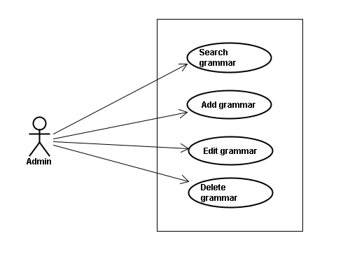

Use case specifications
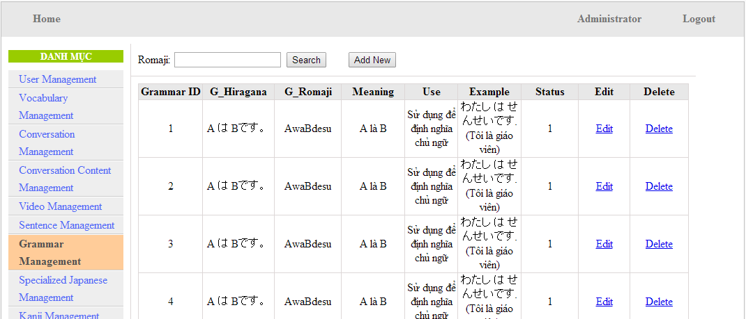
Screen Description: This is Grammar Management screen. When admin want to do work with grammar database, admin have to log in. At here, Admin can manage grammar database by search grammatical structure, add new grammatical structure, edit grammatical structure and delete grammatical structure.

UC0028: <Admin> Search grammar
Search grammar screen:
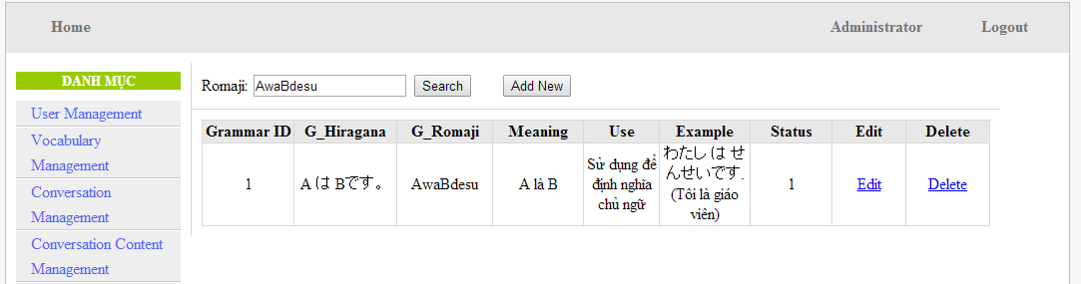
UC0028 - Specification
Use-case No. | <UC0028> | Use-case Version |  | <1.0>
Use-case Name | Search grammar
Author | Minh PT
Date | 09/06/2014 | Priority | <High >
Actor:
Admin
Summary:
When Administrator wants to search a grammatical structure in database, Admin can input a grammatical structure by “romaji” letter then click button “Search”. If that grammatical structure is existed, system will return meaning.
Triggers
Click on “Grammar management” tab, input grammatical structure in the right text box then click “Search” button
Preconditions:
- Website is available
- User has to login as Administrator
- User has to input data in search area
Post Conditions:
Display detail information of grammatical structure
Main Success Scenario:
Step | User | System
1 | Have logged into system as an admin
2 | Click on “Grammar management” tab | Displays criteria search screen
3 | Fill information of the grammatical structure that they want to find into these fields then click “Search” button | Displays search result as a table with these elements:  - Grammar ID  - G_Hiragana  - G_Romaji  - Level  - Meaning  - Use  - Example  - Status  - Edit  - Delete

Alternative Scenario:
At Step | User | System
3 | Fill information of the grammatical structure that they want to find into these fields then click on another link | Switch to selected page

Exceptions:
At Step | User | System
3 | Fill information of the grammatical structure that they want to find (that do not exited in database) into these fields then click “Search” button | Return Error message to inform that grammatical structure cannot be found

UC0029: <Admin> Add grammar
Add grammar screen:
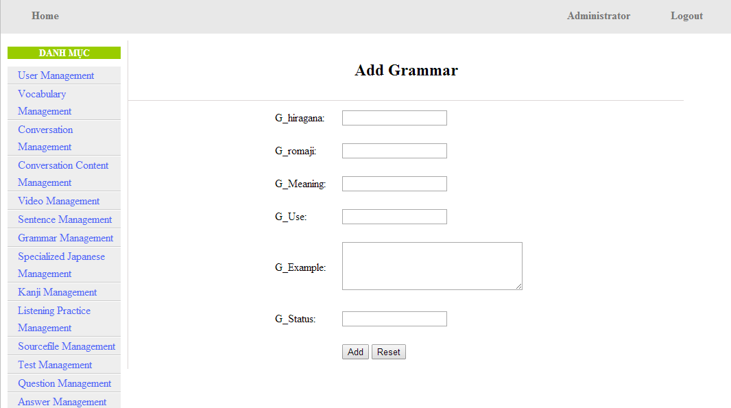
UC0029 - Specification
Use-case No. | <UC0029> | Use-case Version |  | <1.0>
Use-case Name | Add grammar
Author | Minh PT
Date | 09/06/2014 | Priority | <High >
Actor:
Admin
Summary:
When Administrator wants to add a grammar into database. They have to insert all necessary data of grammar into “Add Grammar” screen then click “Add” button
Triggers
User must click on “Grammar management/ Add New” and input all necessary information of grammar into the right fields then click on “Add” button
Preconditions:
- Website is available
- User has to login as Administrator
- All mandatory fields have been filled
- All input data must be valid and have not existed in system
Post Conditions:
New grammatical structure has been saved into system database successfully
Main Success Scenario:
Step | User | System
1 | Have logged into system as an admin
2 | Click on “Grammar management/Add New” | Display “Add Grammar” screen that contains these elements:  - G_hiragana  - G_romaji  - G_Meaning  - G_Use  - G_Example  - G_Status
3 | Fill grammar information into all necessary or mandatory fields
4 | Click “Add” button | The system validates the input data and then save new grammar data into database
4 | Click “Reset” button | The system clear all data in text fields and text area

Alternative Scenario:
At Step | User | System
4 | Click on another link | Do not save new grammar data into database then redirect to selected page

Exceptions:
At Step | User | System
4 | Do not fill full information into fields then click “Add” button | Return Error message and request user input data into all fields

UC0030: <Admin> Edit grammar
Edit grammar screen:
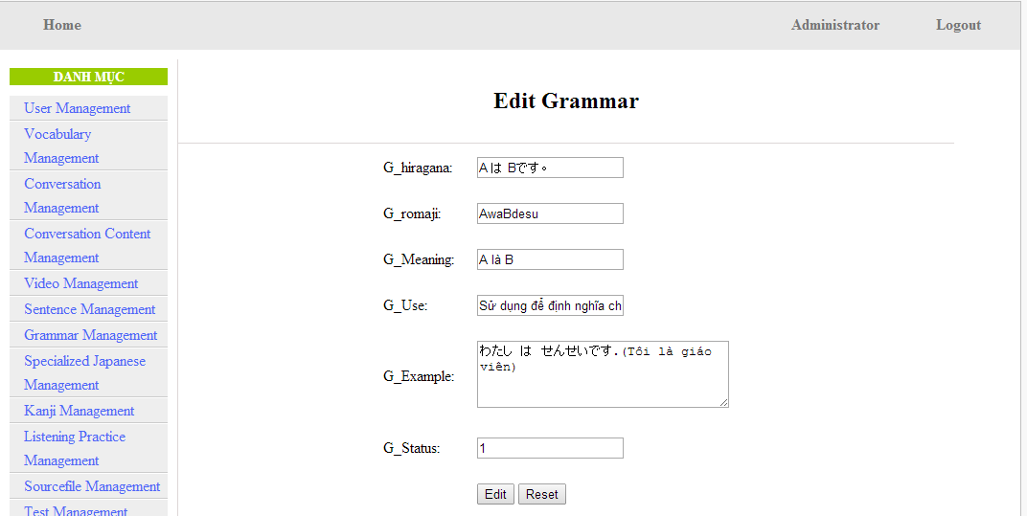
UC0030 - Specification
Use-case No. | <UC0030> | Use-case Version |  | <1.0>
Use-case Name | Edit grammar
Author | Minh PT
Date | 09/06/2014 | Priority | <High >
Actor:
Admin
Summary:
When Administrator want to edit a grammatical structure in database which has some new meanings or errors. Admin will search that grammar then click “Edit” link. When edit finished, new meaning of that grammar will be updated.
Triggers
User must click on “Grammar management” then search for the grammatical structure. User click on “Edit” link corresponding with grammar which want to edit. User edit necessary information of grammar in the right fields then click on “Edit” button.
Preconditions:
- Website is available
- User has to login as Administrator
- All mandatory fields have been filled
- All input data must be valid and have not existed in system
Post Conditions:
Changed information of grammar has been saved into system database successfully
Main Success Scenario:
Step | User | System
1 | Have logged into system as an admin
2 | Click on “Management grammar ” then search for the grammatical structure that they want to edit | Displays search result as a table
3 | Click on “Edit” link corresponding with grammar | Display “Edit Grammar” screen that contains the information of chosen grammar with these elements:  - G_hiragana  - G_romaji  - G_Meaning  - G_Use  - G_Example  - G_Status
4 | Edit grammar information
5 | Click “Edit” button | The system validates the input data and then save data into database
5 | Click “Reset” button | The system clear all data in text fields and text area

Alternative Scenario:
At Step | User | System
4 | Edit grammar information then click to another link | Do not save edited data then redirect to selected page

Exceptions:
At Step | User | System
4 | Edit grammar information to be similar to another existed grammar
5 | Click “Edit” button | The system validates the input data and return Error message and do not save edited data into database
Reference:
UC0028 - <Admin> Search Grammar

UC0031: <Admin> Delete grammar
UC0031 - Specification
Use-case No. | <UC0031> | Use-case Version |  | <1.0>
Use-case Name | Delete grammar
Author | Minh PT
Date | 09/06/2014 | Priority | <High >
Actor:
Admin
Summary:
When Administrator want to delete a grammar in database. Admin will search that grammar then click “Delete” link. When deleted finished, that grammar no longer exist in database.
Triggers
User must click on “Grammar management” then search for the grammatical structure. User click on “Delete” link corresponding with grammar which want to delete.
Preconditions:
- Website is available
- User has to login as Administrator
Post Conditions:
Grammar has been deleted from system database successfully
Main Success Scenario:
Step | User | System
1 | Have logged into system as an admin
2 | Click on “Grammar management ” then search for the grammar that they want to delete | Displays search result as a table
3 | Click on “Delete” link corresponding with grammar | Remove that grammar in database
Reference: UC0028 - <Admin> Search grammar

Reading Document Management

Use case diagram
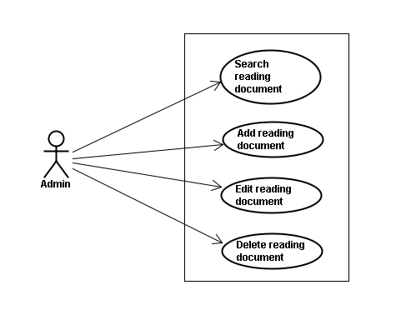

Use case specifications
Screen Description: This is Grammar Management screen. When admin want to do work with grammar database, admin have to log in. At here, Admin can manage grammar database by search grammatical structure, add new grammatical structure, edit grammatical structure and delete grammatical structure.

UC0032: <Admin> Search reading document
UC0032 - Specification
Use-case No. | <UC0032> | Use-case Version |  | <1.0>
Use-case Name | Search document
Author | Minh PT
Date | 09/06/2014 | Priority | <High >
Actor:
Admin
Summary:
When Administrator want to search reading document in database and Administrator can search reading document in database successfully if it is existed
Triggers
Click on “Reading management” tab, input name of reading document in the right text box then click “Search” button
Preconditions:
Input data must be correctly and User has to login as Administrator user
Post Conditions:
Display detail information of reading document
Main Success Scenario:
Step | User | System
1 | Have logged into system as an admin
2 | Click on “Reading management” tab | Displays criteria search screen
3 | Fill information of the reading document that they want to find into these fields then click “Search” button | Displays search result as a table with these elements:  - Serial number  - Title  - Content  - Meaning  - Edit  - Delete

Alternative Scenario:
At Step | User | System
3 | Fill information of the reading document that they want to find into these fields then click on another link | Switch to selected page

Exceptions:
At Step | User | System
3 | Fill information of the reading document that they want to find (that do not exited in database) into these fields then click “Search” button | Return Error message to inform that reading document cannot be found

UC0033: <Admin> Add reading document
UC0030 - Specification
Use-case No. | <UC0030> | Use-case Version |  | <1.0>
Use-case Name | Add document
Author | Minh PT
Date | 09/06/2014 | Priority | <High >
Actor:
Admin
Summary:
When Administrator want to add new reading document into database. They have to insert all necessary data of reading document into “Add new reading” screen
Triggers
User must click on “Reading management/ Add new” tab and input all necessary information of grammar into the right fields then click on “Add new” button
Preconditions:
- User have logged into system as an admin.
- All mandatory fields have been filled
- All input data must be valid and have not existed in system
Post Conditions:
New reading document has been saved into system database successfully
Main Success Scenario:
Step | User | System
1 | Have logged into system as an admin
2 | Click on “Reading management/Add new” tab | Display “Add New Reading” screen that contains these elements:  - Title  - Content  - Meaning
3 | Fill reading document information into all necessary or mandatory fields
4 | Click “Add new” button | The system validates the input data and then save new reading document data into database

Alternative Scenario:
At Step | User | System
4 | Click on another link | Do not save new reading document data into database then redirect to selected page

Exceptions:
At Step | User | System
4 | Do not fill full information into fields then click “Add new” button | Return Error message beside empty field and ask if user want to add with empty field.

UC0034: <Admin> Edit reading document
UC0034 - Specification
Use-case No. | <UC0034> | Use-case Version |  | <1.0>
Use-case Name | Edit reading document
Author | Minh PT
Date | 09/06/2014 | Priority | <High >
Actor:
Admin
Summary:
When Administrator want to edit reading document on database which has some new meanings or errors
Triggers
User must click on “Reading management” then search for the reading document. User click on “Edit” link on corresponding reading document. They edit necessary information of reading document in the right fields then click on “Edit” button.
Preconditions:
- User have logged into system as an admin.
- All mandatory fields have been filled
- All input data must be valid and have not existed in system
Post Conditions:
Changed information of reading document has been saved into system database successfully
Main Success Scenario:
Step | User | System
1 | Have logged into system as an admin
2 | Click on “Reading management ” then search for the reading document that they want to edit | Displays search result as a table
3 | Click on “Edit” link | Display “Edit reading” screen that contains the information of chosen reading with these elements:  - Title  - Content  - Meaning
4 | Edit reading document information
5 | Click “Edit” button | The system validates the input data and then save data into database

Alternative Scenario:
At Step | User | System
4 | Edit reading information then click to another link | Do not save edited data then redirect to selected page

Exceptions:
At Step | User | System
4 | Edit reading information to be similar to another existed reading
5 | Click “Edit” button | The system validates the input data and return Error message and do not save edited data into database
Reference:
UC0032- <Admin> Search reading document

UC0035: <Admin> Delete reading document
UC0035 - Specification
Use-case No. | <UC0035> | Use-case Version |  | <1.0>
Use-case Name | Delete reading document
Author | Minh PT
Date | 09/06/2014 | Priority | <High >
Actor:
Admin
Summary:
When Administrator want to delete reading document on database
Triggers
User must click on “Reading management” then search for the reading document. User click on “Delete” link on corresponding reading document.
Preconditions:
- User have logged into system as an admin.
- All mandatory fields have been filled
- All input data must be valid and have existed in system
Post Conditions:
Reading document has been deleted from system database successfully
Main Success Scenario:
Step | User | System
1 | Have logged into system as an admin
2 | Click on “Reading management ” then search for the reading document that they want to delete | Displays search result as a table
3 | Click on “Delete” link beside that reading document row | Displays pop up to confirm if they really want to remove that reading document
4 | Click “Yes” button on popup | Closes the popup then remove that reading document name from reading list

Alternative Scenario:
At Step | User | System
4 | Click close icon of the popup | Only closes the popup, does not remove that reading document

Exceptions:
At Step | User | System
4 | Click “Cancel” button on popup | Only closes the popup, does not remove that reading document
Reference:
UC0032 - <Admin> Search reading document

Conversation management

Use case diagram
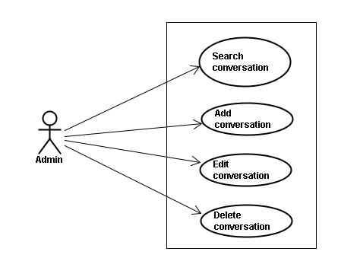

Use case specifications
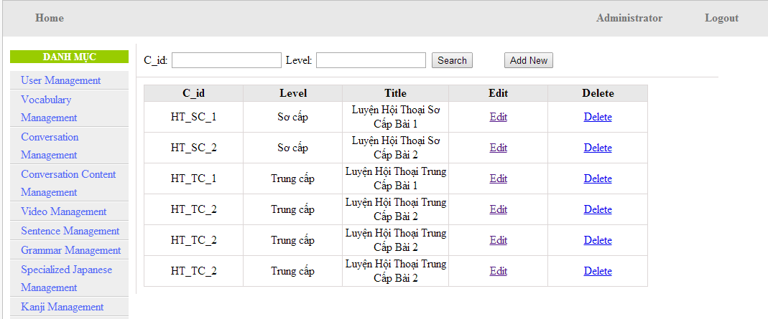
Screen Description: This is Conversation Management screen. When admin want to do work with conversation database, admin have to log in. At here, Admin can manage conversation database by search conversation, add new conversation, edit conversation and delete conversation. After create new conversation, admin go to Conversation Content Management to manage content of conversation. At here, admin also can search, add, edit, delete each content of conversation.

UC0036: <Admin> Search conversation
Search conversation screen:
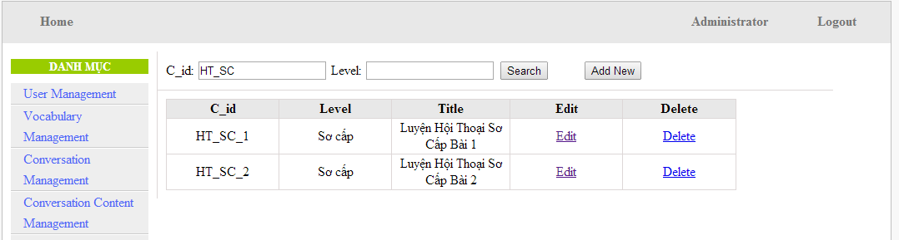
UC0036 - Specification
Use-case No. | <UC0036> | Use-case Version |  | <1.0>
Use-case Name | Search conversation
Author | Minh PT
Date | 09/06/2014 | Priority | <High >
Actor:
Admin
Summary:
When Administrator wants to search conversation in database. User input name of conversation or level then click “Search” button
Triggers
Click on “Conversation management” tab, input name of conversation in the right text box then click “Search” button
Preconditions:
- Website is available
- User has to login as Administrator
- User has to input data in search area
Post Conditions:
Display detail information of conversation
Main Success Scenario:
Step | User | System
1 | Have logged into system as an admin
2 | Click on “Conversation management” tab | Displays criteria search screen
3 | Fill information of the conversation that they want to find into fields: C_id or Level then click “Search” button | Displays search result as a table with these elements:  - C_id  - Level  - Title  - Edit  - Delete

Alternative Scenario:
At Step | User | System
3 | Fill information of the conversation that they want to find into these fields then click on another link | Switch to selected page

Exceptions:
At Step | User | System
3 | Fill information of the conversation that they want to find (that do not exited in database) into these fields then click “Search” button | Return Error message to inform that conversation cannot be found

UC0037: <Admin> Add conversation
Add conversation screen:
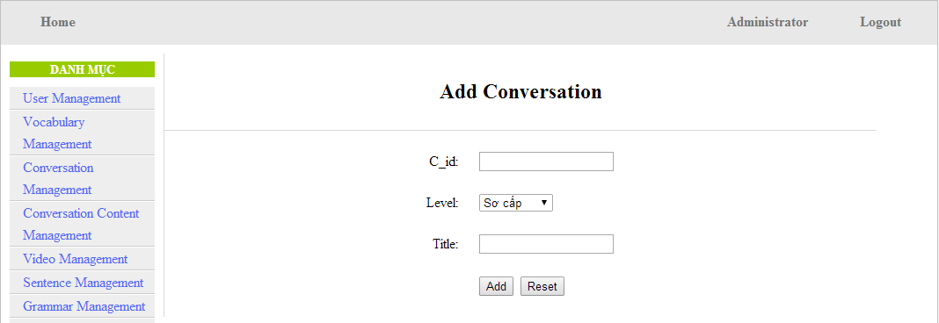
Add new conversation content screen:
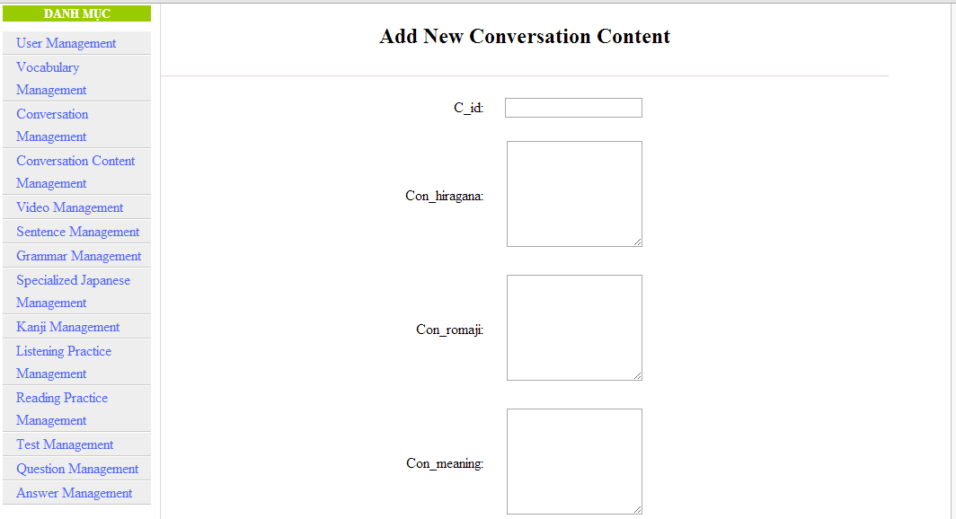
UC0037 - Specification
Use-case No. | <UC0037> | Use-case Version |  | <1.0>
Use-case Name | Add conversation
Author | Minh PT
Date | 09/06/2014 | Priority | <High >
Actor:
Admin
Summary:
When Administrator wants to add new conversation into database. They have to insert all necessary data of conversation into “Add Conversation” screen
Triggers
User must click on “Conversation management/ Add New” and input all necessary information of conversation into the right fields then click on “Add” button
Preconditions:
- Website is available
- User have logged into system as an admin.
- All mandatory fields have been filled
- All input data must be valid and have not existed in system
Post Conditions:
New conversation has been saved into system database successfully
Main Success Scenario:
Step | User | System
1 | Have logged into system as an admin
2 | Click on “Conversation management/Add New” | Display “Add Conversation” screen that contains these elements:  - C_id  - Level  - Title
3 | Fill conversation information into all necessary or mandatory fields
4 | Click “Add” button | The system validates the input data and then save new conversation data into database
4 | Click “Reset” button | The system clear all data in text fields
5 | Click “Conversation Content Management\Add New” | Display “Add New Conversation Content” screen that contains these elements:  - C_id  - Con_hiragana  - Con_romaji  - Con_meaning
6 | Fill conversation content information into all necessary or mandatory fields
7 | Click “Add” button | The system validates the input data and then save new conversation content data into database
7 | Click “Reset” button | The system clear all data in text fields

Alternative Scenario:
At Step | User | System
4 | Click on another link | Do not save new conversation data into database then redirect to selected page
7 | Click on another link | Do not save new content conversation data into database then redirect to selected page

Exceptions:
At Step | User | System
4 | Do not fill full information into fields then click “Add” button | Return Error message and request user input data into all fields
7 | Do not fill full information into fields then click “Add” button | Return Error message and request user input data into all fields
8 | C_id (that do not exited in database then click “Add” button | Return Error message and request user create name of conversation first

UC0038: <Admin> Edit conversation
Edit conversation screen:
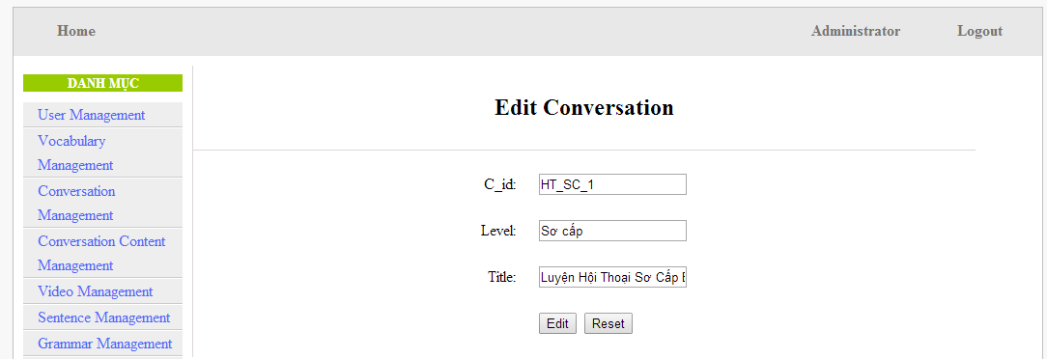
Edit conversation content screen:

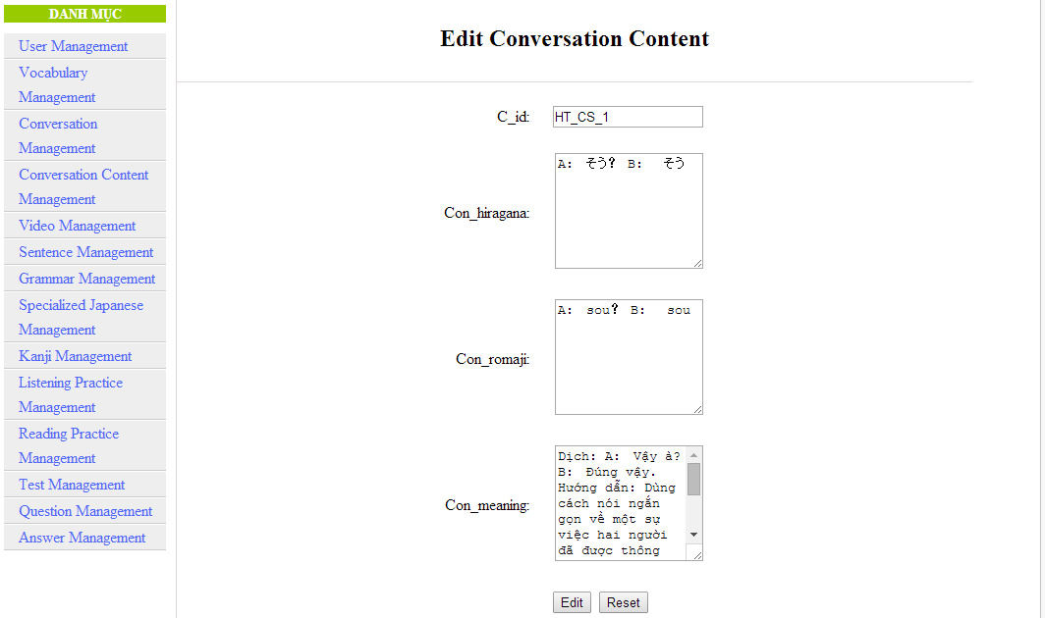
UC0038 - Specification
Use-case No. | <UC0038> | Use-case Version |  | <1.0>
Use-case Name | Edit conversation
Author | Minh PT
Date | 09/06/2014 | Priority | <High >
Actor:
Admin
Summary:
When Administrator want to edit conversation in database which has some new meanings or errors. When edit finished, new meaning will be updated
Triggers
User must click on “Conversation management” then search for the conversation. User click on “Edit” link on corresponding conversation. They edit necessary information of conversation in the right fields then click on “Edit” button.
Preconditions:
- Website is available
- User have logged into system as an admin.
- All mandatory fields have been filled
- All input data must be valid and have not existed in system
Post Conditions:
Changed information of conversation has been saved into system database successfully
Main Success Scenario:
Step | User | System
1 | Have logged into system as an admin
2 | Click on “Conversation management ” then search for the conversation that they want to edit | Displays search result as a table
3 | Click on “Edit” link corresponding | Display “Edit conversation” screen that contains the information of chosen conversation with these elements:  - C_id  - Level  - Title
4 | Edit conversation information
5 | Click “Edit” button | The system validates the input data and then save data into database
5 | Click “Reset” button | The system clear all data in text fields
6 | Click “Conversation Content Management” then search for the conversation content that they want to edit | Displays search result as a table
7 | Click on “Edit” link corresponding | Display “Edit Conversation Content” screen that contains the information of chosen conversation with these elements:  - C_id  - Con_hiragana  - Con_romaji  - Con_meaning
8 | Edit conversation content information
9 | Click “Edit” button | The system validates the input data and then save data into database
9 | Click “Reset” button | The system clear all data in text fields

Alternative Scenario:
At Step | User | System
4 | Edit conversation then click to another link | Do not save edited data then redirect to selected page
8 | Edit conversation content then click to another link | Do not save edited data then redirect to selected page

Exceptions:
At Step | User | System
4 | Edit conversation to be similar to another existed conversation
5 | Click “Edit” button | The system validates the input data and return Error message and do not save edited data into database
8 | Edit conversation content to be similar to another existed conversation content
9 | Click “Edit” button | The system validates the input data and return Error message and do not save edited data into database

Reference:
UC0036- <Admin> Search conversation

UC0039: <Admin> Delete conversation
UC0039 - Specification
Use-case No. | <UC0039> | Use-case Version |  | <1.0>
Use-case Name | Delete conversation
Author | Minh PT
Date | 09/06/2014 | Priority | <High >
Actor:
Admin
Summary:
When Administrator want to delete conversation in database
Triggers
User must click on “Conversation management” then search for the conversation. User click on “Delete” link on corresponding conversation.
Preconditions:
- Website is available
- User have logged into system as an admin.
Post Conditions:
Conversation has been deleted from system database successfully
Main Success Scenario:
Step | User | System
1 | Have logged into system as an admin
2 | Click on “Conversation management ” then search for the conversation that they want to delete | Displays search result as a table
3 | Click on “Delete” link corresponding with conversation | Remove that conversation in database

Exceptions:
At Step | User | System
3 | Click on “Delete” link corresponding with conversation (conversation content is existing) | Return Error message and request user remove conversation content first

Reference:
UC0036 - <Admin> Search conversation

Video Management

Use case diagram
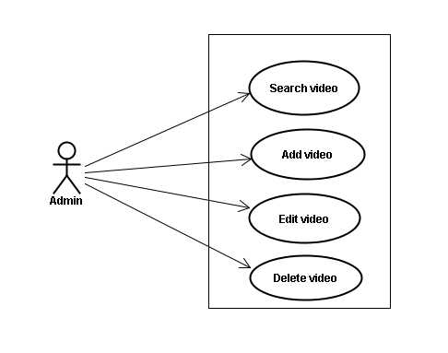

Use case specifications
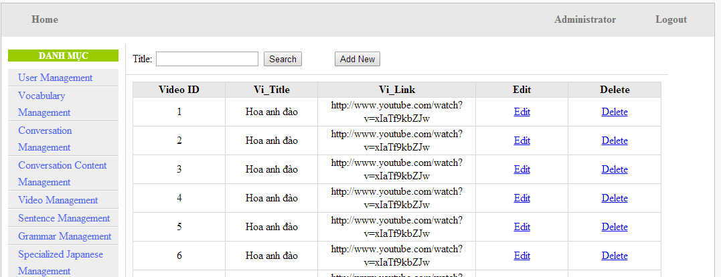
Screen Description: This is Video Management screen. When admin want to do work with video database, admin have to log in. At here, Admin can manage video database by search video, add new video, edit video and delete video.

UC040 <Video management>: Search video
Search video screen:
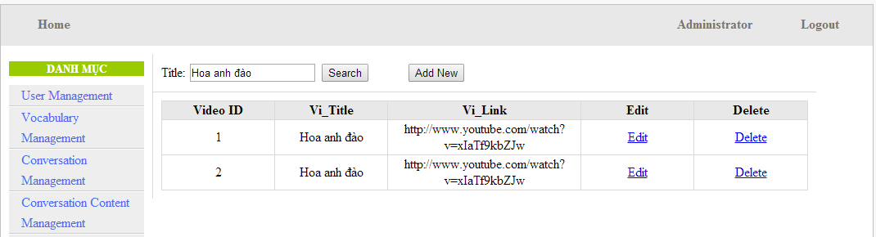
UC0040 - Specification
Use-case No. | <UC0040> | Use-case Version |  | <1.0>
Use-case Name | Search video
Author | Minh PT
Date | 09/06/2014 | Priority | <High >
Actor:
Admin
Summary:
When Administrator wants to search video in database. User input name of video then click “Search” button
Triggers
Click on “Video management” tab, input name of video in the right text box then click “Search” button
Preconditions:
- Website is available
- User has to login as Administrator
- User has to input data in search area
Post Conditions:
Display detail information of video
Main Success Scenario:
Step | User | System
1 | Have logged into system as an admin
2 | Click on “Video management” tab | Displays criteria search screen
3 | Fill information of the video that they want to find into these fields then click “Search” button | Displays search result as a table with these elements:  - Video ID  - Vi_Title  - Vi_Link  - Edit  - Delete

Alternative Scenario:
At Step | User | System
3 | Fill information of the video that they want to find into these fields then click on another link | Switch to selected page

Exceptions:
At Step | User | System
3 | Fill information of the video that they want to find (that do not exited in database) into these fields then click “Search” button | Return Error message to inform that video cannot be found

UC041 <Video management>: Add video
Add video screen:
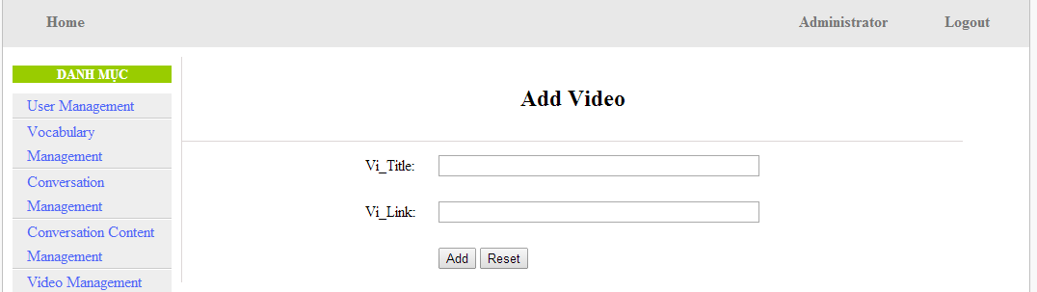
UC0041 - Specification
Use-case No. | <UC0041> | Use-case Version |  | <1.0>
Use-case Name | Add video
Author | Minh PT
Date | 09/06/2014 | Priority | <High >
Actor:
Admin
Summary:
When Administrator wants to add new video into database. They have to insert all necessary data of video into “Add Video” screen
Triggers
User must click on “Video management/ Add New” tab and input all necessary information of video into the right fields then click on “Add” button
Preconditions:
- Website is available
- User have logged into system as an admin.
- All mandatory fields have been filled
- All input data must be valid and have not existed in system
Post Conditions:
New video has been saved into system database successfully
Main Success Scenario:
Step | User | System
1 | Have logged into system as an admin
2 | Click on “Video management/Add New” tab | Display “Add Video” screen that contains these elements:  - Vi_Title  - Vi_Link
3 | Fill video information into all necessary or mandatory fields
4 | Click “Add” button | The system validates the input data and then save new video data into database
4 | Click “Reset” button | The system clear all data in text fields

Alternative Scenario:
At Step | User | System
4 | Click on another link | Do not save new video data into database then redirect to selected page

Exceptions:
At Step | User | System
4 | Do not fill full information into fields then click “Add” button | Return Error message and request user input data into all fields

UC042 <Video management>: Edit video
Edit video screen:
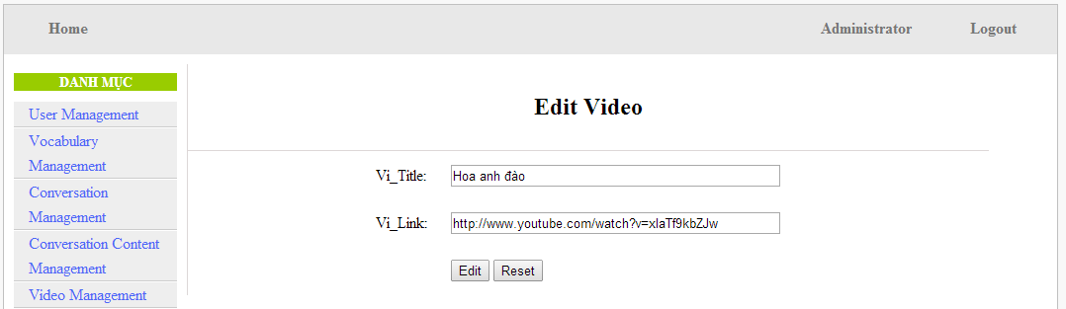
UC0042 - Specification
Use-case No. | <UC0042> | Use-case Version |  | <1.0>
Use-case Name | Edit video
Author | Minh PT
Date | 09/06/2014 | Priority | <High >
Actor:
Admin
Summary:
When Administrator wants to edit video in database which has some new meanings or errors. When edit finished, new meaning will be updated
Triggers
User must click on “Video management” then search for the video. User click on “Edit” link corresponding with video. User edit necessary information of video in the right fields then click on “Edit” button.
Preconditions:
- Website is available
- User have logged into system as an admin.
- All mandatory fields have been filled
- All input data must be valid and have not existed in system
Post Conditions:
Changed information of video has been saved into system database successfully
Main Success Scenario:
Step | User | System
1 | Have logged into system as an admin
2 | Click on “Video management ” then search for the video that they want to edit | Displays search result as a table
3 | Click on “Edit” link corresponding | Display “Edit video” screen that contains the information of chosen video with these elements:  - Vi_Title  - Vi_Link
4 | Edit video information
5 | Click “Edit” button | The system validates the input data and then save data into database
5 | Click “Reset” button | The system clear all data in text fields

Alternative Scenario:
At Step | User | System
4 | Edit video then click to another link | Do not save edited data then redirect to selected page

Exceptions:
At Step | User | System
4 | Edit video to be similar to another existed video
5 | Click “Edit” button | The system validates the input data and return Error message and do not save edited data into database
Reference:
UC0040- <Admin> Search video

UC043 <Video management>: Delete video
UC0043 - Specification
Use-case No. | <UC0043> | Use-case Version |  | <1.0>
Use-case Name | Delete video
Author | Minh PT
Date | 09/06/2014 | Priority | <High >
Actor:
Admin
Summary:
When Administrator wants to delete video in database
Triggers
User must click on “Video management” then search for the video. User click on “Delete” link on corresponding video.
Preconditions:
- Website is available
- User have logged into system as an admin.
Post Conditions:
Video has been deleted from system database successfully
Main Success Scenario:
Step | User | System
1 | Have logged into system as an admin
2 | Click on “Video management ” then search for the video that they want to delete | Displays search result as a table
3 | Click on “Delete” link corresponding with conversation | Remove that video in database

Reference:
UC0040 - <Admin> Search video

Listening Article Management

Use case diagram
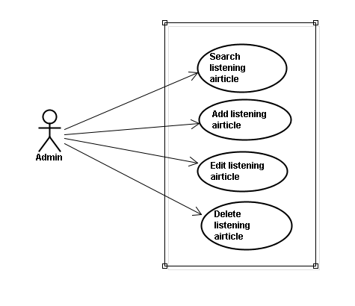

Use case specifications
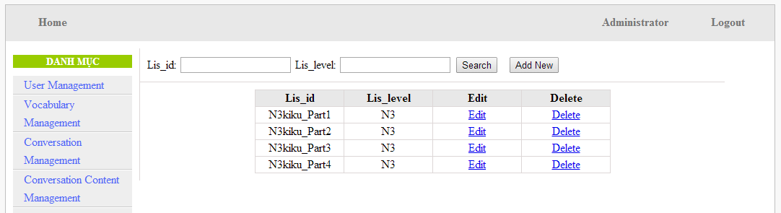
Screen Description: This is Listening article Management screen. When admin want to do work with listening database, admin have to log in. At here, Admin can manage listening database by search listening, add new listening, edit listening and delete listening. After create new listening article, admin go to Sourcefile Management to manage content of listening. At here, admin also can search, add, edit, delete each content of listening.

UC044 <Listening Article Management>: Search listening article
Search listening screen:
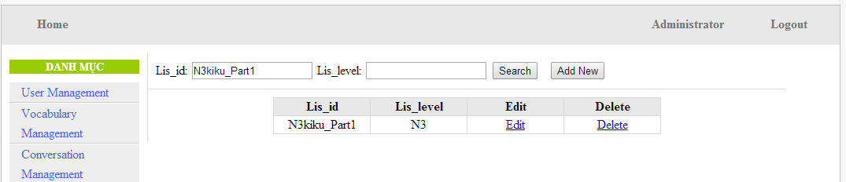
UC0044 - Specification
Use-case No. | <UC0044> | Use-case Version |  | <1.0>
Use-case Name | Search listening article
Author | Minh PT
Date | 09/06/2014 | Priority | <High >
Actor:
Admin
Summary:
When Administrator wants to search listening article in database. User input listening id or listening level then click “Search” button
Triggers
Click on “Listening practice management” tab, input listening id or level in the right text box then click “Search” button
Preconditions:
- Website is available
- User has to login as Administrator
- User has to input data in search area
Post Conditions:
Display detail information of listening article
Main Success Scenario:
Step | User | System
1 | Have logged into system as an admin
2 | Click on “Listening article management” tab | Displays criteria search screen
3 | Fill information of the listening article that they want to find into lis_id or lis_level then click “Search” button | Displays search result as a table with these elements:  - Lis_id  - Lis_level  - Edit  - Delete

Alternative Scenario:
At Step | User | System
3 | Fill information of the listening article that they want to find into these fields then click on another link | Switch to selected page

Exceptions:
At Step | User | System
3 | Fill information of the listening article that they want to find (that do not exited in database) into these fields then click “Search” button | Return Error message to inform that listening article cannot be found

UC045 <Listening Article Management>: Add listening article
Add listening screen:
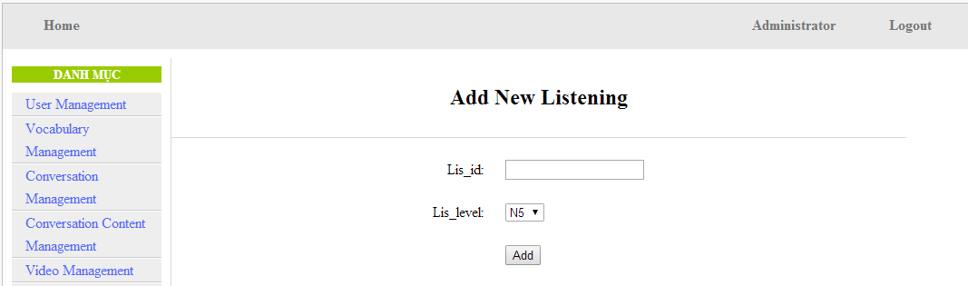
Add listening content screen:
UC0045 - Specification
Use-case No. | <UC0045> | Use-case Version |  | <1.0>
Use-case Name | Add listening article
Author | Minh PT
Date | 09/06/2014 | Priority | <High >
Actor:
Admin
Summary:
When Administrator wants to add new listening article into database. They have to insert all necessary data of listening article into “Add new listening” screen
Triggers
User must click on “Listening management/ Add New” and input all necessary information of listening article into the right fields then click on “Add” button
Preconditions:
- Website is available
- User have logged into system as an admin.
- All mandatory fields have been filled
- All input data must be valid and have not existed in system
Post Conditions:
New listening article has been saved into system database successfully
Main Success Scenario:
Step | User | System
1 | Have logged into system as an admin
2 | Click on “Listening article management/Add New” | Display “Add New Listening” screen that contains these elements:  - Lis_id  - Lis_level
3 | Fill listening article information into all necessary or mandatory fields
4 | Click “Add” button | The system validates the input data and then save new listening article data into database

Alternative Scenario:
At Step | User | System
4 | Click on another link | Do not save new listening article data into database then redirect to selected page

Exceptions:
At Step | User | System
4 | Do not fill full information into fields then click “Add” button | Return Error message and request user input data into all fields

UC046 <Listening Article Management>: Edit listening article
Edit listening screen:
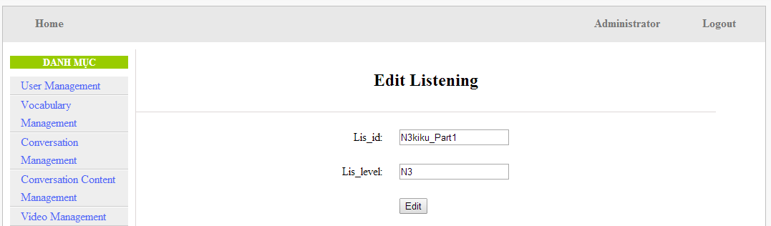
UC0046 - Specification
Use-case No. | <UC0046> | Use-case Version |  | <1.0>
Use-case Name | Edit listening article
Author | Minh PT
Date | 09/06/2014 | Priority | <High >
Actor:
Admin
Summary:
When Administrator wants to edit listening article in database which has some new meanings or errors. When edit finished, new meaning will be updated

Triggers
User must click on “Listening management” then search for the listening article. User click on “Edit” link corresponding with listening article. They edit necessary information of listening article in the right fields then click on “Edit” button.
Preconditions:
- Website is available
- User have logged into system as an admin.
- All mandatory fields have been filled
- All input data must be valid and have not existed in system
Post Conditions:
Changed information of listening article has been saved into system database successfully
Main Success Scenario:
Step | User | System
1 | Have logged into system as an admin
2 | Click on “Listening article management ” then search for the listening article that they want to edit | Displays search result as a table
3 | Click on “Edit” link corresponding | Display “Edit listening” screen that contains the information of chosen listening article with these elements:  - Lis_id  - Lis_level
4 | Edit listening article information
5 | Click “Edit” button | The system validates the input data and then save data into database

Alternative Scenario:
At Step | User | System
4 | Edit listening article then click to another link | Do not save edited data then redirect to selected page

Exceptions:
At Step | User | System
4 | Edit listening article to be similar to another existed listening article
5 | Click “Edit” button | The system validates the input data and return Error message and do not save edited data into database
Reference:
UC0044- <Admin> Search listening article

UC047 <Listening Article Management>: Delete listening article
UC0047 - Specification
Use-case No. | <UC0047> | Use-case Version |  | <1.0>
Use-case Name | Delete listening article
Author | Minh PT
Date | 09/06/2014 | Priority | <High >
Actor:
Admin
Summary:
When Administrator want to delete listening article inn database
Triggers
User must click on “Listening article management” then search for the listening article. User click on “Delete” link corresponding with listening article.
Preconditions:
- Website is available
- User have logged into system as an admin.
Post Conditions:
Listening article has been deleted from system database successfully
Main Success Scenario:
Step | User | System
1 | Have logged into system as an admin
2 | Click on “Listening article management ” then search for the listening article that they want to delete | Displays search result as a table
3 | Click on “Delete” link corresponding | Remove that listening article in database

Reference:
UC0044 - <Admin> Search listening article

Doing test management

Use case diagram
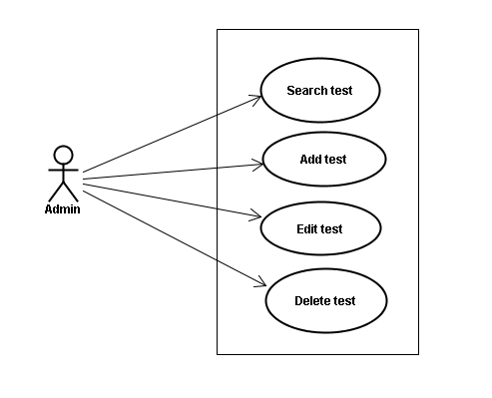

Use case specifications
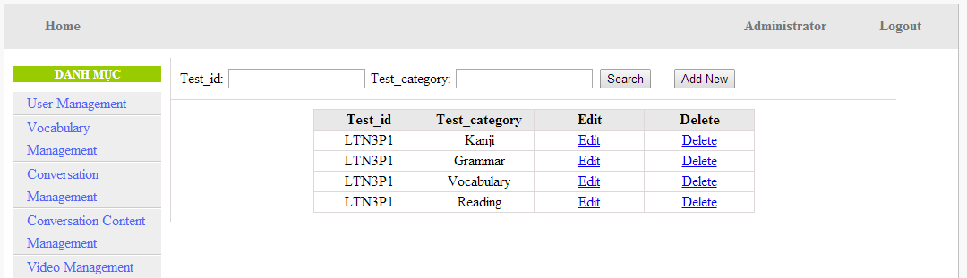
Screen Description: This is Doing test Management screen. When admin want to do work with test database, admin have to log in. At here, Admin can manage doing test database by search test, add new test, edit test and delete test.

UC048 <Test management>: Search test
Search test screen:
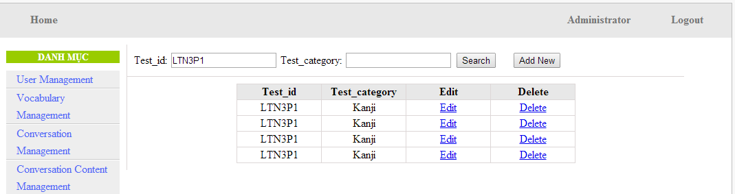
UC0048 - Specification
Use-case No. | <UC0048> | Use-case Version |  | <1.0>
Use-case Name | Search test
Author | Minh PT
Date | 09/06/2014 | Priority | <High >
Actor:
Admin
Summary:
When Administrator wants to search test article in database. User input test id or test category then click “Search” button.
Triggers
Click on “Test management” tab, input Test_id or test_ in the right text box then click “Search” button
Preconditions:
- Website is available
- User has to login as Administrator
- User has to input data in search area
Post Conditions:
Display detail information of that test
Main Success Scenario:
Step | User | System
1 | Have logged into system as an admin
2 | Click on “Test management” tab | Displays criteria search screen
3 | Fill information of the test that they want to find into test_id or test_catagory then click “Search” button | Displays search result as a table with these elements:  - Test_id  - Test_category  - Edit  - Delete

Alternative Scenario:
At Step | User | System
3 | Fill information of the test that they want to find into these fields then click on another link | Switch to selected page

Exceptions:
At Step | User | System
3 | Fill information of the test that they want to find (that do not exited in database) into these fields then click “Search” button | Return Error message to inform that test cannot be found

UC049 <Test management>: Add test
Add test screen:
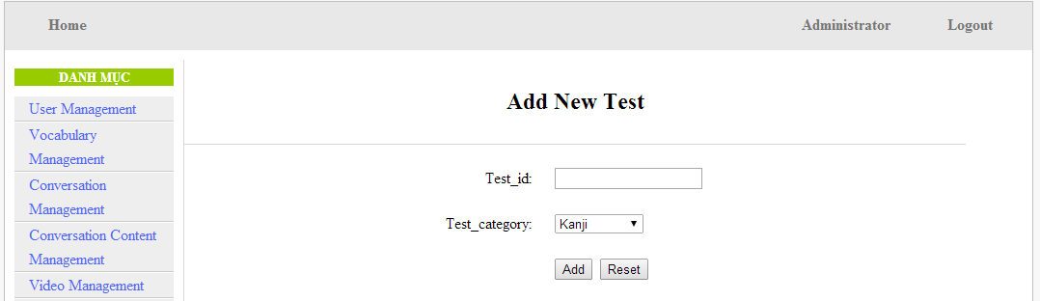
UC0049 - Specification
Use-case No. | <UC0049> | Use-case Version |  | <1.0>
Use-case Name | Add test
Author | Minh PT
Date | 09/06/2014 | Priority | <High >
Actor:
Admin
Summary:
When Administrator want to add new test into database. They have to insert all necessary data of test into “Add new test” screen
Triggers
User must click on “Test management/ Add New” and input all necessary information of test into the right fields then click on “Add” button
Preconditions:
- Website is available
- User have logged into system as an admin.
- All mandatory fields have been filled
- All input data must be valid and have not existed in system
Post Conditions:
New test has been saved into system database successfully
Main Success Scenario:
Step | User | System
1 | Have logged into system as an admin
2 | Click on “Test management/Add New” | Display “Add New Test” screen that contains these elements:  - Test_id  - Test_category
3 | Fill test information into all necessary or mandatory fields
4 | Click “Add” button | The system validates the input data and then save new test data into database

Alternative Scenario:
At Step | User | System
4 | Click on another link | Do not save new test data into database then redirect to selected page

Exceptions:
At Step | User | System
4 | Do not fill full information into fields then click “Add” button | Return Error message and request user input data into all fields

UC050 <Test management>: Edit test
Edit test screen:
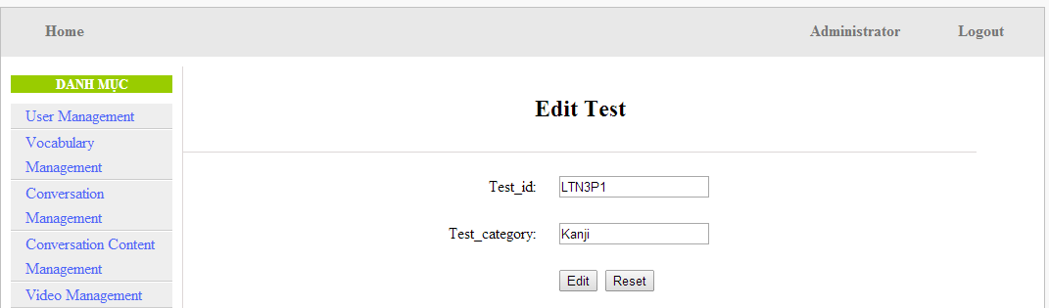
UC0050 - Specification
Use-case No. | <UC0050> | Use-case Version |  | <1.0>
Use-case Name | Edit test
Author | Minh PT
Date | 09/06/2014 | Priority | <High >
Actor:
Admin
Summary:
When Administrator want to edit test in database which has some new meanings or errors. When edit finished, new meaning will be updated
Triggers
User must click on “Test management” then search for the test. User click on “Edit” link on corresponding test. User edit necessary information of test in the right fields then click on “Edit” button.
Preconditions:
- Website is available
- User have logged into system as an admin.
- All mandatory fields have been filled
- All input data must be valid and have not existed in system
Post Conditions:
Changed information of test has been saved into system database successfully
Main Success Scenario:
Step | User | System
1 | Have logged into system as an admin
2 | Click on “Test management ” then search for the test that they want to edit | Displays search result as a table
3 | Click on “Edit” link corresponding | Display “Edit Test” screen that contains the information of chosen test with these elements:  - Test_id  - Test_category
4 | Edit test information
5 | Click “Edit” button | The system validates the input data and then save data into database
5 | Click “Reset” button | The system clear all data in text fields

Alternative Scenario:
At Step | User | System
4 | Edit test then click to another link | Do not save edited data then redirect to selected page

Exceptions:
At Step | User | System
4 | Edit test to be similar to another existed test
5 | Click “Edit” button | The system validates the input data and return Error message and do not save edited data into database
Reference:
UC0048- <Admin> Search test

UC051 <Test management>: Delete test
UC0051 - Specification
Use-case No. | <UC0051> | Use-case Version |  | <1.0>
Use-case Name | Delete test
Author | Minh PT
Date | 09/06/2014 | Priority | <High >
Actor:
Admin
Summary:
When Administrator want to delete test in database
Triggers
User must click on “Test management” then search for the test. User click on “Delete” link corresponding with test.
Preconditions:
- Website is available
- User have logged into system as an admin.
Post Conditions:
Test has been deleted from system database successfully
Main Success Scenario:
Step | User | System
1 | Have logged into system as an admin
2 | Click on “Test management ” then search for the test that they want to delete | Displays search result as a table
3 | Click on “Delete” link corresponding | Remove that test in database

Reference:
UC0048 - <Admin> Search test

Contributed content management

Use case diagram
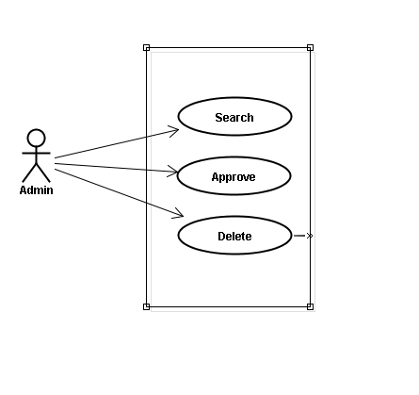

Use case specifications

UC052 <Contact’s content Management>: Search contribute content
Search contribute content screen:
- Contribute kanji screen:
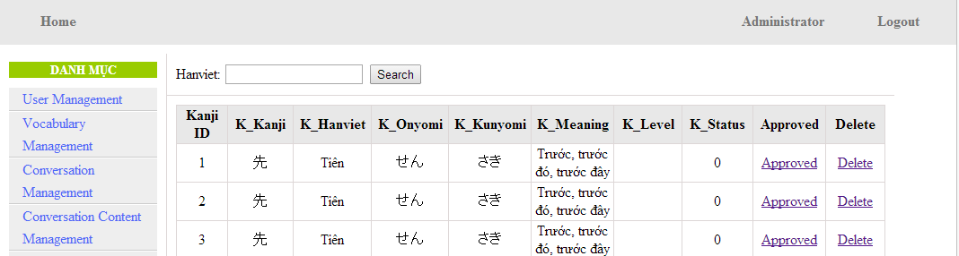
- Contribute grammar screen:
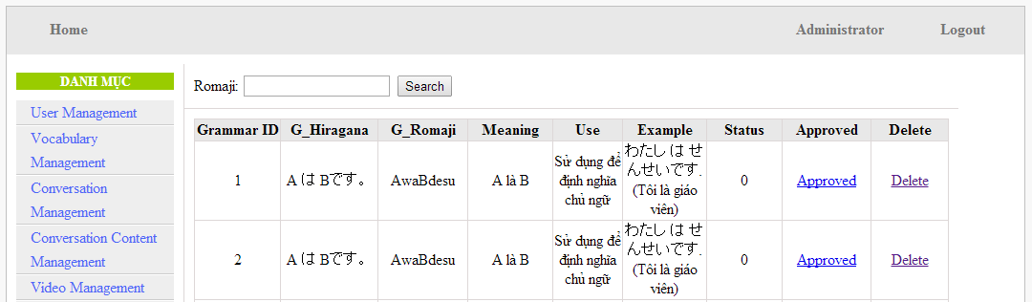
- Contribute vocabulary screen:
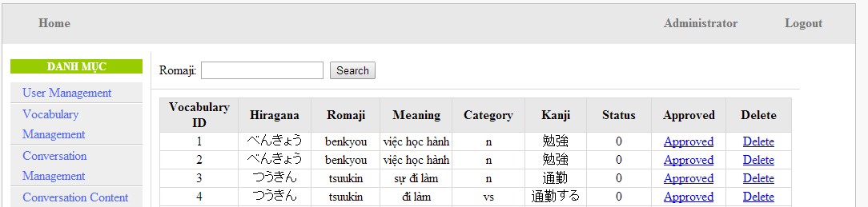
UC0052 - Specification
Use-case No. | <UC0052> | Use-case Version |  | <1.0>
Use-case Name | Search contribute content
Author | Minh PT
Date | 09/06/2014 | Priority | <High >
Actor:
Admin
Summary:
When administrator wants to search contribute content include kanji, grammar, vocabulary in database. User input data then click “Search” button.
Triggers
Click on “Contribute Kanji Management ” or “Contribute Grammar Management ” or “Contribute Vocabulary Management ” tab, input data in the right text box then click “Search” button
Preconditions:
- Website is available
- User has to login as Administrator
- User has to input data in search area
Post Conditions:
Display detail information of contribute content
Main Success Scenario:
Step | User | System
1 | Have logged into system as an admin
2 | Click on “Contribute Kanji Management ” or “Contribute Grammar Management ” or “Contribute Vocabulary Management ” tab | Displays criteria search screen
3 | Fill information that they want to find into text box then click “Search” button | Displays search result as a table with these elements:  - Kanji:  - Kanji ID  - K_Kanji  - K_Hanviet  - K_Onyomi  - K_Kunyoumi  - K_Meaning  - K_level  - K_Status  - Approved  - Delete  - Grammar:  - Grammar ID  - G_Hiragana  -G_ Romaji  - Meaning  - Use  - Example  - Status  - Approved  - Delete  - Vocabulary:  - Vocabulary ID  - Hiragana  - Romaji  - Meaning  - Category  - Kanji  - Status  - Approved  - Delete

Alternative Scenario:
At Step | User | System
3 | Fill information that they want to find into these fields then click on another link | Switch to selected page

Exceptions:
At Step | User | System
3 | Fill information that they want to find (that do not exited in database) into these fields then click “Search” button | Return Error message to inform that listening article cannot be found

UC053 <Contact’s content Management>: Approve contribute content
Approve contribute content screen:
- Approve contribute kanji screen:
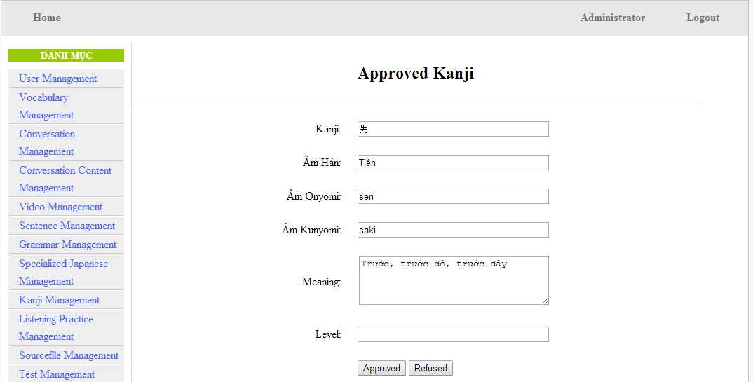
- Approve contribute grammar screen:
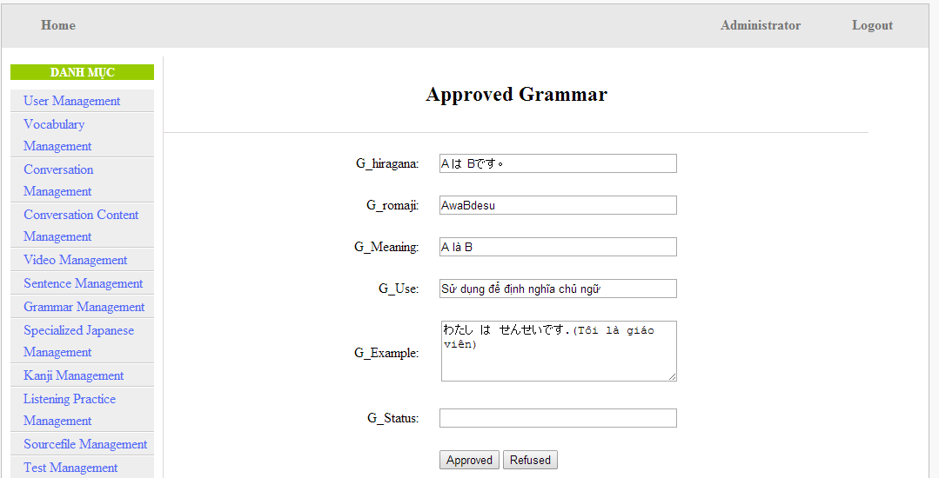

- Approve contribute vocabulary screen:
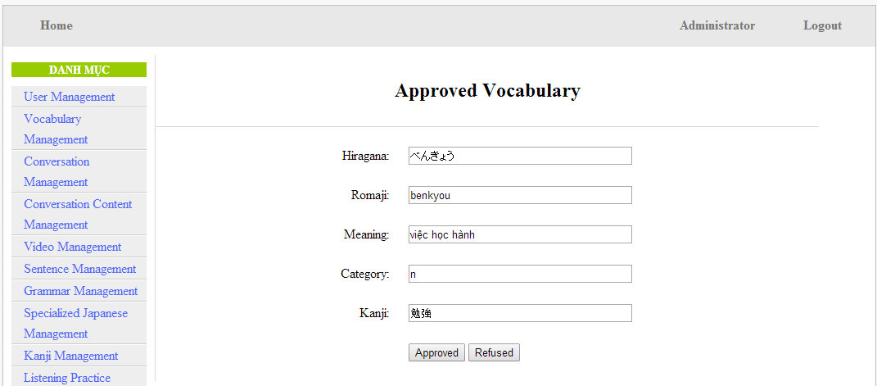
UC0053 - Specification
Use-case No. | <UC0053> | Use-case Version |  | <1.0>
Use-case Name | Approve contribute content
Author | Minh PT
Date | 09/06/2014 | Priority | <High >
Actor:
Admin
Summary:
When administrator wants to approve contribute content include kanji, grammar, vocabulary in database. User click on link corresponding with kanji, grammar, vocabulary
Triggers
Click on “Contribute Kanji Management” or “Contribute Grammar Management” or “Contribute Vocabulary Management” tab, input data in the right text box then click “Search” button. Click on link corresponding with kanji, grammar, vocabulary which want to approve to database
Preconditions:
- Website is available
- User has to login as Administrator
- All mandatory fields have been filled
- All input data must be valid and have not existed in system
Post Conditions:
Display detail information of contribute content
Main Success Scenario:
Step | User | System
1 | Have logged into system as an admin
2 | Click on “Contribute Kanji Management ” or “Contribute Grammar Management ” or “Contribute Vocabulary Management ” tab | Displays criteria search screen
3 | Fill information that they want to find into text box then click “Search” button | Displays search result
4 | Click “Approved” link corresponding want to update into database | Display Approve kanji screen with these elements:  - Kanji  - Kanji  - Âm hán  - Âm Onyomi  - Âm Kunyoumi  - Meaning  - level  - Approved  - Refused  - Grammar:  - G_Hiragana  - G_ Romaji  - G_Meaning  - G_Use  - G_Example  - G_Status  - Approved  - Refused  - Vocabulary:  - Hiragana  - Romaji  - Meaning  - Category  - Kanji  - Approved  - Refused
5 | Edit or add more information
6 | Click “Approved” button | The system validates the input data and then save data into database
6 | Click “Refused” button | The system cancel approve data

Alternative Scenario:
At Step | User | System
5 | Fill information then click on another link | Switch to selected page

Exceptions:
At Step | User | System
5 | Fill information that exited in database into fields then click “Approved” button | Return Error message to inform that data is exiting in database
Reference:
UC0052 - < Contact’s content Management > Search contribute content

UC0054: < Contact’s content Management > Delete contribute content
UC0054 - Specification
Use-case No. | <UC0054> | Use-case Version |  | <1.0>
Use-case Name | Delete contribute content
Author | Minh PT
Date | 09/06/2014 | Priority | <High >
Actor:
Admin
Summary:
When Administrator wants to delete a contribute content. Admin will search that content then click “Delete” link corresponding.
Triggers
User must click on “Contribute Kanji Management” or “Contribute Grammar Management” or “Contribute Vocabulary Management” tab then search for the contribute content. User click on “Delete” link corresponding with kanji, grammar, vocabulary which want to delete.
Preconditions:
- Website is available
- User has to login as Administrator
Post Conditions:
Kanji, grammar, vocabulary have been deleted from list successfully
Main Success Scenario:
Step | User | System
1 | Have logged into system as an admin
2 | Click on “Contribute Kanji Management ” or “Contribute Grammar Management ” or “Contribute Vocabulary Management ” tab then search for the kanji, grammar, vocabulary that user want to delete | Displays search result as a table
3 | Click on “Delete” link corresponding with kanji, grammar, vocabulary | Remove that kanji, grammar, vocabulary from list

Reference:
UC0052 - < Contact’s content Management > Search contribute content

Contributed opinion management

Use case diagram
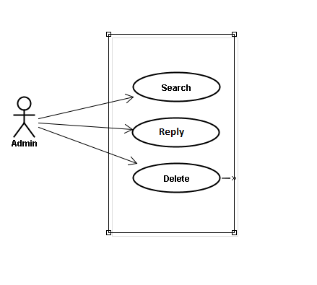

Use case specifications
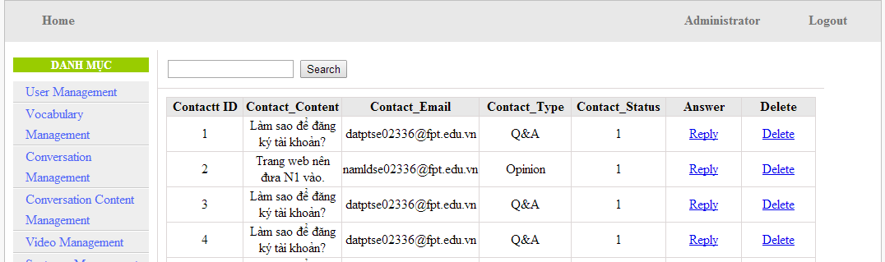
Screen Description: This is Opinion/Q&A Management screen. When admin want to reply question from member, admin have to log in. At here, Admin can manage by search question, reply question and delete question

UC055 <Opinion/Q&A Management>: Search question
Search question screen:
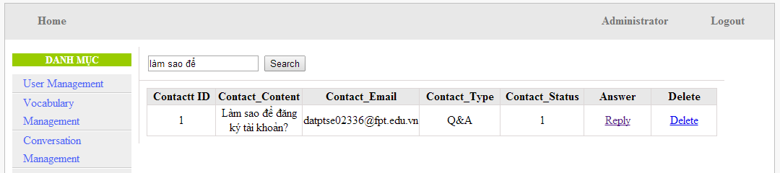
UC0055 - Specification
Use-case No. | <UC0055> | Use-case Version |  | <1.0>
Use-case Name | Search question
Author | Minh PT
Date | 09/06/2014 | Priority | <High >
Actor:
Admin
Summary:
When administrator wants to search question from member. User input data then click “Search” button.
Triggers
Click on “Contact Management ” tab, input data in the right text box then click “Search” button
Preconditions:
- Website is available
- User has to login as Administrator
- User has to input data in search area
Post Conditions:
Display detail information of question
Main Success Scenario:
Step | User | System
1 | Have logged into system as an admin
2 | Click on “Contact Management ” tab | Displays criteria search screen
3 | Fill information that they want to find into text box then click “Search” button | Displays search result as a table with these elements:  - Contact ID  - Contact_Content  - Contact_Email  - Contact_Type  - Contect_Status  - Answer  - Delete

Alternative Scenario:
At Step | User | System
3 | Fill information that they want to find into these fields then click on another link | Switch to selected page

Exceptions:
At Step | User | System
3 | Fill information that they want to find (that do not exited in database) into these fields then click “Search” button | Return Error message to inform that cannot be found

UC056 <Opinion/Q&A Management>: Reply question
Reply question screen:
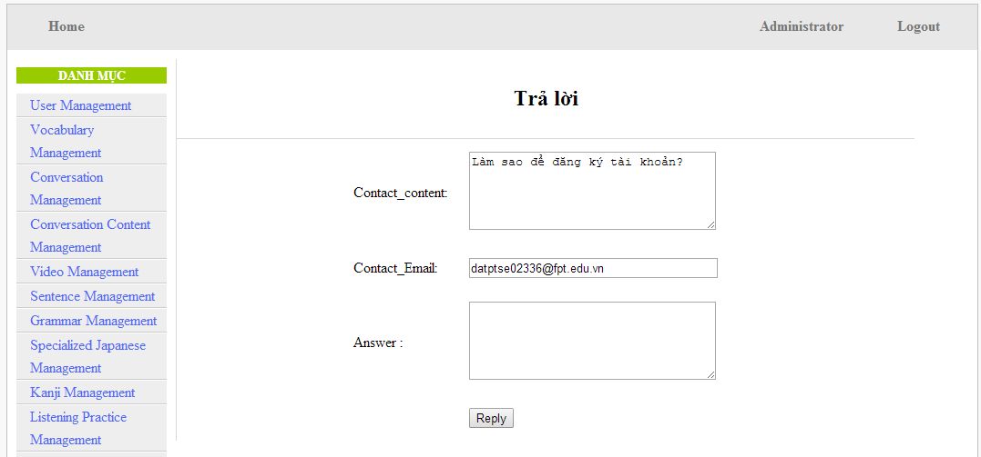
UC0056 - Specification
Use-case No. | <UC0056> | Use-case Version |  | <1.0>
Use-case Name | Search question
Author | Minh PT
Date | 09/06/2014 | Priority | <High >
Actor:
Admin
Summary:
When administrator wants to reply question from member.
Triggers
Click on “Opinion/Q&A Management ” tab, User search question then click “Reply” link corresponding
Preconditions:
- Website is available
- User has to login as Administrator
- User has to input answer
Post Conditions:
Answer be sent to user
Main Success Scenario:
Step | User | System
1 | Have logged into system as an admin
2 | Click on “Opinion/Q&A Management ” tab | Displays criteria search screen
3 | Click “Reply” link corresponding | Displays Reply screen with these elements:  - Contact_Content  - Contact_Email  - Answer
4 | Input the answer
5 | Click “Reply” button | The answer of question will be sent to member

Alternative Scenario:
At Step | User | System
4 | Input answer then click on another link | Switch to selected page

Exceptions:
At Step | User | System
Reference:
UC0055 - < Opinion/Q&A Management > Search question

Non-functional Specification

Reliability
- Mean time between failures: The mean time between each failure is expected to be about 480 hours of using.
- Mean time to repair: Immediately when Administrator finds out problem or website is attacked/hacked by someone. Average 1 day.
- The maximum bugs per function are 2 bugs/a function when user uses software within 2 months. The average number of bugs in the software during system testing is about to be around 1 bugs/1000 LOC.
- The database must be backed up daily and can be recovered if necessary

Performance Requirements

Availability
The application must be available 95% of time. Users can access to it everywhere from their
Web browser with internet connection.

Response time
In term of response time, waiting time of processing will be 2 to 5 seconds; time to process any functions will not exceed 7 seconds.

User Interface
● Color: The background color will be white and blue in default. The color of text will
be black or white.
● Text: All texts bases on Helvetica style and title or label will use upper case with the
first letter.

Maintainability
- Coding standards and naming conventions
  - Output of the project must include coding standards and naming conventions documentations. Implementation code must be easy to maintain.
  - All code must be clearly commented, including class, method documentations.
  - If some components are reused, the documentations of those components must also be included.
- Design
  - The design of the system must be loosely coupled that chances on some module will not affect others.
- Logging
  - All the errors should be logged, supporting for bug fixing and maintenance.
  - All strange or sensitive situations should also be logged.

Usability
Usability Requirements support the following from the perspective of its primary users:
● Efficiency of use: user can complete each function in less than 12 actions
● Intuitiveness: all help/error messages are simple to understand; user can know exactly how to do each feature after one time using it.

Security Requirements
In order to avoid unwanted access by strangers, the security implemented in various ways:
- User layer: Each function must be distributed system access and manipulate the individual parts. To edit information, user must declare their username and password before the operation. Functions will be show after users login dependencies user’s role and permission of each user.
- Manage Data Layer: Only Administrator can modify database system.
- Stored Data: All data about information of user, tested, etc.. will be saved in My SQL Server, and be easy for data classification or backup..

Hardware/Software Requirements
● Hardware requirement: PC/Laptop (window 7, window 8, window XP…)
● Software requirements: Web browser (Chrome, Firefox, IE…) with internet connection

