
The harvey nash soFTwARE development center



Morses – Customer Accounts Processing
Installation Guides

Project Code: Morses-CAP-P1
Document Code: Morses-CAP_P1_Installation Guides_v1.8

Hanoi, Oct 2006
Record of change
*A - Added M - Modified D - Deleted
Effective Date | Changed Items | A*  M, D | Change Description | New Version | Name
03-Oct-2005 | Whole document | A | Create new | 1.0 | BinhPH
14-Nov-05 | 3.8 Build up Message Queue  3.9.7 Switch Message Queue on and off | M | Add section to guide installing PDA Integration Package | 1.1 | BinhPH
28-Nov-05 | 3.9.8. Background processes | A | Added this section to describe how to configure for back ground process | 1.2 | Sang Nguyen
19-Dec-05 | 3.9 Config for SSO  3.11 Screen Hieralchical Relation | A | - Add configuration to SSO  - List Screens in Morses-CAP in hieralchical structure | 1.3 | BinhPH
23-Jan-06 | 3.10.8.4 Verify Configuration of Export to Product Partner Process | M | Update description for verifying email address of Argos Product Partner | 1.4 | Sang Nguyen
23-Jan-06 | 3.10.7 Switch Message Queue on and Off | D | Delete this section because this function is removed | 1.4 | Sang Nguyen
07-Jul-06 | 3.8 Update PDA Database Version | M | Change content of this section | 1.5 | Sang Nguyen
07-Aug-06 | 3.11 User Role Mapping | A | Add this section to guide how to map the users in Oracle App Server to MORSES_USER role | 1.6 | Sang Nguyen
13-Oct-06 | 3.10.7.8 Verify Configuration of JVM  3.10.7.9 Create Trigger | A | Add this sections to guide how to check JVM parameters & Triggers of BO | 1.7 | Sang Nguyen
27-Oct-06 | 3.10.7.10 Switch Summary Calculation Mode | A | Change summary mode | 1.8 | Sang Nguyen

SIGNATURE PAGE

ORIGINATOR: Pham Hai Binh Nov 14th, 2005

REVIEWERS: Project Team Nov 28th, 2005

Tran Thuc Quyen Nov 28th, 2005
HVN SDC Project SQA

APPROVAL: Nguyen Trung Kien Aug 07th , 2006
HVN SDC Project Manager

Nguyen Van Sang
HVN SDC Project Manager

Dinh Huy Nguyen
HVN SDC Project Manager
TABLE OF CONTENTS
1 Introduction 5
2 Environment Installtion 5
2.1 Software required 5
3 Application installation 5
3.1 MORSES-CAP EAR file 5
3.2 Create database and default data for MORSES-CAP 5
3.3 Setting up the Oracle Enterprise Manager 10g for MORSES-CAP 6
3.4 Create new OC4J instance 6
3.5 Setting up MORSES-CAP Data Source 8
3.6 Installing MORSES-CAP EAR file to server 11
3.7 Modify information for Address Search Webservice 13
3.8 Update PDA Database Version 14
3.9 Config for Single Sign On 14
3.10 Installation verification 15
3.10.1 sessions.xml 15
3.10.2 toplink-deployment-descriptor.xml 15
3.10.3 Disable JSP cached 15
3.10.4 log4j.properties 15
3.10.5 Update server after changes properties 16
3.10.6 Running MORSES-CAP application 16
3.10.7 Background Processes 16
3.11 User Role Mapping 18
3.12 Screens Hierarchical Relation 22

Introduction
This document contains guide-lines step by step to build up MORSES-CAP application, and set up the MORSES_CAP database.
This document assumes that an Oracle 10g database server and an Oracle 10g Application Server have been setup properly.

Environment Installtion

Software required
Following are the software required to setup the MORSES-CAP:
- Operating System: Sun Solaris 9
- Application Server: Oracle Application Server 10g version 9.0.4, run with model of 2 physical servers, one running Oracle AppServer in Infrastructure mode and the other running Application Server mode.
- Database: Oracle Database 10g version 10.1.0.3

Application installation

MORSES-CAP EAR file
In Morses-Cap Phase 1, software package is delivered as a single EAR file.
The package is packed in a single EAR file named “MORSES-CAP.ear”.

Create database and default data for MORSES-CAP
Please follow these steps to create database and test data for MORSES-CAP.
Step 1 – Create Table Spaces.
The following 8 table spaces need to be created before running script to create tables and constrains. You need login the database with DBA role and create the following table spaces:
VERY_LARGE_INDEXES
VERY_LARGE_DATA
LARGE_DATA
LARGE_INDEXES
MEDIUM_INDEXES
MEDIUM_DATA
SMALL_INDEXES
SMALL_DATA
Step 2 – Create Tables and Constrains
Run the script in file Morses-CAP-P1_Database_Script(BO)_vx.x.sql to create Tables and Constraints
Step 3 – Create Sequence
Run the script in file Morses-CAP-P1_Database_Sequence(BO)_vx.x.sql to create Sequences
Step 4 – Build System data
System data is used by system only, it should never be changed by the user. This contains data in General_References, Screens, Group_Fields, Batch, Batch_Time tables.
To build System data run the script in file Morses-CAP-P1_SystemData_script_vx.x.sql .
Step 5 – Build Reference data
Reference data contains data for reference tables such as Event_Reasons, Product_Types, Product_Partners…
Run the script in file Morses-CAP-P1_ReferenceData_script_vx.x.sql to create Test Data

Setting up the Oracle Enterprise Manager 10g for MORSES-CAP
Configuration and deployment on Oracle Enterprise Manager 10g are done via web-based Application Server Control Console.
Assume the Enterprise Manager is installed on host <host-name/ip>, with Application Server Control port is <port> (default is 1810), the Control Console can be accessed from a browser with this URL: http://<host-name/ip>:<port>
After logging in with IAS administrator account (ias_admin), a Farm homepage is showed as:
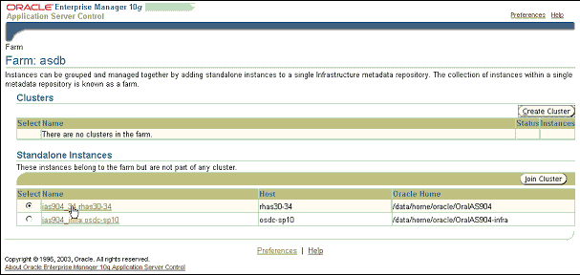
Figure 1 – Oracle Enterprise Manager 10g’s Application Server Control Console

This installation guide assumes a single server instance without clustering.
Click on server instance link to enter control console of the application server, where user can change its configuration and/or manage deployed applications.

Create new OC4J instance
Create new OC4J instance which EAR file deploy to.
Step 1 – From control console of the application server, click “Create OC4J Instance” to create new OC4J instance.
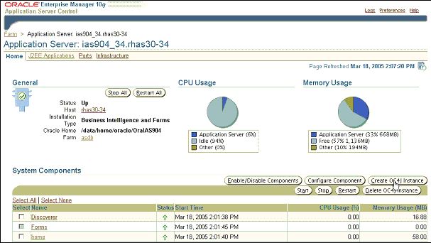
Figure 2 – Click “Create OC4J Instance” button to create new OC4J instance.

Step 2 - Enter the name of the OC4J instance you wish to create (In this case, OC4J Instance Name is OC4J_MORSES_CAP).
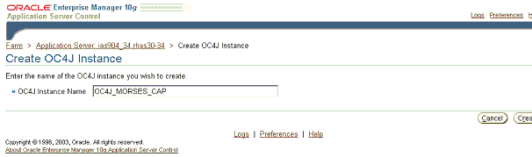
Figure 2 – Click “Create” button to create new OC4J_MORSES_CAP instance.
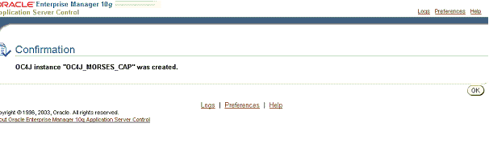
Figure 3 – Click “OK” when OC4J instance created successfully.

Step 3 – Enter OC4J_MORSES_CAP instance homepage and start this instance by clicking on Start button.

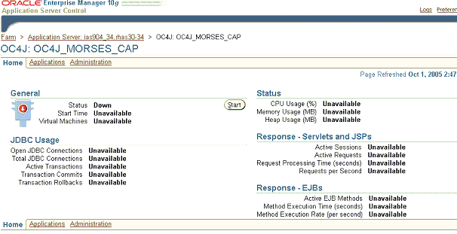
Figure 4 – Click “Start” to start OC4J_MORSES_CAP instance.

Setting up MORSES-CAP Data Source

Step 1 – In OC4J_MORSES_CAP instance homepage, select Administration tab:
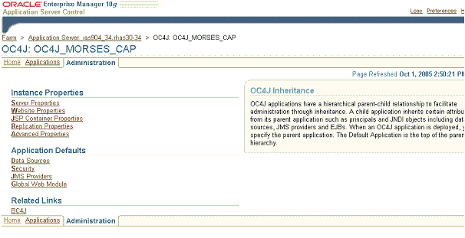
Figure 16 – Select Administration tab link on In OC4J_MORSES_CAP instance homepage

Step 2 – In Administration tab, select Data Sources.
Step 3 – In Data Sources screen, select “Create” to create new Data Source:
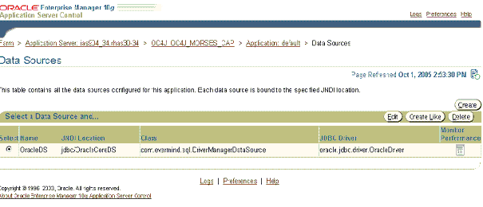
Figure 18 – Select “Create” button on Data Sources page

Step 4 – In Create Data Sources screen, enter all information to create new Data Source:

General information:
Data Source name: MorsesCapDS (which is defined in session.xml file)
Data Source Class: com.evermind.sql.DriverManagerDataSource
JDBC URL: jdbc:oracle:thin:@(DESCRIPTION=(ADDRESS=(PROTOCOL=tcp)(HOST=%DBHOSTNAME%)(PORT=%DBPORT%))(CONNECT_DATA=(SID=%DBSID%))) (The JDBC URL string needs to update with actual MORSES-CAP Oracle database)
JDBC Driver: oracle.jdbc.driver.OracleDriver
Schema name: <Database’s schema name>

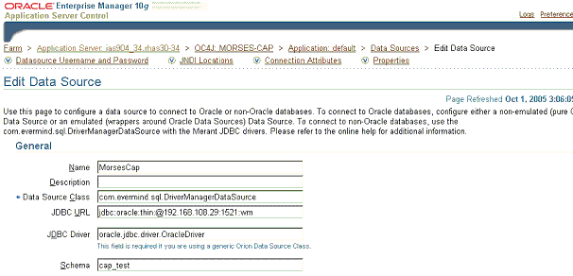

Figure 19 – Enter Data Source name, Data Source Class, JDBC URL, JDBC Driver and Schema name

Datasource Username and Password:
Username: <The user name to login database>
Password: <The password to login database>
Select Use Cleartext Password
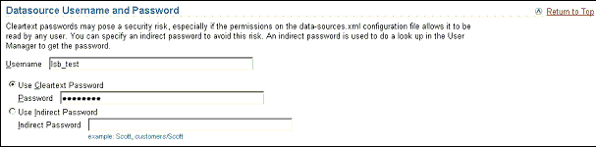
Figure 20 – Enter Username and Password to login database
JNDI Locations:
Location: jdbc/MorsesCapDS
Transactional(XA) Location: jdbc/xa/MorsesXADS
EJB Location: jdbc/MorsesCapDS

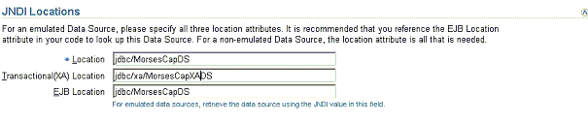
Figure 21 – Enter Location, Transactional(XA) Location and Password

Finally, let click on “Create” button to create the Data Source.

Installing MORSES-CAP EAR file to server

Step 1 – on Application Server management screen select OC4J_MORSES_CAP instance.
Step 2 – On OC4J_MORSES_CAP page, select Applications tab:
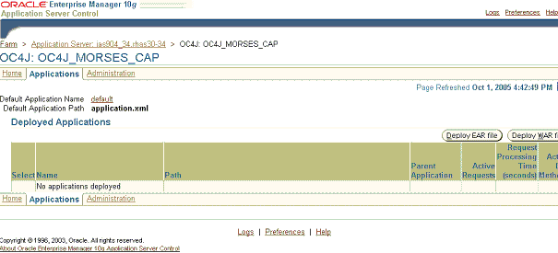
Figure 25 – Select Applications tab on OC4J_MORSES_CAP instance homepage

Step 3 – Select “Deploy EAR file” button to deploy MORSES-CAP EAR file. If the application has already existed, remove it by “Undeploy” button.

Step 4 – Specify location of MORSES-CAP EAR file, and enter application name as “MORSES-CAP”, then click “Continue” button:
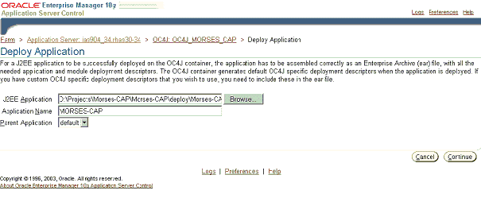
Figure 27 – Select EAR file location and enter application name

Step 5 – Keep default URL mapping (MORSES-CAP) and click “Next”:
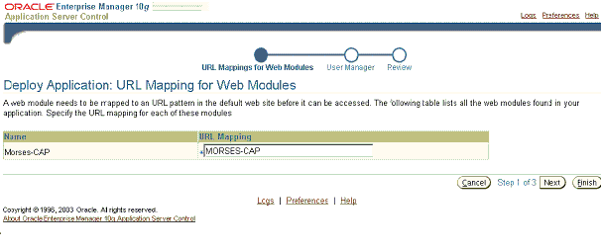
Figure 28 – Keep default URL mapping as “MORSES-CAP”

Step 6 – Keep default User Manager and click “Next”:
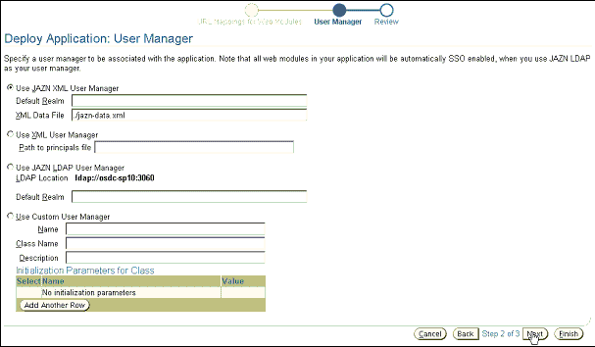
Figure 29 – Keep default User Manager and click “Next”

Step 7 – Click “Deploy” to start deployment process. Click “OK” when finished.
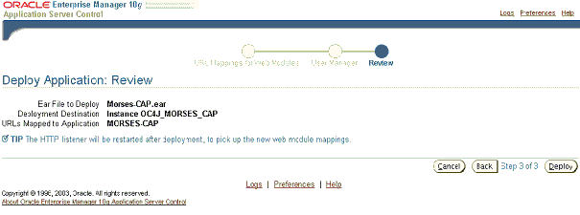
Figure 30 – Click “Deploy” to start deployment process

Modify information for Address Search Webservice
Please be ensured the Address Search Webservice has been deployed properly.
LSB admin team is responsible to provide Address Search Web Service and support deployment. Say the URL to call AddressSearch webservice is http://Address_Search_Web_ServiceURL , you need to update this information into morses-cap-online.xml, you can find this file under following path after you’ve successfully deployed MORSES-CAP.EAR : $ORACLE_HOME/j2ee/OC4J_MORSES_CAP/applications/MORSES-CAP/MORSES-CAP/WEB-INF/.
In morses-cap-online.xml, let find this tag:
<web_services>
<qas_services>
<location>
and update the URL to call Address Search Web service to it’s content. This should be:
<web_services>
<qas_services>
<location>http://Address_Search_Web_ServiceURL</location>

Any other change to tags <ns1>,<namespace>,<method_name> of Address Search Webservice need to be updated accordingly to this xml file.

Update PDA Database Version
To support for PDA application, the value in PDA_DB_Version table must be the same with version configured in .xml configuration file of PDA Application. If there is no data in this table, please use SQL statement in “PDA_DB_Version.SQL” to insert a record into this table.
To check this value, please use the following SQL statement to select database version
Select * from PDA_DB_VERSION;

Config for Single Sign On
Please be ensured the SingleSignOn Webservice has been deployed properly.
LSB admin team is responsible to provide Single Sign On Web Service and support deployment. Say the URL to call Single Sign On Web Service is http://SSO_Web_ServiceURL , you need to update this information into morses-cap-online.xml (you can find this file under following path after you’ve successfully deployed MORSES-CAP.EAR : $ORACLE_HOME/j2ee/OC4J_MORSES_CAP/applications/MORSES-CAP/MORSES-CAP/WEB-INF/).
In morses-cap-online.xml, let find this tag:
<web_services>
<sso_services>
<location>
…
</sso_services>
<web_services>

and update the URL to call Address Search Web service to it’s content. This should be:
<web_services>
<sso_services>
<location>http://SSO_Web_ServiceURL</location>
…
</sso_services>
<web_services>
Any change on SSO web service (method name, Object Uri) should be updated respectively in moreses-cap-online.xml, e.g:
<method_name_authenticate>
<method_name_change_pw>
<target_object_uri>

Installation verification
After deployment, MORSES-CAP EAR file is extracted to a folder on server at this location:
MORSES-CAP application:
$ORACLE_HOME/j2ee/OC4J_MORSES_CAP/applications/MORSES-CAP/MORSES-CAP/

sessions.xml
This file defines session settings for Oracle TopLink and is located at:
$ ORACLE _HOME/j2ee/OC4J_MORSES-CAP/applications/MORSES-CAP/MORSES-CAP/WEB-INF/classes/META-INF
You can configure DataSource name and TopLink debug parameters in this XML file:
<login>
<datasource>jdbc/MorsesCapDS</datasource>
<platform-class>oracle.toplink.oraclespecific.Oracle9Platform</platform-class>
<uses-external-connection-pool>true</uses-external-connection-pool>
</login>
<!—-This value should be set “False” because if it is set “True”, the Oracle Application Instance may be died when the log is full -->
<enable-logging>false</enable-logging>
<logging-options>
<log-debug>true</log-debug>
<log-exceptions>true</log-exceptions>
<log-exception-stacktrace>true</log-exception-stacktrace>
<print-thread>false</print-thread>
<print-session>true</print-session>
<print-connection>false</print-connection>
<print-date>false</print-date>
</logging-options>

toplink-deployment-descriptor.xml
This file defines TopLink mappings for MORSES-CAP. It is located in same folder as sessions.xml.

Disable JSP cached
To avoid error when using JSP 1.1 TLDs that do not include a DOCTYPE:
Turn off TLD caching by adding the following attribute to the orion-web-app element in the the j2ee/OC4J_MORSES_CAP/config/global-web-application.xml file
<orion-web-app ... jsp-cache-tlds="false">

log4j.properties
This file defines Log4J parameters and is located in same folder as sessions.xml file.
You need to update log file location to suit your environment.
log4j.appender.MORSES-CAPLogger.File = MORSES-CAP.log

Update server after changes properties
After changing any of above property files, you need to restart the OC4J_MORSES_CAP instance (“Restart” button on Figure 11) for the changes to take effect.

Running MORSES-CAP application
In a browser, type this URL to run MORSES-CAP application:
http://<host-name/ip>:<HTTP-port>/MORSES-CAP/login.do
where <HTTP-port> is the HTTP port of Oracle Application Server.

Background Processes

Switch Off Processes
The option to switch all background processes off is set in the file morses-cap-online.xml
This file is under $ ORACLE _HOME/j2ee/OC4J_MORSES-CAP/applications/MORSES-CAP/MORSES-CAP/WEB-INF/ after MORSES-CAP has been deployed successfully.
Please find the following tag and then change value to be “false”:
<background>
<start>true</start>
</background>

Verify Last Executed Date & End Date of Batch Jobs
Currently, the system has two types of Background processes. The first type of background process runs daily (at 00:00:01 of a new day). The second type runs weekly (at the start time of new financial week). All Background processes can run correctly if the last executed time of back ground processes is set correctly.
1. For Weekly Background Processes, the “LAST_EXECUTED_TIME” in “BATCH” table in Back Office Database must be the “Start Date” of a financial week which has been set-up in the system. They will be used to calculate data and to control the running time.
Please note that after general reference data is inserted by executing “Gereneral_Reference Script”, the last executed date of Weekly Background processes is empty. If they have not been setting up, the system will set default by the “Start Date” of the current financial week.

Below is a sample SQL script to select all weekly batch processes
select * from Batch where batch_type='WEEKLY';

2. For Daily Background processes, the “LAST_EXECUTED_TIME” must be the date, from which you wants to calculate date. Time in “LAST_EXECUTED_TIME” should be in format “00:00:01”. When the application is installed, it is set-up default by “28-Nov-05”, so they should be changed to the actual date.

Below is a sample SQL script to select all daily batch processes
select * from Batch where batch_type='DAILY';
3. Batch Jobs will use “End_Date” field to define whether they continue to run or not. When the “End_Date” is reached, Batch Jobs will stop running. To update this field, we can use Batch Management function to update value of “End_Date”

Verify Mail Server (SMTP Mail Server) Configuration
Some background processes uses SMTP email server to send data, so the following configuration should be changed

<background>
<mail>
<SMTPDebug>N</SMTPDebug>
<SMTPAuthentication>Y</SMTPAuthentication>
<SMTPHost>192.168.106.12</SMTPHost>
<SMTPUsername>morses</SMTPUsername>
<SMTPPassword>morses</SMTPPassword>
<SMTPPort>25</SMTPPort>
<SendTimeout>10000</SendTimeout>
<ConnectionTimeout>4000</ConnectionTimeout>
<RetryWait>5000</RetryWait>
</mail>
<background>

Verify Configuration for Export to Product Partner Process
1. File Path of temp data file
Back Office uses the following tag to store temp data file while it processes data and sends it to email server of Argos product partner, so that it should be modified to reflect the actual file pat in sever
<export_to_product_partner>
<path_name>D:/Projects/Morses-CAP/data/exportToProductPartner</path_name>
</export_to_product_partner>

2. Product Partner Name
Please find the following tag and change its value to be actual product partner name of Argos Card. Its value must be same with a product partner in “Product_Partner” table
<export_to_product_partner>
<partner_argos>
<argos>ARGOS</argos>
</partner_argos>
</export_to_product_partner>

3. Verify Mail From/To
Please find the following tags and change their values to be actual email from/to address of Morses & Argos Card Product Partner.
<export_to_product_partner>
<mail>
<from>Morses-Club@mail.co.uk</from>
</mail>
</export_to_product_partner>
The email address of Argos that the .CSV file will be sent to is stored in COM_INFO field of Product_Partner table. This value should be changed to be actual email address of Argos

Verify Configuration for Export Data to CODA system Process
Please find the following tag to update its value to be the real file path where CODA data file should be exported to
<export_to_coda>
<file_path></file_path>
</export_to_coda>

Verify Configuration for Export Data to Payroll/Invoice Process
- File Path of temp data file
Please find the following tag to update its value to be the real file path where temp Payroll/Invoice file should be stored.
<finance>
<export_directory>/csv</export_directory>
</finance>
- Email Address (from/to).
Please change the email address where the Payroll/Invoice .CVS file will be sent to in the following tags
<finance>
<mail>
<from>Morses-Club@mail.co.uk</from>
<pfrom>Morses-Club</pfrom>
<to>sales@arcanedirectmarketing.co.uk</to>
</mail>
</finance>

Verify Configuration for Letter Send Process
Please verify the following configurations in morses-cap-online.xml. They are used to store temp .csv files and send these .csv files to Arcane system.

<send_letter>
<path_name>/data/home/oracle/OraIAS904/j2ee/home/Morses-CAP/data/sent_Letters</path_name>
<mail_from>Morses-Club@mail.co.uk</mail_from>
<mail_personal_from>Morses-Club</mail_personal_from>
<mail_to>sales@arcanedirectmarketing.co.uk </mail_to>
</send_letter>

Verify Configuration of JVM in Oracle Application Server
Before start Back office application server, please check the parameters of JVM for OC4J -Xms256m -Xmx1536m

Create Back Office Triggers
Please check to make sure that triggers enclosed with Back Office Database scripts (Morses-CAP-BO-Trigger.sql) have been created and valid in Back Office database.

Switch Summary Calculation Mode
After the Batch Jobs have finished for 10 week summary data, the following configuration should be updated to ‘false’ to change to the calculation mode
<dm_mode>true</dm_mode>

User Role Mapping
All users accesses to Morses CAP Back Office application must have “MORSES_USER” role. This role is defined in the following tags of web.xml file of Back Office application.
<security-role>
<description>Morses user</description>
<role-name>MORSES_USER</role-name>
</security-role>
To map the users in Oracle Application Server with “MORSES_USER” role, please follow the steps below:
Step 0: Create users in Oracle Single SignOn if you want to use the users in SSO or users in Oracle Application Server (See Administration Guide of Oracle Application Server and Oracle SSO) and then open Oracle Administration Console screen.
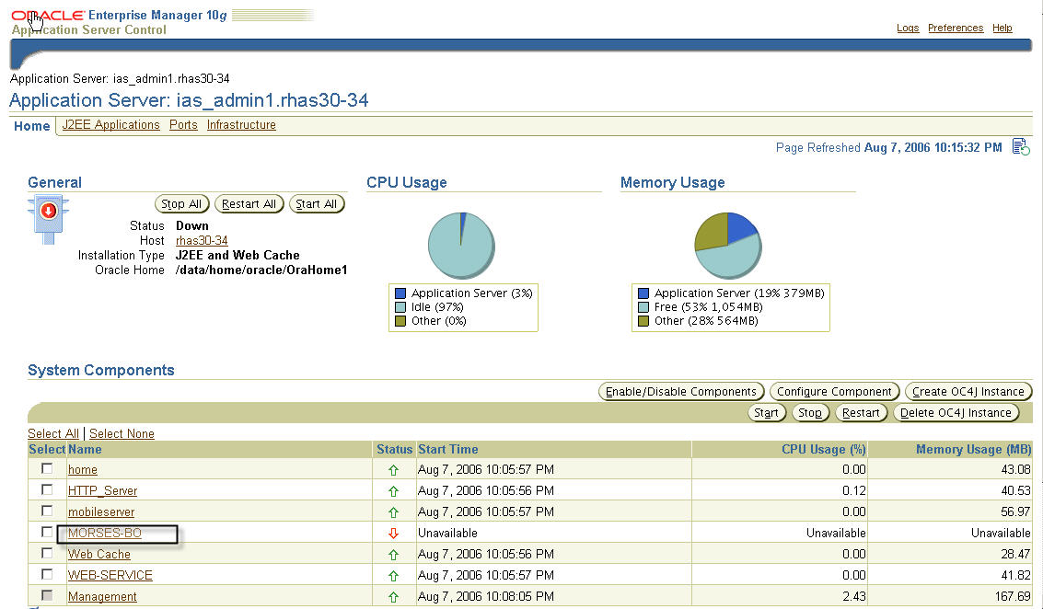

Step 1: Click on MORSES CAP Back Office instance in Oracle Application Server Console
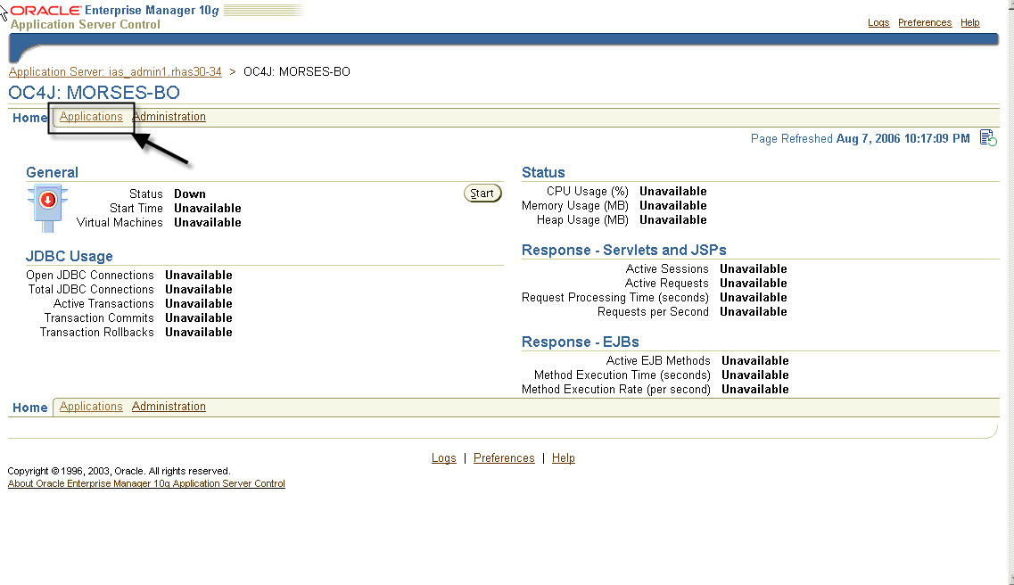
Step 2: Clicks on “Applications” tab on the screen

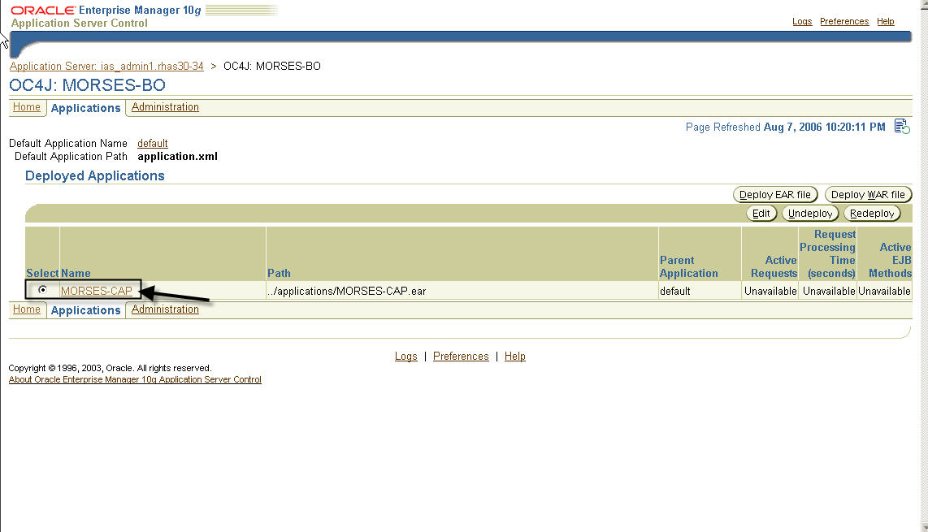
Step 3: Clicks on “MORSES-CAP” application

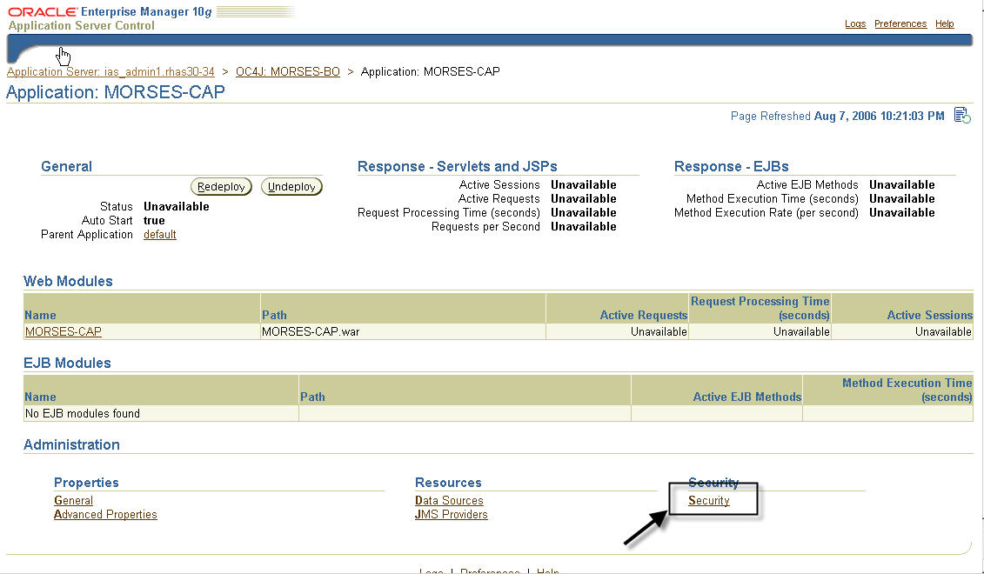

Step 4: Clicks on “Security” and then select “Map Role to Principals”
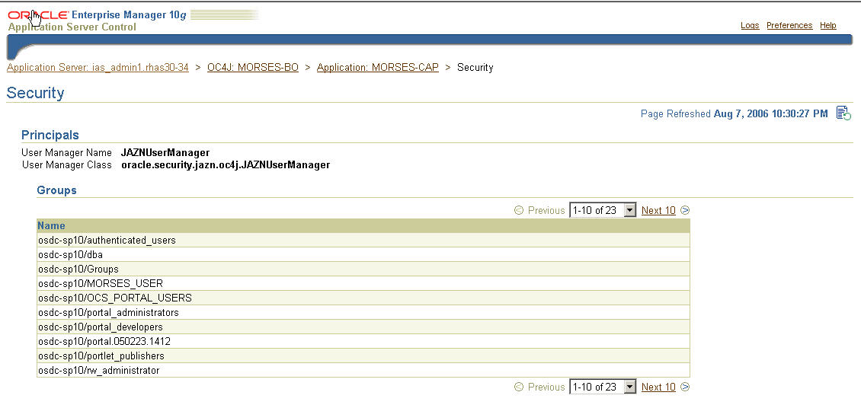
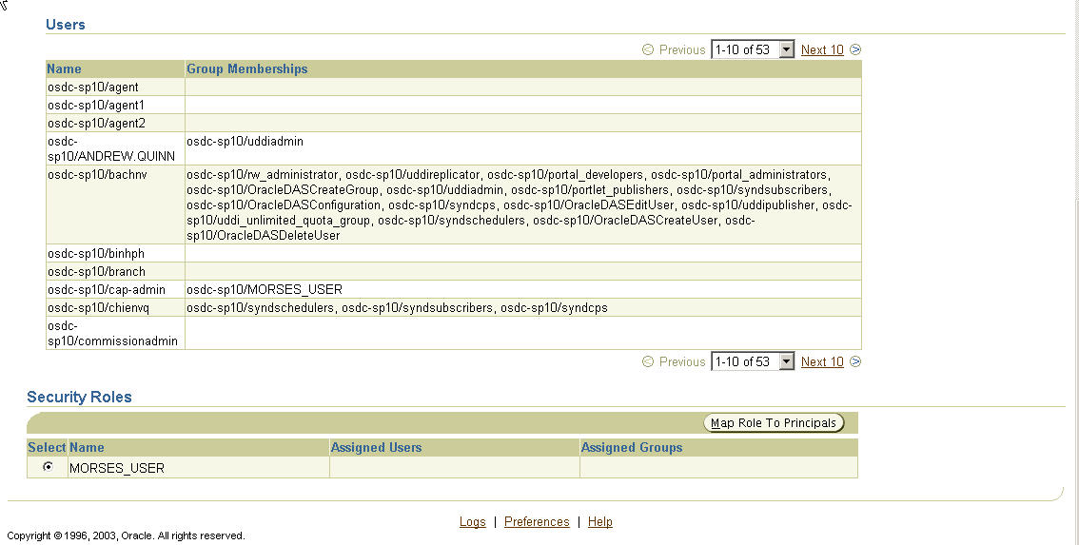

Step 5: Checks all the users that you wants to assign to “MORSES_USER” role and then clicks on “Apply”
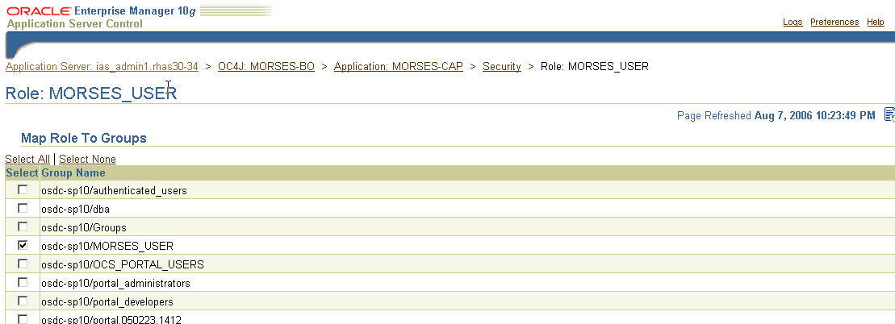
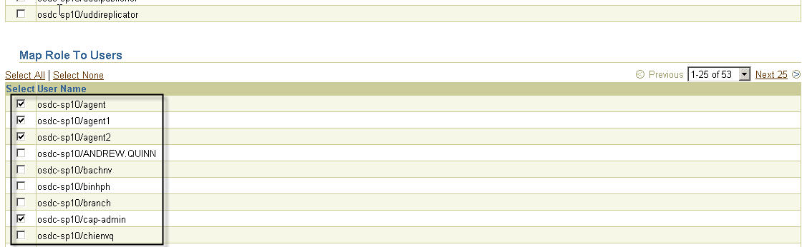
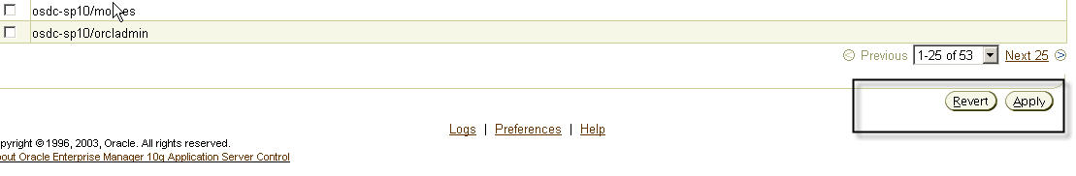

Screens Hierarchical Relation
This section lists all screens in Morses-CAP application with their hierarchical structure.
When Administrator set up privileges for User Group (Screen Permission function), there is a rule should be note that: when a child screen is select its parent screen is automatic selected too.
|- Customer
| |- Search Customer
| |- View Customer Summary
| | - View Customer Details
| | - Amend Customer Details
| | - Amend Customer Summary
| | - Amend Customer Statement
| | - View Customer Statement
| | - Sale Transaction
| | - Account Payment
| | - Account Cancellation
| | - Account Adjustment
| | - View Customer Event
| | - View Letter Details
| | - Create New Log Entry
| | - View Customer History
| | - View Customer Business Unit
| |- Setup Customer
| |- Letter Management
| - Staff
| |- Search Staff
| |- View Staff Details
| | - ViewCommission Schemes
| | - View Business Units
| | - Assign Business Unit for Staff
| | - Un-assign Business Unit
| | - Amend Staff-Business Unit
| | - View Cash reconciliation
| | - Amend Cash reconciliation
| | - View Total Collections
| | - View Payment Details
| | - Update Payment
| | - View Total ATM Withdrawals
| | - Add ATM Withdrawal
| | - Amend ATM Withdrawal
| | - View Loan Sales
| | - View Loan Sale Details
| | - Update Sale
| | - View Refunds List
| | View Refund Details
| | Amend Refund Details
| | - View Commission Taken
| | - Add Commisson Taken transaction
| | - View Banking Different
| | -Add Value for Banking Different
| | - Confirm Banking
| | - View Commission history
| | - View Commission statement
| | - View Commission Adjustments
| | - Add/Amend Commission Adjustments
| | - View Payments Taken
| | - Add value for Payment Taken
| | - View Additional Commissions
| | - Add value for Commission Bonus
| | - Amend Staff Details
| | - View Additional Data
| | - View/Amend Work hours
| | - Add/Amend/View Absence records
| |- Setup Staff
| |- Commission Schemes
| |- View Commission Scheme
| | - Amend Commission Scheme
| | - View Scheme Details
| | - Un-allocate Scheme for Staff
| | - Allocate Scheme for Staff
| | - Setup Commission
| - Product
| | - List Product
| | - View Product
| | - Amend Product
| | - Setup Product
| - Finance
| | - Credit Control Schemes
| | - View Credit Control Scheme
| | - Amend Credit Control Scheme
| | - Delete Credit Control Schemes
| | - Setup Schemes
| | - Export Commission
| | - Create and send payroll file
| - Organisation
| | - Search Business Unit
| | -View Business Unit Details
| | - Amend Business Unit Details
| | - Assign Staff for Business Unit
| | - Amend Staff in Business Unit
| | - View Business Unit Summary
| | - Setup Business Unit
| - Business Administration
| | - Week Numbering
| | - Amend Week Numbering
| | - Setup Week Numbering
| | - Manage Business Streams
| | - Widthdraw Business Stream
| | - View Business Stream
| | - Amend Business Stream
| | - Add Business Stream
| | - Manage Reason Codes
| | - View/Amend Adjustment Reason Codes
| | - Add Adjustment Reason Codes
| | - View/Amend Event Reason Codes
| | - Add Event Reason Codes
| | - Manage System Variables
| | - Amend System Variables
| | - Manage User Group
| | - View User Group Details
| | - Amend User Group Details
| | - Delete User from User Group
| | - Set User Permission
| | - Assign User to Group
| | - Delete User Group
| | - Setup User Group
| | - Letter Management
| | - Reset User Password
| | - Letter Queue Management
| | - User Password Management
| | - Batch Management

