|  |  |
| --- | --- |
| Logo_FPT_University_doc | **MINISTRY OF EDUCATION AND TRAINING** |

**FPT UNIVERSITY**

**CAPSTONE PROJECT DOCUMENT**

**<Project Code>**

**Report #3 – Software Design Specification**

|  |  |
| --- | --- |
| **<Group Code>** | |
| **Group Member** | <ID - Name> |
| <ID - Name> |
| <ID - Name> |
| <ID - Name> |
| **Supervisor** | <Name> |
| **Ext. Supervisor** |  |
| **Project Code** | <Code> |

- Hanoi, 05/2012 -

Table of Contents

[1 ARCHITECTURE DESIGN 3](#_Toc364951304)

[1.1 Choice of Architecture Design 3](#_Toc364951305)

[1.2 Architectural Presentation 3](#_Toc364951306)

[1.3 Component/Package Design 3](#_Toc364951307)

[2 DETAILED DESIGN 3](#_Toc364951308)

[2.1 Common Design 3](#_Toc364951309)

[2.2 <UC xx- Use case name> 3](#_Toc364951310)

[2.2.1 Class Diagram 3](#_Toc364951311)

[2.2.2 Class Description 3](#_Toc364951312)

[2.2.3 Screen Design 5](#_Toc364951313)

[2.2.4 Sequence Diagram 5](#_Toc364951314)

[3 DATABASE DESIGN 6](#_Toc364951315)

[3.1 Entity Relationship Diagram 6](#_Toc364951316)

[3.2 Database Diagram 6](#_Toc364951317)

[3.3 Table Descriptions 6](#_Toc364951318)

[3.3.1 Table xxx 6](#_Toc364951319)

[3.3.2 Table xxx 6](#_Toc364951320)

# ARCHITECTURE DESIGN

## Choice of Architecture Design

<Description about AD decision and Why choose the technology and design architecture?>

## Architectural Presentation

<Khái quát về kiến trúc của hệ thống>

## Component/Package Design

<Khái quát kiến trúc của hệ thống dưới góc nhìn về component - các thành phần biểu diễn bằng UML >

# DETAILED DESIGN

## Common Design

<Phần mô tả thiết kế cho các thành phần chung của tất cả các chức năng>

## <UC xx- Use case name>

### Class Diagram

<Sơ đồ quan hệ giữa các lớp của chức năng>

### Class Description

<Phần mô tả chi tiết các lớp của chức năng>

#### <Class Name>

|  |  |  |  |  |
| --- | --- | --- | --- | --- |
| Class | <Class Name> | | | |
| **Description** |  | | | |
| **Base Class** |  | | | |
| **Constructor** |  | | | |
| **Prototype** |  | | | |
| **Source File** |  | | | |
| **Namespace** |  | | | |
| **Attributes** | Name | Type | Description | |
|  |  |  | |
|  |  |  | |
|  |  |  | |
|  |  |  | |
| **Methods** | Name | Input | Output | Description |
|  |  |  |  |
|  |  |  |  |

#### <Class Name>

|  |  |  |  |  |
| --- | --- | --- | --- | --- |
| Class | <Class Name> | | | |
| **Description** |  | | | |
| **Base Class** |  | | | |
| **Constructor** |  | | | |
| **Prototype** |  | | | |
| **Source File** |  | | | |
| **Namespace** |  | | | |
| **Attributes** | Name | Type | Description | |
|  |  |  | |
|  |  |  | |
|  |  |  | |
|  |  |  | |
| **Methods** | Name | Input | Output | Description |
|  |  |  |  |
|  |  |  |  |

......

### Screen Design

<Screen Layout - Manage news- Delete news >

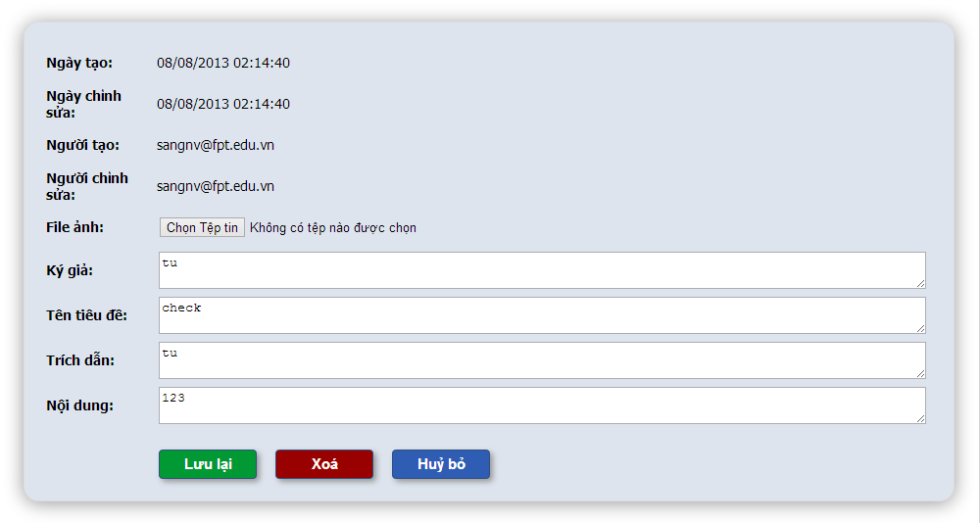

<Screen Definition>

**Table 4-x:** Manage news- Delete news

|  |  |  |  |  |  |  |
| --- | --- | --- | --- | --- | --- | --- |
| **No** | **Object/Control Name** | **Object/Control Name in English** | **Type** | **Required** | **Length** | **Description** |
| 1 |  |  |  |  |  |  |
| 2 |  |  |  |  |  |  |
| 3 |  |  |  |  |  |  |
| 4 |  |  |  |  |  |  |

### Sequence Diagram

#### <Use-case ID - Use case name>

...

#### <Use-case ID - Use case name>

................

# DATABASE DESIGN

## Entity Relationship Diagram

## Database Diagram

## Table Descriptions

### Table xxx

|  |  |  |  |  |
| --- | --- | --- | --- | --- |
| No. | Attribute | Type | Constraints | Description |
| 1 |  |  |  |  |
| 2 |  |  |  |  |
| 3 |  |  |  |  |

### Table xxx

|  |  |  |  |  |
| --- | --- | --- | --- | --- |
| No. | Attribute | Type | Constraints | Description |
| 1 |  |  |  |  |
| 2 |  |  |  |  |
| 3 |  |  |  |  |
| 4 |  |  |  |  |
| 5 |  |  |  |  |
| 6 |  |  |  |  |
| 7 |  |  |  |  |
| 8 |  |  |  |  |
| 9 |  |  |  |  |
| 10 |  |  |  |  |
| 11 |  |  |  |  |
| 12 |  |  |  |  |
| 13 |  |  |  |  |
| 14 |  |  |  |  |
| 15 |  |  |  |  |