FPT University
Source: Exported from FU-EOS
Subject: SR
Generated Time: 7/23/2013 3:32:56 PM

MULTIPLE CHOICES QUESTIONS:
QN=1 (2888) | Which of the following is NOT a characteristic of an entity?1111
a. | The instances of an entity may exist in system independently of instances of other objects
b. | The instances of an entity can be distinctly identifiable and enumerated.
c. | The instances of an entity can be enumerated in any system state.
d. | The instances of an entity can control behavior of other objects.
ANSWER: | D
MARK: | 1
UNIT: | Chap10
MIX CHOICES: | Yes

QN=2 (1498) | An______ link may be introduced between an object Ob and objects PartOb1,… PartObn if every current instance of Ob is a tuple of current instances of PartOb1, …., PartObn.1
a. | aggregation
b. | composition
c. | association
d. | combination
ANSWER: | A
MARK: | 1
UNIT: | Chap10
MIX CHOICES: | Yes

QN=3 (2897) | Agent instances have individual behaviors captured by sequence of state transitions for the _________ that they control. These variables refer to attributes/associations of object instances.11
a. | state variables
b. | system state variables
c. | system object variables
d. | object attributes
ANSWER: | A
MARK: | 1
UNIT: | Chap10
MIX CHOICES: | Yes

QN=4 (2895) | When an individual becomes instance of an object, the object's attributes & associations get instantiated as _______ to characterize it1
a. | state variables
b. | system state variables
c. | system object variables
d. | object attributes
ANSWER: | A
MARK: | 1
UNIT: | Chap10
MIX CHOICES: | Yes

QN=5 (2889) | A conceptual object is a discrete set of instances of a domain-specific concept that are manipulated by the modeled system. These instances will have the following characteristics EXCEPT?2
a. | They are distinctly identifiable
b. | They can be enumerated in any system state
c. | They share similar features.
d. | They may not differ from each other in their individual states and state transitions.
ANSWER: | D
MARK: | 1.5
UNIT: | Chap10
MIX CHOICES: | Yes

QN=6 (2892) | Which of the following is the correct type of object aggregation in Figure 10-1 ?  (1) Library and Shelf, Director, and AntiTheft  (2) Car and Door object2222  [file:2892.jpg]  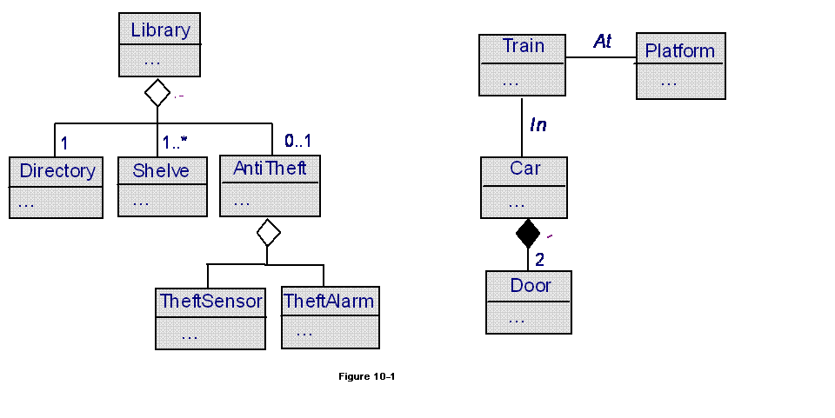
a. | (1) : aggregation, (2) : composition
b. | (2) : aggregation, (1) : composition
c. | (1) : association, (2) : aggregation
d. | (1) : association, (2) : composition
ANSWER: | A
MARK: | 1
UNIT: | Chap10
MIX CHOICES: | Yes

QN=7 (1497) | In specialization, the object SubOb plays the role ______ whereas the object SuperOb plays the inverse role ______.3
a. | Generalizes / Specializes
b. | Specializes / Generalizes
c. | IsA / SubClassOf
d. | SubClassOf / IsA
ANSWER: | B
MARK: | 1
UNIT: | Chap10
MIX CHOICES: | Yes

QN=8 (1499) | _______ is a particular case of aggregation whether the composite object Ob and its parts PartObi appear and disappear together in the system.33
a. | aggregation
b. | composition
c. | association
d. | combination
ANSWER: | B
MARK: | 1
UNIT: | Chap10
MIX CHOICES: | Yes

QN=9 (2894) | Which of the following features of an object specifies the necessary & sufficient condition for an individual to satisfy InstanceOf (o, Ob)?3333
a. | Def annotation
b. | Name
c. | DomInvar
d. | Type
ANSWER: | A
MARK: | 1
UNIT: | Chap10
MIX CHOICES: | Yes

QN=10 (1494) | The multiplicity on one side of an association specifies the minimum and maximum number of object instances on _______ that may be associated.33
a. | the other side
b. | this side
c. | both sides
d. | None of the others
ANSWER: | B
MARK: | 1
UNIT: | Chap10
MIX CHOICES: | Yes

QN=11 (2898) | Which of the following features of an entity specifies that the conditions for an individual to appear & disappear as instance of this entity must not necessarily refer to other objects in the model?4
a. | Def annotation
b. | Name
c. | DomInvar
d. | Type
ANSWER: | A
MARK: | 1
UNIT: | Chap10
MIX CHOICES: | Yes

QN=12 (2890) | The object model plays the following roles in model-based software development EXCEPT?44
a. | It precises definition of system concepts involved in other views, their structure & descriptive properties
b. | It yields the state variables manipulated in other views
c. | It provides a basis for generating a glossary of terms
d. | It is used to estimate the cost of the project
ANSWER: | D
MARK: | 1.5
UNIT: | Chap10
MIX CHOICES: | Yes

QN=13 (1490) | The features shared by object instances include.4444
a. | common vocabularies, glossary of terms, object's attributes and definition
b. | goals, agents, operations and behavior models
c. | object's definition, type, individual attributes, associations, domain invariants
d. | None of the others
ANSWER: | C
MARK: | 1
UNIT: | Chap10
MIX CHOICES: | Yes

QN=14 (2891) | An (a)_______ is an instantaneous object. Any its instance exists in a single state of the system only.4
a. | event
b. | entity
c. | association
d. | agent
ANSWER: | A
MARK: | 1
UNIT: | Chap10
MIX CHOICES: | Yes

QN=15 (1495) | An attribute is _______________.5555
a. | An intrinsic feature of an object regardless of other objects in the model
b. | A relevant feature of an object, including the association with other objects in the model
c. | A quantitative feature of an object
d. | none of the others
ANSWER: | A
MARK: | 1
UNIT: | Chap10
MIX CHOICES: | Yes

QN=16 (1496) | A specialization link may be introduced in a model between an object SubOb and an object SuperOb if every current instance of _____ is a current instance of _____ as well.5
a. | SuperOb / SubOb
b. | SubOb / SuperOb
ANSWER: | B
MARK: | 0.5
UNIT: | Chap10
MIX CHOICES: | Yes

QN=17 (1491) | An entity is ___________.555
a. | An autonomous and active object
b. | A conceptual object dependent on other objects that it links.
c. | An instantaneous object
d. | None of the others
ANSWER: | D
MARK: | 0.5
UNIT: | Chap10
MIX CHOICES: | Yes

QN=18 (2893) | An (a)___________ is an autonomous and active object. Its instances have individual behaviors captured by sequence of state transitions for the state variables that they control.55
a. | event
b. | entity
c. | association
d. | agent
ANSWER: | D
MARK: | 1
UNIT: | Chap10
MIX CHOICES: | Yes

QN=19 (2896) | State variables of the system are defined by the set of ___________ of all conceptual objects declared in the object model.6
a. | state variables
b. | system state variables
c. | system object variables
d. | object attributes
ANSWER: | A
MARK: | 1
UNIT: | Chap10
MIX CHOICES: | Yes

QN=20 (2899) | The arity of an association is the number of objects linked by it. We can speak of n-ary associations when this number is ______6666
a. | equal and greater than 2
b. | greater than 2
c. | greater than 3
d. | greater than 1
ANSWER: | B
MARK: | 1
UNIT: | Chap10
MIX CHOICES: | Yes

QN=21 (1488) | An object model provides a _________ of the system-as-is and system-to-be.66
a. | Intentional view
b. | Functional view
c. | structural view
d. | behavioral view
ANSWER: | C
MARK: | 1
UNIT: | Chap10
MIX CHOICES: | Yes

QN=22 (1489) | A/an _________ is a discrete set of instances of a domain-specific concept that are manipulated by the modelled system66
a. | System state
b. | State variable
c. | Object class
d. | Conceptual object
ANSWER: | D
MARK: | 1
UNIT: | Chap10
MIX CHOICES: | Yes

QN=23 (1493) | Each linked object in an association plays specific _____ in the association7777
a. | Relation
b. | Role
c. | Link
d. | none of the others
ANSWER: | B
MARK: | 1
UNIT: | Chap10
MIX CHOICES: | Yes

QN=24 (1492) | The association is also called under synonymous term __________7
a. | 'relation'
b. | 'relationship'
c. | 'linked object'
d. | none of the others
ANSWER: | B
MARK: | 1
UNIT: | Chap10
MIX CHOICES: | Yes

READING QUESTIONS:
FILL BLANK QUESTIONS:
MATCH QUESTIONS:

