FPT University
Source: Exported from FU-EOS
Subject: SR
Generated Time: 7/23/2013 3:19:06 PM

MULTIPLE CHOICES QUESTIONS:
QN=1 (4771) | _________ is parallel composition of State machine diagrams1
a. | Statechart
b. | Event trace diagram
c. | Sequence diagram
d. | R-net diagram
ANSWER: | A
MARK: | 0.5
UNIT: | Chap4
MIX CHOICES: | Yes

QN=2 (2821) | All of the following statements about outputs of requirement specification and documentation phase are correct EXCEPT?11
a. | Requirements documentation provides a precise specification of all general objectives, system requirements, and software requirements
b. | All general objectives, system requirements, software requirements .e.g. are organized in RD according to some coherent structure so as to meet the various defined target qualities.
c. | Each RD statement should be precisely specified in an appropriate specification language.
d. | The diagrams should not be used while documents requirements.
ANSWER: | D
MARK: | 1.5
UNIT: | Chap4
MIX CHOICES: | Yes

QN=3 (1478) | Actigrams (Datagrams) declare activities (data) by their input/output data (producing/consuming activities) and interconnect them through data (___________) dependency links.11
a. | Action
b. | Value
c. | Data
d. | Control
ANSWER: | D
MARK: | 1
UNIT: | Chap4
MIX CHOICES: | Yes

QN=4 (1487) | A _______ diagram can be further detailed by indicating explicitly which component controls a shared phenomena, which component constitutes the machine needs to be built, and which components are affected by which requirements.2
a. | context
b. | Frame
c. | Problem
d. | state machine
e. | entity-relationship
ANSWER: | C
MARK: | 1
UNIT: | Chap4
MIX CHOICES: | Yes

QN=5 (2827) | Which of the followings captures the activities and data in the system (system-to-be or system-as-is), these diagrams allow these activities and data to be documented in a graphical way?22
a. | SADT diagrams
b. | Dataflow diagrams
c. | Entity-relationship diagrams
d. | Context diagrams
ANSWER: | A
MARK: | 1
UNIT: | Chap4
MIX CHOICES: | Yes

QN=6 (2822) | Which of the followings is a standard technique for structuring complex if-then condition?22
a. | Using stylistic rules
b. | Using decision table
c. | Using predefined statement templates
d. | Using grouping rules
ANSWER: | B
MARK: | 1
UNIT: | Chap4
MIX CHOICES: | Yes

QN=8 (2819) | The following questions should be used while writing a requirements document EXCEPT?3333
a. | Is this comprehensible to the reader?
b. | Can he or she get lost at this point?
c. | Can it be expressed in a complex way?
d. | Is this the appropriate level of detail?
ANSWER: | C
MARK: | 1
UNIT: | Chap4
MIX CHOICES: | Yes

QN=9 (2824) | All of the following statements about advantages of free documentation in unrestricted natural language are correct EXCEPT?3
a. | There are no limitations in expressiveness on language.
b. | There is no communication barrier.
c. | Free text in natural language can be understood by all parties
d. | There is no notable ambiguities, noises .etc.
ANSWER: | D
MARK: | 1
UNIT: | Chap4
MIX CHOICES: | Yes

QN=10 (4772) | Which of the following specifies all the operations that a system component is required to perform, possibly under a particular condition, in response to a particular input stimulus?33
a. | A use-case diagram
b. | An event trace diagram
c. | An R-net diagram
d. | A SADT diagram
ANSWER: | C
MARK: | 0.5
UNIT: | Chap4
MIX CHOICES: | Yes

QN=11 (2830) | Figure 4.10 shows an Event Trace Diagram specifying a meeting scheduling scenario. The first event is meetingRequest, ________ by an Initiator instance and _________ by a Scheduler instance.3  [file:2830.jpg]  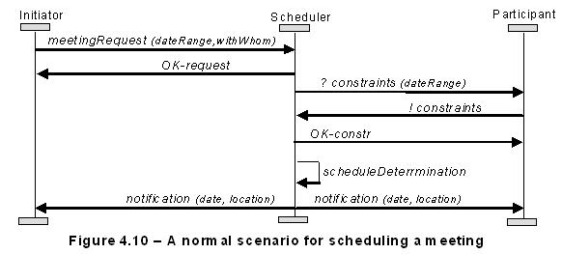
a. | controlled/monitored
b. | monitored/controlled
c. | requested/responded
d. | responded/requested
ANSWER: | A
MARK: | 1
UNIT: | Chap4
MIX CHOICES: | Yes

QN=12 (2820) | All of the followings are correct inputs of the specification and documentation phase EXCEPT?444
a. | General objectives
b. | System requirements
c. | Software requirements
d. | Environmental assumptions, relevant domain properties
e. | System-to-be design documents
ANSWER: | E
MARK: | 1
UNIT: | Chap4
MIX CHOICES: | Yes

QN=13 (4770) | Which of the following capture positive scenarios by sequences of interactions among instances of system components?4444
a. | Event Trace diagrams
b. | Dataflow diagrams
c. | State machine diagrams
d. | SADT Diagram
ANSWER: | A
MARK: | 0.5
UNIT: | Chap4
MIX CHOICES: | Yes

QN=14 (2828) | In Figure 4.9 , "DetermineSchedule - <<include>> - ResolveConflicts" means:5  [file:2828.jpg]  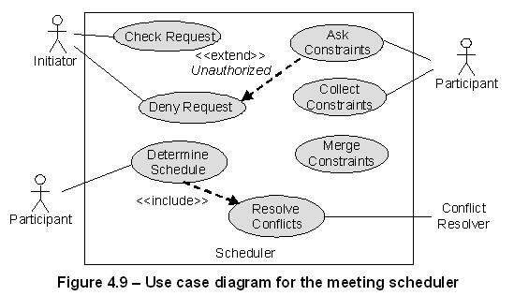
a. | ResolveConflicts is a 'sub-operation' of DetermineSchedule.
b. | ResolveConflicts is an 'alternative-operation' of DetermineSchedule.
ANSWER: | A
MARK: | 1
UNIT: | Chap4
MIX CHOICES: | Yes

QN=16 (4763) | In Entity-relationship diagram, a (an) __________ on one side of a relationship specifies the minimum and maximum number of entity instances on this side that may be linked at the same time to a given single subtuple of entity instances on the other sides.555
a. | multiplicity
b. | attribute
c. | entity
d. | relationship attribute
ANSWER: | A
MARK: | 0.5
UNIT: | Chap4
MIX CHOICES: | Yes

QN=18 (1477) | The data-activity duality principle requires actigram items to have some __________ in a datagram, and vice versa.66
a. | Countermeasures
b. | Counterparts
c. | Opponents
d. | Companions
ANSWER: | B
MARK: | 1
UNIT: | Chap4
MIX CHOICES: | Yes

QN=19 (4972) | Which of the following provide a simple functional outline of the system-to-be?6
a. | Use-case diagrams
b. | Dataflow diagrams
c. | Context diagrams
d. | SADT Diagrams
ANSWER: | A
MARK: | 0.5
UNIT: | Chap4
MIX CHOICES: | Yes

QN=20 (2831) | In figure 4.11 , the "Planning" state (source state) changes to "MeetingScheduled" state (target state) if __________ (the event) occurs and only if _________ (the guard condition) is true.777  [file:2831.jpg]  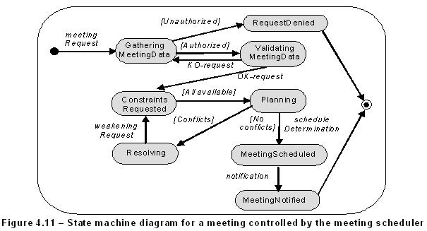
a. | scheduleDetermination/[No conflicts]
b. | [No conflicts]/scheduleDetermination
ANSWER: | A
MARK: | 1
UNIT: | Chap4
MIX CHOICES: | Yes

QN=21 (4971) | Which of the following captures operations to be performed by a system component & interactions with other components?77
a. | Use-case diagram
b. | Dataflow diagram
c. | Context diagram
d. | SADT Diagram
ANSWER: | A
MARK: | 0.5
UNIT: | Chap4
MIX CHOICES: | Yes

QN=22 (2825) | All of the following are differences of problem diagram comparing with context diagram, EXCEPT?7
a. | A rectangle with double vertical stripe represent the machine to be built
b. | A rectangle with a single vertical stripe represent the component to be designed
c. | Shared phenomena are controlled/monitored by components
d. | An interface can be declared separately the exclamation mark after a component name prefixing
ANSWER: | C
MARK: | 1
UNIT: | Chap4
MIX CHOICES: | Yes

QN=23 (4970) | The arrows in a DFD capture the incoming/outgoing flows of _____ labeling them.8
a. | the system component
b. | the data
c. | the operation
d. | the repository
ANSWER: | B
MARK: | 0.5
UNIT: | Chap4
MIX CHOICES: | Yes

QN=24 (4765) | Below statement about Dataflow diagram is true or false?  "In Dataflow diagram, the origin and end of a flow can be specified as a system component or a data repository in which operations can put or get data."8888
a. | TRUE
b. | FALSE
ANSWER: | A
MARK: | 0.5
UNIT: | Chap4
MIX CHOICES: | Yes

QN=25 (1485) | A_________ is captured by a sequence of state transitions for the system items that the component control888
a. | Behavior
b. | State
c. | SM state transition
d. | SM trace
e. | SM State
ANSWER: | A
MARK: | 1
UNIT: | Chap4
MIX CHOICES: | Yes

QN=26 (2829) | In Figure 4.9 , "DenyRequest - <<extend>> - AskConstraints" means:88  [file:2829.jpg]
a. | DenyRequest is a sub-operation of AskConstraints.
b. | DenyRequest is an alternative operation of AskConstraints.
c. | DenyRequest is an alternative operation of AskConstraints, when the condition named Unauthorized holds.
d. | None of the others
ANSWER: | C
MARK: | 1
UNIT: | Chap4
MIX CHOICES: | Yes

QN=27 (2823) | A_____ captures the set of all situations where some variable characterizing the controlled item always has the same value regardless of other characterizing variables, whose values may differ from one situation in this set to the other.999
a. | Behavior
b. | State
c. | SM state transition
d. | SM trace
e. | SM State
ANSWER: | E
MARK: | 1
UNIT: | Chap4
MIX CHOICES: | Yes

QN=28 (4764) | Which of the following captures system operations linked by data dependencies?99
a. | Dataflow diagrams
b. | SADT Diagrams
c. | Event Trace Diagrams
d. | Context Diagrams
ANSWER: | A
MARK: | 1
UNIT: | Chap4
MIX CHOICES: | Yes

QN=29 (1475) | ER diagram is made from three core constructs: entities, __________ and relationships.1010
a. | Classes
b. | Methods
c. | Objects
d. | Attributes
ANSWER: | D
MARK: | 1
UNIT: | Chap4
MIX CHOICES: | Yes

QN=31 (4969) | Bubbles in a DFD represent________ that are processed by an implicit system component associated with DFD.1010
a. | operations
b. | input data
c. | output data
d. | system component
ANSWER: | A
MARK: | 0.5
UNIT: | Chap4
MIX CHOICES: | Yes

QN=34 (2818) | All of the following statements about local rules on writing statements in requirements document are correct EXCEPT?11111111
a. | Identify who will read this and write accordingly.
b. | Say what you are going to do before doing it.
c. | Motivate first, summarize after
d. | Make sure that every concept is defined after its use.
ANSWER: | D
MARK: | 1
UNIT: | Chap4
MIX CHOICES: | Yes

QN=36 (1476) | State machine diagram is made by two core constructs:111111
a. | States, Relationships
b. | States, Associations
c. | States, Transitions
d. | States, Operations
ANSWER: | C
MARK: | 1
UNIT: | Chap4
MIX CHOICES: | Yes

QN=37 (1482) | In state machine diagram, the event occurrence is a ________ condition for transition firing, whereas a guard is a ________ condition for firing.121212
a. | sufficient/necessary
b. | necessary/sufficient
ANSWER: | A
MARK: | 1
UNIT: | Chap4
MIX CHOICES: | Yes

QN=39 (1486) | Which of the following is not the differences of problem diagram comparing with context diagram?12121212
a. | A rectangle with double vertical stripe represent the machine to be built
b. | A rectangle with a single vertical stripe represent the component to be designed
c. | Shared phenomena are controlled/monitored by components
d. | An interface can be declared separately the exclamation mark after a component name prefixing
ANSWER: | C
MARK: | 1
UNIT: | Chap4
MIX CHOICES: | Yes

QN=40 (2826) | Which of the following declares the system component and their interface, from which, the system structure can be defined?1212
a. | Context diagrams
b. | Dataflow diagrams
c. | Entity-relationship diagrams
d. | Use case diagrams
ANSWER: | A
MARK: | 1
UNIT: | Chap4
MIX CHOICES: | Yes

READING QUESTIONS:
FILL BLANK QUESTIONS:
MATCH QUESTIONS:

