Subject: Software Requirements
Title: Progress Test 2
Content: Chapter 4,5,7,8
Time: 30’
Number of question: 32/52

QN=1 | Which of the following are NOT differences of problem diagram comparing with context diagram?
a. | A rectangle with double vertical stripe represent the machine to be built
b. | A rectangle with a single vertical stripe represent the component to be designed
c. | Shared phenomena are controlled/monitored by components
d. | An interface can be declared separately the exclamation mark after a component name prefixing
e.
f.
ANS: | c
PTS: | 1
CHAPTER: | 4
MIX CHOICES: | YES
QN=2 | Which of the following is A context diagram that can be further detailed by indicating explicitly which component controls a shared phenomena, which component constitutes the machine needs to be built, and which components are affected by which requirements?
a. | context diagram
b. | Frame diagram
c. | Problem diagram
d. | state machine diagram
e. | entity-relationship diagram
f.
ANS: | C
PTS: | 1
CHAPTER: | 4
MIX CHOICES: | YES

QN=3 | A_________ is captured by a sequence of state transitions for the system items that the component control
a. | Behavior
b. | State
c. | SM state transition
d. | SM trace
e. | SM State
f.
ANS: | A
PTS: | 1
CHAPTER: | 4
MIX CHOICES: | YES

QN=4 | 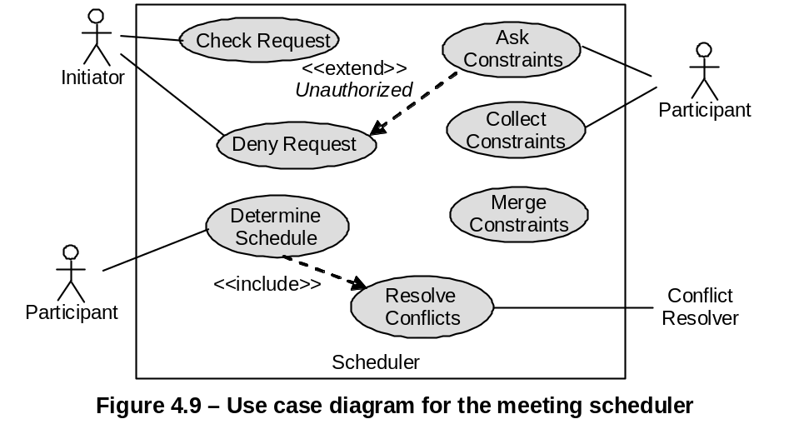  In Figure 4.9 [file: Figure-4.9.jpg], “DenyRequest - <<extend>> - AskConstraints” means:
a. | DenyRequest is a sub-operation of AskConstraints.
b. | DenyRequest is an alternative operation of AskConstraints.
c. | DenyRequest is a variant operation of AskConstraints, when the condition named Unauthorized holds.
d. | None of the others
e.
f.
ANS: | C
PTS: | 1
CHAPTER: | 4
MIX CHOICES: | YES

QN=5 | State machine diagram is made by two core constructs:
a. | States, Relationships
b. | States, Associations
c. | States, Transitions
d. | States, Operations
e.
f.
ANS: | C
PTS: | 1
CHAPTER: | 4
MIX CHOICES: | YES

QN=6 | Actigrams (Datagrams) declare activities (data) by their input/output data (producing/consuming activities) and interconnect them through data (___________) dependency links.
a. | Action
b. | Value
c. | Data
d. | Control
e.
f.
ANS: | D
PTS: | 1
CHAPTER: | 4
MIX CHOICES: | YES

QN=7 | ER diagram is made from three core constructs: entities, __________ and relationships.
a. | Classes
b. | Methods
c. | Objects
d. | Attributes
e.
f.
ANS: | D
PTS: | 1
CHAPTER: | 4
MIX CHOICES: | YES

QN=8 | In Figure 4.9 [file: Figure-4.9.jpg], “DetermineSchedule - <<include>> - ResolveConflicts” means:
a. | ResolveConflicts is a ‘sub-operation’ of DetermineSchedule.
b. | ResolveConflicts is an ‘alternative-operation’ of DetermineSchedule.
c. | ResolveConflicts is a ‘variant-operation’ of DetermineSchedule.
d.
e.
f.
ANS: | A
PTS: | 1
CHAPTER: | 4
MIX CHOICES: | YES

QN=9 | 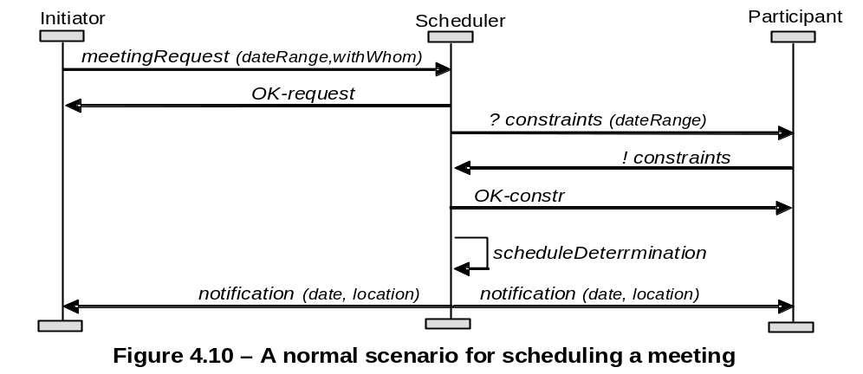  Figure 4.10 [file: Figure-4.10.jpg] shows an Event Trace Diagram specifying a meeting scheduling scenario. The first event is meetingRequest, ________ by an Initiator instance and _________ by a Scheduler instance.
a. | controlled/monitored
b. | monitored/controlled
c. | requested/responded
d. | responded/requested
e.
f.
ANS: | A
PTS: | 1
CHAPTER: | 4
MIX CHOICES: | YES

QN=10 | In state machine diagram, the event occurrence is a ________ condition for transition firing, whereas a guard is a ________ condition for firing.
a. | sufficient/necessary
b. | necessary/sufficient
c.
d.
e.
f.
ANS: | A
PTS: | 1
CHAPTER: | 4
MIX CHOICES: | YES

QN=11 | 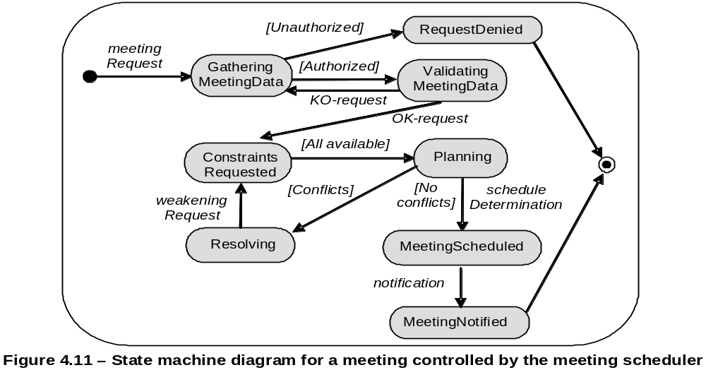  In figure 4.11 [file: Figure-4.11.jpg], the “Planning” state (source state) changes to “MeetingScheduled” state (target state) if __________ (the event) occurs and only if _________ (the guard condition) is true.
a. | scheduleDetermination/[No conflicts]
b. | [No conflicts]/scheduleDetermination
c.
d.
e.
f.
ANS: | A
PTS: | 1
CHAPTER: | 4
MIX CHOICES: | YES

QN=12 | Which of the following specifies all the operations that a system component is required to perform, possibly under a particular condition, in response to a particular input stimulus?
a. | A use-case diagram
b. | An event trace diagram
c. | An R-net diagram
d. | A SADT diagram
e.
f.
ANS: | c
PTS: | 0.5
CHAPTER: | 4
MIX CHOICES: | YES

QN=13 | Which of the followings captures the activities and data in the system (system-to-be or system-as-is), these diagrams allow these activities and data to be documented in a graphical way?
a. | SADT diagrams
b. | Dataflow diagrams
c. | Entity-relationship diagrams
d. | Context diagrams
e.
f.
ANS: | A
PTS: | 1
CHAPTER: | 4
MIX CHOICES: | YES

QN=14 | Which of the following activities should NOT be done in the phase “Defect evaluation at review meetings” of “Requirements inspection & review process”?
a. | The defects found by each inspector are collected and discussed by the meeting participants
b. | The meeting participants keep only defects on which all agree
c. | Each inspector reads the RD or part of it individually to look for defects.
d. | The team documents the conclusions in an inspection report
e.
f.
ANS: | C
PTS: | 1
CHAPTER: | 5
MIX CHOICES: | YES

QN=15 | Requirements Inspection process uses __________ guidelines to make it more effective in finding defects.
a. | WHY-WHAT-WHO
b. | WHY-WHAT-WHO-HOW
c. | WHAT-WHO-WHEN-WHERE
d. | WHY-WHAT-WHO-WHERE
e.
f.
ANS: | C
PTS: | 1
CHAPTER: | 5
MIX CHOICES: | YES

QN=16 | The phase “Individual reviewing”, inspectors reads the Requirement Document for defects. They can operate this phase in which of the following modes?
a. | Free mode, process-based mode, checklist-based mode
b. | Free mode, guideline-based mode, checklist-based mode
c. | Free mode, guideline-based mode, process-based mode
d. | Free mode and checklist-based mode
e.
f.
ANS: | A
PTS: | 1
CHAPTER: | 5
MIX CHOICES: | YES

QN=17 | Which of the following modes of individual reviewing rely on lists of specific issues to address while searching for defects?
a. | Checklist-based mode
b. | Checklist-based and Process-based modes
c. | Free mode
d. | None of the others
e.
f.
ANS: | B
PTS: | 1
CHAPTER: | 5
MIX CHOICES: | YES

QN=18 | ____________________ form an effective technique for quality assurance, it is the widest in scope and applicability.
a. | “Requirements inspection and reviews”
b. | “Queries on a requirements database”
c. | “Requirements validation by specification animation”
d. | None of the others
e.
f.
ANS: | A
PTS: | 1
CHAPTER: | 5
MIX CHOICES: | YES

QN=19 | All of the following questions should be in the checklist used for verifying "Poor structuring" defect type, EXCEPT?
a. | Is the structuring rule for organizing these RD sections apparent?
b. | Does this RD item cover unrelated requirements?
c. | Does this RD item mix requirements and assumptions together?
d. | Would there be alternative sensible choices?
e.
f.
ANS: | d
PTS: | 1
CHAPTER: | 5
MIX CHOICES: | YES

QN=20 | For a binary decision table with N entry conditions, there must be _______ columns for the table to list all possible combinations of conditions exhaustively.
a. | 2^N
b. | 2xN
c. | N^2
d. | None of the others
e.
f.
ANS: | A
PTS: | 1
CHAPTER: | 5
MIX CHOICES: | YES

QN=21 | Because the requirements errors are the most expensive, numerous and persistent software errors, so “requirements inspection & review process” should be applied as soon as possible.
a. | TRUE
b. | FALSE
c.
d.
e.
f.
ANS: | B
PTS: | 1
CHAPTER: | 5
MIX CHOICES: | YES

QN=22 | __________specialize the defect-based ones to the specific constructs of the structured, semi-format or formal specification language used in the requirement document.
a. | Domain-specific checklists
b. | Quality-specific checklists
c. | Defect-based checklist
d. | Language-based checklist
e.
f.
ANS: | d
PTS: | 1
CHAPTER: | 5
MIX CHOICES: | YES

QN=23 | Which of the following questions should be in the checklist used for verifying "Over specification" defect type?
a. | Is the structuring rule for organizing these RD sections apparent?
b. | Does this RD item cover unrelated requirements?
c. | Would there be alternative sensible choices?
d. | Does this RD item mix requirements and assumptions together?
e.
f.
ANS: | c
PTS: | 1
CHAPTER: | 5
MIX CHOICES: | YES

QN=24 | In requirements validation by specification animation, the _______ is an execution of the software model, and an animation is a visualization of the simulated model in its environment.
a. | Simulation
b. | Scenarios
c. | Validation
d. | Animator
e.
f.
ANS: | A
PTS: | 1
CHAPTER: | 5
MIX CHOICES: | YES

QN=25 | Which of the following questions should be in the checklist used for verifying "Ambiguity" defect type?
a. | Can this statement be interpreted differently in different relevant contexts?
b. | Is the structuring rule for organizing these RD sections apparent?
c. | Does this RD item cover unrelated requirements?
d. | Does this RD item mix requirements and assumptions together?
e.
f.
ANS: | a
PTS: | 1
CHAPTER: | 5
MIX CHOICES: | YES

QN=26 | “Queries on a requirements database” technique for “Requirements quality assurance” work on parts of the Requirements Document that are specified in terms of the __________.
a. | Structured natural language
b. | Unrestricted natural language
c. | Diagrammatic notations
d. | None of the others
e.
f.
ANS: | C
PTS: | 1
CHAPTER: | 5
MIX CHOICES: | YES

QN=27 | Unlike domain properties and ________, goals may be refined, negotiated, assigned as responsibilities to agents and transformed in case of conflict or overexposure to risks.
a. | assumptions
b. | expectations
c. | requirements
d. | hypotheses
e.
f.
ANS: | D
PTS: | 1
CHAPTER: | 7
MIX CHOICES: | YES

QN=28 | An expectation is a goal assigned to a single agent of the _________.
a. | problem world
b. | environment
c. | software-to-be
d. | system-as-is
e.
f.
ANS: | B
PTS: | 1
CHAPTER: | 7
MIX CHOICES: | YES

QN=29 | Which of the following statements is a “soft goal”?
a. | If a book is requested then within a week a copy of the book is borrowed by the requesting patron.
b. | If a train is at a platform then within 5 minutes the train is at the next platform.
c. | The meeting scheduler software should be easy to use by administrative staff.
d. | If a meeting is requested then sooner-or-later the meeting takes place and is attended by all important invited participants.
e.
f.
ANS: | C
PTS: | 1
CHAPTER: | 7
MIX CHOICES: | YES

QN=30 | In the goal model, the finer-grained a goal is, the _______ are required to satisfy it.
a. | fewer requirements
b. | better agents
c. | more agents
d. | fewer agents
e.
f.
ANS: | D
PTS: | 1
CHAPTER: | 7
MIX CHOICES: | YES

QN=31 | A goal refinement graph show the refinement and contribution links among goals. ________ appear as leaf nodes in this graph.
a. | Soft goals
b. | Domain properties
c. | Requirements
d. | Behavior goals
e.
f.
ANS: | C
PTS: | 1
CHAPTER: | 7
MIX CHOICES: | YES

QN=32 | Goals are generally found by top-down ________ of higher-level concerns and by bottom-up ______ from lower-level material such as scenario examples and operational descriptions.
a. | Refinement / abstraction
b. | Abstraction / refinement
c. | Generalization / specialization
d. | Specialization / generalization
e.
f.
ANS: | A
PTS: | 1
CHAPTER: | 7
MIX CHOICES: | YES

QN=33 | ___________ prescribe different types of protection of agent assets against unintended behaviors.
a. | Accuracy goals
b. | Information goals
c. | Security goals
d. | Stimulus-response goals
e.
f.
ANS: | c
PTS: | 1
CHAPTER: | 7
MIX CHOICES: | YES

QN=34 | Behavioral goals are used for building _________ specifications of the system.
a. | Operational
b. | Non-functional
c. | Critical requirements
d. | None of the others
e.
f.
ANS: | A
PTS: | 1
CHAPTER: | 7
MIX CHOICES: | YES

QN=35 | _______ are used as criteria for selecting system options among multiple alternatives.
a. | Maintain goals
b. | Avoid goals
c. | Achieve goals
d. | Soft goals
e.
f.
ANS: | D
PTS: | 1
CHAPTER: | 7
MIX CHOICES: | YES

QN=36 | Goals provide a precise ________ for requirements completeness and pertinence.
a. | Evidence
b. | Criterion
c. | Tool
d. | Link
e.
f.
ANS: | B
PTS: | 1
CHAPTER: | 7
MIX CHOICES: | YES

QN=37 | The relationship between goals and scenarios are_______
a. | coverage link
b. | responsibility link
c. | interaction link
d. | performance link
e.
f.
ANS: | a
PTS: | 1
CHAPTER: | 7
MIX CHOICES: | YES

QN=38 | All of the following describe the central role of goals in the requirements engineering process, EXCEPT?
a. | Goal refinement provides a natural mechanism for structuring complex specifications at different levels.
b. | Goals provide the rational for requirements
c. | Goals drive the identification of requirements to support them.
d. | Goal refinement captures agent responsibilities, and agent interfaces
e.
f.
ANS: | d
PTS: | 1
CHAPTER: | 7
MIX CHOICES: | YES

QN=39 | All of the following are usages of goal categories, EXCEPT?
a. | Goal categories are using for eliciting or finding missing goals
b. | Goal categories are using for detecting conflicts among goals
c. | Goal categories are using for conflict resolutions
d. | Goal categories are using for refining and abstracting goals
e.
f.
ANS: | d
PTS: | 1
CHAPTER: | 7
MIX CHOICES: | YES

QN=40 | An AND-refinement of a goal G into sub-goals G1, G2, …, Gn should be
a. | Complete, inconsistent, minimal
b. | Complete, accuracy, coverage
c. | Complete, consistent, minimal
d. | Complete, consistent, minimal, entailments
e.
f.
ANS: | C
PTS: | 1
CHAPTER: | 8
MIX CHOICES: | YES

QN=41 | Which of the following is an incorrect statements about the leaf nodes in goals refinement trees?
a. | They are nodes that need not be refined further.
b. | They are nodes whose responsibility can be assigned to single software agents.
c. | They are nodes whose responsibility can be assigned to single environment agents.
d. | They can not be domain properties or hypotheses.
e.
f.
ANS: | D
PTS: | 1
CHAPTER: | 8
MIX CHOICES: | YES

QN=42 | The goal model captures ______ and responsibility links from goals to system agents
a. | concern links between goals and conceptual objects
b. | obstruction links between goals and obstacles
c. | operationalization links between goals and system operations
d. | coverage links between goals and scenarios
e.
f.
ANS: | a
PTS: | 1
CHAPTER: | 8
MIX CHOICES: | YES

QN=43 | A goal model makes it possible to capture alternative options by_____
a. | alternative goal refinements
b. | alternative goal refinements or alternative responsibility assignments
c. | alternative goal refinements, AND-refinement, or alternative responsibility assignments
d. | None of the others
e.
f.
ANS: | B
PTS: | 1
CHAPTER: | 8
MIX CHOICES: | YES

QN=44 | We can build refinement and abstraction paths in a goal diagram by recursively asking ___ and ___ questions about available goals, respectively
a. | WHY / HOW
b. | WHY / WHAT
c. | HOW / WHY
d. | WHAT / WHY
e.
f.
ANS: | C
PTS: | 1
CHAPTER: | 8
MIX CHOICES: | YES

QN=45 | 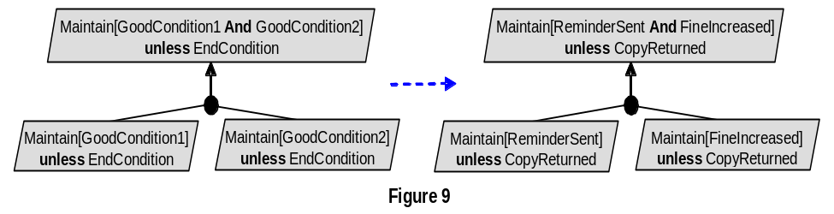  Figure 9 [file: Figure-8.9.jpg] shows the __________________
a. | Unrealizability-driven refinement pattern.
b. | Unmonitorability-driven refinement pattern.
c. | Divide-and-conquer refinement pattern.
d. | Milestone-driven refinement pattern
e.
f.
ANS: | C
PTS: | 1
CHAPTER: | 8
MIX CHOICES: | YES

QN=46 | 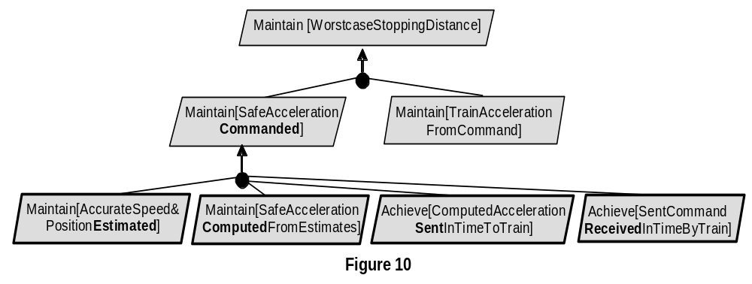  Figure 10 [file: Figure-8.10.jpg] shows the __________________
a. | Case-driven refinement pattern
b. | Guard-introduction pattern
c. | Divide-and-conquer pattern
d. | Milestone-driven refinement pattern
e.
f.
ANS: | D
PTS: | 1
CHAPTER: | 8
MIX CHOICES: | YES

QN=47 | An AND-refinement states that the parent goal can be satisfied by satisfying ______sub-goals in the refinement.
a. | one of
b. | all
c. | some of
d.
e.
f.
ANS: | B
PTS: | 1
CHAPTER: | 8
MIX CHOICES: | YES

QN=48 | The goals G1, G2, …, Gn are divergent in a domain Dom if we can find a feasible boundary condition B under which the goals cannot satisfied the arguments. Which of the following reflects the above definition?
a. | {G1, G2, …, Gn, B, Dom} |= true
b. | {G1, G2, …, Gn, B, Dom} |= false
c. | {G1, G2, …, Gn, B, Dom} |= G
d. | {G1, G2, …, Gn, B, Dom} satisfied G
e.
f.
ANS: | B
PTS: | 1
CHAPTER: | 8
MIX CHOICES: | YES

QN=49 | Which refinement pattern is applied for the goal refinement in the figure 8-12 [file: Figure-8.12.GIF]?  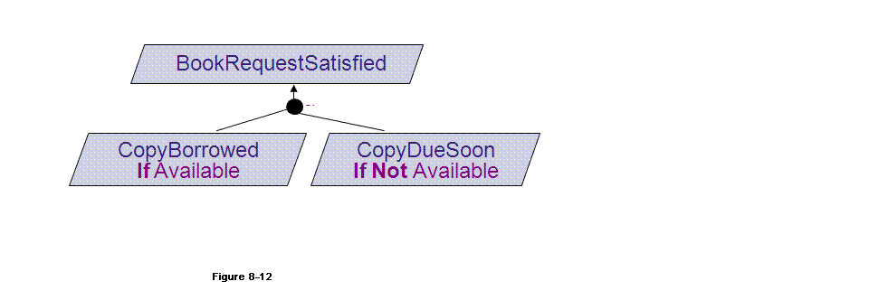  [CopyBorrowedIfAvailable]  Def A book has a copy available for the requesting borrower  [CopyDueSoonIfNotAvailable]  Def A book without any copy available for loan shall have a copy available within 15 days for the requesting borrower
a. | Case-driven refinement pattern
b. | Guard-introduction pattern
c. | Divide-and-conquer pattern
d. | Milestone-driven refinement pattern
e.
f.
ANS: | a
PTS: | 1
CHAPTER: | 8
MIX CHOICES: | YES

QN=50 | When doing goals refinement, we refine goals until___________
a. | the sub-goals assignable to single agents
b. | the sub-goals assignable to a multi-agents
c. | the sub-goals to be easier assessment feasibility
d. | the sub-goals to be easier implementation
e.
f.
ANS: | A
PTS: | 1
CHAPTER: | 8
MIX CHOICES: | YES

QN=51 | 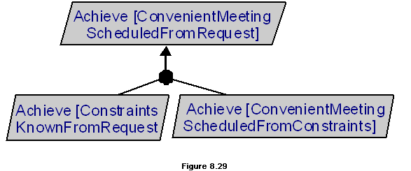  In the figure 8.29 [file: Figure-8.29.gif], the goal refinement pattern is _____
a. | Refinement towards goal realizability
b. | Refinement by milestones
c. | Refinement by case
d. | Divide-and-Conquer
e.
f.
ANS: | b
PTS: | 1
CHAPTER: | 8
MIX CHOICES: | YES

QN=52 | 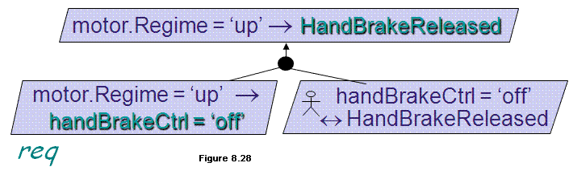  In the figure 8.28 [file: Figure-8.28.gif], the goal refinement pattern is _____
a. | Refinement towards goal realizability
b. | Refinement by milestones
c. | Refinement by case
d. | Divide-and-Conquer
e.
f.
ANS: | a
PTS: | 1
CHAPTER: | 8
MIX CHOICES: | YES

