Export Booking and Shipping Note Processes

Software Requirement Specification

Project Code: GCS

Document Code: GCS_SRS_EP1&2-ExportBooking_v1.4.4

DOCUMENT AGREEMENT
Name | Position | Agreement |  | Date

Record of change
*A - Added M - Modified D - Deleted
Effective Date | Changed Items | A*  M, D | Change Description | New Version
10-Jun-08 | Whole document | M | The first baseline | 1.0
15-Jun-08 | 2.5.1 Create Export Booking  2.5.3 Search Export Booking | M | Change screen mock-up (add search export booking screen for internal user, modify BRN field for Create Export Booking  Refine date format in business rules and field description | 1.1
29-Jun | All sections | M | Update business rules, business flows basing requirements of Export/Re-Export Booking discuss with DW IT/DW Power Users on 25-Jun-08 | 1.2
11-Jul-08 | 2.4 Use Case Diagram | M | Add Shipper actor | 1.2.1
11-Jul-08 | 2.5.1 UC EP1.1: Create Export Booking | M | Add External Interface  Update Screen and field description | 1.2.1
11-Jul-08 | 2.5.3 UC EP1.3 Search Export Booking  2.5.2 UC EP1.2 Update Export Booking  2.5.7 UC EP1.7: View Export Booking | M | Update Screen and field description | 1.2.1
15-Jul-08 |  | M | Update based on ITC and power user’s review comments | 1.2.2
25-Jul-08 | All sections | A | Refine the entire document.  Add C&F Agent, Instruction to Port fields into Shipping Note  EB Validation for vessel/shipping agents  Add Update Shipping Note function  Packing List screen and validation rules is pending with issues | 1.4
28-Jul-08 | 2.5.1 UC EP1.1 Create Export Booking | M | Refine some business rules | 1.4.2
28-Jul-08 | 2.5.3 UC EP1.3 Search Export Booking | M | Refined rules for search Export bookings and shipping notes | 1.4.2
29-Jul-08 | A5.2. Cancel Export Booking | M | Update validation rules for export booking cancellation | 1.4.3
29-Jul-08 | 2.5.3 UC EP1.3 Search Export Booking | M | Refine business rule for cancelling Export Booking | 1.4.4

SIGNATURE PAGE

ORIGINATOR: Nguyen Anh Tuan 27-Jul-2008

REVIEWERS: Nguyen Anh Tuan 28-Jul-2008

Nguyen Thai Son

APPROVAL: Nguyen Van Sang 28-Jul-2008
Suhail Falak

Thajudeen Shaik Ali

Siva Narasimhan

TABLE OF CONTENTS

1 Introduction 7
1.1 Purpose 7
1.2 Scope 7
1.3 Assumptions 7
1.4 Definitions, Acronyms, and Abbreviations 8
1.5 References 9
1.6 Document Overview 9
2 Functional Specification 10
2.1 Overview 10
2.2 Entity Diagram 10
2.3 Business Process Flow 11
2.4 Use Case Diagram 14
2.5 Use Case Details 15
2.5.1 UC EP1.1: Create Export Booking 15
2.5.1.1 Actors 15
2.5.1.2 Pre-condition 15
2.5.1.3 Mock-up Screen & Data Fields 15
2.5.1.4 Main Flow 23
2.5.1.5 Alternatives Flows 24
2.5.1.6 Business Rules 25
2.5.1.7 External Interface 26
2.5.1.8 Open Issues 27
2.5.2 UC EP1.2: Update Export Booking 27
2.5.2.1 Actors 27
2.5.2.2 Pre-condition 27
2.5.2.3 Mock-up Screen & Data Fields 28
2.5.2.4 Main Flow 31
2.5.2.5 Alternatives Flows 32
2.5.2.6 Business Rules 33
2.5.2.7 External Interface 34
2.5.2.8 Open Issues 35
2.5.3 UC EP1.3: Search Export Booking 35
2.5.3.1 Actors 35
2.5.3.2 Pre-condition 35
2.5.3.3 Mock-up Screen & Data Fields 35
2.5.3.4 Main Flow 37
2.5.3.5 Alternatives Flows 38
2.5.3.6 Business Rules 40
2.5.3.7 Open Issues 41
2.5.4 UC EP1.4: Auto-Update Export Booking 41
2.5.4.1 Actor 41
2.5.4.2 Pre-condition 41
2.5.4.3 Main Flow 41
2.5.5 UC EP1.5: Generate Export Booking Report 42
2.5.5.1 Actors 42
2.5.5.2 Pre-condition 42
2.5.5.3 Mock-up Screen & Data Fields 42
2.5.5.4 Main Flow 44
2.5.5.5 Alternatives Flows 44
2.5.5.6 Business Rules 45
2.5.5.7 Open Issues 45
2.5.6 UC EP1.6: Create Shipping Note 45
2.5.6.1 Actors 45
2.5.6.2 Pre-condition 45
2.5.6.3 Mock-up Screen & Data Fields 46
2.5.6.4 Main Flow 53
2.5.6.5 Alternatives Flows 54
2.5.6.6 Business Rules 56
2.5.6.7 External Interface 57
2.5.6.8 Open Issues 58
2.5.7 UC EP1.7: View Export Booking 58
2.5.7.1 Actors 58
2.5.7.2 Pre-condition 58
2.5.7.3 Mock-up Screen & Data Fields 58
2.5.7.4 Main Flow 62
2.5.7.5 Alternatives Flows 62
2.5.7.6 Business Rules 62
2.5.7.7 Open Issues 62
2.5.8 UC EP1.8: Upload Export Booking 63
2.5.8.1 Actors 63
2.5.8.2 Pre-condition 63
2.5.8.3 Mock-up Screen & Data Fields 63
2.5.8.4 Main Flow 64
2.5.8.5 Alternatives flows 65
2.5.8.6 Business rules 65
2.5.8.7 Open Issues 66
2.5.9 UC EP1.9: Update Shipping Note 67
2.5.9.1 Actors 67
2.5.9.2 Pre-condition 67
2.5.9.3 Mock-up Screen & Data Fields 67
2.5.9.4 Main Flow 68
2.5.9.5 Alternative Flows 68
2.5.9.6 Business Rules 68
2.5.9.7 External Interface 69
2.5.9.8 Open Issues 69
3 APPENDICES 70
3.1 Email Template 70
3.1.1 Email to inform Shipping Agent when he submits Export Booking 70
3.1.2 Email to notify GC Officer of new Export Booking 70
3.1.3 Email to notify Shipping Agent when Export Booking is approved 71
3.1.4 Email to inform Shipping Agent when Export Booking is cancelled 71
3.1.5 Email to notify GC Officer when Export Booking is cancelled 71
3.1.6 Email to notify GC Officer when Export Booking is updated 72

- Introduction
  - Purpose
This document aims at describing the details of requirements (functional requirements such as functionalities, user interfaces) of the Export Booking & Shipping Note process of GCS application. In this document, the behaviors of the system will be fully described such as how the system communicates with others, the factors of the system, and all design constraints of the system.
By using this document, project team, business support team and the other people can have a full view about the functions of the GCS application and business/power users can review this document to know whether the requirements meet with their expectation or not.
  - Scope
This document provides the detailed software requirements for Export Booking process and Shipping Note process of GCS application.
  - Assumptions
The proposed functionalities of Export Booking process are based on the following assumptions:
- Export booking information will be stored in GCS Database only. It is not necessary to push into MDS, CTMS, or other systems in Dubai Port
- Vessel Agent information is already existent in CTMS or Marine system.
- Shipping Agent can cancel direct loading Export Booking before time of loading cargo.
- When Shipping Agent submits Export Booking if it is indirect loading, the email notification should be sent to Storage Clerk
- It is assumed that all actors mentioned in the section “2.3 – Business Process Flow” would have secured user account set up for logging into GC System.
- It is assumed that berth booking for vessels working at GC Terminal berths would be issued and finalized in advance. This will generate Rotation No for the relevant use.
- It is assumed that at the time of berth booking, vessel agent would provide the list of authorized shipping agents. So that in the export booking process afterward, one of the authorized shipping agents has ability to request booking against vessel / rotation number.
And predefined data of the following lookup fields can be found in existing PROMIS database for the time being. This however will be converted/synchronized into GCS database:
- Vessel wise (i.e. vessel detail, rotation number, ETA, ETD)
- Port information
- Shipper wise
- Agent wise
- IMO Class
- Commodity code: this is also known as harmonized code of commodity.
  - Definitions, Acronyms, and Abbreviations
Term | Description
Shipping Agent | Cargo Operator, Freight Forwarder
DT | Dubai Trade Portal System
DPA | Dubai Port Authority
GC Officer | General Cargo Officer
GCS | General Cargo System
BRN | Booking Reference Number. Once export booking is made, the BRN is sent to Customs. Customs will use this BRN to generate Export Bill.
C & F | Clear and Forwarding
CBM | Cubic Meter
EB | Export Booking
EDI | Electronic Data Interchange. EDI is the electronic exchange of structured business documents between organizations and trading partners. It provides the means to streamline and integrate internal and external processes and offers extensive business benefits.
ETA | Estimated Time of Arrival
ETD | Estimated Time of Departure
IMO | International Maritime Organization.  UN agency which promotes safety at sea through safety codes, rules on tonnage measurements, control of pollution, and requirements relating to dangerous goods, through the International Maritime Dangerous Goods (IMDG) Code in compliance with international legal requirements.
DT | Dubai Portal system
PL | Packing List.  Itemized list of articles usually included in each shipping package, giving the quantity, description, and weight of the contents. Prepared by the shipper and sent to the consignee for accurate tallying of the delivered goods. Also called bill of parcels, packing slip, or unpacking note.
PROMIS | Port Operations Management Information System
TBA | To be advice
E/D, ED No | Export Declaration number
Shipper | The person or company who is usually the supplier or owner of commodities shipped. Also called Consignor.
SN | Shipping Note
SO | Storage Order
  - References
No. | Name of document and location/Description
1 | PROMIS_BRS_ExportCargoReceiving_process_L2_Final.doc
2 | PROMIS_SRS_VO.GO_V1.0 (final).doc
3 | PROMIS_BRS_ExportAuthorization_L2.doc
4 | PROMIS_BRS_VesselArrivalNotification_L2.doc
5 | PROMIS_BRS_ExportCargoReceiving_process_L2_Final.doc
6 | Cargo recieve for Export.doc
7 | GCS_SRS_MasterGlossary_v1.2.doc

  - Document Overview
This document includes following sections:
- This Introduction.
- Functional Specification: Describes all the use cases of Export Booking & Shipping Note processes of GCS application.
- Appendixes: Defines the external interfaces of the other system which GCS will interact with or some documents which will be used for these processes.
- Functional Specification
  - Overview
- The cargo export process basically involves the following steps at a high level: Creation of export booking by the shipping agent. He possibly needs to communicate with vessel agent for vessel information and rotation number. The shipping agent needs to be validated against vessel agent berth booking details.
- Creation of shipping note and export declaration by the shipper, issuing of export bill, clearance from customs and other regulators if required. Shipper also can delegate this step to the agent. Shipper needs raise the shipping note before bringing the cargo inside the port. Shipping note will be used by the DPA to collect the port charges. It also has to provide cargo details.
- For charges clearance purpose shipper or shipping agent may be required to provide packing list information. Shipper submits packing list beforehand either electronically uploading the scanned copy or by faxing to GC Officer.
- And finally paying the necessary port charges at Documentation section so that the cargo can be shipped.
  - Entity Diagram
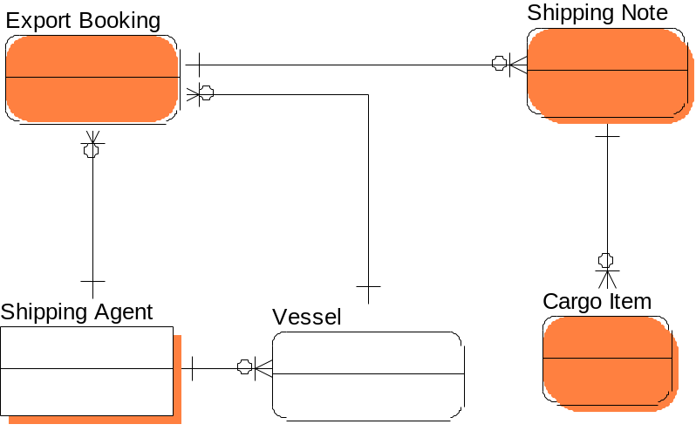

Figure 1: Entity Diagram
Details of entity attributes are described in the Master Glossary (GCS_SRS_MasterGlossary_v1.2.doc) document
  - Business Process Flow
Below are process flow details of Export Booking process.
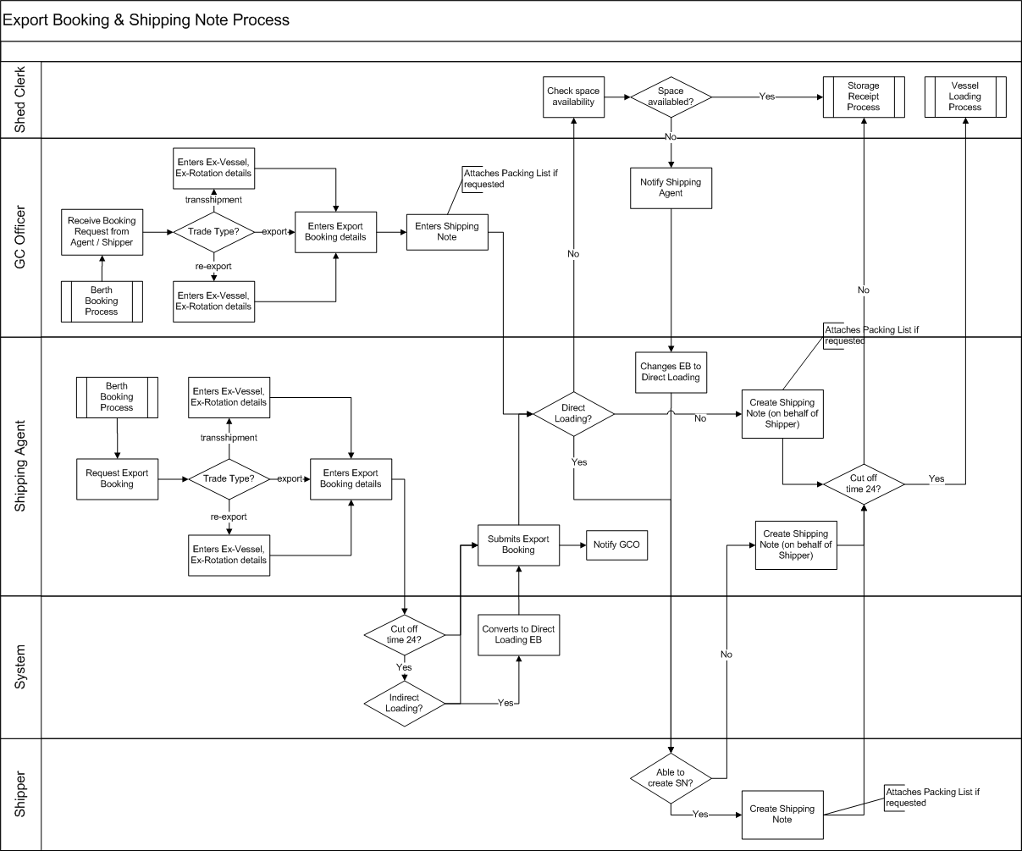

Figure 2: Business Process Diagram

Business Process Description
- When Vessel Agent received a request from Shipping Agent, Vessel Agent can submit Berth Booking to Dubai Port to prepare for vessel arrival via Dubai Trade. Vessel Agent can get the Rotation No generated by the system after Berth Booking is submitted. This Rotation Number will be used for all Export Bookings of the vessel.
If Vessel Agent is different with Shipping Agent (In the Berth Booking Shipping Agent has been allocated as a second agent), the system should allow Shipping Agent to select Vessel Name & Rotation assigned to him into the Berth Booking.
- Shipping Agent can submit Export Booking information to Dubai Port via Dubai Trade. He/she needs to select trade type (Export/Re-Export cargo) and fill BRN (Booking Reference Number) for Export Booking.
  - If Export Booking is for exporting cargo, he does not have to provide Ex-Vessel Name and Ex-Rotation Number
  - If Export Booking is for re-exporting cargo, he is required to provide Ex-Vessel Name and Ex-Rotation Number
- The system auto approves Export Booking, sends an email notification to GC officer, and Storage Clerk (if it is indirect loading) when Shipping Agent submits Export Booking.
- Shipping Agent is able to submit Export Booking after or before 24 hours of ETA.
  - If EB is submitted after 24 hours of ETA, he has one option to select direct loading for Export Booking.
  - If EB is submitted before 24 hours, he has two options to select for EB to be indirect/direct loading. If Shipping Agent selects indirect loading for EB, the system sends an email notification to Storage Clerk in order informs him to prepare storage space for cargo. If there is no available space for Shipping Agent’s cargo, Storage Clerk informs GC officer to call Shipping Agent to change from indirect loading to direct loading.
- After Shipping Agent has created EB, Shipping Agent can create Shipping Notes on behalf of Shipper or Shipper can create Shipping Note by himself.
  - All Shipping Notes of direct loading EB will be direct loading.
  - Shipping Note of indirect loading EB can be either direct loading or indirect loading. If Shipping Note is created after ETA - 24 hours, then it will be direct loading. Otherwise, it will be indirect loading.
  - If EB is indirect loading, Shipping Agent needs to send cargo to port before 24 hours of ETA. In case, Shipping Agent does not send cargo to port before cut off time; EB will be automatically changed from indirect loading to direct loading. These rules are also applied for Shipping Notes.
- Shipping Agent can cancel EB if
  - EB is direct loading and before loading time of cargo (ETA if Vessel Operation is Loading, Estimated Time of Discharging Complete if Vessel Operation is both Loading & Discharging)
  - EB is indirect loading and Date of Creation of EB is before cut off time. Shipping Agent has not sent any cargo to Dubai Port.
- Shipping Agent can make consolidation and shut out cargo for indirect loading EB in the period from 48 hours to 24 hours before ETA.
- Loading List for Indirect Loading Export Booking is automatically created by the system at cut off time.
- Final Loading List can have both Direct and Indirect Loading Export Booking. It will be created at time of loading.

Screen Flow Diagram of Export Booking & Shipping Note
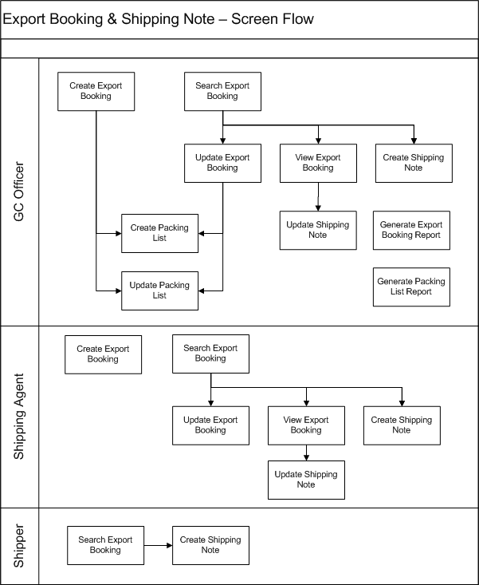

Figure 03: Screen Flow Diagram
  - Use Case Diagram
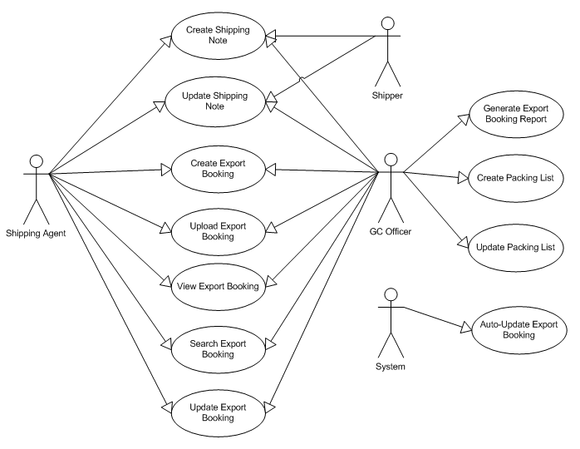

Figure 4: Use Case Diagram

ID | Description | Comments
UC EP1.1 | Create Export Booking | This use case allows Shipping Agent to create an export booking and submits to GC Terminal via DT system. For several agent that has not ability to access DT, GC Officer can on be half of the agent to do the task.
UC EP1.2 | Update Export Booking | Export Booking should be able to be amended by actor (shipping agent or GC officer) if he submits by mistake.
UC EP1.3 | Search Export Booking | Actors should have ability to query their authorized export bookings by keying in search parameters. The feature is for both internal and external users.
UC EP1.4 | Auto-Update Export Booking | This allows an export booking can be converted automatically by the system from indirect loading EB to the direct loading. This can happen when space availability issue occurs.
UC EP1.5 | Generate Export Booking Report | This use case is for internal use by GC Officer. This allows reporting of the export booking.
UC EP1.6 | Create Shipping Note | Shipper or shipping agent have ability to add shipping note(s) into his export booking. The feature allows users to add cargo/vehicle item(s) into each shipping note.
UC EP1.7 | View Export Booking | This use case allows user to see his authorized export booking .
UC EP1.8 | Upload Export Booking | User has ability to upload an export booking in EDI format into GC system. The system should provide validation function against the uploading file content given.
UC EP1.9 | Update Shipping Note | Creation of shipping note can be done my mistake. This use case allows user/actor to amend his shipping note.
UC EP1.10 | Create Packing List | This allows GC Officer to feed packing list in GCS, hence calculating the actual Marks & Nos, weight, CBM. This use case is pending with issues of packing list attributes (dimensions issue and tariff code)
UC EP1.11 | Update Packing List | Packing List can be created by mistake. This is to amend the detail. This use case is pending as open issues of dimensions and tariff code.

  - Use Case Details
    - UC EP1.1: Create Export Booking
      - Actors
Refer to Security Matrix
      - Pre-condition
Shipping Agent logins into GCS via DP Portal or GC Officer logins to GCS system
      - Mock-up Screen & Data Fields

MOCK-UP: Create Export Booking for External user screens
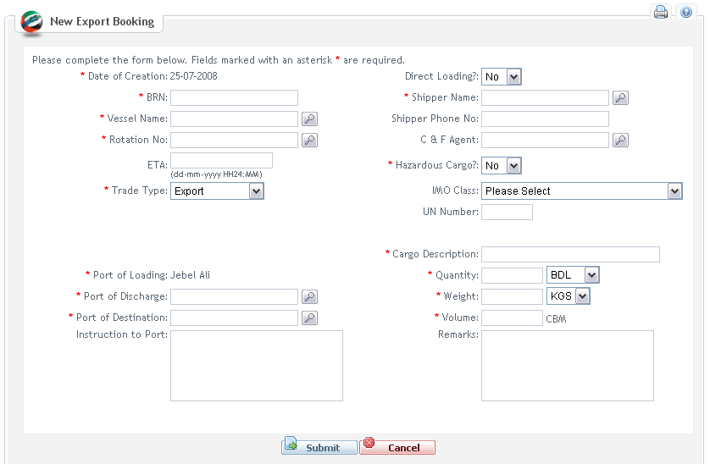

Screen 01: Create Export Booking by external users for export cargo

Create Re-Export Booking screen for External Users
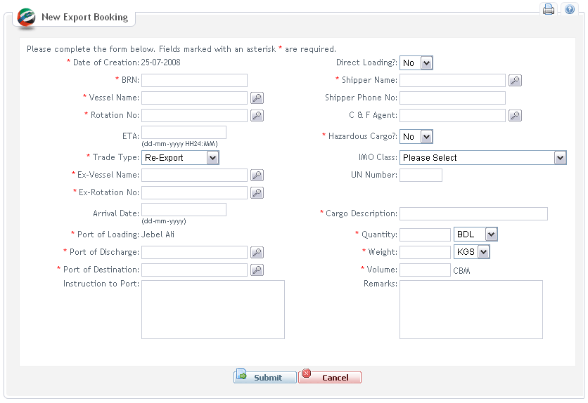

Screen 02: Create Export Booking via DT for re-export cargo

MOCK-UP: Create Export Booking for Internal User screen:
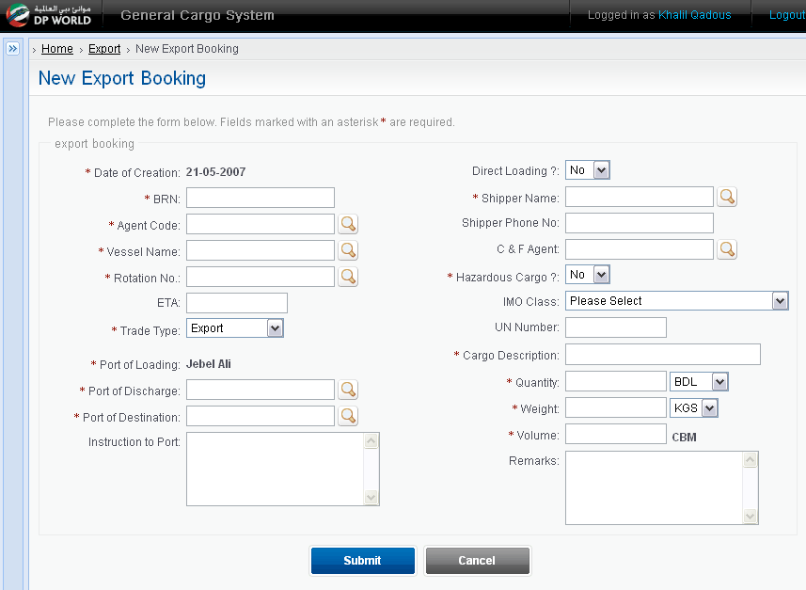

Screen 03: Create Export Booking by GC Officer for export cargo
Re-export Booking screen for Internal User

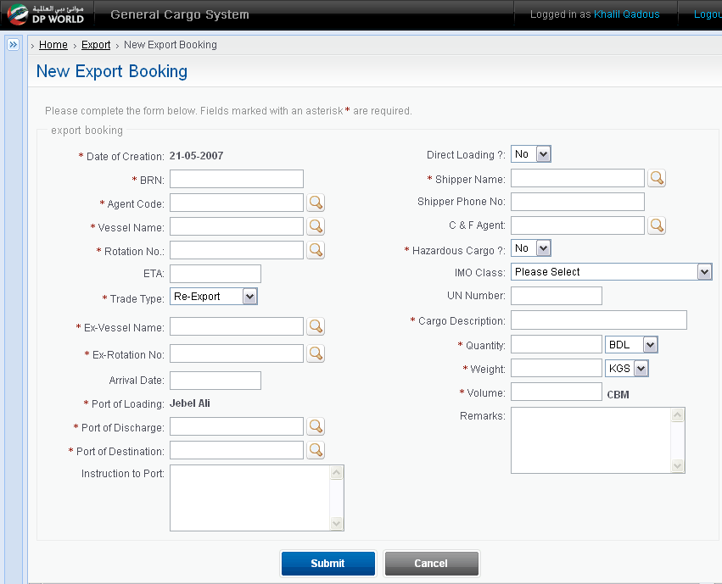

Screen 04: Create Export Booking by GC Officer for re-export cargo

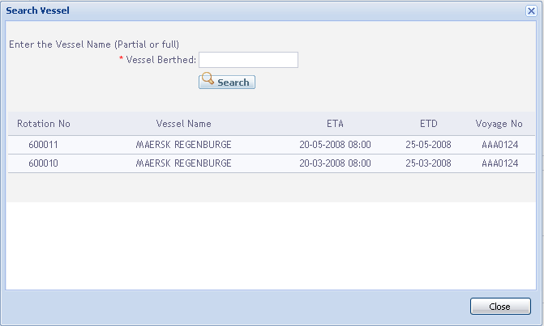

Screen 05: Search for vessel popup window
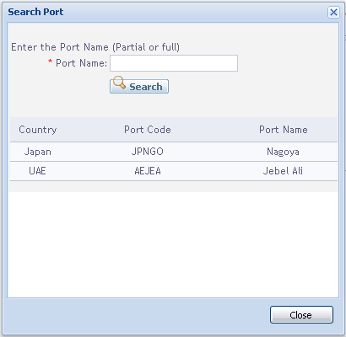

Screen 06: Search for port popup window

DATA FIELDS
Field name | Mandatory | Control Type | Data Type | Length | Rules
Date of Creation | Yes | Label | Date | 10 | This field is auto-generated by the system. The value follows system schedule of the current date at server side. This is also to identify if cut-off time is met
Trade Type | Yes | Drop-down list | Text | 20 | Includes: Re-Export, Export, Transshipment
BRN | Yes | Text field | Text | 15 | This is alpha numeric field. This is entered by the user.
Ex-Vessel Name | No | Text field | Text | 50 | Note: Search icon will be used to search Ex-Vessel Name  This field is displayed when trade type =”Re-export” or Transshipment
Ex-Rotation No | No | Text field | Text | 20 | Note: Search icon will be used to search Ex-Rotation No  This field is displayed when trade type= “Re-export” or Transshipment
Arrival Date | No | Text field | Date/Time | 18 | Read only. (dd-mm-yyyy HH24:MM)  Note: It is auto shown when selecting Ex-Rotation No  This field is displayed when trade type= “Re-export” or Transshipment
Shipping Agent | No | Text field | Text | 30 | Read only  Note: Search icon will be used to search Shipping Agent  This field is displayed when GC Officer create Export Booking on behalf of Shipping Agent
Vessel Name | Yes | Text field | Text | 50 | Read only  Note: Search icon will be used to search Vessel Name
Rotation No | Yes | Text field | Text | 20 | Read only  Note: Search icon will be used to search Rotation No. This can be auto-populated from vessel selection of vessel popup window.
ETA | Yes | Text field | Date/Time | 18 | Read only. (dd-mm-yyyy HH24:MM)  Note: It is auto shown when selecting Rotation No. Or this can be auto-populated from vessel selection.
Port of Loading | Yes | Label | Text | 25 | Default value is Jebel Ali  Read only
Port of Destination | Yes | Text field | Text | 25 | Read only field. This is lookup field and populated from port search popup window.
Port of Discharge | Yes | Text field | Text | 25 | The first discharge port. Read only field. This is populated from port search popup window.
Shipper Name | Yes | Text field | Text | 50 | Read only  Note: Search icon will be used to search Shipper Name
Shipper Phone No | No | Text field | Text | 20
C & F Agent | No | Text field | Text | 50 | Read only. This is Clear & Forwarding field. This can be populated from the agent popup window.
Direct Loading? | Yes | Drop-down list | Text | 1 | The indicator to identify whether export booking is direct loading. Default option is No.
Hazardous Cargo? | Yes | Drop-down list | Text | 1 | Yes/No option to identify if export booking contains hazardous cargo item. This aims at preparation of proper equipment, storage area,… at port.
IMO Class | No | Drop-down list | Text | 30 | See Appendices section of Master Glossary document for predefined IMO Class. This is mandatory to enter if hazardous cargo, otherwise this is optional.
UN Number | No | Text Field | Text | 4 | This is mandatory to enter if hazardous cargo, otherwise this is optional. This is four digit number.
Cargo Description | Yes | Text Field | Text | 200 | Description of cargo in export booking.
Quantity | Yes | Text field | Number | 5 | Total of packages/units in export booking
 | Yes | Drop-down list |  |  | Includes: BDL, PLT, PCS, SKID, COLLI, PKG, CRT, UNIT, CTN, COILS. The full list of predefined package type can be found in Master Glossary document.
Weight | Yes | Text field | Decimal | 10 | Weight at export booking level
 | Yes | Drop-down list |  |  | Includes: KGS, MT
Volume | Yes | Text field | Decimal | 10 | Volume in CBM at export booking level.
Instruction to Port | No | Text area | Text | 300 | This is to mention special equipments which will be needed to offload abnormal cargo as well as the port overtime if any at the time receiving.
Remarks | No | Text area | Text | 300 | Export booking remarks.
Submit |  | Button | N/A | N/A | Clicking on this button to submit the export booking request to GC Officer.
Cancel |  | Button | N/A | N/A | This button/link allows user to go back the previous page.

      - Main Flow
Step | Action Description | Comment
1 | The user clicks on Create Export Booking link on left menu
2 | The system:  - Loads initial and default data into export booking object  - Populates export booking detail into Create Export Booking screen. | Refer to Data Fields section.  See Screen 01 and 02
3 | The user inputs the data and selects Submit. | Refer to Master Glossary document to see how to use “Search icon” for Vessel Name, Rotation No, Ex-Vessel Name, Ex-Rotation No, Shipper Name and Shipping Agent.  Note: Search Shipping Agent only applicable for internal user.  See Screen 05 and 06 for vessel and port popup windows.  User also can discard the entered booking request by clicking on Cancel button. See alternative flow A3.1: Cancel for Create Export Booking
4 | The system displays pop-up screen to confirm with two options: Yes or No | See alternative flow:  - A4.1: Cancel confirmation
5 | The user selects Yes to confirm the submission
6 | The system:  - validates the data input by the user (BR01 to BR10).  - validates the data input as business rule BR14 for vessel wise availability.  - validates data input as business rule BR15 for vessel / rotation validation against vessel agent  - validates data input as business rule BR13 for loading, discharging, and destination ports.  - creates a new export booking entry in database table.  - sends notification email to GC Officer in case of IMO Class is Class 1 or 2 (Refer to Notification email template section 4.1)  - sends email to GC Officer to notify about new Export Booking (Refer to Notification email template section 4.1)  - closes the current screen and displays successful information of the creation with notice about email notification. | See alternative flow:  - A6.1: Validation failure

      - Alternatives Flows
A3.1: Cancel for Create Export Booking
Step | Action Description | Comment
3.1.1 | At step 3 user clicks the Cancel button
3.1.2 | The system displays pop-up screen to confirm the Cancellation with two options: Yes or No
3.1.3 | The user selects Yes to confirm the Cancellation | See alternative flow:  - A4.1: Cancel confirmation
3.1.4 | The system closes the current screen and displays previous screen

A4.1: Cancel confirmation
Step | Action Description | Comment
4.1.1 | At step 4 user selects No to cancel the confirmation
4.1.2 | Return to Step 3 in Main Flow

A6.1: Validation failure
Step | Action Description | Comment
6.1.1 | At step 6 the system identifies that one or more errors have occurred. The system displays the relevant error messages to the user.
6.1.2 | Return to Step 3 in Main Flow

      - Business Rules

ID | Rule Description | Message ID
EP1.1BR01 | Mandatory field(s) has(have) not been input | MS06
EP1.1BR02 | Quantity should be greater than zero | MS03
EP1.1BR03 | Gross Weight should be greater than zero. | MS03
EP1.1BR04 | Gross Volume should be greater than zero. | MS03
EP1.1BR05 | Hazardous Cargo is Yes but IMO Class is “Please select” and/or UN Number is blank. | MS06
EP1.1BR06 | If ETA - Date of Creation > 24, Shipping Agent can select indirect/direct loading. Otherwise, Shipping Agent only creates direct loading Export Booking
EP1.1BR7 | Trade type is Re-export or Transshipment but user does not input Ex-Vessel Name and/or Ex-Rotation No | MS06
EP1.1BR8 | BRN is an unique value for a Rotation Number | MS21
EP1.1BR9 | Export Booking is set status = “Approved” by default
EP1.1BR10 | If ETA – Date of Creation =< 24, the “Direct Loading?” will be set to Yes by default
EP1.1BR11 | If the user selects IMO Class 1 & Class 2, the IMO Class information, Gross Weight, Gross Volume, & Quantity should be sent to GC Officer to notify the dangerous cargo
EP1.1BR12 | Agent information can get from Agent table of Dubai Trade system
EP1.1BR13 | Port of Loading, Port of Discharge, and Port of Destination fields will include port name which is populated from the relevant Port popup window.
EP1.1BR14 | Vessel information (vessel name, rotation number, ETA, ETD, and Voyage No) must be identified from voyage details. Export Booking cannot be issued until vessel wise is finalized.
EP1.1BR15 | For a pair value of Vessel Name and Rotation No, it should be booked for a relevant vessel agent and a list of authorized shipping agents.  In creation of export booking, the logged shipping agent user should be in the list. Otherwise, selection of vessel name / rotation can be considered as invalid export booking.

      - External Interface
Below table defines the data fields that will be sent to MISAL2 system.
Field name | Mandatory | Data Type | Length | Rules
BRN | Yes | Text | 15
Trade Type | Yes | Text | 20 | Includes: Re-Export, Export, Transshipment
Date of Creation | Yes | Date | 10 | Auto generated with value = date of Export Booking creation
Vessel Name | Yes | Text | 50
Rotation No | Yes | Text | 20
ETA | Yes | Date | 10 | The date value follow standard date format defined in Master Glossary
Ex-Vessel Name | No | Text | 50 | This field has value when trade type =”Re-export” or Transshipment
Ex-Rotation No | No | Text | 20 | This field has value when trade type= “Re-export” or Transshipment
Port of Destination | Yes | Text | 25
Port of Discharge | No | Text | 25 | The first discharge port
Shipper Name | Yes | Text | 50
Shipper Phone No | No | Text | 20
Direct Loading? | No | Text | 1 | Y/N
Hazardous Cargo | Yes | Text | 1 | Y/N
IMO Class | No | Text | 4
UN Number | No | Text | 6
Cargo Description | Yes | Text | 100
Quantity | Yes | Number | 5
Package Type | Yes | Text | 10
Gross Weight | Yes | Decimal | 10
Weight Type | Yes | Text | 10
Gross Volume | Yes | Decimal | 10
      - Open Issues
- Refer to GCS issue log.

    - UC EP1.2: Update Export Booking
      - Actors
Refer to Security Matrix
      - Pre-condition
User is able to update Export Booking when he has been authorized and:
- ETA – current date/time > 24 hours if EB is indirect loading
- Or ETA > current date/time if EB is direct loading.
      - Mock-up Screen & Data Fields
MOCK-UP: Update screen for Shipping Agent
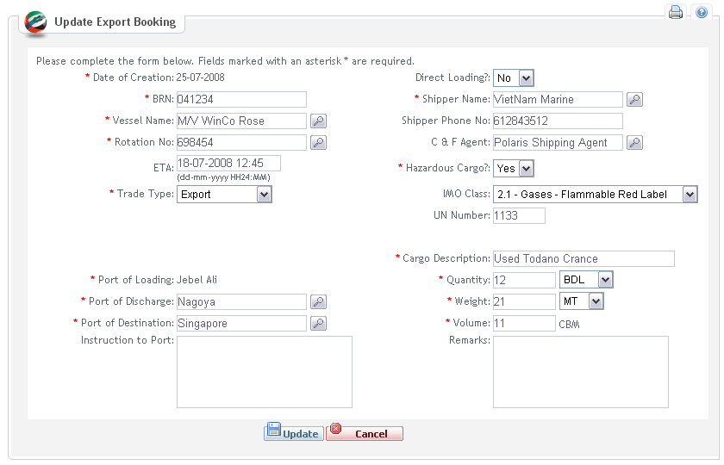

Screen 07: Update Export Booking by Shipping Agent for export cargo

MOCK-UP: Update screen for GC Officer
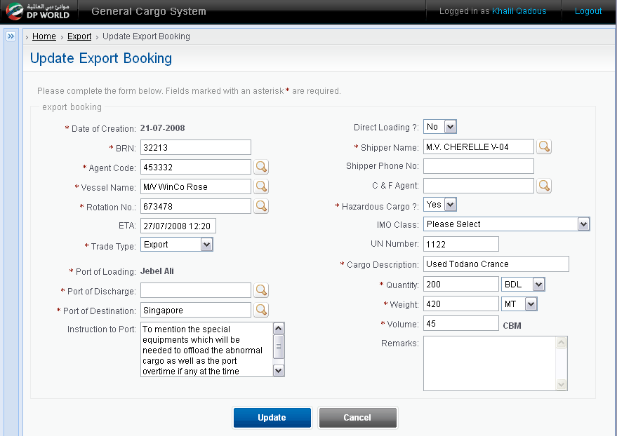

Screen 08: Update Export Booking by GC Officer for export cargo

DATA FIELDS
Field name | Mandatory | Control Type | Data Type | Length | Rules
Date of Creation | Yes | Label | Date | 10 | This is populated from existing export booking. This is also to identify if cut-off time is met.
Trade Type | Yes | Drop-down list |  | 20 | Includes: Re-Export, Export, Transshipment
BRN | Yes | Text field | Text | 15 | This is alpha numeric field. This is auto-populated from existing export booking.
Ex-Vessel Name | No | Text field | Text | 50 | Note: Search icon will be used to search Ex-Vessel Name  This field is displayed when trade type =”Re-export”
Ex-Rotation No | No | Text field | Text | 20 | Note: Search icon will be used to search Ex-Rotation No  This field is displayed when trade type= “Re-export”
Arrival Date | No | Text field | Date/Time | 18 | Read only. (dd-mm-yyyy HH24:MM)  Note: It is auto shown when selecting Ex-Rotation No  This field is displayed when trade type= “Re-export”
Shipping Agent | No | Text field | Text | 30 | Read only  Note: Search icon will be used to search Shipping Agent  This field is displayed when GC Officer creates Export Booking on behalf of Shipping Agent
Vessel Name | Yes | Text field | Text | 50 | Read only  Note: Search icon will be used to search Vessel Name
Rotation No | Yes | Text field | Text | 20 | Read only  Note: Search icon will be used to search Vessel Name
ETA | Yes | Text field | Date/Time | 18 | Read only. (dd-mm-yyyy HH24:MM)  Note: It is auto shown when selecting Rotation No
Port of Loading | Yes | Label | Text | 25 | Default value is Jebel Ali  Read only
Port of Destination | Yes | Text field | Text | 25 | Read only field is populated from port search popup window.
Port of Discharge | Yes | Text field | Text | 25 | The first discharge port. It is a read only field populated from port search popup window.
Shipper Name | Yes | Text field | Text | 50 | Read only  Note: Search icon will be used to search Shipper Name
Shipper Phone No | No | Text field | Text | 20
C & F Agent | No | Text field | Text | 50 | Clear and Forwarding agent name. This can be selected from the agent popup search.
Direct Loading? | Yes | Drop-down list | Text | 1 | Yes/No option to identify if Direct Loading is required.
Hazardous Cargo | Yes | Drop-down list | Text | 1 | Yes/No option is identify if export booking contains dangerous goods.
IMO Class | No | Drop-down list | Text |  | IMO Class is predefined data in the system. Please refer to Appendices section in Master Glossary for the data list. This field is mandatory to enter if hazardous cargo. Otherwise this is optional.
UN Number | No | Text Field | Text | 6 | UN Number of cargo. This is four digit number.
Cargo Description | Yes | Text Field | Text | 100 | Description of cargo
Quantity | Yes | Text field | Number | 5 | Total amount of cargo items in export booking. This is also known as export booking quantity.
 | Yes | Drop-down list | Text |  | Includes: BDL, PLT, PCS, SKID, COLLI, PKG, CRT, UNIT, CTN, COILS. See Master Glossary for the full list of quantity type.
Weight | Yes | Text field | Decimal | 10 | Export booking weight
 | Yes | Drop-down list | Text |  | Includes: KGS, MT
Volume | Yes | Text field | Decimal | 10 | CBM
Update |  | Button | N/A | N/A | Clicking on this button/link to save the user entered export booking into existing one.
Cancel |  | Button | N/A | N/A | To discard all entered information and the control is back to previous screen.

      - Main Flow
Step | Action Description | Comment
1 | The user:  - clicks on Update button on View Export Booking screen  - or selects Search Export Booking link on left menu and searches for Export Booking then selects one Export Booking and clicks on Edit button (refer to UC EP1.3)
2 | The system displays Export Booking details screen | Refer to Data Fields section. See Screen 07 and 08
3 | The user updates information and clicks on Update button | Refer to Master Glossary document to see how to use “Search icon” for Vessel Name, Rotation No, Ex-Vessel Name, Ex-Rotation No, Shipper Name and Shipping Agent.  Note: Search Shipping Agent only applicable for internal user.  See alternative flow:  - A3.1: Cancel
4 | The system displays pop-up screen to confirm with two options: Yes or No | See alternative flow:  - A4.1: Cancel confirmation
5 | The user selects Yes to confirm the Update
6 | The system:  - validates the data input by the user is valid (BR01 to BR08, BR10)  - validates the data input as business rule EP1.1BR14 for vessel wise availability.  - validates data input as business rule EP1.1BR15 for vessel / rotation validation against vessel agent  - validates data input as business rule EP1.1BR13 for loading, discharging, and destination ports.- updates data into database.  - sends notification email to GC Officer in case of IMO Class is Class 1 or 2 (Refer to Notification email template section 4.1)  - sends email to GC Officer to notify about updated Export Booking (Refer to Notification email template section 4.1)  - closes the current screen and displays previous screen | See alternative flow:  - A6.1: Validation failure

      - Alternatives Flows
A3.1: Cancel
Step | Action Description | Comment
3.1.1 | At step 3 user clicks the Cancel button
3.1.2 | The system displays pop-up screen to confirm the Cancellation with two options: Yes or No
3.1.3 | The user selects Yes to confirm the Cancellation | See alternative flow:  - A3: Cancel confirmation
3.1.4 | The system closes the current screen and displays previous screen

A4.1: Cancel confirmation
Step | Action Description | Comment
4.1.1 | At step 4 user selects No to cancel the confirmation
4.1.2 | Return to Step 3 in Main Flow

A6.1: Validation failure
Step | Action Description | Comment
6.1.1 | At step 6 the system identifies that one or more errors have occurred. The system displays the relevant error messages to the user.
6.1.2 | Return to Step 3 in Main Flow

      - Business Rules

ID | Rule Description | Message ID
EP1.2BR01 | Mandatory field(s) has(have) not been input | MS06
EP1.2BR02 | Quantity should be greater than zero | MS03
EP1.2BR03 | Gross Weight should be greater than zero | MS03
EP1.2BR04 | Gross Volume should be greater than zero | MS03
EP1.2BR05 | Hazardous Cargo is Yes but IMO Class is “Please select” and/or UN Number is blank. | MS06
EP1.2BR06 | If ETA - Date of Creation > 24, Shipping Agent can change indirect/direct loading. Otherwise, Shipping Agent cannot change indirect/indirect loading information.
EP1.2BR07 | Trade type is Re-export but user does not input Ex-Vessel Name and/or Ex-Rotation No | MS06
EP1.2BR08 | BRN is an unique value for a Rotation Number | MS21
EP1.2BR09 | Export Booking cannot be updated when Shipping Note has been added to the Export Booking
      - External Interface
Below table defines the data fields that will be sent to MISAL2 system if Export Booking has been updated.
Field name | Mandatory | Data Type | Length | Rules
Old BRN | Yes | Text | 15
New BRN | Yes | Text | 20
Updated Date | Yes | Date | 10
Vessel Name | Yes | Text | 50
Rotation No | Yes | Text | 20
ETA | Yes | Date | 10 | The date value follow standard date format defined in Master Glossary
Ex-Vessel Name | No | Text | 50 | This field has value when trade type =”Re-export”
Ex-Rotation No | No | Text | 20 | This field has value when trade type= “Re-export”
Port of Destination | Yes | Text | 25
Port of Discharge | No | Text | 25 | The first discharge port
Shipper Name | Yes | Text | 50
Shipper Phone No | No | Text | 20
Direct Loading? | No | Text | 1 | Y/N
Hazardous Cargo | Yes | Text | 1 | Y/N
IMO Class | No | Text | 4
UN Number | No | Text | 6
Cargo Description | Yes | Text | 100
Cargo Description | Yes | Text | 100
Quantity | Yes | Number | 5
Package Type | Yes | Text | 10
Gross Weight | Yes | Decimal | 10
Weight Type | Yes | Text | 10
Gross Volume | Yes | Decimal | 10
      - Open Issues
- Refer to GCS issue log.
    - UC EP1.3: Search Export Booking
      - Actors
Refer to Security Matrix
      - Pre-condition
Shipping Agent logins into GCS via DP Portal or GC Officer has been authenticated and authorized
      - Mock-up Screen & Data Fields
MOCK-UP: Search Screen for Shipping Agent
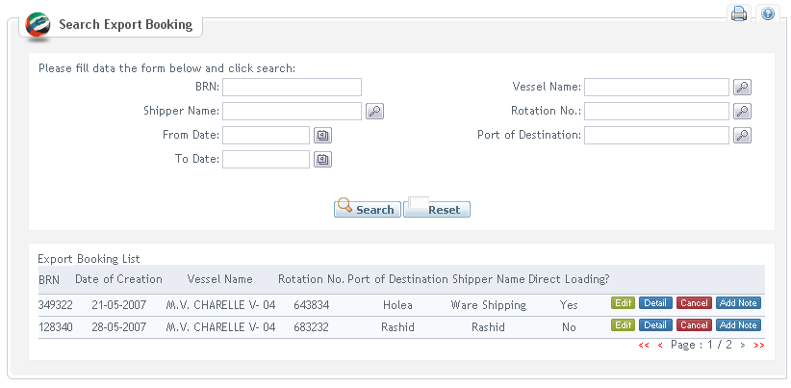

Screen 09: Search Export Booking by Shipping Agent

MOCK-UP: Search Screen for GC Officer
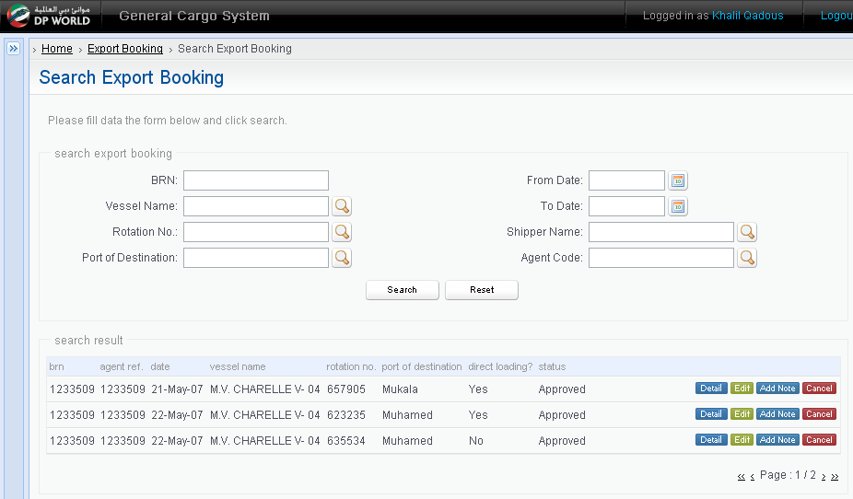

Screen 10: Search Export Booking by GC Officer

DATA FIELDS

Field name | Mandatory | Control Type | Data Type | Length | Rules
Input
From Date | No | Text field | Date | 10 | Date picker will be use to select a date.
To Date | No | Text field | Date | 10 | Date picker will be use to select a date.
BRN | No | Text field | Text | 15
Vessel Name | No | Text field | Text | 50 | Read only.  Note: Search icon will be used to search Vessel Name  It will list all available Vessels. This list will be obtained from other system
Rotation No | No | Text field | Number | 20 | Read only.  Note: Search icon will be used to search Rotation No
Port of Destination | No | Text field | Text | 25 | Lookup field to select from port search popup.
Agent Code | No | Text field | Text | 100 | Read only.  Note: Search icon will be used to search Agent Code  This field is only shown in case user is GC Officer
Shipper Name | No | Text field | Text | 50 | Read only.  Note: Search icon will be used to search Shipper Name
Status | No | Drop-down list | Text | 20 | Includes: Please select, Approved, Received, Cancelled, Shut-out
Search |  | Button | N/A | N/A
Reset |  | Button | N/A | N/A
Output (The output will be show in grid with following columns)
BRN | Yes | Label | Number | 15
Vessel Name | Yes | Label | Text | 50
Rotation No | Yes | Label | Text | 20
Agent Code | Yes | Label | Text | 20 | This field is for GC Officer
Port of Destination | Yes | Label | Text | 25
Shipper Name | Yes | Label | Text | 50
Direct Loading? | Yes | Label | Text | 5 | Yes/No
Status | Yes | Label | Text
Edit |  | Button | N/A |  | Click on this button to update export booking
Add Note |  | Button | N/A |  | This is to add shipping note(s) into an export booking
Cancel |  | Button | N/A |  | To cancel a booking request
Detail |  | Button | N/A |  | To view export booking with shipping note(s) come along.

      - Main Flow
Step | Action Description | Comment
1 | The user selects Search Export Booking link on left menu | Shipping Agent and GC Officer will use the same Search View but criteria is deferent
2 | The system displays Search Export Booking screen with search criteria on top of the screen | Refer to Data requirement section
3 | The user inputs search criteria and selects Search button
4 | The system  - validates the data input by the user (BR)  - retrieves Export Booking list based on input criteria and returns the search result in grid | Note: The search criteria will be use AND condition.  See alternative flow:  - A4.1: Validation failure
5 | The user selects Reset button | See alternative flows:  - A5.1: Update Export Booking  - A5.2: Cancel Export Booking  - A5.3: Create Shipping Note  - A5.4: View Export Booking details
6 | The system clear all search criteria. All input fields are blank

      - Alternatives Flows
A4.1: Validation failure
Step | Action Description | Comment
4.1.1 | At step 4 the system identifies that one or more errors have occurred. The system displays the relevant error messages to the user.
4.1.2 | Return to Step 2 in Main Flow

A5.1: Update Export Booking
Step | Action Description | Comment
5.1.1 | At step 5 user clicks on Edit button for Export Booking
5.1.2 | The system executes Use Case “Update Export Booking”

A5.2: Cancel Export Booking
Step | Action Description | Comment
5.2.1 | At step 5 user clicks on Cancel button for Export Booking
5.2.2 | The system displays pop-up screen to confirm with two options: Yes or No | See alternative flow:  - A5.2.2.1: Cancel confirmation
5.2.3 | The user selects Yes to confirm the Update
5.2.4 | The system:  - validates export booking detail against EP1.3BR17  - updates status of Export Booking from Approved to Cancelled  - sends email to user to inform about Export Booking cancellation (Refer to Inform email template section 3.1.5 )  - sends email to GC Officer to notify about cancellation Export Booking (Refer to Notification email template section 3.1.6  - closes the current screen and displays Search Export Booking screen

A5.2.2.1: Cancel confirmation
Step | Action Description | Comment
5.2.2.1.1 | At step 5.1.2 user selects No to cancel the confirmation
5.2.2.1.2 | Return to Step 4 in Main Flow

A5.3: Create Shipping Note
Step | Action Description | Comment
5.3.1 | At step 5 user clicks on Add Shipping Note button for Export Booking
5.3.2 | The system executes Use Case “Create Shipping Note”

A5.4: View Export Booking details
Step | Action Description | Comment
5.4.1 | At step 5 user clicks on ”View Details” button
5.4.2 | The system executes Use Case “View Export Booking”

      - Business Rules
ID | Rule Description | Message ID
EP1.3BR01 | All search criteria are blank / spaces | MS01
EP1.3BR02 | From Date is not a valid date. It is greater than today | MS02
EP1.3BR03 | From Date must be in date format defined in Master Glossary. | MS02
EP1.3BR04 | To Date is not a valid date or it is greater than today | MS02
EP1.3BR05 | To Date must be in date format defined in Master Glossary. | MS13
EP1.3BR06 | “From Date” must be less than or equal to” To Date”. | MS13
EP1.3BR07 | User cannot cancel the indirect loading Export Booking if cargo is already in the Port or current time is after cut off time | MS18
EP1.3BR08 | If From Date & To Date are entered, the search result must match the condition: Date of Creation >= From Date and Date of Creation <= To Date
EP1.3BR10 | If no records match with search criteria, the system shows a message on the screen | MS12
EP1.3BR13 | If search result have more than “x” (x: configurable) records, the system should support for pagination and it shows only “x” records on the search result.
EP1.3BR14 | User can use “Edit” button when current time <= ETA -24 hours if EB is indirect loading and status =”Approved” or EB is direct loading
EP1.3BR15 | User can use “Add Note” button if EB has status in ( “Approved” or “Received”) and Gross Volume of EB > ∑Gross Volume of its Shipping Notes
EP1.3BR16 | Shipping Agent/ Shipper can only see his Export Booking/Shipping Notes. He cannot see Export Booking of the other Shipping Agent/Shipper for any update/view/cancel operations.  GC Office can see Export Bookings/Shipping Notes of all Shipping Agents/Shippers based on role & responsibility
EP1.3BR17 | Shipping Agent has ability to cancel his export booking if all of following things are met:  No cargo received against booking and no bill generated:  - Export Booking is before cut off time 24 (saying ETA – 24 hours > current date) in case of direct loading.  - Export Booking is before consolidate time (saying ETA – 48 hours > current date) in case of indirect loading.  No cargo received against booking but bill generated:  - Export bill to be canceled  Cargo received against booking:  - Shut out process to be followed
      - Open Issues

N/A
    - UC EP1.4: Auto-Update Export Booking
      - Actor

Please refer to Security Matrix
      - Pre-condition
It is automatically run every time interval as configured in the system.
      - Main Flow
Step | Action Description | Comment
1 | The system identifies all indirect loading Export Bookings which has status =”Approved” or “Received”
2 | The system checks cut off time of Export Booking and cargo received.
3 | The system updates all Export Bookings & Shipping Notes from indirect loading to direct loading and send email notification to Shipping Agent (refer to Appendices section) | Only update indirect loading Export Booking and indirect loading Shipping Notes when ETA – 24 hours <= current time and has no cargo received.

    - UC EP1.5: Generate Export Booking Report
      - Actors
Refer to Security Matrix
      - Pre-condition
GC Officer has logged into GCS via internal Single Sign On and he has been authorized.
      - Mock-up Screen & Data Fields
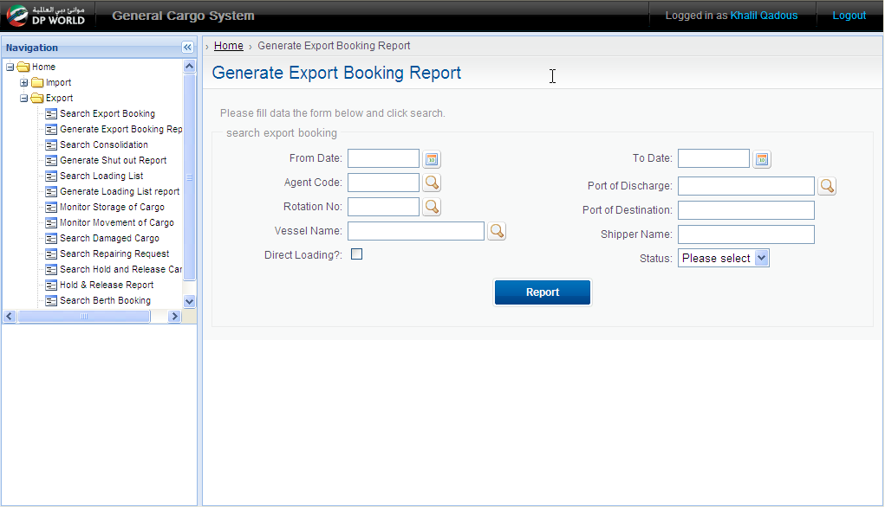

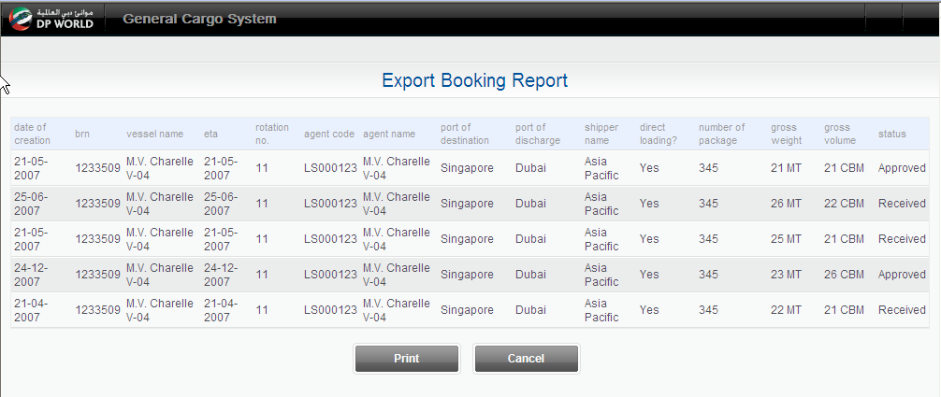

DATA FIELDS
Field name | Mandatory | Control Type | Data Type | Length | Rules
Input
Agent Code | No | Text field | Text | 100 | Note: Icon search, allow the user to search Agent Code
From Date | No | Text field | Date | 10 | Follow standard date format
To Date | No | Text field | Date | 10 | Follow standard date format
Vessel Name | No | Text field | Text | 30 | Note: Icon search, allow the user to search Vessel Name
Rotation No | No | Text field | Text | 25 | Note: Icon search, allow the user to search Rotation No
Port of Destination | No | Text field | Text | 30
Port of Discharge | No | Text field | Text | 25
Shipper Name | No | Text field | Text | 50
Direct Loading? | No | Check box
Status | No | Text field | Text | 10 | Please select, Received, Approved, Exported, And Cancelled.
Report |  | Button | N/A | N/A
Output
Date of Creation | Yes | Label | Date | 10 | Read only
BRN | Yes | Label | Number | 15 | Read only
Vessel Name | No | Label | Text |  | Read only
ETA | No | Label | Date | 10 | Read only
Rotation No | No | Label | Text |  | Read only
Agent Code | Yes | Label | Text | 20 | Read only
Agent Name | Yes | Label | Text | 100 | Read only
Port of Destination | Yes | Label | Text | 25 | Read only
Port of Discharge | No | Label | Text | 25 | Read only
Shipper Name | Yes | Label | Text | 50 | Read only
Direct Loading? | No | Label
Number of package | Yes | Label | Number | 5 | Read only
Gross Weight | Yes | Label | Decimal | 10 | Read only
Gross Volume | Yes | Label | Decimal | 10 | Read only
Status | Yes | Label | Text | 10 | Read only
Print |  | Button | N/A | N/A
Cancel |  | Button | N/A | N/A

      - Main Flow
Step | Action Description | Comment
1 | The user clicks Report link in menu
2 | The system displays Report Criteria screen
3 | The user inputs the report criteria and clicks on Report button
4 | The system:  - identifies that the data input by the user is valid  - retrieves Export Booking list based on input criteria and displays Export Booking Report screen | See alternative flows:  A4.1: System error or no record found
5 | The user select Print button | See alternative flows:  A5.1: Close
6 | The system execute Print function of web browser

      - Alternatives Flows
A4.1: System error
Step | Action Description | Comment
4.1.1 | At step 4 the system identifies that one or more errors have occurred. The system displays the relevant error messages to the user.
4.1.2 | Return to Step 3 in Main Flow

A5.1: Close
Step | Action Description | Comment
5.1.1 | At steps 5, the user selects Close
5.1.2 | The system closes report screen and displays Report Criteria screen

      - Business Rules

ID | Rule Description | Message ID
EP1.5BR01 | All search criteria are blank / spaces | MS01
EP1.5BR02 | From Date is not a valid date and From Date is a future date. | MS02
EP1.5BR03 | From Date must be in date format (see Master Glossary) | MS02
EP1.5BR04 | To Date is not a valid date | MS02
EP1.5BR05 | To Date must be in date format (see Master Glossary). | MS02
EP1.5BR0.6 | From Date must be less than or equal to “To Date”. | MS13
EP1.5BR07 | The system shows a messages when no records match with search condition | MS12
EP1.5BR08 | If From Date & To Date are entered, the search result must match the condition: Date of Creation >= From Date and Date of Creation <= To Date
EP1.5BR09 | The system does not allow wildcard search for all text fields. It is exactly search

      - Open Issues

N/A

    - UC EP1.6: Create Shipping Note
      - Actors
Refer to Security Matrix
      - Pre-condition
Shipping Agent searched and found Approved Export Booking
      - Mock-up Screen & Data Fields
MOCK-UP: Create Shipping Note for External User
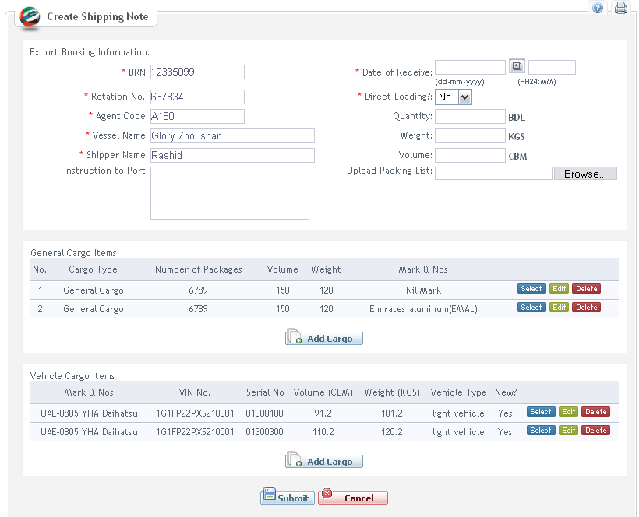

Screen 12: Create Shipping Note by Shipping Agent / Shipper

MOCK-UP: Create Shipping Note for Internal User
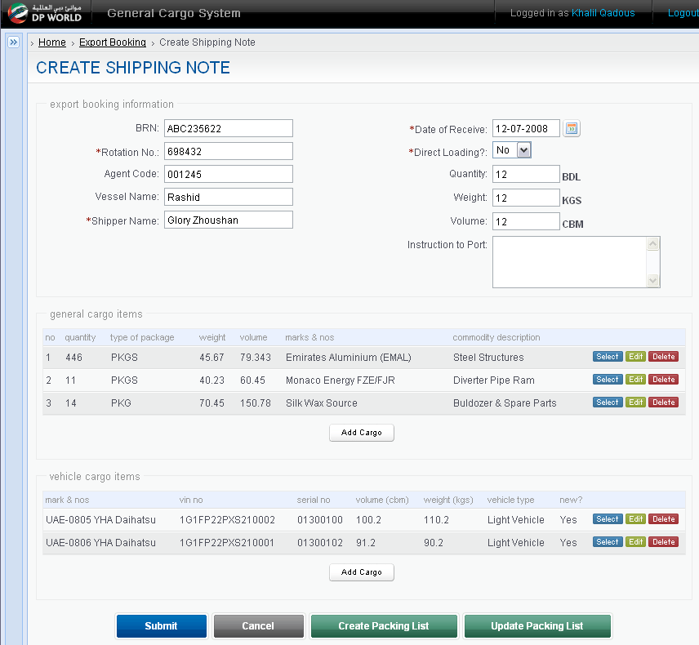

Screen 13: Create Shipping Note by GC Officer

DATA FIELDS: Create Shipping Note
Field name | Mandatory | Control Type | Data Type | Length | Rules
BRN | Yes | Text field | Text | 15 | Read only
Vessel Name | Yes | Text field | Text | 50 | Read only
Rotation No | Yes | Text field | Text | 20 | Read only
Shipper Name | Yes | Text field | Text | 50 | Read only
Agent Code | Yes | Text field | Text | 30 | Read only. This is for internal user only.
Direct Loading? | Yes | Drop-down field | Text | 1 | Yes/No option to identify if shipping note is direct loading.
Quantity | Yes | Text field | Number | 12 | Read-only. This is automatically calculated from cargo/vehicle item(s)
Volume | Yes | Text field | Decimal | 12 | Read only. This is automatically calculated from cargo/vehicle item(s)
Weight | Yes | Text field | Decimal | 12 | Read only. This is automatically calculated from cargo/vehicle item(s).
 | Yes | Text field | Text | 5 | (HH24:MM)
Instruction to Port | No | Text area field | Text | 300 | This is to mention special equipments which will be needed to offload abnormal cargo as well as the port overtime if any at the time receiving.
Cargo Item list (General Cargo)
No | Yes | Label | Number | 3
Quantity | Yes | Label | Number | 5
Marks & Nos | Yes | Label | Number | 50
Weight | Yes | Label | Number | 12
Volume | Yes | Label | Number | 12
Commodity Description | Yes | Text field | Text | 100 | Read only
Select | Yes | Button | N/A | N/A | To view cargo detail
Edit | Yes | Button | N/A | N/A | To amend cargo detail
Delete | Yes | Button | N/A | N/A | To remove cargo item from the shipping note.
Add Cargo | Yes | Button | N/A | N/A | To add cargo item into the shipping note.
Cargo Item list (Vehicle Cargo)
Mark & Nos | Yes | Label
VIN No | Yes | Label |  |  | Vehicle Identification Number
Serial No | Yes | Label
Volume (CBM) | Yes | Label
Weight (KGS) | Yes | Label
Vehicle Type | Yes | Label |  |  | It can be ‘Light Vehicle’ or ‘Heavy Vehicle’
New? | Yes | Label |  |  | New or used vehicle
Select | Yes | Button | N/A | N/A | To view vehicle detail
Edit | Yes | Button | N/A | N/A | To edit vehicle detail
Delete | Yes | Button | N/A | N/A | To remove vehicle item from shipping note.
Add Cargo | Yes | Button | N/A | N/A | To add vehicle item into shipping note.
Submit | Yes | Button | N/A | N/A | Clicking on this button allows to submit all shipping note detail coming along with cargo/vehicle items.
Cancel | Yes | Button | N/A | N/A | To cancel the creation of shipping note
Upload Packing List | No | Text field | Text | 100 | File path/name to the packing list file. Once attached in shipping note, the system will upload this file to remote server.
Create Packing List | Yes | Button | N/A | N/A | This button/link allows user to enter packing information (faxed by shipping agent / shipper) into the system as electronic data.
Update Packing List | Yes | Button | N/A | N/A | If packing list is created by mistake, this button/link allows the amendment.

MOCK-UP: Add Cargo Details screen for General Cargo

External User
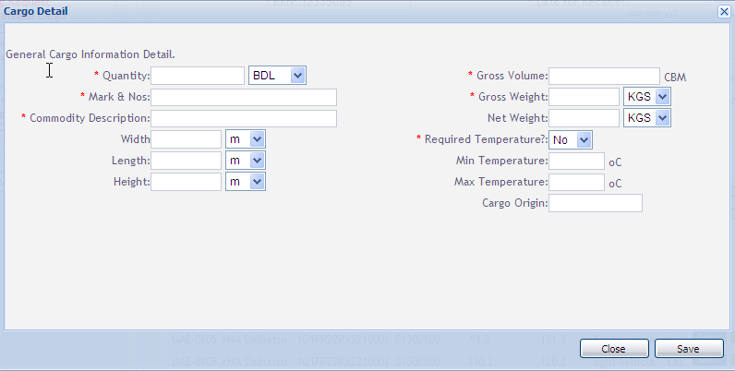

Internal User
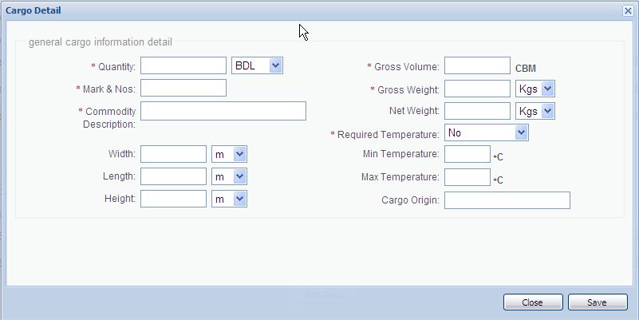

DATA FIELDS: General Cargo
Field name | Mandatory | Control Type | Data Type | Length | Rules
Cargo Origin | No | Text field | Text
Quantity | Yes | Text field | Number | 10
 | Yes | Drop-down list | Text |  | Values: BDL, PLT, PCS, SKID, COLLI, PKG, CRT, UNIT, CTN, COILS
Mark & Nos | Yes | Text field | Text | 255
Commodity Description | Yes | Text field | Text | 255
Net Weight | No | Text field | Decimal | 10 | Has 3 decimal number
 | Yes | Drop-down list | Text |  | Values: KGS, MT
Gross Weight | Yes | Text field | Decimal | 10 | Has 3 decimal number
 | Yes | Drop-down list | Text |  | Values: KGS, MT
Gross Volume | Yes | Text field | Decimal | 10 | CBM: Cubic meter (m³). Has 3 decimal number
Length | No | Text field | Number
 | Yes | Drop-down list | Text |  | Values: m, cm
Width | No | Text field | Number
 | Yes | Drop-down list | Text |  | Values: m, cm
Height | No | Text field | Number
 | Yes | Drop-down list | Text |  | Values: m, cm
Required Temperature | Yes | Drop-down list | Text |  | Yes and No. Default is No.
Min Temperature | No | Text Field | Number | 3 | It is minimum temperature.
Max Temperature | No | Text Field | Number | 3 | It is maximum temperature.
Save | Yes | Button | N/A | N/A
Cancel | Yes | Button | N/A | N/A

MOCK-UP: Add Cargo Details screen for Vehicle Cargo

External User
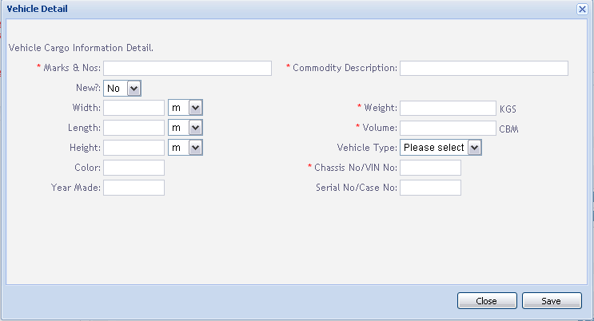

Internal User
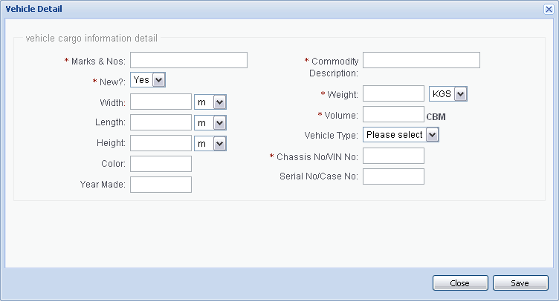

DATA FIELDS: for Vehicle Cargo
Field name | Mandatory | Control Type | Data Type | Length | Rules
Marks & Nos | Yes | Text field | Text | 255
Commodity Description | Yes | Text field | Text | 255
New? | No | Check box
Weight | Yes | Text field | Decimal | 10 | MT: Megaton. Has 3 decimal number
Volume | Yes | Text field | Decimal | 10 | CBM: Cubic meter (m³). Has 3 decimal number
Length | No | Text field | Number
Width | No | Text field | Number
Height | No | Text field | Number
Vehicle Type | No | Drop-down list | Text |  | Includes: Please select, Heavy Vehicle, Light Vehicle
Chassis No/VIN No | No | Text Field | Text | 30
Year Made | No | Text Field | Number | 4
Color | No | Text Field | Text | 30
Serial No/Case No | No | Text field | Text | 20
Save | Yes | Button | N/A | N/A
Cancel | Yes | Button | N/A | N/A

      - Main Flow
Step | Action Description | Comment
1 | The user selects Search Export Booking link on left menu and searches for all Approved Export Booking then selects one Export Booking and clicks on Add Shipping Note button | Refer to UC EP1.3
2 | The system displays Shipping Note master screen
3 | The user  - inputs data for Shipping Note  - clicks on Add Cargo button (for both General and Vehicle cargo)
4 | The system open Cargo details pop-up screen
5 | The user inputs Cargo details and clicks on Save button | Note: The user can execute step 5 and 6 many times to add many cargo details.  See alternative flow:  - A5.1: Close Cargo details screen
6 | The system:  - validates the data input by the user (BR1, 2, 3, 4, 5, 7, 8, 9, 10, 11, 12, 13, 14, 15, 16)  - closes pop-up screen and returns to Shipping Note master screen with Cargo details in the grid | See alternative flow:  - A6.1: Validation failure
7 | The user clicks on Submit button. | See alternative flows:  - A7.1: Cancel  - A7.2: View Cargo details  - A7.3: Update Cargo details  - A7.4: Delete Cargo details
8 | The system displays pop-up screen to confirm with two options: Yes or No
9 | The user selects Yes to confirm the submission | See alternative flow:  - A9.1: Cancel confirmation
10 | The system:  - validates the data input by the user (BR06)  - saves data into database.  - closes current screen and returns to previous screen | See alternative flow:  - A10.1: Validation failure

      - Alternatives Flows
A5.1: Close Cargo details screen
Step | Action Description | Comment
5.1.1 | At step 5 user clicks the Close button on pop-up screen
5.1.2 | The system closes the Cargo details screen and displays Shipping Note master screen

A6.1: Validation failure
Step | Action Description | Comment
6.1.1 | At step 6 the system identifies that one or more errors have occurred. The system displays the relevant error messages to the user.
6.1.2 | Return to Step 4 in Main Flow

A7.1: Cancel
Step | Action Description | Comment
7.1.1 | At step 7 user clicks on Cancel button to cancel the Shipping Note creation
7.1.2 | The system displays pop-up screen to confirm the Cancellation with two options: Yes or No
7.1.3 | The user selects Yes to confirm the Cancellation | See alternative flow:  - A7.1.3.1: Cancel confirmation
7.1.4 | The system closes the current screen and displays Search Export Booking screen

A7.2: View Cargo details
Step | Action Description | Comment
7.1.1 | At step 7 user clicks on Select button for corresponding Cargo item to view details
7.1.2 | The system displays Cargo details pop-up screen with all details information | Note: All data are Read only
7.1.3 | The user clicks on Close button
7.1.4 | The system closes pop-up screen and displays Shipping Note master screen

A7.3: Update Cargo details
Step | Action Description | Comment
7.2.1 | At step 7 user clicks on Update button for corresponding Cargo item to update details
7.2.2 | The system displays pop-up screen
7.2.3 | The user updates Cargo details and clicks on Save button | See alternative flow:  - A5.1: Cancel
7.2.4 | The system:  - identifies that the data input by the user is valid (BR1, 2, 3, 4, 5, 7, 8, 9, 10, 11, 12, 13, 14, 15, 16)  - closes current screen and returns to Search Export Booking screen | See alternative flow:  - A6.1: Validation failure

A7.3: Delete Cargo details
Step | Action Description | Comment
7.2.1 | At step 7 user clicks on Delete button for corresponding Cargo item
7.2.2 | The system displays pop-up screen to confirm the Deletion with two options: Yes or No
7.2.3 | The user selects Yes to confirm the Deletion
7.2.4 | The system deletes the selected Cargo and return to Step 2 in Main flow

      - Business Rules

ID | Rule Description | Message ID
EP1.6BB01 | Mandatory field(s) has(have) not been input | MS06
EP1.6BR02 | Number of package should be greater than zero | MS03
EP1.6BR03 | Net Weight should be greater than zero. | MS03
EP1.6BR04 | Gross Weight should be greater than zero. | MS03
EP1.6BR05 | Gross Volume should be greater than zero | MS03
EP1.6BR06 | Receive date is not a valid date. | MS02
EP1.6BR08 | Cargo Length should be greater than zero | MS03
EP1.6BR09 | Cargo Width should be greater than zero. | MS03
EP1.6BR10 | Cargo Height should be greater than zero | MS03
EP1.6BR11 | Required Temperature is Yes but Min Temperature and/or Max Temperature are/is blank | MS06
EP1.6BR12 | Min Temperature must be in number | MS03
EP1.6BR07 | Max Temperature must be in number | MS03
EP1.6BR13 | Number of package summary exceeds the Total number of package in Export Booking  - Number of packages of Shipping Note = ∑ Number of packages of cargo items | MS22
EP1.6BR14 | Gross Weight summary exceeds the Total Gross Weight in Export Booking  - Gross Weight of Shipping Note = ∑ Weight of cargo items | MS22
EP1.6BR15 | Gross Volume summary exceeds the Total Gross Volume in Export Booking  - Gross Volume of Shipping Note = ∑ Volume of cargo items | MS22
EP1.6BR16 | Made Year must be in number | MS03
EP1.6BR17 | Shipping Note of indirect loading EB is direct loading if it is created after cut off time

      - External Interface
Below table defines the data fields that will be sent to MISAL2 system.
Field name | Mandatory | Data Type | Length | Rules
BRN | Yes | Text | 15
SRN | Yes | Text | 15 | Shipping Note Reference Number
Date of Receive | Yes | Date | 10
Cargo Type | Yes | Text | 20 | Vehicle Cargo/General Cargo
Cargo Commodity | Yes | Text | 100
Quantity | Yes | Number | 5
Package Type | Yes | Text | 10
Gross Weight | Yes | Decimal | 10
Weight Type | Yes | Text | 10
Gross Volume | Yes | Decimal | 10
Length | No | Number | 5
Width | No | Number | 5
Height | No | Number | 5
Vehicle Type | No | Text | 20 | These fields will include values for Vehicle Cargo
Chassis No/VIN No | No | Text | 30 | These fields will include values for Vehicle Cargo
Year Made | No | Number | 4 | These fields will include values for Vehicle Cargo
Color | No | Text | 30 | These fields will include values for Vehicle Cargo
Serial No/Case No | No | Text | 20 | These fields will include values for Vehicle Cargo

      - Open Issues
- Refer to GCS issue log.

    - UC EP1.7: View Export Booking
      - Actors
Refer to Security Matrix
      - Pre-condition
The user logins the system and has been authorized
      - Mock-up Screen & Data Fields

MOCK-UP: Shipping Agent Screen
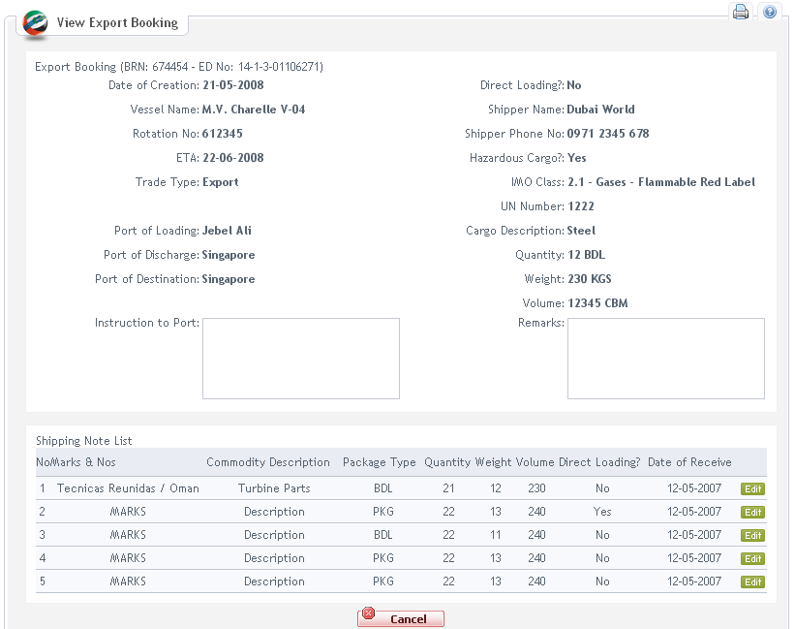

Screen 18: View Export Booking by Shipping Agent

GC Officer Screen
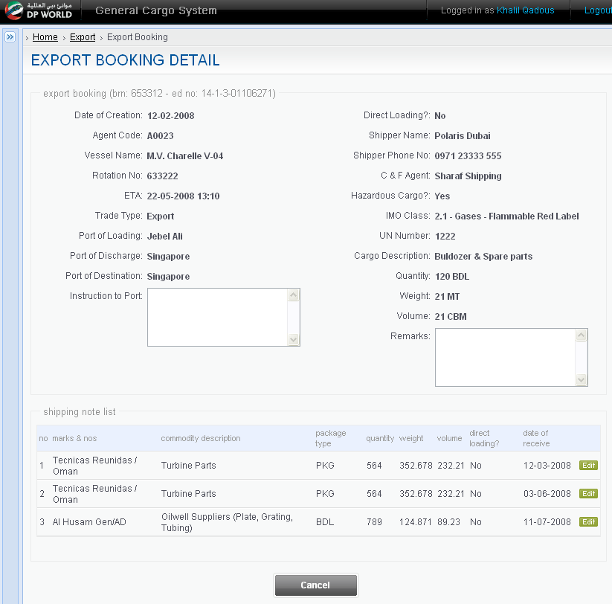

Screen 19: View Export Booking by GC Officer

DATA FIELDS
Field name | Mandatory | Control Type | Data Type | Length | Rules
Date of Creation | Yes | Label | Date | 10 | Read only
Trade Type | Yes | Label | Text |  | Read only
BRN | Yes | Label | Text | 15 | Read only
ETA | Yes | Label | Date | 10 | Read only
Ex-Vessel Name | No | Label | Text |  | Read only. This field is shown when Trade Type =”Re-Export”
Ex-Rotation No | No | Label | Text |  | Read only. This field is shown when Trade Type =”Re-Export
Arrival Date | No | Label | Date | 10 | Read only. This field is shown when Trade Type =”Re-Export
 | No | Label | Text | 5 | Read only
Vessel Name | Yes | Label | Text |  | Read only
Rotation No | Yes | Label | Text |  | Read only
Agent Code | Yes | Label | Text | 20 | Read only. It is only shown on GC Officer screen
Port of Loading | Yes | Label | Text |  | Read only
Port of Destination | Yes | Label | Text | 25 | Read only
Port of Discharge | No | Label | Text | 25 | Read only
Shipper Name | Yes | Label | Text | 50 | Read only
Shipper Phone No | No | Label | Text | 20
Direct Loading? | No | Label |  |  | Read only
Hazardous Cargo | Yes | Label | Text |  | Read only
IMO Class | No | Label | Text | 4 | Read only
UN Number | No | Label | Text | 6 | Read only
Cargo Description | Yes | Label |  |  | Read only
Quantity | Yes | Label | Number | 5 | Read only
Gross Weight | Yes | Label | Decimal | 10 | Read only
Gross Volume | Yes | Label | Decimal | 10 | Read only
Shipping Note List (Data Grid)
No | Yes | Label | Number | 3 | The Cargo items which belong to the Export Booking will be showed in grid with these columns
Cargo Type | Yes | Label | Text | 15
Marks & Nos | Yes | Label | Number | 50
Commodity Description | Yes | Label | Text | 50
Number of Package | Yes | Label | Number | 5
Package Type | Yes | Label | Text
Gross Weight | Yes | Label | Decimal | 10
Gross Volume | Yes | Label | Decimal | 10
Date of Receive | Yes | Label | Date
Cancel |  | Button | N/A | N/A
Update |  | Button | N/A |  | This button is only available on Shipping Agent screen
Edit |  | Button | N/A | N/A | This button allows user to amend shipping note detail.

      - Main Flow
Step | Action Description | Comment
1 | The user clicks on the "Details” button on a Export Booking in search result after executing search
2 | The system displays View Export Booking screen | Refer to data requirement section
3 | The user clicks on Cancel button | See alternative flow:  - A3.1: Update Export Booking
4 | The system closes current screen and returns to use case “Search Export Booking”

      - Alternatives Flows
A3.1: Update Export Booking
Step | Action Description | Comment
3.1.1 | At step 3 user clicks the Update button on screen
3.1.2 | The system displays the Update Export Booking screen. (continue UC EP1.2)

      - Business Rules

N/A
      - Open Issues

N/A
    - UC EP1.8: Upload Export Booking
      - Actors
Refer to Security Matrix
      - Pre-condition
The user logins the system and has been authorized
      - Mock-up Screen & Data Fields

MOCK-UP: Shipping Agent Screen
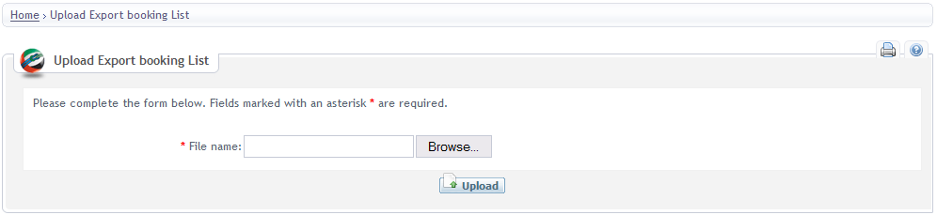
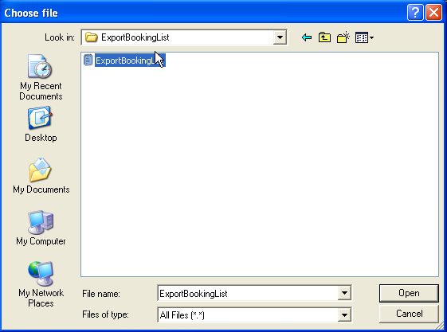

GC Officer Screen
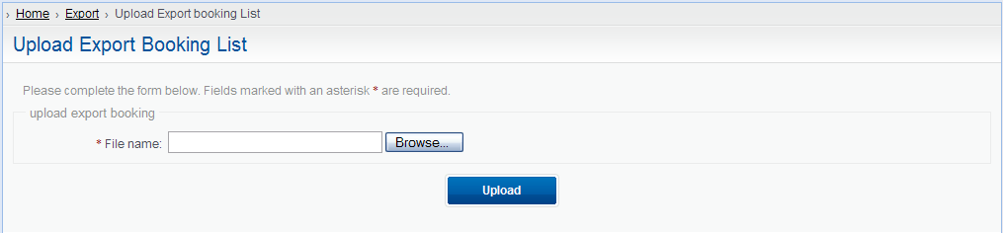

DATA FIELDS

Field name | Mandatory | Control Type | Data Type | Length | Rules
File Name | Yes | Text field | Text | 50
Browse… |  | Button | N/A | N/A
Upload |  | Button | N/A | N/A

      - Main Flow
Step | Action Description | Comment
1 | The user clicks on the Export Booking list link on left menu
2 | The system displays Upload Export Booking list screen | Refer to data requirement section
3 | The user clicks on “Browse…” button
4 | The system opens the Chose file screen
5 | The user selects a file and clicks on Open button
6 | The system closes the Chose file screen and displays Export Booking list screen with file name in File name field
7 | The user clicks on Upload button
8 | The system:  - identifies that the data input by the user is valid (EP1.8BR01)  - saves data into database  - send email notification to GC Officer and Shipping Agent  - closes current screen and returns to previous screen | Alternative flow:  - A8.1: Validation failure

      - Alternatives flows
A8.1: Validation failure
Step | Action Description | Comment
8.1.1 | At step 8 the system identifies that one or more errors have occurred. The system displays the relevant error messages to the user.
8.1.2 | Return to Step 6 in Main Flow

      - Business rules
ID | Rule Description | Message ID
EP1.8BB01 | Mandatory field(s) has(have) not been input
EP1.8BR02 | Quantity should be greater than zero.
EP1.8BR03 | Gross Weight should be greater than zero
EP1.8BR04 | Gross Volume should be greater than zero
EP1.8BR05 | Hazardous Cargo is “Y” but IMO Class and/or UN Number are blank.
EP1.8BR06 | If ETA - time of upload < 24 hours the system will set Direct Loading field is Yes by default
EP1.8BR07 | Trade type is Re-Export but user does not input Ex-Vessel Name and/or Ex-Rotation No
EP1.8BR08 | BRN is an unique value for a Rotation Number
EP1.8BR09 | Export Booking is set status = “Approved” by default
EP1.8BR10 | Shipping Agent Info (Agent Code, Agent Name) accompanied with Export Booking is got from user profile if the user is an external user.
EP1.8BR11 | The Port of Loading is set default “Jebel Ali”
EP1.8BR12 | Vessel Name must belong to Shipping Agent
EP1.8BR13 | Rotation No must belong to Vessel Name and Voyage No
EP1.8BR14 | Agent Code is not existing in the system if internal user uploads Export Booking file
EP1.8BR15 | Export Booking file is a flat file. Fields in flat file is separated by a comma

Data Fields in Export Booking File
Field name | Mandatory | Data Type | Length | Rules
Trade Type | Yes | Text | 20 | Re-Export, Export, Transshipment
BRN | Yes | Text | 15
Agent Code | No | Text | 30 | Require if the upload file is for internal users
Ex-Vessel Name | No | Text | 50 | This field has value when trade type =”Re-export” or Transshipment
Ex-Rotation No | No | Text | 20 | This field has value when trade type= “Re-export” or Transshipment
Vessel Name | Yes | Text | 50
Rotation No | Yes | Text | 20
Port of Destination | Yes | Text | 25
Port of Discharge | Yes | Text | 25 | The first discharge port
Shipper Name | Yes | Text | 50
Shipper Phone No | No | Text | 20
Direct Loading? | No | Text | 1 | Y/N
Hazardous Cargo | Yes | Text | 1 | Y/N
IMO Class | No | Text | 4 | Required if Hazardous Cargo=”Y”
UN Number | No | Text | 6 | Required if Hazardous Cargo=”Y”
Cargo Description | Yes | Text | 100
Quantity | Yes | Number | 5
Package Type | Yes | Text | 10
Gross Weight | Yes | Decimal | 10
Weight Type | Yes | Text | 10
Gross Volume | Yes | Decimal | 10

      - Open Issues
- Refer to GCS issue log.
    - UC EP1.9: Update Shipping Note
      - Actors

Refer to Security Matrix
      - Pre-condition

The user logins the system and has been authorized
      - Mock-up Screen & Data Fields
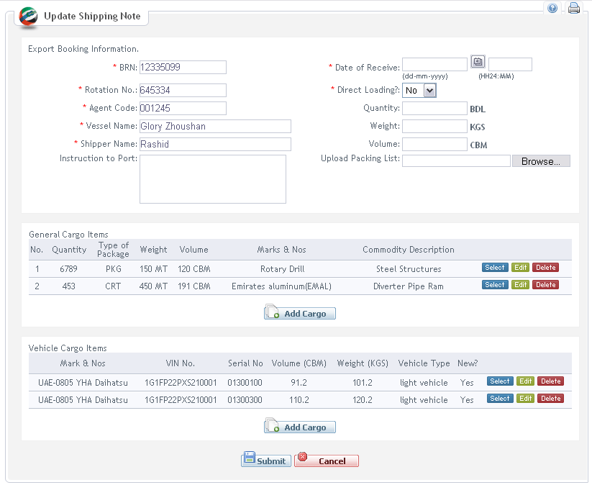

Screen 21: Update Shipping Note by Shipping Agent / Shipper

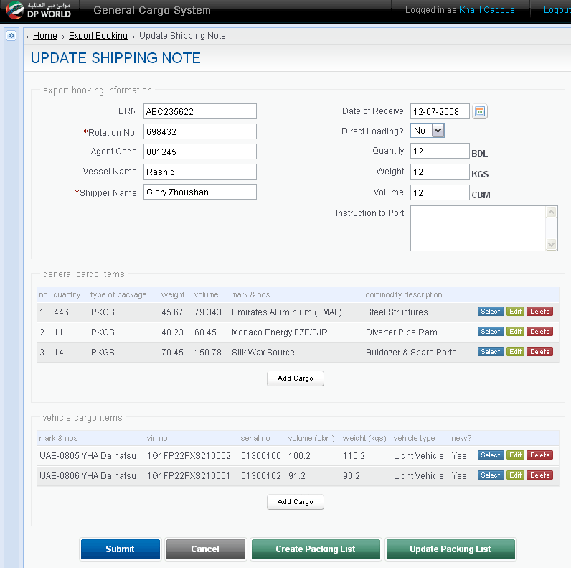

Screen 22: Update Shipping Note by GC Officer
      - Main Flow

Please refer to Main Flow of UC EP1.6 Create Shipping Note.
That shipping note details can be populated from existing shipping note, and the system will make it available for user to make change(s).
      - Alternative Flows

Please refer to Alternative Flows of UC EP1.6 Create Shipping Note.
      - Business Rules

Please refer to Alternative Flows of UC EP1.6 Create Shipping Note.
      - External Interface

N/A
      - Open Issues

N/A
- APPENDICES
  - Email Template
    - Email to inform Shipping Agent when he submits Export Booking
Email Header
From: | GCS Administrator
To: | [Agent email]
Subject: | EXPORT BOOKING FOR [Vessel Name] AT JEBEL ALI
Email Content
PLEASE BE INFORMED THAT FOLLOWING EXPORT BOOKING [Link to Export Booking] WAS SUBMITTED FOR GCS

    - Email to notify GC Officer of new Export Booking

Email Header
From: | GCS Administrator
To: | [GC Officer email]
Subject: | EXPORT BOOKING FOR [Vessel Name] AT JEBEL ALI
Email Content
KINDLY ACCEPT FOLLOWING EXPORT BOOKING FOR LOADING [Vessel Name] FOR DESTINATION [Port of Destination]
[If IMO Class 1,2: Cargo Description, Volume, Weight, IMO Class, UN Number will be enclosed in the email]
[Link to Export Booking]
WE CONFIRM SHIPPERS WILL ARRANGE TO COMPLETE EXPORT DOCUMENTATION FOR THE CARGO PAYING APPLICATION PORT HANDLING CHARGES PRIOR LOADING
THANKS AND REGARDS
[Agent Name]

    - Email to notify Shipping Agent when Export Booking is approved

Email Header
From: | GCS Administrator
To: | [Agent email in Export Booking form]
Subject: | EXPORT BOOKING FOR [Vessel Name] AT JEBEL ALI APPROVED
Email Content
KINDLY BE INFORMED THAT FOLLOWING EXPORT BOOKING WAS APPROVED
[Link to Export Booking]
PLEASE KINDLY PROCEED
GCS

    - Email to inform Shipping Agent when Export Booking is cancelled

Email Header
From: | GCS Administrator
To: | [Agent email in Export Booking form]
Subject: | EXPORT BOOKING FOR [Vessel Name] AT JEBEL ALI CANCELLED
Email Content
KINDLY BE INFORMED THAT YOU JUST CANCELLED THE FOLLOWING EXPORT BOOKING [Link to Export Booking]
REGARDS,
GCS

    - Email to notify GC Officer when Export Booking is cancelled

Email Header
From: | GCS Administrator
To: | [Agent email in Export Booking form]
Subject: | EXPORT BOOKING FOR [Vessel Name] AT JEBEL ALI CANCELLED
Email Content
KINDLY BE INFORMED THAT FOLLOWING EXPORT BOOKING WAS CANCELLED BY [Agent Name]
[Link to Export Booking]
REGARDS,
GCS
    - Email to notify GC Officer when Export Booking is updated

Email Header
From: | GCS Administrator
To: | [Agent email in Export Booking form]
Subject: | EXPORT BOOKING FOR [Vessel Name] AT JEBEL ALI CANCELLED
Email Content
KINDLY BE INFORMED THAT FOLLOWING EXPORT BOOKING WAS UPPDATED BY [Agent Name]
[Link to Export Booking]
REGARDS,
GCS

