FPT University
Source: Exported from FU-EOS
Subject: SR
Generated Time: 7/23/2013 3:34:20 PM

MULTIPLE CHOICES QUESTIONS:
QN=1 (2903) | An agent model of the system serves the following purposes, EXCEPT?1
a. | It defines the system scope and configuration, in term of agents and their interfaces
b. | An agent model may also serve as an input to software architecture design
c. | We may formulate heuristics for responsibility assignment and capture dependency chains among agents for vulnerability analysis.
d. | It provides a basis for generating a glossary of terms
ANSWER: | D
MARK: | 1
UNIT: | Chap11
MIX CHOICES: | Yes

QN=2 (2914) | A goal turns to be unrealizable by an agent if and only if one of the following criteria hold, EXCEPT?11
a. | The agent is unable to control a variable in the goal specification that needs to be constrained for goal satisfaction.
b. | There is a variable in the goal specification that needs to be evaluated in a future state.
c. | An external circumstance can make the goal unsatisfiable.
d. | The goal is an unbounded Achieve goal; that is, its target condition can be definitely postponed to future states.
ANSWER: | D
MARK: | 1
UNIT: | Chap11
MIX CHOICES: | Yes

QN=3 (1501) | An agent is an ______ system component play a role in goal satisfaction.1111
a. | Active
b. | Passive
c. | Instantaneous
d. | none of the others
ANSWER: | A
MARK: | 1
UNIT: | Chap11
MIX CHOICES: | Yes

QN=4 (2909) | Which of the following are mandatory features of an agent making it clear under what conditions an individual is currently an instance of an agent?1
a. | Name and definition
b. | Name and category
c. | Definition and category
d. | Name and domain invariant
ANSWER: | A
MARK: | 0.5
UNIT: | Chap11
MIX CHOICES: | Yes

QN=5 (2904) | Which of the following captures agent capabilities, responsibility, interfaces and possibility, refinements, wishes, beliefs, and dependencies?2
a. | Goal model
b. | Object model
c. | Obstacles model
d. | Agent model
e. | Behavioral model
ANSWER: | D
MARK: | 1
UNIT: | Chap11
MIX CHOICES: | Yes

QN=6 (1502) | Which of the following statements about agent capabilities is wrong?.222
a. | An agent monitors an attribute of an object if its instances can get the value of this attribute from object instances
b. | An agent monitors an association if its instances can control this association holds between object instances
c. | An agent controls an attribute of an object if its instances can set values for this attribute on object instances
d. | An agent controls an association if its instances can create and delete association instances
ANSWER: | B
MARK: | 1
UNIT: | Chap11
MIX CHOICES: | Yes

QN=8 (2900) | The agent model describes the responsibility view of the system. This view covers ________ of requirements engineering.3
a. | WHO-dimension
b. | WHAT-dimension
c. | WHY-dimension
d. | HOW-dimension
ANSWER: | A
MARK: | 1
UNIT: | Chap11
MIX CHOICES: | Yes

QN=9 (2906) | Which of the following is NOT a rule for agent identification when building agent model of the system?3333
a. | For a goal already identified in the goal model, review all the objects that are active ones. For each object determine what attribute and association in the object model the object can monitor or control.
b. | For a goal already identified in the goal model, identify what agents could be made responsible for it. Then, for every object this goal refer to, determine the object's attributes and associations in the object model that could be monitored and controlled by those agent.
c. | For a goal already identified in the goal model, identify which human agents might wish this goal and which capabilities these agents might have.
d. | For a realizable leaf goal in the goal model, consider for all alternative assignments any identified agent whose capabilities enable it to (a) monitor all variables that need to be evaluated in the goal specification, and (b) control all variables that are constrainted by the goal specification.
ANSWER: | D
MARK: | 1.5
UNIT: | Chap11
MIX CHOICES: | Yes

QN=10 (2910) | An agent performs an operation if the applications of this operation are activated by instances of this agent. The operations performed by an agent define which agent instance activates which operation application, they specified in instance declaration annotating ___________.333
a. | Performance link
b. | Responsibility link
c. | Assignment link
d. | Monitor/control link
ANSWER: | A
MARK: | 1
UNIT: | Chap11
MIX CHOICES: | Yes

QN=11 (2908) | Which of the following is NOT a rule for agent responsibility when building agent model?4444
a. | Assignment to wisher
b. | Assignment refinement
c. | Assignment based on goal-capability matching
d. | Assignment selection based on achieve goal
ANSWER: | D
MARK: | 1
UNIT: | Chap11
MIX CHOICES: | Yes

QN=12 (2907) | Which of the following is NOT a rule used for agent identification when building agent model?4444
a. | Variable monitor/controller.
b. | Goal wisher
c. | Goal enforcer
d. | Assignment to wisher
ANSWER: | D
MARK: | 1
UNIT: | Chap11
MIX CHOICES: | Yes

QN=13 (1503) | A goal under the responsibility of an agent must be realizable by the agent in view of its ________.4444
a. | Responsibilities
b. | Capabilities
c. | Realizabilities
d. | None of the others
ANSWER: | B
MARK: | 1
UNIT: | Chap11
MIX CHOICES: | Yes

QN=14 (2912) | Agent capabilities define the ________ with respect to other agents in the system; an agent monitor some object attributes or association controlled by some other agents.44
a. | agent's interface
b. | agent responsibilities
c. | goal realizability
d. | monitored/controlled conditions
ANSWER: | A
MARK: | 1
UNIT: | Chap11
MIX CHOICES: | Yes

QN=15 (1506) | Which one of the following statements is the definition of "capability instance declaration" (CID)?5
a. | It annotating a performance link in an agent diagram makes precise which agent instance is performing the operation on which input/output object instance
b. | It annotating a monitoring or control link makes precise which agent instance is monitoring or controlling the attribute/association of which object instance
c. | It annotating a responsibility link in an agent diagram makes it precise which agent instance is responsible for which goal instantiation to specific object instances
d. | None of the others
ANSWER: | B
MARK: | 1.5
UNIT: | Chap11
MIX CHOICES: | Yes

QN=16 (1505) | In figure 11.4, what is the name of the annotation attached to the link between the agent and the operation in the agent model?  555  [file:1505.jpg]  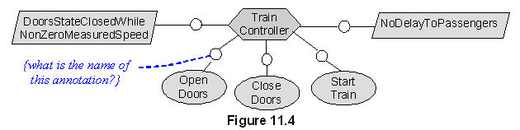
a. | Responsibility instance declaration
b. | Capability instance declaration
c. | Performance instance declaration
d. | none of the others
ANSWER: | C
MARK: | 1
UNIT: | Chap11
MIX CHOICES: | Yes

QN=17 (2905) | Which of the followings can we base on to build system architecture and to understand the interface between system components?55
a. | Goal model
b. | Object model
c. | Obstacles model
d. | Agent model
e. | Behavioral model
ANSWER: | D
MARK: | 1
UNIT: | Chap11
MIX CHOICES: | Yes

QN=18 (1509) | In figure 11.6, "Train" and "TrainInfo" are classified as  6  [file:1509.jpg]  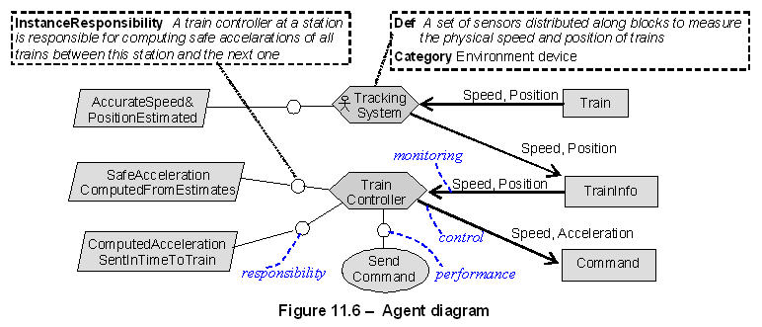
a. | Agents
b. | Events
c. | Entities
d. | Associations
ANSWER: | C
MARK: | 1
UNIT: | Chap11
MIX CHOICES: | Yes

QN=19 (1507) | In the agent model, an agent ag1 is said to depend on another agent ag2 for a goal G under the responsibility of ag2, if ___'s failure to get G satisfied can result in ___'s failure to get one of its assigned goals satisfied6666
a. | ag1 / ag2
b. | ag2 / ag1
ANSWER: | B
MARK: | 1
UNIT: | Chap11
MIX CHOICES: | Yes

QN=20 (1500) | An agent model captures the ____-dimension of requirements engineering66
a. | WHY
b. | WHO
c. | WHAT
d. | HOW
ANSWER: | B
MARK: | 0.5
UNIT: | Chap11
MIX CHOICES: | Yes

QN=21 (2901) | Which of the following is NOT a purpose of An agent model of the system?7
a. | It shows the distribution of responsibilities within the system and provides a basis for load analysis.
b. | It defines the system scope and configuration, in term of agents and their interfaces
c. | It defines the boundary between the software-to-be and its environments.
d. | It precises definition of system concepts involved in other views, their structure & descriptive properties
ANSWER: | D
MARK: | 1
UNIT: | Chap11
MIX CHOICES: | Yes

QN=22 (1504) | Agent capabilities are defined in terms of the system variables that the agent can _____ and _____77
a. | Assign / evaluate
b. | Specify / realize
c. | Monitor / control
d. | none of the others
ANSWER: | C
MARK: | 1
UNIT: | Chap11
MIX CHOICES: | Yes

QN=23 (2911) | A________ between a human agent and a goal in agent model captures the fact that this agent would like the goal to be satisfied.7777
a. | Wish link
b. | Assignment link
c. | Responsibility link
d. | Performance link
ANSWER: | A
MARK: | 1
UNIT: | Chap11
MIX CHOICES: | Yes

QN=24 (2902) | Which of the following is an incorrect statement about purposes of An agent model of the system?7
a. | It shows the distribution of responsibilities within the system and provides a basis for load analysis.
b. | It defines the system scope and configuration, in term of agents and their interfaces
c. | An agent model may also serve as an input to software architecture design
d. | It yields the state variables manipulated in other views
ANSWER: | D
MARK: | 1.5
UNIT: | Chap11
MIX CHOICES: | Yes

QN=25 (1508) | What is an agent-goal co-refinement process?8888
a. | A process in which an agent and its assigned goals are refined in parallel into finer-grained agents, sub-goals and responsibility assignments
b. | A process in which agents and assigned goals are generalized in parallel into coarse-grained agents and abstract goals
c. | Both of the others statements are wrong
d. | None of the others
ANSWER: | A
MARK: | 1
UNIT: | Chap11
MIX CHOICES: | Yes

READING QUESTIONS:
FILL BLANK QUESTIONS:
MATCH QUESTIONS:

