FPT University
Source: Exported from FU-EOS
Subject: SR
Generated Time: 7/23/2013 3:30:42 PM

MULTIPLE CHOICES QUESTIONS:
QN=1 (1699) | The goal model captures ______ and reference links from goals to system agents11
a. | responsibility links between goals and conceptual objects
b. | obstruction links between goals and obstacles
c. | operationalization links between goals and system operations
d. | coverage links between goals and scenarios
ANSWER: | A
MARK: | 1
UNIT: | Chap8
MIX CHOICES: | Yes

QN=2 (1704) | Figure 9 shows the __________________  1  [file:1704.jpg]  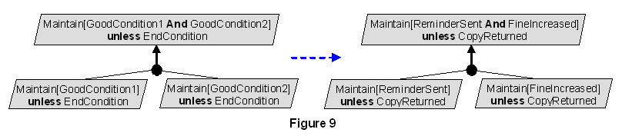
a. | Unrealizability-driven refinement pattern.
b. | Unmonitorability-driven refinement pattern.
c. | Divide-and-conquer refinement pattern.
d. | None of the others
e. | Milestone-driven refinement pattern
ANSWER: | C
MARK: | 1
UNIT: | Chap8
MIX CHOICES: | Yes

QN=3 (2874) | Alternative goal refinements in goal model yield different system proposals. Pros/cons to be evaluated against ________ for selection of best option.111
a. | soft goals
b. | behavioral goal
c. | maintain goal
d. | achieve goal
ANSWER: | A
MARK: | 1
UNIT: | Chap8
MIX CHOICES: | Yes

QN=4 (4780) | In the figure 8.28 , the goal refinement pattern is _____222  [file:4780.jpg]  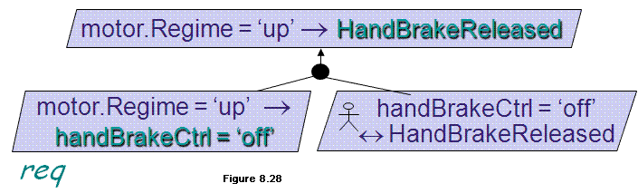
a. | Refinement towards goal realizability
b. | Refinement by milestones
c. | Refinement by case
d. | Divide-and-Conquer
ANSWER: | A
MARK: | 1
UNIT: | Chap8
MIX CHOICES: | Yes

QN=5 (1697) | An AND-refinement of a goal G into sub-goals G1, G2, …, Gn should be2222
a. | Complete, inconsistent, minimal
b. | Complete, accuracy, coverage
c. | Complete, consistent, minimal
d. | None of others
ANSWER: | C
MARK: | 0.5
UNIT: | Chap8
MIX CHOICES: | Yes

QN=6 (2866) | AND/OR graph shows how goal nodes contribute to each other. The root of the graph is…222
a. | high-level system goals that are functional or non-functional goals
b. | requirements or expectations that is assignable to single agents
c. | lower-level system goals that are functional or non-functional goals
d. | lower-level system goals that are behavioral or soft goals
ANSWER: | A
MARK: | 1
UNIT: | Chap8
MIX CHOICES: | Yes

QN=7 (4994) | In the figure 8.29 , the goal refinement pattern is _____333  [file:4994.jpg]  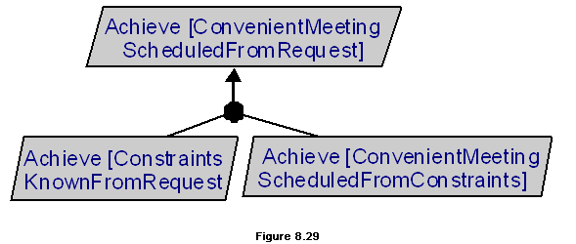
a. | Refinement towards goal realizability
b. | Refinement by milestones
c. | Refinement by case
d. | Divide-and-Conquer
ANSWER: | B
MARK: | 1
UNIT: | Chap8
MIX CHOICES: | Yes

QN=8 (1698) | Which one of the following statements about the leaf nodes in goals refinement trees is false?33
a. | They are nodes that need not be refined further.
b. | They are nodes whose responsibility can be assigned to single software agents.
c. | They are nodes whose responsibility can be assigned to single environment agents.
d. | They can not be domain properties or hypotheses.
ANSWER: | D
MARK: | 1
UNIT: | Chap8
MIX CHOICES: | Yes

QN=9 (2865) | Alternative assignments in goal model yield different system proposals. Pros/cons to be evaluated against _______ for selection of best option.3
a. | soft goals
b. | behavioral goal
c. | maintain goal
d. | achieve goal
ANSWER: | A
MARK: | 1
UNIT: | Chap8
MIX CHOICES: | Yes

QN=10 (2864) | An _______ of goal G into refinements R1, ..., Rm states that G can be satisfied by satisfying all sub-goals from any of the alternative refinements Ri4444
a. | OR-refinement
b. | AND-refinement
c. | OR-assignment
d. | AND-assignment
ANSWER: | A
MARK: | 1
UNIT: | Chap8
MIX CHOICES: | Yes

QN=11 (2876) | __________ feature can be attached to a refinement or to an assignment for unambiguous reference when dealing with alternatives.4444
a. | Name
b. | The system reference (SysRef)
c. | Status
d. | Definition (Def)
e. | Tactic
ANSWER: | A
MARK: | 0.5
UNIT: | Chap8
MIX CHOICES: | Yes

QN=12 (4987) | All of the following are heuristic rules for eliciting preliminary goals, EXCEPT?444
a. | Analyze the current objectives and problems in the system-as-is
b. | Search for goal-related keywords in elicitation material
c. | Instantiate goal categories
d. | Refinement by case
ANSWER: | D
MARK: | 1.5
UNIT: | Chap8
MIX CHOICES: | Yes

QN=13 (1702) | A goal model makes it possible to capture _______ alternative options444
a. | only one kind of (Alternative goal refinements)
b. | two kinds of (Alternative goal refinements, Alternative responsibility assignments)
c. | three kinds of (Alternative goal refinements, Alternative goal contributions, Alternative responsibility assignments)
d. | None of the others
ANSWER: | B
MARK: | 1
UNIT: | Chap8
MIX CHOICES: | Yes

QN=14 (4777) | All of the following are heuristic rules for later discovery of goals, EXCEPT?55
a. | Identifying goals from WHY questions about scenario episodes
b. | Identify wishes of human agents
c. | Identify soft goals from pros & cons of alternative options
d. | Refinement towards goal realizability
ANSWER: | D
MARK: | 1
UNIT: | Chap8
MIX CHOICES: | Yes

QN=16 (1696) | An AND-refinement states that the parent goal can be satisfied by satisfying ___ sub-goals in the refinement.555
a. | one of
b. | all
c. | some of
ANSWER: | B
MARK: | 0.5
UNIT: | Chap8
MIX CHOICES: | Yes

QN=17 (1703) | We can build refinement and abstraction paths in a goal diagram by recursively asking ___ and ___ questions about available goals, respectively5
a. | WHY / HOW
b. | WHY / WHAT
c. | HOW / WHY
d. | WHAT / WHY
ANSWER: | C
MARK: | 1
UNIT: | Chap8
MIX CHOICES: | Yes

QN=18 (4776) | To identify goals along refinement branches, we can check the converse of _____ for missing Maintain goal.66
a. | Achieve goal
b. | Soft goal
c. | Functional goal
d. | Non-functional goal
ANSWER: | A
MARK: | 1
UNIT: | Chap8
MIX CHOICES: | Yes

QN=19 (1700) | To start building a goal model, we may obtain ________ goals. Once these goals are obtained, we may build refinement and abstraction paths in a goal diagram6666
a. | Behaviour
b. | Soft
c. | Critical
d. | Preliminary
ANSWER: | D
MARK: | 1
UNIT: | Chap8
MIX CHOICES: | Yes

QN=20 (2873) | An _____ of goal G to agents A1, ..., Am states that G can be satisfied by behavioral restrictions of any of the alternative agents Ai6
a. | OR-refinement
b. | AND-refinement
c. | OR-assignment
d. | AND-assignment
ANSWER: | C
MARK: | 1
UNIT: | Chap8
MIX CHOICES: | Yes

QN=21 (2870) | Which of the following is a feature of a goal to be used for evaluating alternative options against it and for checking whether the goal is satisfactorily met by sub-goals?6666
a. | Stability
b. | Priority
c. | FitCriterion
d. | FormalSpec
e. | Source
ANSWER: | C
MARK: | 1
UNIT: | Chap8
MIX CHOICES: | Yes

QN=24 (4773) | In AND/OR graph, an OR-refinement links a parent goal to a set of alternative ______ that yield alternative system options77
a. | AND-refinements
b. | OR-refinements
c. | OR/AND-refinements
ANSWER: | A
MARK: | 0.5
UNIT: | Chap8
MIX CHOICES: | Yes

QN=25 (1701) | Which of the following refers to "The goals G1, G2, …, Gn are divergent in a domain Dom if we can find a feasible boundary condition B under which the goals cannot satisfied the arguments"?777
a. | {G1, G2, …, Gn, B, Dom} |= true
b. | {G1, G2, …, Gn, B, Dom} |= false
c. | {G1, G2, …, Gn, B, Dom} |= G
d. | {G1, G2, …, Gn, B, Dom} (Not Satisfied) G
ANSWER: | B
MARK: | 1
UNIT: | Chap8
MIX CHOICES: | Yes

QN=26 (2867) | Which of the followings is NOT a feature of goal refinement and assignment for better documentation of the goal model?88
a. | Name
b. | The system reference (SysRef)
c. | Status
d. | Definition (Def)
ANSWER: | D
MARK: | 1
UNIT: | Chap8
MIX CHOICES: | Yes

QN=27 (2869) | Which of the following are mandatory features for any goal in goal model?888
a. | Source & Name
b. | Name & Specification (Definition)
c. | Category & Name
d. | Priority & Name
ANSWER: | B
MARK: | 1
UNIT: | Chap8
MIX CHOICES: | Yes

QN=29 (1706) | Given figure 8-11 below.  Which of the followings is a pattern used in the figure?  9999  [file:1706.jpg]  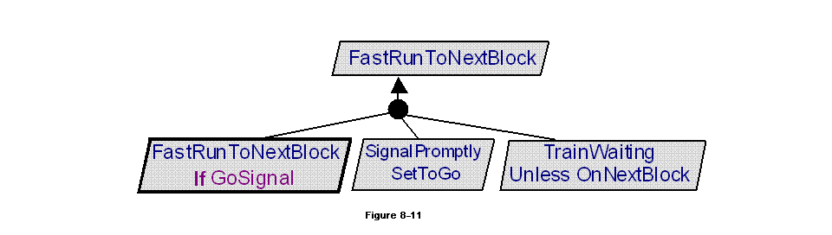
a. | Case-driven refinement pattern
b. | Guard-introduction pattern
c. | Divide-and-conquer pattern
d. | Milestone-driven refinement pattern
ANSWER: | B
MARK: | 1
UNIT: | Chap8
MIX CHOICES: | Yes

QN=31 (1708) | Peter is responsible for goals discovery in RE. He uses some words like "in order to, so as to, so that,.. etc." to search goals in documents. Which of the followings is a Heuristic rules that Peter is using?9999
a. | Analyze current objectives & problems in system-as-is
b. | Search for goal-related keywords
c. | Instantiate goal categories
d. | By abstraction
e. | By refinement
ANSWER: | B
MARK: | 1
UNIT: | Chap8
MIX CHOICES: | Yes

QN=32 (4778) | In the figure 8.26 , the goal refinement pattern is _____101010  [file:4778.jpg]  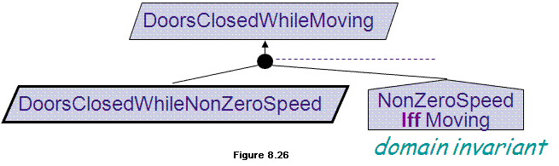
a. | Refinement towards goal realizability
b. | Refinement by milestones
c. | Refinement by case
d. | Divide-and-Conquer
ANSWER: | A
MARK: | 1
UNIT: | Chap8
MIX CHOICES: | Yes

QN=34 (2875) | _______ feature can be attached to a refinement or to an assignment in order to indicate which alternative is taken in which version of the system.11
a. | Name
b. | The system reference (SysRef)
c. | Status
d. | Definition (Def)
e. | Tactic
ANSWER: | B
MARK: | 1
UNIT: | Chap8
MIX CHOICES: | Yes

QN=35 (2871) | Which of the following is a feature that indicates a qualitative level of estimated un-changeability with respect to other comparable goals?11111111
a. | Stability
b. | Priority
c. | FitCriterion
d. | FormalSpec
e. | Source
ANSWER: | A
MARK: | 1
UNIT: | Chap8
MIX CHOICES: | Yes

QN=37 (4779) | In the figure 8.27 , the goal refinement pattern is _____121212  [file:4779.jpg]  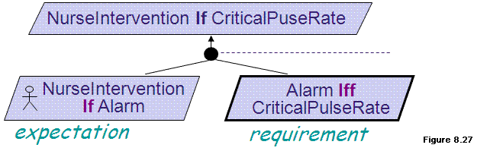
a. | Refinement towards goal realizability
b. | Refinement by milestones
c. | Refinement by case
d. | Divide-and-Conquer
ANSWER: | A
MARK: | 1
UNIT: | Chap8
MIX CHOICES: | Yes

QN=38 (4775) | All of the following are heuristic rules for identifying goals along refinement branches, EXCEPT?121212
a. | Ask HOW and WHY questions
b. | Split responsibilities among agents
c. | Identifying soft goals by analyzing the pros and cons of alternative refinements
d. | Refine by milestones
ANSWER: | D
MARK: | 1
UNIT: | Chap8
MIX CHOICES: | Yes

QN=39 (1707) | Which refinement pattern is applied for the goal refinement in the figure 8-12?  [CopyBorrowedIfAvailable]  Def A book has a copy available for the requesting borrower  [CopyDueSoonIfNotAvailable]  Def A book without any copy available for loan shall have a copy available within 15 days for the requesting borrower  13131313  [file:1707.jpg]  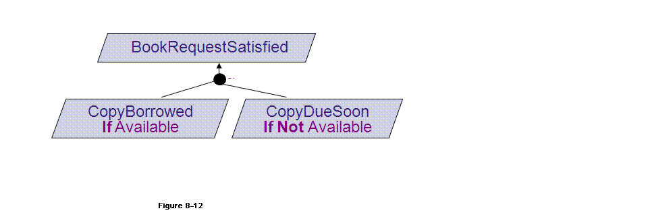
a. | Case-driven refinement pattern
b. | Guard-introduction pattern
c. | Divide-and-conquer pattern
d. | Milestone-driven refinement pattern
ANSWER: | A
MARK: | 1
UNIT: | Chap8
MIX CHOICES: | Yes

QN=40 (2872) | An AND-refinement of goal G into sub-goals G1, ..., Gn states that G can be satisfied by satisfying G1, ..., Gn. Sub-goal Gi is said to _________ to G13
a. | OR-refinement
b. | contribute positively
c. | responsibility assignment
d. | contribute negatively
ANSWER: | B
MARK: | 1
UNIT: | Chap8
MIX CHOICES: | Yes

QN=41 (2868) | Satisfied two goals - Achieve [CopyBorrowed If Available] and Achieve[CopyDueSoonIf Not Available] are enough to satisfy a parent goal - Achieve [BookRequestSatisfied] in DOM (see figure 8-13 ).  This refinement is called_________131313  [file:2868.jpg]  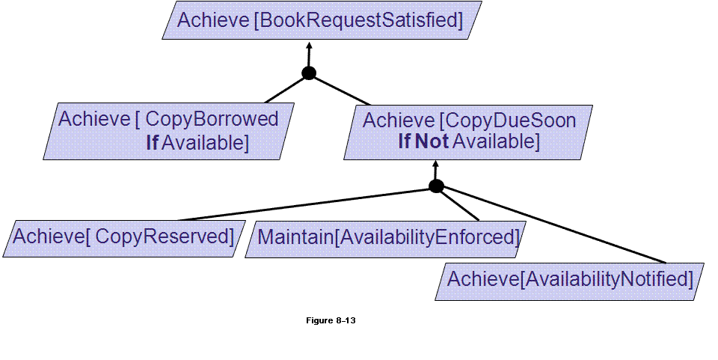
a. | AND-refinement
b. | Complete AND-refinement
c. | Complete OR-refinement
d. | OR-refinement
ANSWER: | B
MARK: | 1
UNIT: | Chap8
MIX CHOICES: | Yes

READING QUESTIONS:
FILL BLANK QUESTIONS:
MATCH QUESTIONS:

